ESSAY ON ACCOUNTING FUNDAMENTALS
By Svetla Aleksandrova
Student ID: 2029252
UWTSD Birmingham
Course: Business and Management
Module: Accounting Fundamentals (LCBB4001_BIRM)
Lector: Ernest Ovia

Table of Contents
Introduction 3
Task 1: Solve the following questions 3
1.) a.) Ledger account 3
1.) b.) The updated trial balance of the company 4
2.) Entertainment business of Mandy 5
Task 2: Producing an essay for the company Michael 7
1.) a.) Journal entries of the additional information 7
1.) b.) Drawing an updated trial balance 8
1.) c.) Financial statement of the company 9
2.) Critical assessment of the relevance of financial statements 11
Conclusion 12
Reference 13

Introduction
Accounting fundamentals is important in the business as it allows them to identify the financial health of the business. Accounting fundamentals include the preparation of financial position in order to make effective decisions easily. It is important as it helps the management to track their expenditures and the income earned during the year. The assessment has shed light on the importance of accounting fundamentals that have been used to evaluate the financial performance of two different companies. Furthermore, depreciation of assets, ledger accounting, and critical assessment of financials have been performed.

Task 1: Solve the following questions

1.) a.) Ledger account
The ledger account has been prepared for the company of Mandy limited in order to analyze the final position of both assets and liabilities. There are certain accounts that have been expanded in accordance with their occurrence in the books of accounts. The account has been prepared for the firm at the end of the year 2019. There are certain expenses and also income that has been placed in accordance with the entries posted in the journal. The business is seen to be having an income which has been received from the rent of £2500 by cash. Furthermore, the business has also purchased goods on cash and even on a credit basis from its creditors. The credit purchase of the firm is seen to be around £2000 at the end of the year. The cash position of the firm is seen to be around £11500 that has been evaluated by adjusting the income and also the expenses at the end of the year.

1.) b.) The updated trial balance of the company
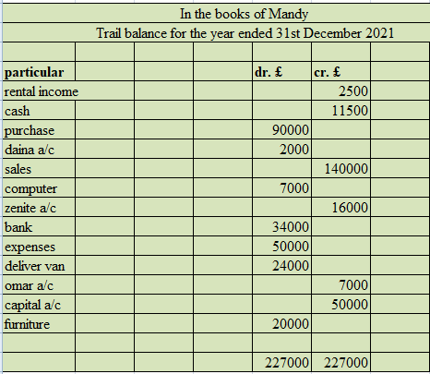
Figure 1: trial balance
(Sources: Self-developed)
As per the above figure, it can be seen that the company is having a final position of £227000 that has been calculated by matching both debit and credit. The rental income of the firm is seen to be pasted in the credit side of the book of £2500. The cash balance of the company is also seen to be calculated at £11500 which has also been placed on the credit side. Moreover, the company is seen to be purchasing goods at the cost of £90000. The company has purchased goods on the basis of both cash and credit. The company has successfully made sales of £140000 both on a credit and cash basis during the year. There are also certain expenses that are seen to have occurred during the year of £50000. The company has also purchased a van of £24000 that has been paid from the bank balance at the end of the year. The final position as per the trial balance is calculated at £227000 at the end of the year. It will be helpful for the company to focus on reducing some of its expenses that will help them to uplift the revenue position easily.

2.) Entertainment business of Mandy
a.) Total expenses
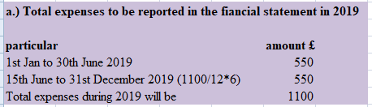
Figure 2: Total expenses
(Sources: Self-developed)
The total expenses of the business have been calculated on the basis of the payment made during the year 2019. The company has paid around £550 for the period from 1st January to 30th June 2019. Moreover, the company is seen to be paying an expense of £1100 for the period starting from 30th June 2019 to 31st June 2020 is £1100. Therefore, the total expenses made by the company for the year 2019 is calculated by dividing the total payment by 12 and multiplying the result by 6 months. Therefore, the total expenses for the year ended are £1100.
b.) Accrual expenses
The total expenses paid for the period from 15th June 2019 to 30th June 2020 is 1100. As per calculation in question a, the total expenses paid from 15th June to 31st December 2019 is 550. The remaining payment of £550 is for 2020. Therefore, the total accrual or prepayment made by the company is £(1100-550) = £550. The company is seen to be paid a sum of £550 which will be considered as prepaid. The company has paid £550 as a prepaid expense that will be reflected in the assets side of the financial position.
c.) Depreciation schedule
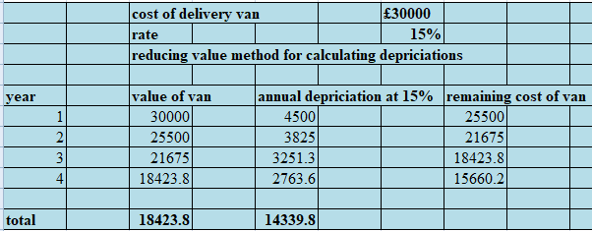
Figure 3: Depreciation
(Sources: Self-developed)
The depreciation of the delivery van has been calculated by using the reducing method. The company is seen to be purchasing a van of £30000. Furthermore, the depreciation for the van is seen to be at a rate of 15% in each of the years. The value of depreciation in each of the years is seen to be calculated at £4500, £3825, £3251.3 and £2763.6 respectively. The final position of the assets is seen to be calculated at £18423.8 with the total depreciation of £14339.8. The motive of calculating the depreciation is to analyze the final position for the company at the end of the year. It is also calculated for the purpose of recovering the cost of assets after it is purchased.

Task 2: Producing an essay for the company Michael

1.) a.) Journal entries of the additional information
Definition: the journal is referred to as the statement which is used in recording the day-to-day transaction of the organization. This is referred to as the initial step which is required to be performed in order to analyze and record the expense for further statements. All the data reflected here will be further transferred to the official accounts like the general ledger and many more.
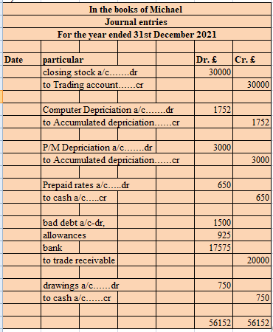
Figure 4: journal entries
(Sources: Self-developed)
In the above table, it can be seen that the journal entries of the companies have been presented which is recorded from the daily transactions. The transaction is required to be recorded in the books of Michael so as to completely understand the expenses and the income. in the above tables various expenses like the drawing which is made by the owner from the books of the organisation. Expenses like the prepaid expenses have been mentioned so as to be assured of the kind of insecurities that can come in the happening of the organization. The closing inventory of the business is transferred to a trading account of £30000 respectively. The accumulated depreciation on plant and machinery reflects £3000 respectively. There is a total £1500 amount of bad debt recorded in the business from the receivable amount of £20000 respectively.

1.) b.) Drawing an updated trial balance
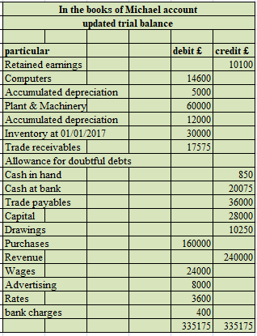
Figure 5: updated trial balance
(Sources: Self-developed)
A trial balance helps to create a balance between the credit and debit sides of the ledger balance. It helps to provide arithmetical accuracy and helps to detect recording errors of the business (Atkinson, Riani and Corbellini, 2020, p.255). As per the above figure, the retained earnings of the business reflect £10100 respectively. The amount of cash left in the business at the end of the accounting period reflects £850 and the bank balance reflects £20075 respectively. The amount of wages needed to pay the workers reflects £24000 and the advertisement expenses of the firm reflect £8000 respectively. There are several expenses recorded in the business that are showcased on the above trial balance. As per the trial balance computation, the debit and credit side of the trial balance get matched by £335175. Therefore, it reflects the transactions are recorded correctly.

1.) c.) Financial statement of the company
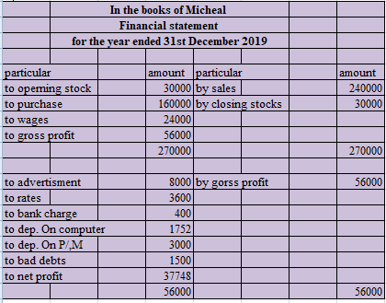
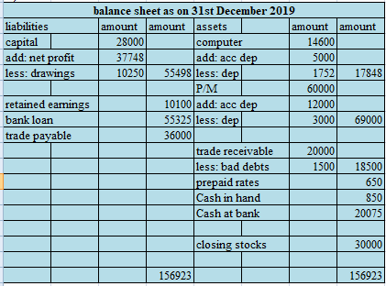
Figure 6: Income statement and balance sheet
(Source: Self-prepared)
An income statement reflects the ability to make a profit from the business. The actual profit a firm earned after paying the expenses of the business can be determined by an income statement (Gurskaya, Kuter and Bagdasaryan, 2019, p.104). In the above figure, an income statement has been produced at the end of 31st December 2019 for Micheal business. As per the computation, the gross profit of the business reflects £56000 respectively. The net profit of the business is computed after covering all the expenses and reflects £37748 respectively. The profit can be improved further by increasing the sales volume of the business.
The balance sheet of a business helps to reflect the actual assets and liability present in the business. Therefore, it helps to determine how much a business exactly owns and how much they owe from the business (Bagdasaryan, 2019, p.104). As per the financial position at the year-end, 31st December 2019 the assets and liability valuation has been computed on the above figure. Therefore, the total assets and liability valuation of the firm reflects £156923 respectively. It reflects a good liquidity position of the business.
As per the above figure, it can be suggested that the company can uplift its revenue position by focusing on reducing its expenses. It will help the firm to achieve maximum benefit in the long run. Furthermore, it will also allow them to overcome the impact of negative cash flow easily in the future.

2.) Critical assessment of the relevance of financial statements
There are three crucial forms of financial statements that allow the business to have a better understanding of its initial performance in the market. Income statement, balance sheet record, and an essential record of the cash flow statement are considered as the primary element that successfully records and depict the initial financial and market performance of the company (Lofamia, 2017, p.56). The statements like the profit and loss help to overall describe the cash involvement in the company. The importance of the cash flow statements in the organization is that it is mainly used for measuring the total cash available and its position in the entity. The term cash position generally means the total inflow and the outflow of the same in the enmity. It is the term which is giving a clear indication about the total cash utilized and saved in terms of closing cash by the organization.
The P/L a/c of the organization is helpful as it is a requirement to be maintained by the organization to comply with the law or to associate with the membership. It critically helps the management to clearly have knowledge about the tidal net profit of the organization (Prosperini et al. 2020, p.704). All the financial statements of the organization clearly help the management in the important decision making which is helpful in attracting the potential creditors of the organization.
The financial statement of a business ideal allows the designated organization to imply an overall assessment of the company’s revenue, profitability, and business expenditures. The maintenance of an effective financial record also successfully meets up its essential financial requirements in the long run. Initially, there are three forms of crucial financial statements that successfully reflect the initial business operation and their availability of money in the current situation. Based on the views of Osadchy et al. (2018, p.2), financial statements are the most essential component that allows the organization to take up sufficient forms of decision and opinions that will maintain definite sustainability and efficiency within the competitive terrains of the market.
However, Minnis and Sutherland (2017, p.201 ) argue in this section that with just a simple understanding of the essential balance sheet, the organization can only have a better understanding of its initial cash flow in the market. The managerial decision-making capabilities of an organization are highly reflected in the internal financial capacity of the company. As of record, sufficient documentation of balance sheet record all9os the management to have a better understanding about whether the company comprises enough cash to successfully pay off its debt or not (Pavić et al. 2017, p.28). Other than that, it also helps the management to maintain a sufficient flow of income within the organization to successfully pay off its expenditures within the running business.

Conclusion
The assignment can be concluded that computing different types of financial statements help to detect the financial position of a business. The trial balance and depreciation of Mandy's business helps to showcase the actual expense and income portion of the business. The income statement of Micheal's business reflects that the firm effectively maintains an adequate amount of profit in their business that will help them to provide a valuable return to its owners and investors. The balance sheet of the firm reflects a good liquidity position of the firm and in the future, it will help to increase the overall valuation of the business.

Reference
Atkinson, A.C., Riani, M. and Corbellini, A., 2020. The analysis of transformations for profit‐and‐loss data. Journal of the Royal Statistical Society: Series C (Applied Statistics), 69(2), pp.251-275.
Bagdasaryan, R., 2019, June. The Structure of the Trial Balance. In International Conference on Integrated Science.–Springer, Cham (pp. 103-116).
Fleckenstein, M. and Longstaff, F.A., 2020. Renting balance sheet space: Intermediary balance sheet rental costs and the valuation of derivatives. The Review of Financial Studies, 33(11), pp.5051-5091.
Gurskaya, M., Kuter, M. and Bagdasaryan, R., 2019, May. The structure of the trial balance. In International Conference on Integrated Science (pp. 103-116). Springer, Cham.
Lofamia, M.J.V., 2017. Addressing timeliness of submission of trial balance: an action research using cooperation levers in CGM local government-Bookkeeping Division of the Accounting Department.
Minnis, M. and Sutherland, A., 2017. Financial statements as monitoring mechanisms: Evidence from small commercial loans. Journal of Accounting Research, 55(1), pp.197-233.
Osadchy, E.A., Akhmetshin, E.M., Amirova, E.F., Bochkareva, T.N., Gazizyanova, Y. and Yumashev, A.V., 2018. Financial statements of a company as an information base for decision-making in a transforming economy.
Palepu, K.G., Healy, P.M., Wright, S., Bradbury, M. and Coulton, J., 2020. Business analysis and valuation: Using financial statements. Cengage AU.
Pavić, I., Žager, K. and Rep, A., 2017. Significance of Notes to the Financial Statements in Business Decision Making. Theory and Applications in the Knowledge Economy, p.28.
Prosperini, L., Castelli, L., De Giglio, L., Bonanno, V., Gasperini, C. and Pozzilli, C., 2020. Dalfampridine to improve balance in multiple sclerosis: substudy from a randomized placebo-controlled trial. Neurotherapeutics, 17(2), pp.704-709.

