ESSAY ON ACCOUNTING FUNDAMENTALS

Table of Contents
Introduction 3
Question 1: Financial transactions of Sandrolia Limited 3
a.) Journal entries 3
b.) Updated Trial balance 4
c.) Financial statement and positions 5
Question 2: Critical analysis of relevance using of financial statement 8
Question 3: Financial transactions of Ricardo’s Limited 9
d.) Journal entries for the additional information 9
e.) Updated trial balance 11
f.) Income statement and final position 12
Question 4: Comparison and contrasting with the liquidity and profitability 14
Conclusion 15
References 16
Bibliography 17

Introduction
The essential perspective of accounting in finance is to assist the business to continue full details of every notebook precisely. It is further accommodating for the administration to detail day-to-day settlements such as income, purchases, sales, and other costs. This analysis has put focus on the theory of accounting fundamentals. The significance of financial standards of accounting, profitability, statements, and liquidity has been summarized. Moreover, transactions in finance as example statements of income, balance sheets also have been made.

Question 1: Financial transactions of Sandrolia Limited
Accounting in finance furnishes the administration to balance their recent settlement in finance with archival accomplishment(Phillips et al. 2019, p.25). Moreover, this even assists shareholders to recognize that year’s situation in finance. Accounting in finance includes epitomizing and detailing settlements in finance in honor of their phenomenon date. According to Stone, (2020, p.25), It gives basic details of the company’s achievements, and this assists the administration in keeping note of the preciseness of the settlements.
The affirmation in finance has been made for the Sandrolia business with a deadline of 31st December of 2019 of the year. There are various patterns in accounting that made, for example, trial balances that have been updated, affirmation in finance, and journal entries for that duration of time. The accounts index through their achievements and description has been recommended below.

a.) Journal entries

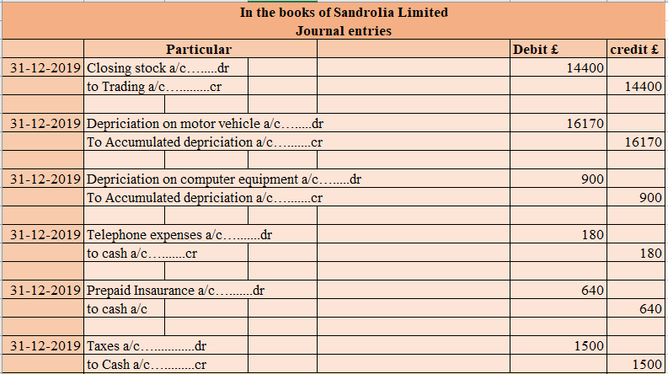
Figure 1: Journal entry
(Source: self-developed)
Entries of the journals have been made for Sandrolia Limited’s business for supporting details of the subsidiary. There are surely subsidiary details that are principal of the business to remember when someone is making the affirmation in finance. These subsidiary details are sections of the final accounts that will be modified in their accounts in particular. From the above-mentioned figure, this can be known that the organization is facing a closing stock worth £14400. This stability will be modified in not only the account of closing stock and also in the business trading account. There are particular different modifications, for example, an explanation that has been counted at £16170 and £900 subsequently for not an only vehicle of motor and also for equipment of the computer. The cost of the phone has not been registered beforehand that has been registered and modified.

b.) Updated Trial balance

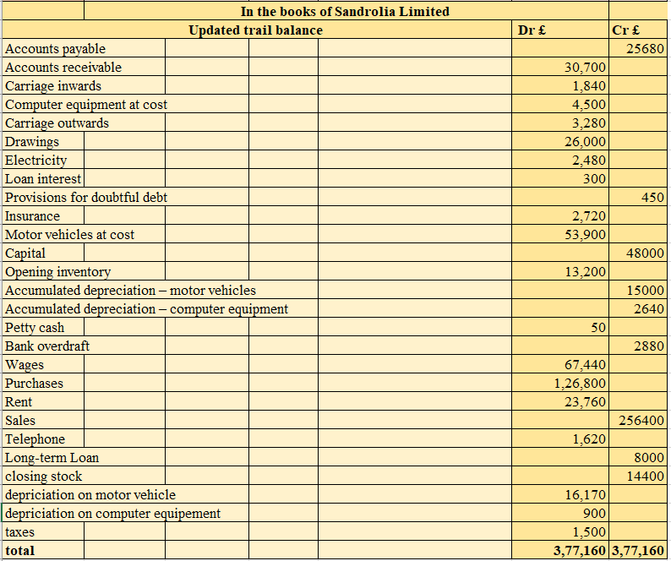
Figure 2: Trial balance
(Source: self-developed)
The trial balance is thoughtful for the organizations to modify the final updates at the end of that year of the particular notebooks. The seriousness of making the trial balance to confirm that all the updates are recommended from the basic ledger (Monte‐Mor et al. 2018, p.175). The trial stability has been made for Sandrolia limited’s business and from that, recognized this can be that the final balance is counted at £377160.

c.) Financial statement and positions

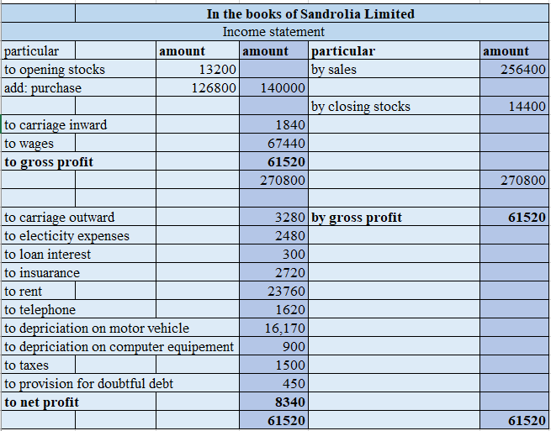
Figure 3: Income statement
(Source: self-developed)
The account of trading has been evolved for Sandrolia Limited’s company or the end of the year 31st December of 2019. From the supervised trading affirmation, this can be shown that the company is facing £13200 opening stock and a obtain of £126800 at the date of starting. Moreover, it has constructed a vending of £256400. This computation has mainly put light on the archival worth that could be impressive in computing settlements in finance. The business’s gross profit has been computed at £61520. There were a few costs that had been registered in the affirmation of income such as, electricity bill, carriage outward, loan interest, phone, rent, and much more. The business’s net profit has been computed at £8340 in the year-end. Hence, this can be stated that the business is facing a better situation of profit at the end of the year-end, Therefore, this would be supportive for the organization to search a few paths to decrease their costs and that will support them to bring up the situation of net profit without any issues.

Balance sheet
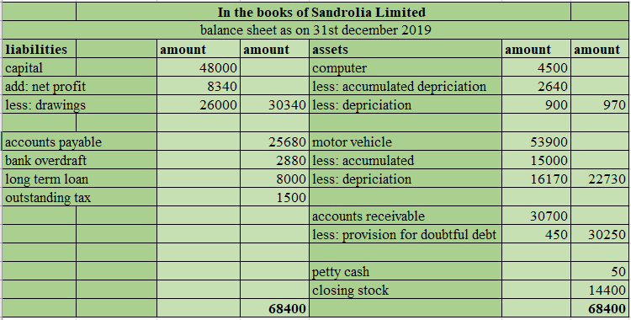
Figure 4: Balance sheet
(Source: self-developed)
The Sandrolia limited’s business on the year-end 31st December of 2019 has been compared from the ultimate state. Likewise, the with of paintings has been decreased from the balance of capital. The final balance of the account of capital in the firm has been computed at £30340 at the yea-rend. The administration also has a few responsibilities, for example, £2880 bank overdraft, outstanding tax of £1500, accounts payable of £25680, and, long-term loan of £8000. On another side, the benefits part of that balance sheet involves a vehicle of motor of £22730, a computer of £970 at the year-end. This stability has been modified after comparing the assembled explanation, and even the annual explanations of the benefits. The final situation of not only benefits and responsibilities in that balance sheet is mirroring the £68400 figure.

Question 2: Critical analysis of relevance using of financial statement

The financial report is regarded as a proper record that principally fosters the monetary movement in a firm. In anticipation of the monetary computation, it mostly creates various kinds of statements to calculate the monetary status. In this estimation, the assessment of the fiscal summary is primarily included for extending the monetary situation of a corporation. The estimation primarily featured the aftereffect of the organizational activity, monetary position and income for a company. The budget report is helpful for processing the decision with respect to the monetary allotment for a corporation. According to assessment, it has featured monetary allotment for a company. The estimation is for the most part pre-arranged the monetary position, proclamation of pay, and furthermore income statement. The clients calculate the monetary situation for assessing organizational value. The users break down the resource with the obligation to assess monetary strength. The estimation has essentially featured monetary importance for doing the measurement. The financial statement is developed to decide monetary value as well as business verdicts. It is additionally valuable in deciding the decrease of the major commitments, which a business needs to pay. Clients fundamentally obtain a positive effect in making business decisions by making a speculation. The tax assessment choices are additionally made utilizing the statement, which can be led utilizing the monetary value (Dewi et al. 2019, p.1373).

Utilizing the financial report, users fundamentally assess the monetary variable by carrying out an investigation. Certain limits are likewise connected with the monetary value, which can be valuable for leading the monetary assessment. Proclamation for the most part records the monetary parts of a firm. Users get stumped with regards to the inside and outer impacts of the association that can't be estimated utilizing the financial report. This calculation essentially featured the verifiable qualities, which can be successful in measuring the monetary assessment. Users of budget summary have neglected to regulate the expense value. Conversely, with the assessment of Hajek and Henriques (2017, p.139), data, which is given by the statement is lacking to assess the current circumstance of a firm. The information can be controlled while computing the financial report. The finacial statement is advantageous for assessing the monetary component that is essentially contrasted and the past incentive for assessment of the development. On contrary, Kim et al. (2020, p.62) stated that users gather information about the genuine costs of the firm from articulations however as a rule neglect to obtain the absolute value of the organisation. The investigation is essentially utilized for processing the genuine outcome with respect to the monetary information. The fiscal summary is helpful for processing the decision in regards to the monetary allotment for a company. The handlers can just assess the monetary presentation and furthermore neglect to dissect the impacts for an association. For assessing the monetary variable, it is additionally significant for assessment of monetary strength. According to measurement, it has directed an investigation over the monetary variable, which does not think about the future expectation. The expansion value is not changed with the fiscal report. According to calculating the genuine value, it has lower similarity with different information.

Question 3: Financial transactions of Ricardo’s Limited

d.) Journal entries for the additional information

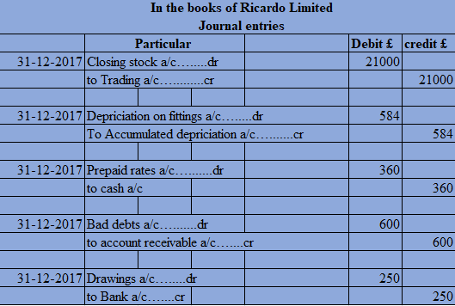

Figure 5: Journal entry
(Source: self-developed)
The diary passages for Ricardo Limited's business have been created to evaluate the additional data. There is most certainly additional data in the files of records. As the finish of the year, the organization's end stocks were accounted for at £21000. Besides, a devaluation worth of £584 has been recorded and subtracted from the installations' total deterioration. During the monetary year, the administration expects a terrible obligation of £600 to show up in the volumes of records. They have likewise settled a 3% hold against the exceptional receivables. The proprietor of the organization took £250 from a bank for individual use, which was recorded as an attracting the organization's books.

e.) Updated trial balance


Figure 6: Trial balance
(Source: self-developed)
The organization's preliminary equilibrium has been refreshed to investigate the last situation of both of the charge and the credit side of the book of records. At the finish of the year, the organization has a last situation of £1,84,124 on the two margins of the preliminary equilibrium. The preliminary equilibrium gives brief data about the association's exhibition and assists the board in suitably recording exchanges in the proper record. The last position infers that Ricardo Limited will be in a solid situation toward the year's end.

f.) Income statement and final position

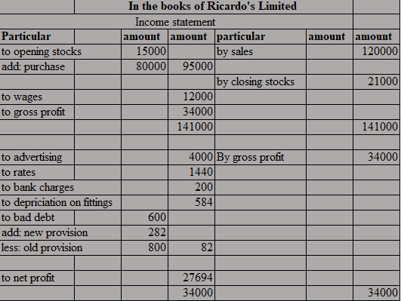

Figure 7: Income statement
(Source: self-developed)
The exchange books were made for Ricardo Limited to study the pay and costs brought about by the organization all through the monetary year. The firm has an underlying supply of £15000. During the time, they additionally bought £80,000, which was extra to the initial stock. The organization's income for the monetary year is £120,000. The organization's end stock has been enrolled as £21000. Certain immediate uses, for example, compensation of £12000, have been salaried by the organization. On the opposite side, the organization has caused roundabout expenses like promoting, rates, bank responsibilities, deterioration, and considerably more. Toward the year's end, the organization's net not set in stone to be £27694.
The business' fiscal reports show a decent pattern, with a net benefit of £27694 registered. It will be accommodating for the board to reduce a few expenses, like promotions, to further develop their net benefit position during the time.
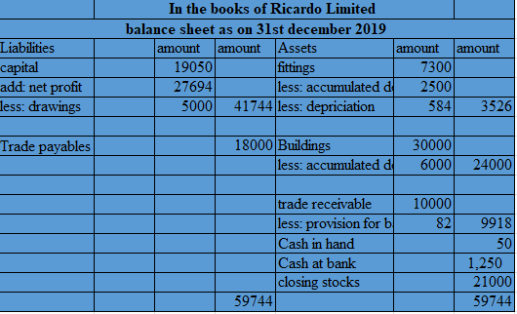
Figure 8: Balance sheet
(Source: self-developed)
Ricardo Limited's monetary circumstance has been created to investigations a definitive situation of the two players. The capital situation of the firm is £19050, as displayed in the above figure. Likewise, a net benefit of £27,694 has been credited, and the worth of draws of £5000 has been subtracted. In the monetary position, a definitive capital position still up in the air to be £41744. In the accounts of record, the worth of exchange payables is accounted for as £18000. Then again, the organization has resources like structures, installations, exchange receivables, and money balance. In the wake of deducting aggregate and yearly deterioration, the worth of fittings and apparatuses was determined to be £3526. Likewise, the structure's end balance has been accounted for subsequent to taking away £6,000 in aggregate devaluation. Toward the year's end, the structure balance is £24,000, and the exchange receivable is £9918.

Question 4: Comparison and contrasting with the liquidity and profitability
Liquidity is the capacity of a company to transform the value of an asset into cash. Mainly, it analyses the position through generating cash, when it is required. It emphasizes the ability of liquidating cash value through the asset for decreasing short debt. Through the calculation of cash value and proportion of current asset help measuring the liquidity of an organization. The current asset helps assessing the capacity of an organization in terms of reducing its debt (Chen et al. 2018, p.164).
It is the sum of cash that is created by investing or selling items. Profit is assessed by calculating pay and costs created annually. Profitability is significant as it portrays the increment or abatement in the value status of a venture. In addition, the business can undoubtedly create development chances, market patterns using profitability (Sari and Sedana, 2020, p.116).
The correlation of liquidity as well as profitability is principally assessed by the profit and the costs of a corporation. Liquidity essentially features the power of relieving the short term loan in an organization. It is additionally valuable in deciding the decrease of the main commitments, which a business needs to pay. It is essentially a boundary of how quick the organization can sell its resources. According to measurement, the benefit of an association is regarded as the liquid worth that is fundamentally helpful for figuring the monetary projection. Deficient liquidity can insolvent a transient firm. Profitability is utilized for assessing the business achievement that is regarded as a sign of the monetary estimation. Then again, assessing the money position for the most part figures the money equilibrium of the income. The profitability is viewed as a criterion of business execution that is fundamentally demonstrated utilizing the pay statement and furthermore different reports (Zuhroh, 2019, p.203). Liquidity is essentially assessed as the proportion and furthermore the income for assessing the money status of a company. The equilibrium value is utilized for the assessment of the power of the business.
The estimation has essentially featured the monetary information that assesses the forte of a venture. To calculate the liquidity, it fundamentally processes the income to extend the capacity of the functioning capital. The fiscal summary estimates the profits and the worth of money in various ways. The financial statement is ready to figure monetary value and furthermore business decisions. According to comparison, the value of profit is essentially assessed income, which is viable in the assessment of productivity. Further, organizations calculate the currency balance in various ways for assessing the monetary component that is estimated the real value. Within this interaction, it has essentially included money projection, which has assessed the liquid power for reducing debt. Besides, it has additionally mirrored the monetary value, which is calculated over the fiscal summary. The statement distinguishes the profitability as well as liquidity to estimate the income and liquid money in an unexpected way.

Conclusion
Here, the basics of accounting are used for making accounting statements. Various kinds of financial statements such as trading balance sheet and journal entries are prepared. Accounting fundamentals help businesses managing their financial dealings. The financial reporting rules help businesses to manage their activities following all the rules and regulations. It gives accuracy to the financial reports.

References
Chen, C.W., Collins, D.W., Kravet, T.D. and Mergenthaler, R.D., 2018. Financial statement comparability and the efficiency of acquisition decisions. Contemporary Accounting Research, 35(1), pp.164-202.
Dewi, N., Azam, S. and Yusoff, S., 2019. Factors influencing the information quality of local government financial statement and financial accountability. Management Science Letters, 9(9), pp.1373-1384.
Hajek, P. and Henriques, R., 2017. Mining corporate annual reports for intelligent detection of financial statement fraud–A comparative study of machine learning methods. Knowledge-Based Systems, 128, pp.139-152.
Kim, J., Kim, R. and Kim, S., 2020. Does financial statement comparability mitigate delayed trading volume before earnings announcements?. Journal of Business Research, 107, pp.62-75.
Monte‐Mor, D.S., Galdi, F.C. and Costa, C.M., 2018. The role of accounting fundamentals and other information in analyst forecast errors. International Finance, 21(2), pp.175-194.
Phillips, F., Libby, R. and Libby, P., 2019. Fundamentals of Financial Accounting, 6e.
Sari, I.A.G.D.M. and Sedana, I.B.P., 2020. Profitability and liquidity on firm value and capital structure as intervening variable. International research journal of management, IT and Social Sciences, 7(1), pp.116-127.
Stone, E.J., 2020. An Analysis of the Fundamentals and Professional Applications of Financial Accounting.
Zuhroh, I., 2019. The Effects of Liquidity, Firm Size, and Profitability on the Firm Value with Mediating Leverage. KnE Social Sciences, pp.203-230.

Bibliography
Beerbaum, D., 2020. Benchmarking and best-practice analysis in Financial Accounting–the case of Related Party Disclosures. Journal of Applied Research in the Digital Economy (JADE).
Demerjian, P.R., 2017. Calculating efficiency with financial accounting data: Data envelopment analysis for accounting researchers. Available at SSRN 2993687.
Dunn, L.N., 2018. The Fundamentals of GAAP: Case Studies of Accounting Principles.
Garbowski, M., Drobyazko, S., Matveeva, V., Kyiashko, O. and Dmytrovska, V., 2019. Financial accounting of E-business enterprises. Academy of Accounting and Financial Studies Journal, 23, pp.1-5.
Gomez, S.M., 2019. ACCT 115-003: Fundamentals of Financial Accounting.
Inuwa, U., Abdullah, Z. and Hassan, H., 2018. A Mixed-Method Study of the Effect of the Demonstration Method on Students' Achievement in Financial Accounting. International Journal of Instruction, 11(4), pp.577-592.
Kachelmeier, S.J., 2020. Financial Accounting and Auditing Experiments in the Journal of Accounting Research: Historical Background and Recent Advances. Journal of Accounting Research.
VILLARREAL, J.L. and CÓRDOBA MARTÍNEZ, J.X., 2017. FUNDAMENTALS FOR THE STUDY OF RESEARCH FLOWS IN ACCOUNTING. Tendencias, 18(2), pp.139-151.

