

Assessment 1 – Reading Task Template
PART 1: Upload your photo of your A3 in-class notes here:
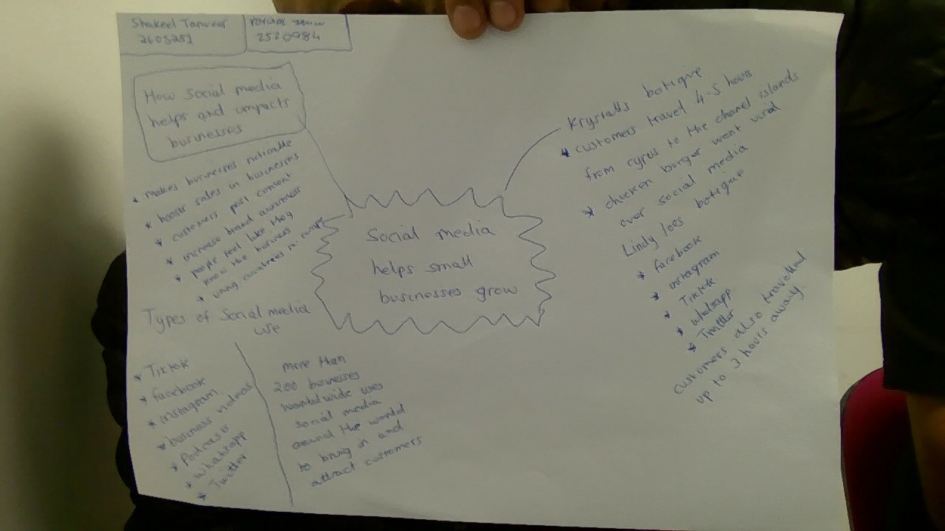

PART 2:
- Answer every question below in 1-3 full sentences.
- Use your own words. Do not use generative AI to answer these questions.
- Include a specific detail from the text when asked.
REMINDER
- The main idea is the overall message of the whole text.
- A key point helps to explain the main idea.
- A specific detail or example from the text shows that the key point is true.
- What is the main idea of the whole text?

The main idea of the whole text is about social media and faster growth in the market to attract more customers with their viral foods and their food chains.

- What is one key point that supports the main idea, and which specific example from the text shows this?
The one key point that supports the main idea is social media the example im giving is the business has racked up about 45 million views in under a year also a combined 320,000 people across Facebook and Instagram and tries to post fresh content showing off her latest stock at least five times a day.

- What is a different key point that supports the main idea, and which specific example from the text shows this?

The main key point is social media it can attract people who live far away to travel so they could try the products. People travel from Cyprus to Krystalls after seeing social media memes and posts.

- Which part of the text do you think is most important, and why?
The text I think which is most important is social media this will attract more customers this is important because businesses can become famous and go viral.

Reflection:
- What did you find difficult in this task (including in-class components), and why was it difficult?

It was difficult to find key point due to a lot of information needed to be read. It was also difficult to choose examples and then find evidence to support.

- What helped you with this difficulty, and how did it help you?

The mind map I created in class helped me with this difficulty. This also helped me find examples from the text. The class discussions and working in a pair were also very helpful.

