

BSc (Hons) Professional Police Practice

LEVEL 5 - 40 Credits

Workbook title: Competency Based Workbook 3 (PCDA)

(SOUTH WALES POLICE, GWENT POLICE AND UWTSD)

Learner name: __Gareth Tucker______

Learner’s University Registration Number:
____1922395________

FACULTY OF BUSINESS AND MANAGEMENT
PUBLIC SERVICE PROGRAMME

Module title: Professional Police Practice 2 (PCDA) BMPP5000D

Workbook Guidance

Please read these notes carefully; they provide essential information.

What is the workbook for?

The purpose of this workbook is to enable learners to demonstrate and provide evidence of how they meet the learning outcomes set by the College of Policing, for the BSc programme. Essentially, you are being asked to outline your experiential learning based upon your theoretical understanding in a range of operational situations.

- Wellbeing and Resilience
- Decision-making and Discretion
- Vulnerability and Risk
- Public Protection
- Maintaining Professional Standards
- Leadership and Team-working
- Policing the roads
- Information and intelligence
- Conducting Investigations

You may wish to use the same incidents as you’ve outlined in the Occupational Competence Portfolio.

How should the workbook be presented?

Blank electronic copies can be found on Moodle of this workbook. You must submit this document electronically therefore it is important that you save your work regularly and upload the final typed version through Turnitin on Moodle.

Word count policy can be found in chapter 7 of the Academic Quality under section 7.7 (this applies to presenting work above and under the specified word count).
(https://www.uwtsd.ac.uk/media/uwtsd-website/content-assets/documents/academic-office/aqh-chapters/chapters---en/Chapter_07_Assessment_Taught_Programmes_Pages_72-79-UPDATED-05-11-2019.pdf)

Reflective practice is a core aspect for your workbooks and although there is a variety of useful resources on Moodle, there is one particular book, that is specifically based on reflective practice in policing, here is a link to one chapter from Selina Copley’s Reflective Practice for Policing Students:
https://moodle.uwtsd.ac.uk/pluginfile.php/298870/mod_resource/content/1/Reflective%20Practice%20for%20Policing%20Students%20-%20Selina%20Copley%20Chapter5.pdf

How is the workbook assessed?

Advice and support about the completion of this workbook will be provided by university staff as part of your initial training day. Your tutor constable and in-force training staff will not be involved in assessing or marking your workbook after it has been submitted.

Dates of workbook submission will be made available during the initial training day and posted on Moodle.

Once submitted your workbook will be assessed and marked independently.

Confidentiality

It is important that no individual can be identified either directly or indirectly from the information in the workbook. Therefore, you must:

- adhere to guidance in the Student Handbook about unfair practice and plagiarism.
- not identify individuals including witnesses, victims or offenders by name.
- not write information that enables any individual to be identified indirectly through the description you provide. This includes references to names, colleagues, places (including hospitals, schools, town, villages, streets) specific incidents which were high profile and could be identified due to past publicity, other professionals or any other personal information including medical or other conditions.
- take personal responsibility for adhering to confidentiality rules.
- not include any dates of any incidents or anything that specifically identifies an actual incident.

NOTE

Your workbook will be submitted electronically via Turnitin on Moodle. Guidance on this is in the Student Handbook.

Remember that the workbook is YOUR responsibility you must not rely on the assessor or anyone else to pick up any confidentiality breaches as this is your work and you must accept full responsibility for confidentiality. Meeting all the confidentiality requirements is very important.

Dyslexia and other special circumstances

If you have any condition that you feel may affect your ability to deal with any part of the programme, please see the Student Handbook for further guidance. The University has a Student Services Unit that may be able to help but it is the learner’s individual responsibility to contact them.

Guidance:

- Your workbook must contain the items specified in the table below (clearly identified and in the order given);
- You should use this particular document to insert your text / answer within each section of this workbook;
- You should upload your completed document as a saved pdf file of this workbook; if this is not possible then a Worddoc file is acceptable. Do not send a scanned file from a photocopier, an apple.dot file or a Microsoft publisher file as Turnitin will not be able to assess them, despite you being able to upload them.

Contents

Workbook | Area of Professional Practice | Word count
Task 1 | Wellbeing and Resilience | 1250
Task 2 | Decision-making and Discretion  Vulnerability and Risk  Public Protection | 1750
Task 3 | Maintaining Professional Standards  Leadership and Team-working | 1750
Task 4 | Policing the roads  Information and intelligence  Conducting investigations | 1750
Task 5 | Individual Learning Plan | 1500 equivalent
 | Total | 8000
 | Bibliography

Task 1

Relevant areas of the National Policing Curriculum:
Wellbeing and Resilience

Having achieved Independent Patrol Status, reflect on the impact of organisation culture within policing on your wellbeing and resilience (organisation change, retaining personal values in a wider organisational culture).

Consider the risks of conforming to organisational culture.

Illustrate your strategies for maintaining wellbeing and resilience.

1250 words (+/- 10%: include your actual word count at the end of each section)

ANSWER:

The organisational culture within policing have had both a negative and positive effect on my wellbeing and resilience. The change from my previous job to my current role has been significant. My previous role was significantly less regimented and was not a ‘disciplined’ organisation. The consequences of policing are also significantly more serious than my previous role and as such this brings an enormous level of responsibility and the stress that goes along with that, prior to independent patrol status this was negated somewhat by the presence of your tutor who was there to guide you and was a safety net. Now that this has been taken away and there is an expectation from your supervisor and colleagues that you can effectively and efficiently work independently, sometimes going entire shifts without ‘on your own’, this brings with it a lot of stress and a risk of compromising values, especially in high pressure situations where there is always the temptation to find the ‘easy way out’ of a situation which may not necessarily be the correct or moral decision. These negatives have been negated for the most part by the organisational culture I have found within my team, everyone I work with has been incredibly helpful from day one, and as a team that is relatively young in service there is very little in the way of ‘old fashioned policing’ and few bad habits, as such retaining my own personal values has not been an issue that I have experienced.

The risks involved with conforming with organisational culture involve compromising on your own values, whilst the overarching values of the police (enshrined in the code of ethics) closely match those of most moral people (accountability, integrity, openness, fairness, leadership, respect, honesty, objectivity, selflessness (Police.uk, 2021)) this is not always reflected in the ‘real world’ for both practical and morally ambiguous reasons. Old habits from years of working a certain way, formerly acceptable practices and cutting corners from apathy can become part of the culture at the micro level. This unfortunately is the culture level most people experience in their day to day and as such can be the culture that they then conform to. A desire to fit in to a new team can lead to a compromising of values and the establishment of negative habits and behaviours. The effects of a negative organisational culture can include: Poor internal communication throughout the organisation, micromanagement putting employees under unnecessary stress a lowering the quality of their work, unhealthy competition which can quickly get out of hand and result in compromised values, bad habits as previously mentioned, a lack of empathy which can translate to the same being shown to the public and lastly poor leadership and future management, if the culture is not correct on the bottom rung of the ladder then as people climb the ladder they’ll take their culture with them (Small Business - Chron.com, 2013).

The strategies I use for maintaining my wellbeing and resilience have become more important since achieving independent patrol status, the added stress of shift work, an ever-increasing workload, low staffing levels, policing during a pandemic, working towards a degree alongside a full-time job where conflict, emotionally difficult and high stress situations are the norm all make effective strategies essential.

I have maintained throughout my time in training and through my tutorship an exercise regimen and have to the best of my ability and time willing maintained this on gaining independent patrol status. I luckily have access to a gym at my station and have made full use of this. The effect of exercise on wellbeing and resilience is well documented. A study by Paluska and Schwenk concluded that:

- ‘Regular physical activity may play an important role in alleviating symptoms of depression and anxiety.
- Both aerobic training and strength/flexibility training appear equally effective for treating depressive and anxiety symptoms.
- Emphasising physical activity itself rather than resultant cardiovascular fitness seems more effective in improving mental health symptoms and mood.
- Physical activity appears as effective as psychotherapy for the treatment of mild-to-moderate depressive symptoms.
- Individuals diagnosed with clinical depression with more severe symptoms or the need for psychological care manifest the greatest improvement in mood following increased physical activity (Paluska and Schwenk, 2000)’

I have also attempted to maintain a regular eating schedule by limiting the amount I eat whilst on a night shift and trying to avoid caffeinated drinks as much as possible (sometimes impossible whilst interviewing a suspect at 3am). This is in order to avoid a circadian rhythm disorder which occur when the biological clock does not match with daily activities. The body aligns this rhythm with certain cues including how light or dark it is, when you are physically active and when you are eating.
A person with a job that consisted solely of night shifts would find their circadian rhythm adjust to suit their sleep-wake cycle however as my shift pattern is not consistent the rhythm is not able to adjust and can cause circadian rhythm disorders. Symptoms of this include insomnia, tiredness, decreased alertness, issues with memory and decision making (Nih.gov, 2019).

Another strategy I use to help combat these issues is ensuring I have enough sleep, especially after a night shift, the temptation to get up after only a few hours is strong as you feel like you are wasting the day, especially as of the four rest days we have the first follows a night shift and so you can waste an entire precious rest day sleeping, which in turn affects the rest as you are awake late into the night following a full day of sleep. I have compromised by waking at lunchtime which I have found (so far) to be a good balance between getting the sleep I need without losing the day, which would equally have a negative effect on my wellbeing.

The final and possibly most important strategy I employ is black humour. Whilst this may seem callous or inappropriate it is a genuine coping strategy utilised by individuals dealing with traumatic incidents which by default includes those in the emergency services. A paper by Sarah Christopher written for student paramedics experiencing the black humour of their more experienced colleagues stated that:

- ‘Humour can act as a form of tension release and can be used as a coping mechanism.
- Emergency services personnel have been shown to typically employ the use of black humour.
- The unique brand of emergency services’ humour may be a culture shock to student paramedics.
- A subject’s previous experience has shown to have a direct influence on the level of black humour used.
- Black humour is acquired by new personnel informally from their more experienced colleagues.
- Humour has shown to be a valuable coping mechanism for many patients’ (Christopher, 2015)

Task 2

Relevant areas of the National Policing Curriculum:
Decision-making and Discretion, Vulnerability and Risk, Public Protection.

You must choose an incident, for example a domestic related incident, and reflect on how you made decisions in complex and unpredictable circumstances using dynamic risk assessment.

Give a brief description of the problem including social and legislative contexts and any relevant cultural, ethnicity and language issues.

Evaluate decisions made during the incident and your use (or otherwise) of the National Decision Model. Explain the rationale behind your decisions and your considerations when recording details of the incident. Consider your ethical approach to the decision. Outline the consequences of your decision making.

1750 words (+/- 10%: include your actual word count at the end of each section)

ANSWER:

The incident I have chosen as an example for this question involving two domestic incidents between a mother and a daughter over the course of two weeks.

The initial call came through as a domestic incident between the two, called in by the mother stating that she needed help as her daughter was being very aggressive and argumentative, nothing physical was disclosed however when checks were made on the address and those involved an extensive history of similar incidents was found. It was at this point that the National Decision Model was first used.
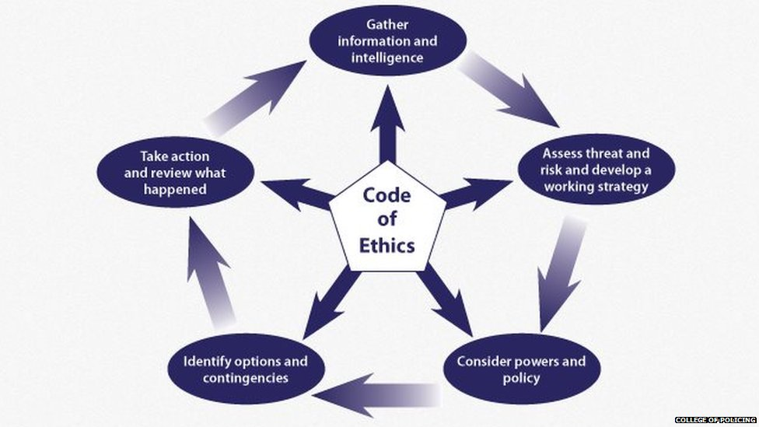

The model has five elements to it each linking back to the code of ethics. Starting with ‘Gather Information and Intelligence’.
In this incident the information and intelligence came from the initial call detailing what was happening and also came from the previous history checks completed on the address and both parties involved. The report from the mother stated that her daughter was acting in an aggressive and intimidating manner and that she could no longer cope with what was happening. The address/persons checks were requested from the force control room and the information passed back revealed a history of similar incidences between the pair.

The second element is ‘Assess Threat and Risk and Develop a Working Strategy’.
This includes an assessment of officer safety, victim safety, public safety etc. and is initially influenced by the call and checks performed. In this incident there was a risk to the mother disclosed via the phone-call as well as the domestic history that had been passed to us from the control room, the incident was occurring within the address and no other people were mentioned so the risk to other members public was low and as no warnings or markers were present, other than those concerning domestic abuse, the risk to officers was also relatively low, however due to the changeable nature of calls and often volatile nature of domestic incidents it was decided to attend double crewed with a female officer accompanying, this was influenced by the fact that both parties were female and close contact/searches etc. may be necessary. The initial working strategy developed was mainly influenced by previous attendance to similar calls, this was down to the limited information and intelligence we had at this initial stage and as such was quite basic, attend, separate both parties, ascertain what had happened and deal.

The third element is ‘Consider Powers and Policy’.
The domestic policy for Gwent Police is to take ‘positive action’ for all incidents and is guided by the college of policing’s authorised professional practice guidance (Police.uk, 2015). In brief the Gwent’s policy acknowledges the seriousness of domestic abuse and makes it a priority, the importance of early positive intervention, the importance of ethical treatment of all parties involved, that the level of action taken is based on intelligence and is influenced by previous history, risk assessments and the judgment of attending officers. The other powers that are taken into consideration in most incidences are the PACE powers of arrest and powers of entry, these are always considered in domestic incidences to ensure the safety of the victim, in this case when no offences had yet been disclosed, I considered arresting to prevent a breach of the peace if necessary. Body worn video is always activated to capture anything evidential.

The fourth element is ‘Identify Options and Contingencies’
Based on the information our initial options and contingencies were generic for this sort of incident and included consideration for method of entry officers, additional officers for support, assistance from the mental health team in the force control room, ambulance, these options, especially the mental health team consideration, were reinforced as we were en-route due to new information received that the daughter suffered with her mental health and that this may have had an influence on what had happened.

The fifth element is ‘Take Action and Review What Happened’.

The initial action being attending the address. On attending we have activated our body worn cameras and entered the property after being let in by the mother. The mother was an elderly woman who was a full-time carer for her adult daughter who was sitting on the sofa in the living room and appeared very calm. Both parties have been separated and spoken with by officers. I have spoken with the mother who has disclosed that she was a full time carer for her adult daughter who was a diagnosed schizophrenic and alcoholic. The daughter had been drinking heavily the previous night and had neglected to take her prescribed medication and as a result had become extremely irate and aggressive the morning after, the mother had felt sufficiently threatened by her to contact the police, however before officer attendance she had managed to convince her daughter to take her medication, and this had had a significant effect on her, and she had calmed down completely and was no longer acting in an aggressive manner.

It is at this point that I have used the NDM again. Then new information to be added at the first stage included the mental health aspect of the incident, the threat that the mother had felt under despite nothing physical having taken place and the fact that the daughter had now taken her medication which had taken effect.

As I only had information, I had concerning the daughter and her condition came from the mother I decided to contact the mental health team in the force control room in order to gain as much information as possible, what I received back confirmed what I had been told, that the daughter was diagnosed schizophrenic.

Returning to the second stage of the NDM I again assessed the risk and developed a working strategy, with the daughter now properly medicated the risk to the mother appeared to have abated and on speaking with her she insisted that everything was now fine and that she felt bad that she had contacted us, she stated that her daughter’s aggressive behaviour only happened when she did not take her medication.
The working strategy I considered at this stage was to leave the daughter at the address in the care of the mother, I first asked the mother what her desired outcome from this situation would be and she reinforced my consideration by insisting that her daughter remained and that she had nowhere else to go as she had behaved like this with other people who would no longer have her at their houses.

I again considered GWP domestic policy of positive action when it comes to domestic issues however the fact that the daughter was calm inside the address, no offences had been disclosed and the mother did not fear any violence there were insufficient grounds for arrest. Detaining the daughter under the mental health act was also not an option as she was in a safe place and no longer a danger.

I was not, however, happy to leave the mother on her own with the daughter and so a neighbour was spoken to who agreed to stay at the address overnight and an appointment made with the daughter’s GP was made for the following morning to reassess. I also completed and submitted a public protection notification referral (PPN) and a DASH (domestic abuse risk assessment) which was submitted to social services in the hope that more support could be found for the mother and daughter.

Officers then stood down after safeguarding the mother and advising her to recontact us immediately if anything else happened.

The ethical elements of the situation that effected my decision making included:

- The mental health issues with the daughter which made me very reluctant to have to use my powers of arrest and which had to be taken into account when considering her behaviour.
- The age/frailty of the mother, her vulnerability was a big factor in ensuring that the neighbour stayed the night as she would have been at considerable risk had her daughter relapsed into her pre medicated behaviour.

I believe at the time that I made the correct decisions which produced the best outcome for all involved, the mother was safeguarded and with the appointment made with the GP and the referral to social services both mother and daughter would hopefully receive the support they needed.
The consequences of my decision however became apparent when I was dispatched less than a week later to the same address for exactly the same reason. The daughter had again not taken her medication and become aggressive towards her mother.
I again attended to find that, as opposed to the previous incident, the daughter had not taken her medication prior to our arrival and instead drunk half a bottle of vodka. The decision this time was to arrest in order to prevent a breach of the peace. This was done to protect the mother from harm. I again completed and submitted a PPN and DASH in the hope that this will reinforce any consideration for support being made.

Task 3

Relevant areas of the National Policing Curriculum:
Maintaining Professional Standards, Leadership and Team-working

Evaluate theories of team dynamics as a means of developing team cohesion (reasons why some teams cannot function, theories and models relating to team dynamics, ways to improve team cohesion).

Consider why inter-personal conflict can occur within a team and outline what strategies can be adopted to enhance individual and team performance.

Consider how team dynamics within the police service can result in failing to comply with professional standards requirements (Code of Ethics, policies, procedures, protocols or legislation).

1750 words (+/- 10%: include your actual word count at the end of each section)

ANSWER:

There are several different theories of team dynamics and I shall look at these and evaluate how well they perform or fit when developing team cohesion. The first theory I am going to look at will be Belbin’s theory on team dynamics. This theory proposes that for a team to be successful then each one of nine categories needs to be filled (one person can fill multiple roles). These roles are: Shaper, Coordinator, Plant, Resource Investigator, Monitor evaluator, Specialist, Team worker, Implementer and Complete Finisher. These roles all have different characteristics that, in theory, complement each other and together form a cohesive and effective team. This also implies that without these roles then the team will be less cohesive and less successful (Imperial College London, n.d.)
Each role has a very specific set of characteristics as shown in the image below:

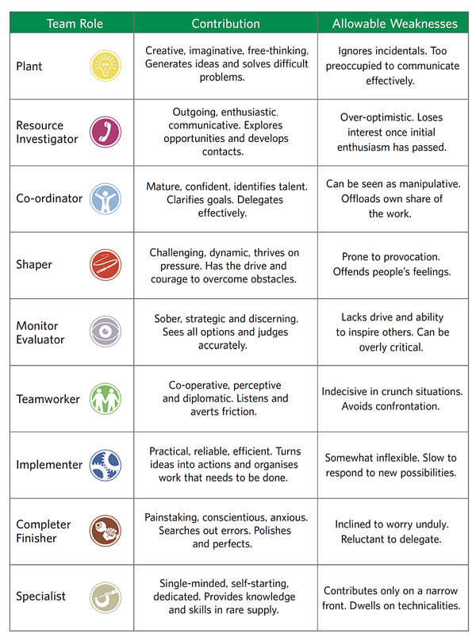

(PrePearl Training Development, 2016)

Belbin also stated that the optimum team size is 6 and that any more than this creates a group as opposed to a team as members will not work closely enough together and can tend to become lazy (Moga, 2017).

In practice however I have found Belbin’s theory to be unrealistic and difficult to achieve especially when it comes to response policing. Response policing by its very nature is reactionary and people often have to work a problem or task individually from start to finish, this can be down to several factors, from staffing levels and the sheer number of calls to the organisational culture of working on your own and only ‘double crewing’ on night shifts. Officers can go entire shifts without interacting with colleagues and so have to rely on themselves fulfilling all 9 roles of Belbin’s theory. Another criticism of the theory when looked at through a policing lens is the allowable weaknesses of the roles. The weaknesses for the resource investigator, shaper and team-worker for example include ‘loses interest once initial enthusiasm has passed, prone to provocation and indecisive in crunch situations/avoids confrontation’. Whilst these may be acceptable or allowable in other roles, they are fundamentally opposed to what is required of a police officer.

Tuckmans theory differs to Belbins in that it states that teams don’t start fully formed and ready to go (as long as the 9 roles are fulfilled). Instead, Tuckman theorises that teams go through 4 stages before becoming an efficient, effective and cohesive unit (Lumenlearning.com, 2014). These 4 stages are Forming Storming Norming and Performing (before adjourning) as illustrated below:

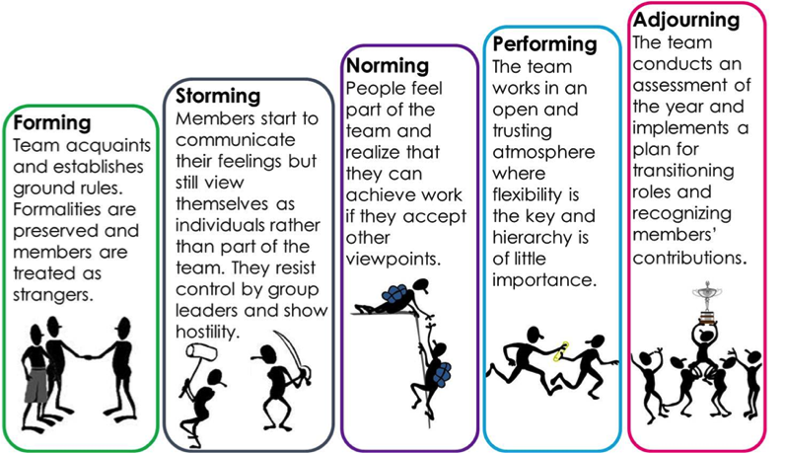

(admin, 2018)

I have found this theory to more accurately reflect my experience within a team. When an officer or indeed any worker joins a new team, they are a stranger, and it can take time to establish themselves within that team and learn to work effectively. This, however, is sometime not possible due to interpersonal conflict.

Inter-personal conflict is to be expected in most workplaces and especially in a workplace that can be highly stressful or challenging. Conflict is not always a negative thing when managed correctly and can lead to productive or surprising results. When poorly managed however it can be detrimental and negatively affect the entire team.
There can be several causes of inter-personal conflict within a team, simple personality differences in value and a lack of communication (for example officers being assigned additional work without being informed or consulted) can all lead to inter-personal conflict. This conflict can be separated into four types (Indeed Career Guide, 2021).
Policy-related interpersonal conflict can be defined as parties wanting separate things and being unable to compromise or come to some sort of agreement, for example on a team task one half of the group wants to tackle the problem via solution A whilst the other half wants to use solution B and neither side is willing to back down.

Pseudo-conflict is caused when two parties don’t see eye to eye on a task, however this often-minor disagreement is not the cause of the conflict and hides the true root of the issue.

Value-related interpersonal conflicts occur when two people have differing values when it comes to the work. This often presents as parties just being stubborn or argumentative however this can mask fundamental value differences, a simple example of this is one person tends to take their work home with them and remains available 24/7 whereas another person believes in a strong separation between work life and home life. This type of interpersonal conflict is often difficult to solve as people are typically unwilling to compromise on their values

The fourth type of interpersonal conflict is the ego-related conflict. This is where the person’s pride is on the line and can be as a result of several prior conflicts or clashes that have gone unresolved. An example of this is a perceived favouritism towards one employee from a line manager causing resentment and leading to conflict each time this is a factor.

These different types of conflict then lead to unproductive behaviour within a team such as ‘hitchhiking’, which is not contributing to the team, ‘hijacking’ which is taking charge of the team or ‘isolating’ which is leaving the team completely (Last, 2019).

To deal with conflict there are a few strategies that can be employed to both prevent and manage it.
Treating all members of a team equally and respectfully and setting the correct tone, active listening by allowing everyone to voice their opinions without interrupting even if you do not agree with what is being said and considering what is being said before responding, this is important in order that the point of view of the speaker is properly understood, as well as the point of view of the person their needs, concerns, difficulties and pain in the current situation can then be understood as well as your own which all aids in understanding perspective (Uwtsd.ac.uk, 2022). Attempting to solve conflicts whilst they are still small is also an effective strategy to dealing with conflict, as previously mentioned pseudo-conflict is often caused by several small conflicts being left to simmer and tackling these before they manifest can make them easier to deal with (Bao et al., 2016).
In Technical Writing Essentials Susan Last provides us with these seven approaches to dealing with conflict:
‘
- Acknowledge, understand, and value the diversity within your team; recognize team members’ various strengths and weaknesses, and play to your strengths, while acknowledging and trying to improve on your weaknesses.
- Don’t “silo” (break up into smaller teams of “us” vs “them”); deal with issues as a team
- Don’t ignore problems or conflicts; deal with them head on; communicate issues quickly and directly with the whole team; maybe review the team charter to remind you of what the expectations and protocols are.
- “Don’t sweat the small stuff”; don’t get side-tracked by minor differences of opinion or approach that don’t have a significant effect on the project; be willing to make some compromises.
- But keep in mind that compromise does not always lead to the best solution; be a strong, but diplomatic advocate for what you think is the best approach. Persuade, but don’t bully. Your teammates will thank you for it in the long run.
- Separate the “people” from the “problem” (avoid “blame game”); don’t dwell on past actions and consequences; focus on coming up with solutions that benefit the whole team.
- Focus on “interests” not “positions” — that is, focus on what is in the best interests of the team rather than on “your position” vs “my position”; try playing “devil’s advocate” or use “debate” format to argue for/against ideas in an objective and neutral way. ‘
(Last, 2019)
Certain problems can arise within the police service when the values of the team do not align with the values of the force i.e., the code of ethics, policy, procedure, protocol and legislation) especially when a new team member joins the team.

The code of ethics followed by all members of and at the core of all aspects of Gwent Police are enshrined in nine values: accountability, integrity, openness, fairness, leadership, respect, honesty, objectivity and selflessness (Police.uk, 2021). Teams can become entrenched in their habits, and as policing culture is dynamic and changes quickly and the training and culture that an officer received and was steeped in is very different to the training and culture of today, whilst a broad knowledge base, background, experience etc. are things to be valued within a team the nature of policing is such that 6 months of classroom learning and 3 months with a tutor barely scratches the surface of what an officer needs to know. So, from where does a new officer gain this? Their new colleagues. Speaking from experience I can say that I have relied heavily on my colleagues, especially within the first few months, to fill the gaps in my knowledge and lack of experience. Where this is a negative is if the values of the team do not align with the organisational values. If members of the team cut corners, turn a blind eye, don’t do things ‘by the book’, then that is what is learnt by the new member of the team. These habits can become entrenched, and the more time spent within the team then the more loyal to that team they become, the more loyal the more likely they are to go along with everyone else and less likely they are to challenge behaviours which do not align with force values or that go against policy, procedure, protocol, and legislation. And then the next new member joins the team, and the cycle begins again.

Task 4
Relevant areas of the National Policing Curriculum:
Policing the roads, information and intelligence and conducting investigations.

Explain how information and intelligence can be used in the disruption of the more prevalent criminal activity (e.g. drug smuggling, human trafficking, child sexual exploitation, counterfeit goods, organised crime groups and ‘county lines’) by effective policing of the roads.

Outline how ANPR can be used as investigative resource when disrupting criminal activity.

1750 words (+/- 10%: include your actual word count at the end of each section)

ANSWER:

Task 5
Individual Learning Plan

The second learning outcome identified in the accompanying module descriptor (BMPP 5000D) asks that you create an individual learning plan to meet your identified needs through reflection upon your continuing practice. This shows confidence in your ability to manage your own learning in response to evolving circumstances in the workplace.

This task differs from the PDPs that you have completed in your previous workbooks in that this learning plan allows you to assess what level you believe you are in key knowledge, skills and experience against where you believe you (and the force) consider you should be – now and in the coming 6 to 12 months of your placement. This should then be used to target future development need.

1500 words equivalent. Please note that this is not the actual number of words used in completing the table, the count reflects the thought and research behind it.

It will count towards the overall equivalent word count of 8000 words expected from this module.

ANSWER:

Knowledge, Skills and Experience Assessment

 | REQUIRED |  |  | RATING |  |  | DEVELOPMENT NEED
KNOWLEDGE | Low  1-4 | Med  5-7 | High  8-10 | Low  1-4 | Med  5-7 | High  8-10 | I have sometimes needed to defer to colleagues when considering what offences are present and/or suitable for a certain situation and this needs work on, there are also things that we were not taught whilst in training and that need learning form scratch
SKILLS | Low  1-4 | Med  5-7 | High  8-10 | Low  1-4 | Med  5-7 | High  8-10 | I have found that the skills I learnt in training have not necessarily been reflected in the day to day situations I have encountered and as a result certain skills I have not used since training will need to be maintained/practiced. Similarly, to the knowledge category there are certain skills that are completely new to me that have to be learnt from scratch
EXPERIENCE | Low  1-4 | Med  5-7 | High  8-10 | Low  1-4 | Med  5-7 | High  8-10 | I have gained a lot of experience in certain elements of police work, namely the day to da activities, and the more common incidents that we attend. Conversely there are some elements of the job that I have had no experience in since leaving training/tutoring. In order to develop this, believe I need to seek out these experiences as much as I can, time and workload allowing.

Bibliography
The bibliography should only include sources referenced within the workbook using the Harvard referencing system. Information about referencing in written assignments and how to avoid plagiarism can be found on Moodle. It is important that you are aware of the importance of ensuring that the work submitted is your original work.

admin (2018). Tuckman’s stages of group development | NS4B - Net Solution For Business. [online] Ns4business.com.br. Available at: https://ns4business.com.br/tuckmans-stages-of-group-development/ [Accessed 20 Dec. 2021].
Bao, Y., Zhu, F., Hu, Y. and Cui, N. (2016). The Research of Interpersonal Conflict and Solution Strategies. Psychology, [online] 07(04), pp.541–545. Available at: https://www.scirp.org/html/9-6901785_65687.htm [Accessed 20 Dec. 2021].
Buchanan, L. and O’Connell, A. (2014). A Brief History of Decision Making. [online] Harvard Business Review. Available at: https://hbr.org/2006/01/a-brief-history-of-decision-making [Accessed 20 Dec. 2021].
Christopher, S. (2015). An introduction to black humour as a coping mechanism for student paramedics. [online] ResearchGate. Available at: https://www.researchgate.net/publication/285582173_An_introduction_to_black_humour_as_a_coping_mechanism_for_student_paramedics [Accessed 21 Dec. 2021].
Imperial College London (n.d.). Belbin Team Roles. [online] Available at: https://www.imperial.ac.uk/media/imperial-college/administration-and-support-services/staff-development/public/impex/Belbin-Team-Roles.pdf [Accessed 20 Dec. 2021].
Indeed Career Guide. (2021). Dealing With Interpersonal Conflict at Work | Indeed.com. [online] Available at: https://www.indeed.com/career-advice/career-development/interpersonal-conflict [Accessed 5 Jan. 2022].
Lumenlearning.com. (2014). The Five Stages of Team Development | Principles of Management. [online] Available at: https://courses.lumenlearning.com/suny-principlesmanagement/chapter/reading-the-five-stages-of-team-development/ [Accessed 21 Dec. 2021].
Moga, B. (2017). Belbin Team Roles: Theory and Practice. [online] ActiveCollab. Available at: https://activecollab.com/blog/collaboration/belbin-team-roles-theory-practice [Accessed 20 Dec. 2021].
Nih.gov. (2019). Circadian Rhythm Disorders | NHLBI, NIH. [online] Available at: https://www.nhlbi.nih.gov/health-topics/circadian-rhythm-disorders [Accessed 5 Jan. 2022].
Paluska, S.A. and Schwenk, T.L. (2000). Physical Activity and Mental Health. Sports Medicine, [online] 29(3), pp.167–180. Available at: https://link.springer.com/article/10.2165/00007256-200029030-00003 [Accessed 5 Jan. 2022].
Police.uk. (2015). Domestic abuse. [online] Available at: https://www.app.college.police.uk/app-content/major-investigation-and-public-protection/domestic-abuse/ [Accessed 4 Jan. 2022].
Police.uk. (2021). Code of Ethics. [online] Available at: https://www.gwent.police.uk/police-forces/gwent-police/areas/about-us/about-us/code-of-ethics/ [Accessed 21 Dec. 2021].
PrePearl Training Development. (2016). Belbin Team Roles - PrePearl Training Development. [online] Available at: https://www.prepearl.net/belbin-team-roles/ [Accessed 20 Dec. 2021].
Small Business - Chron.com. (2013). What Are the Strengths & Weaknesses of a Professional Leadership Style Within an Organization? [online] Available at: https://smallbusiness.chron.com/strengths-weaknesses-professional-leadership-style-within-organization-62749.html [Accessed 20 Dec. 2021].
Tiemen, R. (2015). Financial Times. [online] FinancialTimes. Available at: https://www.ft.com/content/9048279e-4778-11e1-b646-00144feabdc0 [Accessed 23 Dec. 2021].
Uwtsd.ac.uk. (2022). Conflict Resolution: Theory and Practice on JSTOR. [online] Available at: https://www-jstor-org.ezproxy.uwtsd.ac.uk/stable/3790868?seq=5#metadata_info_tab_contents [Accessed 21 Dec. 2021].

