BMIH4003 Hospitality and Guest Services

Assignment 2: Report - The importance of effectively monitoring guest service approaches

Student ID: 2246360
Student Name: Mihaela Costache
Course Name: Hospitality and Guest Services(BMIH4003)
Submission deadline: 15.11.2023
Executive Summary
In this study, two aspects of management of guest services in the hospitality industry have been explained with the help of examples from different hotels and hospitality institutions and how these different strategies have been utilised there. Firstly, the importance of offering effective services to guests by different hospitality organisations has been discussed with respect to maintaining and enhancing reputation. The next aspect has been the different approaches taken by different hotel chains and hospitality organisations to ensure that guests are being serviced appropriately and in the most effective manner. Recommendations have also been presented regarding economically viable ways for hospitality organisations to implement practices to provide the most efficient services to guests.

Table of Contents
Introduction 3
Main Findings 3
The Impact of effectiveness in the provision of guest services in reputation management of hospitality organisations 3
The Variety of Approaches to delivery of exceptional guest service by hospitality industry organisations 4
Conclusion 7
Recommendations 7
Reference List 9

Introduction
The hospitality industry is a service industry and therefore, a core task for the industry is to provide effective guest service (Walker, 2021). Therefore, this aspect of the hospitality industry will be explored in this study in an effective manner, assessing how significant the effective monitoring of guest service approaches is to the industry.
Different factors are contained in the effective management of guest services by the hospitality industry, including reputation management through exceptional service provision and the various approaches to the management of guest service approaches are to be evaluated in the main findings portion of this study.

Main Findings

The Impact of effectiveness in the provision of guest services in reputation management of hospitality organisations
The concept of effective guest service management is maintained by organisations in the hospitality industry to meet the demands and expectations of the guests and maximise their satisfaction throughout the duration of their stay. As stated by Solnet et al. (2019), in the service-oriented hospitality industry, the aspect of the ‘human touch’ is the most evident in the crucial concept of management of guest expectations and satisfaction. This basic idea is the guiding principle for guest service management in the stated industry. While automation is being implemented in the technological era in many industries, including the hospitality industry, the importance of the human touch is still significant when it comes to ensuring that the guests are provided with the highest quality of services. According to Heppell (2015), the effectiveness of guest services is, most crucially, linked with hospitality which creates the best possible experience for a guest staying at a hotel. The emotional or ‘human’ factors of kindness, a welcoming attitude, genuineness, empathy and respect can elevate the quality of guest services within a hospitality institution and are crucial to the management of reputation in the hospitality industry.
Furthermore, as a service-oriented industry, reputation management is significant in ensuring the long-term sustainability of the operations of any institution forming a part of the hospitality sector. As observed by Mmutle and Shonhe (2017), the customer perception of the quality of service offered by a hospitality organisation is the main driving force behind managing the reputation of the institution. The positive perception of the services can lead the guests to spread positive stories of their experiences while staying at a hotel and create a positive addition to the reputation of the hotel through word-of-mouth. Therefore, effective management of guest services can be useful in reputation management in the hospitality industry.
Managing reputations effectively is becoming a challenge for hospitality organisations in the present business landscape with more customers becoming focused on the aspect of sustainable development. This, according to Grotte (2018), further raises the significance of effective management of guest expectations by undertaking ethical and sustainable management practices across every operational aspect of a hospitality business, to foster convincingly positive experiences for guests and maintain a positive reputation for the organisation. Moreover, according to Qoura and Khalifa (2017), in the case of international tourism, as in internal guests, the reputation of a hotel is a vital factor. Therefore, reputation is acting as a key factor for performance measurement, including quality of service, guest satisfaction and so on.
An effective measure for guest service management that has been instrumental in providing positive feedback to the hotel has been the case of Premier Inn. Before even booking the hotel, the guests are allowed to virtually experience what they are going to be offered when they stay at a Premier Inn hotel room through Augmented Reality implementation (Morgan, 2020). Therefore, while the human touch is necessary for the implementation of effective guest management approaches, Premier Inn has shown how technology can also be a significant supporting tool in that aspect.

The Variety of Approaches to delivery of exceptional guest service by hospitality industry organisations
The effectiveness of guest services is crucial to the success of any hospitality sector organisation. Therefore, the management and the workforce of any such organisation need to devise and implement the most effective strategies for it and put in the necessary effort (Wood, 2015). Different hospitality organisations have undertaken different effective measures to ensure the most efficient service provision to guests and raise customer satisfaction levels to generate an improved brand image and create the possibility to attract guests. In the modern technological age, many hotel brands are enlisting support from technological tools to provide the highest quality of services to guests. One such technological tool is Big Data. As observed by Lyu et al. (2022), the development of data sciences and analytical tools has allowed modern organisations the opportunity to analyse large volumes of unstructured data. Therefore, as opined by Mariani and Baggio (2022), hospitality organisations can utilise this opportunity to convert immense volumes of data into necessary practical knowledge to improve the capacity to provide effective services to guests and gain competitive advantage. The Marriott International hotel chain has been using big data analytics to improve customer service and thus enhance loyalty (Woo, 2022). The hotel chain has used a digital system referred to as “MDS” to ensure the optimisation of its service strategy.
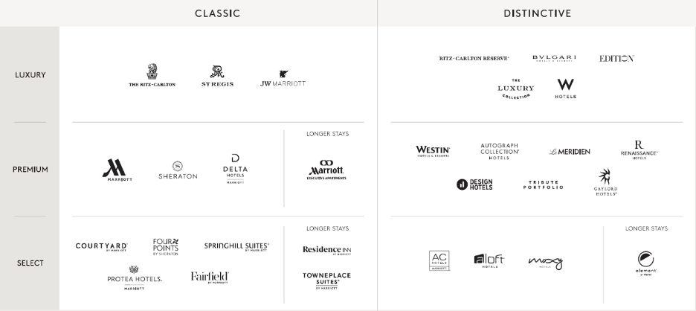
Figure 1: The MDS System
(Source: Woo, 2022)
Other technical tools such as artificial intelligence (AI) and machine-learning (ML) have also been used as automation techniques to improve the capacity of hospitality organisations to provide exceptional services to the guests. As observed by Alotaibi (2020), AI and ML have been useful for hospitality organisations in different capacities such as demand forecasting, prediction of bookings and cancellation, competitive pricing strategies and improving efficiency and productivity of the workforce. Therefore, the competition in the hotel industry has allowed for strategies of automation for achieving competitive advantage. Additionally, as observed by Li et al. (2019), the use of AI tools such as task oriented chatbots has been an important recent development in the world of e-commerce. This technology has also been utilised by the hospitality industry, with informations such as travel expectations, itineraries, hotel and lodging preferences in the aspect of online bookings and transactions among guests and hospitality institutions. Therefore, raising the capabilities of these institutions to provide the highest quality services to their guests.
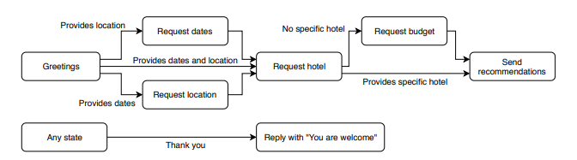
Figure 2: Task Oriented Chatbot Application Conceptual Framework
(Source: Li et al., 2019)
The Hilton Hotels have been among the most significant hospitality institutions that have utilised AI and ML applications to provide opportunities for improved guest service. The Hilton App can be used by customers to use facial recognition and AI-controlled chatbots for checking in and creating tour plans (Rama, 2023).
Finally, however, the most significant and core strategy that is utilised by hotels and other hospitality institutions to improve their capacity to serve the guests better is taking a customer-centric business approach. A customer-centric approach to business can create the thought process among business organisations that involves considering what can be important to the consumer’s perception. In the case of the hospitality industry, this signifies a personalised approach to management of the needs and expectations of the guests. According to Rini and Ferdinand (2021), the paradigm of customer-centric service strategy in hospitality is focused on creating value for customers. Thus, making it the most crucial approach in providing the most effective services to guests. Moreover, as stated by Inversini et al. (2020), among all industrial sectors, hospitality is where the customer’s interests, needs and wants should be provided the most importance. The most critical advantage that a customer-centric approach fosters for hospitality institutions is the creation of value for the guests. A clear understanding of customer-centric business practices can therefore help hospitality institutions manage guest service approaches effectively. Additionally, customer engagement is also a factor that is improved by customer centricity in approaches of hotels. The Four Seasons Hotel Group is a luxury hotel brand that is known for its approach, which is centred around effectively servicing customers (Siegel, 2021). Collecting relevant customer data, creating an engaging connection between employees and customers are some of the most significant goals of the organisation.

Conclusion
As per the study conducted above, the provision of highest quality services is among the most crucial aspects of the hospitality industry, as it creates guest satisfaction, engagement through the human approach of providing a positive experience based on kindness, empathy, friendliness and so on. However, this aspect is also necessary to enhance the reputation of a hospitality organisation. Although, technological applications have all played significant roles in effective management of guest services in the case of many hotel chains. Marriott Group’s AR application, Hilton Hotels Group’s efficient usage of AI and ML, and most importantly, the customer-centric approach of Four Seasons are some of the most preferred approaches to providing highest quality of service to guests.

Recommendations
A few important recommendations to hospitality organisations to provide effective guest service are to be mentioned in this part of the study.
As observed by Talón-Ballestero et al. (2022), utiliing Big Data Analytics to apply dynamic pricing techniques can be a qualitative approach to the customer-centric pricing values. This allows for the most effective personalisation of pricing approaches in the hospitality industry.
Moreover, as per Lam and Law (2019), digital business tools can also be most significant in the hospitality industry to gain better insight of guest needs and expectations. Thus, a hospitality organisation following a digital business model can be effective in serving the guests.

Reference List
Alotaibi, E., 2020. Application of machine learning in the hotel industry: a critical review. Journal of Association of Arab Universities for Tourism and Hospitality, 18(3), pp.78-96.
Grotte, J., 2018. Future Challenges of the Hospitality Industry. 7th International Conference on Tourism & Hospitality Management, pp.11-25.
Heppell, M., 2015. Five Star Service: How to deliver exceptional customer service. Pearson UK.
Inversini, A., De Carlo, M. and Masiero, L., 2020. The effects of customer-centricity in hospitality. International Journal of Hospitality Management, 86, p.102436.
Lam, C. and Law, R., 2019. Readiness of upscale and luxury-branded hotels for digital transformation. International Journal of Hospitality Management, 79, pp.60-69.
Li, B., Jiang, N., Sham, J., Shi, H. and Fazal, H., 2019, September. Real-world conversational ai for hotel bookings. In 2019 Second International Conference on Artificial Intelligence for Industries (AI4I), pp.58-62. IEEE.
Lyu, J., Khan, A., Bibi, S., Chan, J.H. and Qi, X., 2022. Big data in action: An overview of big data studies in tourism and hospitality literature. Journal of Hospitality and Tourism Management, 51, pp.346-360.
Mariani, M. and Baggio, R., 2022. Big data and analytics in hospitality and tourism: a systematic literature review. International Journal of Contemporary Hospitality Management, 34(1), pp.231-278.
Mmutle, T. and Shonhe, L., 2017. Customers' perception of service quality and its impact on reputation in the hospitality industry. NWUM, pp.1-25.
Morgan, B., 2022. 10 examples of Customer Experience Innovation in hospitality. [online] Forbes. Available at: <https://www.forbes.com/sites/blakemorgan/2020/02/20/10-examples-of-customer-experience-innovation-in-hospitality/?sh=38941a3c2033> [Accessed 16 Oct. 2023].
Rama, S., 2023. How hotel brands utilize AI to their advantage. [online] NewGen Advisory. Available at: <https://newgenadv.com/2023/03/how-top-hotel-brands-utilizes-ai-to-their-advantage/#:~:text=Hilton%20Hotels%20%26%20Resorts,-This%20famous%20and&text=Instead%20of%20waiting%20in%20line,recommend%20local%20attractions%20and%20restaurants.> [Accessed 16 Oct. 2023].
Rini, G.P. and Ferdinand, A.T., 2021. Customer Centric in Hospitality Industry: A Systematic Literature Review and Future Research Direction. JDM (Jurnal Dinamika Manajemen), 12(1), pp.88-101.
Siegel, K., 2021. Four Seasons and the invention of a customer-centric hotel. [online] Medium. Available at: <https://kyra-siegel.medium.com/four-seasons-and-the-invention-of-a-customer-centric-hotel-693517afe3de> [Accessed 16 Oct. 2023].
Solnet, D., Subramony, M., Ford, R.C., Golubovskaya, M., Kang, H.J. and Hancer, M., 2019. Leveraging human touch in service interactions: lessons from hospitality. Journal of Service Management, 30(3), pp.392-409.
Talón-Ballestero, P., Nieto-García, M. and González-Serrano, L., 2022. The wheel of dynamic pricing: Towards open pricing and one to one pricing in hotel revenue management. International journal of hospitality management, 102, p.103184.
Walker, J.R., 2021. Introduction to hospitality. Pearson.
Woo, J., 2022. Marriott: Data-Driven Customer Experience for decades at scale. [online] Digital Innovation and Transformation. Available at: <https://d3.harvard.edu/platform-digit/submission/marriott-data-driven-customer-experience-for-decades-at-scale%EF%BF%BC/#:~:text=Marriott%20uses%20Big%20Data%20technologies,individual%20room%20throughout%20the%20year.&text=Marriott%20International%2C%20Inc.%20is%20a,more%20than%20a%20hotel%20franchise.> [Accessed 16 Oct. 2023].
Wood, R.C. ed., 2015. Hospitality management: a brief introduction. Sage.

