Database Design (The Book Store)
Information Engineering
Correy Heard (1901709)
2020
Table of Contents
Entity Relationship Diagram 3
Tables 4
Books Table 4
Customer Table 4
Customer Orders Table 5
Department Table 5
Staff Table 6
Suppliers Table 6
Relationships 7
Normalisation 7
Reports 8
Newsletters report 8
Customer Orders Report (Calculations) 8
First Edition Report 9
Customers that have purchased a specific book Report (Macro Query) 9
Forms 10
Main Menu 10
Reports Menu 10
Forms Menu 11
Customers that have purchased a specific book (Macro Query) 11
Books Form 12
Customer Form 12
Customer_Orders Form 12
Department Form 12
Staff Form 13
Staff within Department (Embedded with Staff Subform) 13
Suppliers Form 14
SQL Evidence 15
Creating Records in SQL 15
Books Table SQL 15
Customers Table SQL 15
Customer_Orders Table SQL 16
Department Table SQL 16
Staff Table SQL 16
Suppliers Table SQL 16
Macro 17
Autoexec 17
RunQuery 17

Entity Relationship Diagram
Figure 1:
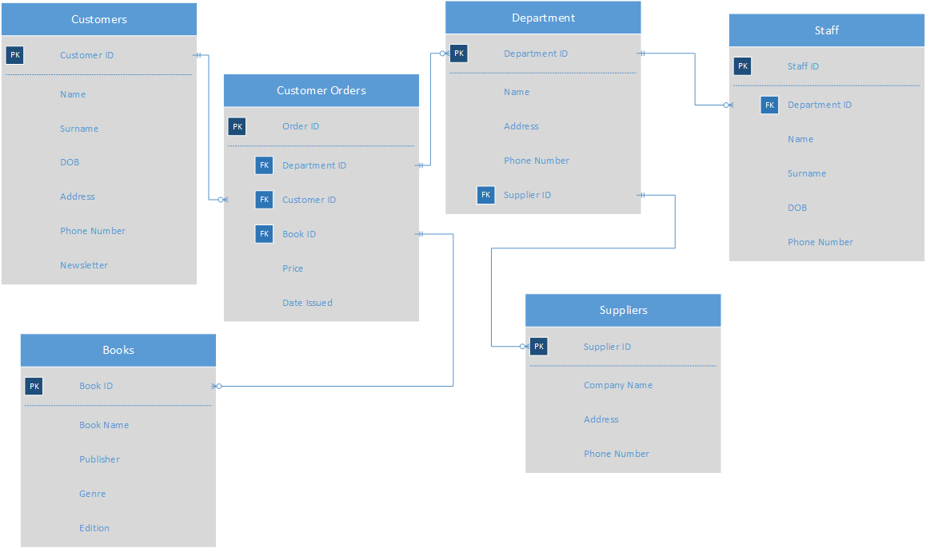
This entity-relationship diagram is a diagram that I created to help me create the structure for the database, it allowed me to design the databases relations before implementing them into the database this helped to focus on making sure that the tables will work correctly and allow me to reduce redundancy within my database. Once finishing this design the results from this worked out great when implementing it to access/database I had no problems with the design of the ERD and it allowed me to be able to create the database with ease.

Tables
I created 6 tables Books, Customers, Customer Orders, Department, Staff and Suppliers which are used to create the database, the databases is a relational database which means that all the tables are linked via a relationship each table has a primary key and some of them have Foreign keys which allows for the data to be connected and to remove any redundant data.

Books Table
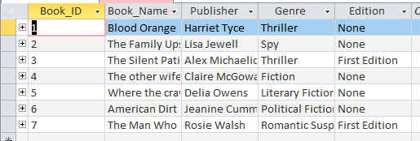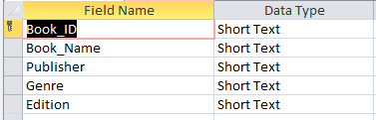

Customer Table
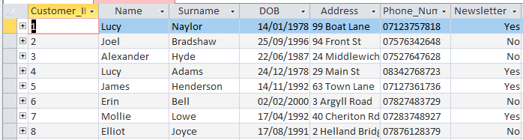
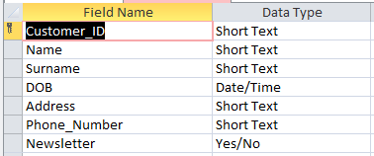

Customer Orders Table
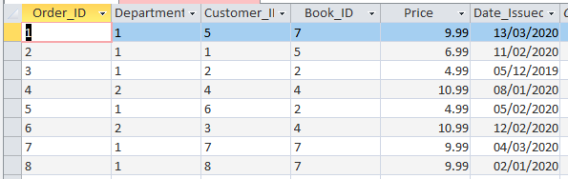
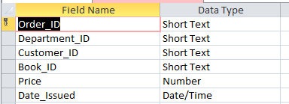

Department Table
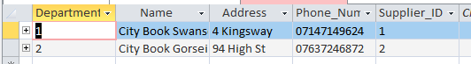
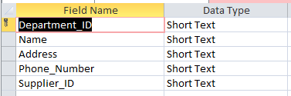

Staff Table
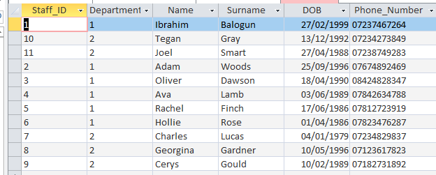
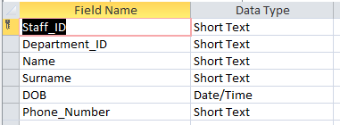

Suppliers Table
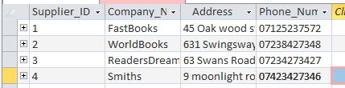
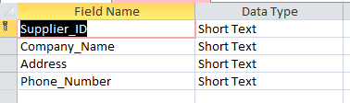

Relationships
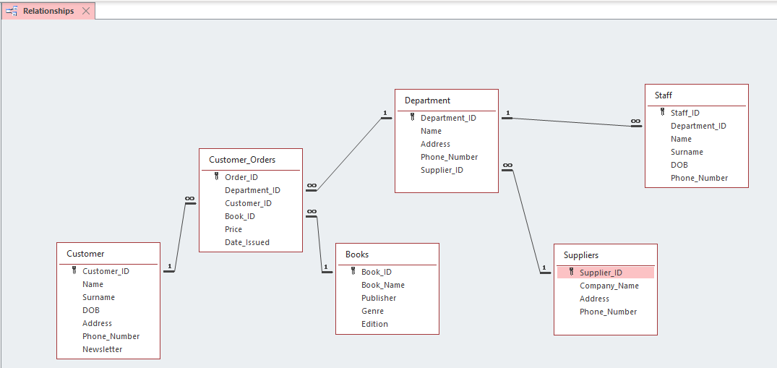
After creating my entity-relationship diagram in Visio, I started to create the SQL code so I can implement the tables and fields into access as a database once I was doing the SQL I used constraints to make sure that the data that will be inserted into the database wasn’t null for the foreign keys, I used REFERENCES to allow me to create the relationships between the primary and foreign keys, in Customers Orders I got 3 Foreign keys which come from departments, books and customer’s tables this allows for the data to be normalised into 3NF.

Normalisation
In my database I implemented 3NF within it so that my database didn’t have any redundancy data, redundancy data is data which is the same but inputted 2 times, for example, if you had a table with book name in and another table with the same field that is redundancy data within 3NF the goal is to remove any redundancy data which would be done by creating a table and having the data in 1 table which then will link to the other tables which need that specific data.

Reports
I have created 4 reports these 3 of the 4 reports are generated automatically the 4th report is generated when the user gives the result from the macro query, I made a newsletter report which shows the company which of their customers receives newsletters this can also be used to generate newsletters, the customer's orders report allows for the user to be able to see orders that have been done this can be used so if a customer had a problem they could confirm that it’s an actual order from the company, The customer orders report also contains calculations within the report it shows the total profits from sales which calculates all the orders price, it also calculates the total number of orders this can be used for financial information, First Edition report is used to see what customers have ordered a first edition book from the store this will show the customer and what book they ordered, Finally the last report is to find all the customers that have purchased a specific book the user will need to input the data for this report on a form which then will generate the report from the macro query.

Newsletters report
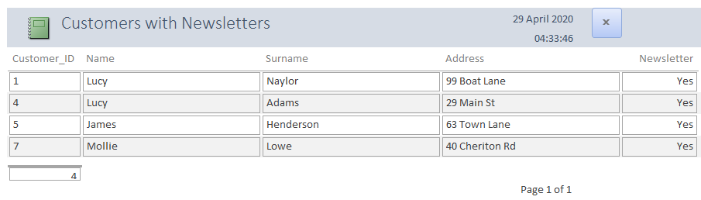

Customer Orders Report (Calculations)
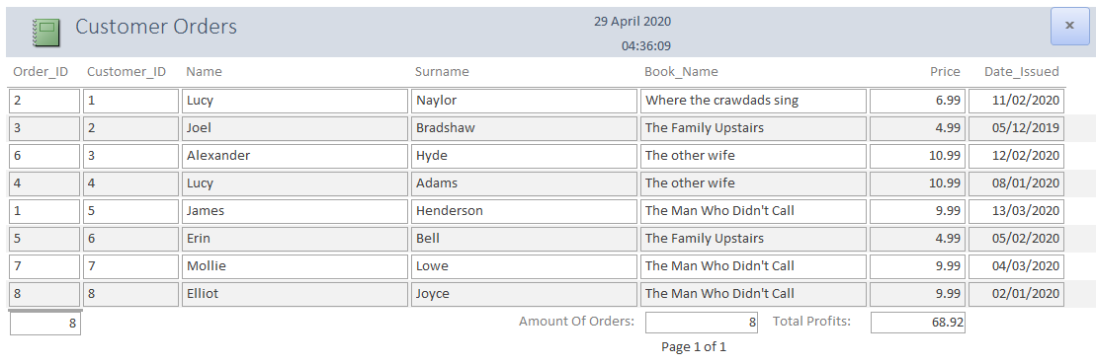
When creating this report I was prompted to add some calculations within a report so I implemented calculations within this report the calculations I used within this report was =Count(*) I used this to get the total amount of orders that calculation works out the number of records which is the number of orders, as well as doing number of orders I also calculated the total amount of profit from orders I done this by using =Sum([Price]) this worked out all the numbers within Price column and calculated them all together to give me a total.

First Edition Report
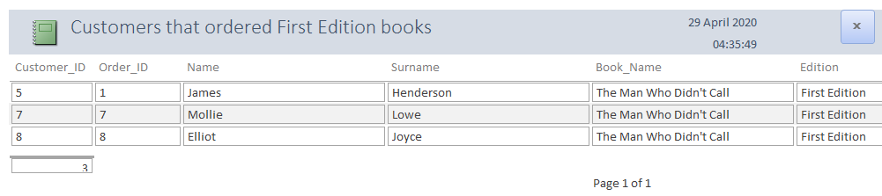
Customers that have purchased a specific book Report (Macro Query)
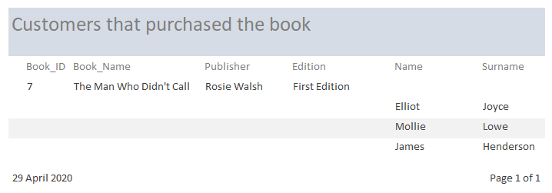
This query is created by the data that is inputted by the user, a user will enter data into a textbox on a form once the data has been entered they would run a macro which will take the data inputted and put within the criteria for the query once this is done it will then run the query once the query is done the user will receive results of the data within a table, to make this better within the macro it will contain a script which will then transfer the data from the query into a report for the user to be able to print or display.

Forms
I have made my database a menu-driven database I have done this so it easy to use and it's straight forward for the users to be able to generate reports and add or delete records from the database within a menu when the user opens the database they will be given the main menu page that is started by the Autoexec macro, the main menu will have 2 buttons which will allow the user to generate the reports or open a form, in the reports menu the user will be allowed to open and view the report or they can print the report from the reports menu instead of going into the report itself. In the form menu, it gives the user many forms for the user to create a report for a specific table in the database for example if a new staff member was employed they could go into the database and enter the new employer's details to the staff table if a staff member was to resign then they can also remove/delete the record from the database.

Main Menu
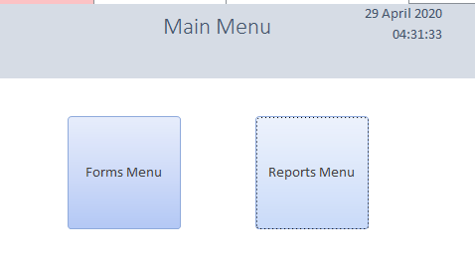

Reports Menu
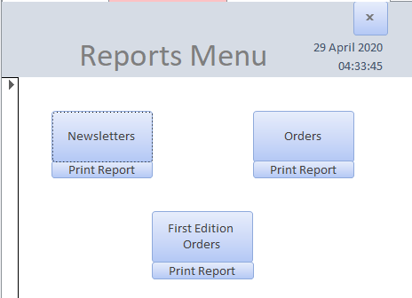

Forms Menu
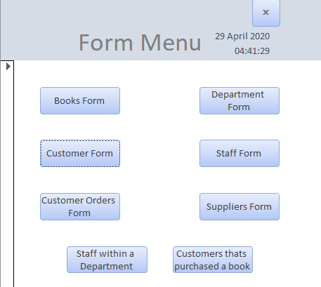
Customers that have purchased a specific book (Macro Query) 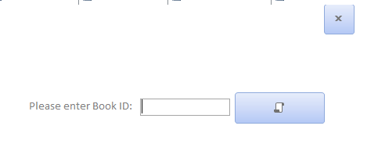
This form is made for the user to generate a report from the results they enter, When the user enters the Book ID it will then get used in a query once it generates the results from that query then a report will get produced and opened with all the data that was produced, the report that it will open is Customers that have purchased a specific book Report, this is done by using a macro when you press the button it runs the macro which will first run the data into the query, after that, it will then re-query the data so the user gets new results rather than the previous run results once the results are processed then it will open a report with the results which was generated from the query.

Books Form
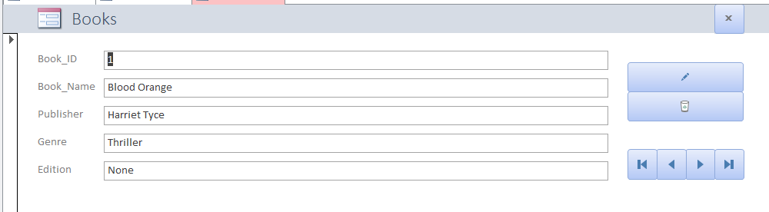

Customer Form
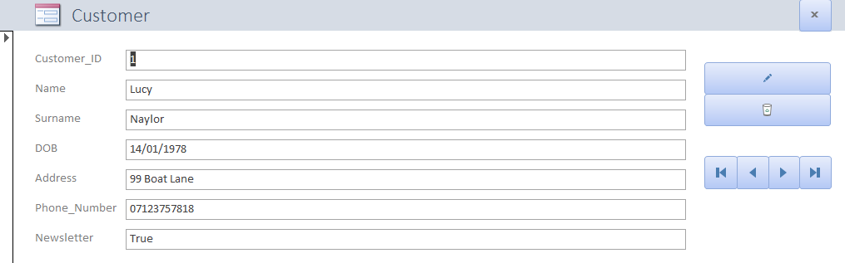

Customer_Orders Form
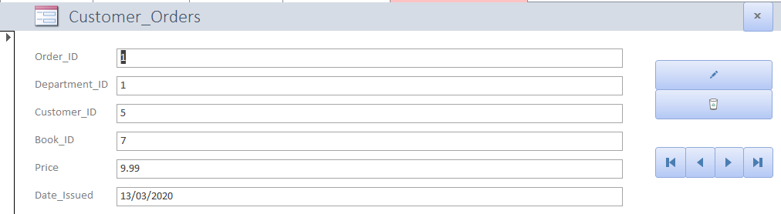

Department Form
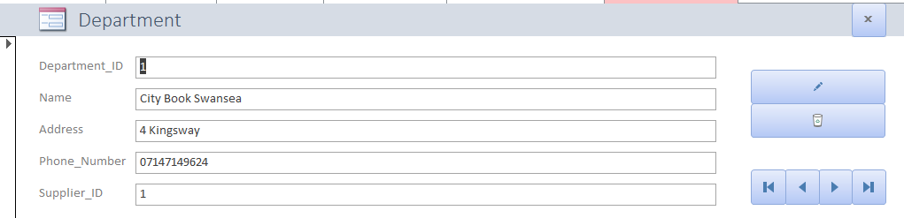

Staff Form
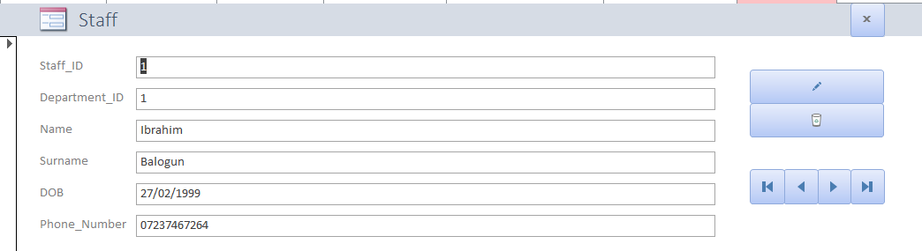

Staff within Department (Embedded with Staff Subform)
I have created an embedded form within this form this allows for me to be able to see other tables data that are related to the current table, here you can see the departments you can create, delete or change records from this current form, Also this can be a faster way to look for a specific staff if you knew the department, for example, if you wanted to remove staff from a specific department instead of checking the staff form and searching for it the user can go to this form and go through the staff within the department, this form can also be used as a lookup table to lookup staff or departments.
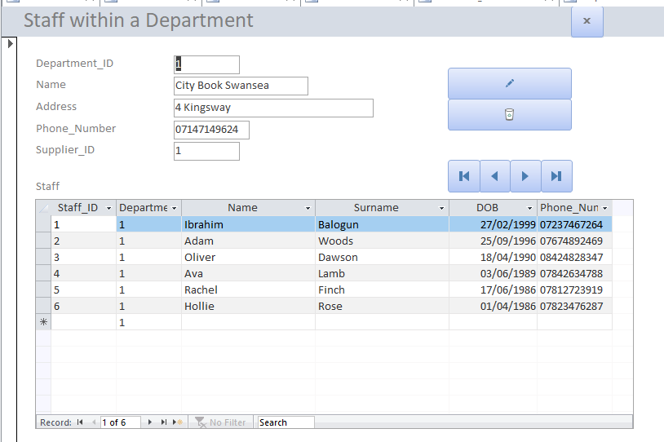

Suppliers Form
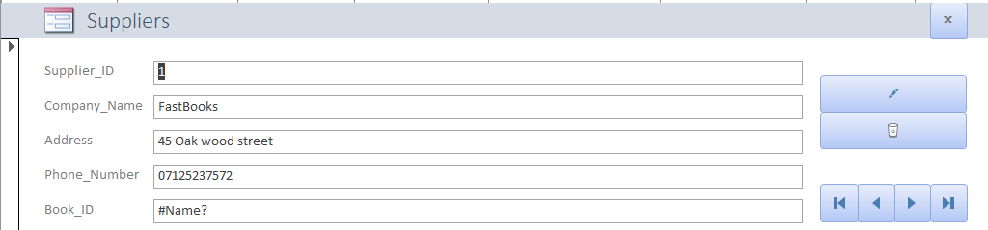

SQL Evidence
When making the database I made all tables and relationships with SQL, SQL is a language that is made to allow developers, database designers, etc to be able to create a relational database within a language rather than GUI, To make this database I had to use SQL to create tables, records and relationships to create tables I needed to use many of commands such as CREATE this allows me to be able to create the table once I’ve done that I would have to input the field name and what data type the field would take so for the Customer table I used Name and a datatype of Text which would make a field called name and would allow text to be inputted into that field, during the process of making tables I needed to declare fields as a required to do this I used CONSTRAINT this declares that data needs to be inputted within the field otherwise it would throw an error, this would be used for fields such as Primary or Foreign keys.

Creating Records in SQL
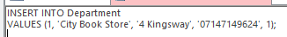
Once I created all the tables in SQL I needed to create records so to do this I had to use the INSERT INTO command this allowed me to be able to declare which table I wanted to work with, in my case I worked with the department table after setting the table I wanted to use I had to use another command VALUES this allows me to enter the values I wanted into the database, creating records in SQL is not efficient enough features like tables, forms and other methods are better creating records in SQL could be used within a program for example if you had an application that you had to enter information about yourself In then it can turn that data into the correct format to be able to be entered as SQL to be inserted into the tables.

Books Table SQL
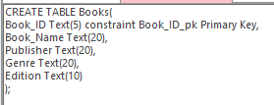

Customers Table SQL
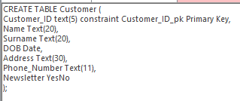

Customer_Orders Table SQL
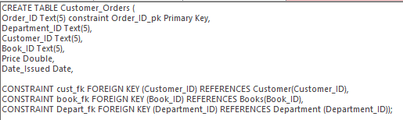

Department Table SQL
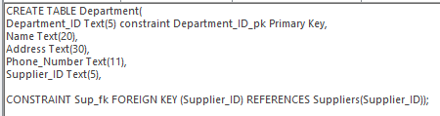

Staff Table SQL
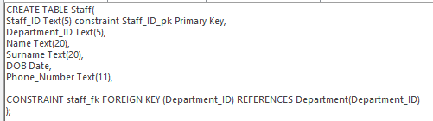

Suppliers Table SQL
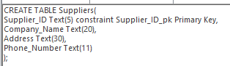

Macro

Autoexec
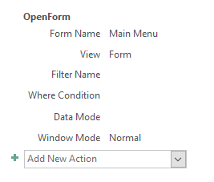
This macro allows for my main menu form to open up because it’s called Autoexec it will automatically run this macro every time the database is opened, this means every time a user opens the database it will take them to the main menu form because the macro will run and it will open the main menu form, Autoexec macros are uses to complete tasks while on the launch of the database these could be opening reports, opening forms or even open queries.

RunQuery
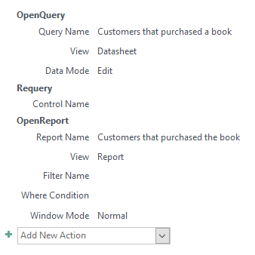
This macro is created so a user can generate a query within a form, for example, you’d have a form with a textbox once the user has entered the data into the textbox you will put this macro onto the button so when the user presses the button it will put the information from the textbox into the query once the data has been entered to the query it will then re-query to make sure that the data you entered gets inputted and it will open a report with the information generated from the query you created, For my database, I made a macro query for a specific book purchased by a customer so the staff members could check how many and who bought that specific book.

