Programme: Master of Business Administration
Module code: LCMB7035
Title: The Rise of E-sports in India and Its Contribution to Economic Growth and Employment Opportunities
Student Name: Gondaliya Meet Jaysukhbhai
Student ID: 2427127
Lecturer: Dr. Andry Rakotovololona
Table of Contents
1. Introduction 3
1.1 Overview of Research 3
1.2 Aim and Objectives 4
1.3 Research Question 4
2. Literature review 5
2.1 E-sports industry growth in India 5
2.2 Generating economic value for India 5
2.3 Employment in various positions 7
2.4 Multi sport discipline, drives popularity in India. 7
3. Methodology 8
3.1 Data collection 8
3.2 Data Analysis 8
3.3 Ethical Consideration 8
4. Expected findings 9
5. Limitations 11
5. Timeframe 11
6. Conclusion 12
7. References 13

1. Introduction

1.1 Overview of Research
Indian e-sports industry has emerged as a fast changing entity in the entertainment industry due to the changing consumer trend which shifted to interactive internet-based games. This expansion is indicative of the wider trends in digital adoption, which have seen gaming go beyond being a form of recreation and, instead, to being a cultural phenomenon that has cut across demographic lines into urban and rural borders. Video game championships and live stream arrangements have amused viewers with a competitive tournament decision making and live spectacle creating communities that are built on the principle of skill, tact, and pageantry (Yadegari, Mohammadi and Masoumi, 2024). This boom is in line with young population in India and rising prevalence of smartphones that has helped level the playing field in terms of high quality content in the gaming arena. Mobile platforms, specifically, act as the entry point to novices with their ability to allow the seamlessness of the gameplay along with the social connectivity features that promote the engagement. Global brand sponsorships also increase brand exposure and makes e-sports a part of the mainstream marketing business and position it equally with other sports. The healthy infrastructure expansion such as specific arenas and broadcasting collaboration favours the ecosystem and boosts the value of production and engagement of viewers.
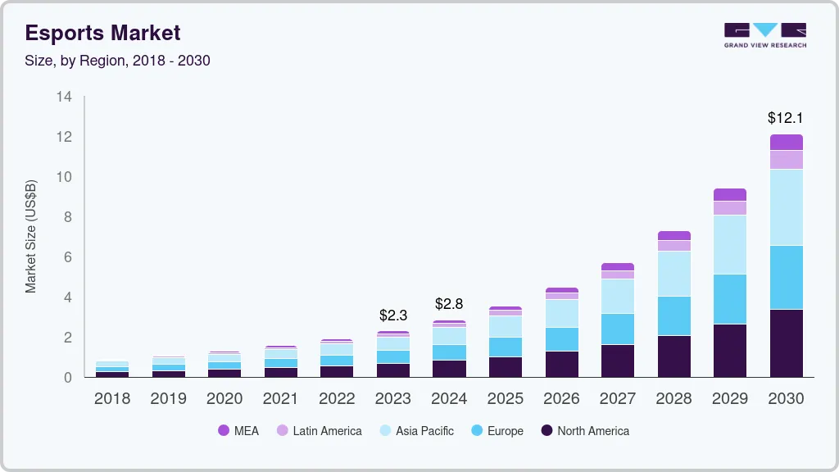

Figure 1: E-sports Market Size
(Source: Grand View Research, 2025)
The research demonstrates that e-sports in India show strong economic growth potential which has emerged as a major entertainment industry. The Indian gaming market consists of 568 million players who include 141 million paying customers according to current data (IBEF, 2025). The gaming industry has expanded from 25 development firms in 2015 to over 900 by 2023, and now includes 1,400 gaming companies and around 15,000 developers (International Journal of Legal Studies and Social Science, 2024). The industry generated $2.3 billion in revenue during 2023, and experts predict that it will grow to $7.5 billion by fiscal year 2027 to 28, which will result in a 20% CAGR growth rate (Grand View Research, 2025). The e-sports industry experienced viewership growth from 25 million in 2022 to 57 million in 2024, while the sector is expected to create 250,000 jobs, indicating significant economic, employment, and digital development opportunities in India.

1.2 Aim and Objectives
The aim of this research is to investigate e-sports popularity in India by studying the impact of economic development such as the growth of the industry, its revenue generation in the Indian digital gaming sector.
- To investigate the e-sports industry growth in India such as increasing number of gamers, sports tournaments and rising viewership.
- To assess the e-sports, generate economic value for India through their revenue streams and investment activities across the market.
- To examine mobile gaming adoption, internet penetration, sponsorships, government recognition of e-sports as a multi-sport discipline function which drive popularity in India.

1.3 Research Question
- How has the e-sports industry risen in India?
- How do the e-sports industries generate economic value for India?
- How does the e-sports industry generate employment in various positions?
- Which mobile gaming's drive popularity in India as a multi-sport discipline function in India?

2. Literature review

2.1 E-sports industry growth in India
The e-sports sector in India has experienced substantial growth because popular games Battlegrounds Mobile India and PUBG Mobile and Free Fire have drawn in excess of 100 million players (The Hindu, 2022). Viewing figures of battlegrounds Mobile India Series attracts massive audience numbers (Suri, 2025). However, the Network Effects Theory with stakeholder networks on a digital platform demonstrates users increase digital platforms' value leads to faster industry growth and greater audience interest (Chen et al., 2022). The relationship between game publishers, telecom providers, and media houses have helped to improve infrastructure, which has been critical in ensuring that the streaming is smooth and the game also plays with low latency even in distant locations. This is a network effect that gives the local leagues a national feel that stirs feelings on the social networking sites. The biggest contributors are influencers and celebrity endorsements, as they combine gaming with the pop culture to attract non-traditional fans and make the e-sports a legitimate career.
The inclusion of virtual reality and augmented features in the specific tournaments increase the interests of the spectators and provide them with indulgent observation opportunities, making it as good as live concerts. Community-based programs, like fan-selected MVPs and online leaderboards, are also arguably more inclusive and attract more people to participate in them, irrespective of their location or value. With the changing nature of platforms, analytics tools are offering more insights into the performance of players which are refining strategies and providing a higher standard of competitive performance. This is in line with the Network Effects Theory by generating self-reinforcing cycles: the more people use it, the better they will help attract crowds, which will enhance the ecosystem bringing even more people. Finally, the e-sports development in India is an indication of an emerging industry with a promising and long-term characteristic of innovation and international impact.

2.2 Generating economic value for India
E-sports generate substantial economic benefits because it receives funding from sponsorships and streaming revenue and advertising and investments. The online gaming industry such as Krafton and Nazara Technologies dedicates gaming lounges, leagues and tournaments to support India's gaming industry, while tournaments create prize distributions and business affiliations (Dasgupta, and Sen, 2024). International investment movements highlight the Digital Economy Theory as it highlight digital platforms and online industries utilize technological advancements (Rong, 2022). It also can drive economic development through their market operations and innovative activities. E-sports also drives increment in the economy by its ripple effect in other supporting industries such as merchandising, apparel, and game accessories where brands use the raw fan-following to promote co-branded products. Organizers of major tournaments utilize venues, logistics, and hospitality services that infuse a fresh twist in the local economies through the tens of thousands of enthusiasts attending and millions of spectators visiting online.
The same multiplier effect is also applied to technology companies that are designed to create specialized hardware, software and cloud solutions that can be used to facilitate the smooth delivery of e-sports. Content monetization techniques, such as in-game purchases, premium subscriptions and pay-per-view models generate diversified revenue sources that support long term growth. Investments by VCs focus on startups advancing in their original technology in sectors such as anti-cheat systems, player data and virtual coaching tools, which have created a start-up ecosystem that reflects the wider technology booms in India. This dynamic is improved by public-private partnerships where workforces in game design, broadcasting and digital marketing are developed through skill development programs. The Digital Economy Theory highlights how these platforms are efficiently vague in terms of size, much effort is put on the reduction of physical barriers and capitalization of worldwide spread of borderless transactions and personalization based on data analysis.
The trade associations lobby the positive policies, like taxes on the development of e-sports infrastructure, making India a local center. And academic collaborations with higher education institutions bring in management programs in esports, which creates intellectual capacity that leads to industry maturity. In addition to direct money, e-sports promotes the soft power of India through exporting talents and stories to other international events and encouraging foreign cooperation and tourism. This value creation turns gaming into more than a form of leisure to a strategic economic asset, and in line with national interests of digital inclusion and prosperity within innovation.

2.3 Employment in various positions
The e-sports ecosystem creates multiple job possibilities for its employees such as S8UL E-sports and Global E-sports teams make money through tournament, streaming work and sponsorship deals (S8UL, 2025). According to Human Capital Theory content creators on platforms like YouTube and Twitch also provides a platform for professional benefit from the opportunities of this leading industry (Mousavi Haghshenas, and Shahghasemi, 2023). The e-sports ecosystem also expands the payment to work with specialized positions in event management where coordinators organise tournaments, including all logistical processes of the event, up to international casts. Such technical jobs as broadcast engineers and cybersecurity professionals provide the glitch-free experience during high-stakes shows. Campaigns designed by marketing professionals are a combination of digital advertising and collaboration with an influencer, whereas the trends of the viewers are analysed by data analysts and are used to maximize interactions. Talent scouts and coaches develop raw talent into professional competence and end up offering a ladder of career structure. Schools have introduced e-sports operations certifications as academic programs to direct the youth to viable lives. The Human Capital Theory clarifies the fact that these investments in human skills make people more productive and make e-sport one of the key drivers of workforce development and social mobility in the digital age of India.

2.4 Multi sport discipline, drives popularity in India.
The e-sports scene in India has grown because of budget-friendly smartphones and widespread internet coverage and strong sponsorships from companies such as Red Bull and Intel. In multi-sport events, the government initiatives such as “Khelo India” have also recognised e-sports (Havas Media Network, 2025). Making technology available as per the Technology Adoption Theory describes how people accept new technologies through creating new solutions, providing institutional assistance for digital entertainment industries (Yadegari et al., 2024). Social media increases this popularity with viral highlights, vlogs by the players, and live communication which creates an emotional bond with fans. The tier-2 city has grassroots leagues that help increase access, transform local talent into national-level icons through online qualifiers. The e-sports is normalized in the mainstream entertainment by celebrity investors and film crossovers. Formal training can be achieved through inclusion in the school curricula and university clubs, and inclusivity can be increased by women-targeted tournaments. Technology Adoption Theory describes the process of this smooth transition because comfortable interfaces and high-quality connectivity reduce barriers to entry, triggering a frenzy of excitement. All these make e-sports an exciting multi-sport field that is transforming the culture and the spirit of competition among the youth in India.

3. Methodology

3.1 Data collection
The research will use secondary qualitative data collection methods to gather necessary information for the study. The data collection process will obtain information from reputable online platforms which include Google websites Google News articles academic journals industry reports and research papers about e-sports in India. The study will select 35 recent articles and reports and websites which have been published since recent years to provide current information. The selected sources will demonstrate Indian e-sports development through their analysis of e-sports growth and economic benefits and job creation and industrial progress.

3.2 Data Analysis
This research will use Thematic analysis to examine the data because it enables researchers to discover patterns. The team will conduct a thorough analysis of both articles and reports to extract relevant details which will be assigned specific codes. The research team will categorize research outcomes into four main themes which study e-sports development and economic impact and job creation and technological advancements. The research method enables researchers to organize their secondary data for analysis while obtaining valuable information which contributes to their research goals.

3.3 Ethical Consideration
The research process requires ethical considerations which safeguard the research study's credibility and integrity. The study will adhere to university research guidelines while following applicable laws which include the General Data Protection Regulation and the Data Protection Act 2018. The research team will provide complete citations for all used information through in-text citations and reference lists which will prevent plagiarism. The research will use only publicly accessible secondary data which will ensure research transparency and academic integrity and responsible information handling throughout the study.

4. Expected findings

Figure 2: India E-sports Market Size
(Source: Grand View Research, 2025)
The market research indicates that the India e-sports market generated USD 67.8 million in revenue during 2024 and it will achieve USD 307.2 million by 2030 with a compound annual growth rate of 28.4% (Grand View Research, 2025). The largest revenue source for the company comes from sponsorships which will experience the most rapid growth compared to other segments. The 2024 e-sports market data shows that India controls 3.2% of the worldwide market share which demonstrates its increasing position within the international gaming market.
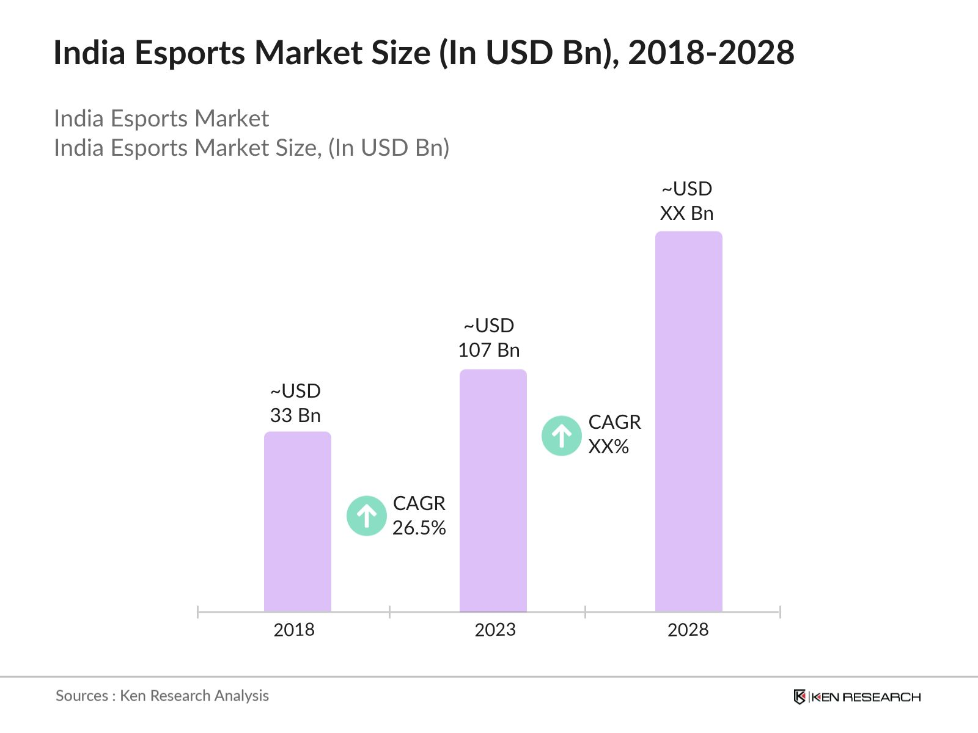

Figure 3: Indian E-sport Market
(Source: Ken Research, 2025)
The visual data supports this trend through its evidence. The market size chart shows a growth from about USD 33 billion across 2018 to around USD 107 billion across 2023, expansion expected by 2028, showing consistent industry growth (Ken Research, 2025). Indian e-sports market followed by PC and console gaming platforms demonstrates that mobile gaming dominates the country’s high smartphone adoption and affordable internet access.
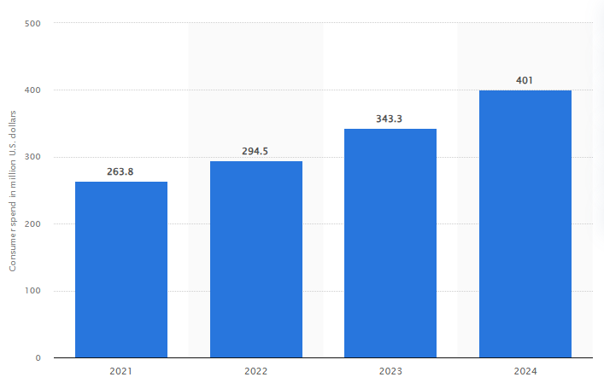

Figure 4: Spent on mobile gaming
(Source: Statista, 2025)
Industry experts believe that India has 400 to 500 million mobile gamers because popular games such as Battlegrounds Mobile India PUBG Mobile, Free Fire have created a large video gaming market (Statista, 2025). The Indian e-sports industry has a market value that exceeds ₹1,100 crore which expands at an annual rate of 45% through investments and brand sponsorships and YouTube streaming.
The expected findings indicate that e-sports will experience rapid growth in India which will create new jobs and drive economic development and establish a vibrant digital entertainment industry. In order to provide job opportunities, industry will transform into a primary driver such as India’s digital economy as young population.

5. Limitations
This research will have limitation such as using secondary data sources such as published articles, reports, and online databases. The secondary data sources give helpful information about e-sports industries but did not go through latest experiences of e-sports industries in India. The collection of primary data would provide researchers with stronger and more precise information. Future research could conduct surveys of e-sports players, content creators, and gaming audiences to better understand their experiences, motivations, and economic contributions.

Timeframe
Phase | Tasks | Start Date | End Date | Duration
Week 1-2 | Finalize proposal, ethics approval, source collection | 23 Feb | 6 Mar | 2 weeks
Week 3-6 | Literature review (Sections 2.1–2.4), theory integration | 9 Mar | 27 Mar | 4 weeks
Week 7-8 | Methodology refinement, data collection (35 sources) | 30 Mar | 10 Apr | 2 weeks
Week 9-11 | Data analysis (thematic coding), expected findings | 13 Apr | 1 May | 3 weeks
Week 12-13 | Draft limitations, conclusion, references; insert figures | 4 May | 15 May | 2 weeks
Week 14-15 | Full proofreading, formatting, visuals (e.g., Figure 5) | 18 May | 29 May | 2 weeks
Week 16 | Final review, submission to lecturers | 1 Jun | 5 Jun | 1 week

6. Conclusion
The research study investigates how the e-sports industry developed in India through its economic growth and job creation efforts. The researchers used 35 recent articles and reports as secondary qualitative data to examine how the industry expanded its operations while generating revenue and creating jobs through its technological advancements. The results show that the industry experiences strong growth such as affordable smartphones, low-cost internet, and the popularity of games like PUBG, BGMI in India experiences rapid growth. It also generates economic development in digital progress so, creates new job opportunities. The industry experiences growth because eSports as a legitimate sport by the Indian government and the emergence of organizations like ESFI rising investments lead to government recognition.

7. References
Chen, X.H., Tee, K. and Chang, V., 2022. Accelerating innovation efficiency through agile leadership: The CEO network effects in China. Technological Forecasting and Social Change, 179, p.121602. https://researchonline.jcu.edu.au/75682/7/75682.pdf
Dasgupta, L. and Sen, S. eds., 2024. Online Gaming in India: Technology, Policy, and Challenges. CRC Press. https://books.google.com/books?hl=en&lr=&id=pzcjEQAAQBAJ&oi=fnd&pg=PA1986&dq=Krafton+and+Nazara+Technologies+dedicate+significant+resources+to+support+India%27s+gaming+industry&ots=CwyKuKE6-O&sig=NitkZYm2EBIvWouworN7JVDJIVU
Grand View Research (2025) India E-sports Market Size & Outlook, 2025-2030. Available from: https://www.grandviewresearch.com/horizon/outlook/e-sports-market/india. Accessed on 009.03.2026
Havas Media Network, (2025) HP Report Design Final_QR. Available from: https://havasmedianetwork.com/wp-content/uploads/2025/05/emerging-sports-%E2%80%93-indias-next-billion-dollar-sports-marketing-opportunity.pdf. Accessed on 20.03.2026
IBEF (2025) India's Thriving Gaming Market. Available from: https://www.ibef.org/blogs/india-s-thriving-gaming-market. Accessed on 009.03.2026
International Journal of Legal Studies and Social Science (2024) Exploring the Rise of E-sports in India: Domestic Dominance and Global Implications. Available from: https://ijlsss.com/exploring-the-rise-of-esports-in-india-domestic-dominance-and-global-implications/. Accessed on 009.03.2026
Ken Research (2025) India E-sports Market Outlook to 2030. Available from: https://www.kenresearch.com/industry-reports/india-esports-market. Accessed on 009.03.2026
Khatri, K., 2025. From policy to podium: Evaluating the evolution and implementation of India’s sports policies from 1984 to khelo India [online] https://www.researchgate.net/profile/Kumud-Khatri/publication/392587523_From_policy_to_podium_Evaluating_the_evolution_and_implementation_of_India's_sports_policies_from_1984_to_khelo_India/links/6849695fea009d33be8b954e/From-policy-to-podium-Evaluating-the-evolution-and-implementation-of-Indias-sports-policies-from-1984-to-khelo-India.pdf
Mousavi Haghshenas, M. and Shahghasemi, E., 2023. The economic, educational, and creative capacities of the twitch platform in the digital games industry. Educational, and Creative Capacities of the Twitch Platform in the Digital Games Industry. https://papers.ssrn.com/sol3/Delivery.cfm?abstractid=4381445
Rong, K., 2022. Research agenda for the digital economy. Journal of Digital Economy, 1(1), pp.20-31. https://www.sciencedirect.com/science/article/pii/S277306702200005X
S8UL (2025) Leading the Gaming Revolution. Available from: https://s8ul.gg/. Accessed on 009.03.2026
Statista (2025) Amount spent on mobile gaming by consumers in India from 2018 to 2024. Available from: https://www.statista.com/statistics/1327729/india-mobile-games-consumer-spend/?srsltid=AfmBOoqGnG5nRIcd2fe-fCn8NHBBtChkDm1DmRBx21PRFZUI1mMw5Q3k. Accessed on 009.03.2026
Suri, G., 2025. Digital Popular Culture and Resistance Narratives: A Case Study of Indian Web Series. Humanities, 12(S1), pp.24-30. https://www.academia.edu/download/124121539/Article_on_OTT.pdf
The Hindu (2022) BGMI touches 100 million registered user bases in India. Available from: https://www.thehindu.com/sci-tech/technology/indias-pubg-registers-100-million-users/article65589444.ece. Accessed on 20.03.2026
Yadegari, M., Mohammadi, S. and Masoumi, A.H., 2024. Technology adoption: an analysis of the major models and theories. Technology Analysis & Strategic Management, 36(6), pp.1096-1110. https://www.researchgate.net/profile/Mahdi-Yadegari-2/publication/360374335_Technology_adoption_an_analysis_of_the_major_models_and_theories/links/6562e258b1398a779db5e50b/Technology-adoption-an-analysis-of-the-major-models-and-theories.pdf
Yakusheva, O., Lee, K.A. and Weiss, M., 2024. The nursing human capital value model. International journal of nursing studies, 160, p.104890. https://www.sciencedirect.com/science/article/pii/S0020748924002037

