

Student name: Mohammed Amir Hussain Chaudhary Student registration Number: 1711710 Module code: LCMB7000 Group number: One Lecturer’s name: Uju Ugochukwu Module name: HUMAN RESOURCE MANAGEMENT

Contents
Contents 2
1. Introduction. 4
2. Literature Review 5
3. Overview of BLGOR. 5
4. Human Resource Management Model. 6
5. Key challenge 1. Training and Developing. 7
5.1. Kirkpatrick’s Model of evaluation. 7
6. Key challenge 2. Health, safety and employee welfare. 9
7. Key challenge 3. Selection and Recruitment. 10
8. Conclusion and Recommendations. 12
9. Reference. 14
Appendix 1. Motivation. 16
Appendix 2: Maslow’s Hierarchy of needs. 16
Appendix 3. SWOT analysis. 17

Table of Figures:
Figure 1: Image of BLCOR first branch website ……………………………………………...5
Figure 2: Human resource management model………………………………………………5
Figure 3: Kirkpatrick’s model of learning evaluation …………………………………………6
Figure 4: Difference between recruitment and selection …………………..........................9
Figure 5: Maslow’s Hierarchy of Needs ………………………………………………………15
Figure 6: SWOT analysis……………………………………………………………………….16

Introduction.

Human Resource Management (HRM) function is to capitalize on the employee performance, in line with the company guidelines, regulations and objectives (Hayes 2021). The primary motive of HRM in Bengal lounge group of restaurants (BLGOR) is to ensure that the company’s objectives are met through performance of its framework and at the same time safeguarding the employee’s welfare and satisfaction.

This report is a case study based on the performance of HRM at BLGOR. The core focus is to identify the challenges and issues faced by BLGOR in current years, as Brexit and Covid-19 has had a devastated effect on the nation and the major effect was on the hospitality sector. This report will evaluate BLGOR’S HRM personals previous and present procedures and scrutinise how the issues affect the internal and external business factors and its employees. Also this report will examine training and developing, health, safety, and welfare and recruitment and selection of employees. Finally, a strategic conclusion and recommendations in order for BLGOR to safeguard its business and enhance their employees, as this will also assist in solving the HRM’s challenges and boost business revenue.

Literature Review
According to Davahli et. al. (2020), Covid-19 was the biggest concern for UK government, there main concern was to safeguard the UK populations and its businesses, especially SME’s and the hospitality sector. Brexit stopped the free movements of EU workers, followed by the government increasing the capping on work permits for over-seas workers from £16,000.00 to £27, 000.00 Annual. This has made it next to impossible to obtain skilled workers from India (Monras and Vázquez 2018).
To revive the economic, UK government has offered grants for businesses, which can be invested in refurbishment, advertising or training new employees (Crossley 2020). Selection is the procedure of finding the correct employee for the correct job. It is a way of identifying organisational desires with the skills and qualifications of applicants, (Bratton and Gold 2007). It is anticipated that the main place where the virus is spreading the most is in the hospitality sector (Ahmad. et. al. 2020). Employee motivation is crucial to an organisation's success, this will assist the organization to achieve its success by improving employee’s performance and productivity (Shahzadi 2014).

Overview of BLGOR.
BLGOR was established in 1990. The first branch was launched in Stafford, trading as an Indian restaurant, their business structure is a basic flat structure business, everyone reporting to one individual (manager), at present they have seven branches, each branch employees about ten to twelve employees.

Responsibilities of HRM in BLGOR is performed by the manager of each branch, their tasks comprise of managing employee schedules and shifts, advertising job vacancies, providing appropriate job descriptions, selecting and recruiting, conducting initial interviews, compensation and benefits and handling new employee’s paperwork’s.

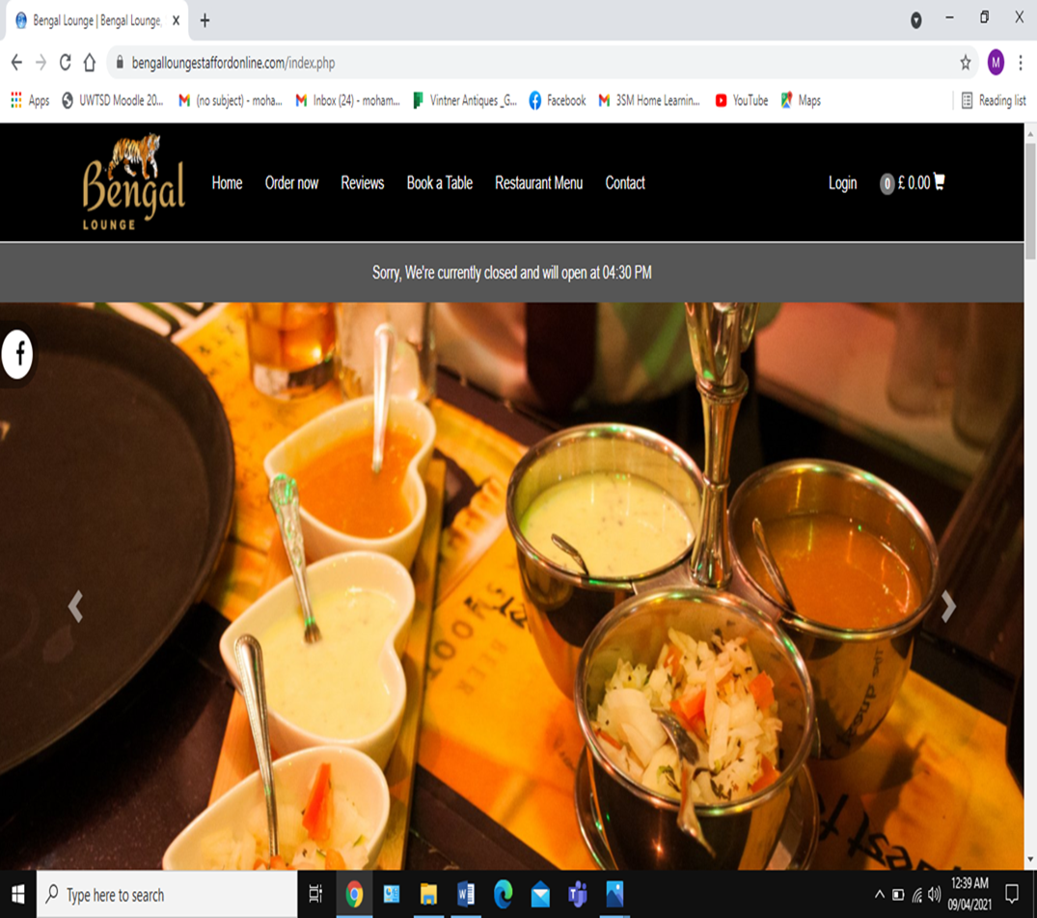
Figure 1: Image of BLGOR first branch website
(Source: crystal apps websites).

4. Human Resource Management Model.

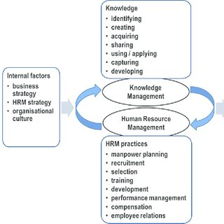

Figure 2: Human resource management model.
(Source: Research gate 2020).

The above structure explains the diverse work carried out by HRM departments to achieve the enterprises objectives. For instance, it could be implementing a new appraisal system or a reward system to motivate its workforce or even implementing a training programme for new services and products introduced by the restaurant.

Key challenge 1. Training and Developing.
Training programs (TD) are significant for employees in every business. According to Aquinas and Krieger (2009), most employees have a couple of weaknesses in their workplace competencies. TD supports in strengthening the individuals’ capability that each employee requires to develop.

6.1. Kirkpatrick’s Model of evaluation.
Kirkpatrick’s model of evaluation is a model which is applied to enhance the employee’s performance (Cahapay. 2021). The model objective is to aid companies to analyse the training programs (TP) from various perceptions to indorse enhancements for the future. The model comprises of 4 diverse stages. Kirkpatrick’s model is utilised below.

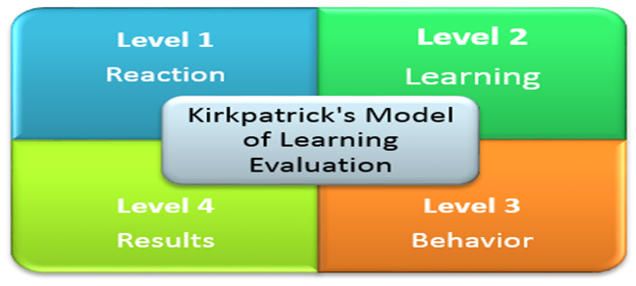

Figure 3: Kirkpatrick’s model of learning evaluation
(source: the training associates).

The pandemic has stopped the society from socialising in outdoor venues like restaurants, this has forced BLGOR to focus on utilising digital platforms like Uber Eats and Just Eats. Also this has altered the old method of taking orders on order pads, now orders have to be taken on Epos systems to cross check customers address and payments through digital card machine. For BLOGR to operate their business smoothly employees need to be trained in using the above digital platforms and gadgets.

It is vital that the HRM at BLGOR monitors the reaction on how the employees is reacting to the TP. Once the TP is accomplished, conducting an employee satisfaction survey is the best way to measure the training and this approach is applied by BLGOR. According to Dorri. et. al. (2016), analyzations of the reaction of employees is beneficial for the company and also employees. The company can clearly identify if they achieved their objective or not, if required offer specific trainings to employees from the feedbacks. According to Rafiq (2015), if reaction is not scrutinised appropriately then the consequences can be distressing, as the trainee might have not been the suitable TP or the trainee was unable to adjust to that TP whatever the reason is this will have a negative impact on the business and its objectives.

Learning is a significant part of training, one of the common method applied by BLGOR is to measure the worker’s performance in the specific field both before and after the training. As the employees (especially waiters) are interacting with customers at all times they need to be able to understand what they have learnt and apply that knowledge in the restaurant. According to Chang and Chen (2014), there are many benefit in evaluating learning in TP, as this can assist in identifying areas for development, improving employee’s preservation, training develops skills, attitudes and knowledge and boosts their self-confidence and commitments. Evaluating learning after training involves effort, time and money and a lot of companies doesn’t want to proceed through this effort as they deem it as a waste of time. BLGOR believes that training developed employees’ skills, knowledge and attitudes, boosting their commitment and confidence (Kirkpatrick and DeWitt 2015).

After training, the employees Behaviour is assessed especially the waiters, on how they behave when they are dealing with customer and how they are serving the customers food. How their behaviour is when customers misbehave are they applying the knowledge and skills that they achieved by training in their workplace and the influence of new knowledge and skills on their performance. Learners must be monitored frequently, which again costs money and is time consuming and it doesn’t stop there, there is the requirement for an in-depth analysis conducting into the reasons for the failure (Maguire. et. al. 2022). The benefits of evaluating the behaviours after training are to assess if employee’s communication skills, social skills, team working skills have improved, at the same time company’s revenue will increase. BLGOR understands the importance of analysing the behaviour after training, as this will assist achieving a dedicated and hardworking workforce (McGuigan et. al. 2021)

Results is the ultimate goals of training, depending on the outcome, the result can be negative or positive of the TP, this is conducted by monitoring the behaviour of the trainee after undergoing the TP, especially the chefs what have they learned from the training program has the training changed the chef, did the TP improve the chef’s performance. After accomplishing a TP, organizations comprehend if they have been successful in achieving their set goal, as TP enhance their confidence which can also improve their overall performance. (Mahmoudi. et. al. (2014). By analysing the literature available on BLGOR, it can be assessed that their viewpoint is every employee’s characters are different and TP ought to be tailor made different employees.

Key challenge 2. Health, safety and welfare.
Due to Covid-19, HRM of BLGOR is faced with the complications of safeguarding the health, safety and welfare of employees and maintaining the operation of its business. According to Davahli et. al. (2020), Covid-19 was the biggest concern for the UK government, there main concern was to safeguard the UK population and its businesses, especially SME’s and the hospitality sector. New measure where implemented by the HRM of BLGOR to safeguard all their stakeholders, be it the employees, customers or suppliers.

- Displaying leaflets about the importance of maintaining the distance and following all the safety processes, to prevent the virus from spreading.

- Providing free hand sanitisers and masks for employees, customers or visitors to stop them from getting infected with the virus.

- Providing advice, leaflets and support on how to self-isolate or Quarantine if an employee is infected by the virus.

- Providing appropriate training on how to maintaining health and safety standards and distancing to avoid getting infected by the virus.

- Providing free hand gloves to stop the virus from spreading and instructions on how often they should be changed.

The health, safety, welfare of employees, customers and visitors is the foundation of any business, as the workers execute the organisation's strategy, so it’s only appropriate that HRM offer safety equipment, access to health safety training materials, employee safety leaflets. It is anticipated that the main place where the virus is spreading the most is in the hospitality sector (Ahmad. et. al. 2020). It is crucial that the workers are safeguarded by BLGOR’s as workers playing a crucial role in delivering foods to the mass, especially the customers that are self-isolating. BLGOR’s employees are providing vital services in a time of need, so it’s only important that their health, safety and welfare is safeguarded.

Advantage: the strategy was successful, as BLGOR was trading successfully throughout the pandemic. Whereas, other businesses in the hospitality sector was unable to continue trading. The workforce of BLGOR, safely worked endlessly throughout the pandemic, staying safe and keeping the customers also safe as they were able to provide vital service to their customers.
Thanks to HRM of BLGOR acting quickly and appropriately in planning all the health and safety procedures, by preparing them-selves very well it helped to avoided a major catastrophe.
Disadvantage: it can be argued that this has created an ethical dilemma between HRM and employees of BLGOR as the requirements of the business become primary and safety of employees secondary. The UK government provided funds, grants and furlough for businesses in the pandemic, so there was no need to put the employees and customers in danger. This was disregarded as the country was at a standstill from the turmoil of the pandemic (Hameed et. al. 2021).

Key challenge 3. Selection and Recruitment.
Selection and Recruitment is a vital process of HRM, it is important for HRM to planned to exploit employee strength in order to meet the employer's strategic objectives and goals. It is a procedure of shortlisting and selecting the correct candidates for the necessary vacant job (Bratton and Gold 2007).


Figure 3: Difference between recruitment and selection
(source: SpriggHR).

BLGOR is faced with the shortages of skilled employees, firstly the Brexit stopped the free movements of EU workers, followed by the government increasing the capping on work permits (foreign workers) from £16,000.00 to £27, 000.00 Annual. This has made it next to impossible to obtain skilled workers from India (Monras and Vázquez 2018). BLGOR ‘s HRM are unable to find any easy solution to this challenges. This has created the present competence gap.

Selection process method applied at BLGOR is focused on searching for the best applicants for the job. Many applicants may apply for the vacancy at BLGOR, HRM at BLGOR analyses all the CV’s and selects four to five applicants, they are finalised for a one two one interview. Finally, the appropriate applicant is recruited. Selection is the procedure of finding the correct employee for the correct job. It is a way of identifying organisational desires with the skills and qualifications of applicants (Hamza. et. al. 2021). In the selection process if incorrect candidates are selected then the work will suffer and costs incurred for changing that candidate will be great, also this will have a negative impact on the company performance (San Cristóbal. et. al. 2018).

Recruitment Process (RP) method applied by HRM at BLGOR ensures that job analysis is performed to figure out the type of applicant that are required, does the applicant have the necessary ability and skills to perform in the job. Once the skills and capabilities that are required is vibrant, the HRM start penetrating for appropriate applicants with such specialisms. Efficient RP helps in achieving faster growth levels, higher-quality product and provides a competitive advantage that directly impacts on your business performance. According to Muscalu (2015), sometimes RP is too complicated, and isn’t attentive on the right priorities when it comes to finding the right employees. Some recruiters are so concentrated on weeding out applicants who are not a perfect match or don't fit all the categories on the perfect employee’s checklist that they alienate possibly great candidates (Cajander and Reiman (2019).

Conclusion and Recommendations.
To briefly recap what has been written and identified in this report. Bengal lounge group of restaurants (BLGOR) has been faced with many challenges which has effected them in the past few years. First it was the Brexit which stopped the free movements of European migrants from working in UK (worker’s shortages) and more recently Covid-19 raised the issue of health, safety and welfare of all stakeholders be it the customers, suppliers or the employees. This was a crucial time for HRM as they were face with the challenges of selecting, recruiting, training to improve new employees, without HRM applying proper approach and methods the employees would be unable to execute the objectives of BLGOR effectively and efficiently. It has been identified that UK government has offered grants, loans for businesses, which can be invested refurbishment, advertising or training new employees. This came as a lifeline for BLGOR. Now HRM’s concept of viewing employees as liability has altered to viewing them as assets and employees can be a key factor to the success of a business.

Recommendations.

Training and Developing: Over the centuries it has been proven in many occasions that training and developing assist in creating a competitive advantage for organisations, HRM’s method of identifying and developing employees is considered as an advantage and not a cost (Topno 2012). It is essential for the HRM of BLGOR to make training and developing future priority, as reskilling existing employees is a cost-effective method than recruiting new employees. Mentoring is an effective method that can be utilised by HMR at BLGOR, by mentoring employees after their training this will assist the employees to understand how effective their training was. Also, the HRM of BLGOR can obtain feedback from the mentor and analyse what further necessary steps that are required, as training and development are a constant process to keep the employees improving (See appendix-2).

Health, safety and welfare: Covid-19 unexpectedly stormed the country (businesses were unprepared). This critically devastated all business environment especially the hospitality sector where BLGOR belongs, to tackle the present scenario, previous policies require restructuring. For instance, the customers were not allowed to dine inside the restaurant, all takeout collections were stopped, only delivery service was available, only online payment and food was left in the Porch-way of the address. Coaching is an ideal technique that BLGOR’s HRM can utilise to enhance their employee’s about health, safety and welfare of all stakeholders, be it customers, suppliers, employees. As this will assist the employees to understand the importance for their health and safety and also trading safely in this pandemic (See-appendix 3)

Recruitment and selection: Brexit have stopped the free movements of EU workers. This has created a gap employment sector and it had direct impacted on the catering sector. To overcome this issues, the HRM of BLGOR must implement further resources in training and development programs and utilise digital platforms like LinkedIn, Facebook and WhatsApp and also approach job centres and focus on employing UK employees. To enticing them HRM need to offer shorter and flexible working hours, more payed holidays, sick leaves etc. This will attract new recruits as well as enhancing the existing workforce. Another solution can be motivation (See-appendix.1).

Reference.
- Ahmad, T., Haroon, M.B. and Hui, J., 2020. Coronavirus disease 2019 (COVID-19) pandemic and economic impact. Pakistan journal of medical sciences, 36(COVID19-S4), p.S73.
- Aquinas, H. and Krieger, K. (2009). Benefits of training and development for individuals and teams, organizations, and society. Annual review of psychology, 60, pp.451-474.
- Bratton, J., 2007. Strategic human resource management. Human Resource Management içinde, Der: John Bratton,-Gold, Jeffrey, London: Palgrave Macmillan, London, pp.37-71.
- Cahapay, M.B., 2021. Kirkpatrick model: Its limitations as used in higher education evaluation. International Journal of Assessment Tools in Education, 8(1), pp.135-144.
- Cajander, N. and Reiman, A., 2019. High performance work practices and well-being at restaurant work. European Journal of Tourism Hospitality and Recreation, 9(1), pp.38-48.
- Chang, N. and Chen, L., 2014. Evaluating the learning effectiveness of an online information literacy class based on the Kirkpatrick framework. Libri, 64(3), pp.211-223.
- Chrystal app websites, 2021. Image of BGOR’s Stafford branch (online) Available at: https://bengalloungestaffordonline.com/index.php. Accessed on 20-3-2021.
- Davahli, M.R., Karwowski, W., Sonmez, S. and Apostolopoulos, Y., 2020. The hospitality industry in the face of the COVID-19 pandemic: Current topics and research methods. International Journal of Environmental Research and Public Health, 17(20), p.7366.
- Dorri, S., Akbari, M. and Sedeh, M.D., 2016. Kirkpatrick evaluation model for in-service training on cardiopulmonary resuscitation. Iranian journal of nursing and midwifery research, 21(5), p.493.
- Dutil, P., 2022. What Do People Want from Politics? Rediscovering and Repurposing the “Maslow Hierarchy” to Teach Political Needs. Journal of Political Science Education, 18(1), pp.138-149.
- Hamza, P.A., Othman, B.J., Gardi, B., Sorguli, S., Aziz, H.M., Ahmed, S.A., Sabir, B.Y., Ismael, N.B., Ali, B.J. and Anwar, G., 2021. Recruitment and Selection: The Relationship between Recruitment and Selection with Organizational Performance. International Journal of Engineering, Business and Management, 5(3), pp.1-13.
- Hayes, D.K., 2021. Human-Resource Management in the Hospitality Industry.
- Katumba, N.Z., 2022. Impact of employee motivation and job satisfaction on job performance among employees of Hotel Africana (Doctoral dissertation, Makerere University).
- Kirkpatrick, J.M. and DeWitt, D.A., 2015. Strategies for evaluating learning outcomes. Teaching in Nursing-E-Book: A Guide for Faculty, p.398.
- Maguire, H., Harper, J.M., Gardner, R.M. and Luiselli, J.K., 2022. Behavioral training and performance management of human services organization care providers during the COVID-19 pandemic. Advances in neurodevelopmental disorders, pp.1-9.
- McGuigan, H.E., Hassmén, P., Rosic, N. and Stevens, C.J., 2021. Monitoring of training in high-performance athletes: what do practitioners do. J Sport Exerc Sci, 5(2), pp.121-129.
- Mahmoudi, S., Ghasemi, F., Mohammadfam, I. and Soleimani, E., 2014. Framework for continuous assessment and improvement of occupational health and safety issues in construction companies. Safety and health at work, 5(3), pp.125-130.
- Monras, J. and Vázquez-Grenno, J., 2018. Understanding the effects of granting work permits to undocumented immigrants.
- Osborn, C. (2018) The training associates (online) Available at:https://thetrainingassociates.com/blog/evaluating-training-effectiveness-kirkpatricks-model/. Accessed on 15-10-21.
- Pickton, D.W. and Wright, S., 1998. What's swot in strategic analysis?. Strategic change, 7(2), pp.101-109.
- Rafiq, M., 2015. Training evaluation in an organization using Kirkpatrick model: A case study of PIA. Journal of Entrepreneurship & Organization Management, 4(03), pp.152-162.
- Research gate (2020) Human resource management model (online) Available at. https://www.researchgate.net/figure/Knowledge-and-human-resource-management-model-towards-corporate-social-responsibility_fig3_270847801. Accessed on 18-3-2022.
- Rousseau, D.M., 2001. Psychological contract inventory: Technical report. Boston: British Library.
- San Cristóbal, J.R., Fernández, V. and Diaz, E., 2018. An analysis of the main project organizational structures: Advantages, disadvantages, and factors affecting their selection. Procedia computer science, 138, pp.791-798..
- Shahzadi, I., Javed, A., Pirzada, S.S., Nasreen, S. and Khanam, F., 2014. Impact of employee motivation on employee performance. European Journal of Business and Management, 6(23), pp.159-166.
- Shaw, J., (2017) How to Complete a Personal SWOT Analysis (online) Available at: https://medium.com/thrive-global/how-to-complete-a-personal-swot-analysis-2f8769aebd5e Accessed on 10-4-2022.
- SpriggHR. 2021. The difference between recruitment and selection (online). Available at: https://sprigghr.com/blog/hr-professionals/what-is-the-difference-between-recruitment-and-selection/. Accessed on 12-10-2021
- Topno, H., 2012. Evaluation of training and development: An analysis of various models. Journal of Business and Management, 5(2), pp.16-22.
- Vulpen, E. V. 2021. What is Performance Management? AIHR academy (online) Available at:
https://www.aihr.com/blog/what-is-performance-management/ Accessed on 13-10-2021.

Appendix 1. Motivation.
motivation is vital for employees at BLGOR as the employees are directly communicating with the clients, when clients are socialising with friends, work colleagues, relatives, family members or business associates etc. According to Shahzadi (2014), employee motivation is crucial to an organisation's success, this will assist the organization to achieve its success by improving employee’s performance and productivity. According to Katumba (2022), if employees are demotivated, this can have a devastating impact on the business, less productivity, less output and eventually the business will dissolve. To motivate employees, the HRM must apply changes to the existing business strategy, by introducing bonus schemes, offer incentives, payed holiday, life insurance policies, appraisal systems, creating a friendly working environment, acknowledging employee’s dedication, recognise and reward employees' hard work and achievement etc. this will attract new applicants and motivate the existing workforce and also solve the challenges of demotivated employees unsatisfied customers for HRM.

Appendix 2: Maslow’s Hierarchy of needs.

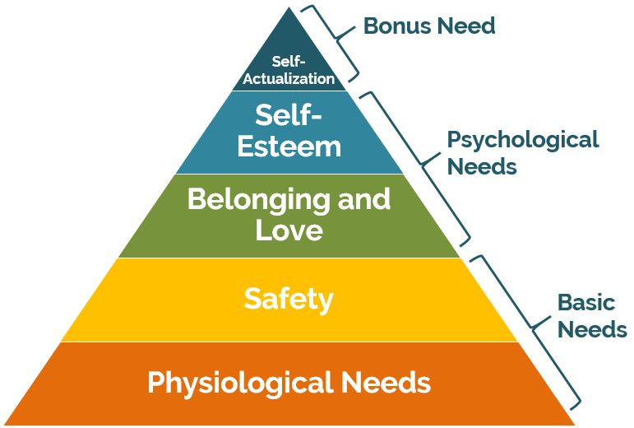
Figure 4: Maslow’s Hierarchy of Needs.
(Source: biznewske.com 2021).

HRM at BLGOR can achieve its goals, to do this it will require to fulfil employee’s aspiration from the lower level of the pyramid to the top level which focuses on employee satisfaction (Dutil. 2022). By utilising Abraham Maslow’s theory, it will provide a better knowledge and clearer understanding of what an employee desire from BLGOR. HRM approach should reflect on Maslow’s methodology.

- Self-actualisation: the HRM of BLGOR should identify talented employees and provide efficient education and non-stop learning resources to aid person perform strategy professionally.

- Self-esteem: After training constantly obtaining feedback and inspiring the staff will be benefit for BLGOR, as this will help worker to understand and create an attachment towards BLGOR.

- Belonging and love: BLGOR provides a social platform for employees such as WhatsApp group to assist workers to socialise, this can be accessed after working hours.

- Safety need: BLGOR provides variety of security for its employees like sick pay, provide health and safety equipment’s and free transport to and from work.

- Physiological needs: BLGOR offers basic services such as free staff toilets, pray facilities, paying employee’s wages on time, free food and drinks for employees when on duty to obtain employee’s loyalty.

Appendix 3. SWOT analysis.
HRM’s recommendation to employees is to perform personal SWOT analysis. SWOT analysis is an outstanding tool to evaluate self-performance within the workplace (Pickton and Wright 1998). This will help employees to recognise what are their strong points, what areas they need to improve on etc.

SWOT analysis.

Figure 5: Image of SWOT analysis.
(Source: Thrive Global)

- Strengths: identifying key strengths like leadership skills, communicating skills, will assist individuals to achieve wonders within the workplace.
- Weaknesses: identifying your weaknesses can assist individuals to plan on what methods that can be applied to improve the weaknesses.
- Opportunities: recognising opportunities encourages individuals and businesses to thinking about new products and services required within the marketplace.
- Threats: that might be an obstacle to personal development.

