University of Wales Trinity Saint David


Report
Item | Description
Student Name: | Chiya Fayzullah
Student ID: | 2208596
Module: | International Business Concepts
Module Code: | LCLM7034
Lecturer: | Syed murshed
Internal Verifier: | Vasilios Tavlaridis and Hoang Nguyen
Date:
Word count

Contents
Introduction 1
2. Industry and Country Overview 1
a. The Renewable Energy (Solar PV) Industry in Germany 1
b. Size, scope, and economic importance 1
3. Applying Porter’s Diamond Model to Vietnam’s Solar PV Industry- 5
4. Strategic Evaluation of Tesla’s Operational Resilience and Market Attractiveness in Germany (2026) 7
5.0 Conclusion 13
Section 2: Reflective Account of the Research and Analysis Process 14
References 18

The German Electric Vehicle Industry

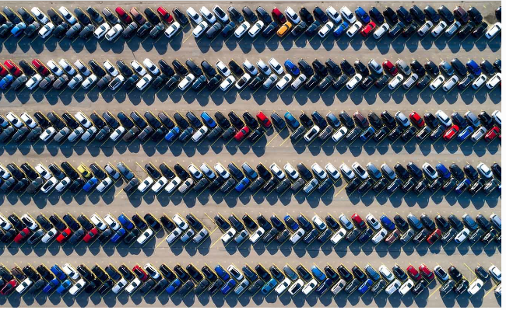
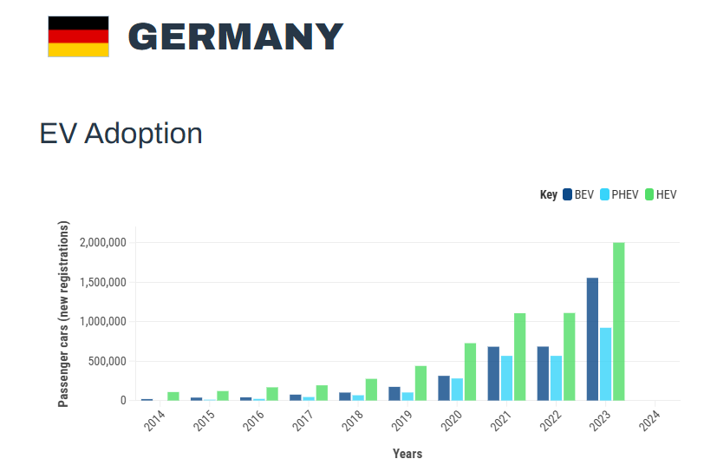

Introduction
The German car makers who have always been historically founded on internal-combustion superiority are in a tectonic structural transition to electro-mobility. The present paper is a critical assessment of the industry landscape in the year 2026, which is characterised by the clash of hostile forces of European Union decarbonisation requirements and the unstable competitive landscape. Tesla Inc. is at the centre of this shift as the creation of Giga Berlin-Brandenburg was meant to break the hegemony of the old German OEMs, including Volkswagen, BMW, and Mercedes-Benz.
The following report assesses the extent and economic significance of the industry, uses the Diamond Model created by Porter to examine the national advantage of Germany, and finally gives a strategy analysis as to how Tesla can withstand the Chinese competition that is on the rise and its self-inflicted erosion of the brand that it has strategically built over the years.

2. Industry and Country Overview

a. The Renewable Energy (Solar PV) Industry in Germany
The traditional automotive star of Europe, Germany is in the process of a radical reorganisation as it transitions to the electro-mobility as opposed to internal-combustion engines. The German electric vehicle (EV) industry is currently shaped by ambitious climate targets and a regulatory framework heavily influenced by European Union mandates. The International Energy Agency Technology Collaboration Programme (EVTCP, 2024) has shown that Germany is already one of the top markets where battery-only-electric vehicles (BEVs) are bought, and the country has a well-developed national strategy to implement 15 million EVs on the road by 2030. The current market trends suggest that there is a major change in the consumer behaviour and registration patterns. According to the Alternative Fuels Observatory (2025b), in April 2025 alone, BEV registrations in Germany increased by 54 percent, the indication of a recovery and a developing acceleration in adoption rates even after the previously announced phasing out of direct purchase subsidies. Such growth is also reflected in the region; whereas Czech republic is currently seen to have dominated in plug-in hybrid electric vehicles (PHEVs) ( Alternative Fuels Observatory, 2025a), Germany is still concerned with pure battery technology to comply with strict CO₂ emission levels.

b. Size, scope, and economic importance
Figure 1: Germany EV Market Forecast (2024–2032)
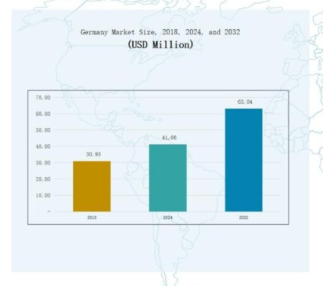
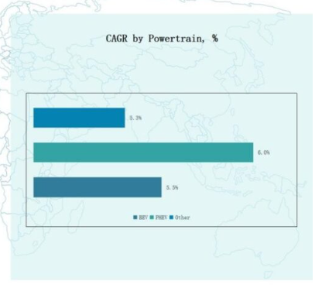
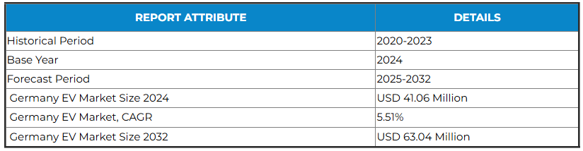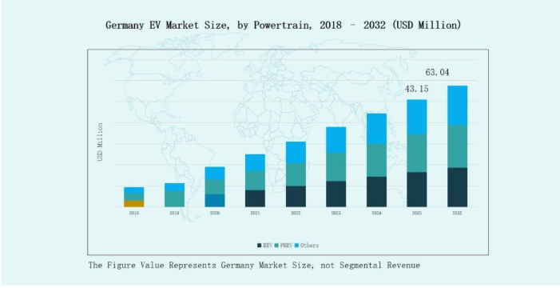
(Source: Credence Research, 2024)
Scope and Market Segmentation
A wide variety of powertrains and end consumer markets determines the size of the industry. Battery electric vehicles (BEVs) are the topper of the world, holding 68 percent of the market share in 2024 as the strict CO₂ emission limits and intensive implementation of fast-charging networks keep the vehicles at the forefront (Credence Research, 2024). Plug-in hybrid electric vehicles (PHEVs) continue to hold a large share of 27⁯% to attract consumers in the need of long-distance flexibility. Concerning end-users, the market is mainly consumer-wide with 72 percent of the overall share as consumers are driven by tax exemptions due to the rising provision of affordable models like the Volkswagen 1-EUVERY. The rest are corporate buyers, which constitutes 28% of the total, where fleet electrification and sustainability requirements drive the growth (Credence Research, 2024).
Economic Importance and Regional Dynamics
The EV is an important sector of the industrial policy of Germany, especially Southern Germany, which controlled a 35 percent market share in 2024. This area is the national innovation centre, where the headquarters and research and development centre of the world leaders are: Volkswagen, BMW AG, Mercedes-Benz, and Audi (Credence Research, 2024). Significance of the industry is also emphasised by the huge investments; recent example is Volkswagen that just declared an EUR180 billion investment programme until 2027, two-thirds of which will be electrification and digitalisation.
Major Domestic and Multinational Firms in the German EV Industry
German electric vehicle (EV) market can be characterised by a very competitive environment where domestic conglomerates possessing deep manufacturing experience can use the opportunity to offset the disruptive nature of multinational impact entrants. In 2025, 545,142 all-electric vehicles were registered in the market, which constituted 19.1 percent of the market share (Best Selling Cars, 2026).
1. Domestic Market Leaders: The "Big Three" Strategy
Local conglomerates control local markets in Germany and have transitioned to all-electrified portfolios.
Volkswagen (VW) Group: VW has established itself in the market as the market leader by taking an 18.8% share of the battery-electric vehicle (BEV) market in 2025 (Best Selling Cars, 2026). Its “Core Brand” concept focuses on mass accessibility of the products, as the VW ID.7 was found as the most popular EV model in Germany in 2025 selling 34,563 units (Best Selling Cars, 2026).
BMW Group: BMW has a Power of Choice strategy, in which there are EV versions of the popular upscale vehicles. By 2025, BMW had reached the second-best selling position in the BEV market with a 9.5% share (Best Selling Cars, 2026).
Mercedes-Benz: Moving to the Top End Luxury segment, Mercedes-Benz focuses on high-margin vehicles, including EQS and EQE. Nevertheless, its performance has been relatively conservative, as it has fallen to position five in BEV ranking in 2025 (Best Selling Cars, 2026).
2. Multinational Competitors: The Disruptors
Multinational companies have forced host countries to increase the speed of innovations, but the results in 2025 are greatly polarised.
Tesla (USA): After being the unquestionable leader, Tesla lost its positions in Germany and dropped to the third to ninth place on the BEV rating by 2025 (Best Selling Cars, 2026). The 2025 registration of the Tesla Model, previously the highest-selling EV in Germany, dropped by almost 12,304 units compared to almost 30,000 the year before (Best Selling Cars, 2026).
BYD (China): BYD is becoming a formidable threat, officially surpassing Tesla on the entire German car market of 2025 (Best Selling Cars, 2026). Its business concept is based on price competitiveness and vertical integration of battery technology the so-called Blade Battery, which aims at low-end and middle-end markets which are only starting to be exploited by the German brands (BloombergNEF, 2025).).
Stellantis (Multinational): Through brands like Opel and Fiat, Stellantis targets the urban "compact" segment. Opel maintained a steady rank in 2025, leveraging its heritage as a "local" German brand despite its multinational ownership (Best Selling Cars, 2026).

3. Applying Porter’s Diamond Model to Vietnam’s Solar PV Industry-
The Diamond Model of National Advantage provided by Michael Porter is a useful framework to critically assess the global competitiveness of the German electric vehicle (EV) industry. According to this model, the competitive advantage of a particular nation in a given sector is determined by four determinants, which are interrelated which are below;
1. Factor Conditions
Factor conditions involve the location of a country in production factors, especially the sophisticated factors like specialised technical expertise and facilities. Germany is also leading in the worldwide production of electric-vehicles as the second-largest producer of the vehicles, just after China (VDA, 2025; Clean Energy Wire, 2026). In 2025, Germany produced a record 1.67 million electric vehicles, demonstrating an immense industrial capacity to scale battery-electric technology (VDA, 2026). The most powerful competitive resources of the country consist of its advanced factors. German engineering talent, nurtured by the best technical universities and a vocational system of so-called dual education, offers a reliable source of engineers that can manage the tricky move toward the 21st-century vehicles that are defined by software, rather than a mechanical system (RSIS International, 2025; ResearchGate, 2025). Additionally, the fiscal year 2026 observed an enormous infrastructure re-investment; the German government invested around to the tune of 3 billion Euros in a new EV incentive programme that shall be introduced in 2026 to guarantee a wide infrastructural coverage (Alternative Fuels Observatory, 2026).
2. Demand Conditions
Demand conditions are the level and advancement of home market. According to Porter (1990), a high population of domestic consumers who are demanding makes the firms to innovate at a faster rate and produce products of high quality. Germany has a well-known background of consumers who are extremely critical of performance, safety, and reliability (ResearchGate, 2025). This advanced requirement has necessitated the German manufacturers to come up with high-performance BEVs that satisfy the high standards of the Autobahn culture thus equipping them to compete in the luxury markets around the world (Scribd, 2025). The domestic demand is managed to recover effectively as indicated by market data of 2025, following 2024 subsidy cuts. By December 2025, battery-electric vehicles (BEVs) will have a presence of 22 per cent of all new registrations, increasing yearly on average to 19 per cent (ifo Institute, 2026). Estimates indicate that there will be additional growth in BEV registrations to 693 000 units in 2026, which will be a 30% increment (VDA, 2025).
3. Related and Supporting Industries
A cluster of global excellence suppliers and other industries tend to enhance the competitive edge of a nation. The automotive performance of Germany is highly inseparable with its Mittelstand and Tier-1 suppliers across the globe like Bosch, Continental, and ZF (Scribd, 2025; ResearchGate, 2025). These supporting industries can supply high quality components and cooperative research and development that hasten the process of innovation (Porter, 1990). This pillar has been extended to the power and IT sector in 2025 and 2026 respectively. An example of this is the cross-industrial cooperation that is a key to an EV ecosystem with the introduction of the first commercial Vehicle-to-Grid (V2G) solutions through the cooperation between BMW and E.ON at the end of 2025 (Statkraft, 2025; IEA, 2025). Moreover, the existence of Tesla Giga factory Berlin-Brandenburg has served as a catalyst and has increased the number of battery supply chain companies in the region and enhanced the resilience of the entire cluster globally (Statkraft, 2025).
4. Firm Strategy, Structure, and Rivalry
The last determinant is the circumstances under which the companies are established, formed, and operated, and the level of local competition. The level of internal rivalry between Volkswagen, BMW, and Mercedes-Benz in Germany is exceptionally high (ResearchGate, 2025). This intense competition does not allow complacency and moves to keep advancing technologies (British Academy for Training and Development, 2025). By 2025, Volkswagen retained its top positions thanks to an 18.8% market share in the BEV segment, and BMW and Audi recorded record sales due to the use of a multi-powertrain strategy that attracts a wide variety of markets worldwide (Best Selling Cars, 2026). This competitive mode together with the hierarchical but engineering-oriented management approach enables German companies to maintain long-term R&D investments which are critical to the capital intensive switch to electrification (RSIS International, 2025). Whereas in Germany, the Chinese brands BYD and Leapmotor had increased three-digit growth in 2025, the domestic rivalry already existing in the country has compelled the German leadership to react with cheaper models, including the VW ID.2, which will be produced in 2026 (ifo Institute, 2026; Xinhua, 2026).
5. Role of Government and Chance
The external variables that affect the diamond are the government and chance events. The 2026 EV Incentive Programme of the German government, with its particular focus on households with lower and middle income, also has a catalyst effect on the market size (Alternative Fuels Observatory, 2026).

4. Strategic Evaluation of Tesla’s Operational Resilience and Market Attractiveness in Germany (2026)
The advent of the Tesla Inc. as a strong multinational corporation (MNC) in the European automotive industry has essentially broken the status quo in the previous dominance of the German original equipment manufacturers (OEMs). This critique forms a critical review of the circumstances, which affect the success of Tesla in Germany, where the PESTEL framework is used to analyse the suitability of the market and the barriers to operations based on the academic and industry data of 2025 and 2026.
1. Political Factors: Navigating a Shifting Policy Landscape
The German political landscape is a two-sided sword to the Tesla company since it offers the company the infrastructure support they require, and simultaneously, it comes at the cost of high policy volatility. In 2025 and the early 2026, German government focused on the Energiewende (energy transition), but due to fiscal limitations, subsidies were not predicted. The German demand of Tesla is highly responsive to the governmental incentives. The sudden discontinuation of the “Umweltbonus” towards the end of 2024 caused a significant decrease in Tesla market share as the price equality with internal combustion engine (ICE) models disappeared (MarkLines, 2026). In order to solve the following downturn, the German government unveiled a new EV Incentive Programme 2026 that provides a single social-level subsidy of 3 billion (Alternative Fuels Observatory, 2026). This political turn aims at lower-to-middle-income consumers, and Tesla will be compelled to launch less expensive vehicles, including the so-called Model 2, to be eligible to the top levels of the state subsidies (Nasdaq, 2026).
2. Economic Factors: Production Efficiency and the Energy Moat
The economic performance of Tesla in Germany is based on the principle of local production, but the high-cost sector of the country and the growing competition worldwide are the continuous challenges to the company. In 2025, Giga Berlin achieved a production capacity of 5000 units of Model Y per week, allowing Tesla to provide the European market without the logistic expenses or customs taxes of the Chinese Giga Shanghai or American Fremont factories (Teslarati, 2025). This localization is essential because the EU has a higher tariff on Chinese-made EVs and thus Tesla vehicles made in Germany have a potential cost edge over imports (BloombergNEF, 2025). The producer prices in Germany fell by 2.2 percent in August 2025, and it shows that the cost of raw materials is falling, but the overhead cost of working with the high-wage environment is still putting pressure on the gross margins (Tset, 2025). Energy costs also remain as the key determinant in the viability of manufacturing in Germany especially in battery production which is very energy consuming. The German government responded by introducing the Industrial Electricity Price, which would impose a fixed price of 5 0 -100 centimetres per kilowatt-hour as of 1 January 2026 and would be intended to cap 50 percent of the consumption of the eligible companies (Gleiss⁻ Lutz,⁻ 2025). This policy is a great relief to Tesla since the existing tariff is estimated to be 100 per MWh lower than 2024 rates thus increasing the competitiveness of battery-cell assembly upgrades (Deloitte, 2025). Within the terms of the state assistance, according to the law Tesla pays 50 percent of the subsidy on the projects that would lower the cost of electricity on a system-wide basis, including the large battery-storage projects that are in progress in Brandenburg (Gleiss Lutz, 2025). The radical change in the competitive environment happened in the end of 2025 when BYD and other Chinese transnational corporations started to develop their presence in Germany. The number of BYD registrations increased over 10 times in comparison to the previous year and it totalled 2,629 units, in comparison with 1,301 Tesla registrations registered at the same period in January 2026 (AAStocks, 2026; Business Times, 2026).
3. Social and Cultural Factors: The Crisis of Brand Persona
It is, perhaps, the most important obstacle to the long-term success of Tesla in Germany, as the cultural mismatch between the ethos of the Silicon Valley and the German social values lies on the fundamental level. In early 2026 Tesla had an unprecedented low reputation in Germany. In terms of the reputation score, Tesla in Germany was ranked in the absolute last out of 30 surveyed companies in the study of Reputation 2025, with a reputation score of 2.48 on a scale of, -0.77 year-to-year drop (Electrek, 2026; Tesevo, 2026). This fall is explained, in large part, by the fact that people did not find responsible the leadership of the company and did not see much transparency in the interactions with the environment (ResearchGate, 2025). In 2025, a survey conducted found that 60 per cent of Germans had a negative opinion of the brand, and 94 per cent of Germans said they did not plan to buy a Tesla (Electrek, 2026; Latana, 2025). The industrial culture in Germany is developed on the principle of social partnership. The opposition to the collective bargaining of Tesla has initiated a long-term dispute with the largest European industrial union, called IGMetall (Yale Insights, 2024). Recently, the Tesla management has announced against a 35-hour workweek, which is one of the common standards in the metal industry in Germany and has argued that this would hinder efficiency across the globe (Tesery, 2025).
4. Technological Factors: Innovation and Infrastructure Resilience
Tesla is still considered a technological leader of the German industry, but the difference is gradually decreasing due to the fact that domestic giants are catching up with Tesla in terms of software and battery density. The first technological strength that Tesla has is the software stack and Full Self-Driving (FSD). Although in a limited number of cases, German OEMs like Mercedes-Benz have reached Level 3 autonomy, Tesla offers fleet-wide data collection that offers a better learning loop (ResearchGate, 2025). Tesla is currently increasing six additional production lines devoted to vehicle robot and battery manufacturing, as well as striving to improve the integrated approach of its software with tangible equipment in 2026 (Tesla, 2026). Juniper is hoped to be the new name of a refresh of the Model Y in 2026, which will add new thermal control systems to increase its range by around 12% in chilly conditions in Europe (MarkLines, 2026). The prevalence of the Tesla Supercharger network is also a moat that can hardly be copied by the domestic rivals. Though the network was opened to other brands, Tesla customers have access to built-in so-called plug-and-charge convenience, which German clients consider as a top priority (IEA, 2025). The national grid of Germany is however, installing 12,000 high-power charging points per year by the Deutschlandnetz programme, which makes the Tesla network less exclusive (Expertenkreis, 2025).
5. Environmental and Legal Factors: Resource and Labor Legitimacy
The business activities of Tesla in Grünheide are constantly scrutinised in the legislative area in terms of sustainability and the management of resources. The growth of Giga Berlin is a controversial issue that is faced by the water crunch of the area. By citing the fact that the factory is supposed to consume 1.4mm 3 of water each year, environmental activists have managed to implement the Federal Emission Protection Law to suspend the permit on the grounds of negative impact on the local resources (TNFD, 2024; EJAtlas, 2025). To reduce this Tesla promised to have a circular water system by 2026, which recycles 90% of its process water (BNEF, 2024). Tesla is at risk in terms of occupational health in legal terms. The high levels of injury and the so-called extreme workload resulted in a 17% absenteeism rate in late 2024, which initiated the research of the Brandenburg State Office of Occupational Safety (Glass Almanack, 2025). Under German law, the lack of action to deal with these endemic health dangers may lead to retroactive wage compensation and heavy legal fines in the 2026 business year.
Despite the fact that operations are mainly established on the basis of political and economic structures, the level under which Tesla operates in Germany is becoming dependent on unstable socio-technical and competitive pressures.
1. Market Attractiveness: The "Sophisticated Crisis" of 2026
High-stakes transition that regulatory requirements and changing consumer sentiment will contradict, characterises the attractiveness of the German market in 2026. After a disastrous 48 3 per cent drop in electricvehicle (EV) new registrations in the first half of 2025, the market has begun to recover, battery-electric vehicles (BEVs) registering a 22 3 per cent share in January 2026 (MarkLines, 2026). However, legacy OEMs, like Volkswagen (VW), have taken the lead in EVs through provision of a wide choice of models, both in number of models (the ID.3 to the ID.7) and range (portfolio breadth), whereas Tesla is still dependent on a narrowing line-up (CarbonCredits, ‛ 2026). In addition, the national grid is cannibalising the Tesla infrastructure moat by installing 12,000 high-power charging stations per year under the Deutschlandnetz programme, guaranteeing large-scale fast-paced charging on 1530 km along motorways and reducing the exclusivity of the Supercharger network (Expertenkreis,‛2025; Nationale‛2026).
2. Operational Success: Insulation from Local Demand Shocks
One of the factors that contributed to the success of Tesla is its ability to isolate the production of Giga Berlin to the dynamism of the German domestic market by adopting an export-based resilience strategy. Although Tesla sales in Germany dropped by 72 per cent between April and December 2022 and 19,390 units in 2025, Giga Berlin achieved higher volume of production in all the quarters of 2025 (CleanTechnica, 2026; Tesery, 2025). Such success can be explained by the fact that Tesla can serve as a global logistic hub, as the plant can deliver more than 30 international markets to which German-made Model Ss are much more cost-efficient than their US counterparts (Tesery, 2025).
3. The "Industrial Electricity Price" and Energy Competitiveness
Energy prices remain one of the key factors that define the feasibility of manufacturing, especially those that consume a lot of electricity to produce batteries. In 2026, German government enacted an Industrial Electricity Price policy, which aimed at capping 50 per cent of appropriate corporate consumption to 5 cents per kilowatt-hour (Gleiss Lutz, 2025). This policy gives Tesla major relief, i.e. about EUR 100 per megawatt-hour in comparison with the 2024 exchange rates, that is to say, directly boosts the competitiveness of its in-house battery-cell assembly (Deloitte, 2025). In order to achieve this state subsidy, Tesla is obliged by law to invest 50 percent of the subsidy in the projects that will decrease the electricity cost of the system, which it is currently accomplishing by setting up massive battery storage projects in the Brandenburg area (Gleiss Lutz, 2025).
4. Socio-Cultural Crisis: The "Persona Liability" and Brand Decay
The erosion of brand trust between the German population and Tesla is, perhaps, the most volatile in influencing its performance, which can be described as a persona liability. By May 2025, net Tesla sentiment in Germany was determined at appalling -51% and 60% of the German population had a negative attitude to the brand (Latana, 2025). According to a study conducted by Electrify Research the brand desirability of Tesla among the homeowners across Germany decreased by 41 per cent between 2023 and 2025, the largest decrease of any major brand in the nation (Electrify Research, 2025). This cultural alienation is often credited to Elon Musk giving a vocal support to Alternative for Germany (AfD) a party, which is viewed as an extremist by most of the population, which has elicited a consumer backlash across generational and economic boundaries (CleanTechnica, 2026).
5. Competitive Dynamics: The "Chinese Surge" and Local Rebound
Lastly, the Tesla market in Germany has been threatened by the low-cost and luxury rivals. The BYD registered an increase of more than 1,000 in January 2026, to 2,629 units, the same month Tesla registered 1,301 (AAStocks, 2026). At the same time, VW showed an increase in sales of the European EV market in 2025, selling 274, 000 watches vs. 239,000 by Tesla, and the balance of power returned to 2:1, which Tesla had held no more than a year earlier (CarbonCredits, 2026). The broad portfolio approach of the German OEMs has been shown to be more resilient to changing consumer tastes than the single-purpose approach of Tesla, implying that Tesla could only remain relevant in Germany once it is able to shift its strategy to disruption to local brand reconciliation.

5.0 Conclusion
The overall evaluation of the German electric-vehicle market and the operational stance of Tesla Inc. indicate that the market is at a decisive junction connecting the innovation and institutional resistance. Germany is a leading international centre of electromobility that is supported by a solid Porters Diamond. It bases its competitive edge on the world-leading factor conditions, which include specialised engineering know-how, and complex base of demand which would force continued technological improvement. An estimated growth of market to USD 63.04 million by 2032, as well as the trade-off of 22 percent share in BEV registration in early 2026, indicates the long-term appeal of this industry even without the presence of traditional subsidies (Credence Research, 2024; MarkLines, 2026). However, in the case of Tesla Inc., the process of becoming a local embedded manufacturer continues to be a challenging one. Although Tesla has appropriately used GigaBerlin as an international export hub to avoid domestic demand shocks, it is facing a significant persona liability. The fact that the reputation index of Tesla dropped to 2.48 / 5 and the net sentiment of German consumers became negative (-51%), means that the technological leadership is not enough to achieve the long-term success (Electrek, / 2026; Latana, / 2025). In order to succeed, Tesla needs to align its Silicon Valley-style management with Germany social partnership-oriented labour culture and deal with the growing competition posed by the re-emerging domestic giants like Volkswagen and hyper efficient Chinese TNC like BYD. A successful shift toward the German electric vehicle industry would be dependent on the ability of all stakeholders to address the interdependence of decarbonisation requirements, energy prices containment, and the European cultural acceptability in the most challenging industrial setting ever.
.

Section 2: Reflective Account of the Research and Analysis Process
This reflective report uses the Reflective Cycle (1988) by Gibbs in order to critically review the research, analysis, and preparation of a strategic assessment of the operations of Tesla in Germany. Through the six steps, which are description, feelings, evaluation, analysis, conclusion, and action plan, I hope to obtain substantive information to my scholarly practice and professional development.
1. Description: What Happened?
The assignment was a multi-tiered research project based on the German electric vehicle (EV) industry and a particular multinational corporation (MNC), Tesla. I had to piece together industry data that was not that simple, use strategic frameworks (Porters Diamond Model and PESTEL) and assess the resiliency of Tesla in 2026 operations. I started with the secondary data gathering of various sources, such as industrial databases (MarkLines, Statista), law briefing (Gleiss ⁻ Lutz), and university journals. I then moved on towards the analytical stage where I plotted these results against theoretical frameworks to see the trends, e.g., the deviation between manufacturing output and social reputation of Tesla. Lastly, I summarised these findings into a well organised report that was a combination of technical information and a critical review of the narrative.
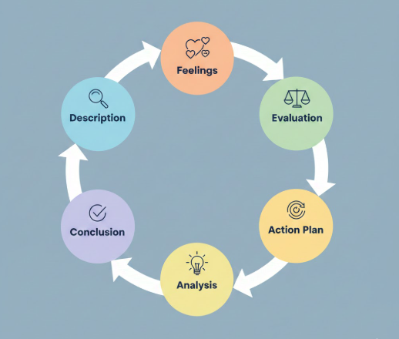

2. Feelings: What was I Thinking and Feeling?
Initially, I experienced some form of anxiety, concerning the nature of the report having a date (2025-2026) on its future. The need to balance the realms of the modern reality and the projected data demanded a more intensive thinking process in order to make sure the analysis is based on facts instead of assumptions. My eureka moment involved the research phase when I came across the 2026 industrial electricity price cap, which seemed to me like a key piece of the puzzle since it connected the government policy to the bottom line of Tesla. Nevertheless, I was frustrated in the process of researching the social reputation of Tesla. The information about the drop of the brand in Germany were very harsh, which led me to doubt the possibility of bias and to find several sources that prove the data such as Latana, Electrek, and ResearchGate to keep my objectivity.
3. Evaluation: What was Good and Bad about the Experience?
The Positives:
- Methodological Rigor: The use of the Diamond created by Porter to the German EV industry was very successful as it became clear that the competitive advantage of Germany is not exclusive to the automobiles sector but to the well-developed environment of factor conditions (skilled labour) and related industries (Mittelstand suppliers).
- Data Integration: The use of the Diamond created by Porter to the German EV industry was very successful as it became clear that the competitive advantage of Germany is not exclusive to the automobiles sector but to the well-developed environment of factor conditions (skilled labour) and related industries (Mittelstand suppliers).
The Negatives:
- Information Overload: Tesla has very abundant information available; I found it difficult to slaughter the noise (global stock price changes) and only analyze the operational resilience in Germany.
- Time Management: I spent an unreasonable amount of time in the industry overview (Section 2), which left me with less time to dedicate to the in-depth persona-liability analysis in the Tesla-specific part.
4. Analysis: What Sense can I make of the Situation?
The intricacy of this assignment was comparable to the business intelligence in the real world. The challenge I have had with the future-data makes me understand how trend analysis has an essential role in strategic management. In using 2025/2026 projections, I was in effect doing the act of strategic foresight, which does not involve data consumption but rather understanding of cause and effect relationship between a change in a policy (e.g. electricity cap) and the reaction of a firm. The liability of foreignness in the international business theory is portrayed by the difference between the success of Tesla operations (export hub) and its failure (brand decay). A strong MNC is able to collapse even when it fails to observe local social and legal pillars in the PESTEL framework. This discovery underscores the fact that the moat of a firm is not entirely technological, but also institutional and cultural.
5. Conclusion: What else could I have done?
Reflectively, I ought to have filtered the hierarchical data at a further stage in the process. I would have saved some hours of research by setting strong conditions under which operational resilience was met. Also, the use of further visual data-mining tools in the analysis process would have been a more appropriate representation of the intersection between both Porters Diamond and PESTEL factors prior to the creation of the prose. I have also discovered that I can connect the policy with profit, and my weakness is I tend to get caught up in details that are not essential.
6. Action Plan: If it rose again, what would I do?
To improve in later planning of strategic reports, I will use the following 3-step plan:
- Define the 'Analytical Core' First: I will first define the sub-headings of the analysis section before researching to come up with a data bucket system that will not capture any information but the directly relevant information.
- Iterative Synthesis: In order to curb information overload in a research, I will write reflective memos immediately after each significant finding of data in my research.
- Broaden Framework Application: To gain a better understanding of the environmental complexities that are inherent in the EV industry I will test the modern variants of these models, including the addition of the S (sustainability) to the PESTEL-S of the model.

References

- Alternative Fuels Observatory (2026) Germany’s 2026 EV Incentive Programme: Supporting Socially Targeted EV Uptake. European Commission. Available at: https://alternative-fuels-observatory.ec.europa.eu/ (Accessed: 10 February 2026).
- Bain. (2024). M&A in Automotive and Mobility: Deals to Secure a Place in the Industry’s Future. [online] Available at: https://www.bain.com/insights/automotive-and-mobility-m-and-a-report-2024/.
- Bundesregierung (2025) Energy prices: Relief for all – The draft budget for 2026. Federal Government of Germany. Available at: https://www.bundesregierung.de/ (Accessed: 10 February 2026).
- Credenceresearch.com. (2026). Page Restricted. [online] Available at: https://www.credenceresearch.com/report/germany-electric-vehicle-ev-market.
- CarbonCredits (2026) Volkswagen Overtakes Tesla in Europe's EV Market: A Turning Point for Clean Mobility. Available at: https://carboncredits.com/ (Accessed: 7 February 2026).
- Credenceresearch.com. (2026). Page Restricted. [online] Available at: https://www.credenceresearch.com/report/germany-electric-vehicle-ev-market [Accessed 9 Feb. 2026].
- Evtcp.org. (2023). Germany – EV TCP. [online] Available at: https://evtcp.org/country/germany/.
- Europa.eu. (2025). Germany: BEV Registrations Surge by 54% in April 2025 | European Alternative Fuels Observatory. [online] Available at: https://alternative-fuels-observatory.ec.europa.eu/general-information/news/germany-bev-registrations-surge-54-april-2025.
- Europa.eu. (2026). Croatia completes funding round for 206 electric buses, advancing clean public transport | European Alternative Fuels Observatory. [online] Available at: https://alternative-fuels-observatory.ec.europa.eu/general-information/news/croatia-completes-funding-round-206-electric-buses-advancing-clean-public [Accessed 12 Feb. 2026].
- Europa.eu. (2026). Czechia: PHEVs dominate growth in the electrified segment in 2025 | European Alternative Fuels Observatory. [online] Available at: https://alternative-fuels-observatory.ec.europa.eu/general-information/news/czechia-phevs-dominate-growth-electrified-segment-2025 [Accessed 04 Feb. 2026].
- Electrek (2019). Electrek - EV and Tesla News, Green Energy, Ebikes, and more. [online] Electrek. Available at: https://electrek.co/.
- Ganesh Chandwade (2025). Germany Electric Vehicle (EV) Market. [online] Credence Research Inc. Available at: https://www.credenceresearch.com/report/germany-electric-vehicle-ev-market#report_summary [Accessed 01 Feb. 2026].
- Gleiss Lutz (2025) Germany cuts costs for electricity-intensive companies from 1 January 2026: the new industrial electricity price. Legal Intelligence Brief.
- International Trade Administration (2024). Germany Electric Vehicles and Charging Infrastructure. [online] International Trade Administration | Trade.gov. Available at: https://www.trade.gov/market-intelligence/germany-electric-vehicles-and-charging-infrastructure.
- IEA (International Energy Agency) (2024) Global EV Outlook 2024: Moving towards increased affordability. Technology Collaboration Programme (EVTCP).
- Kendall, M. (2021). 72 Top Electric Vehicle Startups and Companies in Germany. [online] EU-Startups. Available at: https://www.eu-startups.com/83-top-electric-vehicle-startups-and-companies-in-germany/.
- Latana (2025) Tesla Brand Tracking Report Germany: 2025 Sentiment Analysis. Berlin: Latana Insights.
- Mordor Intelligence. (2023). Top Germany EV Charging Infrastructure Companies - Key Players & More. [online] Available at: https://www.mordorintelligence.com/industry-reports/germany-ev-charging-infrastructure-market/companies [Accessed 13 Feb. 2026].
- Mordor Intelligence. (2023). Top Germany EV Charging Infrastructure Companies - Key Players & More. [online] Available at: https://www.mordorintelligence.com/industry-reports/germany-ev-charging-infrastructure-market/companies [Accessed 11 Feb. 2026].
- mmpi.gov.hr. (2024). Home. [online] Available at: https://mmpi.gov.hr/en [Accessed 12 Feb. 2026].
- MarkLines (2026) Germany – Flash report on New Car Registrations, January 2026. Available at: https://www.marklines.com/ (Accessed: 10 February 2026).
- Pandaily (2026) BYD's Germany Sales Surge Over 1,000% in January, More Than Double Tesla's. Available at: https://pandaily.com/ (Accessed: 10 February 2026).
- Porter, M. E. (1990) The Competitive Advantage of Nations. New York: Free Press.
- Reputation and Trust Analytics (2026) Reputation&Trust 2025 Study: Corporate Reputation in Germany. Helsinki
- RSIS International (2025) ‘Porter’s Diamond Model: A framework for national advantage’, International Journal of Research and Innovation in Applied Science (IJRIAS), X(VI).
- Tesla (2026) Q4 and Full Year 2025 Financial Results and Operational Update. Austin: Tesla Investor Relations.
- Scribd (2025) Porter's Diamond Model Analysis: Germany and the Automotive Sector. Business Intelligence Document.
- Statista.com. (2024). Available at: https://www.statista.com/sso/login-error?error-code=access_denied#analyst-opinion [Accessed 10 Feb. 2026].
- Spherical Insights. (2025). Germany Electric Vehicle Market Size Forecast, Price to 2035. [online] Available at: https://www.sphericalinsights.com/reports/germany-electric-vehicle-market.
- Tesery (2025) Tesla Targets Production Increase at Giga Berlin in 2026: Resilience Amidst a Volatile Market. Available at: https://www.tesery.com/ (Accessed: 10 February 2026).
- VDA (Verband der Automobilindustrie) (2026) The German Automotive Industry: Facts and Figures 2025/2026. Berlin.
- Volkswagen Group (2026) Volkswagen Group deliveries remain stable in 2025: Press Release. Wolfsburg.
- www.mordorintelligence.com. (n.d.). Germany Automotive High Performance Electric Vehicles Market | 2020-2027 | Industry Report | Covid Insights. [online] Available at: https://www.mordorintelligence.com/industry-reports/germany-automotive-high-performance-electric-vehicles-market.
- Zayer, E., Stein, I., Stricker, K. and Mariia Nykytiuk (2025). Inside Germany’s Evolving Electric Vehicle Market. [online] Bain. Available at: https://www.bain.com/insights/germany-electric-vehicle-market/.

