Module name: digital skills for personal development and buiness
Student name and number Adela Bleda and 2425573
lectuer name: Muhammad cassamo
Introduction
The purpose of this project was to carry out market research for my business idea, Velvet Bloom Cakes. This is a homemade, allergy-free cake brand based in Cardiff. I wanted to learn what people look for when buying baked treats, how many people need allergy-friendly products, what flavours they enjoy, and what prices they feel are fair. The answers from my questionnaire helped me design my website, choose my products, and create my Canva marketing materials. This report explains the findings from the most important questions and how they helped me shape my business and design choices.

Questionnaire Analysis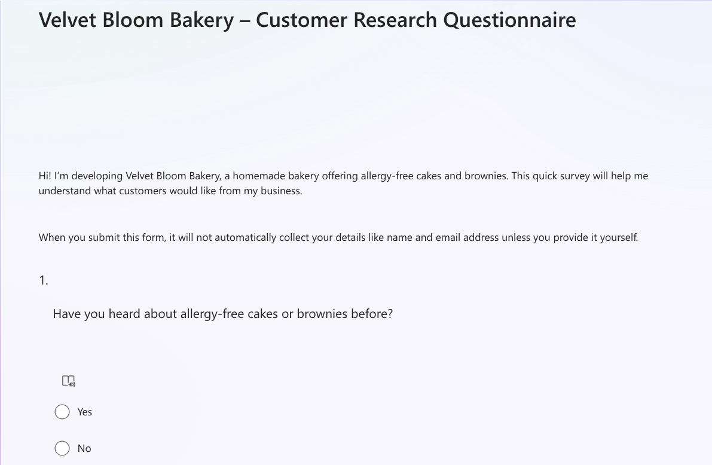

I created a questionnaire on Microsoft Forms with 13 questions. I shared it with classmates and people in the local community. The questions asked about allergies, product preferences, prices, and buying habits. Four questions were the most helpful for developing my brand.

1. Awareness of allergy-free cakes

One of the questions in my survey asked people if they had heard of allergy-free cakes before. Most people said yes, which was really helpful for me. It showed that alot customers already understand things like gluten-free, dairy-free, and nut-free baking. Because of this, I knew my idea would not feel confusing or new to them. Instead, it would be something they already recognise, which makes it easier for me to introduce Velvet Bloom to the market.
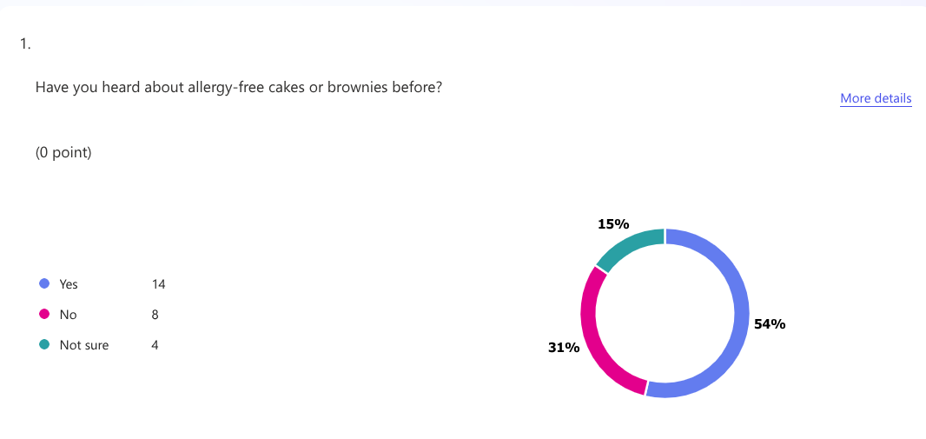

Even though most people were familiar with allergy-free cakes, a small number of people said they had never tried them before. This was interesting because it showed that people have heard of these cakes, but they do not always have access to them. It means there is awareness, but not enough choice on the market. From this, I realised that Cardiff is still missing more allergy-friendly cake options, especially ones that are homemade, fresh, and made with care.

This feedback helped me understand that my business idea meets a real need. There are people who want safe and tasty cakes but struggle to find them. So, this research confirmed that VelvetBloom has a strong place in the Cardiff cake market.

2. have you brought allergy free cakes or brownies?
The results were close, with 15 people saying yes and 11 saying no, which showed a 50/50 split. The people who said yes explained that they usually buy allergy-free cakes for family or friends who have allergies, not always for themselves. This tells me that many customers want cakes that everyone at an event can enjoy, even if only one person has an allergy. It also shows that buyers care a lot about safety and trust, because they want to be sure the cakes are safe for the person with the allergy. The people who said no usually said they didn’t know where to buy reliable allergy-free options or they had never needed to. This shows that there is still room for a brand like mine to stand out and offer something clear, safe, and trustworthy. These answers helped me understand that my brand should focus on inclusivity, which is why I chose the message: “Where everyone gets a slice.”

3. Preferred products and flavours
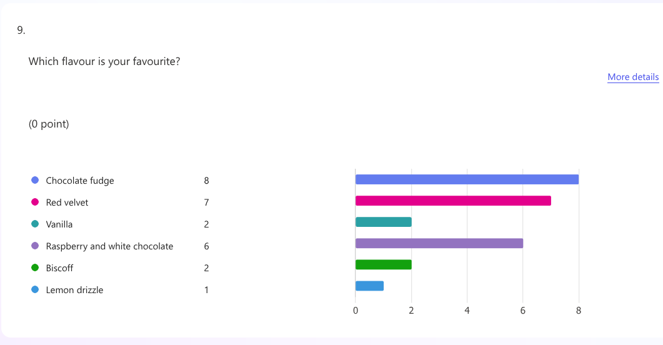
The questionnaire also asked what sweet treats people prefer. Cakes and brownies were the most popular answers, which matches the products Velvet Bloom Cakes offers. Popular flavours were chocolate, red velvet, berry, lemon, and vanilla. These answers helped me decide what to show on my website. I chose cakes and brownies that match these flavours so customers see products they already like.

4. Pricing expectations

One question asked what people think is a fair price for six homemade brownies. Most chose between £15–£20 and over 20£ This showed that customers want mid-range prices. My cakes are homemade and allergy-safe, so I can keep my prices at the higher end of this range while still being affordable. This helped me place Velvet Bloom Cakes as a “treat-yourself” brand, not too cheap and not too expensive.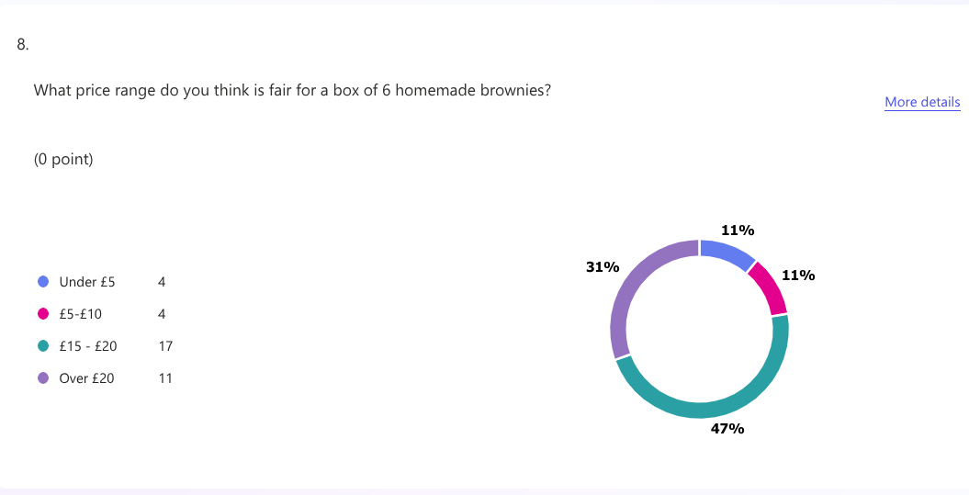

Audience Segmentation and How the Research Shaped My Business Idea
The questionnaire showed me my main customers are parents of children with allergies, young adults who like homemade cakes, and people planning parties. This helped me design a friendly and easy-to-use website.
The research also showed a need for allergy-free cakes in Cardiff. It helped me set prices by creating options for different budgets, from cheaper brownies to higher-priced celebration cakes.

How the Research Shaped My Website

My website was strongly shaped by what I learned from the questionnaire.
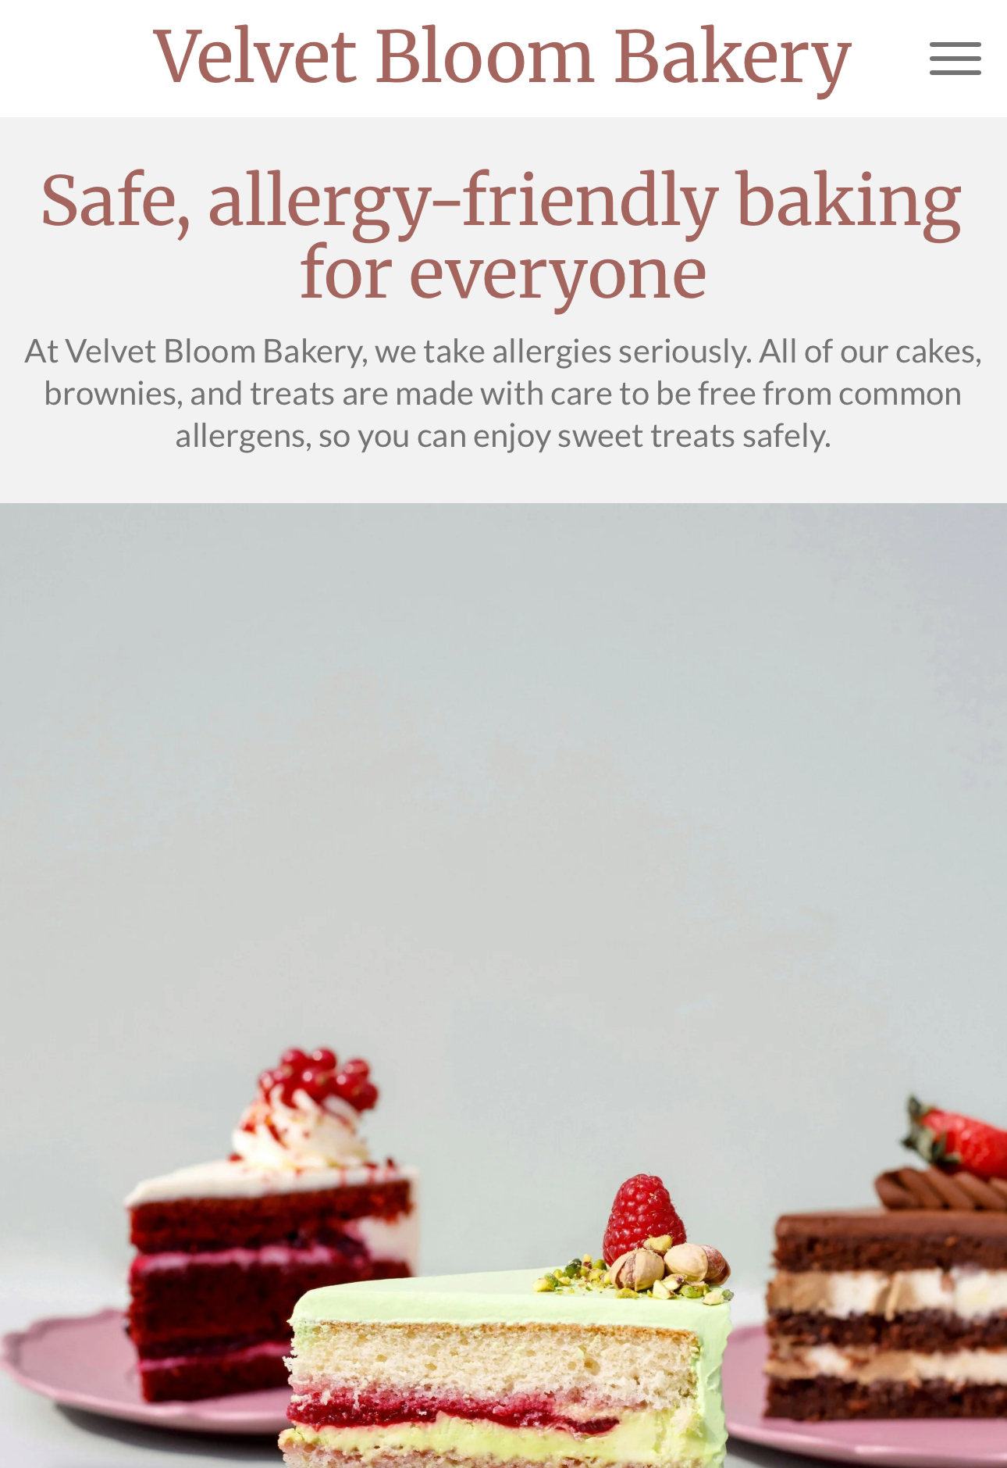
- Clear allergy information

Because allergy safety is very important to customers, I wrote clearly on the homepage that the brand is allergy-free. I also added a short section explaining what ingredients I avoid and how cross-contamination is prevented.
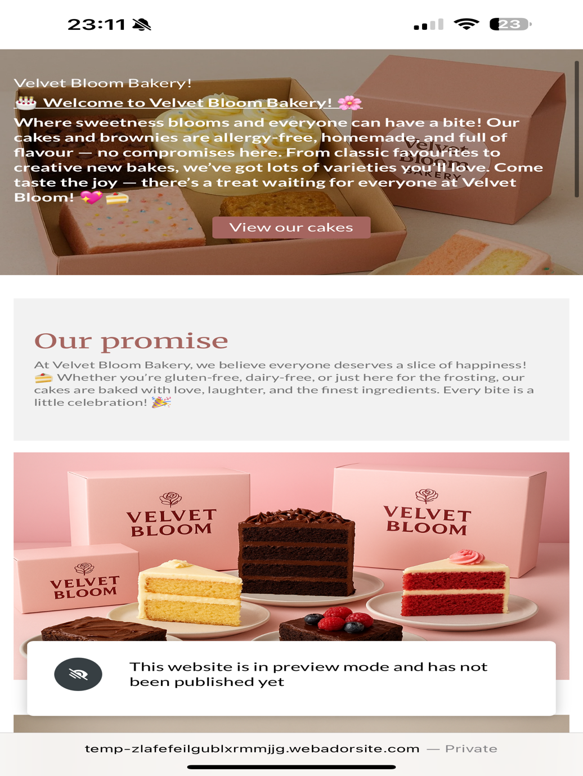

2. Warm and friendly look

People preferred cakes that look colourful and homemade. I used soft pink and pastel colours on the website to make it feel warm and welcoming. This matches the brand personality.

3. Cardiff location

I wrote “Cardiff-based” on the homepage so local people know they can order from me easily.
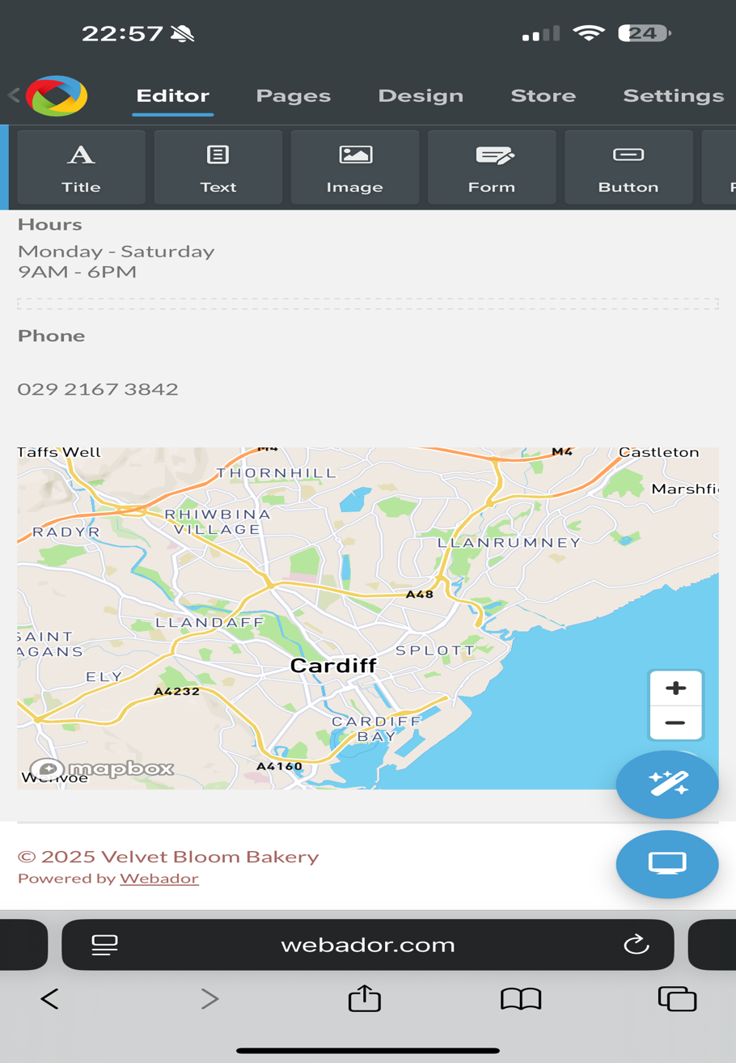

4. Simple navigation

Most customers find small businesses through social media, usually on their phones. This is why I kept the website simple with clear buttons like “Order Now” and “View Our Cakes.”

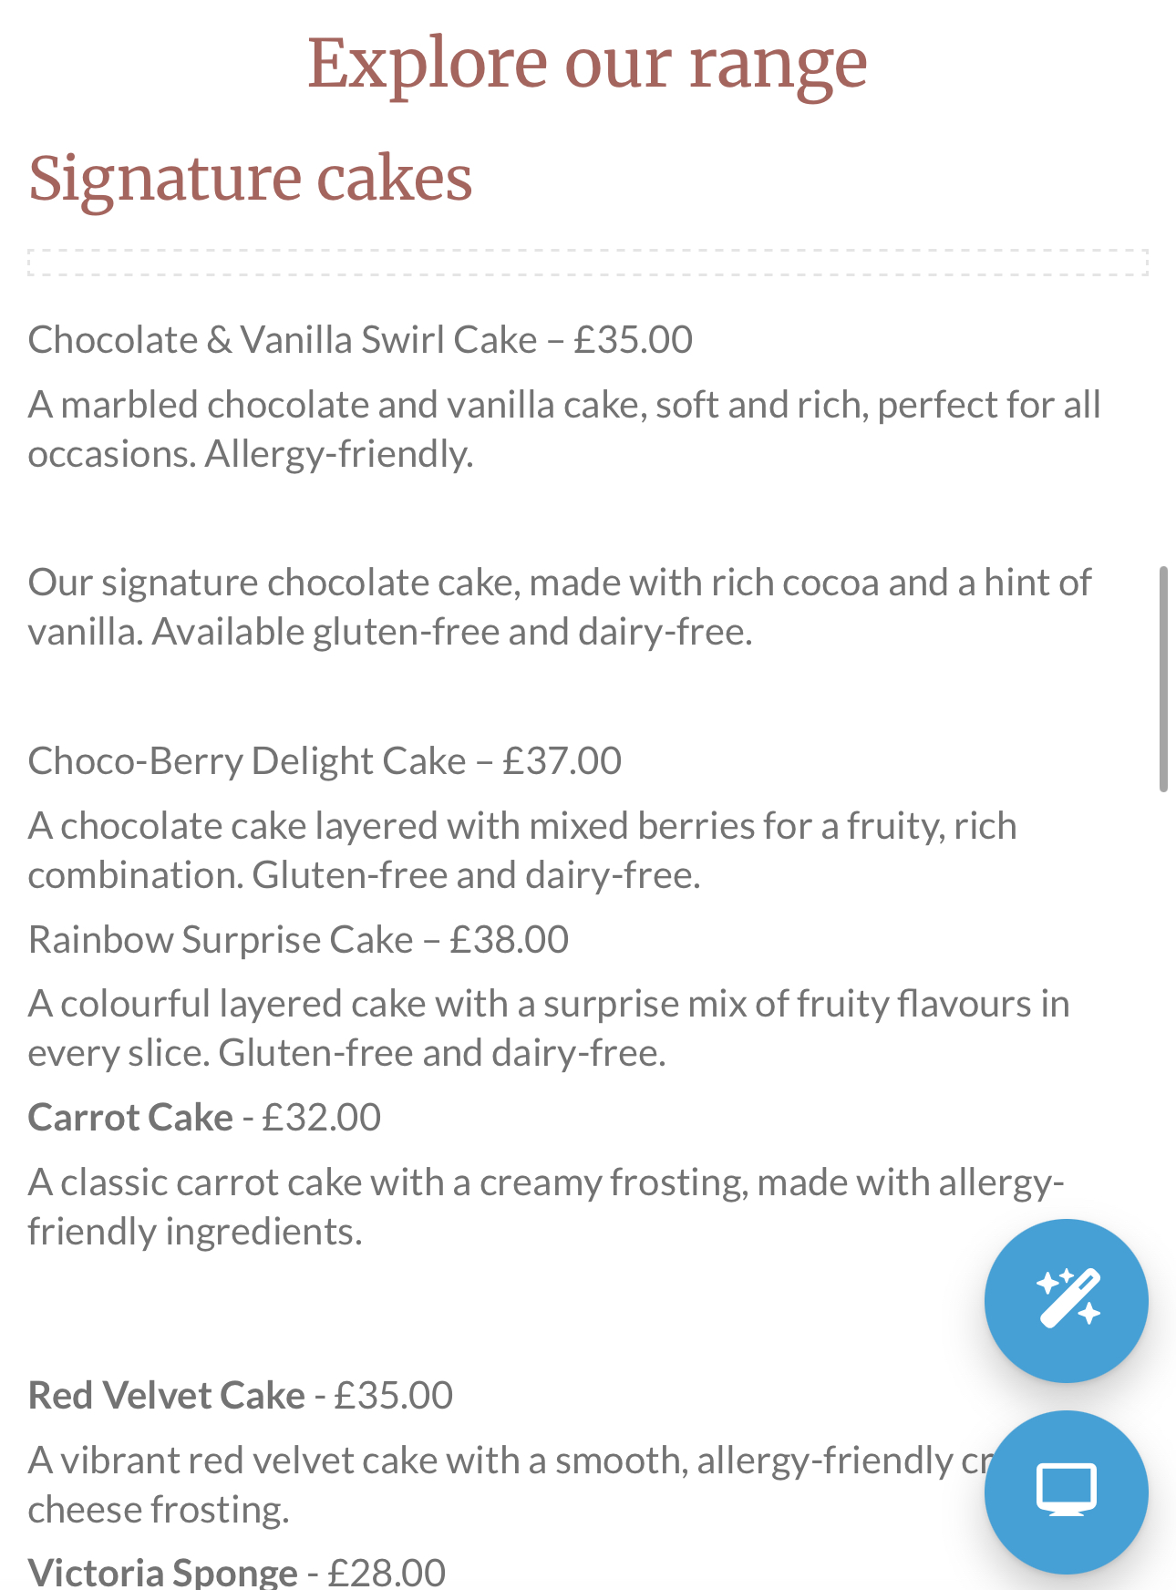
5. Showing popular flavours

I included photos of cakes and brownies in the most popular flavours from the questionnaire. This helps attract customers because they recognise flavours they enjoy.

SEO Strategy

I used basic SEO to help people find my website online. I added simple keywords like “allergy-free cakes Cardiff,” “homemade cakes Cardiff,” and “nut-free brownies.” I used these in headings and short descriptions. I also added alt text to my product photos so search engines can read them. These steps help customers find Velvet Bloom Cakes when they search for allergy-safe cakes in Cardiff.

Conclusion

Overall, the questionnaire results helped me shape every part of Velvet Bloom Cakes. The research showed that many people are aware of allergy-free cakes and want safe options for friends and family. Cakes and brownies were the favourite products, and chocolate and red velvet were the most liked flavours. The data also helped me understand fair pricing and identify my main audience groups. These findings guided my website design, my product choices, my brand message, and my SEO strategy. By using real customer feedback, Velvet Bloom Cakes became a friendly, trustworthy, and customer-focused business designed for the needs of people in Cardiff. Velvet Bloom Bakery – Customer Research Questionnaire – Results

References list
1.British Baker (2025) Bakery Market Report 2025. Available from: https://bakeryinfo.co.uk/bakery-market-report/bakery-market-report-2025/703671.article [Accessed 24November 2025]
- BBC Good Food (2024) Cake pricing and popular flavours. Available at: https://www.bbcgoodfood.com (Accessed: 24 November 2025).
3. Canva (2024) Online design and video creation tool. Available at: https://www.canva.com (Accessed: 24 November 2025)
- Adobe (2024) Color theory and palette design. Available at: https://color.adobe.com (Accessed: 24 November 2025)
- Chan, G. (2021) ‘Why Asking Questions Is Good For Your Brand And Your Career’, Forbes, 1 February. Available at:https://www.forbes.com/sites/goldiechan/2021/02/01/why-asking-questions-is-good-for-your-brand-and-your-career/ (Accessed: 24 November 2025)
- Studio1 Design (2025) How Important is Color in Website Design? Available at: https://studio1design.com/how-important-is-color-in-website-design/ (Accessed: 24November 2025)
7. Ridler, G. (2023) ‘Coeliacs excluded from 95% of birthday cake options’, Food Manufacture, 15 May. Available from:https://www.foodmanufacture.co.uk/Article/2023/05/15/coeliacs-excluded-from-95-of-birthday-cake-options/ (Accessed: 24 November 2025).
- Polo-Richards, L. (2022) ‘Why food allergies should be seen as a business opportunity, not a threat’, New Food Magazine, 2 November. Available at:https://www.newfoodmagazine.com/article/169293/food-allergies-changing-the-narrative/ (Accessed: 24 November 2025)
- The Home Baking Business Academy (2024) ‘Are Baking Businesses Profitable?’, The Home Baking Business Academy, 12 November. Available at:https://anniebennett.co.uk/are-baking-businesses-profitable/ (Accessed: 24 November 2025)
- Bake This Happen (2022) ‘5 pages every bakery website needs’, Bake This Happen. Available at: https://www.bakethishappen.com/blog/5-pages-every-bakery-website-needs (Accessed: 24 November 2025).

The Importance of Excel in the Digital Era and How It Supports My Business
Microsoft Excel is an important digital tool used in many workplaces today. It is used by small businesses, large companies, and schools to organise information and work with numbers. Excel is helpful because it is easy to use and saves time. For a small business like Velvet Bloom Cakes, Excel is useful for planning, budgeting, and keeping financial records.

Excel helps businesses organise information clearly by using rows and columns. This makes it easy to record sales, expenses, and customer orders in one place. Keeping information organised helps business owners stay in control and avoid confusion.

Excel is also useful for calculations. It can automatically add up income, expenses, and profit using simple formulas. I created a 12-month cash flow in Excel for Velvet Bloom Cakes to track the business finances. The average prices used were £35 for full-size cakes, £6.50 for mini cakes, and £24 for brownie boxes. The cash flow assumes that 100 units of each product are sold per month. This gives a monthly income of £3,500 from full-size cakes, £650 from mini cakes, and £2,400 from brownie boxes. The total monthly income is £6,550.
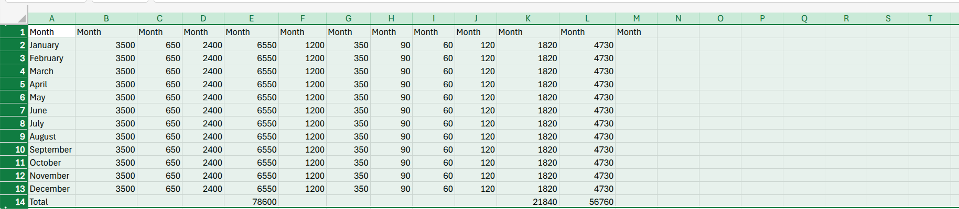

Excel can also show information using charts. Charts make it easier to understand numbers and see patterns, such as which months perform better than others. This helps with planning and decision-making.

Excel helps with financial planning by showing income and expenses over time. This allows businesses to plan ahead and manage costs better. For Velvet Bloom Cakes, this is useful for preparing for busy periods and controlling spending.

In conclusion, Excel is a simple and useful tool in today’s digital world. It helps businesses stay organised, manage money, and make better decisions. The Excel cash flow created for Velvet Bloom Cakes shows income clearly over a 12-month period and helps with planning for the future.

References list
- Charlesworth, L. (2024) What is Microsoft Excel used for and is it still relevant? Kaplan. Available at: https://kaplan.co.uk/blog/features/is-microsoft-excel-still-relevant (Accessed: 10 December 2025).
- ICAEW (2021) Importance of Excel to the financial system. Available at: https://www.icaew.com/technical/technology/excel-community/excel-community-articles/2021/importance-of-excel-to-the-financial-system (Accessed 10 December 2025)

- Team DigitalDefynd (2024) 15 reasons you must learn Excel. 3 July. Available at: https://digitaldefynd.com/IQ/reasons-you-must-learn-excel/ (Accessed 10 December 2025)
- Raymond, D. (2024) 10 advantages of managing your projects with Excel. AceProject. Available at: https://www.aceproject.com/blog/10-pros-advantages-of-managing-your-projects-with-excel-9387815 (Accessed 10 December 2025)

5 . Bulani, A. (2024) Why Microsoft Excel is important for business organisations? Delphi Star Training, 23 February. Available at: https://edudelphi.com/blog/why-microsoft-excel-is-important-for-business-organizations/(Accessed 10 December 2025)

