Crime scripts task UCJP Classicism workshop

- Most human activity can be broken down into a script, a logical sequence of events which when put together describe and possibly explain an activity. For example, the crime script for eating in a restaurant might be: enter the restaurant; get shown to a table; study the menu; order; be served; eat; get the bill; pay; and leave the restaurant. Crime scripts are similar; they walk us through what might happen and consider and explain the rational choices included in the activity. They often explain and answer the questions as to who, what, when, where, why, and how, so theorists often create them to try to predict and prevent crimes from occurring. The crime script for a pickpocket might be:

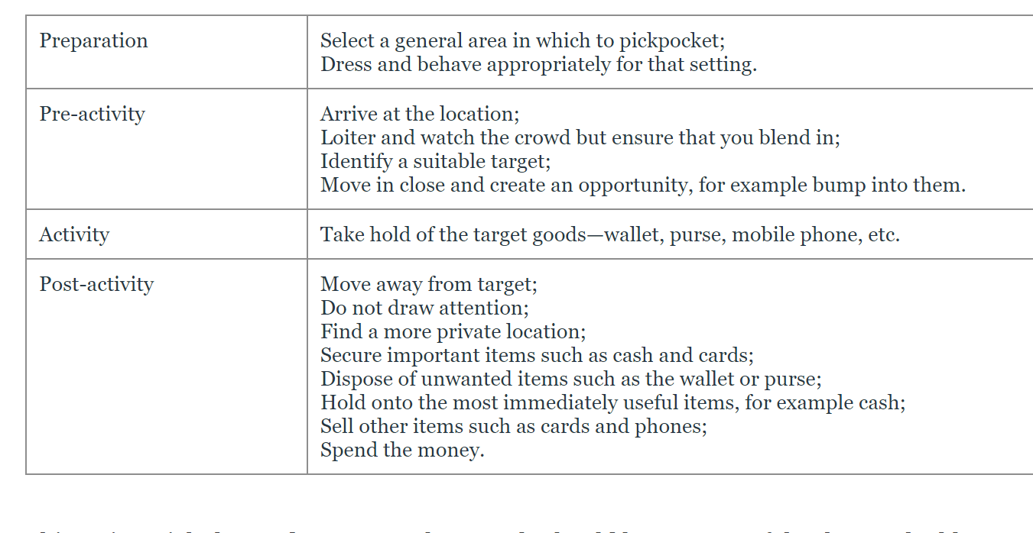

Create a crime script for one of these offences:
- •bank robbery;
- •house burglary;
- •shoplifting.
- Consider what aspects need to be present for this crime to be committed. Classify each aspect of the crime into: preparation; pre-activity; activity; and post-activity.
- Remember that neo-classical thinkers are keen to prevent crime happening in the first place, so using your script consider what might be done to prevent the activity.
- Neo-classical thinkers also argue that people who choose to offend should be punished. Go back over your script and consider whether there are any aspects of the script that might require a lot of thought and planning. And are there any aspects that might be able to be performed by someone without making a rational choice? Then consider whether these aspects should be used to increase or decrease punishment.

Preparation

Pre-activity

Activity

Post-activity

