

Evaluating BMW’s Global Marketing Adaptation: A Comparative Study between the UK and Bangladesh

Student Name: Tajwar Ahmed
Student ID: 2436033

Module Name: International Marketing Principles and Practices

Module Code: LCMB7026

Lecturer’s Name: Tushara Balendran

Contents
1.0 Introduction 3
2.0 Brand Overview 3
3.0 Macro environment Analysis 4
3.1 PESTLE Comparison 4
3.1.1 Political 4
3.1.2 Economic 5
3.1.3 Social 5
3.1.4 Technological 8
3.1.5 Legal 8
3.1.6 Environmental 9
3.1.7 PESTEL Similarities and Differences between the UK and Bangladesh (BMW Context) 9
4.0 STP (Segmentation, Targeting, and Positioning) 11
4.1 Segmentation 11
4.1.1 Demographic Segmentation 11
4.1.2 Geographic Segmentation 12
4.1.3 Psychographic Segmentation (VALS Model) 12
4.2 Targeting 13
4.3 Positioning 13
4.4 Perceptual Map - UK Market 14
4.5 STP Similarities and Differences 15
5.0 Marketing Mix (7Ps) Strategies in the UK and Bangladesh 16
5.1 Product Strategy 16
5.2 Pricing Strategy 18
5.3 Place (Distribution Strategy) 19
5.4 Promotion Strategy 20
5.5 People Strategy 20
5.6 Process Strategy 21
5.7 Physical Evidence Strategy 21
5.8 Similarities and Differences of BMW’s 7Ps in the UK and Bangladesh 22
6. Evaluation of Marketing Strategy Effectiveness 23
6.1 Ethical Marketing Evaluation 25
7.0 Recommendations 25
8.0 Conclusion 27
References 28

Figure 1: PESTEL Analysis 4
Figure 2: Hofstede Six-Dimensional Cultural Comparison 6
Figure 3: Segmentation, Targeting, Positioning (STP) 11
Figure 4: Perceptual Map - UK Market 14
Figure 5: Marketing Mix (7ps) 16
Figure 6: BMW 5 Series (UK Model) 17
Figure 7: BMW X7 (Bangladesh Model) 18
Figure 8: BMW Showroom (UK) 22
Figure 9: BMW Showroom in Bangladesh 22

1.0 Introduction
International marketing is a critical practice in the ever-globalized economy, where it is imperative to allow the brands to grow past the national boundaries, to acclimate to different environments, and to gain a competitive advantage (Lubis and Muniapan, 2024). This challenge is best exemplified by the BMW Group, which has a global image of a premium performance with a German engineering brand and at the same time needs to be relevant to the local market. The UK market is a mature and competitive luxury car market with a high level of consumerism, and highly regulated, and Bangladesh is the opposite of this, a developing aspirational economy with infrastructural development and local marketing dynamics. The current report discusses the marketing environment of BMW in these two opposite markets, and compares the way the strategy of the company reacts to and takes advantage of various external conditions using the PESTEL, STP and 7Ps frameworks. It is organized in the following way: the macro-environmental analysis (PESTEL), segmentation, targeting and positioning (STP), marketing-mix (7Ps) analysis, and a conclusion with a performance analysis, ethical concerns and recommendations.

2.0 Brand Overview
BMW Group (Bayerische Motoren Werke AG) is a German luxury automobile conglomerate that was established in 1916, and its strategic incentive is the high-end mobility, inventiveness and the shift to electric and eco-friendly transport (BMW Group, 2024). The global strategy of the company focuses on the position of premium, ongoing product evolution and innovation in digitalization and e-mobility (Yu, Zhang and Ju, 2023). BMW is decentralized in terms of its operations, although strategic decisions are centrally located in Munich, and regional markets are free to make flexible choices in sales and service.
BMW produces the BMW MINI brand in the United Kingdom in the Plant Oxford and it has more than 3,100 employees and exports to some 110 countries (BMW Group Careers UK, 2025). The sustainable premium positioning of BMW is supported by the developed infrastructure in the UK, increased disposable incomes, and EV incentives. By contrast, in Bangladesh, BMW has an operation in Executive Motors Ltd that serves a small, aspirational luxury market inhibited by high import taxation and paucity of EV infrastructure (Dhaka Tribune, 2023). This comparison will underline the necessity of BMW to balance the UK market of scale and technological development with the exclusive and individualized service in Bangladesh.

3.0 Macro environment Analysis
The macro environment consists of external demographic, economic, technological, political and cultural forces shaping firms’ strategic decisions and performance.

3.1 PESTLE Comparison
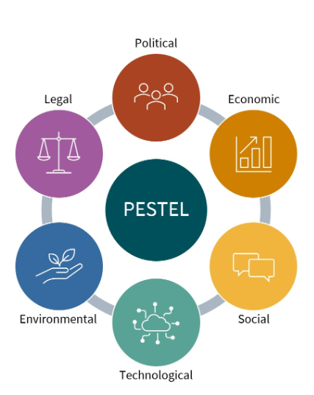
Figure 1: PESTEL Analysis
(ModernAKIS & ATTRACTISS, 2025).

3.1.1 Political
UK: The United Kingdom boasts of a stable government and a solid policy interest in electric vehicle (EV) growth via the Zero Emission Vehicle (ZEV) Mandate, mandating an increasing EV sales quota by 2035 (Department for Transport, 2025). This will be a positive political climate, and will offer favorable conditions of premium brands like BMW to fast track electrification strategies. But since Brexit trade tensions under the Trade and Cooperation Agreement have decreased the UK-EU trade volumes, introducing non-tariff barriers, and other logistics expenses, which are still unfavorable to the operation effectiveness.
Bangladesh: Bangladesh is less politically stable and levies high import taxes on vehicles according to National Board of Revenue tariff schedules (TRW Law Firm, 2025). These obligations increase the costs of imported luxury cars and unfavorable policy environment of luxury automotive development. All in all, UK provides favorable environment to the expansion of the EV by BMW, whereas Bangladesh is unfavorable because of political risk and import barriers.

3.1.2 Economic
UK: The UK is a mature and high-income economy with a GDP of approximately US $3.64 trillion in 2024, which is supported by well-developed infrastructures and well-developed financing systems that maintain premium auto demand, and the economic environment is favorable, despite cyclical headwinds (Trading Economics, 2025a). Also, GNP the Gross National Product of the UK was about US $920.7 billion in September 2024, which represents the overall income of the resident producers and foreign income.
Bangladesh: Bangladesh, On the other hand, with a GDP of approximately US $450 billion in 2024 is a rapidly developing emerging economy and its middle-income population is expanding, which is a moderately favorable forecast (World Bank, 2025). Its 2024 GNP The Gross National Product was approximately BDT 35.4 trillion, which highlights the increasing national income but on a significantly smaller scale than in developed markets (Trading Economics, 2025b). Nevertheless, poorer per-capita income and poor access to auto-finance are not favorable conditions that restrict the development of premium markets.

3.1.3 Social
United Kingdom: The socio-cultural environment of the UK supports the use of high-end automotive brands such as BMW because of a high degree of individualism and hedonism, which allows expressing oneself through owning luxury vehicles (The Culture Factor Group Oy, 2025). Empirical research shows that the consumers of the UK do not see EVs as a means of transport only, but as a symbol of identity and status (Salari, 2022). Spatial disparities in the accessibility of chargers, however, place disadvantageous obstacles to wider adoption, particularly in households that do not have personal driveways (Mesquita et al., 2025). To conclude, the BMW premium-electric strategy is supported by the UK environment, but inequity in infrastructure is a limitation.
Bangladesh: In Bangladesh, the culture of prestige consumption, which is supported by collectivism and high-power distance, dictates the demand of luxury goods - this is where BMW has a niche (The Culture Factor Group Oy, 2025). Literature highlights the fact that luxury consumption in the developing markets is less functional than socially visible (Gaur, 2025). However, affordability, small financing and infrastructure disparity offers poor conditions to mass adoption of luxury-EV uptake. Therefore, as much as the Bangladesh market offers a favorable segment in terms of elite luxury, the larger premium and EV approach has scale-and-access limitations.
Cultural Dimensions (Hofstede Model)
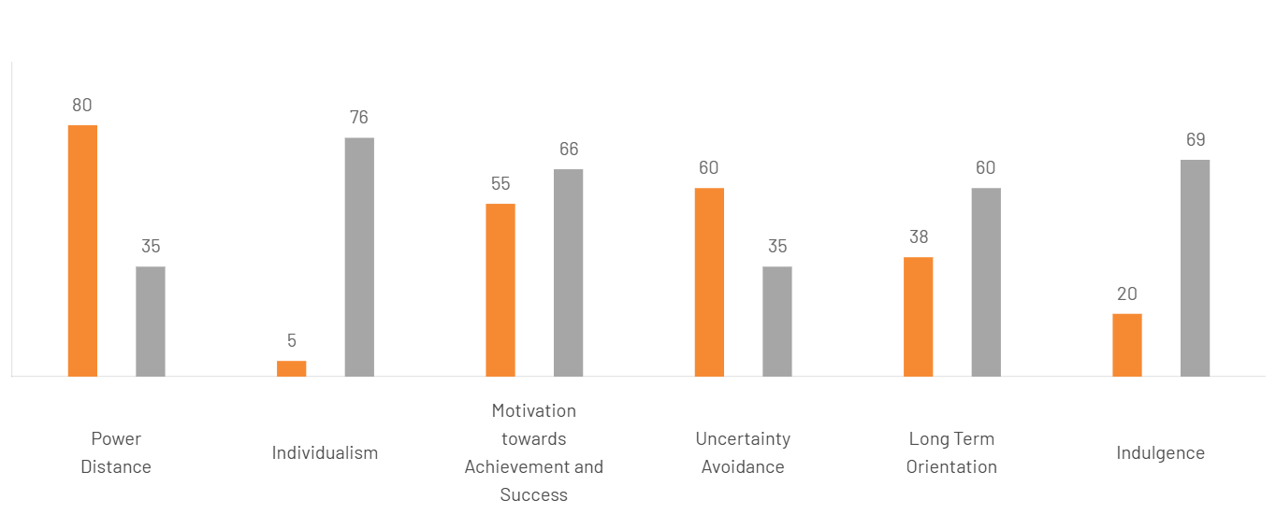
Figure 2: Hofstede Six-Dimensional Cultural Comparison
(The Culture Factor Group Oy, 2025)
Power Distance
United Kingdom (35): Low hierarchy and egalitarian values promote transparent communication and empower consumers favorable for customer-centric brand approach.
Bangladesh (80): Bangladesh scores very high on power distance, indicating a society that accepts hierarchical order and authority. Decision-making tends to be top-down, and deference to power is common. This limits customer empowerment but favors prestige marketing tied to social hierarchy.
Individualism
United Kingdom (76): A strong emphasis on independence and personal achievement aligns perfectly that favor to premium-performance positioning.
Bangladesh (5): A highly collectivist culture, Bangladeshi consumers prioritise family and community influence in purchasing decisions. This restricts independent luxury purchases but enables group-oriented brand endorsements.
Masculinity
United Kingdom (66): High masculinity reflects ambition and competition, which strengthens help to established appeal to achievement-oriented buyers.
Bangladesh (55): The moderate masculinity score shows competitiveness and ambition. This dimension is favorable for status-focused marketing.
Uncertainty Avoidance
United Kingdom (35): Low uncertainty avoidance indicates openness to innovation and technological change, highly favorable for expansion of any kind of brand.
Bangladesh (60): Bangladesh shows moderate discomfort with uncertainty, implying caution toward technological shifts like EVs. This creates an unfavorable setting for rapid innovation adoption.
Long-Term Orientation
United Kingdom (60): Future-oriented thinking and sustainability awareness support to long-term green strategy.
Bangladesh (38): A short-term outlook prioritizes immediate rewards over sustainability, limiting long-horizon investments in electric mobility. This is unfavorable for sustainability goals.
Indulgence
United Kingdom (69): High indulgence signifies a culture of enjoyment and luxury consumption, making premium car ownership aspirational.
Bangladesh (20): Low indulgence indicates restrained spending and social conservatism. Luxury car demand remains limited to affluent elites.
Overall, Hofstede’s theory shows that the UK has more favorable culture reason it supports equality, independence, and flexibility. These features help organizations work efficiently and encourage innovation. In contrast, Bangladesh is unfavorable because of strong hierarchy and resistance to change, that reduce effectiveness.
Advantages and Disadvantages of Hofstede’s Cultural Dimensions
The Hofstede framework provides valuable cross-cultural insights that assist in understanding variations in social behavior, decision-making, and organizational culture across nations (Gerlach and Eriksson, 2021). In this context, Bangladesh’s hierarchical and collectivist society tends to support prestige-based social interactions but constrains innovation and individual consumer expression. Conversely, the United Kingdom’s individualistic and indulgent culture fosters openness to new ideas, self-expression, and technological adoption (The Culture Factor Group Oy, 2025). Despite its analytical utility, Hofstede’s model is criticized for being overly static and for failing to capture the dynamic and fluid nature of modern cultural change (Yeganeh, 2025).

3.1.4 Technological
UK: The UK offers a highly technologically advanced and innovation-focused platform, especially in the field of electric vehicles (EVs). EV infrastructure is growing at a high rate, and the proportion of over 60,000 public chargers and a high focus on fast-charging systems are assisted by government programmed, including the Electric Vehicle Infrastructure Strategy (Department for Transport, 2022). This creates a favorable environment for BMW to expand its EV portfolio and align with the UK's sustainability goals. However, regional disparities in charger distribution and limited access for households without private driveways remain unfavorable, as they constrain EV adoption (Walker et al., 2025).
Bangladesh: In contrast, Bangladesh's technological environment is unfavorable for premium EV adoption due to inadequate charging infrastructure and weak technological readiness. Despite the fact that the government has already started the discussions on EV policies, the network is still underdeveloped and there are only several experimental charging points in Dhaka (Sadik, Labib and Disha, 2025). This is, however, an opportunity that BMW could take up in the future in the form of infrastructure partnerships and localization in order to become the first to adopt the premium EV.

3.1.5 Legal
UK: The UK's legal environment is favorable for global automakers, providing robust intellectual property protection, consumer safety standards, and environmental compliance frameworks. Predictable conditions of compliance and high accountability of manufacturers are established by such laws as Consumer Rights Act 2015 and Climate Change Act 2008 (The Culture Factor Group Oy, 2025). In the case of BMW, this provides operational transparency, quality and minimized brand risk. However, frequent updates in environmental legislation and post-Brexit trade adjustments can pose unfavorable compliance challenges (Walker et al., 2025).
Bangladesh: Conversely, Bangladesh faces unfavorable legal conditions for premium automotive operations. Although the country has a system in place, such as the Environmental Conservation Act (1995), it is not well enforced, and the intellectual property protection is relatively low (Haque and Hossain, 2024). Regulatory uncertainty is also enhanced by tax complexities and grey import market, which make compliance and brand protection expenses more expensive to BMW. The reinforcement of alliances with official dealers like the Executive Motors Ltd will enable BMW to act within the scope of law and reduce the risks of operating in the informal markets.

3.1.6 Environmental
UK: The UK's environmental landscape is highly favorable, characterized by stringent sustainability standards and policy commitment to net-zero carbon emissions by 2050. The Net Zero Strategy of the government encourages the process of decarburization with the help of green transport and offers increased popularity to EV and hybrid BMW models (GOV.UK, 2024). However, growing consumer scrutiny of luxury consumption's ecological footprint remains an unfavorable social pressure on premium automakers (Osburg et al., 2020).
Bangladesh: On the contrary, Bangladesh faces unfavorable environmental conditions marked by high air pollution, outdated fuel standards, and inefficient transportation systems (Saha, Sabur and Saif, 2023). These issues limit the mass use of EVs, but they also present possibilities of corporate social responsibility (CSR) programmes and the introduction of hybrid cars at BMW that would help to fill in the gaps in sustainability. Association with environmental agencies would increase the image of BMW as a sustainable mobility pioneer in the emerging markets.

3.1.7 PESTEL Similarities and Differences between the UK and Bangladesh (BMW Context)

Table1: PESTEL Similarities and Dissimilarities between the UK and Bangladesh
Factor | Similarities | Differences (UK vs Bangladesh)
Political | Both countries recognize the importance of automotive regulation and environmental policy in shaping market entry. | UK has stable governance and pro-EV mandates (favorable); Bangladesh faces political instability and high import duties on vehicles (unfavorable).
Economic | Both economies show ongoing recovery and consumer demand for vehicles, though at different scales. | UK is a high-income, mature market (GDP ≈ US $3.64 trillion); Bangladesh is emerging with GDP ≈ US $450 billion, limited auto finance and lower affordability.
Social | In both countries, luxury vehicles are viewed as status symbols. | UK’s individualism and indulgence promote innovation and self-expression; Bangladesh’s collectivism and hierarchy limit independent purchasing but enhance prestige branding.
Technological | Both governments recognize EV technology’s strategic importance. | UK has strong EV infrastructure (>60,000 chargers, advanced innovation ecosystem); Bangladesh’s EV readiness is weak, with limited charging facilities and policy implementation.
Legal | Both operate under defined legal systems addressing environmental and consumer protection. | UK enforces robust IP and environmental laws (e.g., Climate Change Act 2008); Bangladesh struggles with enforcement, weak IP protection, and complex tax regimes.
Environmental | Both countries acknowledge sustainability goals and EV relevance. | UK enforces stringent carbon reduction and net-zero targets by 2050; Bangladesh faces pollution, outdated fuel standards, and relies on CSR/hybrid adaptation.

4.0 STP (Segmentation, Targeting, and Positioning)
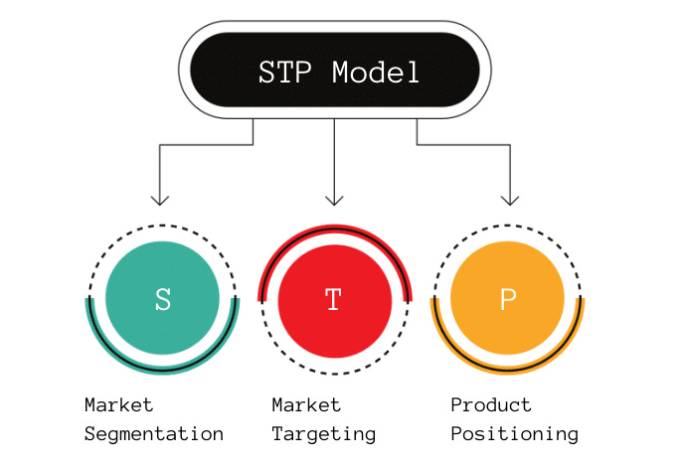

Figure 3: Segmentation, Targeting, Positioning (STP)
(Product Mindset, 2022)
The STP framework enables firms to segment markets, target consumers and position offerings, supporting BMW’s strategic adaptation across mature and emerging markets (Kotler, Keller and Chernev, 2022).

4.1 Segmentation

4.1.1 Demographic Segmentation
United Kingdom:
BMW’s UK consumer base primarily comprises affluent professionals aged 30–60, representing dual-income households with established careers in finance, technology, and management (Large, 2025). This segment consists of both a man and a woman, but in M-performance line the male buyers are more dominant whereas in compact EV segment the female buyers are on the rise. The majority of the buyers possess a tertiary education and have annual earnings exceeding PS60,000, which further strengthens their ability to spend money on luxuries. The Ultimate Driving Machine brand identity of BMW targets those who are achievement-focused and want to get a combination of performance and sustainability (Bellezza, 2022).
Bangladesh:
In Bangladesh, BMW serves a very high-income elite of 35-60 years old such as industrialists, entrepreneurs, expatriates, and top executives. It is a population that is largely dominated by men because of the traditional gender roles and patterns of wealth distribution (Dhaka Tribune, 2023). Customers are highly educated, and most have foreign education and are status conscious. Since the owning of vehicles is aspirational, the purchases of cars are heavily connected to social status, but not mobility requirements (The Culture Factor Group Oy, 2025).

4.1.2 Geographic Segmentation
United Kingdom:
Urban centers such as London, Manchester, and Birmingham account for the majority of BMW sales due to high population density, disposable income, and access to public EV charging (Department for Transport, 2022). Rural markets, while growing, lag behind due to infrastructure limitations and reliance on combustion-engine vehicles.
Bangladesh:
The brand’s operations are concentrated in Dhaka and Cartogram, which account for over 90% of national luxury vehicle sales. These metropolitan areas host affluent neighborhoods and corporate headquarters. Rural regions remain inaccessible for premium vehicles due to poor road conditions and limited service facilities (Sadik, Labib and Disha, 2025).

4.1.3 Psychographic Segmentation (VALS Model)
United Kingdom:
As the VALS (Values, Attitudes, and Lifestyles) framework indicates, the buyers of UK BMW are mostly Innovators and Achievers, the categories of people who are confident, resourceful, and leaders (Kotler, Keller and Chernev, 2022). They appreciate technology, performance, and environmental responsibility. Their way of life is in line with high-quality digital connectivity and environmentally friendly lifestyle, which is why BMW i4 and i7 are particularly appealing to them (More and Amann, 2025).
Bangladesh:
Strivers and Achievers are the two major categories of consumers in Bangladesh as they are driven by success and social status. They relate BMW ownership to prestige and social advancement, and they tend to show it as a symbol of success (Bellezza, 2022). According to the framework of VALS, this is a symbolic consumption behavior in which brand ownership implies membership in a group of aspirational elite. Nevertheless, the insufficient availability of auto financing limits the opportunities to expand to the upper-middle-income populations (World Bank, 2025).

4.2 Targeting
United Kingdom:
In the UK, BMW pursues a differentiated market approach, which focuses on several premium and environmentally friendly segments of customers.
Performance-seekers: BMW 3 and 5 Series, M variants.
Sustainability-conscious consumers: BMW i4, iX1, and i7.
Luxury executives - 7 Series, X7: This multi-layered targeting allows BMW to capitalize on the market maturity and have a balanced market income on both the traditional and electric models. The large network of dealerships and service centers increases accessibility, brand loyalty programmes and financing schemes guarantee long-term retention (Large, 2025). The strategy also conforms to the high individualism and indulgence culture of the UK in which self-expression via consumption contributes to the success of a premium brand (The Culture Factor Group Oy, 2025).
Bangladesh:
On the other hand, BMW has a narrow-targeted marketing strategy, that is, it targets only high-net-worth people. The low-end import 7 Series, X5, and X7 model serves a small customer base who value exclusivity and social status. The sales are managed by the Executive Motors Ltd, the sole authorized dealer, and the company focuses on personal relationship marketing, and customized after-sales services (Dhaka Tribune, 2023).
Despite the small market size, the level of customer loyalty and brand prestige is high because other luxury car manufacturers in the world have limited competition (Haque and Hossain, 2024).

4.3 Positioning
United Kingdom:
BMW’s positioning in the UK is built on the proposition “Sustainable Premium Performance” a combination of cutting-edge engineering, driving pleasure, and environmental responsibility.
Benefit positioning: Advanced electric drivetrains and reduced emissions create an eco-luxury appeal.
Competitive positioning: BMW positions itself between Audi (tech refinement) and Mercedes-Benz (comfort luxury), focusing on sporty handling and innovation (Kotler, Keller and Chernev, 2022).
The messaging integrates brand heritage with future-oriented values, leveraging campaigns like “Born Electric” to highlight its EV transition (BMW Group PressClub, 2020).
Bangladesh:
In Bangladesh, BMW’s positioning centers on “Symbol of Prestige and Success”, leveraging emotional and social identity cues.
User positioning: Appeals to elite consumers seeking recognition, success, and exclusivity.
Benefit positioning: Highlights craftsmanship, status, and reliability under challenging local conditions (Bellezza, 2022).
Limited product variety reinforces exclusivity, allowing BMW to maintain high symbolic capital and price leadership. This approach suits a market where prestige consumption drives brand equity more than technological or environmental considerations (World Bank, 2025).

4.4 Perceptual Map - UK Market
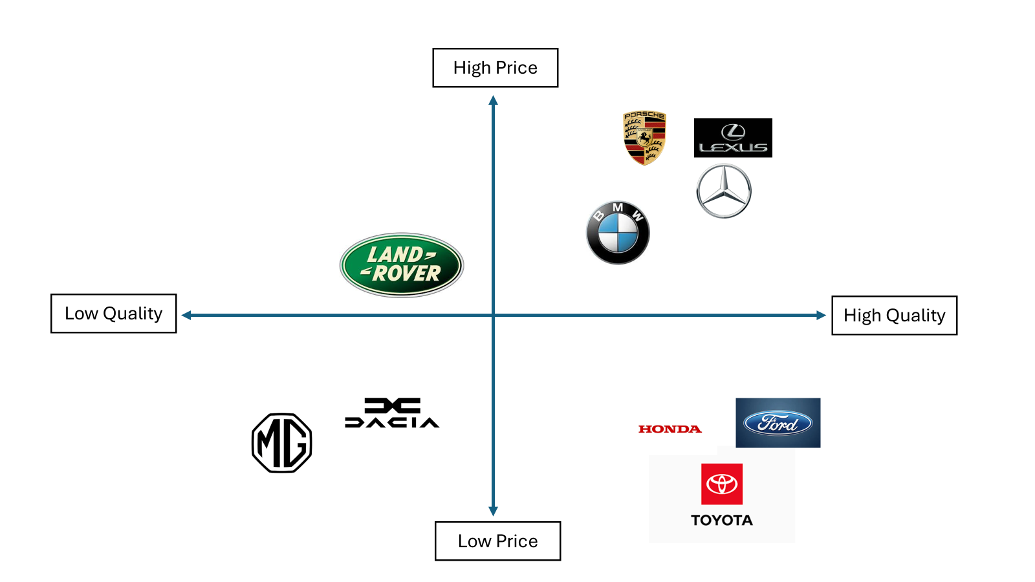
Figure 4: Perceptual Map - UK Market
(Created by Author)
The UK automobile market perceptual map places brands according to price and perceived quality. The high price-high quality quadrant consists of BMW, Mercedes-Benz, Porsche, and Lexus as the representatives of luxury, performance, and innovation. The position of Land Rover is in the high price-low quality zone, which indicates the issue of reliability in spite of high prices. Toyota, Ford and Honda are in the low-price high-quality quadrant which provides reliable low-quality cars. On the other hand, Dacia and MG will be of the low-price low-quality category and they will be appealing to cost-conscious customers who want basic functionality. This is how BMW can be differentiated as a high-quality and premium brand in the competitive UK market.

4.5 STP Similarities and Differences
Table 2: STP in UK and BD
Aspect | United Kingdom | Bangladesh
Market Maturity | Mature, diversified | Emerging, niche luxury
Segmentation | Multi-tiered demographic and psychographic segmentation | Highly elite, status-oriented segmentation
Targeting | Differentiated, EV and performance markets | Concentrated, prestige niche
Positioning | Sustainable premium performance | Symbol of prestige and success
Consumer Motivation | Performance, sustainability | Status, recognition
Infrastructure | Developed EV and finance network | Weak infrastructure, import dependency

BMW’s positioning reflects macro-environmental differences: UK consumers priorities sustainability and performance, while Bangladeshi elites value status, requiring a balance between technological leadership and prestige symbolism.

5.0 Marketing Mix (7Ps) Strategies in the UK and Bangladesh

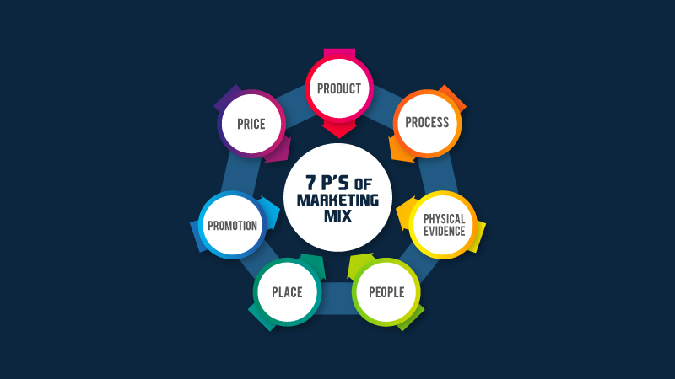
Figure 5: Marketing Mix (7ps)
(lima, 2024)
The 7Ps marketing mix framework describes the ability of firms to adjust product and service strategies to the varying market conditions. The comparison of 7Ps of BMW in the UK and Bangladesh shows the trade off between global and localisation.

5.1 Product Strategy
A product refers to a mix of physical and nonphysical features that provide customers with value and benefit such as features, packaging, branding, and supporting services (Kotler, Keller and Chernev, 2022).
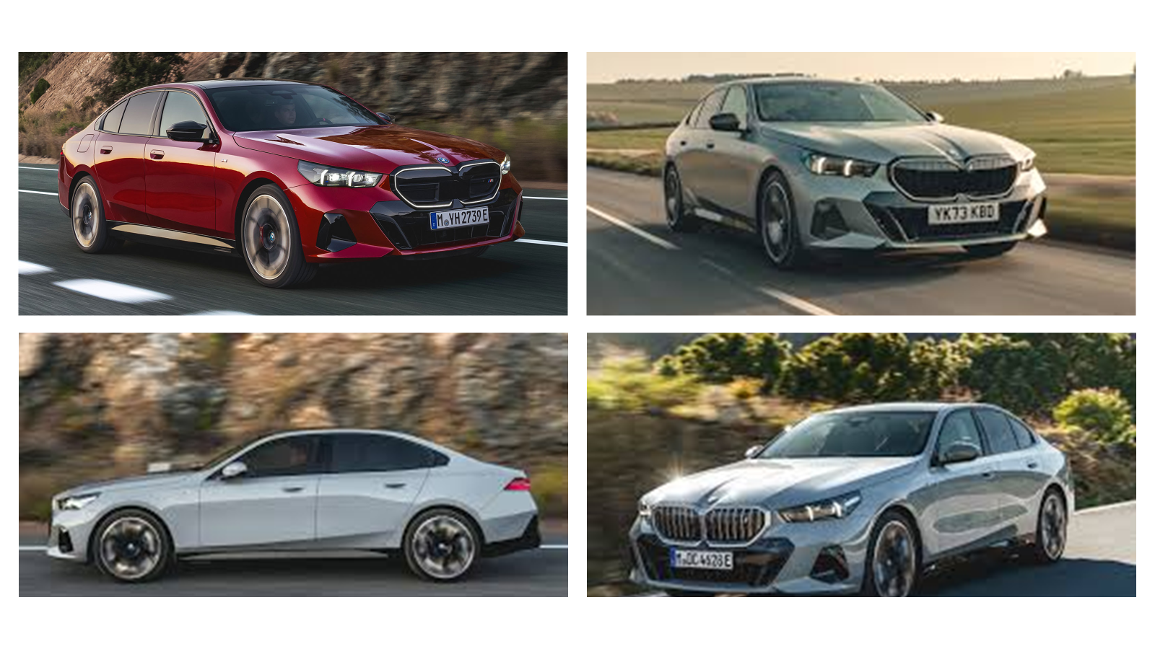
Figure 6: BMW 5 Series (UK Model)
(Kable, 2023)
United Kingdom: In the UK, BMW has a wide range of petrol, diesel, hybrid, and fully electric cars, with a high level of diversity in the trims, such as SE, M Sport, and Plug-in Hybrid. The line consists of saloons, SUVs, and EVs, all designed in an aerodynamic manner, smooth metallic surfaces, and ergonomic interiors. Such essential information as EV range, safety rating, and fuel efficiency feature are highly featured in marketing. The branding remains the same as the image of BMW around the world, with its traditional roundel, kidney grille, and Ultimate Driving Machine slogan. The UK-specific features emphasise the sustainability, digital connectivity, and the high-quality performance, which corresponds to the local PESTLE factors including high EV adoption and orienting to the innovation-oriented and environmentally conscious consumers (Kable, 2023).
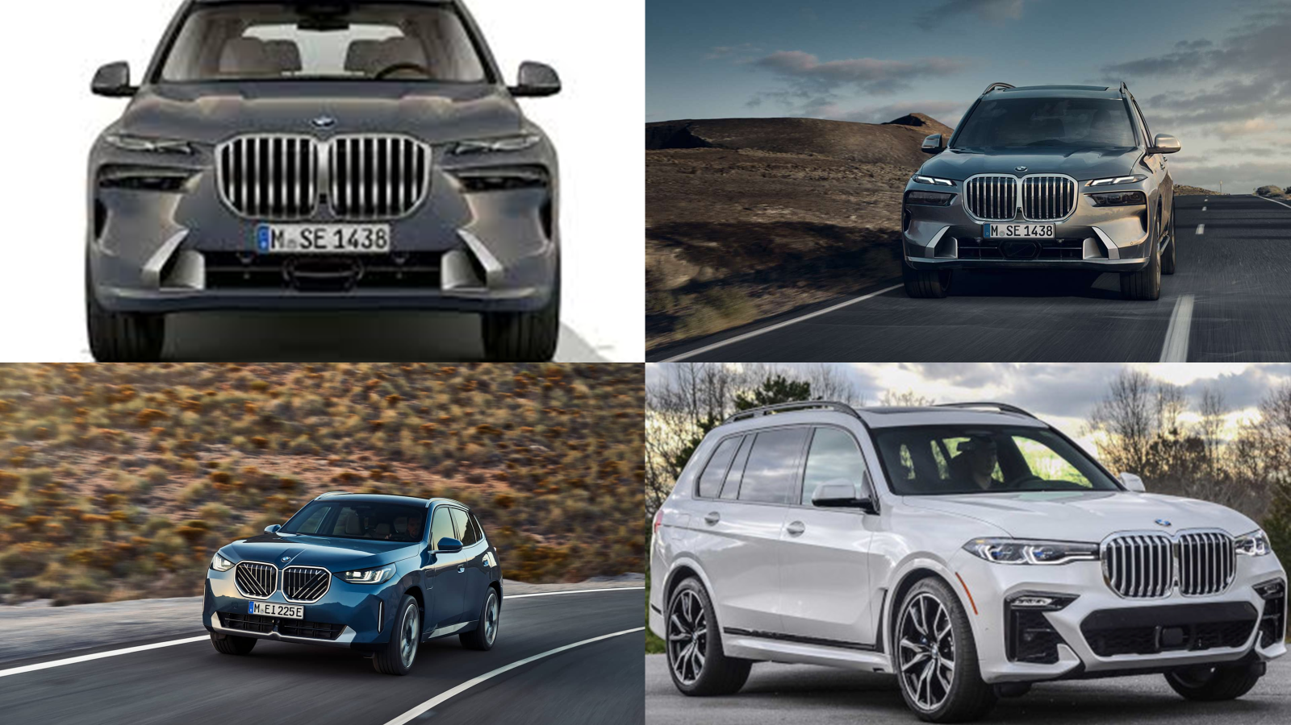
Figure 7: BMW X7 (Bangladesh Model)
(BMW, 2025)
Bangladesh: Bangladesh: BMW Bangladesh has a smaller range of products, with most products being ICE luxury sedans and SUVs such as the 5 Series, X5 and X7 since there is low infrastructure on EV products and severe import limitations. There is minimal product depth available, and there are less trims and configurations. Packaging focuses on the use of bold chrome, huge SUV body design and luxury interior design finishes that are targeted towards prestige buyers. The informational factors are safety, durability and engine capacity, which are based on local consumer values. Branding approach is universal yet focuses on exclusivity and not on the level of technological advancement. Features and benefits attraction is primarily emphasized on status signaling, comfort and durability during challenging roads, which are influenced by the infrastructural and cultural background of Bangladesh (Car Update BD, 2025).

5.2 Pricing Strategy
Pricing is defined as the value that a customer gives in terms of money in exchange of products based on the cost, competition, demand and market conditions (Ingenbleek, Frambach and Verhallen, 2013).
United Kingdom: The UK is a value-based, competitor-oriented pricing model used by BMW based on consumer demand, competition with Mercedes-Benz and Audi, inflation trends and government EV incentives. A BMW 5 Series normally costs between PS51,000 and PS90,000 (electric) (Kable, 2023). The accessibility of prices to the premium buyers is aided by higher purchasing power, good financial strategies like PCP/lease deals and steady economic conditions.
Bangladesh: The pricing in Bangladesh is prestige-based, and this is highly affected by the outside factors. Duty charges that are above 200, high inflation and lack of finance have a great impact on the prices. The price of an average BMW 5 Series is about BDT 1.3 crore, and SUVs such as X7 cost more than BDT 4.5 crore (TRW Law Firm, 2025; Car Update BD, 2025). The purchasing power is held by the affluent elites and the pricing process is more of a social status symbol than a performance measure.

5.3 Place (Distribution Strategy)
Place refers to the distribution systems that make the product available to target customers, including channels, intermediaries and logistics (Kotler, Keller & Chernev, 2022).
United Kingdom: BMW operates a multi-channel distribution system in the UK, combining nationwide dealerships, service centers, digital sales platforms and strong EV infrastructure. Efficient logistics, regional coverage and supply-chain support ensure accessibility for diverse consumer segments. This aligns with the UK’s technologically advanced and geographically dispersed market (Large, 2024).
Bangladesh: In Bangladesh, BMW relies on a single authorised distributor (Executive Motors Ltd) with showrooms concentrated in Dhaka, offering limited national reach. Distribution constraints include dependency on imported parts, restricted logistics capacity and urban-only accessibility. This exclusive distribution model aligns with the country’s narrow luxury segment and centralized consumer geography (Car Update BD, 2025).
Market Entry Methods
The entry mode by BMW in UK involved direct investment which included local production, wholly owned subsidiaries and a countrywide network of authorized dealers. This mode of entry has been selected to have complete strategic and operating control within a large and stable and competitive premium market. The benefits that come with direct investment are that they have more control over the brand standards and have a high potential of making profits in the long run, and the drawbacks are in that they require a lot of capital and are subject to market risks. Conversely, the high import taxes, small market size and complexity of the regulations made BMW to venture in Bangladesh through indirect exporting by its authorized dealer, Executive Motors Ltd. The benefits of the approach are the low cost of financial risk and local market knowledge, and the drawbacks are the lack of managerial control and the reliance on the performance of distributors (Chugh et al., 2019).

5.4 Promotion Strategy
Promotion refers to communication activities used to inform, persuade and remind target consumers about a product (Kotler, Keller & Chernev, 2022).
United Kingdom: BMW UK uses primarily offline promotional tools (i.e., print advertisements in Auto car, Top Gear Magazine and national newspapers); outdoor billboards located along major UK motorways (i.e., M25, M1); TV advertising during prime automotive advertising hours. BMW also undertakes sponsorships such as professional golf and performance activities which are also used to strengthen the premium positioning of the brand. Print and TV are credible and reach high in the UK but are costly and cannot be targeted. BMW employs two types of emotional-rational appeal: emotional with image of luxury and rational with engineering and safety statements (Large, 2024).
Bangladesh: Executive Motors Ltd, a distributor of BMW in Bangladesh, engages in offline promotion with newspaper advertisements, features in high end lifestyle magazines, in-store and exhibition displays, billboards in Dhaka, and corporate sponsorships (Dhaka Tribune, 2023). These mediums are appropriate to the luxury market in Bangladesh that is prestige based and has low digital penetration. Its strong symbolic appeal and exclusivity are its advantages; its weaknesses are its limited geographical coverage beyond Dhaka. Appeals are mainly emotional, which concern status, high-end identity and social rise.

5.5 People Strategy
People- refers to the employees whose skills, motivation and service behavior influence service quality (Hollensen, 2020).
United Kingdom: BMW UK has thousands of employees that work in its retail and service network (BMW Group, 2024). There is constant training of employees, such as EV technical certification and customer-experience programmes. Employee motivation incorporates merit-based rewards, career growth and career progressions. The skilled level is in favor of informed consultations and effective servicing that is essential to the UK, technologically informed market that is EV-ready.
Bangladesh: Executive Motors Ltd has fewer sales executives, relationship managers and technicians whose training is placed on personalized hospitality, luxury service standards and after sales handling. Incentives given to motivate the staff can be in the form of commission and loyalty building. The connexions are more relational and formal, which is another feature of the collectivist, high power-distance culture of Bangladesh (Haque and Hossain, 2024).

5.6 Process Strategy
Process refers to the procedures through which services are delivered, including purchase flow and complaint handling (Wilson et al., 2020).
United Kingdom: BMW UK has a systematic method of complaint-resolution. Customers may lodge complaints using dealerships, telephone or service desk of BMW UK. Cases are handled in a set of procedures governed by the Motor Ombudsman, with immediate reaction, clear lines of escalating and written reports on the resolution timeline. This is an indicator of high institutional regulation.
Bangladesh: Bangladesh has more personalized and manual coordination in complaint handling. Follow-ups are made through call or a personal visit with customers normally making direct contact with the relationship managers. Informal and slower escalation is partly explained by the lack of digital systems and the use of processes at the distributor level.

5.7 Physical Evidence Strategy
Physical evidence includes tangible components of service delivery such as facilities, décor, uniforms and printed materials (Mukherjee and Shivani, 2013).
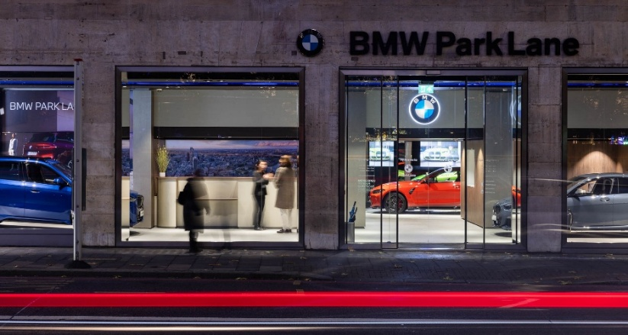
Figure 8: BMW Showroom (UK)
(Stride Treglown, 2025)
United Kingdom: BMW UK showrooms use modern minimalist designs, EV display areas, premium lighting and branded décor. Staff uniforms consist of branded polo shirts, dark trousers and BMW badges.

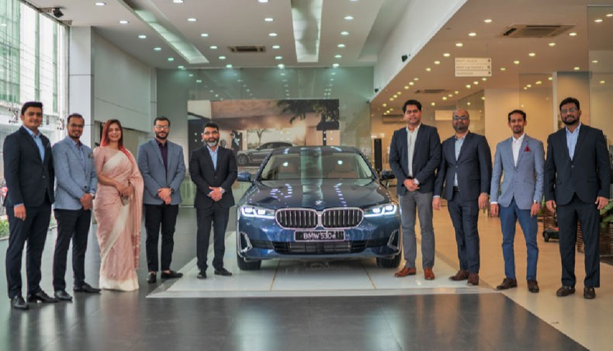
Figure 9: BMW Showroom in Bangladesh
(Newagebd.net, 2025)
Bangladesh: BMW Bangladesh showrooms highlight luxury décor, VIP lounges and exclusive consultation rooms. Staff uniforms follow formal corporate attire consistent with BMW branding.

5.8 Similarities and Differences of BMW’s 7Ps in the UK and Bangladesh
Similarities:
In both markets, BMW has a premium brand image which is globally consistent as it is manifested in the identical showroom design, recognizable branding features, and product quality. In both the UK and Bangladesh operation, the offline promotional tools are used and the luxury-focused physical evidence is put in priority. BMW has not lost its focus on personalized customer interaction and high-quality service delivery either and core brand values are not going to change despite the geographical market variations.
Differences:
There are evident differences under the influence of economic, cultural and infrastructural factors. UK has a wide and technologically developed portfolio of products, value pricing and countrywide distribution but Bangladesh has a narrower ICE product range, prestige pricing influenced by importation duties and single dealer distribution. Promotional appeals vary, and the UK has rational-emotional appeals and the Bangladesh promoted status. In UK the processes of service are regulated and structured as compared to Bangladesh which is based on manual handling of complaints which are personalized and slower.

6. Evaluation of Marketing Strategy Effectiveness
The marketing approach of BMW is very effective in the United Kingdom but has structural limitations in Bangladesh as indicated in the sales performance, social interaction and customer response.
United Kingdom
BMW recorded high market effectiveness in 2024 in the UK. BMW and Mini registrations were 172240 units, and BMW registered 125265 cars and controlled 22.6 percent of the premium auto market, which is a strong indicator of sales and revenue generation in an already competitive market. More than 26.9 percent of those registrations were fully electric, which indicated a good fit between the product strategy of BMW and the increase of EV usage among the UK consumers (BMW Group PressClub, 2024). This performance attests to the good commercial stand and profitability of BMW in the mature UK premium car market.
A diversified portfolio of products and a premium positioning bolster profitability. Reviews of the company on platforms like Trust pilot, dealership surveys, and so on are mostly satisfied with the performance, build quality, and technological functionality, but some of the comments include the problem of service responsiveness. The active brand community is seen in the activities of social media relating to UK campaigns, especially those devoted to electrified models and luxury features. Although this is not a primary promotional medium in this study, this type of engagement is an effective measure of consumer interest and brand relevance as opposed to direct marketing effectiveness.
The driving dynamics and innovation of models like iX1 and i5 are always featured in automotive media, including Autocrat and Top Gear. Combined with the systematic marketing mix of BMW, network of dealerships and developed infrastructure of EVs, the mentioned points prove that BMW UK strategy is effective and corresponds with the local regulatory, technological and consumer demands.

Bangladesh
In Bangladesh, the strategy of BMW is providing a low level of effectiveness in a targeted manner. The demand for luxury vehicles is limited by the imposition of importation taxes exceeding 200 per cent, which substantially increases prices and restricts the customer pool to wealthy elites (Chowdhury et al., 2019). Official sales data are limited, but industry estimates indicate that BMW only comprises of less than 1% of the national vehicle market, which can be viewed as low sales volume and high prestige positioning. The latest industry reports also indicate that annual sales are further constrained by inflationary pressure and currency instability, which has decreased the sales of luxury cars (The Daily Star, 2025).
The level of social media activity in Bangladesh is relatively low although it is targeted at the relatively wealthy consumers and fans, with the emphasis on status, comfort and luxury. The regional forums focus on customer feedback, which highlights exclusivity and brand prestige, and worries about expensive maintenance costs and lack of after-sales infrastructure. These observations suggest that BMW brand attraction is still a symbolically good brand, but lacks commercial performance due to macroeconomic and infrastructural challenges and not poor market orientation.
Similarities and Differences
In both markets, BMW has an advantage in the form of good brand equity and a perceived product quality. Nevertheless, UK is more effective due to scale, EV adoption and organized service system, whereas Bangladesh is a niche, prestige-driven market with little growth potential due to external constraints.

6.1 Ethical Marketing Evaluation
Ethical marketing refers to those marketing choices and practises that are morally correct, just and advantageous to both stakeholders and the society and maintain transparency and consumer confidence (Laczniak and Murphy, 2019). Assessment of ethical marketing assists in determining whether the approaches used by a firm are in tandem with the expectations and the acceptable business practices in the society.
United Kingdom
Generally, BMW has good ethical marketing practices in the UK. An example of ethical marketing is BMW advertising the power of its electric cars, in which the emission figures, the range and efficiency of driving statistics are accompanied by technical features that can be proven. This is consistent with the environmentally-sensitive target audiences (STP) and Product component of the 7Ps because it allows the informed choice of the consumer. Nevertheless, there is the possible ethical risk, where sustainability-friendly promotional messages focus on the positive aspects of the environment but do not also focus on the complete vehicle lifecycle, including the manufacturing and disposal of batteries. In terms of 7Ps, this problem can be connected to Promotion where there is no complete information and thus the message can mislead the consumers accidentally. On the whole, the ethical positioning of BMW in the UK is high, yet the continuity of openness in environmental reporting is still the key to maintaining ethical competence.

7.0 Recommendations
To strengthen BMW’s competitive performance in both the UK and Bangladesh, several strategic recommendations are proposed, grounded in STP insights and PESTLE analysis.
1. Target Market Expansion and Segmentation Strategy
United Kingdom: The existing segmentation plan of BMW in the UK is quite efficient and focuses on career professionals and high end consumers who are environmentally aware. To reinforce this argument, BMW ought to continue to increase its attractiveness to younger urban professionals, by marketing more flexible ownership options including short-term subscriptions and entry-level electric variants. This would be in line with demographic and economic PESTLE variables, especially the increase in the living cost and awareness of sustainability, and would preserve the premium status of BMW.
Bangladesh: Conversely, BMW is too focused in high-net worth individuals in Bangladesh which limits the growth of volumes. BMW needs to create a new second target market group: Aspiring Professionals - this group includes the consumers of upper-middle-income working in such fields as IT, finance and entrepreneurship. By catering to this market with certified pre-owned (CPO) cars or semi-knocked-down (SKD) assembly, price barriers would be lowered and access to the market would be ethical.
2. Pricing Strategy and Ethical Transparency
United Kingdom: BMW price strategy that is based on value in the UK is suitable but needs to be strengthened by making its EV lifecycle costs, such as battery life and sustainability effects, more transparent. This would enhance the ethical marketing practices and assist in making informed consumer choices especially in a highly regulation-aware world.
Bangladesh: In Bangladesh, pricing is an ethical issue because the importation duties are high and the costs are not clearly visible. BMW ought to come up with transparent pricing structures, which outline responsibilities, taxes, maintenance expenses and leasing facilities. Also, foreseeable leasing or subscribing would be an ethical way of taking the pricing out of exclusivity prestige signaling and making it moderated by affordability, enhancing trust and long-term brand credibility..
3. Service Process and People Development
United Kingdom: BMW needs to keep on enhancing its organized service and complaint management system by incorporating customer review feedback to enhance responsiveness and uniformity among dealerships. This helps in service quality and helps strengthen the brand loyalty in a competitive market.
Bangladesh: The service process of BMW in Bangladesh is still informal and sluggish. A digital system of complaints and service-tracking would help in enhancing efficiency and transparency. At the same time, BMW would be well advised to invest in personnel development by providing vocational training in conjunction with a BMW Technical Academy Bangladesh, to solve skill gaps and enhance the organization, ethically, in strengthening workforce development.

8.0 Conclusion
The international marketing performance of BMW in the UK and Bangladesh shows that there are significant differences that are based on macro-economic factors, expectations of the culture, STP alignment and marketing-mix adjustment. The UK plan is successful because of high EV preparedness, extensive product selections, moderate prices framework and controlled services operations. On the contrary, the performance of Bangladesh is limited due to high importation taxes, exclusive distribution and prestige-based segmentation, yet the brand appeal is high. In both markets, BMW has shown good branding at the global level but with different degrees of local operational performance. The fundamental point here is obvious: sustainable international performance is based on so that global excellence is adjusted to the local reality on the basis of ethical, inclusive and situation-specific strategies. In the future, BMW will expand its emerging markets based on clear pricing, innovation of services and culturally sensitive products that will expand the reach to more people but maintain the high-end status.

References
Bellezza, S. (2022). Distance and Alternative Signals of Status: A Unifying Framework. Journal of Consumer Research, 50(2). doi:https://doi.org/10.1093/jcr/ucac049.
BMW (2025) The new BMW X7. Available at: https://www.bmw.com.bd/models/the-new-x7/ (Accessed: 25 November 2025)
BMW Group Careers UK. (2025) ‘Our UK & IE Locations – Plant Oxford’. BMW Group Careers UK. Available at: https://www.bmwgroup.jobs/gb/en/location/location-oxford.html (Accessed: 20 October 2025).
BMW Group PressClub. (2020). ‘Born Electric’: The fully electric BMW iX takes centre stage in the BMW winter sports commitment. [online] Available at: https://www.press.bmwgroup.com/ireland/article/detail/T0321678EN/born-electric%E2%80%99:-the-fully-electric-bmw-ix-takes-centre-stage-in-the-bmw-winter-sports-commitment?language=en [Accessed 11 Nov. 2025].
BMW Group PressClub. (2024). BMW Group UK Leads the Premium Segment in 2024 with Strong Electric Growth. [online] Available at: https://www.press.bmwgroup.com/united-kingdom/article/detail/T0447261EN_GB/bmw-group-uk-leads-the-premium-segment-in-2024-with-strong-electric-growth?language=en_GB.
Car Update BD. (2025). BMW X5 (xDrive M60i) Price in Bangladesh 2025 - Car Update BD. [online] Available at: https://carupdatebd.com/product/bmw-x5-xdrive-m60i-price-in-bangladesh/? [Accessed 19 Nov. 2025].
Chowdhury, C., Bhargava, R., Ghosh, S., Vignesh, M., De, S. and Babar, S. (2019). A Study of Domestic Penetration and Export Potential of Premium Cars from India.
Chugh, R., Lindsay, V.J., Ashill, N.J. and Crick, D. (2023). The influence of psychological contracts on exporter–distributor relationships and export venture performance: the conditional role of institutional distance. Asia Pacific Journal of Marketing and Logistics, 36(3), pp.641–659. doi:https://doi.org/10.1108/apjml-01-2023-0089.
Department for Transport (2022). UK electric vehicle infrastructure strategy. [online] GOV.UK. Available at: http://www.gov.uk/government/publications/uk-electric-vehicle-infrastructure-strategy [Accessed 29 Oct. 2025].
Department for Transport (2025). Backing British business: Prime Minister unveils plan to support carmakers. [online] GOV.UK. Available at: https://www.gov.uk/government/news/backing-british-business-prime-minister-unveils-plan-to-support-carmakers [Accessed 29 Oct. 2025].
Dhaka Tribune. (2023) ‘Executive Motors Ltd introduces BMW iX3 M Sport: The first EV from BMW in Bangladesh’, Dhaka Tribune, 26 August. Available at: https://www.dhakatribune.com/323579 (Accessed: 21 October 2025).
Gaur, S. (2025). A Critical Analysis of Luxury Consumption and Its Psychosocial Factors. Journal of Informatics Education and Research, 5(1). doi:https://doi.org/10.52783/jier.v5i1.2340.
Gerlach, P. and Eriksson, K. (2021). Measuring Cultural Dimensions: External Validity and Internal Consistency of Hofstede’s VSM 2013 Scales. Frontiers in Psychology, [online] 12(1). doi:https://doi.org/10.3389/fpsyg.2021.662604.
GOV.UK. (2024). Department for Energy Security and Net Zero. [online] Available at: http://www.gov.uk/government/organisations/department-for-energy-security-and-net-zero [Accessed 29 October 2025].
Haque, A.K.M. and Hossain, I. (2024). Environmental Governance in Bangladesh: A Comprehensive Analysis of Environmental Laws and Policies. Bangladesh: Environment, Society and Politics, pp.978-984.
Hollensen, S. (2020). Global marketing (pp. 978-1). Harlow: Pearson.
Ingenbleek, P.T.M., Frambach, R.T. and Verhallen, T.M.M. (2013). Best Practices for New Product Pricing: Impact on Market Performance and Price Level under Different Conditions. Journal of Product Innovation Management, 30(3), pp.560–573. doi:https://doi.org/10.1111/jpim.12008.
Kable, G. (2023). New BMW 5 Series priced from £51,000 in the UK. [online] Autocar. Available at: https://www.autocar.co.uk/car-news/new-cars/new-bmw-5-series-priced-%C2%A351000-uk [Accessed 19 Nov. 2025].
Kotler, P., Keller, K.L. and Chernev, A. (2022). Marketing Management, Global Edition. 16th ed. S.L.: Pearson Education Limited.
Laczniak, G.R. and Murphy, P.E. (2019). The role of normative marketing ethics. Journal of Business Research, 95(1), pp.401–407. doi:https://doi.org/10.1016/j.jbusres.2018.07.036.
Large, P. (2025). SMMT Motor Industry Facts 2025 - SMMT. [online] SMMT. Available at: https://www.smmt.co.uk/smmt-motor-industry-facts-2025/.
lima (2024). Marketing Myths Busted: The Core Principles You NEED to Know. [online] Exeed College. Available at: https://exeedcollege.com/blog/the-core-marketing-principles-you-need-to-know/.
Lubis, M. and Muniapan, B. (2024). International Market Development Strategies for Enhancing Global Expansion in the Export Industry. Involvement International Journal of Business, [online] 1(1), pp.14–27. doi:http://dx.doi.org/10.62569/iijb.v1i1.3.
Mesquita, A.R., Hugo, V., Nunes, P.C. and Santos, A.S. (2025). Barriers to Electric Vehicle Adoption: A Framework to Accelerate the Transition to Sustainable Mobility. Sustainability, [online] 17(18), p.8318. doi:https://doi.org/10.3390/su17188318.
ModernAKIS & ATTRACTISS. (2025) PESTEL Analysis: ISS Tools and Methods. AKISconnect – Connecting all EU AKIS actors. Available at: https://akisconnect.eu/en/iss-tools-and-methods/tool-details?id=34&name=Pestel+Analysis (Accessed: 22 October 2025).
More, R. and Amann, C. (2025). BMW boosts profit margin for cars as EV spending passes peak. Reuters. [online] 5 Nov. Available at: https://www.reuters.com/business/autos-transportation/bmw-boosts-profit-margin-cars-third-quarter-2025-11-05/.
Mukherjee, S. and Shivani, S. (2013). Influence of Physical Evidence on Service Brand Image Dimensions and Brand Equity. Indian Journal of Marketing, 43(6), p.15. doi:https://doi.org/10.17010/ijom/2013/v43/i6/36389.
Newagebd.net. (2025). New BMW 5 Series launched in Bangladesh. [online] Available at: https://www.newagebd.net/article/130360/new-bmw-5-series-launched-in-bangladesh [Accessed 26 Nov. 2025].
Osburg, V.-S., Davies, I., Yoganathan, V. and McLeay, F. (2020). Perspectives, Opportunities and Tensions in Ethical and Sustainable Luxury: Introduction to the Thematic Symposium. Journal of Business Ethics, [online] 169(2). doi:https://doi.org/10.1007/s10551-020-04487-4.
Product Mindset (2022). STP Model: Segmentation, Targeting & Positioning. [online] productmindset.substack.com. Available at: https://productmindset.substack.com/p/stp-model-segmentation-targeting.
Sadik, M.S., Labib, M.I. and Disha, A.S. (2025). Transitioning to Cleaner Transport: Evaluating the Environmental and Economic Performance of ICE, HEVs, and PHEVs in Bangladesh. World Electric Vehicle Journal, 16(7), p.380. doi:https://doi.org/10.3390/wevj16070380.
Saha, R.C., Sabur, H.M.A. and Saif, T.Md.R. (2023). Environmental Sustainability of Inland Freight Transportation Systems in Bangladesh. International Supply Chain Technology Journal, [online] 9(9). doi:https://doi.org/10.20545/isctj.v9i9.300.
Salari, N. (2022). Electric vehicles adoption behaviour: Synthesising the technology readiness index with environmentalism values and instrumental attributes. Transportation Research Part A: Policy and Practice, 164, pp.60–81. doi:https://doi.org/10.1016/j.tra.2022.07.009.
Stride Treglown. (2025). BMW/MINI Flagship Showroom. [online] Available at: https://stridetreglown.com/projects/bmw-mini-flagship-showroom/.
The Culture Factor Group Oy. (2025) Country Comparison Tool – United Kingdom and Bangladesh. The Culture Factor. Available at: https://www.theculturefactor.com/country-comparison-tool?countries=bangladesh%2Cunited+kingdom (Accessed: 22 October 2025).
The Daily Star. (2025). The Daily Star. [online] Available at: https://www.thedailystar.net/business/news/luxury-car-sales-plunge-amid-political-economic-uncertainty-3946551 [Accessed 16 Dec. 2025].
Trading Economics. (2025a) ‘United Kingdom GDP’. Trading Economics. Available at: https://tradingeconomics.com/united-kingdom/gdp (Accessed: 22 October 2025).
Trading Economics. (2025b) ‘Bangladesh Gross National Product’. Trading Economics. Available at: https://tradingeconomics.com/bangladesh/gross-national-product (Accessed: 22 October 2025).
TRW Law Firm (Tahmidur Rahman Remura Wahid). (2025) ‘NBR Tax & VAT Compliance (2025): The complete, practical playbook for CFOs, founders, and compliance teams’. Tahmidur Rahman Law Firm in Bangladesh. Available at: https://tahmidurrahman.com/nbr-tax-vat-compliance/ (Accessed: 21 October 2025).
Walker, A., Webb, D., Hutton, G., Jozepa, I., Stewart, I., Tyers, R. and Hinson, S. (2025). Electric vehicles and infrastructure. [online] House of Commons Library. Available at: https://commonslibrary.parliament.uk/research-briefings/cbp-7480/? [Accessed 2 November 2025].
Wilson, A., Zeithaml, V., Bitner, M.J. and Gremler, D., 2020. EBK: Services marketing: Integrating customer service across the firm 4e. McGraw Hill.
World Bank (2025) Bangladesh Data: Country Indicators 2024–2025. The World Bank Group. Available at: https://data.worldbank.org/country/bangladesh (Accessed: 10 November 2025).
World Bank Group (2025) ‘Bangladesh: Data’. The World Bank – World Development Indicators. Available at: https://data.worldbank.org/country/bangladesh (Accessed: 21 October 2025).
Yeganeh, H. (2025). Hofstede, GLOBE, Schwartz and Inglehart’s cultural dimensions: a critical examination and assessment. European Business Review. doi:https://doi.org/10.1108/ebr-05-2025-0144.
Yu, Q., Zhang, M. and Ju, Y. (2023). BMW’s International Marketing Strategy Analysis. Advances in Economics Management and Political Sciences, 42(1), pp.89–96. doi:https://doi.org/10.54254/2754-1169/42/20232084.

