Financial Management for the Hotel Industry

Student name: Digbijoy Roy
ID: 2117381
Module: BMIH 5007

COMPARISON OF TWO HOSPITALITY ORGANISATIONS

Executive summary
The entire report effectively described the effective comparison of two different organizations that operate their business in the hospitality industry. Marriott International and Accor International are two well-known hospitality organizations and an overall business comparison between the two companies has been done with accurate information in an adequate manner. As per the comparisons it has been found that Marriot is performing better as compared to Accor. Eventually, once the marketing manager of both organizations implements appropriate strategy, they will be able to maintain sustainability in the international competitive marketplace.
Table of Contents
Introduction 4
Comparing Approaches to financial management 5
Total Revenue 5
Market Position 6
Growth Potential 8
Financial Commitment to CSR 9
Recommendation 10
Conclusion 10
Reference list 12

Introduction
Comparing different approaches to the financial management systems of two different organizations in the same industry is the most important factor that helps to recognize the organizational performance in the marketplace. The entire study paper is going to discuss effective compression between two different approaches of two organizations such as Marriott International and Accor International, which are operating their business in the hospitality industry. Considering the relevant information regarding total revenue, growth potential, market position and financial commitment to the CSR model of both organizations severely will be found in the paper. Based on the effective information, an effective decision can be made to get opportunities for growth and potential for outsourcing. Eventually, the organizations will be able to maintain sustainability in the international marketplace.
Company details

Figure 1: Company logo of Marriott International
(Source: Marriott.com, 2023)
Marriott Hotels & Resorts is one of the famous brands of Marriott International of full-service hotels as well as resorts-based Bethesda in Maryland. The company was founded in 1957 and J. Willard Marriott is the founder of the company... The organization is operating their business with its headquarters in Bethesda, Maryland in the US. According to the business report of Marriott International of 2020, it has been identified that they are servicing their services among 582 hotels and resorts with 205053 rooms under the brand. They also have additional 160 hotels with around 47765 rooms that are planned for further development which depicts a great organizational plan for potential growth. However, Marriott Group is spread over more than 8500 locations which is great to get a high position in the international marketplace.

Figure 2: Company logo of Accor International
(Source: Accor.com, 2023)
Accor S.A. is one of the well-known French multinational hospitality business organizations that manages, owns and franchises vacation properties, resorts and hotels. Accor Group is the largest hospitality business organization in Europe and also it is determined that the company is the sixth largest hospitality organization worldwide. The CEO of the company is “Sébastien Bazin” and they are operating their business activity with its headquarters at “Issy-les-Moulineaux”, France. The company was founded in 1967 and the founders of the company are “Paul Dubrule” and “Gérard Pelisson”. In this present situation, the company operates across 5300 locations in over 110 countries.

Comparing Approaches to financial management

Total Revenue
The annual revenue of Marriott International for the year 2022 is determined at $20.773 billion and comparing the amount of total revenue of the year 2022 with 2021, it is 49.91% value from the financial year 2021. Therefore, it is determined that the company improves its efficiency in terms of generating total revenue by using its assets and managing its operational activities properly. Furthermore, for the twelve months ending March 31 in the year 2023, the total revenue of Marriott is evaluated for $22.189 billion, and which is a 40.97% appreciated value year-over-year (Helmold and Helmold, 2020, p.11). Therefore, it can be recognized that Marriott is very much concerned to improve its financial performance in the upcoming years by implementing strategic approaches.
On the other hand, focusing on the financial performance of Accor Group, which generated total revenue of approximately 2.2 billion Euros in the financial year 2021? The company generated total revenue in the financial year 2021 by increasing the value from 1.62 billion Euros in the previous financial year (Demirçiftçi, 2022, p.8). Furthermore, focusing on the financial performance of the year 2022, it has been found that 4224 million Euros which is higher than in 2021 and that is representing a better financial performance for the company. However, comparing the total revenue of both organizations it has been found that the financial performance of Marriott Group is better as compared to the Accor group. In this case, Marriott is truly efficient in implementing and using appropriate strategies and advanced technologies to reduce total expenses over a financial period as compared to Accord International. Therefore, Marriott International generated a high profit in this recent financial year which makes them a top-level organization in the international hospitality industry.

Market Position
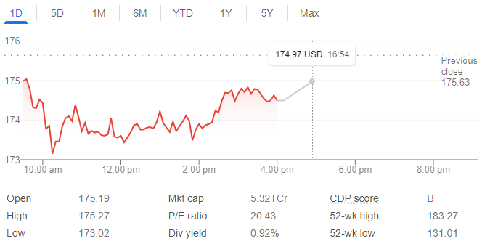
Figure 3: Market position of Marriott International
(Source: Soegiono, 2021, p.6)
Concerning the current stock price of Marriott Group, it is determined at 174.49 USD and the curve of the stock price is shifting downwards in this present financial situation. Marriott International is one of the well-known global hospitality chain-based organizations in the United States market. The market size of the Marriott group in the global hospitality industry is computed for 4699.6 billion USD which is great to generate a high profit by operating business in the international marketplace (Statista.com, 2023). However, the market cap of the company is 5.32TCr and the price-earnings ratio is determined at 20.43 in this current financial period.
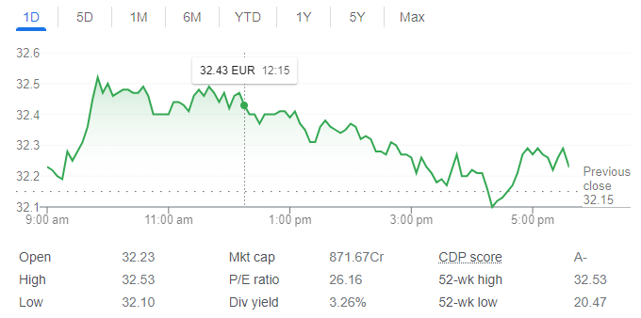
Figure 4: Market position of Accor International
(Source: Seraphin, 2021, p.34))
Concerning the recent stock price of Accor International, it has been found that the stock price of the company was recently determined at 32.23 Euro and the curve of the stock is shifting upwards which is great to get strong financial support from the external market. Accor International has an amount of market cap of 871.67cr which is lower as compared to Marriott International (Sikó and Vetró, 2022, p.184). Furthermore, concerning the price-earnings ratio of the company it has been found that the ratio is determined at 26.16 which is quite better than the P/E ratio of Marriott International. However, recently Marriott is facing a few financial issues in the case of earnings per share, and they are very concerned to mitigate the financial issues in an adequate manner in the upcoming situation. Apart from this, Accor Group significantly follows the market penetration strategy that helps them to enhance their ability to get more orders of the products. Once Accor International focuses on completing further marketing strategies by meeting all the requirements they will be able to achieve a high position in the international marketplace.

Growth Potential
Marriott International globally added more than 65000 rooms within around 394 properties during the financial period 2022. In this case, the company included approximately 40000 rooms in the global market and very closely around 175000 conversion rooms. Considering the growth of Marriott International, it is predicted that net room growth for the year 2023 can be between 4% and 4.5%. In this case, it is great for the internal hospitality organization to expand its business in terms of providing better service to an appreciated number of customers (Simões, 2021, p.5). Marriott Group reported growth in gross system size of 5.8% year over year and around 0.9% year to date. At the end of the financial year 2022, the worldwide system of Marriott consisted of close to 83000 properties and approximately 1.5 million rooms in 138 territories and countries.
On the other hand, focusing on the continual hotel expansion of Accor International, great prices can be identified in the business performance of the company. Accor Group is internationally progressing apace as per the latest accounting figure from its 2022 accountings. The group significantly opened around 299 hotels and approximately 43000 rooms in the financial year 2022 (Rahmawati et al. 2023, p.5). In this case, it effectively equates to net organic growth in a network of 3.2% over the upcoming financial period. As per detailed information from the "development and design & technical services teams" of Accor Group, it has been found that the company achieved a net growth rate of 3% in financial 2021 with more signings and openings.
After all of these, comparing the growth potentials of both organizations it has been found that Marriott is more concerned to expand their business within every concise period than Accor Group. The growth rate of Marriott is also higher than the growth rate of Accor International. In this case, the marketing manager and organizational manager of the Marriot need to be concerned about the further potential risks that may become barriers to maintaining a positive growth rate. Therefore, they will be able to maintain organizational growth efficiently and maintain sustainability in the marketplace in the long run.

Financial Commitment to CSR
Recognizing every financial year, Marriott Group shall efficiently spend at least 2% of its average net Profits in the preceding three financial years immediately. The company believes in preparing the communities where they significantly operate a better place to live, visit and work. Moreover, in terms of supporting resilience as well as sustainable development of all the communities, the international hospitality company invests in the vitality of their natural resources and children as well as efficiently delivers support and aid by considering their needs. However, the company is very much concerned with maintaining spending for the CSR expenditure and that shall mean all the essential expenditure incurred respecting the specific programmers or projects regarding the approved CSR activities (Sanvitale, 2020, p.5). However, CSR expenditure shall not effectively include the programs or projects or activities undertaken outside India. Contribution by other affiliates of Marriott or the employees may be received too and utilized respecting the CSR activities undertaken. The CSR committee shall generally have the authority for constituting the Core CSR Sub-Group along with appoints as well as removing the members of the same. Furthermore, the Cure CSR Sub-Group would be a significant sub-committee of the Committee of CSR. Focusing on major factors of the CSR commitment of Marriott it has been found that the company is truly concerned to make better organizational behavior and improve the workflow with great efficiency in the upcoming situation.
On the other hand, Accor International is deeply committed to its sustainable value creation and efficiently plays a significant and active role in the case of giving back to the community and planet. Accor International is a committed, inclusive organization that efficiently strives to restrict its carbon footprint and its major impact on the entire planet (Le Bot et al. 2022, p.102945). In this present situation, Accor Group considers its corporate responsibility for the next financial level by bolding a new CSR commitment and looking for four major strategic areas of action as well as 2 properties. The international business organization takes responsibility in terms of involving its hotels along with their consumers in the sustainable development program and it is entitled ‘Planet 21'.

Recommendation
Opportunities for Growth
Comparing the different aspects of financial managers of both organizations Marriott International Inc and Accor International it has been found that both organizations are trying to improve their marketing style in an adequate manner. However, in this recent financial period, the stock price of Marriott International became lower as compared to the previous financial period and that needs to be improved in the upcoming situation. In this concern, it can state that issuing more shares, as well as offering more shares for sale and eventually buying back the shares is the strategic approach to improve the stock price of a company, once the marketing manager of Marriott focuses on considering each strategic approaches, they will be able to gain high return as per share in the future. Eventually, the curve of stock price will go upward. Therefore, the company will get the opportunities to maintain continuous growth and maintain long-term sustainability in the international marketplace.
The most effective way of appreciating the share price is through dividends. Once the marketing manager of Accor International focuses on offering high dividends to its investors they will be able to attract the attention of more stakeholders. Consequently, strong financial support will be gained, and it will help them to achieve potential growth.
Potential for Outsource
Finding out potential outsourcing is the most important factor for any kind of business organization. In this present case, it can state that making a list of organizational goals and objectives will be the best strategic approach for Accor International. On the other hand, "thinking quality not about cost" will be an effective strategic approach for Marriott International to maintain the potential outsources. Therefore, both organizations will be able to maintain sustainability in the international competitive hospitality industry greatly.

Conclusion
After all of these, it can be concluded that comparing the organizational performance of the different organizations is the most important factor to make effective decisions for sustainability. The entire report described a comparison between Marriott International and Accor International in the global hospitality industry. However, total revenue and CSR commitment of variation are truly better as compared to Accor which brings them a better position in the international hospitality industry. On the other hand, the market position of Accor is recently better as compared to Marriott. Eventually, once both organizations become concerned about adopting further marketing strategies, they will be able to maintain their sustainability in the competitive marketplace.

Reference list
Accor.com, (2023), ‘About Us’ available at: https://group.accor.com/en/hotel-development/Optimise-your-costs/People [Accessed on: 12th May, 2023]
Demirçiftçi, T., (2022). How To Be a Successful Revenue Manager: A Case from the Marriott Turkey Cluster. Journal of Tourismology, 8(1).
Helmold, M. and Helmold, M., (2020). Total revenue management (trm) (pp. 1-12). Springer International Publishing.
Le Bot, C., Perrigot, R., Déjean, F. and Oxibar, B., (2022). Corporate Social Responsibility in franchise chains: Specificities, insights from French franchise chains’ CSD, and avenues for future research. Journal of Retailing and Consumer Services, 66, p.102945.
Marriott.com, (2023), ‘About Us’ available at: https://www.marriott.com/marriott/aboutmarriott.mi [Accessed on: 12th May, 2023]
Rahmawati, O.M., Sugiharto, S., Yudiarti, T., Widiastuti, E., Wahyuni, H.I., Sartono, T.A., Agusetyaningsih, I. and Ayasan, T., (2023). Effect of unripe banana flour as a functional feed ingredient on growth performance, internal organ relative weight and carcass traits of broilers. Veterinary Medicine and Science.
Sanvitale, A.L., (2020). Corporate Social Responsibility in the Hotel Industry: A Study of Marriott International and Odyssey Hotel Group.
Seraphin, H., (2021), January. COVID-19: An opportunity to review existing grounded theories in event studies. In Journal of Convention & Event Tourism (Vol. 22, No. 1, pp. 3-35). Routledge.
Sikó, B. and Vetró, R., (2022). Green Hotels–business potential and market advantage. In Shape the future together! -IV. BBS International Sustainability Student Conference Proceeding (PDF) Budapesti Gazdasági Egyetem (p. 184).
Simões, A.V.C., (2021). Equity valuation of Marriott International (Doctoral dissertation).
Soegiono, D.P., (2021). INTERNSHIP REPORT “DIM SUM TRAINING AT TANG PALACE JW MARRIOTT SURABAYA”.
Statista.com, (2023), ‘Market size of Marriott group’ available at: https://www.statista.com/topics/1872/marriott-international/#topicOverview [Accessed on: 12th May, 2023]

