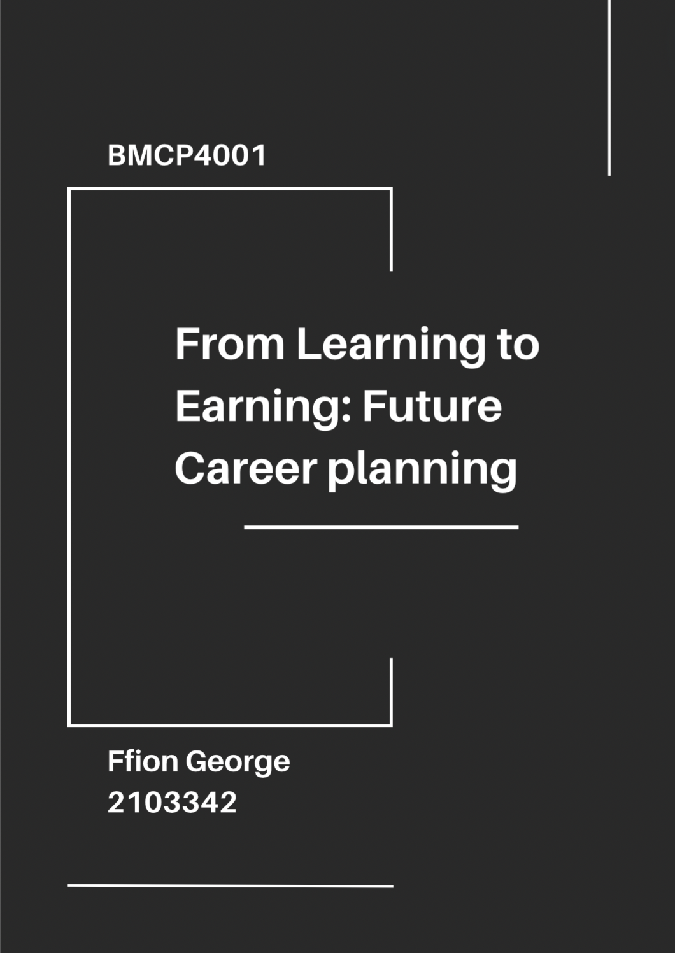
Table of Contents
Introduction 1
Success in the workplace 1
Qualities for success 1
General attributes essential for success 1
How to be successful in work 2
What do employers want? 3
Important skills for employability within the Police 3
CV 4
Covering letter 6
LinkedIn profile 8
Reference list 11

Introduction

Success in the workplace

Success can be defined in many different ways, personal to each individual. Jackson, N (2023) states that the word "success" can mean different things to different individuals. Achieving a particular degree of financial security or professional success could be considered success for some, whereas others might define success as making a positive difference in the world or leading a fulfilling personal life. Developing employability skills are important as not only do they help individuals feel more confident in their work but through utilising them correctly individuals can make use of them in a a variety of different ways outside of work. Having these skills can help job applications appear stronger as well.

Qualities for success

According to Indeed (2023) Professionals that are successful frequently credit their accomplishments to their favourable attributes and effectiveness. It's advantageous to cultivate specific success traits in order to realise full potential and accomplish professional objectives.

Some of the best qualities for success in the workplace include ambition and dedication. Ambition inspires us to set objectives, stretch ourselves, and rise to challenges that lead to development. Dedication keeps individuals going no matter how challenging the task or job may be. Individuals will always find a reason to continue doing what they are doing if they are committed to something.

General attributes essential for success

According to Forbes (2023) some of the most important attributes for success include resilience. The ability to successfully adjust to demanding or difficult life situations—particularly by exhibiting mental, emotional, and behavioural flexibility and adjusting to both internal and external demands is the process and result of resilience (American psychological association, 2024). According to High-Speed Training (2020) It also makes it possible to live a proactive daily life. As a resilient individual typically feels more comfortable with normal day-to-day chores because of their logic-oriented perspective and dedication to problems solving. Another general attribute that is key for success is mental toughness. According to Kambo, S (2023) mentally strong people, according to research, are better able to control their impulses and behaviour so they can choose a more suitable response and focus on the tasks at hand. They are able to use self-enhancing humour and positive, motivating imagery as well as coping mechanisms that effectively manage stress. These qualities are conducive to effective learning, academic success, productive work, and other
Goal setting is another key quality as helps individuals concentrate on the following action and progress in the desired direction (Positive Psychology, 2019). Teamwork and collaboration are important qualities for success also. According to Middleton, T (2024) Studies demonstrate that cooperatively addressing problems produces superior results and with a team behind them, people are more inclined to take measured chances that result in innovation.

The Big 5 Model

The big 5 model includes the following five broad aspects of personality. Neuroticism, agreeableness, extraversion, conscientiousness, and openness to new experiences. Researchers and psychologists frequently use these dimensions to characterise and forecast behaviour in a variety of contexts, including the workplace. The Big 5 model provides a thorough framework for comprehending the ways that individual personality variations can affect career outcomes (Treglown, L. 2023)

How to be successful in work

Developing the mindset that learning never stops is a terrific approach to keep improving your abilities and skills while working. You can have faith and confidence in your abilities, but in order to maximise your performance and grow in those areas, it's critical to identify your strengths and weaknesses. Having regular discussions are highly advantageous if you're eager to advance your career. Through doing this individuals will have the chance to discuss workload and any prospects for advancement, in addition to asking questions and airing any grievances an individual may have. Doing this can also display how committed individuals are to improving as employee’s and how enthusiastic about your work and individual is. Career burnout can happen when individuals spend too much focus on work specifically. Happiness and success at work are largely dependent on maintaining a good work-life balance. A healthy work-life balance just entails finding time for self-care in addition to working hard. (Michael Page, 2024)

What do employers want?

According to Prospects (2023) employers value effective communication, resilience, commercial awareness, leadership and management, planning and research skills, adaptability, teamwork and interpersonal skills, and relevant work experience the most.

Important skills for employability within the Police

The police force is one of the most challenging careers, being not only physically demanding but mentally and emotionally demanding too. West Mercia Police (2024) states that some of the key qualities for a police officer includes being able to handle delicate and complicated cases that call for logical reasoning, the collection of evidence, the assessment of data, and the recording of specifics. According to Careers Wales (2024) police officers require honestly, confidence, social awareness, resilience, strong communication skills, and self-discipline for success.

CV

FFION GEORGE


Professional summary
Confident leader with background upholding high standards in busy industrial settings.
Methodical thinker with proven organisational skills. Driven to deliver high-quality service and consistent results. Energetic and well-versed in strong communication and organisation skills. Adept at multi-tasking, and keen to develop and advance professionally into position offering additional professional challenge and room for advancement.
Ffion.george01@gmail.com
Work History

KFC - Shift supervisor
Carmarthen, Carmarthenshire 10/2021 – Current

•Positively reinforced successful shift performance, providing clear, specific, timely and respectful coaching to shift staff
• Kept employees operating productively to meet business and customer needs.
• Trained and mentored new employees to maximise team performance.
• Adhered to company standards and compliance requirements for operations and cleanliness.
• Addressed staff absences and holiday requests to achieve consistent rota coverage.
•Employed forward-thinking mindset to anticipate and quickly eliminate issues on shift.
Skills
• Safety assessment
• Customer-centric attitude
• Accurate money handling
• Engaging leadership style
• Communication skills
• Problem solving
•Training and development
• Time management
• Staff coaching
• Performance management
• Inventory control

www.linkedin.com/in/ffion-george-7164622b7
28/12/2002
@gmail.com
Gorslas, Llandeilo Road
07539 291968

Education

Ysgol Bro Dinefwr
Llandeilo, Carmarthenshire A-Levels
• History - B
• Welsh Baccalaureate - C
• Double Award Sport - DM

Ysgol Bro Dinefwr
Llandeilo, Carmarthenshire GCSEs
• Mathematics - B
• Welsh Language - B
• English Language - B
• Welsh literature - C
• English literature - C
• Numeracy - C
• Biology
• Chemistry
• Geography - C
• Food and Nutrition - O
• Welsh Baccalaureate- C
• Physics - D
• Religious Education Short Course - D
• Health and Social Care - D
Dunbia - General operative
Cross hands, Carmarthenshire - 06/2021 - 08/2021

• Picked and packed with speed and precision.
•Worked part of fast-paced production line, continually achieving targets.
• Followed production guidelines and specifications to produce quality products.
• Kept clean working areas for safe, productive warehouse environments.
• Assembled products with precision to meet quality standards within agreed timeframes.
• Moved or rearranged stock manually or with aid of special equipment.

Languages
English, Welsh
Accomplishments
• Achieved Duke of Edinburgh Bronze Award
Cwmcerrig - Waitress assistant
Cefnithin, Carmarthenshire - 07/2018 - 08/2020

• Upheld excellent standards to create safe working environment complying with health and safety regulations and food safety standards.
• Served meals and drinks with professionalism and skill, maintaining high presentation and quality standards.
• Created friendly, welcoming atmosphere to encourage positive guest experiences, prolonging visits to increase profitability.
• Resolved guest complaints promptly and professionally, notifying restaurant management of concerns.
• Informed kitchen staff regarding special order requirements.
• Checked in with customers during meals to check orders were received correctly and met guests' expectations.
• Greeted and escorted guests to tables.

Covering letter

FFION GEORGE
Ffion.george01@gmail.com

To whom it may concern,

I would like to express my interest in the position within the Dyfed Powys Police Force. I am a self-motivated, resourceful and progress driven individual. I am an astute problem solver capable of prioritising and completing complex projects with proficiency. I have been interested with the police force since a young age and am currently studying Criminology and Policing at the University of Trinity Saint David.

As an experienced shift supervisor, skilled with 2 and a half years of experience, I am certain that my background and skill set would be of great use to this job. I have acquired useful knowledge in health and safety, communication and leadership in my current position at KFC. At the University of Wales Trinity Saint David, I have gained a strong understanding of the police force as well as legislation.

Throughout my time working as well as studying, I have honed my skills in remaining calm and composed under pressure, which I believe are essential qualities for a successful police officer. In addition, my attention to detail and ability to follow procedures meticulously ensure that tasks are completed accurately and efficiently. My ability to multitask in a fast-paced work environment, pay close attention to detail, and possess good organisational and communication skills have allowed me to regularly produce high-quality work and cultivate positive connections with customers as well as co-workers. In my role as a shift supervisor, I exercised ability to learn and grow, develop my leadership as well as communication skills. Whilst studying I was able to successfully develop my time management skills, critical thinking skills, research skills as well as my adaptive thinking skills.

I am drawn to Dyfed Powys Police because of its reputation for safeguarding the community. I am excited about the opportunity to contribute my skills and experience to a company that shares my passion for helping people in need. In addition to my experience as a shift supervisor, I possess excellent confrontation management skills, as well as the ability to think on my feet. I am a quick learner, a team player, and I can work under pressure to meet tight deadlines. I have proven to be effective and motivational with proficiency in creative problem solving and collaborative work. I have enclosed my CV for your review, and I would appreciate the opportunity to speak to you regarding my candidacy for the role.

Regards,
Ffion George

LinkedIn profile

LinkedIn - www.linkedin.com/in/ffion-george-7164622b7

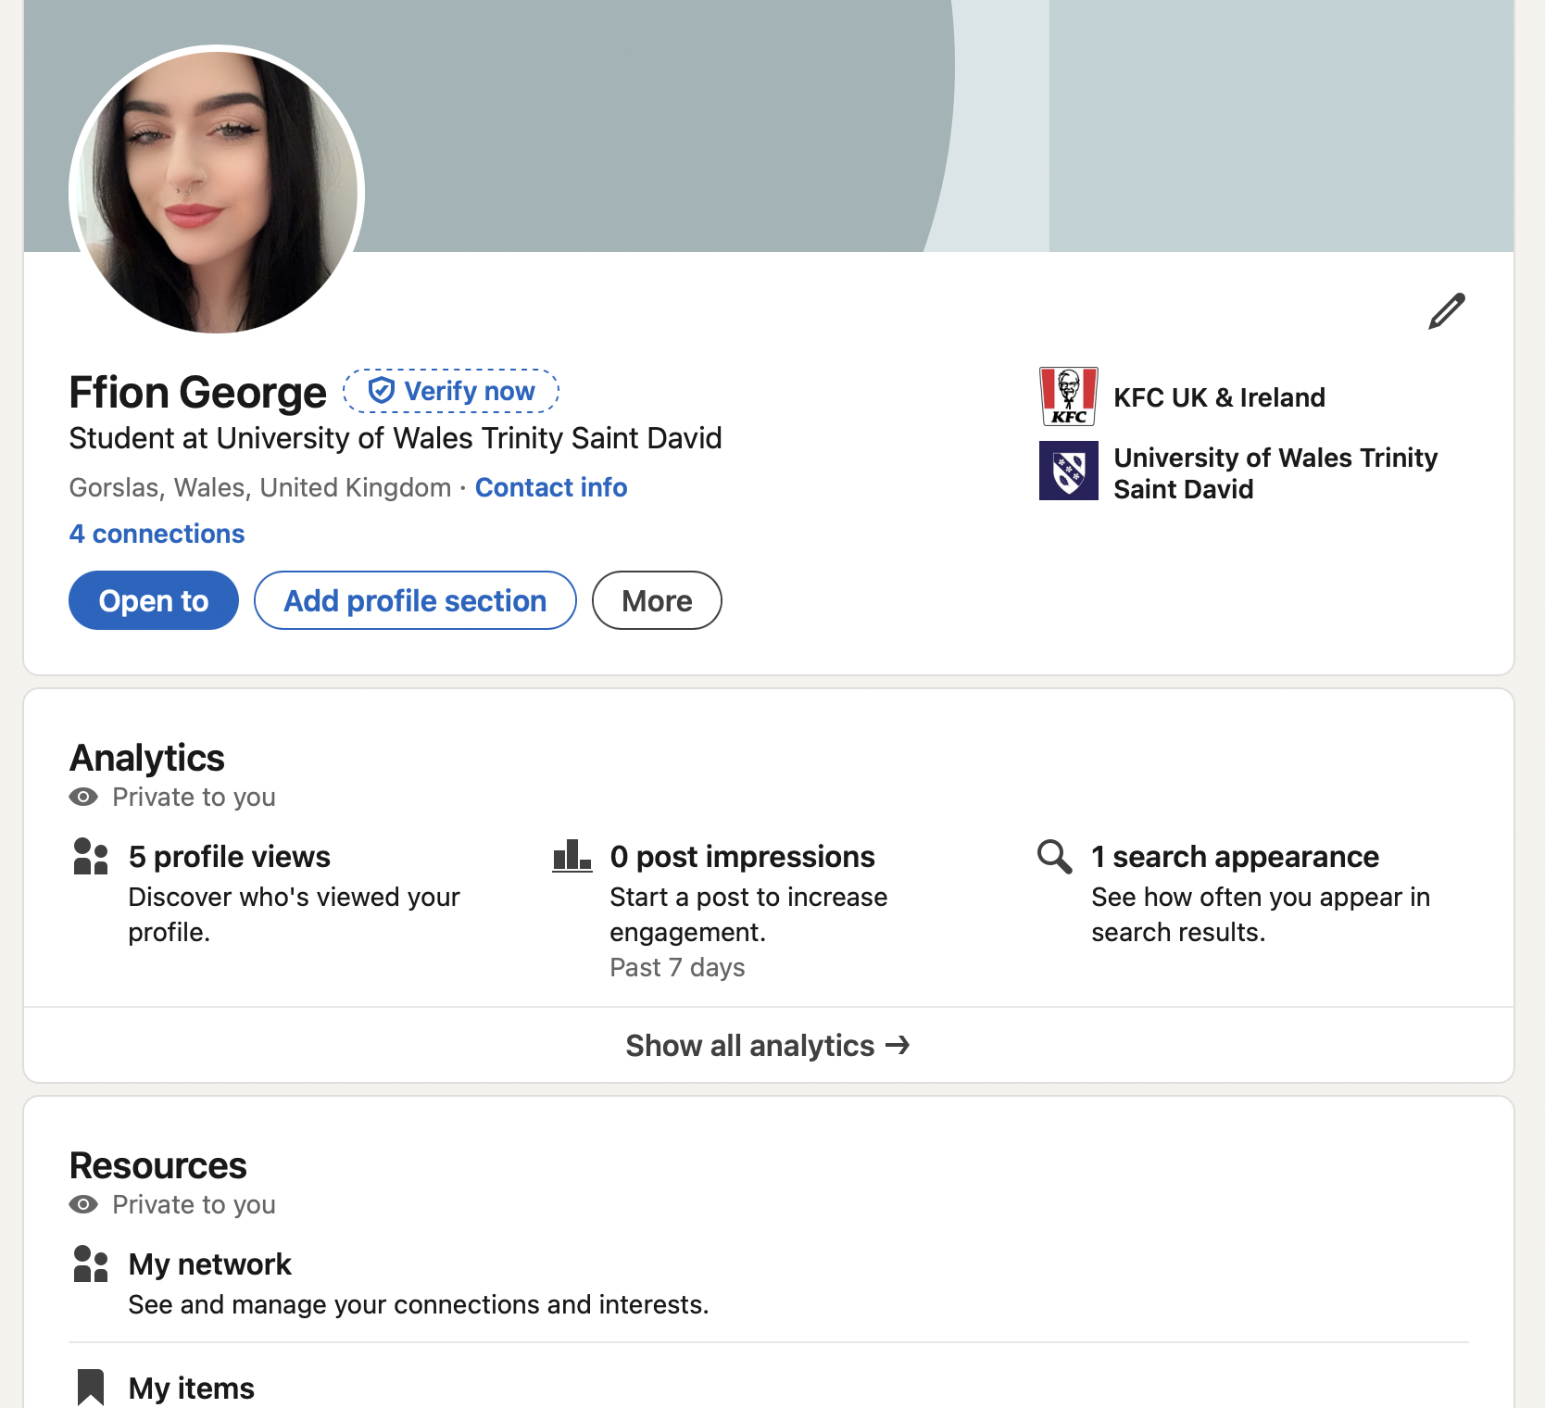

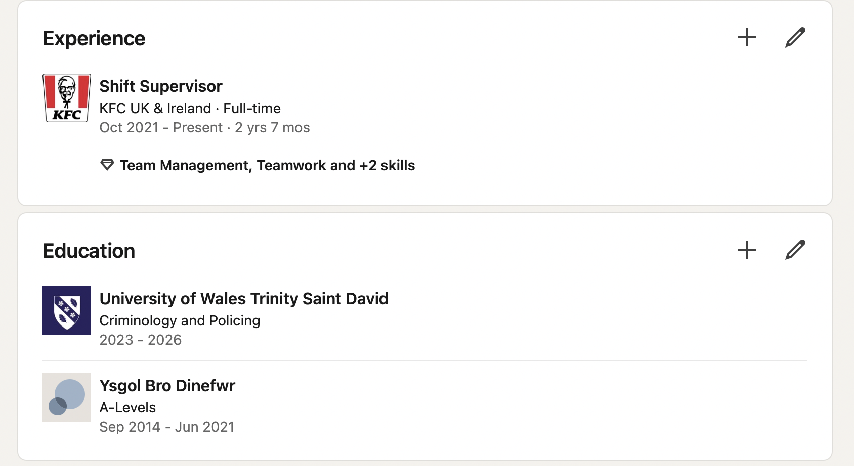
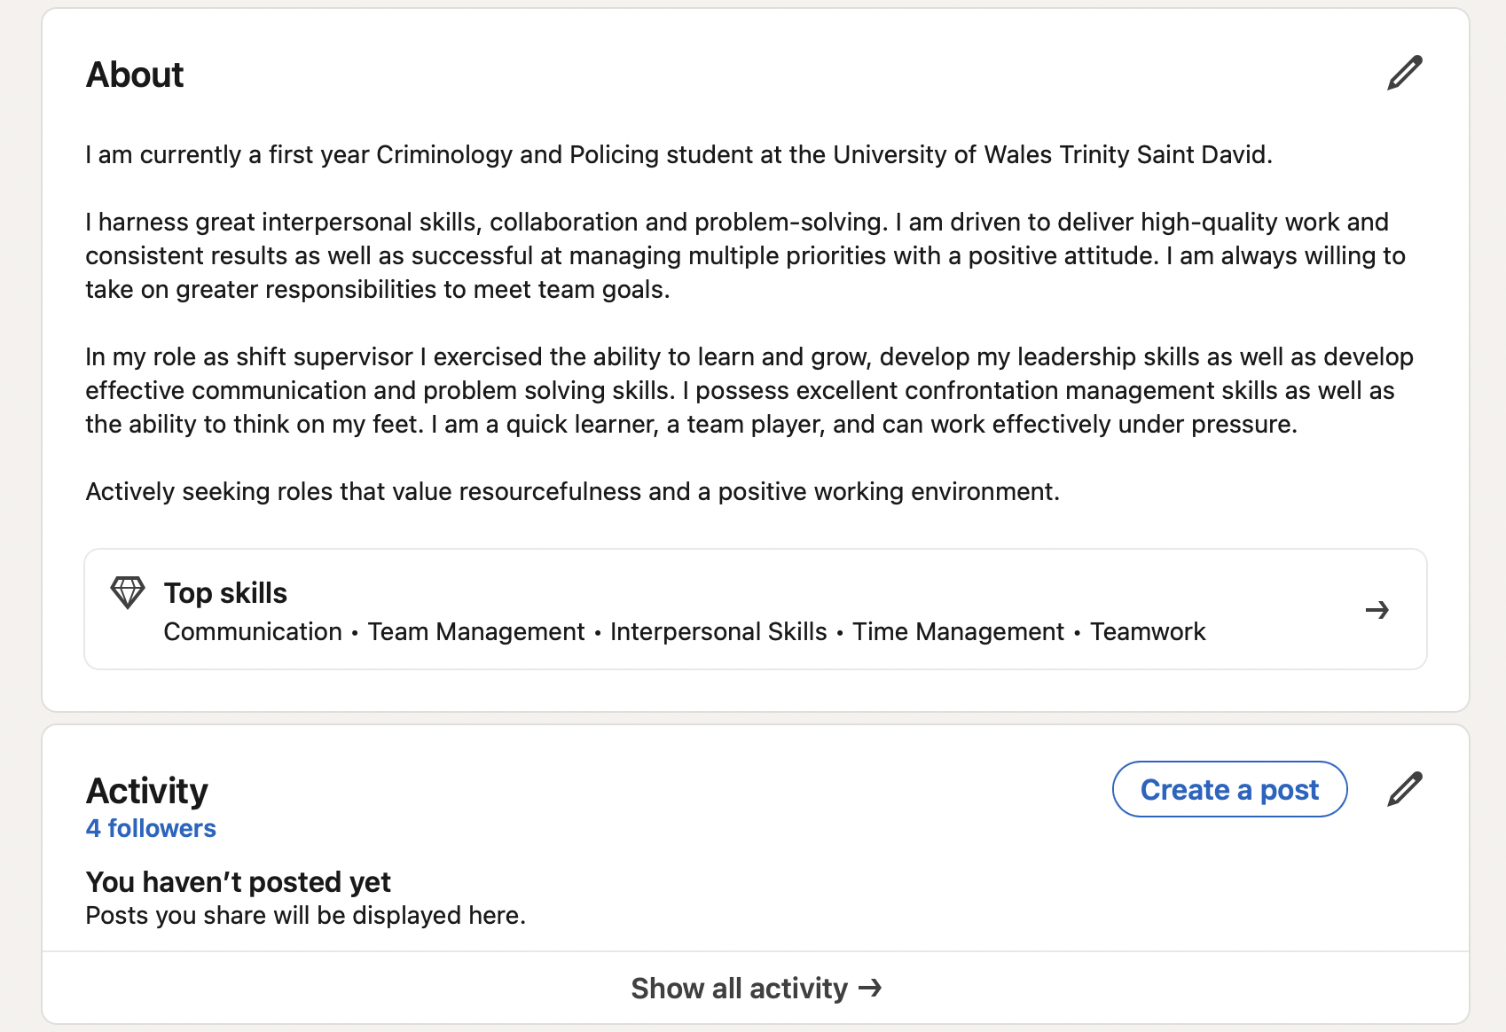
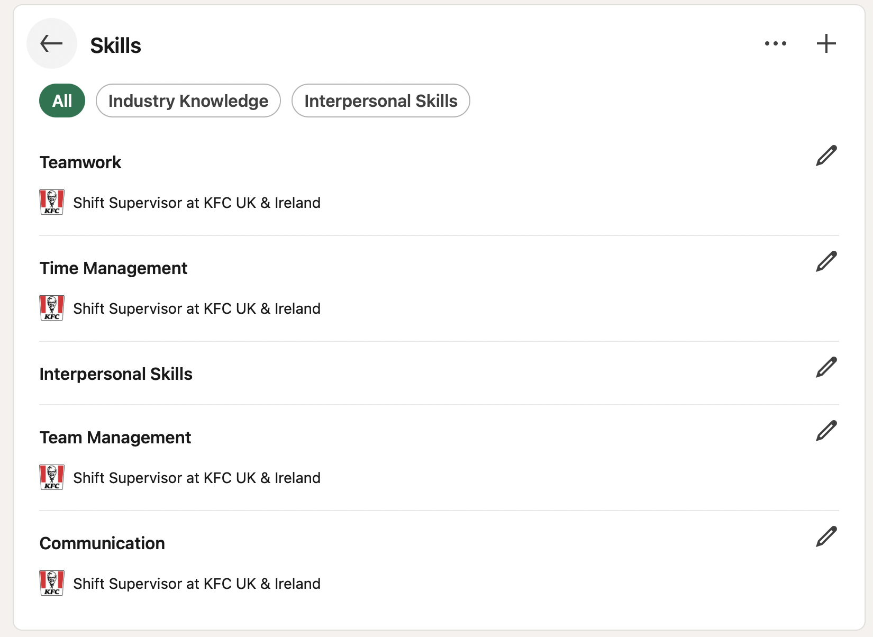
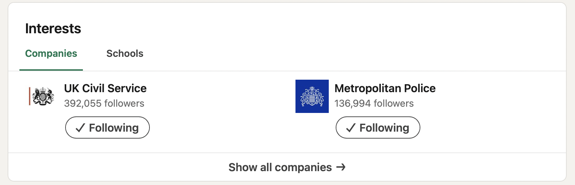

Reference list
American Psychological Association (2022). Resilience. American Psychological Association. [online] Available at: https://www.apa.org/topics/resilience [Accessed 21 Apr. 2024].
Careers Wales (2022). Job Information. [online] Available at: https://careerswales.gov.wales/job-information/police-officer/skills-and-qualities [Accessed 22 Apr. 2024].
Cherry, K. (2023). What Are the Big 5 Personality Traits? [online] Available at: https://www.verywellmind.com/the-big-five-personality-dimensions-2795422#:~:text=Many%20contemporary%20personality%20psychologists%20believe [Accessed 11 Apr. 2024].
Jackson, N. (2023). Defining Success: What Does Success Mean to You? [online] Available at: https://www.linkedin.com/pulse/defining-success-what-does-mean-you-jackson-jd-edd-bcc/ [Accessed 16 Apr. 2024].
Kambo, S. (2023). Is Mental Toughness the Key to Success & How to Build It. [online] Available at: https://harrisonhealthcare.ca/mental-toughness/#:~:text=Psychologists%20point%20to%20mental%20toughness.&text=They%20have%20the%20ability%20to [Accessed 20 Apr. 2024].
Lucas, N. (2023). Neal Lucas on LinkedIn: Ambition is often seen as the key to success and achievement. But how…. [online] www.linkedin.com. Available at: https://www.linkedin.com/posts/neallucasni_ambition-is-often-seen-as-the-key-to-success-activity-7097857090454482944-oY5B/#:~:text=Ambition%2C%20when%20channelled%20wisely%2C%20can [Accessed 24 Apr. 2024].
Middleton, T. (2023). The benefits of teamwork (as proven by science). [online] Available at: https://www.atlassian.com/blog/teamwork/the-importance-of-teamwork#:~:text=Research%20shows%20that%20collaborative%20problem [Accessed 23 Apr. 2024].
Page, M. (2024). Six top tips on how to succeed at work. [online] Available at: https://www.michaelpage.co.uk/advice/career-advice/growing-your-career/six-top-tips-how-succeed-work [Accessed 10 Apr. 2024].
Pazlight (2024). Why Is Dedication Important And How Can It Bring Success? | Pazlight.com. [online] Available at: https://pazlight.com/why-is-dedication-important-and-how-can-it-bring-success/?utm_content=cmp-true [Accessed 25 Apr. 2024].
Prospects (2023). What skills do employers want? | Prospects.ac.uk. [online] Available at: https://www.prospects.ac.uk/careers-advice/applying-for-jobs/what-skills-do-employers-want#effective-communication [Accessed 17 Apr. 2024].
Riopel, L. (2019). The importance, benefits, and value of goal setting. [online] Available at: https://positivepsychology.com/benefits-goal-setting/ [Accessed 19 Apr. 2024].
Treglown, L. (2023). New research identifies the traits that take you to the top. [online] Available at: https://www.thomas.co/resources/type/hr-blog/new-research-identifies-traits-take-you-top [Accessed 19 Apr. 2024].
West Mercia Police (2024). Available at: https://www.westmercia.police.uk/police-forces/west-mercia-police/areas/west-mercia/ca/careers/police-officers/policerecruitment/key-qualities/ [Accessed 12 Apr. 2024].

