
Asthma and Respiratory Function



Table of Contents
Introduction 1
Structure of the Respiratory System 1
Upper Respiratory Tract 1
Trachea 1
Bronchi and Bronchioles 2
Alveoli 2
Relationship Between Structure and Function 3
Mechanical Respiration 3
Inspiration 3
Expiration 4
Role of Respiratory Muscles and Pressure Changes 4
Gas Exchange 4
Alveolar-Capillary Membrane 5
Oxygen Diffusion 5
Carbon Dioxide Removal 5
Importance of Efficient Gas Exchange 5
Effects of Irritants and Inflammation 5
Smoking, Vaping and Air Pollution 5
Respiratory Infections 6
Bronchoconstriction and Mucus Production 6
Impact on Breathing 7
Monitoring and Tracking Respiratory Function 7
Peak Flow Monitoring 7
Symptom Diaries 7
Self-Management Benefits 8
Lifestyle Recommendations 8
Conclusion 8
Reference list 9

Table of Figures
Figure 1 Structure of the Respiratory System 4

Introduction
Asthma is a long-term inflammation of the respiratory system that causes the airways to become swollen, sensitive and narrow (Sinyor and Perez, 2023). It is often associated with wheezing, coughing, chest tightness and difficulty breathing. The symptoms are due to a lack of free air movement through the bronchi and bronchioles. Asthma is important because it impacts on sleep, education, work, exercise and quality of life.
Asthma is prevalent in all age groups and is still a public health problem (Merhej and Zein, 2023). Family history, exposure to allergens, tobacco smoke, vaping, air pollution, respiratory infections and obesity are all considered main risk factors (Koppelman et al., 2025). These can make the airways more sensitive to triggers or can make the airways inflamed. It will talk about structure, mechanical respiration, gas exchange, inflammation, monitoring, lifestyle recommendations and self-management.

Structure of the Respiratory System
The respiratory system is designed to move air into the lungs, exchange gases with the blood and remove carbon dioxide from the body. Its shape is closely related to its function, as each part has special characteristics to facilitate the efficient breathing.

Upper Respiratory Tract
Upper respiratory tract consists of nose, nasal cavity, sinuses, and pharynx and larynx. These structures warm, humidify and filter the air before it enters the lungs. Mucus and cilia in the nose captures dust particles, microorganisms and allergens (Çetinsu and Çelik, 2023). This helps to keep many irritants from getting into the lower airways. The air is also heated and moisturized, preventing irritation of the delicate lung tissue. In asthma, cold and/or dry air can cause bronchoconstriction in susceptible airways.

Trachea
A tube (trachea) transports air from the larynx (voice box) to the lungs. Held open by C-shaped cartilage rings during breathing (Ball and Padalia, 2023). This helps to prevent collapses in the thoracic cavity due to pressure change. The lining of the trachea is also ciliated epithelium and mucus that help to propel trapped particles up to the throat. This is a protective effect to lower risk of infection and airway irritation.

Bronchi and Bronchioles
The right and left bronchus form within the trachea and lead into the lungs where they branch into smaller bronchioles. The branching pattern sends air into all parts of the lungs, allowing ventilation to reach many alveoli. Bronchioles contain smooth muscle in their walls, allowing their diameter to change. In a healthy person, this assists in regulating breathing (Moussavi, 2006). In asthma, however, the bronchioles are hyperresponsive (Zhang et al., 2025). Excessive SMC can result from triggers like smoke, pollen, pollution or infection (Upadhyay, 2023). This bronchoconstriction reduces the lumen of the airway and markedly increases the resistance of the airway. Therefore, this individual has to exert additional effort to breathe, particularly on expiration.

Alveoli
The bronchioles end in millions of tiny air sacs called alveoli, which are surrounded by blood vessels called capillaries. Alveoli have thin walls and a large surface area. These adaptations enable rapid diffusion of O2 into the blood and CO2 out of the blood. The alveoli also contain surfactant which lowers the surface tension and prevents the collapse of the alveoli during exhalation (Francis and Saha, 2022). Asthma primarily involves narrowing of the airways, but narrowing bronchioles means that less air reaches the alveoli. This may make it harder to breathe during an asthma attack.
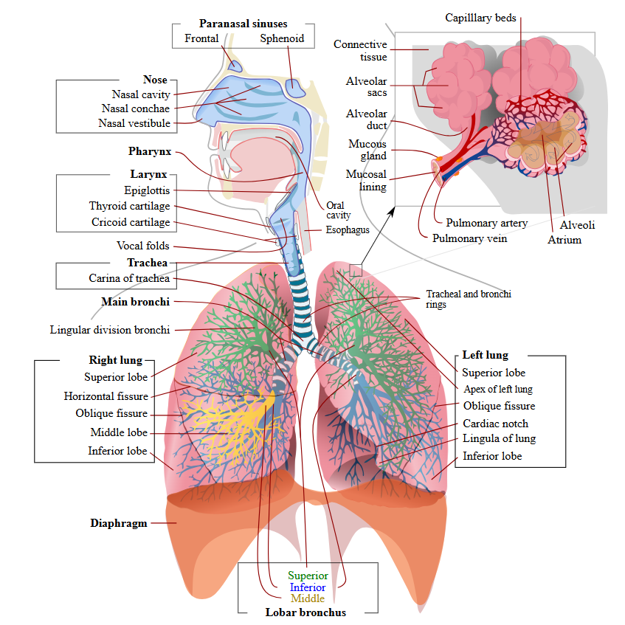
Figure 1 Structure of the Respiratory System

Relationship Between Structure and Function
The lungs are specialised structures which make the respiratory system efficient. Large airways are kept open by cartilage, cilia prevent irritation, bronchioles adjust the flow of air and alveoli increase the diffusion area. Asthma interferes with this balance by causing inflammation, mucus buildup and narrowing of airways. These changes make breathing more difficult, cause wheezing, coughing, breathlessness and chest tightness.

Mechanical Respiration
Mechanical respiration refers to the movement of air in and out of the lungs. Relies on the differential pressures generated by a change in thoracic cavity volume.

Inspiration
Inspiration is a dynamic process (Bissel, Doolittle and González, 2025). The diaphragm contracts and moves downward and the external intercostal muscles contract and lift the ribs up and out. The movements expand the thoracic cavity. As the volume increases, the pressure in the lungs will decrease below the pressure of the atmosphere, causing air to move into the lungs. This is because air moves from a high pressure to low pressure. It is important because it supplies oxygen-rich air to the alveoli, where the alveoli pick up oxygen and cellular respiration takes place.

Expiration
In normal breathing, expiration is passive, in most cases. Diaphragm and external intercostal muscles relax, which decreases thoracic volume. This makes the air pressure in the lungs higher than that outside, causing air to exit. Expiration eliminates carbon dioxide, a by-product of cellular metabolism. This is important because too much carbon dioxide can change the pH of the blood and disrupt the normal operation of the body.
With asthma, breathing out may be difficult. Narrowing of the airways occurs normally during exhalation but it is worsened by inflammation and bronchoconstriction (Sánchez, 2023). Mucus can also block the airway lumen. This can lead to hyperinflation of the lungs as air can get stuck. This can cause a sensation of tightness in the chest due to the increased effort needed to expel air from the lungs.

Role of Respiratory Muscles and Pressure Changes
The diaphragm is the primary muscle for breathing, and intercostal muscles move the rib cage. They work together to produce the pressure gradients required for ventilation. In asthma, the resistance is higher and a greater pressure difference is needed to move the same volume of air (Vartiainen et al., 2023). This is one reason why asthma attacks can leave you feeling tired and make breathing difficult. Wheezing is the result of turbulent airflow through narrowed bronchioles.

Gas Exchange
Alveoli are the site of gas exchange and exchange of oxygen with the blood and carbon dioxide with the blood. The diffusion of gases from higher to lower concentrations is required for this process.

Alveolar-Capillary Membrane
Alveolar-capillary membrane is very thin and composed of alveolar wall, capillary wall and fused basement membranes. This short diffusion distance enables gases to flow rapidly between air and blood. The dense capillary network surrounding each alveolus maintains the gradients by constantly carrying deoxygenated blood to the lungs and oxygenated blood from the lungs.

Oxygen Diffusion
The alveoli contain more O2 than the venous blood from the pulmonary circulation. Thus, oxygen moves from the alveoli to the blood. It then binds to haemoglobin in red blood cells for transport to the body tissues. This oxygen is necessary for aerobic respiration which provides energy for the cells.

Carbon Dioxide Removal
Expulsion of CO2 occurs during expiration as it diffuses from the blood to the alveoli, where it is packaged into expired air. This prevents CO2 buildup and maintains acid-base balance.

Importance of Efficient Gas Exchange
Good ventilation, healthy alveoli and adequate blood flow are essential to efficient gas exchange. During asthma, the airways narrow and the ventilation decreases in some alveoli. This can lead to ventilation-perfusion mismatch, in which blood is flowing past poorly ventilated alveoli (Powers and Dhamoon, 2023). As a result, oxygen consumption can decrease, leading to dyspnea, fatigue and loss of exercise capacity. Severe attacks can result in dangerous low levels of oxygen.

Effects of Irritants and Inflammation
Airway inflammation and irritants are strongly associated with asthma symptoms. Irritants can cause exacerbations and make the airways more sensitive.

Smoking, Vaping and Air Pollution
Smoking harms the respiratory system by putting toxic chemicals into the airway tissues. It affects cilia, thus reducing the clearance of mucus and particles. This causes irritation, infection risk and mucus buildup. Smoking increases inflammation and decreases asthma control in individuals with asthma (Kamga et al., 2022). Vaping can also cause irritation to the airways. While some consider it to be safe, inhaled aerosols can contain chemicals that can cause inflammation and coughing. This can lead to wheezing and/or shortness of breath in sensitive airways. Respiratory tract exposure to air pollution, such as particulate matter, NO2 and O3, may lead to inflammatory reactions (Krismanuel and Hairunisa, 2024). These pollutants can cause airway swelling and make them more reactive. Asthma sufferers are especially susceptible since their airways are already highly sensitive to triggers.

Respiratory Infections
Asthma attacks are often triggered by respiratory infections, particularly viral infections (Sharma et al., 2022). Infection activates the immune system, increasing inflammation, swelling and mucus production in the airways. This constricts the airway lumen and makes breathing harder. Infection can cause more coughing due to an effort to expel mucus

Bronchoconstriction and Mucus Production
Inflammation causes immune cells to release chemical mediators that make bronchiolar smooth muscle contract. This produces bronchoconstriction. Goblet cells and mucus glands also make too much mucus at the same time. The airways are also made narrower and there is a buildup of mucus that makes it harder to breathe. As the diameter of the passageways decreases, resistance increases sharply and even a small constriction of the bronchiole makes breathing difficult.
Trigger (Smoke, Allergen, Infection)
↓
Airway Inflammation
↓
Bronchoconstriction
↓
Excess Mucus Production
↓
Narrowed Airways
↓
Reduced Airflow
↓
Wheezing • Coughing • Breathlessness

Impact on Breathing
These physiological changes can explain the symptoms of asthma. Turbulent airflow through narrowed airways causes wheezing. Coughing is the body's effort to expel the excess mucus and irritants. The lungs can over-inflate and respiratory muscles may be over-working, causing chest tightness. Breathlessness is due to limitation of airflow that affects ventilation and can affect the amount of oxygen taken up (Ferreira et al., 2023). This reflects the direct effects of inflammation on the respiratory function.

Monitoring and Tracking Respiratory Function
It is important to monitor asthma because narrowing of the airway can get worse before symptoms do. Timely diagnosis may help to tailor treatment before the exacerbation reaches a dangerous level.

Peak Flow Monitoring
The peak flow meter measures how fast a person can breathe out (Wang et al., 2022). Falling readings imply constriction of airways and a diminished expiratory flow. Peak flow monitoring can be done regularly and helps to detect early deterioration, particularly when compared to the person's personal best peak flow.

Symptom Diaries
Symptom diaries are used to document wheezing, coughing, breathlessness, symptoms of the night, reliever inhaler use and potential triggers. This will help to detect a pattern, such as worsening symptoms after exercise, infection, smoke exposure, or pollen exposure. It also aids health care providers determine if asthma is controlled.

Self-Management Benefits
Respiratory monitoring enables self-management as people become more aware of their symptoms and triggers. This can foster timely use of medicines and trigger avoidance and medical review as required. Monitoring can help to minimise admission to hospital, increase confidence and support long-term asthma control.

Lifestyle Recommendations
Asthma control and lung function can be significantly affected by lifestyle choices (Born et al., 2024). Smoking cessation is important since it decreases airway irritation, ciliary function and inflammation. It is also advised not to vape as aerosols can make airways more sensitive. Regular exercise can enhance cardiovascular fitness, build respiratory muscle strength and promote well-being (Faghy et al., 2024). People with asthma, however, should take medical advice and use their inhalers if they need to. Weight management is also important as extra weight makes breathing more difficult and can make breathing more laboured. The prevention of infection is of significance, because cold and flu exacerbations are frequent. Vaccinations and proper hand hygiene can help in reducing this risk. It is also critical to take the medication as prescribed. Preventer inhalers help to stop the inflammation, while reliever inhalers help to make the airways wider during symptoms. Proper medication use keeps the airways open and decreases serious attacks.

Conclusion
Asthma is a chronic inflammatory disorder that affects the normal function of the respiratory system by causing bronchi constriction, swelling, and the buildup of mucus. Asthma makes breathing harder and makes the airflow less efficient. This is why symptoms include wheezing, coughing, chest tightness and breathlessness. Irritants including smoking, vaping, pollution and infections can worsen inflammation and trigger exacerbations. Use of peak flow and symptom diaries assists in monitoring, early detection, and self-management. The maintenance of respiratory health and the quality of life depended on lifestyle measures, adherence to medications and education.

Reference list
Ball, M. and Padalia, D. (2023). Anatomy, Airway. [online] PubMed. Available at: https://www.ncbi.nlm.nih.gov/books/NBK459258/.
Bissel, L., Doolittle, E. and González, L. (2025). On Inspiration. Turning Toward Being The Journal of Ontological Inquiry in Education, p.1. doi:https://doi.org/10.31986/issn.2995-8288_vol3iss2.2.
Born, C., Rohini Bhadra, D’Souza, G., Kremers, J., Sucharita Sambashivaiah, Annemie M. W. J. Schols, Rik Crutzen and Beijers, R. (2024). Combined Lifestyle Interventions in the Prevention and Management of Asthma and COPD: A Systematic Review. Nutrients, 16(10), pp.1515–1515. doi:https://doi.org/10.3390/nu16101515.
Çetinsu, V. and Çelik, M. (2023). Steps to Respiratory Health. Airway Diseases, pp.2541–2551. doi:https://doi.org/10.1007/978-3-031-22483-6_138-1.
Faghy, M.A., Tatler, A., Chidley, C., Fryer, S., Stoner, L., Deepika Laddu, Arena, R. and Ashton, R.E. (2024). The physiologic benefits of optimizing cardiorespiratory fitness and physical activity – From the cell to systems level in a post-pandemic world. Progress in Cardiovascular Diseases, 83, pp.49–54. doi:https://doi.org/10.1016/j.pcad.2024.02.006.
Ferreira, D., Slavica Kochovska, Brunelli, V. and Currow, D. (2023). Understanding persistent breathlessness: Impact on patients and optimal approaches to symptomatic reduction – an overview. Expert Review of Respiratory Medicine, 17(5), pp.365–379. doi:https://doi.org/10.1080/17476348.2023.2208348.
Francis, I. and Saha, S.C. (2022). Surface tension effects on flow dynamics and alveolar mechanics in the acinar region of human lung. Heliyon, 8(10), p.e11026. doi:https://doi.org/10.1016/j.heliyon.2022.e11026.
Kamga, A., Rochefort-Morel, C., Guen, Y.L., Ouksel, H., Pipet, A. and Leroyer, C. (2022). Asthma and smoking: A review. Respiratory Medicine and Research, [online] 82(82), p.100916. doi:https://doi.org/10.1016/j.resmer.2022.100916.
Koppelman, G.H., Pino-Yanes, M., Melén, E., Powell, P., Bracke, K.R., Celedón, J.C. and Brusselle, G.G. (2025). Genetic and environmental risk factors for asthma: towards prevention. The Lancet. Respiratory medicine, [online] pp.S2213-2600(25)002565. doi:https://doi.org/10.1016/S2213-2600(25)00256-5.
Krismanuel, H. and Hairunisa, N. (2024). The Effects of Air Pollution on Respiratory Problems: A Literature Review. Poltekita : Jurnal Ilmu Kesehatan, [online] 18(1), pp.1–15. doi:https://doi.org/10.33860/jik.v18i1.3151.
Merhej, T. and Zein, J. (2023). Epidemiology of Asthma: Prevalence and Burden of Disease. Advances in Experimental Medicine and Biology, 1426, pp.3–23. doi:https://doi.org/10.1007/978-3-031-32259-4_1.
Moussavi, Z. (2006). Anatomy and Physiology of Respiratory System. Synthesis Lectures on Biomedical Engineering, pp.1–8. doi:https://doi.org/10.1007/978-3-031-01617-2_1.
Powers, K.A. and Dhamoon, A.S. (2023). Physiology, Pulmonary Ventilation and Perfusion. [online] Nih.gov. Available at: https://www.ncbi.nlm.nih.gov/sites/books/NBK539907/.
Sánchez, E. (2023). Acute Respiratory Failure in Exacerbations of Bronchial Asthma. [online] www.intechopen.com. Available at: https://www.intechopen.com/chapters/86810.
Sharma, S., Tasnim, N., Agadi, K., Asfeen, U. and Kanda, J. (2022). Vulnerability for Respiratory Infections in Asthma Patients: A Systematic Review. Cureus, [online] 14(9), pp.1–6. doi:https://doi.org/10.7759/cureus.28839.
Sinyor, B. and Perez, L.C. (2023). Pathophysiology Of Asthma. [online] Nih.gov. Available at: https://www.ncbi.nlm.nih.gov/sites/books/NBK551579/?report=reader.
Upadhyay, R.K. (2023). Health Hazards of Various Micro-Pollutants, Stubble Smoke, Furnace Fumes and Dust Particles in Urban Areas. Global Research in Environment and Sustainability, [online] 1(1), pp.07-30. Available at: https://hspublishing.org/GRES/article/view/62.
Vartiainen, V.A., Lavorini, F., Murphy, A.C. and Rabe, K.F. (2023). High inhaler resistance does not limit successful inspiratory maneuver among patients with asthma or COPD. Expert Opinion on Drug Delivery, 20(3), pp.385–393. doi:https://doi.org/10.1080/17425247.2023.2179984.
Wang, X., Ke, Z., Liao, G., Pan, X., Yang, Y. and Xu, W. (2022). A Fast-Response Breathing Monitoring System for Human Respiration Disease Detection. IEEE Sensors Journal, 22(11), pp.10411–10419. doi:https://doi.org/10.1109/jsen.2022.3167023.
Zhang, X., Chengjian Lv, Hao, H., Lin, J., Zhang, M. and Tian, X. (2025). Airway inflammation, bronchial hyperresponsiveness, and anti-asthma therapy responses in cough variant asthma and classic asthma with FEV1% ≥80% predicted. BMC Pulmonary Medicine, 25(1). doi:https://doi.org/10.1186/s12890-025-03627-8.

