University of Wales Trinity Saint David
London Campus
Assessment 2
Configure and manage the Virtualised Enterprise Network
Module Name: Network Operating Systems and Services
Module Code: ACCA5023
Student Name: Elena Alexandra Mihail
Student ID: 2437664
Group: 1
Lecturer’s Name: MD Sadeque Imam Shaikh

Table of Contents
Introduction 2
Task 1: Installation and Configuration of Routing and Critical Network Services 3
Task 1.1: Birmingham Server (B-DC) 3
Task 1.2: London Server (L-DC) 10
Task 2: Domain Server (Birmingham) 15
Task 2.1: Create a forest named yourname.acca 15
2.2 Create all corresponding A records for all servers in the Birmingham and London networks 15
2.3 Creating a reverse lookup zone and PTR records for all servers 16
Task 3: Encrypted Connection between Birmingham and London 17
Task 3.1: Configure Site-to-Site VPN to London Network 17
Task 4: User Accounts Provisioning and Active Directory Integration 28
Task 5: Domain Membership Configuration 30
Task 6: DHCP Server & DHCP Relay Configuration 31
Task 6.1: Overview and theoretical foundation: 31
Task 6.2: DHCP server configuration on B-DC (Birmingham) 32
Task 6.3 Configuring the DHCP relay agent at L-DC (London) 35
Task 7: Test and Troubleshoot 36
Task 8: Disk Drive 38
9. IIS Server 40
9.1 Create webs.yourname.acca website and enable windows internal authentication 40
Task 10: Remote Desktop Services 41
Task 10.1: Configure remote access for B-DC from any other computer on the network 41
Conclusion: 42

Introduction
This report documents the practical implementation of network configuration and management tasks based on the topology from the course's first activity. The primary objective is to configure Local Area Network (LAN) routing, IP forwarding, and firewall rules on the B-DC (Birmingham) and L-DC (London) domain controllers. Through the deployment of the Routing and Remote Access Service (RRAS) and the execution of specific PowerShell cmdlets, this configuration establishes secure and seamless inter-subnet communication across the simulated multi-site network infrastructure.

Note on Server Naming: Due to a typographical error during virtual machine deployment, the London server was designated as L-DC instead of L-CD. All service configuration, routing functions and IP setting are fully implemented as required for London node.

Task 1: Installation and Configuration of Routing and Critical Network Services
Implementing routing services in multi-site domain infrastructures is essential for establishing seamless connectivity between subnets and ensuring controlled traffic forwarding. This task details the configuration of Routing and Remote Access Services (RRAS), host-level IP forwarding, and dynamic Windows Firewall rules on the Birmingham (B-DC) and London (L-DC) domain controllers. Implementing these fundamental network services facilitates inter-site communication and enables cross-subnet management within the simulated enterprise network environment.

Task 1.1: Birmingham Server (B-DC)
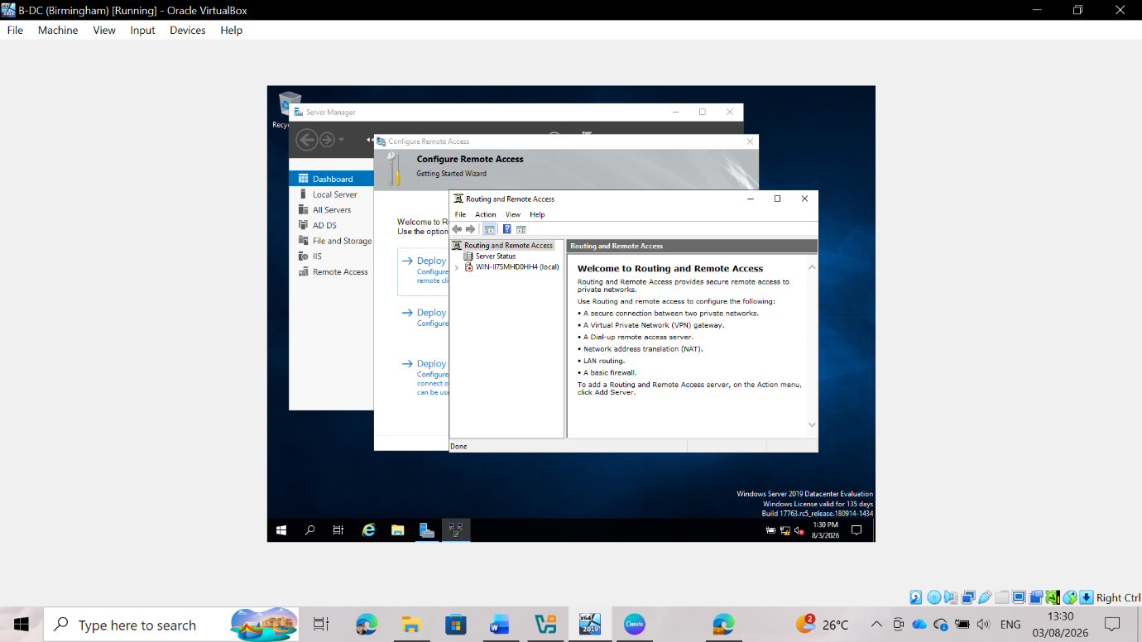Fig 1: Initial RRAS Console
The Routing and Remote Access Service (RRAS) console on the Birmingham domain controller (B-DC) initially displays the server management node in an unconfigured state. At this stage, the local operating system does not route IP packets between connected physical or virtual network adapters. Opening the MMC snap-in confirms that the service is installed but currently inactive, requiring full initialization via the configuration wizard to enable communication between local subnets and establish routing protocols on the server node.
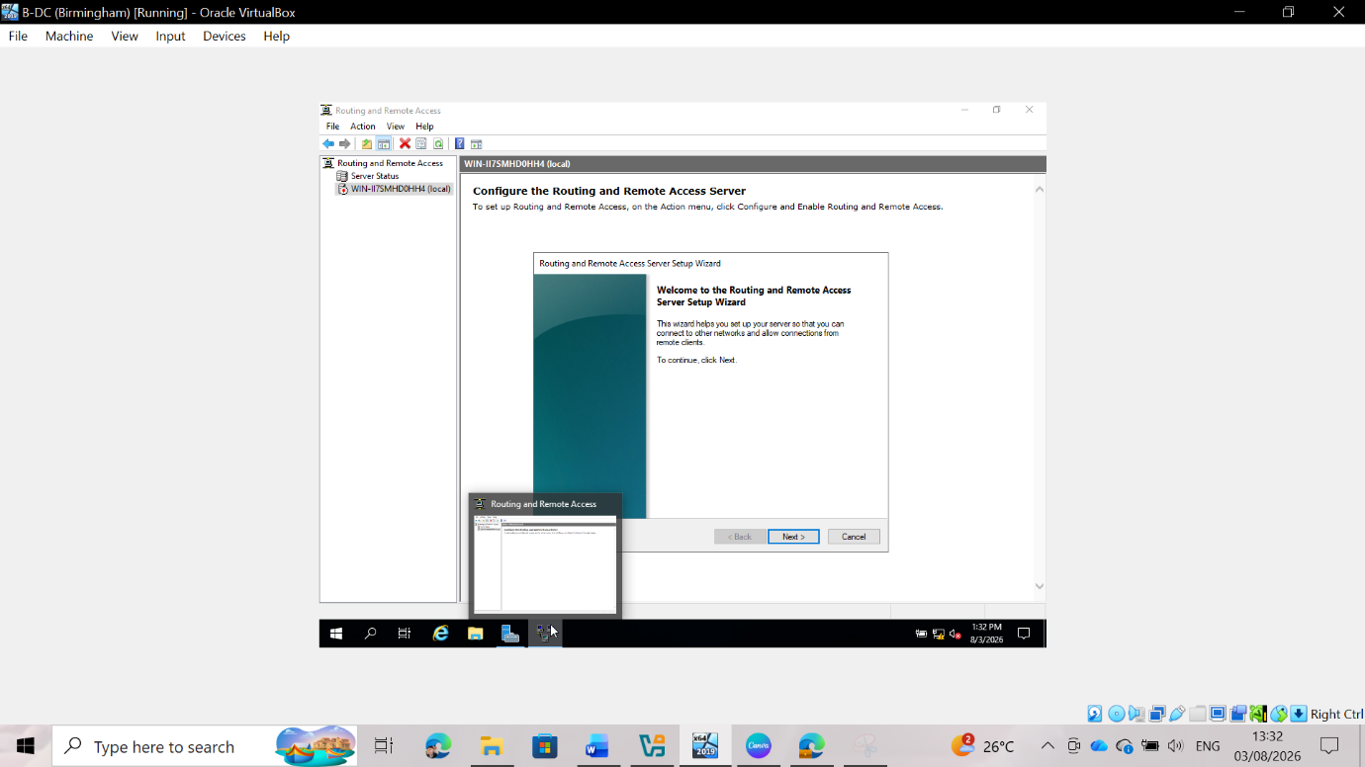
Fig 2: Launching the configuration wizard
Running the server configuration wizard on B-DC initiates the process of deploying network routing services. This step allows administrators to select specific operational roles tailored to the network domain architecture. Accessing this wizard ensures that the appropriate protocol associations, interface assignments, and service configurations are correctly applied to B-DC, thereby transforming the standalone domain controller into an active gateway capable of processing inbound and outbound traffic across specific internal network segments.
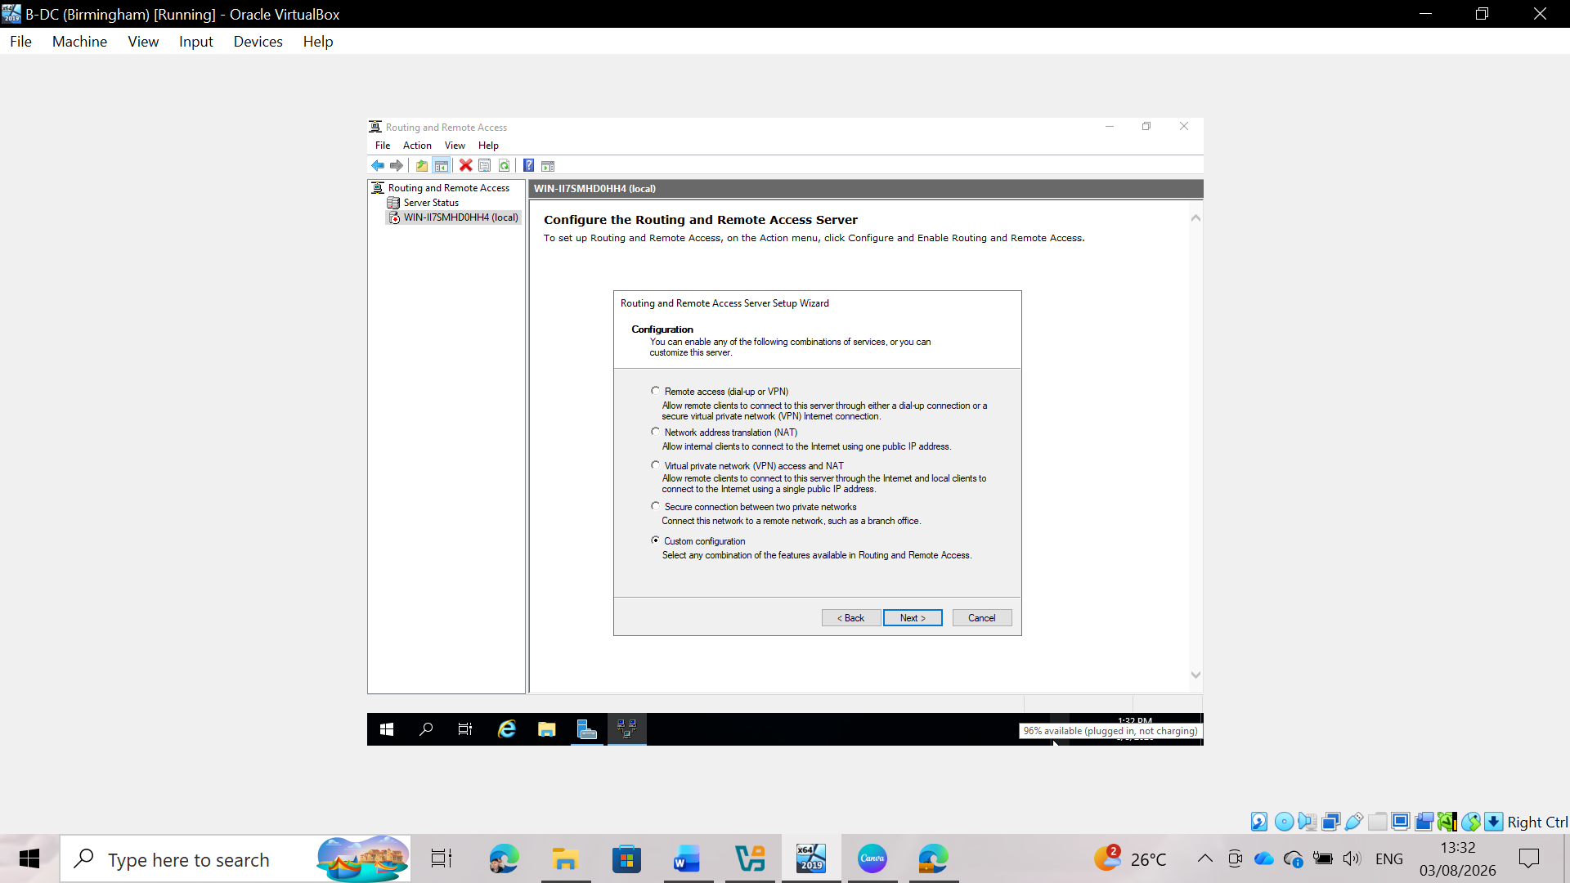
Fig 3: Custom configuration selection
Choosing the custom configuration deployment model in the RRAS Wizard provides full control over which individual network services are enabled on the B-DC. Instead of deploying the wizard's preconfigured templates—such as standard NAT gateways or access routers—selecting a custom configuration allows for manual control. This ensures that only the necessary enterprise routing components, traffic management functions, and custom remote access settings remain active on the Birmingham server node.
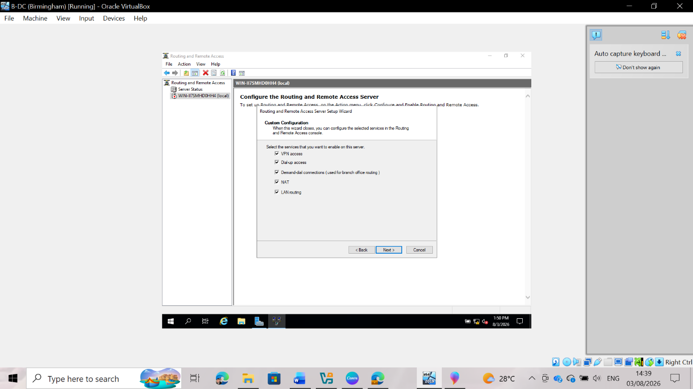
Fig 4: Service role selection
During wizard-based configuration, all critical service checkboxes are explicitly selected, including VPN access, dial-up access, on-demand connections, Network Address Translation (NAT), and LAN routing. Enabling LAN routing ensures static and dynamic IP routing between local subnets, while the NAT and remote access configuration allows for the translation of outbound traffic and the establishment of inbound management tunnels. Selecting these roles prepares the B-DC to handle various routing functions and maintain traffic flow across multiple subnets within the enterprise network.
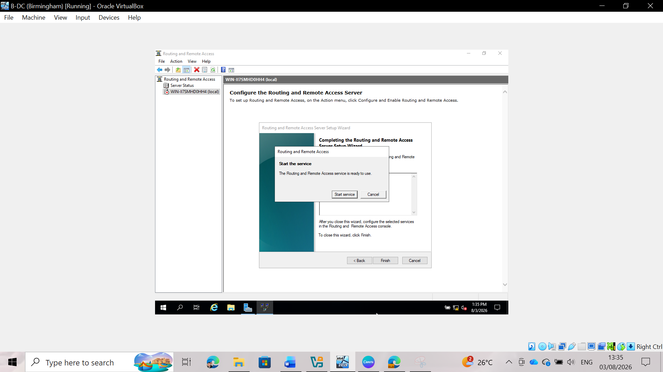
Fig 5: Wizard completion
Upon reaching the summary screen of the RRAS Configuration Wizard, you can verify the selected options before applying the changes to the B-DC. Clicking Finish writes the configuration parameters to the Windows Server system registry and prepares the system components to create the routing table. This critical step confirms that service dependencies are met and prepares the server to start the background routing process (daemon) without configuration errors or indications of missing dependencies.
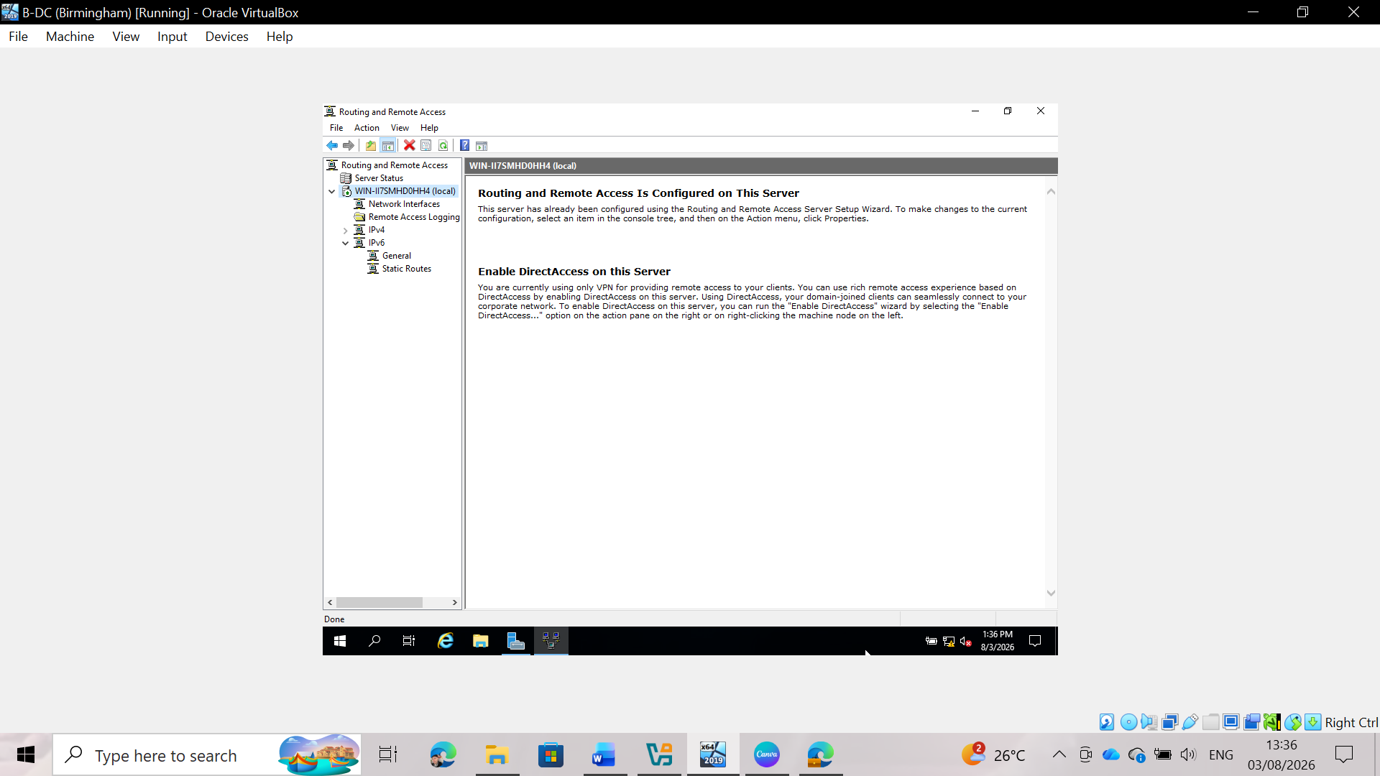
Fig 6: Active service status
Once the wizard completes, the RRAS service process activates on B-DC, indicated by the green operational status icon in the MMC console tree. This running state confirms that the host is actively listening on the configured network interfaces, maintaining local routing tables, and is ready to process inter-subnet traffic. Successful initialization confirms that the Birmingham server is operating as a functional network routing node within the domain infrastructure.
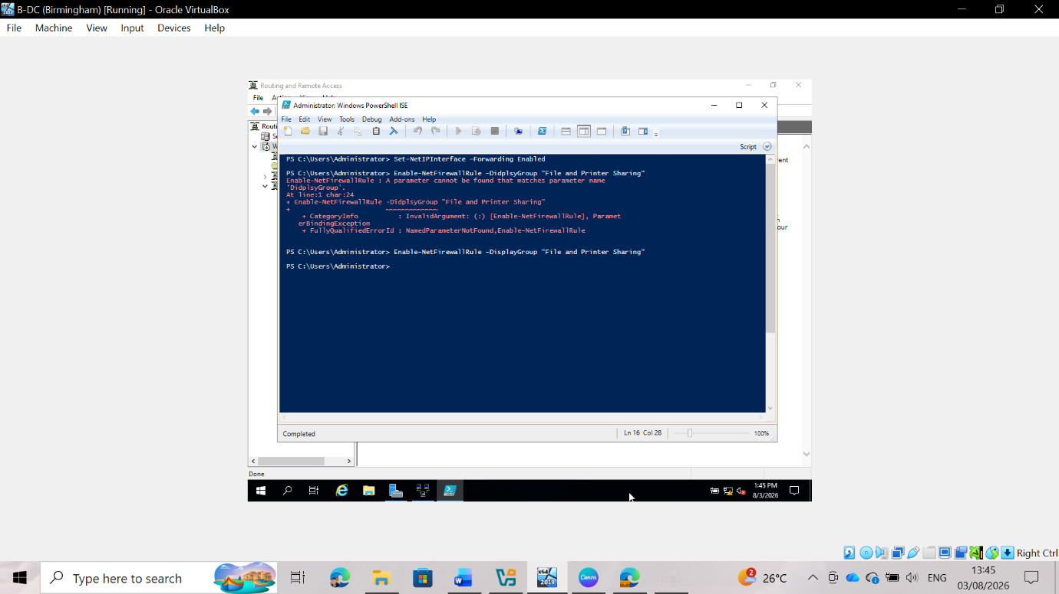
Fig 7: PowerShell execution on B-DC
Executing PowerShell administration cmdlets on B-DC configures granular system-level parameters that complement the RRAS implementation. Running `Set-NetIPInterface -Forwarding Enabled` explicitly enables the IPv4 stack to forward packets between network interfaces at the kernel level. Similarly, executing `Enable-NetFirewallRule -DisplayGroup "File and Printer Sharing"` modifies local security rules to allow ICMP echo requests and SMB traffic, thereby ensuring unobstructed verification of host-to-host connectivity across subnets.

Task 1.2: London Server (L-DC)
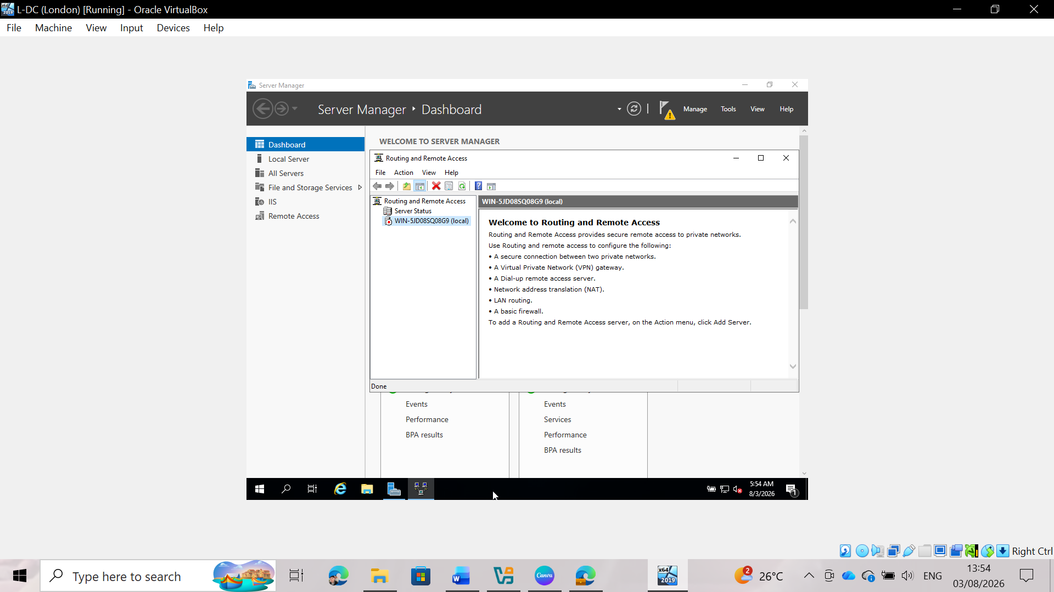
Fig 8: Initial state of the L-DC console
Opening the Server Manager interface on the London domain controller (L-DC) prior to configuring routing services reveals the general management environment. This screen provides an operational snapshot of active server roles, local IP network configurations, and system administration tools on L-DC. Verifying the system's baseline status in Server Manager ensures that all network interfaces are correctly recognized by the operating system before specialized configuration routines begin.
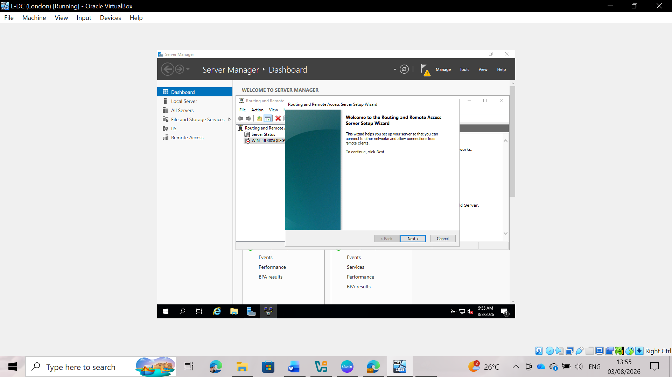
Fig 9: Configuration wizard startup
Running the configuration process on L-DC opens the welcome screen of the Routing and Remote Access Server Setup Wizard directly. This wizard initiates the configuration sequence for the London domain controller and serves as the starting point for defining server roles, configuring interface parameters, and implementing network routing services on the local subnet to ensure proper traffic distribution.

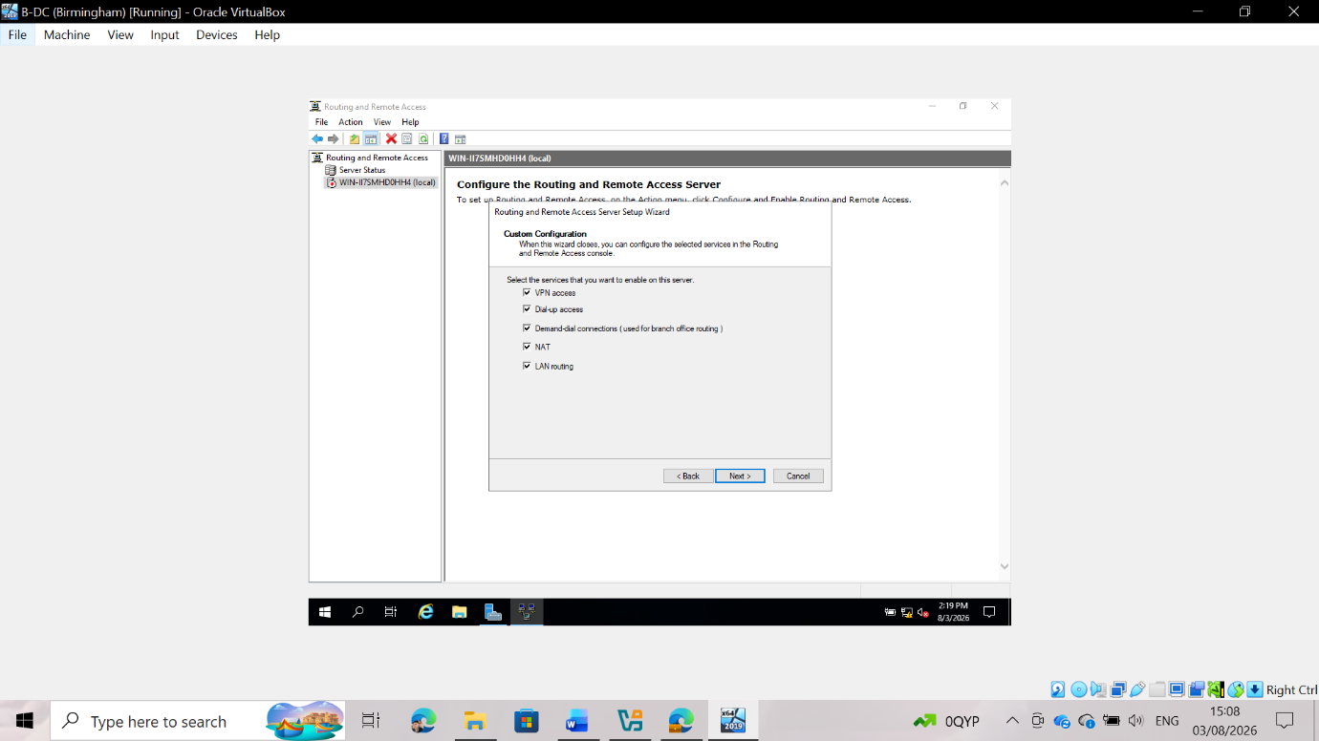Fig 10: Service role selection
Selecting all service checkboxes—including VPN access, dial-up access, on-demand connections, NAT, and LAN routing—aligns the L-DC configuration with that of the Birmingham domain controller. Enabling these options ensures full functional parity between both domain sites, allowing for LAN packet routing across subnets while maintaining compatibility with the remote connectivity and network address translation required by the enterprise architecture.

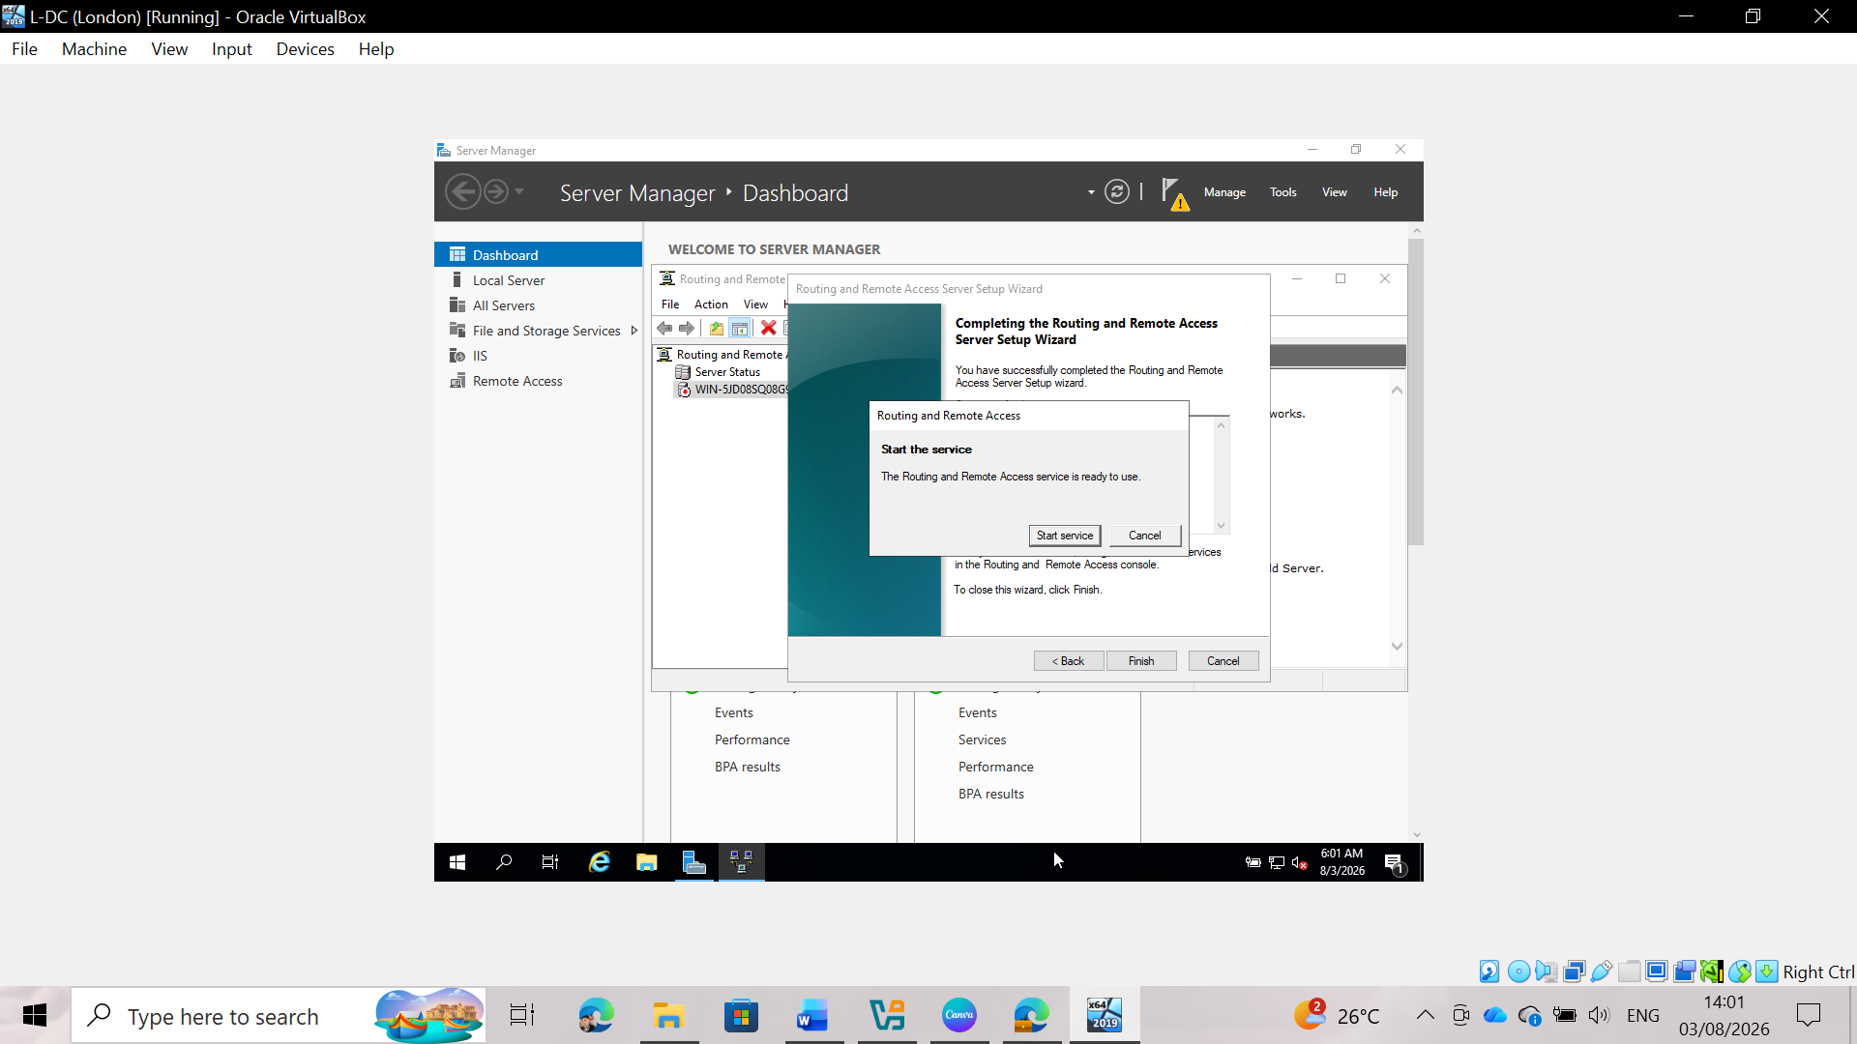
Fig 11: Completing Routing and Remote Access Setup
Upon finalizing the Routing and Remote Access Server Setup Wizard, the administrator is prompted to start the service. Initializing this service. Initializing this service actives the selected routing protocols and NAT features on L-DC, establishing active network routing between the subnets and allowing cross-site communication across the domain infrastructure.
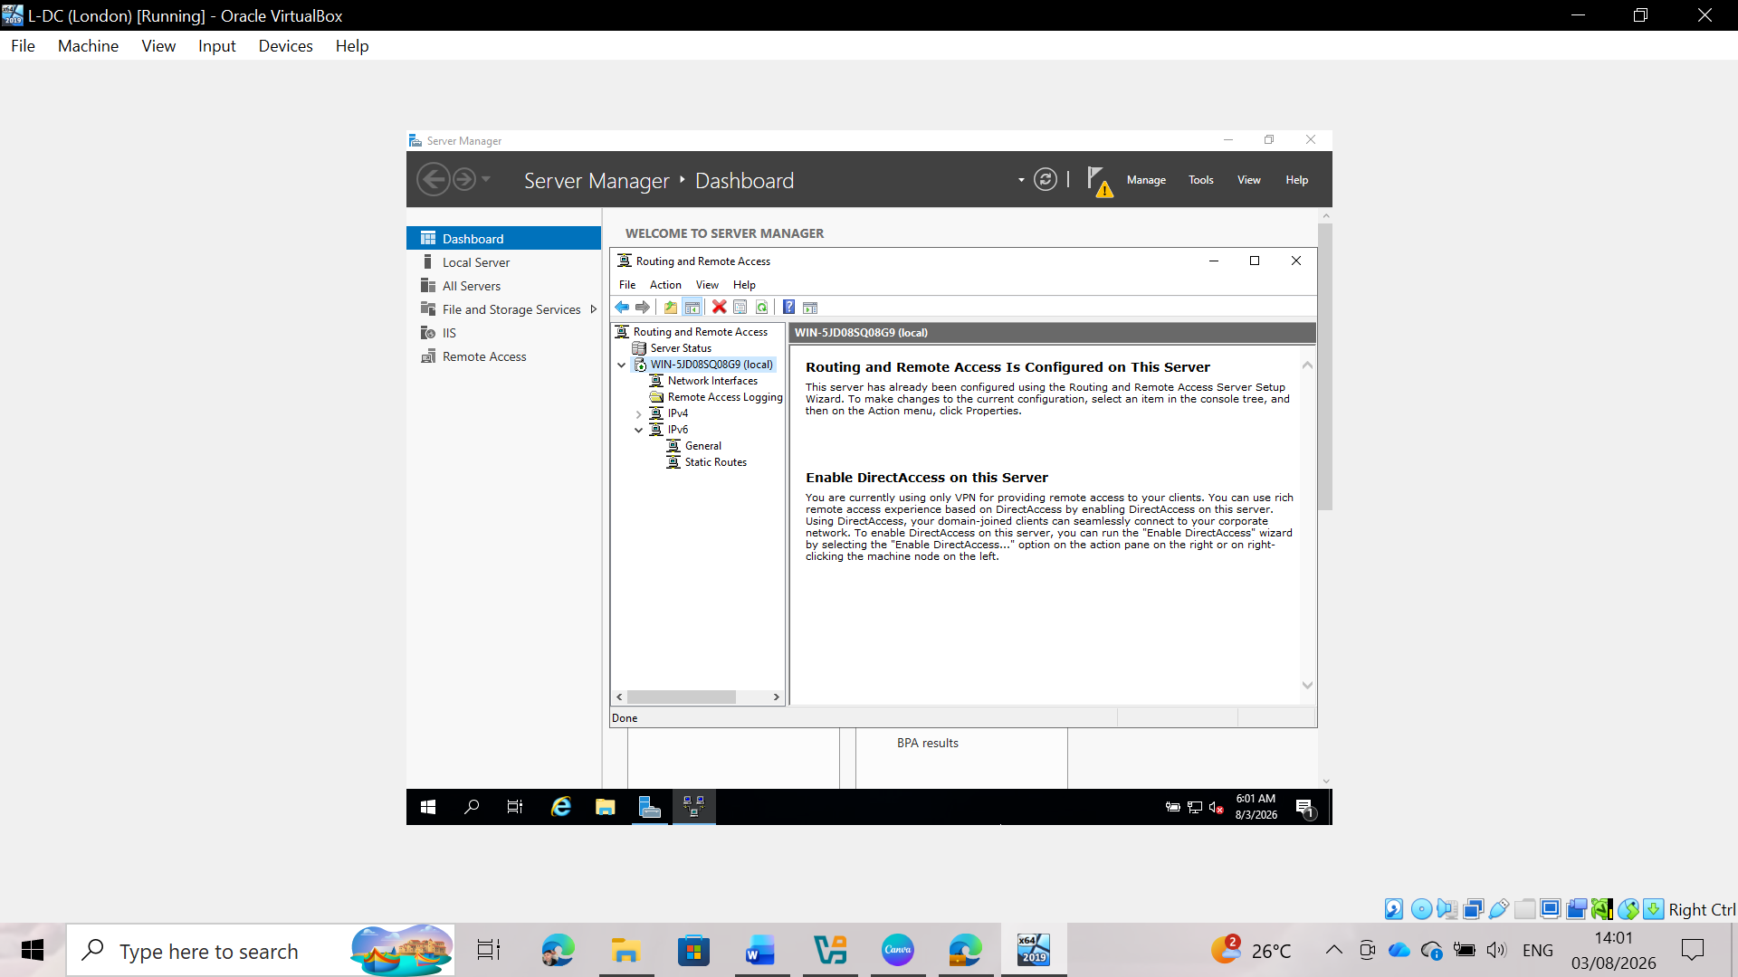
Fig 12: Active service status on L-DC
The successful startup of the RRAS service process on L-DC is visually confirmed by the green status indicator appearing next to the server node name in the administration console tree. This active status verifies that the background routing daemon is running, local interface associations are functioning correctly, and internal routing tables have been initialized. The London domain controller is now fully capable of acting as an active gateway for inter-subnet communications.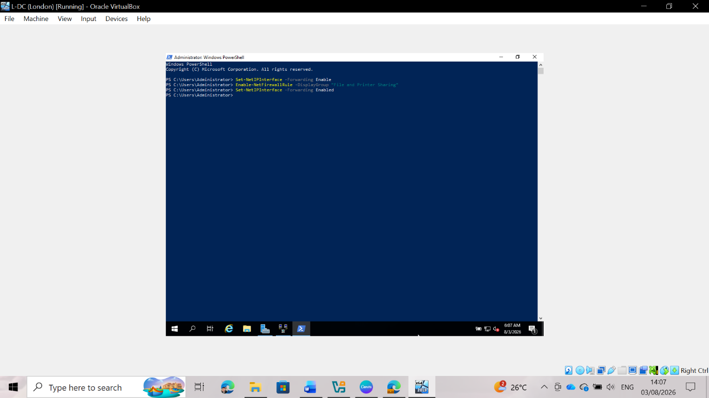
Fig 13: PowerShell execution on L-DC
Executing specific PowerShell cmdlets on L-CD completes the system-level network configuration on the London server. Running `Set-NetiPInterface -Forwarding Enabled` activates packet forwarding at the interface level on the host operating system. Subsequently, enabling the "File and Printer Sharing" firewall rule group opens the ports required for ICMP diagnostics and network sharing protocols, thereby ensuring full cross-subnet connectivity and remote management capabilities across the domain network.

Task 2: Domain Server (Birmingham)
Installing and deploying Active Directory Domain Services (AD DS) and Domain Name System (DNS) on the Birmingham domain controller (B-DC)—running Windows Server 2019—establishes the foundational directory service for the entire enterprise environment. This task involves promoting the B-DC as the root domain controller for the new forest and creating critical forward and reverse lookup DNS zones—along with their associated records—to support cross-site domain operations.

Task 2.1: Create a forest named yourname.acca
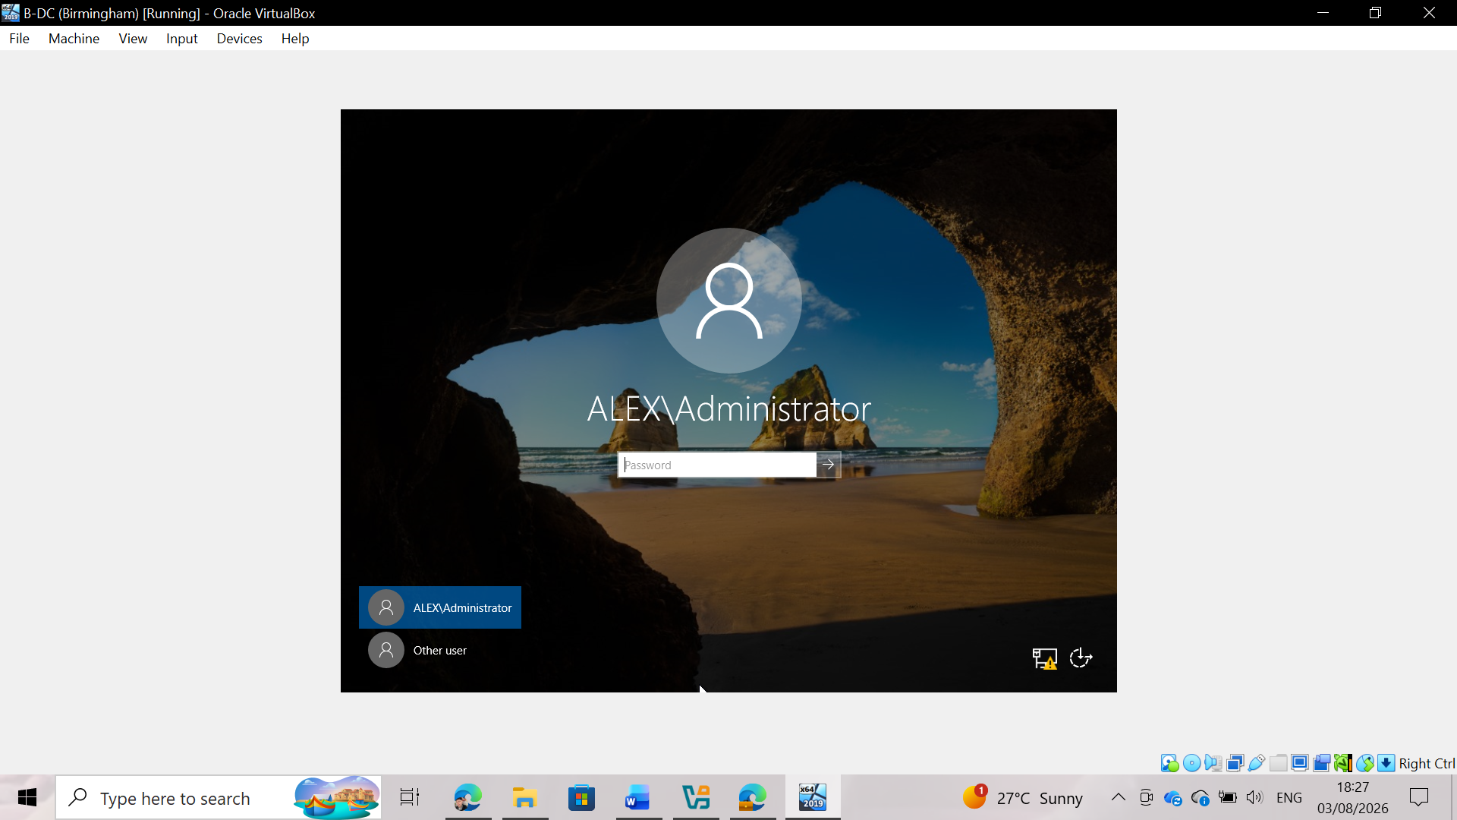
Fig 14: Creating the Active Directory forest (yourname.acca)
Launching the Active Directory Domain Services (AD DS) installation wizard on the Birmingham domain controller (B-DC), running Windows Server 2019, promotes the server to the primary domain controller of the new root forest, yourname.acca. This process generates the central Active Directory database (NTDS.dit), initializes schema definitions, and establishes the primary security boundary for the enterprise infrastructure. Configuring this forest root assigns essential FSMO roles to the B-DC, establishing the centralized authentication authority, security policy engine, and Global Catalog required to manage domain accounts and operations across the Birmingham and London locations.

2.2 Create all corresponding A records for all servers in the Birmingham and London networks

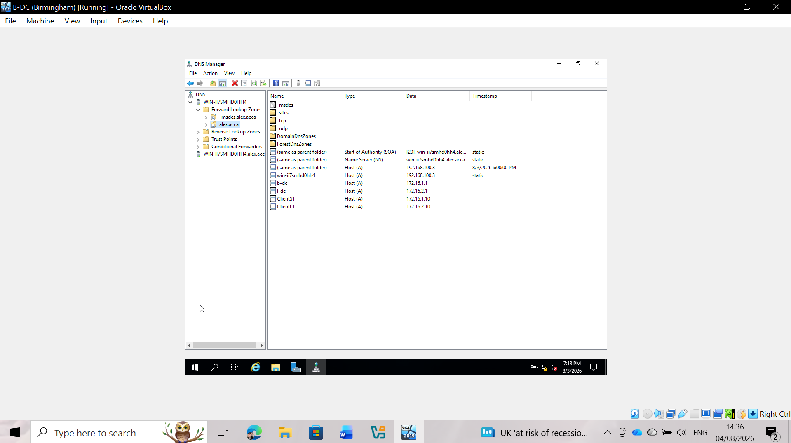
Fig 15: Creating the DNS forward lookup zone and host (A) records
Configuring the forward lookup zone for yourname.acca within the B-DC's DNS management console enables hostname-to-IP address resolution across the multi-site network. Static host (A) records are created for all core infrastructure servers and endpoints located in the Birmingham (172.16.1.0/24) and London (172.16.2.0/24) subnets. Pre-populating these A records ensures seamless domain name resolution for key services such as IIS, RDS, and LDAP, preventing network timeouts during domain-join operations and client service requests.

2.3 Creating a reverse lookup zone and PTR records for all servers

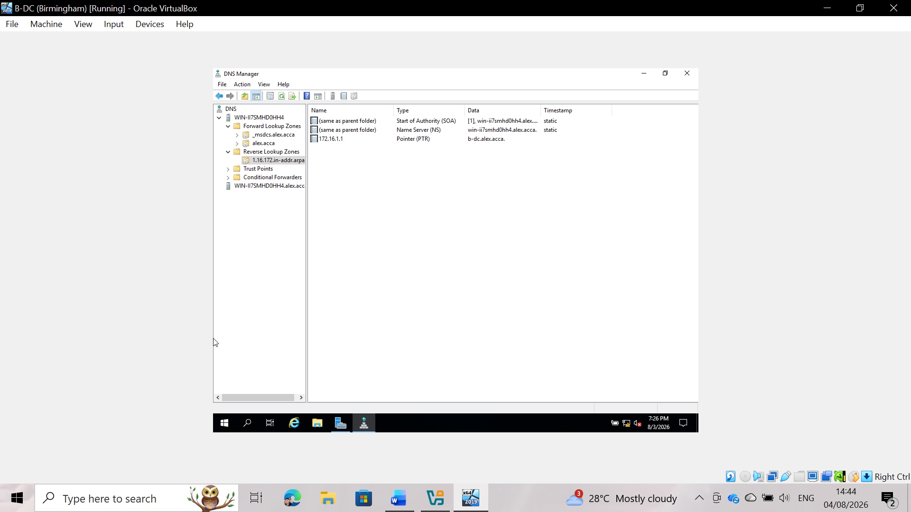
Fig 16: Creating the DNS reverse lookup zone and pointer (PTR) records
Configuring reverse lookup zones (1.16.172.in-addr.arpa and 2.16.172.in-addr.arpa) in the DNS MMC snap-in enables accurate IP address-to-hostname resolution across subnets. Corresponding pointer (PTR) records are configured for every domain server and member host throughout the enterprise topology. Comprehensive reverse mapping capabilities are essential for network diagnostic tools (such as ping -a and tracert), Kerberos authentication ticket verification, and security event logging in a distributed Active Directory environment.

Task 3: Encrypted Connection between Birmingham and London

Task 3.1: Configure Site-to-Site VPN to London Network
Part 1: Birmingham Server Configuration
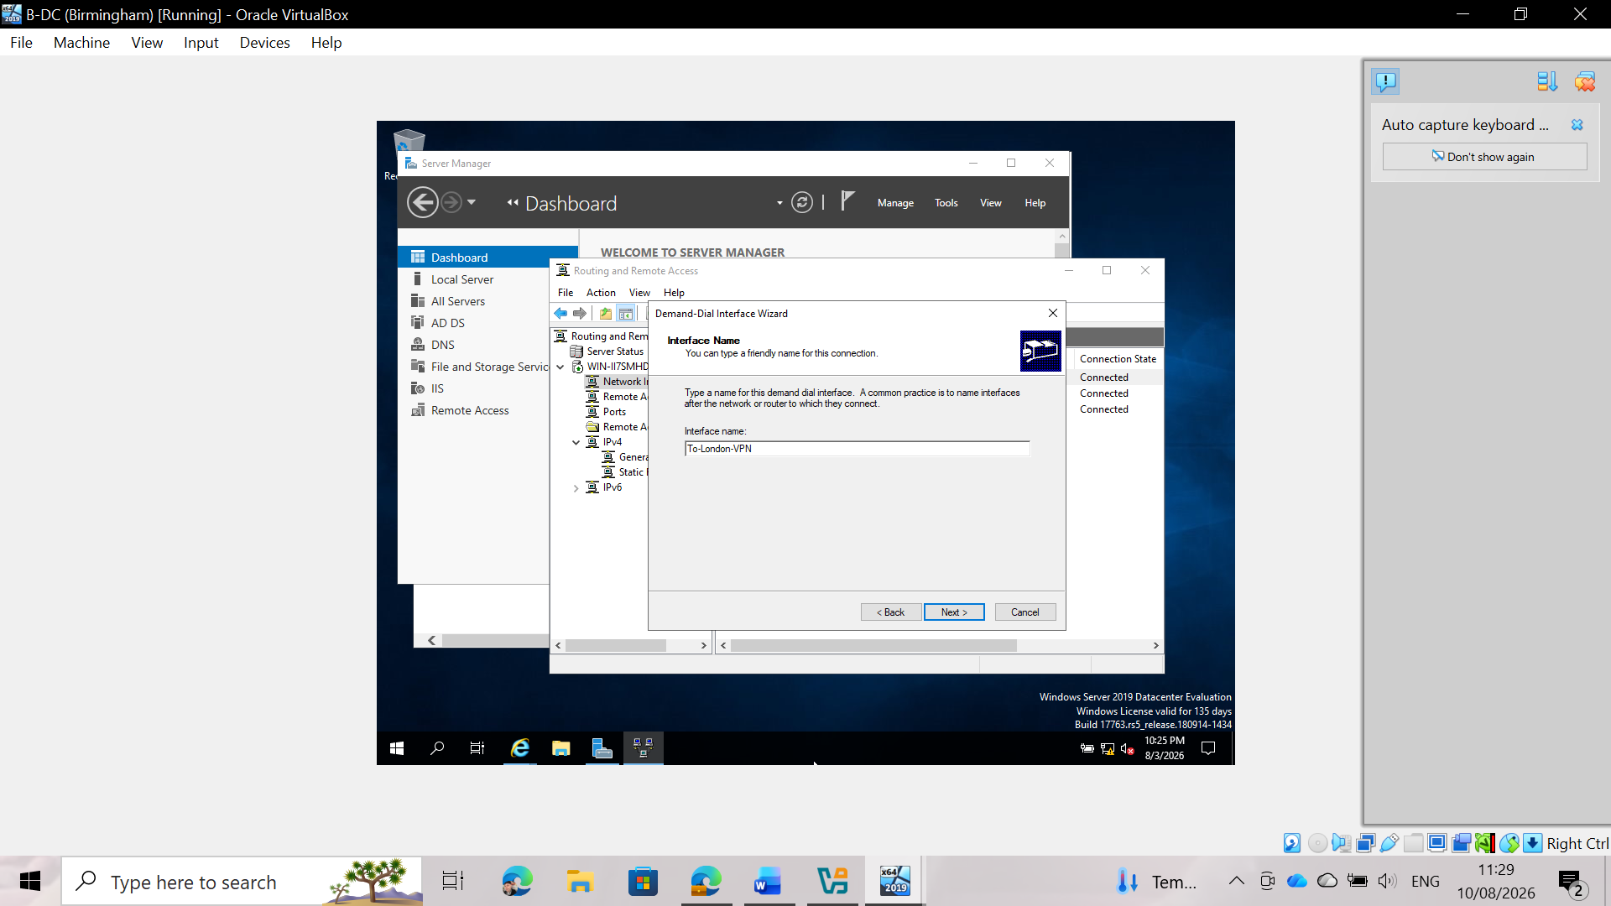
Fig 17: Creating Demand-Dial Interface on Birmingham Server
Creation of the demand-dial interface named To-London-VPN on the Birmingham RRAS server. This interface acts as the virtual network adapter responsible for managing and routing traffic through the encrypted tunnel to the London site.
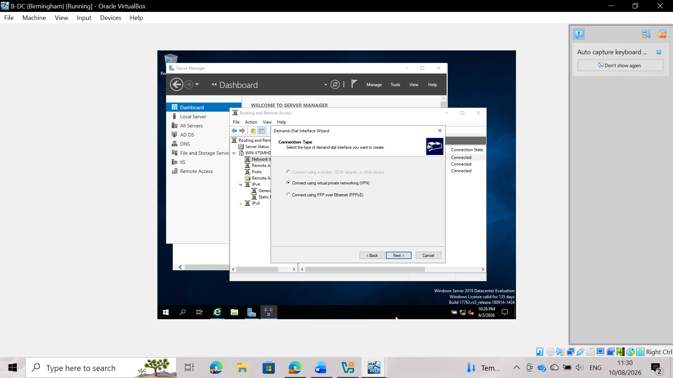
Fig 18: VPN Connection Type Selection
Select Virtual Private Network (VPN) as the connection type in the Demand-Dial Interface Wizard. This configures the system to route network traffic through an encrypted virtual tunnel over the public network.
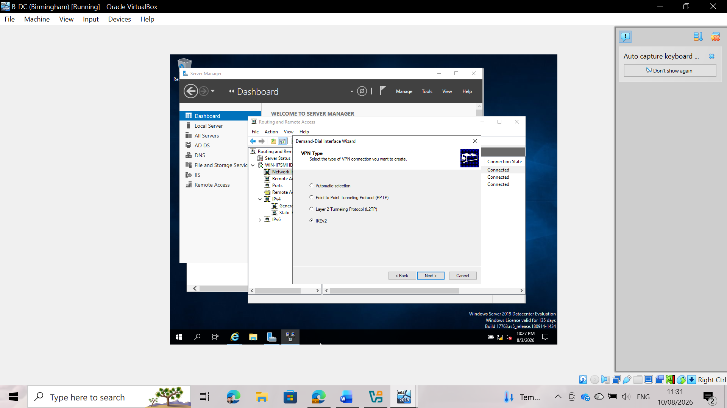
Fig 19: VPN tunnel protocol configuration
Selection of IKEv2 (Internet Key Exchange v2) as the VPN protocol for site-to-site communication. IKEv2 offers robust IPsec encryption, high reliability, and automatic tunnel recovery in the event of temporary network interruptions.
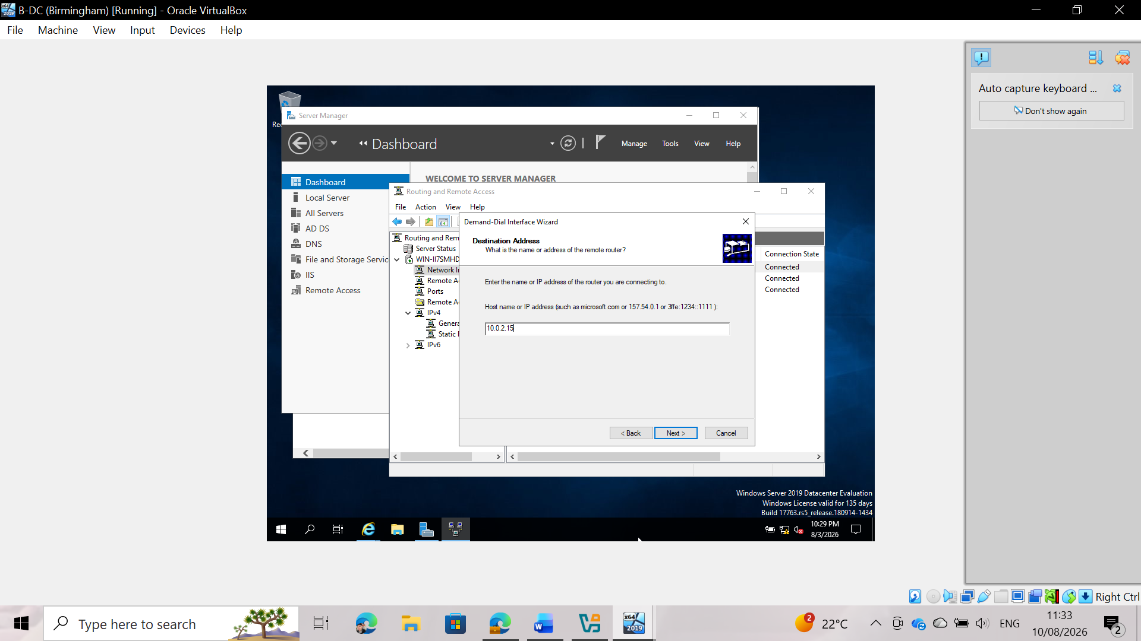
Fig 20: Destination IP address assignment
Specification of the destination IP address (10.0.2.15) corresponding to the remote London VPN gateway. This establishes the exact network endpoint to which connection requests and key negotiations are sent.
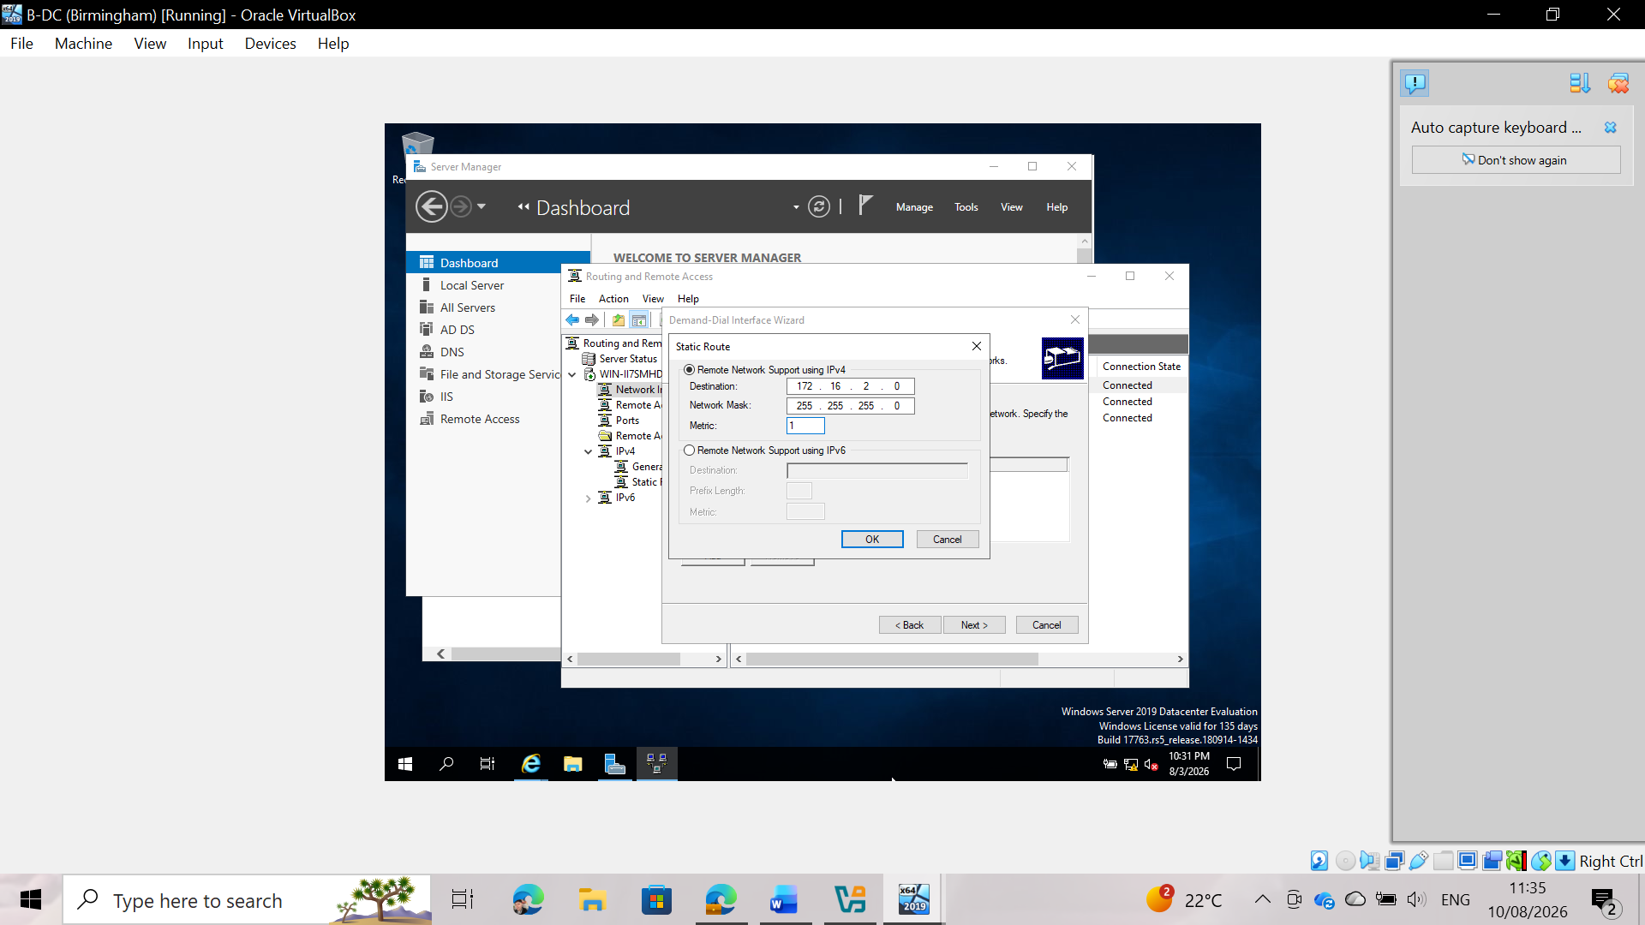
Fig 21: IPv4 static route definition
Addition of a static route for the London internal subnet (172.16.2.0/24) with a metric of 1. This ensures that all local traffic destined for London resources is redirected via the To-London-VPN interface.
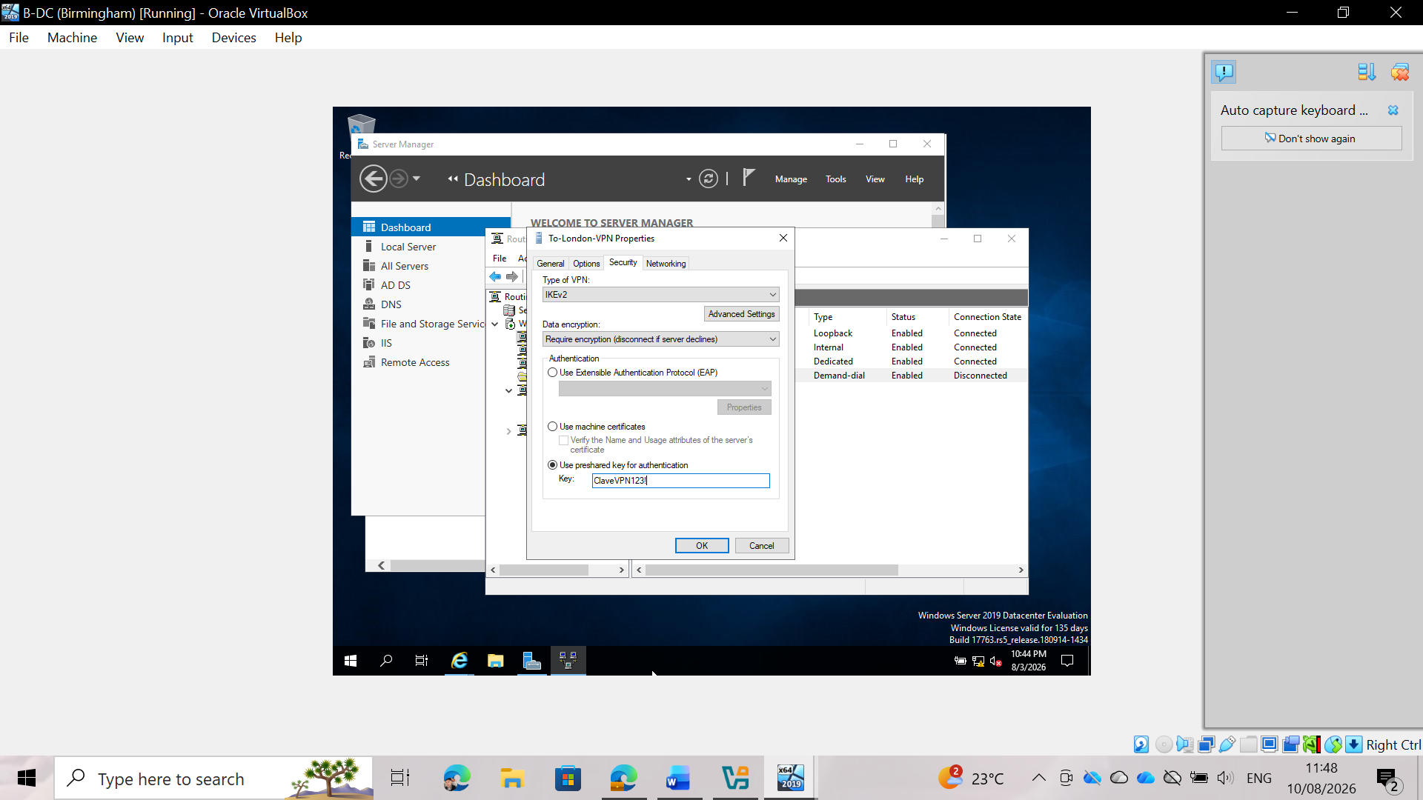
Fig 22: Authentication using a pre-shared key (PSK)
Security authentication configuration using a pre-shared key (PSK) in the interface properties. The use of matching keys at both ends ensures mutual authentication before the encrypted IPsec tunnel is established.
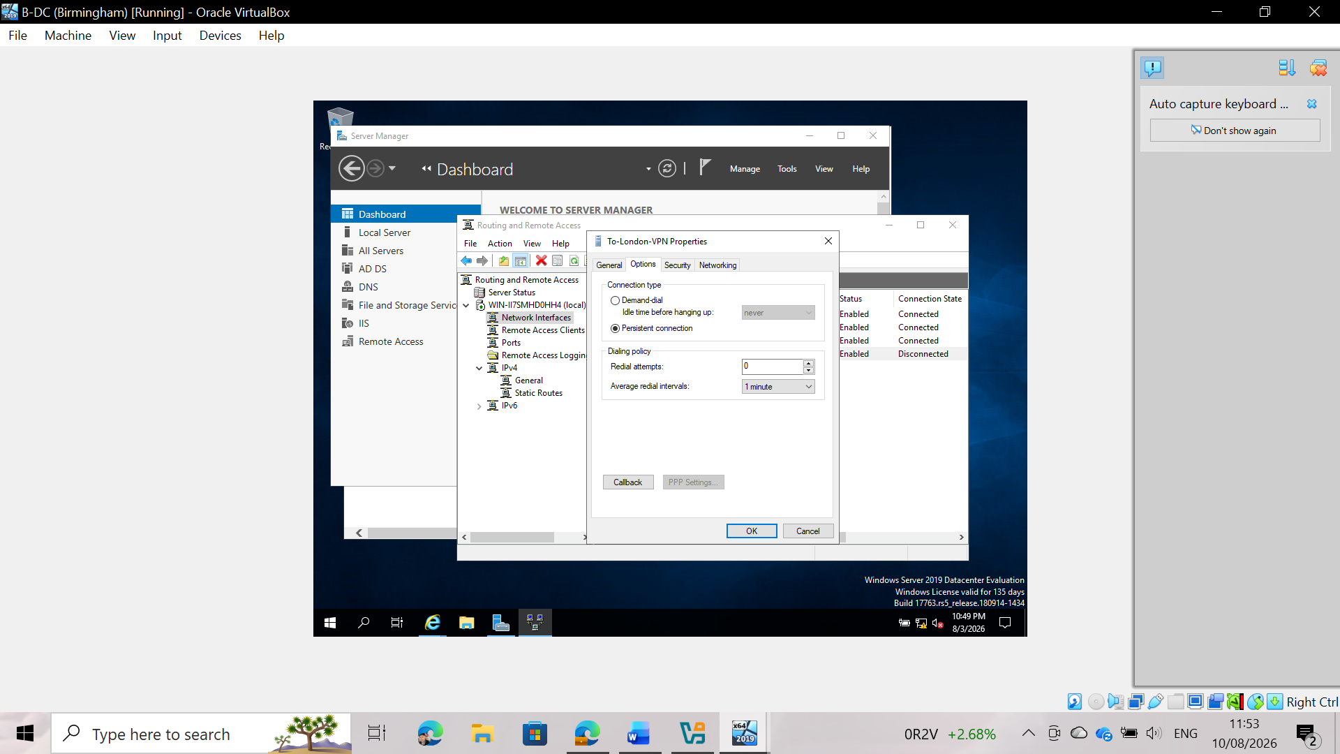
Figure 23: Activating persistent connection mode
Configuration of interface options for the "persistent connection." This maintains continuous tunnel operation and enables automatic reconnection, ensuring uninterrupted site-to-site connectivity without the need for manual initiation.

Part 2: London Server Configuration
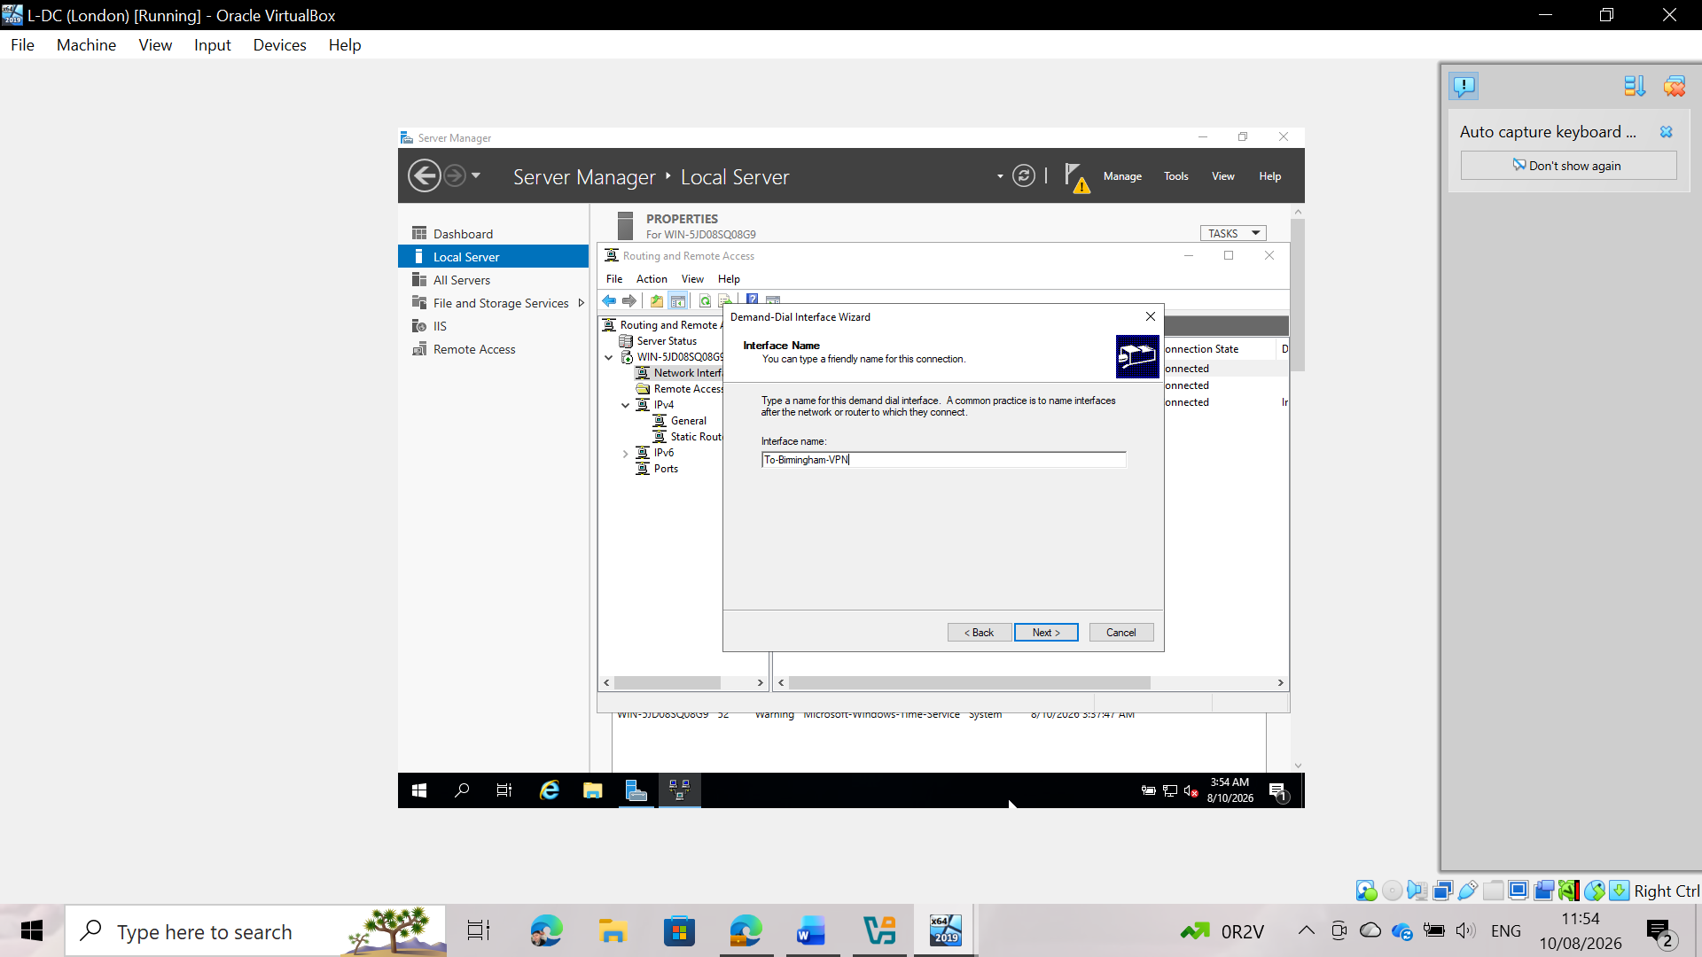
Fig 24: Creating an on-demand dial-up interface on the London server
Creating the reciprocal on-demand dial-up interface named To-Birmingham-VPN on the London RRAS server. This completes the opposite endpoint required for bidirectional communication between both sites.
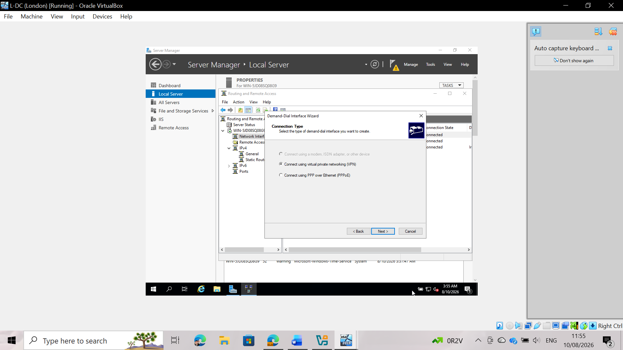
Fig 25: Selecting the VPN connection type
Selecting Virtual Private Network (VPN) in the Demand-Dial Interface Wizard on the London server, matching the initial protocol configuration used at the Birmingham gateway.
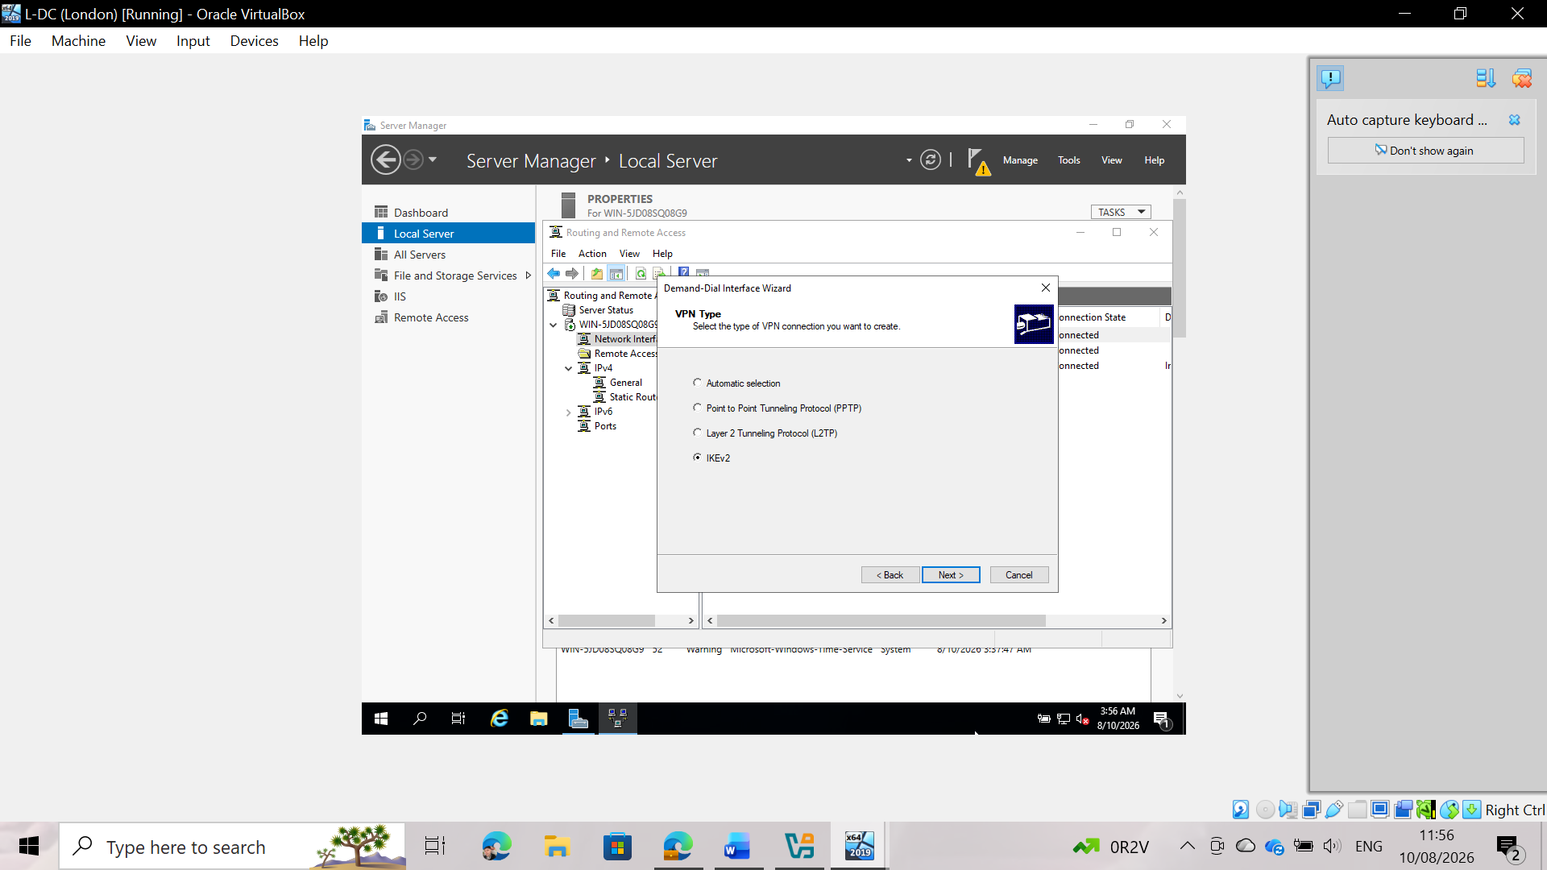
Fig. 26: VPN tunneling protocol configuration
Selection of IKEv2 as the VPN protocol on the London server. Both gateway endpoints must use identical tunneling and encryption protocols to successfully negotiate security parameters.
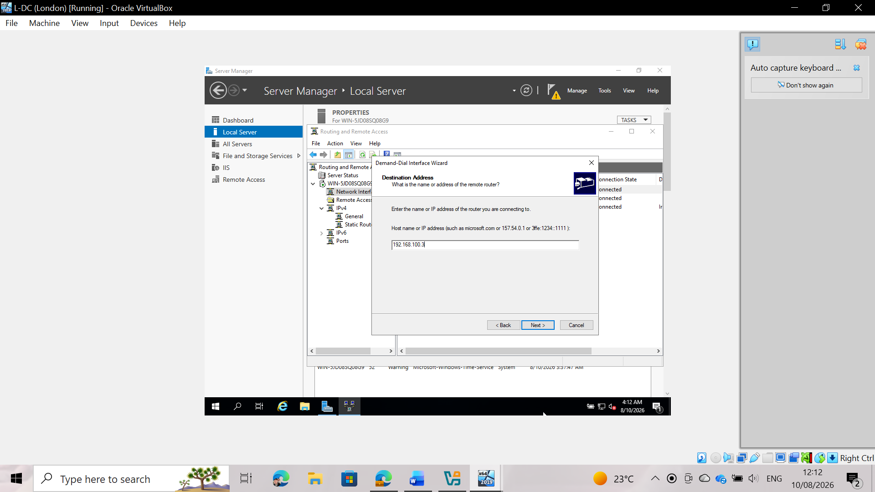
Figure 27: Destination IP address assignment
Entry of the destination IP address (192.168.100.3) corresponding to the Birmingham VPN server gateway to locate the remote endpoint during tunnel initiation.
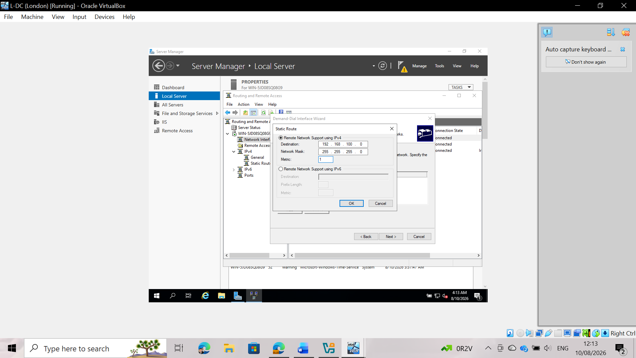
Fig 28: IPv4 static route definition
Definition of a static route directed to the local Birmingham subnet (192.168.100.0/24). This instructs the London server to forward packets destined for Birmingham via the active VPN interface.
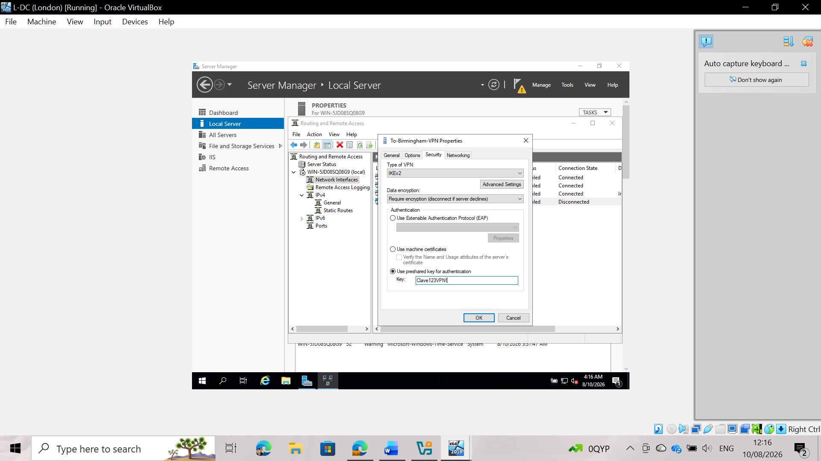
Figure 29: Authentication using a pre-shared key (PSK)
Entering the corresponding pre-shared key (PSK) in the security properties of the London server. For IKEv2 authentication to succeed, the string must match on both gateways.
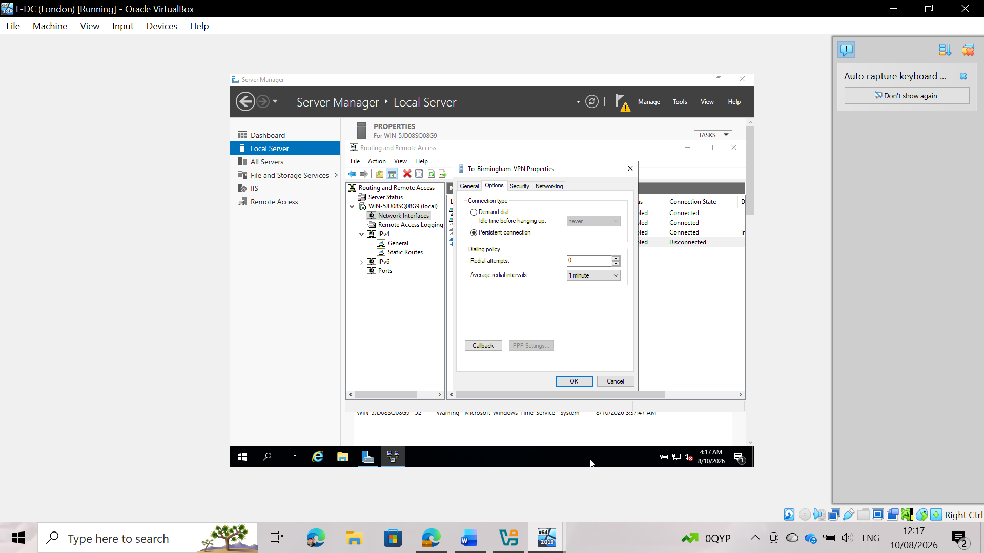
Fig 30: Activation of persistent connection mode
Configuring connection properties as a "persistent connection" on the London server to prevent disconnections due to inactivity timeouts and maintain continuous network connectivity.
Part 3: Operation State verification
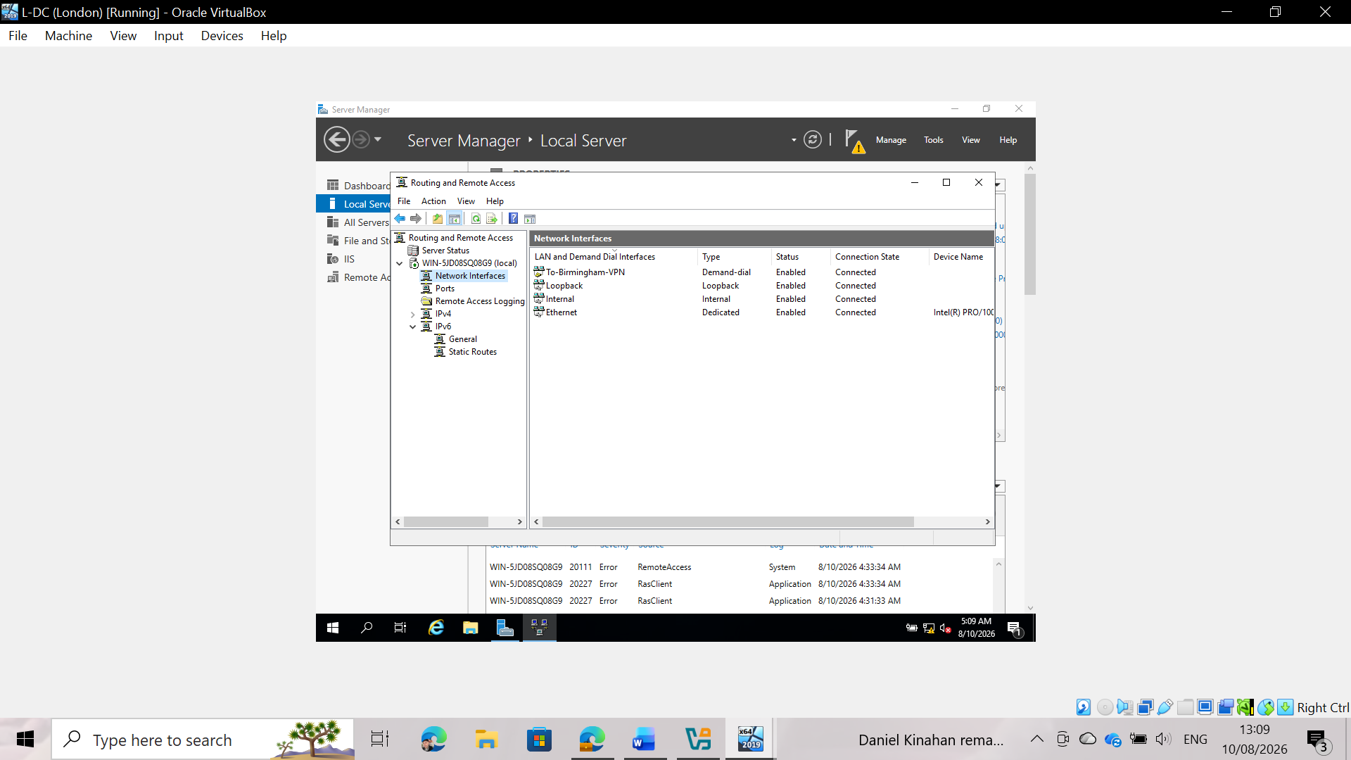
Fig 31: Operational verification (London endpoint)
Verification of the final status in the Routing and Remote Access console on the London server. The "To-Birmingham-VPN" demand-dial interface shows a connection status of "Connected," confirming that the tunnel negotiation was successful.
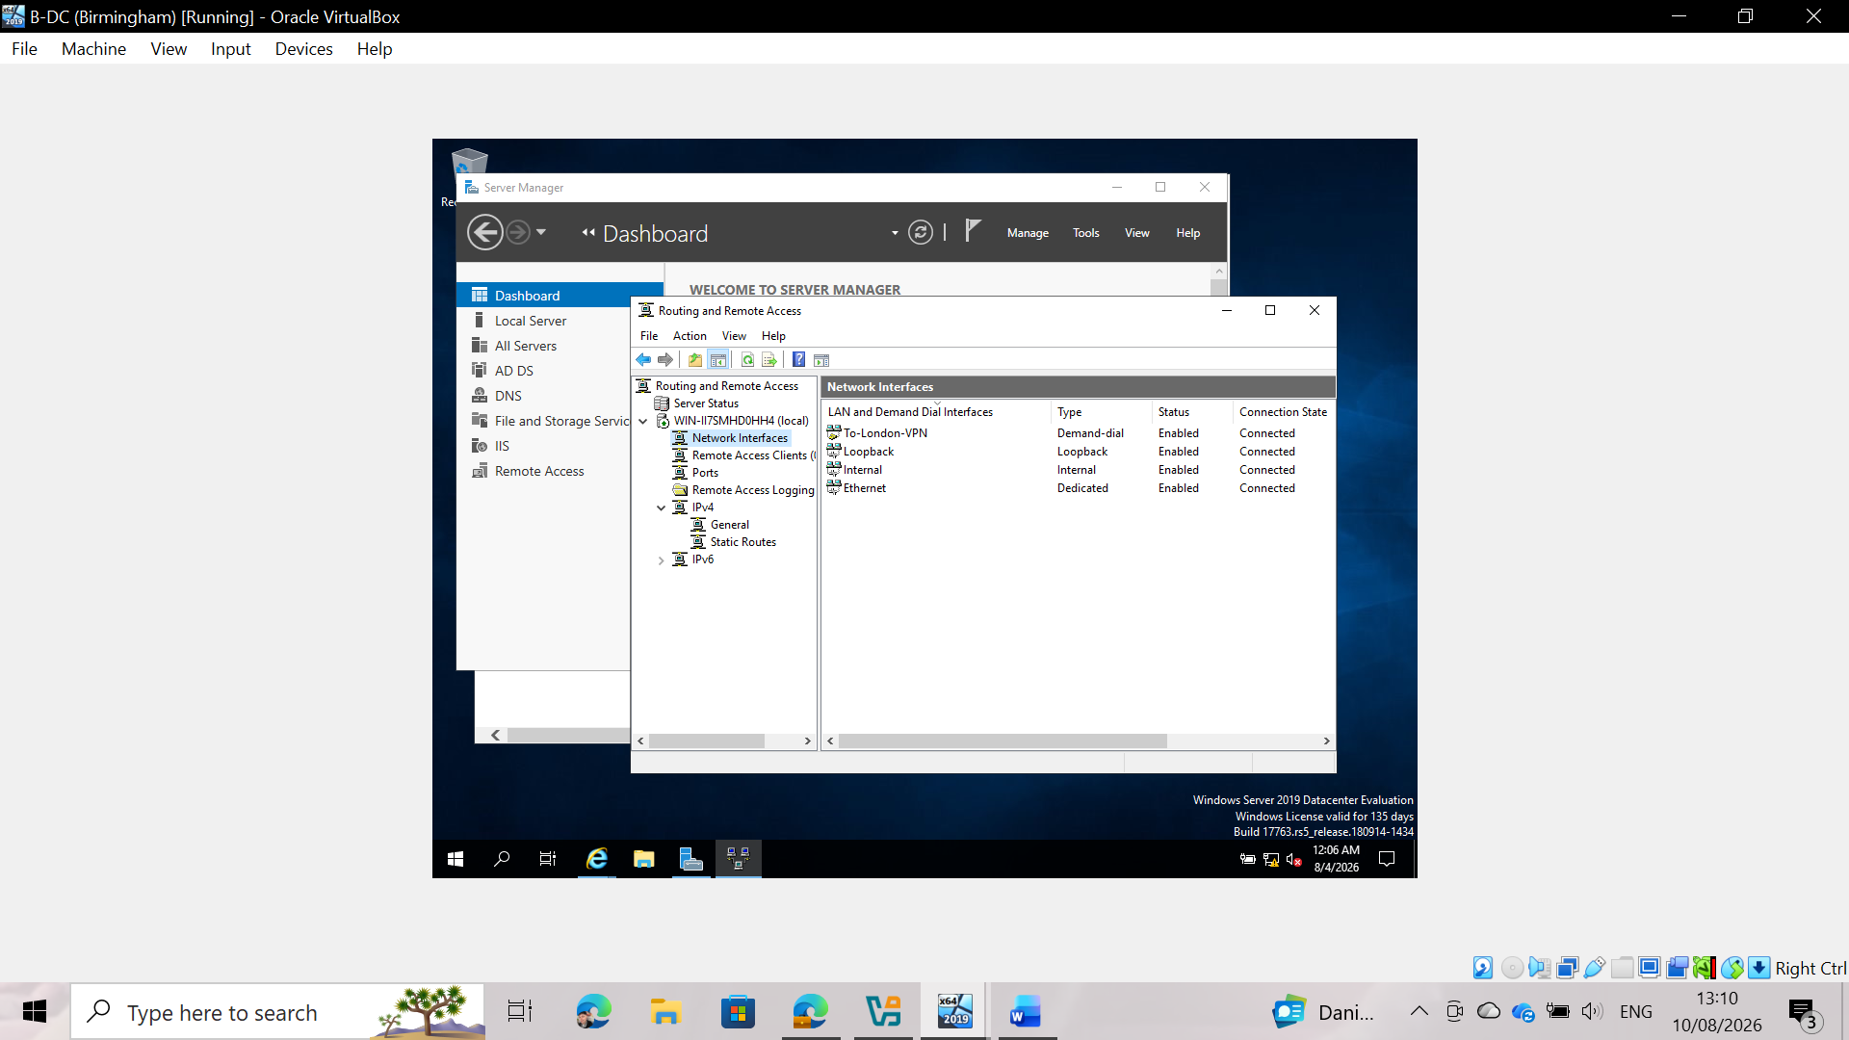
Fig. 32: Operational verification (Birmingham endpoint)
Verification of the final status on the Birmingham server, showing the "To-London-VPN" interface in a connected state. This demonstrates fully operational, bidirectional, encrypted communication across the enterprise.

Task 4: User Accounts Provisioning and Active Directory Integration

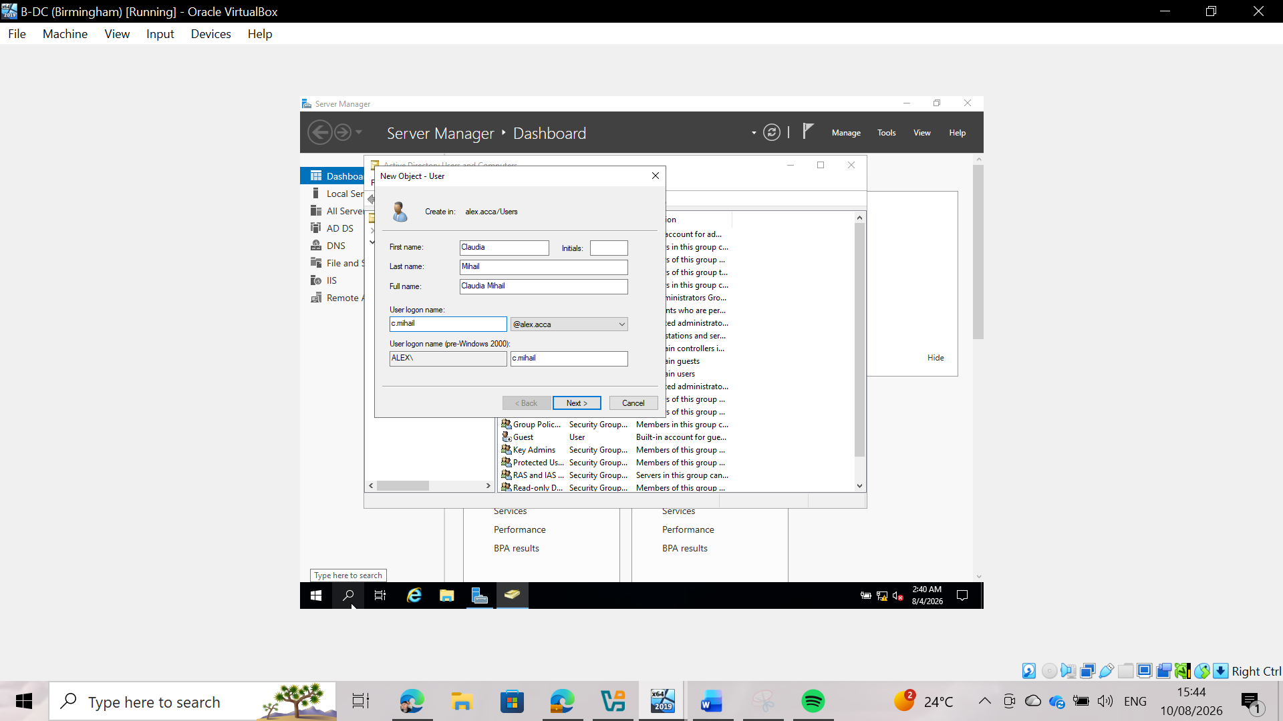
Fig 33: User Account Creation for c.mihail
Creation of the user account for Claudia Mihail (c.mihail) in Active Directory, applying the mandatory SAM Account Name format (<FirstInitial>.<LastName>).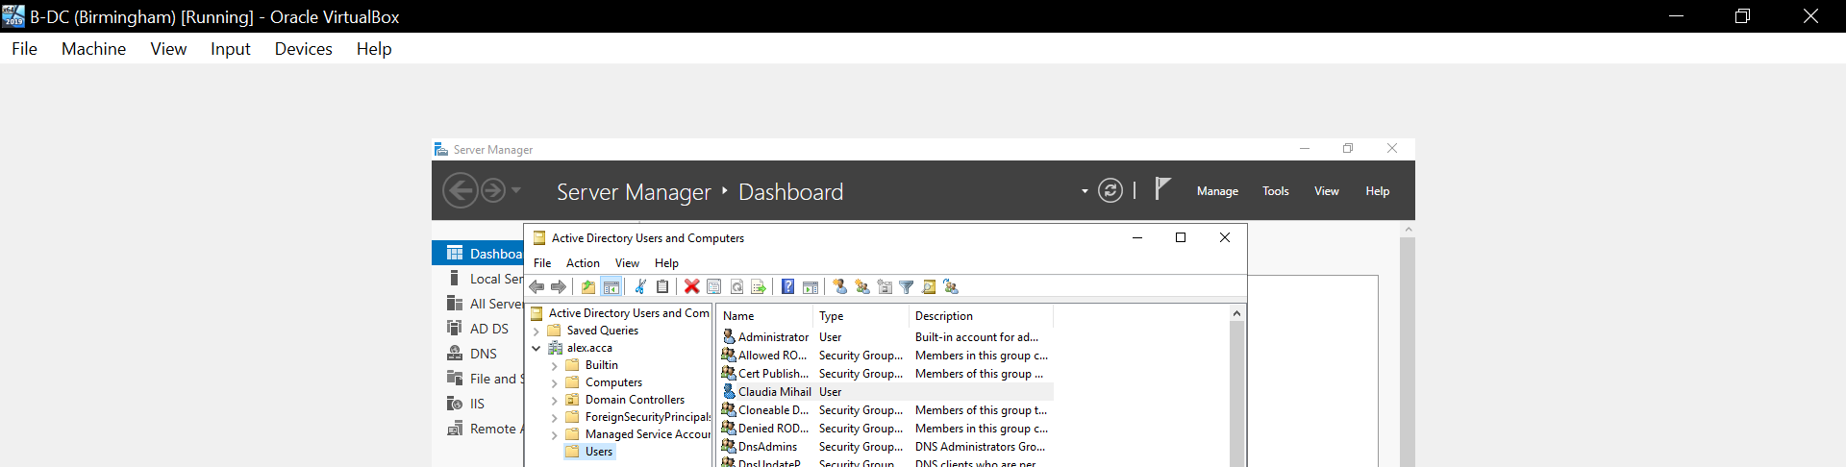
Fig 34: Active Directory Account Verification
Verification of the c.mihail account listed inside the Active Directory Users and Computers (ADUC) console.

Task 5: Domain Membership Configuration
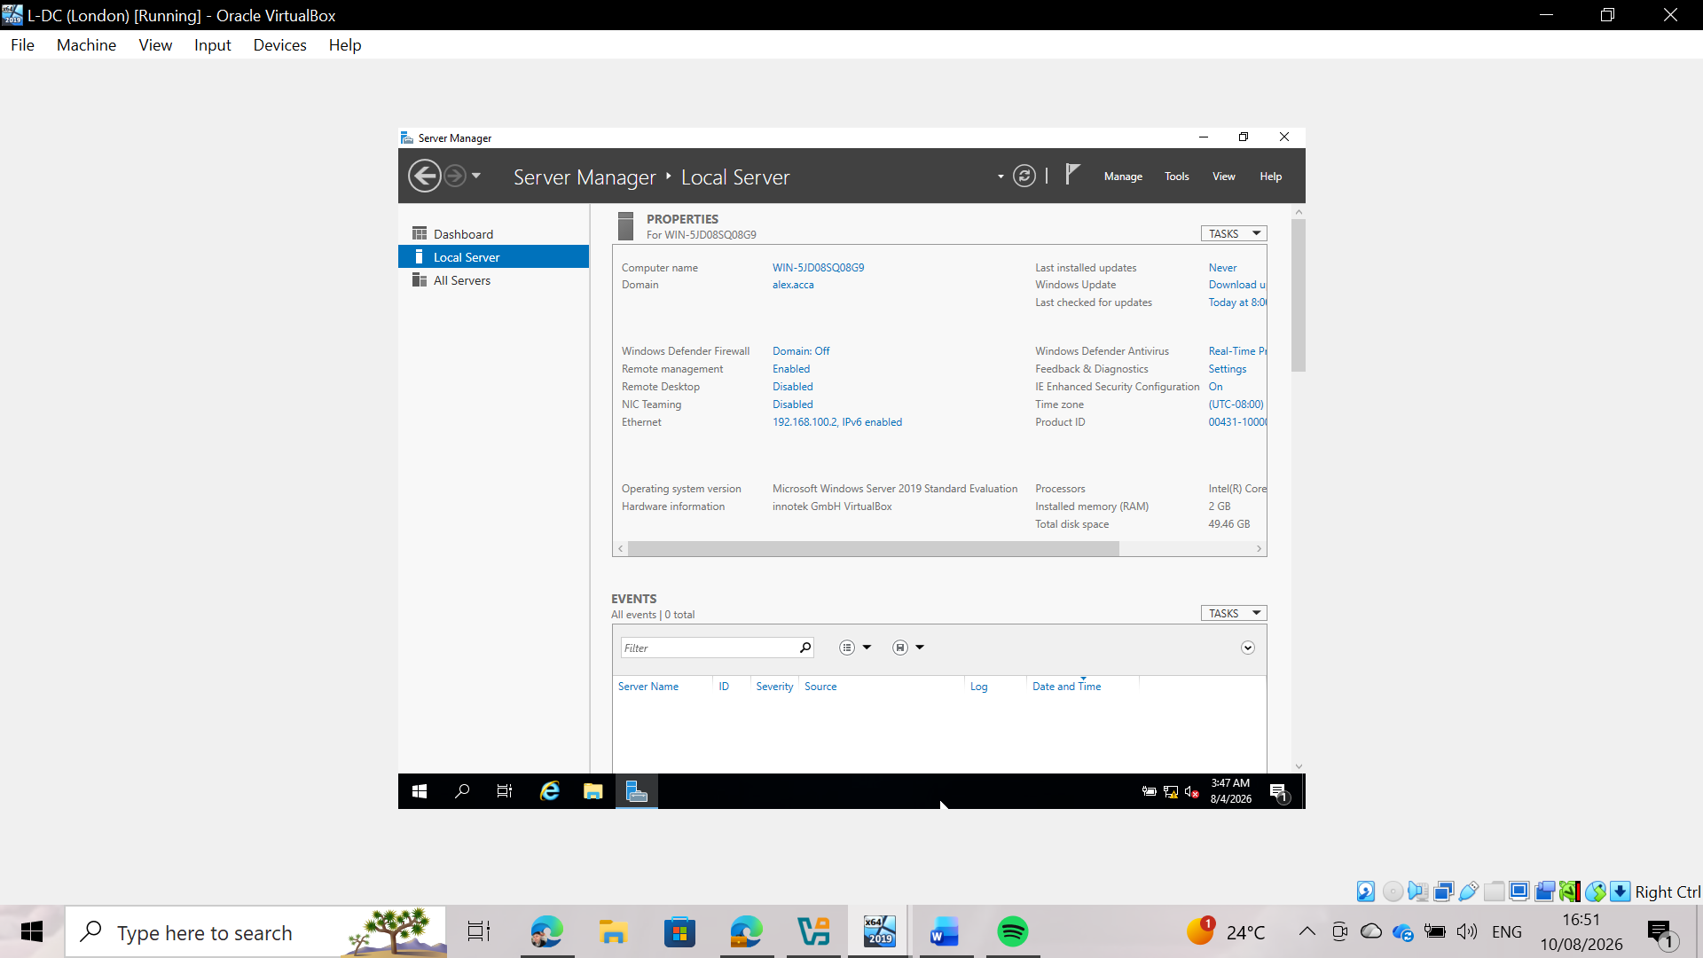
Fig 35: Confirmation of the L-DC server joining the alex.acca domain
The image shows the "Local Server" section within Server Manager on the L-DC machine (London). It confirms that the machine is no longer part of the default workgroup (WORKGROUP) and has successfully joined the alex.acca domain, managed by the primary controller.

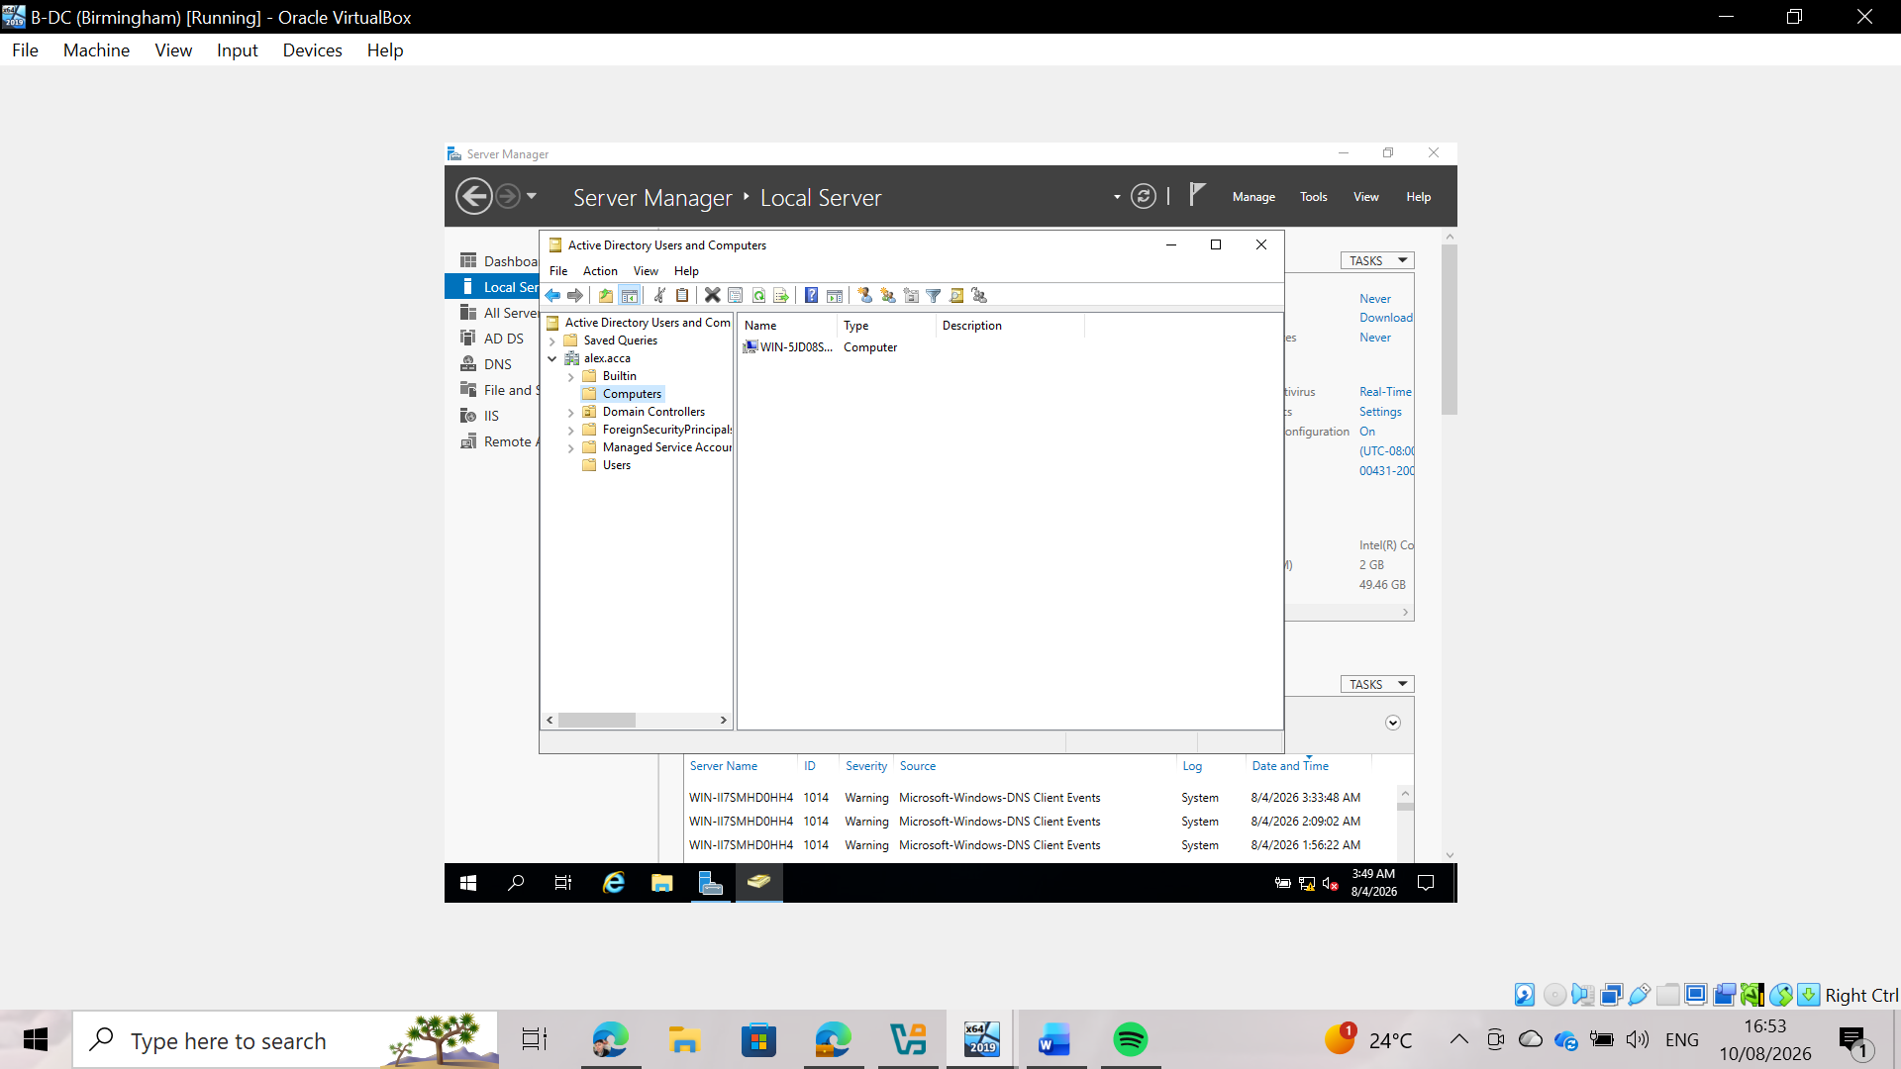
Fig 36: L-DC computer object registered in Active Directory Users and Computers
In the Active Directory administration console on server B-DC (Birmingham), the automatic creation of the computer object corresponding to the London machine (WIN-5JD08SQ08G9) within the "Computers" container is verified, confirming that the domain join process completed successfully.

Task 6: DHCP Server & DHCP Relay Configuration

Task 6.1: Overview and theoretical foundation:
DHCP (Dynamic Host Configuration Protocol): A network management protocol used to automatically assign IP addresses, subnet masks, default gateways, and DNS server addresses to client devices within a network. This eliminates the need to manually configure IP addresses and avoids IP conflicts.
DHCP Relay Agent: Routers and firewalls do not relay DHCP broadcast traffic between different subnets. Since the primary DHCP server is located in B-DC (Birmingham), the DHCP relay agent in L-DC (London) intercepts requests from local clients and forwards them as *unicast* packets directly to the central DHCP server.

Task 6.2: DHCP server configuration on B-DC (Birmingham)
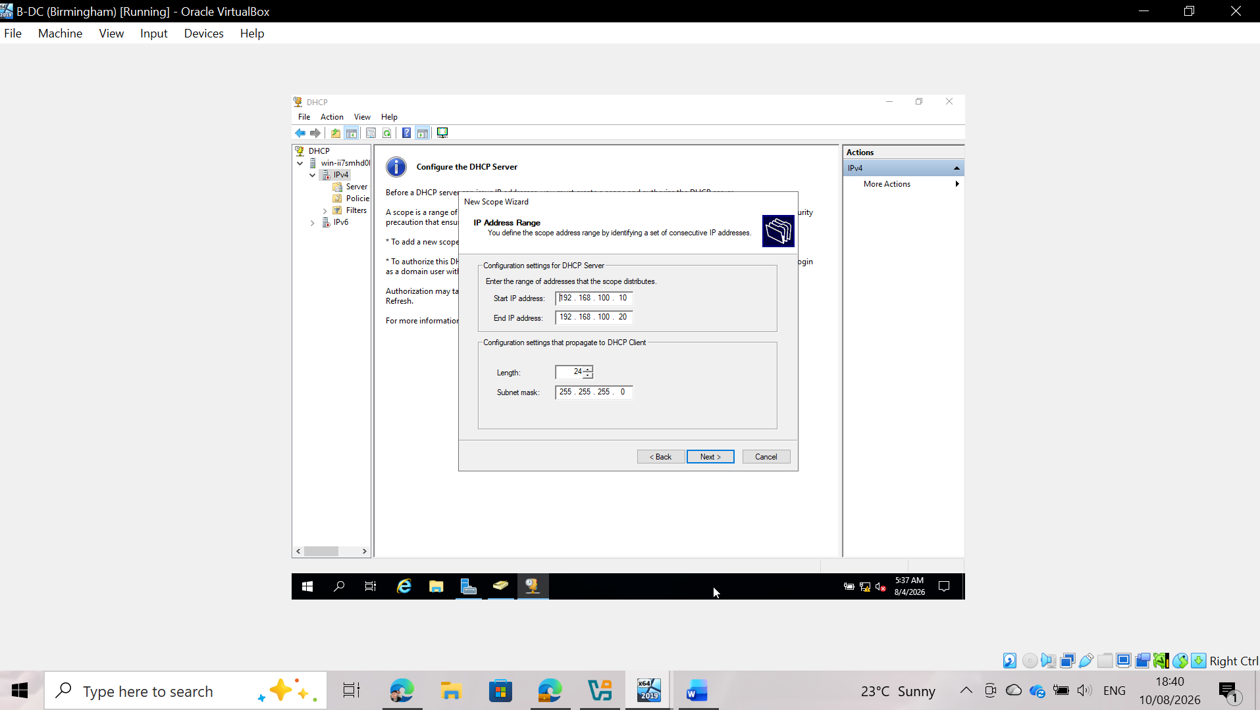
Fig 37: DHCP scope IP address range configuration for the London network on B-DC
Configuration of the IP address range for the remote London subnet (172.16.100.0/24) using the New Scope Wizard on server B-DC. The start IP address is set to 172.16.100.10 and the end IP address to 172.16.100.20, with a subnet mask of 255.255.255.0 (length 24).
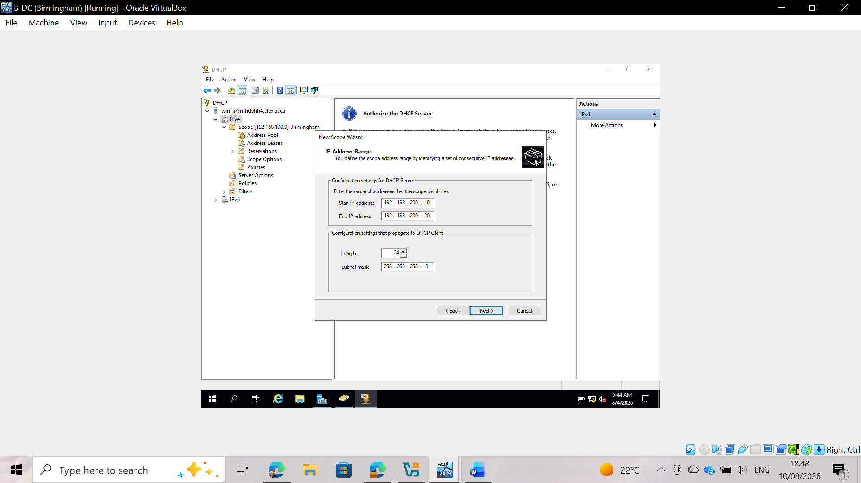
Fig 38: Configuration of the DHCP scope IP address range for the Birmingham network on B-DC
Configuration of the IP address range for the local Birmingham subnet (192.168.100.0/24) using the New Scope Wizard on B-DC. The address pool is defined with a start IP address of 192.168.100.10 and an end IP address of 192.168.100.20, with a subnet mask of 255.255.255.0 (length 24).
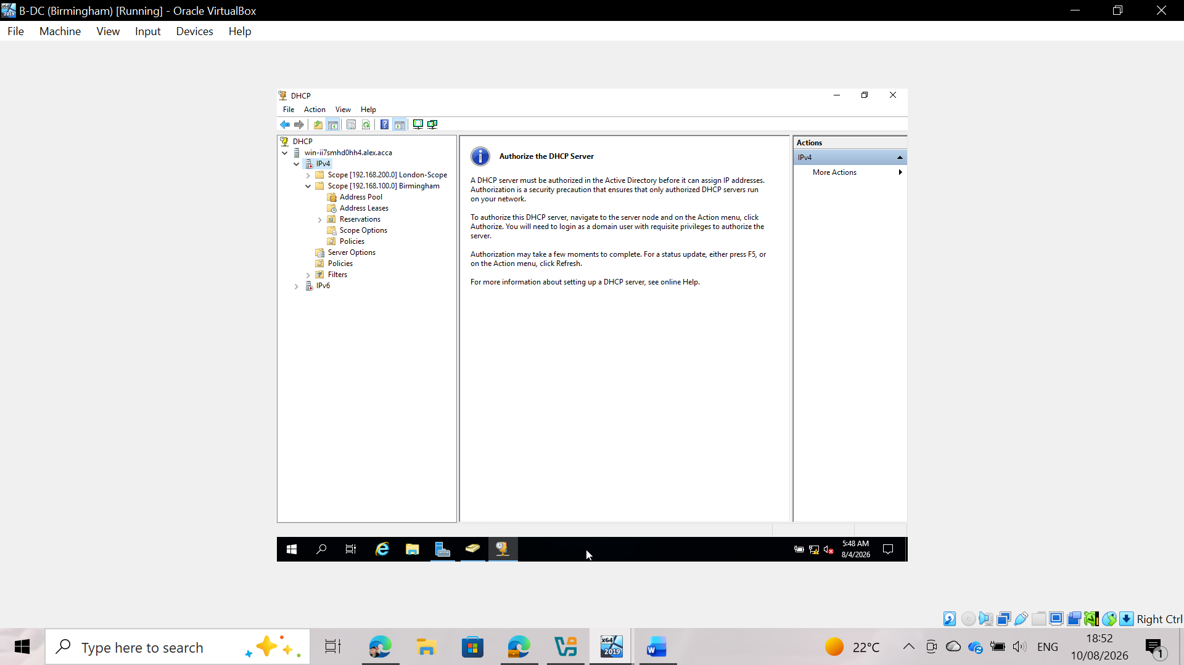Fig 39: DHCP server authorization in Active Directory on B-DC
DHCP management console on B-DC showing both created scopes (London Scope and Birmingham Scope) under IPv4. The main pane displays the "Authorize DHCP server" action, which is required to grant the DHCP server Active Directory authorization before it can actively assign IP address leases on the domain network.

Task 6.3 Configuring the DHCP relay agent at L-DC (London)
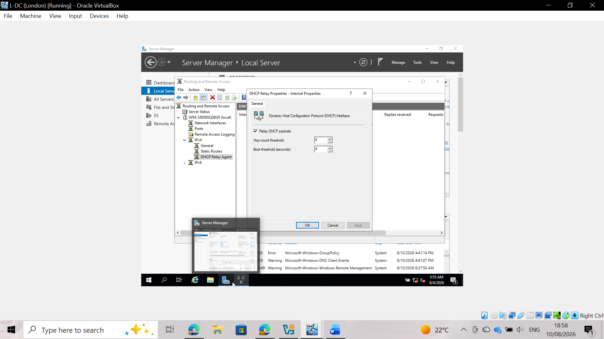
Fig 40: Configuring DHCP relay agent properties on the L-DC internal interface
Routing and Remote Access (RRAS) management console on L-DC (London). Accessing the DHCP relay properties window (internal interface) to enable the "Relay DHCP packets" option on the internal network interface (with a default hop-count threshold of 4 and a boot threshold of 4 seconds), thereby allowing DHCP broadcast requests from local clients in London to be captured and forwarded to B-DC.

Task 7: Test and Troubleshoot
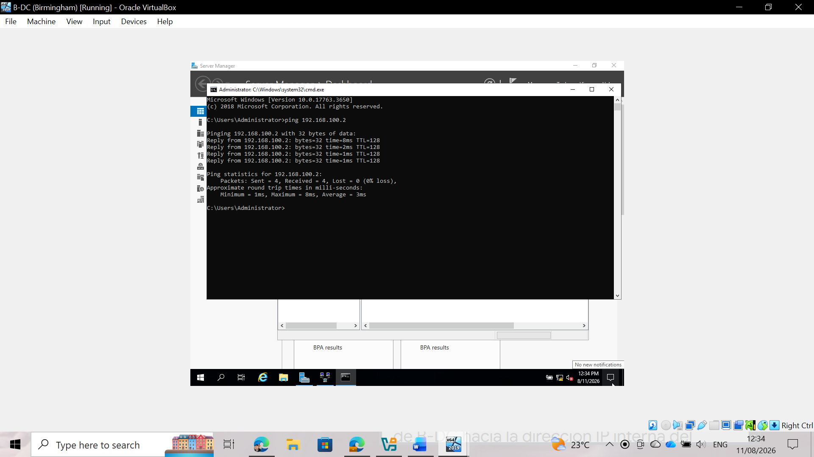
Fig 41: ICMP ping test from B-DC (Birmingham) to L-DC (London)
An ICMP connectivity test (ping) was executed from the B-DC command console to the L-DC server's internal IP address (192.168.100.2). The response, showing 0% packet loss, confirms that the static routing table and the IKEv2 VPN tunnel are correctly routing traffic from Birmingham to the London network.
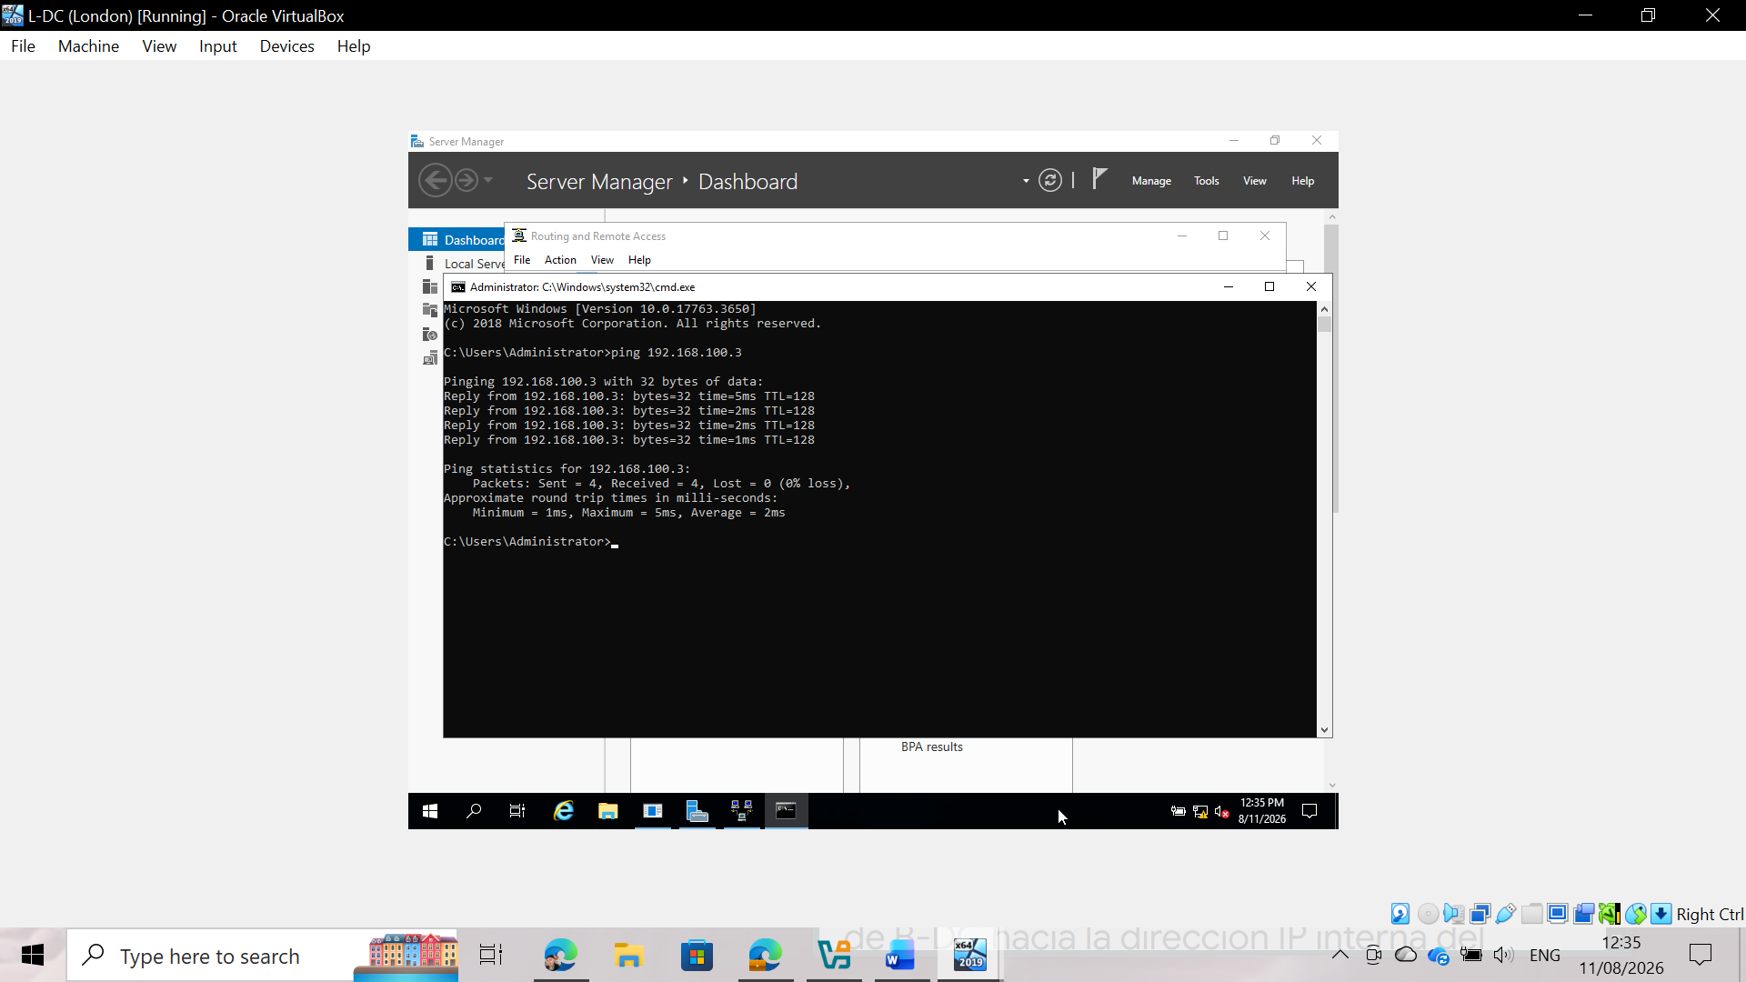
Fig 42: ICMP ping test from L-DC (London) to B-DC (Birmingham)
A bidirectional ping test was executed from the L-DC command console to the internal IP address of B-DC (192.168.100.3). The successful result, with no data loss, confirms that the return path is active and that the Windows Firewall rules on both servers allow ICMP traffic in both directions.

Task 8: Disk Drive
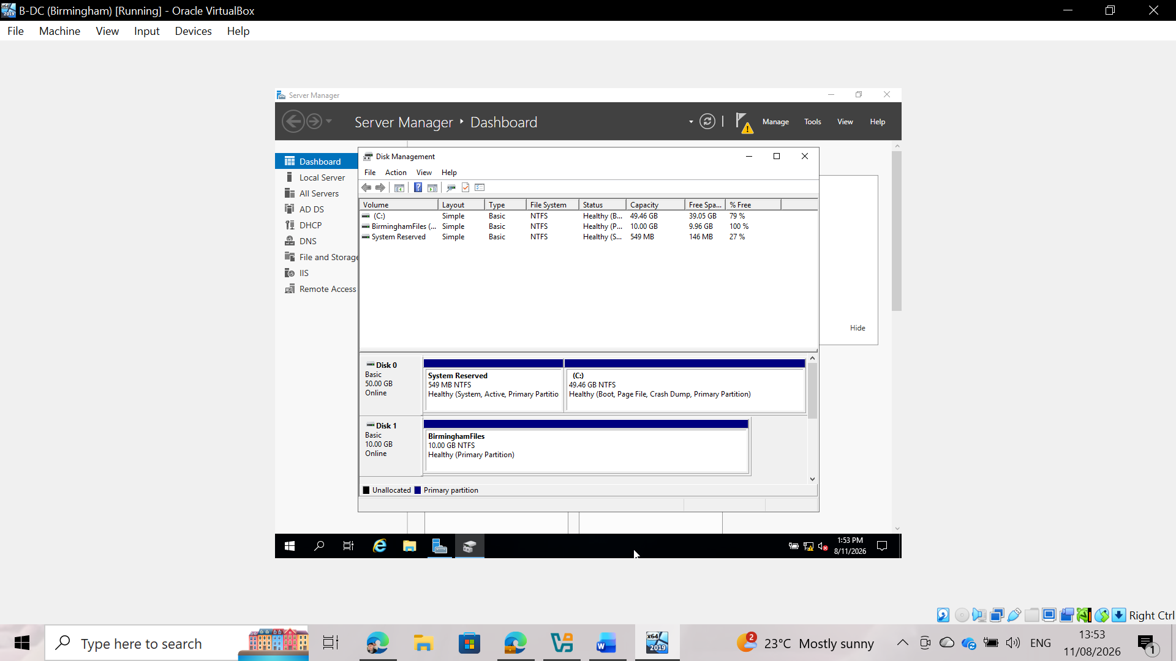
Fig 43: Formatting and initialization of the new drive E: (BirminghamFiles).
A new 10 GB secondary hard drive was added to the B-DC virtual machine via the VirtualBox settings. Subsequently, using the Windows Server Disk Management tool, the drive was initialized with the MBR partition style; a simple volume was created and formatted with the NTFS file system, assigned the drive letter E:, and labeled "BirminghamFiles."
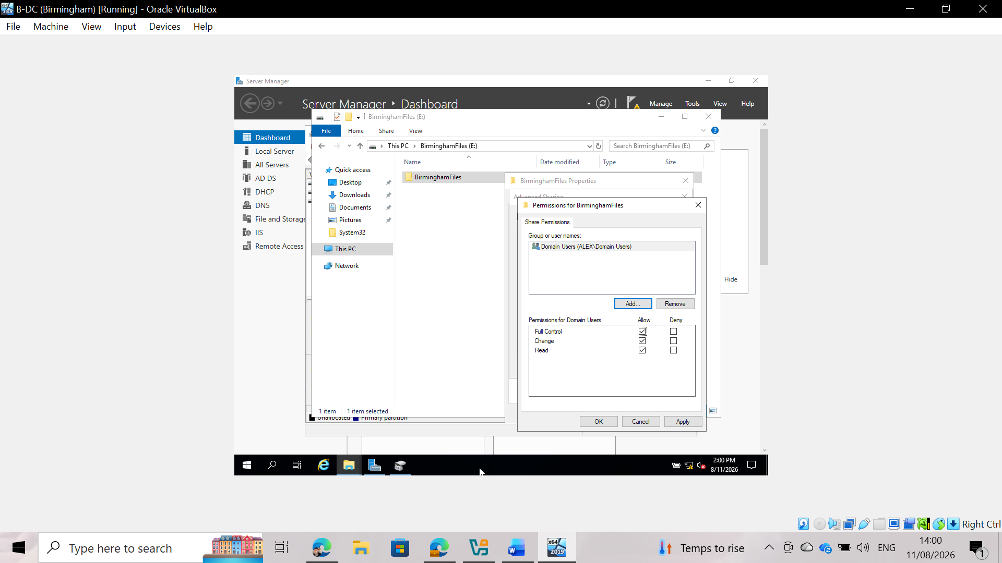Fig 44: Configuring shared resource permissions for domain users
The corresponding shared folder has been created at the path E:\BirminghamFiles. Via the Advanced Sharing tab, the access control entries were modified by removing the generic "Everyone" group and adding the "Domain Users" group, granting them "Full Control" permissions to ensure that authenticated domain users have full access to the folder.
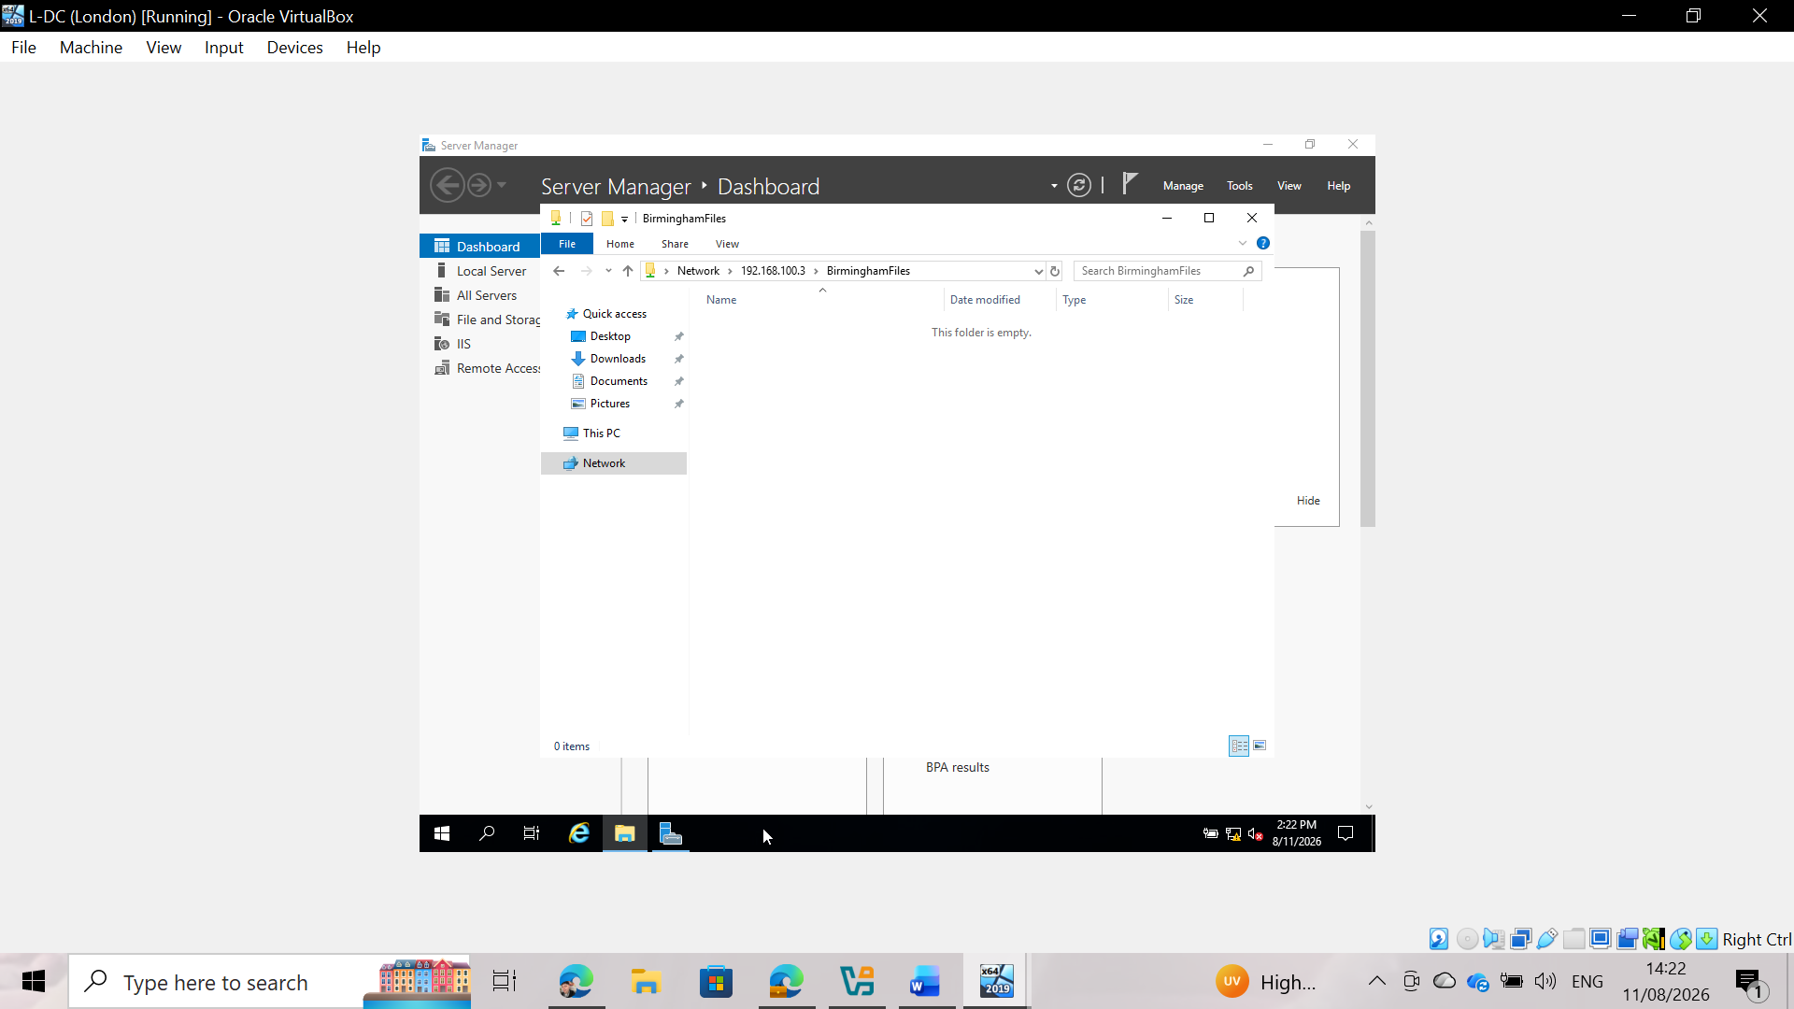
Fig 45: Verifying remote access to the shared folder from the L-DC
To verify site-to-site connectivity and the correct publishing of network resources via the VPN tunnel, remote access is initiated from the L-DC machine by entering the UNC path \\192.168.100.3\BirminghamFiles. After validating domain credentials, the successful opening of the shared network directory is confirmed.

9. IIS Server

9.1 Create webs.yourname.acca website and enable windows internal authentication
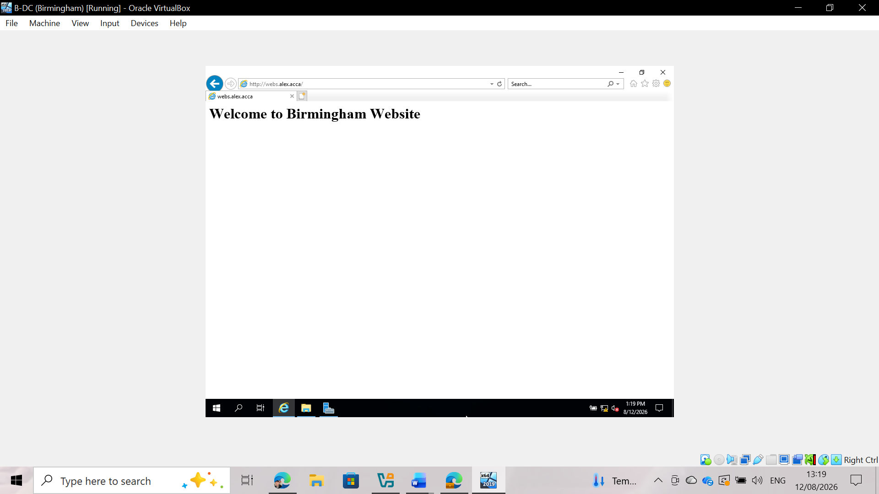
Fig 46: Successful access to webs.alex.acca via IIS
Purpose of the IIS (Internet Information Services) service:
IIS (Internet Information Services) is a flexible, secure, and easy-to-manage web server role provided by Microsoft Windows Server systems. Its primary function in an enterprise network is to host websites, web applications, and services; the service receives HTTP/HTTPS requests from clients over the network and delivers the requested content to end-user web browsers.
Configuration and authentication:
The website "webs.alex.acca" was created and bound to the server's IP address and domain name within the DNS system. Windows authentication was enabled for the site to restrict access exclusively to authorized Active Directory domain users. As shown in the previous screenshot, upon successful authentication, the web server displays the requested page with the message: "Welcome to Birmingham Website".

Task 10: Remote Desktop Services

Task 10.1: Configure remote access for B-DC from any other computer on the network
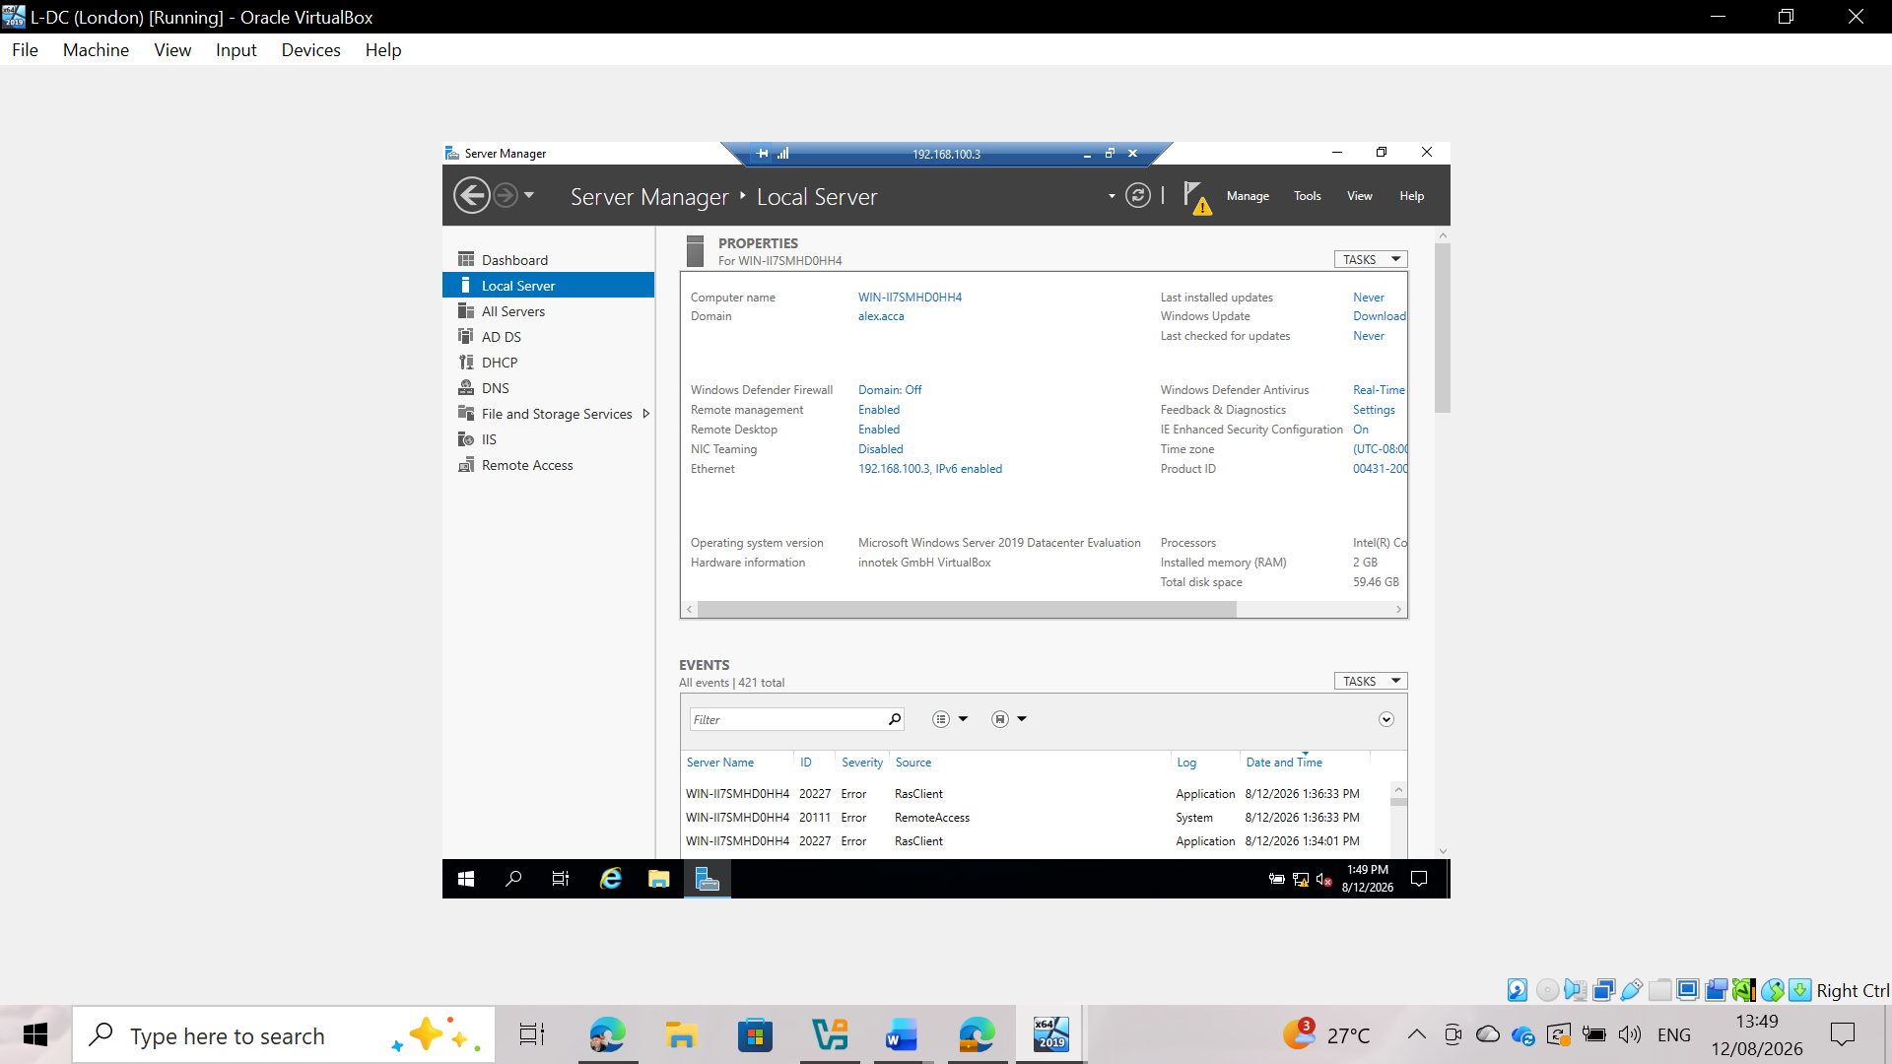
Fig 47: A Remote Desktop Connection session to B-DC has been established from a client machine
Analysis of its significance:
Remote Desktop Services (RDS) and the Remote Desktop Protocol (RDP) are fundamental components for centralized server administration within an Active Directory enterprise environment. By enabling remote access to B-DC, administrators can manage server roles, perform routine maintenance, troubleshoot issues, and deploy software updates from any authorized workstation on the network, without requiring physical access to the server hardware. This centralized management model enhances administrative efficiency, reduces operational downtime, and strengthens network security through strict access control based on Active Directory authentication.
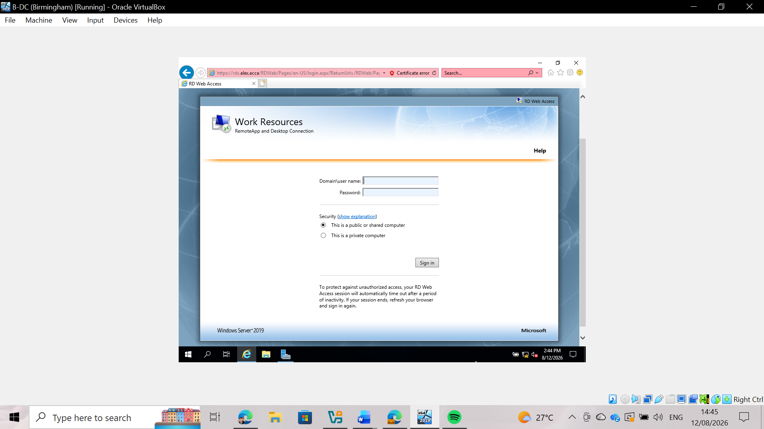
Fig 48: Access to Remote Desktop Web Access via an HTTPS domain ([https://rds.alex.acca/RDWeb](https://rds.alex.acca/RDWeb))
Remote Desktop Web Access and SSL certificate configuration:
To meet the advanced requirements of a high-quality deployment, Remote Desktop Web Access (RDWeb) was deployed and configured in IIS on the domain controller. A dedicated DNS host record (A record)—rds.alex.acca—was created and mapped to the server's IP address (192.168.100.3). Additionally, an SSL certificate was generated and bound to the HTTPS protocol (port 443) on the IIS web server to encrypt communication between client browsers and the server. As shown in the screenshot, users can securely access the Remote Desktop Web Access login page using the Fully Qualified Domain Name (FQDN) over an encrypted HTTPS connection.

Conclusion:
This technical report documented the implementation and deployment of a multi-site enterprise network connecting the Birmingham (B-DC) and London (L-DC) nodes. Key achievements included the establishment of the alex.acca domain, configuration of RRAS routing, DNS resolution, an IKEv2 VPN tunnel, DHCP relay, and secure resource sharing. Diagnostic tests confirmed full connectivity and compliance with security standards.

