
Module Code: ECAD4007-C.
Name: ebony Tuckwood.
Student Number: 1900477.
Word count: 2,111.
Date:13/12/2019.
module: The learner: who am i teaching?


There are many ideas and theories from a variety of people and places that underpin child development and our understandings of it. It is vital that all people working with young children are aware of and have a reasonable understanding of the developmental stages of children, how they can be effected and the impact their role has upon them. It is important that individuals within education focus on all areas of development and their sub categories equally to ensure they are supporting each child as a whole without placing more focus on certain developments, areas or stages (Voko, K et al, 2014). According to (UKEssays, 2018) in order to understand the implications of the developmental processes of children teachers need to develop their observation skills and learn to interpret and act upon these accordingly to allow them to meet the individual needs of each child. It is further stated by (UKEssays, 2018) that through the comparison of the observed abilities to that of the expected for a child of the same age, teachers can begin to analyse and compare what they have observed against their understandings of what child theorists have proposed and their personal as well as relevant read about experiences. Further enabling them to explain how environmental factors may affect the development and growth of specific children with regards to their characteristics and interactions within their surrounding area (UKEssays, 2018). It could be argued and has been suggested by (Voko, K et al, 2014) that teachers can achieve the level of understanding they require through the adoption of a Holistic approach with regards to their observations and practice. The Holistic approach to child development places great importance on the idea that children learn different things at different stages for example the development of their fine motor skills, walking and talking and overall the development of every aspect of development within children (UKEssays, 2018). This approach simultaneously addresses the spiritual, relational, intellectual, physical and emotional areas of a child’s life, it is suggested by (gene2genius, No Date) that this means it’s not only focused on learning alone there is also a great focus on the implementation of what is being learnt. The holistic approach with regards to the health of the child looks further than just the physicality of the child and is also concerned with the emotional, intellectual, social and spiritual health and the addressing of these areas within development and how these can affect teaching and learning (Faletra, M, 2018). In terms of teaching and learning and its effect on the child it can be argued that if teachers have a varied understanding of the underpinning theories of child development and use their knowledge and understanding coupled with their observational findings to create lessons and activities that enable them to support every child individually focusing on all areas of development equally despite their developmental stage, this will have a positive impact on the child as an individual, the class environment and teaching and learning as a whole (Voko, K et al, 2014). Within this essay I will be exploring the social, cognitive and physical areas of development with reference to a case study which I will refer to as Ella, I will be using research, theorists’ opinions and my own experiences as well as her pupil profile to assess where Ella is within her development and to suggest what might be done to help her to effectively improve.
Children become subject to many influences upon their development, these begin with parents and lead to the various aspects of school life with a large influence coming from their peers (Sulkin, A, 1981). Social development is a process of interaction involving the development and creation of relationships and friendships and the ability to resolve conflicts and disagreements within these new found relationships (SCAN, 2019). There are many ideas and opinions as to the levels a four-year-old child is expected to have reached within the social aspect of their development, it is suggested by (Children’s Therapy & Family Resource Centre, 2011), that children of Ella’s age should be able to separate from their parents, initiate and join in on play with others and be able to have independence from their caregivers/teachers. It is evident within Ella’s profile that she has separation issues with regard to her mother and is heavily reliant on the adults in her life for direction and decision making. It is also clear that she doesn’t wish to initiate play and would prefer to play alone with a reluctance to share and isn’t really aware of her peers. It could benefit Ella socially to work and play with others within small groups and perhaps pairs during school, this should be easily provided due to the structure of the foundation phase which encourages the use of play to aid the understanding and development of social behaviors (Children’s Therapy & Family Resource Centre, 2011). This could be done through the use of social skills games (Appendix 1), circle time and group tasks to improve sharing skills and the understanding of turn taking. The idea of learning partners which I experienced in my bridging school could benefit Ella’s development greatly because of its implementation of Vygotsky’s theory of the zone of proximal development, the idea of an MKO works well as it allows children to learn with all types of children in their class encouraging peer learning and developing their social skills and academic abilities simultaneously, it is suggested by (Vygotsky, 1978) that social interaction is vital to cognitive development (McLeod, S.A, 2018).
Cognitive development encompasses the development of the brain, knowledge and skills as well as other aspects such as thought (help me GROW, 2016). According to Piaget’s stages of cognitive development (Appendix 2) Ella is in the Preoperational stage, this suggests she is Egocentric to an extent and should be able to use symbols and language to express herself and communicate. According to Ella’s profile she is egocentric to a degree and has difficulty seeing others perspectives and realising consequences and her effect on others. It is further implied within her pupil profile that she is not as good at interpreting or communicating with language as would maybe be expected for a child in the preoperational stage of development (Cliffs Notes, 2016), for example Ella doesn’t talk clearly and rarely initiates talk and tends to have to be persuaded to complete tasks however, she does use gestures to communicate her needs although she is reluctant. It could be suggested that Ella would benefit from positive reinforcements focusing on growth mindset and values (Appendix 3) in particular a mix of intrinsic and extrinsic motivations to encourage engagement in learning, for example in my bridging school I experienced the effective use of Dojo points to encourage children to want to behave and complete their work to the best of their abilities thus aiding their cognitive development. However, it is suggested by (Dweck, C, 2015) that praise is only effective in producing a growth mindset if the praise is used properly, teachers should praise the process of the learning, the effort and the focus. (Dweck, C, 2015) further states that the teacher must themselves have a growth mindset for themselves and the children, teachers should focus on collaboration and development to allow children to understand they develop and improve over time teaching them a growth mindset which could be vital to their cognitive development as it encourages learning and the challenging of themselves as learners to improve and achieve. It could also benefit Ella’s cognitive development to partake in a variety of physical activities, this is supported by (Scharaldi, K, 2017) which implies physical activities have a positive impact on attention, academic achievement, the brain and cognition.
The physical development of a child is the most visible of all the areas of development but however largely corresponds to the less visible brain development, it encompasses the gross and fine motor skills as well as aspects such as the height and weight of the child (Child Development Institute, 1999). According to (WebMD, 2005) children of age 4 are expected to be able to hop, use stairs alone, copy shapes, draw a person with a body and also count 10 or more objects. It is indicated by Ella’s pupil profile that she is unable to imitate zig zag lines, cannot hop consistently, count 10 objects and also needs adult help to walk up and down steps however, she is able to draw a person with a body which is showcased within the profile itself (Appendix 4). It is evident that Ella’s development of both her gross and fine motor skills needs improving and further development, (Hwb, No Date) states to develop physically, children need opportunities to work in a variety of settings and ways but always at their pace to allow them to consolidate and practice their skills. Practitioners need to provide children with opportunities for experiential and active learning while providing the appropriate provisions to give the best opportunities for physical development, it is the role of the teacher to provide opportunities and a suitable environment to develop physically (Hwb, No Date). Play could benefit Ella’s motor development significantly; children’s physical skills should be developed holistically with an emphasis on play (Hwb, No Date). According to (Markham Stouffville Hospital, 2013) Ella is currently practicing solitary play and so would benefit from having the opportunity to experience parallel play, the introduction of indoor and outdoor play into her learning would enable her to develop her gross motor skills through balance and coordination on scooters and resources such as a trim trail (Appendix 5) which I experienced in my bridging school which allowed children to experiment and take risks. It is suggested by (Extension, 2019) that play can also aid the development of Ella’s fine motor skills, with a splayed four finger grip and without a definite hand preference the introduction of sensory stimulus as a continuous provision for example Lego, pasta and thread and play dough in a make ‘n’ do area would allow Ella the chance to develop and practice her grip and control to further develop her writing and drawing abilities. This idea is supported by both (Hwb, No Date) which implies children’s physical development needs collaborative work and (Vygotsky,1978) who states that children should work with a MKO to allow them to develop the physical skills they require, which can be provided through play. Physical skills as well as spatial and body awareness contribute to a child’s social and personal development by enhancing self-esteem and confidence (Hwb, No Date).
To conclude, it can be deducted from reading Ella’s pupil profile that she is behind where she is expected to be for her age developmentally this is supported by both (Children’s Therapy & Family Resource Centre, 2011) and (WebMD, 2005). As a student Ella lacks specific elements of her social, cognitive and physical development this means that she mainly demonstrates solitary play (Markham Stouffville Hospital, 2013), she finds communication difficult (Cliffs Notes, 2016) and also has underdeveloped gross and fine motor skills (WebMD, 2005). From research and my bridging experiences I can infer that it may benefit Ella’s development in all areas to be introduced to more play along with other appropriate interventions such as access to make ‘n’ do areas, this idea is supported by (Ginsburg, K.R et al, 2007) which states play is crucial in providing the optimal circumstances for effective child development and is further reiterated by article 31 of the UNCRC’s rights of the child (Appendix 6) which implies every child should be able to rest and play. It is suggested by (Ginsburg, K.R et al, 2007) that play contributes heavily to all areas of a child’s development, which raises the question of whether we can separate the areas of development in children or whether they are all interlinked and effected by each other. (UKEssays, 2018) states that the areas are interconnected because development can be viewed as holistic, while children develop at different rates to each other they all develop in the same order because the body cannot move on in development until it is ready, all children go through the same stages. Development is a process that all children go through at different paces however, in order to develop to the best of their abilities children need an appropriate environment with suitable resources and the right conditions for them, it is the role of the adults within the child’s life to provide this as well as optimal support and praise for every child for their part in the process of learning, their effort and their focus as well as their academic achievements (Dweck, C, 2015).
References.
1. Available at: http://gene2genius.com/holistic-development/ , [Accessed on 5 December 2019].
2. Available at: https://hwb.gov.wales/storage/d5d8e39c-b534-40cb-a3f5-7e2e126d8077/foundation-phase-framework.pdf , [Accessed 6 December 2019].
3. Available at: https://hwb.gov.wales/storage/9b5ebf42-d636-4232-9452-e186c21b7eae/physical-development.pdf , [Accessed 6 December 2019].
4. Child Development Institute (1999), Physical Development in Children and Adolescents, Available at: https://childdevelopmentinfo.com/child-development/physical-development-in-children-and-adolescents/#gs.le1dxq , [Accessed 6 December 2019].
5. Children’s Therapy & Family Resource Centre (2011), Preschool Developmental Milestones, Available at: http://www.kamloopschildrenstherapy.org/social-emotional-preschool-milestones , [Accessed 5 December 2019].
6. Cliffs Notes (2016), Piaget’s model of Cognitive Development, Houghton Mifflin Harcourt.
7. Dweck, C (2015), Mindset: The New Psychology of Success, The Brainwaves Video Anthology, YouTube, Available at: https://www.youtube.com/watch?v=aQ0VQjKU8og .
8. Extension (2019), Play Activities to Encourage Motor Development in Child Care, Extension Alliance for Better Child Care.
9. Faletra, M. (2018). ‘The 5 Aspects of Holistic Health and why they are so important’, The Well Essentials, Holistic Health [Accessed 6 December 2019].
10. Ginsburg, K.R; and the Committee on Communications and; and the Committee on Psychosocial Aspects of Child and Family Health (2007), The importance of play in promoting Healthy Child Development and maintaining strong parent-child bonds, Pediatrics.
11. Gottfried, A. (1983). Intrinsic Motivation in Young Children. Young Children, 39(1), 64-73. Retrieved from www.jstor.org/stable/42658350 .
12. help me GROW (2016) , What is Cognitive Development, Available at: http://helpmegrowmn.org/HMG/HelpfulRes/Articles/WhatCognitiveDev/index.html , [Accessed 7 December 2019].
13. Markham Stouffville Hospital, Child Development Programs (2013), Stages of Development of Social Play.
14. McLeod, S. A. (2018, Aug 05). Lev Vygotsky. Simply Psychology. https://www.simplypsychology.org/vygotsky.html .
15. SCAN of Northern Virginia (2019), Social Development in Children, Available at: https://www.scanva.org/support-for-parents/parent-resource-center-2/social-development-in-children/ , [Accessed 7 December 2019].
16. Scharaldi, K (2017), The Cognitive Benefits of Physical Activity in the Classroom, Kids Discover.
17. Sluckin, A. (1981). Growing up in the Playground, The Social Development of Children, Volume 51, Routledge Library Editions.
18. UKEssays. November 2018. Holistic Development of a Child. [online]. Available from: https://www.ukessays.com/essays/young-people/a-holistic-approach-to-child-development-young-people-essay.php?vref=1 [Accessed 12 December 2019].
19. UKEssays. November 2018. Holistic and interconnected. [online]. Available from: https://www.ukessays.com/essays/childcare/holistic-and-interconnected.php?vref=1 [Accessed 12 December 2019].
20. Voko, K, Duci, V and Tahsini, I (2014), Role of Teachers in support of individual Holistic Development According to age groups, Save the Children.
21. WebMD (2005), 4- to 5-Year-Olds: Developmental Milestones, Available at: https://www.webmd.com/parenting/4-to-5-year-old-milestones# ,[Accessed 5 December 2019].

Appendix.
Appendix 1:
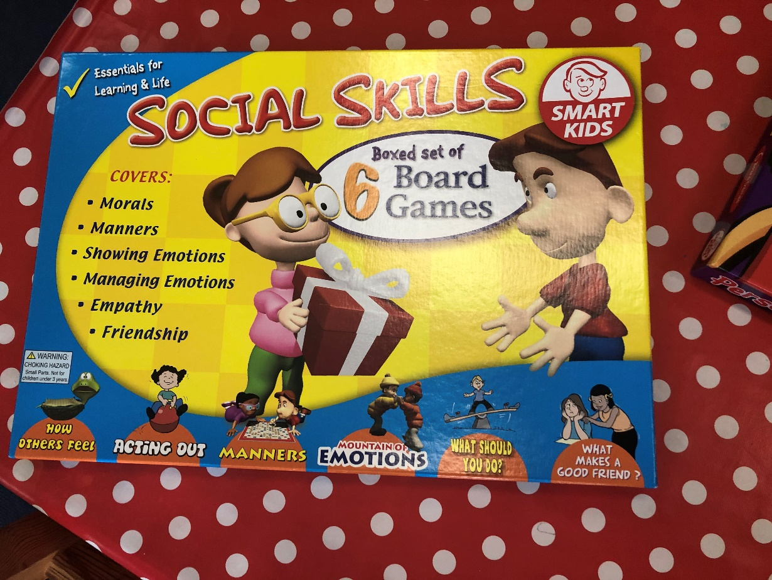
(Bridging School, 2019).
Appendix 2:
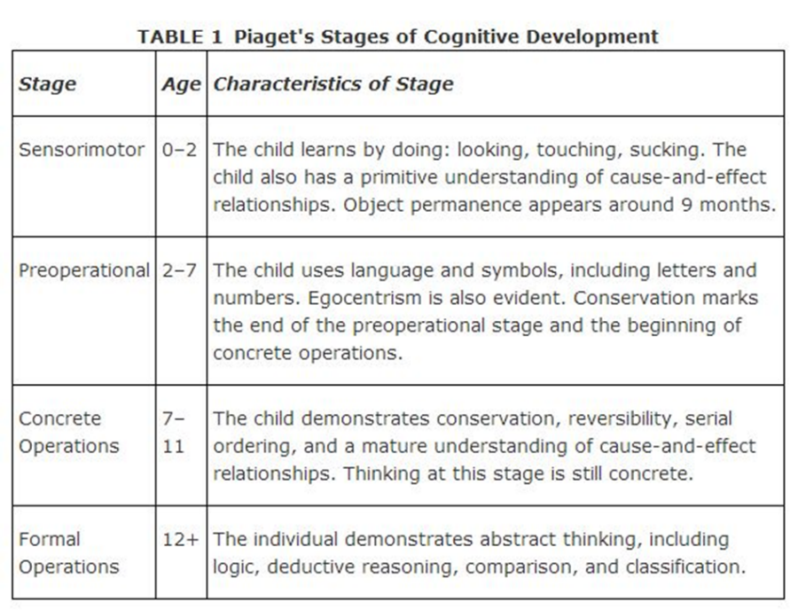(Cliffs Notes, 2016).
Appendix 3:
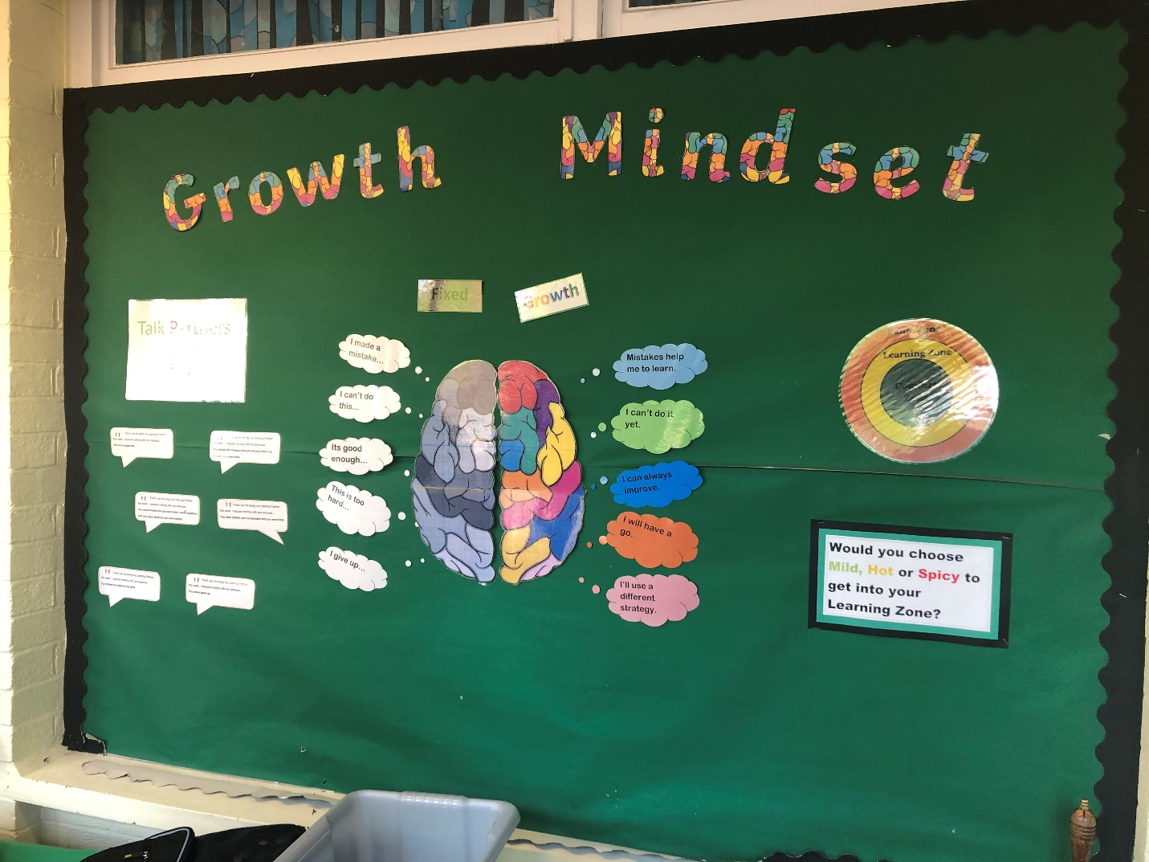
(Bridging School, 2019).
Appendix 4:
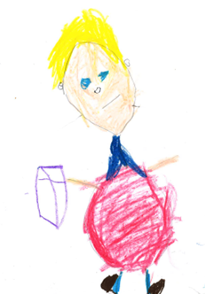

(Pupil Profile, 2019).

Appendix 5:
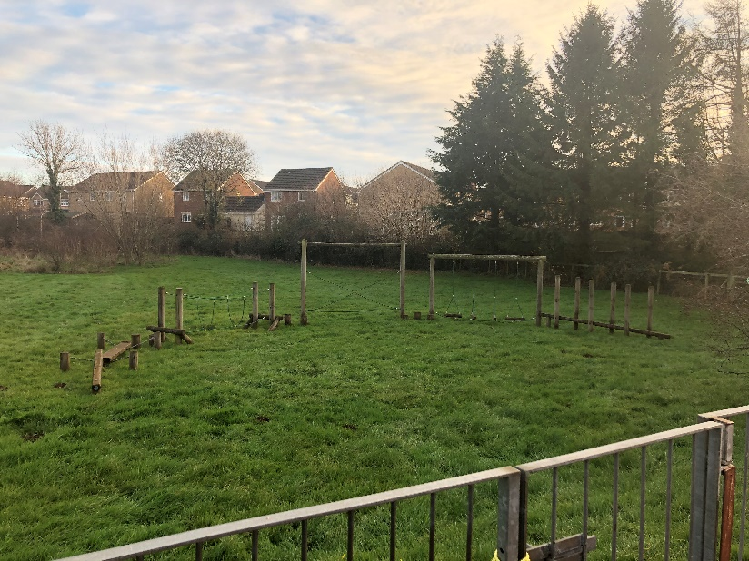
(Bridging School, 2019).
Appendix 6:
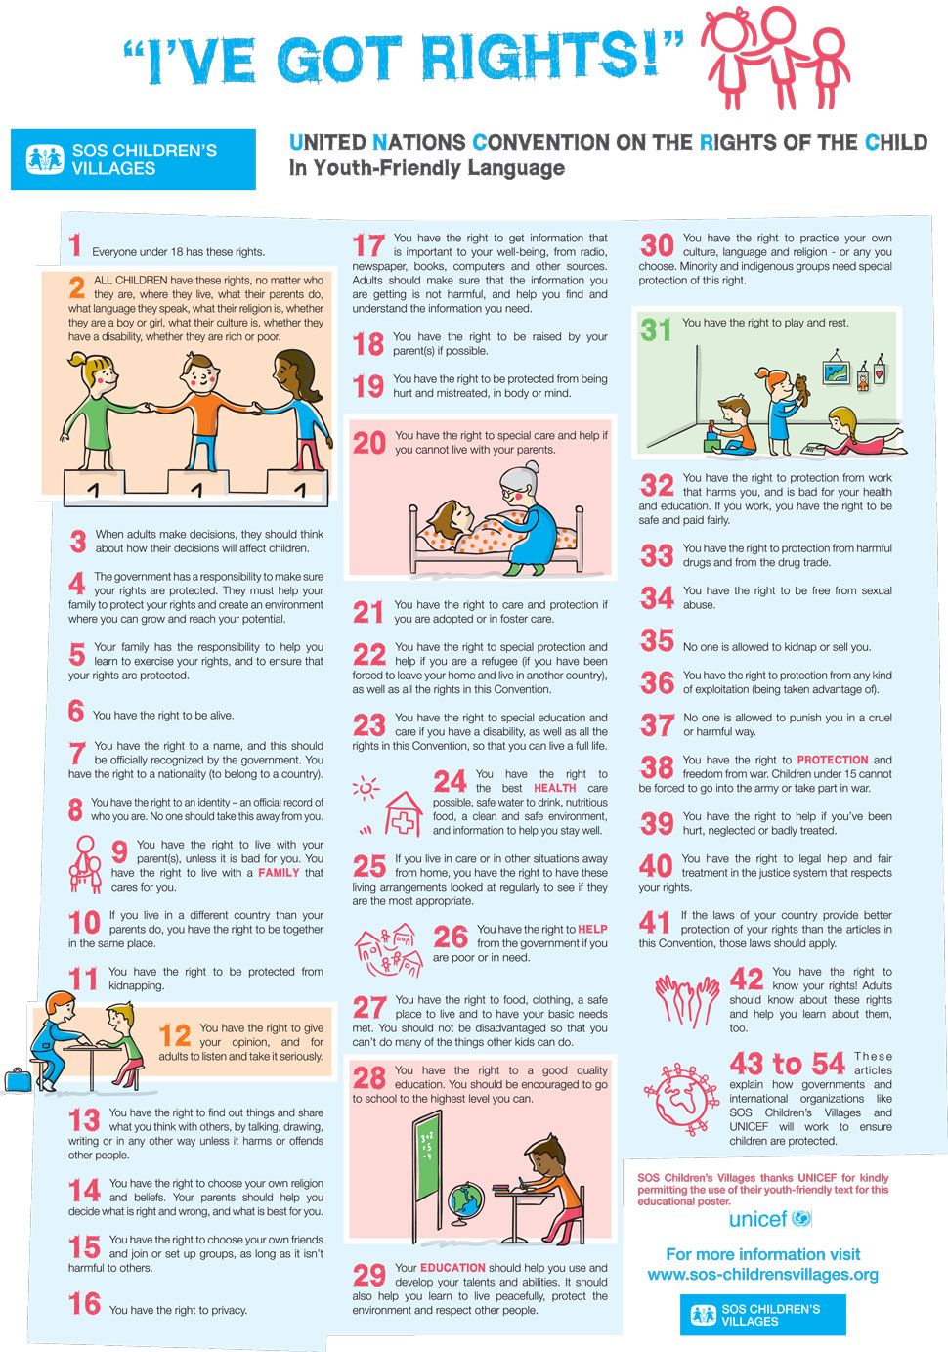
https://www.pinterest.co.uk/pin/41447259047055687/

