
Skills for the Workplace
Module Assignment Submission
Student Name: | Roselyn Tenkorang
Student Number: | 1604295
Module No: | BMSK5006
Module Title: | Knowledge and Information Management Sills for the Workplace

Statement of Confirmation of Authenticity
By the act of making this submission, the student declares that this is the work of the student named above. The work has not, in whole or in part, been knowingly presented elsewhere for assessment, or where assessment has been built on a previous assessment, this has been identified. Where materials have been used from other sources it has been properly acknowledged. If this statement is untrue, the student acknowledges that an assessment offence has been committed.
Attention is drawn to the plagiarism and unfair practice policies of both the University and of ILM.

TABLE CONTENTS
Heading
Introduction
1. The Relationship Between Data, Information, Knowledge and Wisdom
1.1 Information Sources
1.2 Capturing Valuable Information

1. The Relationship Between Data, Information, Knowledge and Wisdom
Knowledge management is a systemic way used by an organisation to identify, use to be creative, sharing and distribute the important knowledge. According to Szuster, M. and Szymczak, M., (2016), knowledge is a resource that enable the organisation to used for making important investments in the latest Technology system and to substructure by supporting the knowledge management. The organization like Tesco have adapted to these kinds of resource as their business strategy. The system is structure for individuals to try to encrypt their knowledge into a contributed database. This process reduces the time and cost for the business.

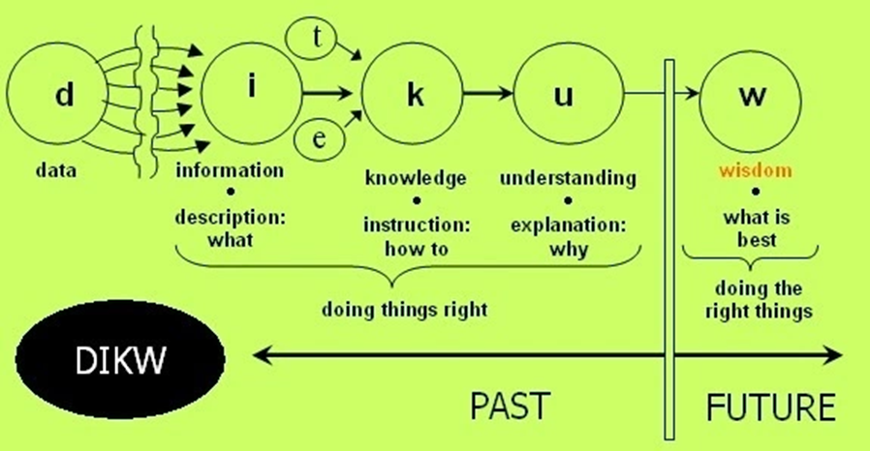
The explanation of collection of date is not general for information, but it is an example of data. The meaning of data is to represent a fact or result.
The aspect of information is about a statistic of time. It is related between data and other relation of characterise as information which may address the figures about the market size, customer requirement and the present production capacity.
It develops to knowledge when individual may grasp the idea of understanding the result design of relation of data and information and the represent of knowledge models. This demonstrate the opportunity for business estimate.
It is then referring as wisdom when someone get the understanding of the principle. This is how knowledge management is created to give understanding to all, this information to collaborate as a guide for other to work effectiveness.

1.1 Information Source
According to Swigon, M. (2013), Knowledge management is about receiving the right information to the righthand people at the appropriate time in order to complete the right target. The act of innovation may be essential for the organisation. Having Knowledge management methods is a refinement of Information System which is refer as managing of knowledge. The knowledge management system to gives support of creating relationship and transferring application of knowledge in the organisation systems. The relationship of individual knowledge is implementing the effective development require as foundation in different related field enable for employees to have system already prepare to be accessible to the organisation records base of factual resources, guideline of information and solution. It uses as software tools in collection of technologies which is a relation of a current information technology infrastructure. It an advantage for great speculation in the current technology, scheme and for overall support to the organisation knowledge management system. It is also information system which address knowledge by sharing the information a broadly and delivering a news idea to present for new or improvement database equipment. This allow all employees to have access to the organisation report, important information and advice of solution. It uses as employment active board for discussion of knowledge networking.
1.2 Capturing Valuable Information
Tesco organisation is projected as one of the biggest supermarket in favour of leading the market with a strategy power. For being the top retailer in the world is about increasing of sales and concentrating on customer service. Their other techniques are to gathering information from the external market and use has an opportunity analysis the strengths of the organisation, how to innovate to become more competitive and have stronger capability by implementing new strategy.
It was good idea for Tesco when they chose to implement the online ordering system that was able to connect the customer with the warehouse and the suppliers. The benefit of the Knowledge management system is to shows the awareness of increasing order processing availability, to decrease cost of hardware system, improving the flexibility of maintain suppliers’ relationships. To achieve better additional of programs by so doing it was able to increase dependability in daily basic operation.
The main aspect of information technology is to persuade current employees to adapt to the new system in order to produce and sell well to increase profitability. This was described in Tesco case study program to make employees relaxed and comfortable to adapt to the new changes in the ways they have been operating so far. These changes happen by encouraging their managers in the procedures for them to inspire their employees that they have some partnership over in their workplace and they can accomplish it in setting time.
But in some cases there was disadvantage that managers had to encounter was employees criticizing the whole project as suspicious. However the people of the company who doubted the procedure spoke out to ensure the purpose of the project or process would match with the company policy for employee procedure which include the full trust on the living service program.

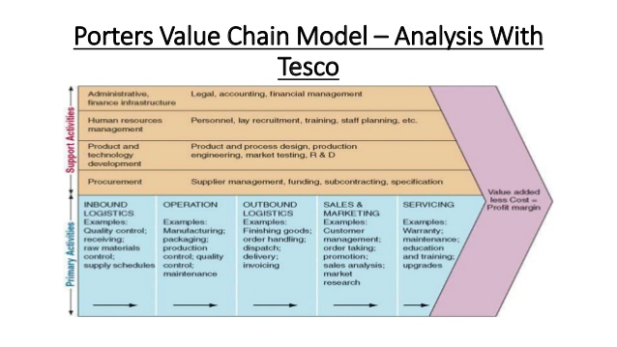

References:
https://techacute.com/the-difference-between-data-information-knowledge-and-wisdom/
https://kvaes.wordpress.com/2013/05/31/data-knowledge-information-wisdom/
https://www.ukessays.com/essays/information-technology/strategic-management-and-information-systems-at-tesco-information-technology-essay.php
https://www.ukessays.com/essays/information-technology/information-systems-in-organization-like-tesco-information-technology-essay.php

Ravasi, D. and Van, R.J., (2003). Key Issues in Organizational Identity and Identification Theory. Corporate Reputation Review, 6(2), pp.118-132.

Szuster, M. and Szymczak, M., (2016). Innovate, Knowledge and Information Management in Supply Chain. 8(1), pp.26-36.
Swigon, M. (2013). Personal Knowledge and Information Management: Conception and Exemplificatio. 39(6), pp.832-845.

https://www.supplychain247.com/article/the_future_is_now_the_tech_trends_reshaping_retail/zebra_technologies
April 24, 2017 · By Zebra Technologie
http://www.scielo.org.co/scielo.php?script=sci_arttext&pid=S1692-02792017000200137
http://www.systems-thinking.org/kmgmt/km7steps.pdf

