
Name: Harrison Davies

Student Number: 2114726

Course: HND Quantity Surveying (Higher Apprenticeship)

Module: Fundamentals of Construction

Assignment Title: New Build Dwelling – Technical Report with Drawings

Lecturer: Gavin Traylor

Contents
Introduction 3
Foundations 4
Ground Floor Construction 5
Openings 6
First Floor Construction 6
Roof Structure 7
Eaves and Roof Covering 8
Construction Process 8
Alternative Roof Construction Method 9
Offsite Construction 10
Bibliography 11

Introduction
The aim of this technical report is to address some of the following unfamiliar details and materials used as part of Miss A’s future single, two storey detached domestic building. This report will include detailed sections and sketches that illustrate the methods to be used in the build and ensuring that they comply with current building regulations for a domestic new build giving particular attention to the thermal performance of the building fabric.
Next, the client wants to utilise the roof space and allow for an attic room. This report will describe the limitations of the current constructions and therefore propose an alternative method of roof structure describing what advantages or disadvantages that this may have.
Finally, the client has been approached by a company offering offsite solutions on this construction project, however the client is unfamiliar with some of the terminology used by the company. Hence this report will clearly outline the term offsite construction and highlight the four main categories of offsite construction and how they can be incorporated into the proposed house.

Foundations
The purpose of a foundation is ultimately to carry the weight of a building. They function by transferring loads of what is above safely, provide a flat surface to build on and give stability for eccentricity of the buildings design. Choosing the right foundation is very important as there are different types suited to different projects. The factors that can affect the choice in foundations may be soil type, ground conditions, underlying geology, the building structure type and size and shape of the layout in accessibility.
There are four common types of foundation which are:
- Strip (Shallow)
- Pad (Shallow)
- Raft (Shallow)
- Piled
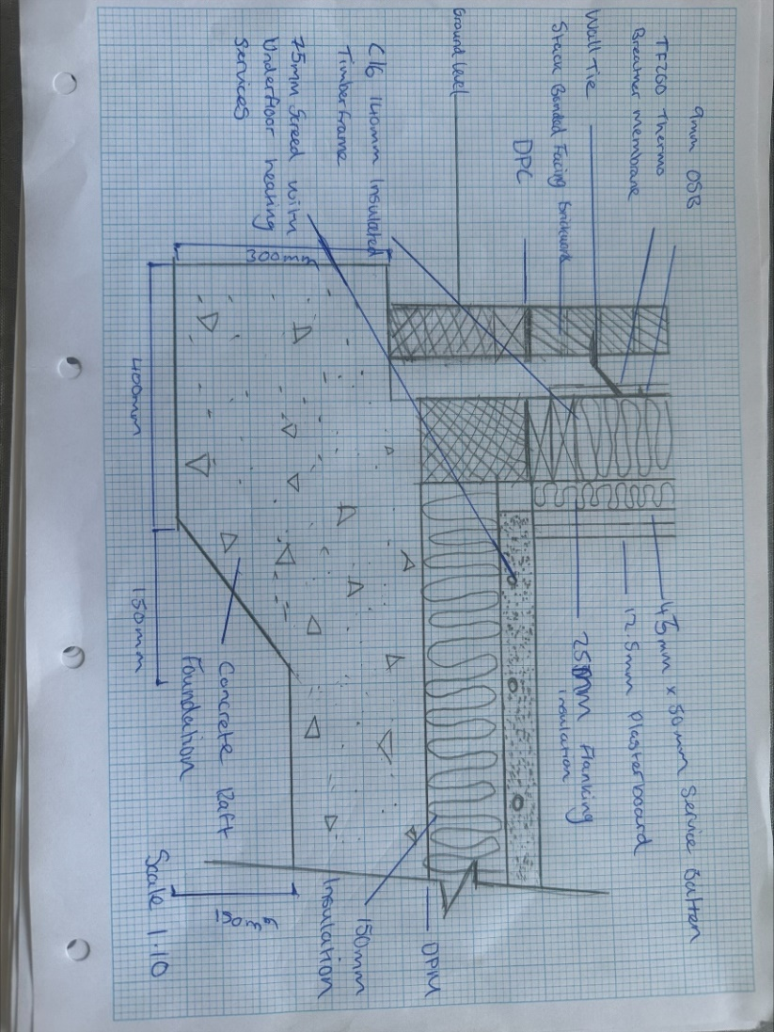
The proposed foundation type for this building is a raft foundation. A Raft Foundation is made up of a reinforced concrete slab. Reinforced concrete is concrete with steel rods/bars embedded in it. This gives a compound such as concrete which has a rather low tensile strength but high compressive, an overall added strength under tension. This is because steel has very good tensile strength and the two materials act together in resisting forces, tension, and compression. (Britannica, 2020). Before the foundation is laid, ground investigations take place which assist in deciding what foundation is best suited to the ground below. It was revealed upon geological investigations that the ground was previously used for agricultural purposes. This means that farmers would have sprayed chemicals into the ground to grow crops, which equally can damage the soil and ground makeup. The plot is to be built on level ground but reclaimed site. Due to this a retaining wall has been specified to retain the banking. After the ground has been excavated, a hardcore sub-base is laid which will be mechanically compacted by a plate compactor or commonly referred to as a whacker plate followed by a polythene sheet and another layer of concrete. This is to stop any vegetation developing beneath the building. The raft typically includes an edge beam in its design which is formed by a steel cage reinforcement. (LABC, 2018)

Please see attached raft foundation detail which is going to be used on this project.
The detail shows the raft foundation itself but also the insulated screed with underfloor heating services above, and external wall build-up.

Ground Floor Construction
Above ground level at 150mm high, a damp proof course (DPC) is laid. The course of brick above DPC is to include air vent bricks, this is so the air can travel beneath the floor and negate any damp areas. Vents are to be placed at a minimum of 1.8m centres. All other elements necessary such as flashing, weep holes, insulation and wall ties shall be included to comply with National Housing Building Council (NHBC) standards. (NHBC, 2023). The building is to be built using timber frame construction with C16 Welsh timber. The speed of build will be quicker than alternative construction methods as timber frame construction is a faster method than a traditional block and beam build. There are many types of grade timbers used, graded timbers mean that it is kiln dried in order to reduce moisture content. It also is Welsh timber this means that this timber was exploited from Wales. It is very beneficial to the environment to locally source timber rather than import Scandinavian as it reduces the carbon footprint and emissions from importation. The external skin of the wall is a stack bonded facing brick with a smooth render course. A clear cavity space of 50mm is left following the start of the timber frame which has a reflective breather membrane which is used for thermal performance and contribute to the overall U-Value of the wall. A 9mm OSB sheathing is also in place. Next is the 140mm insulated timber frame panel followed by an additional layer of insulation, also known as flanking insulation as this is the internal face of the external wall. A 45mm x 50mm service batten is included in the wall build up. This is for first fix trades to run services through. Finally, a 12.5mm layer of plasterboard is added.

Openings

Construction openings are gaps or voids in a building's structure that allow for the passage of people, light, air, and utilities like electricity, water, and gas. Examples of construction openings include windows, doors, vents and skylights. To make these openings function properly, a variety of materials and components can be used, depending on the specific opening and its purpose.
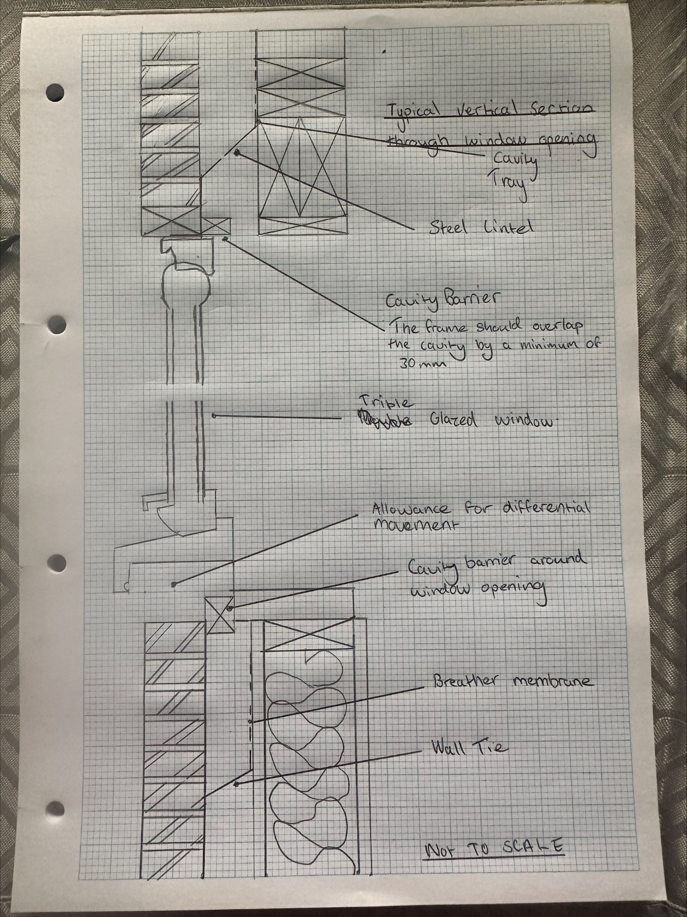

The above image shows a window opening section. It is important that calculations are made so that the lintel which is situated above the opening can structurally support the weight. There are many different types of lintels however for a project of this type, a Catnic lintel is the most likely to be used. But this would be pending the architect’s specification for the project and local planning authorities’ approval. The lintel material/coating is dependent on how many stories the building is and if the building is located in a coastal area as per The British Standards 'Code of practice for the use of masonry - Part 3: Materials and components, design and workmanship'. (Catnic, 2023)

First Floor Construction
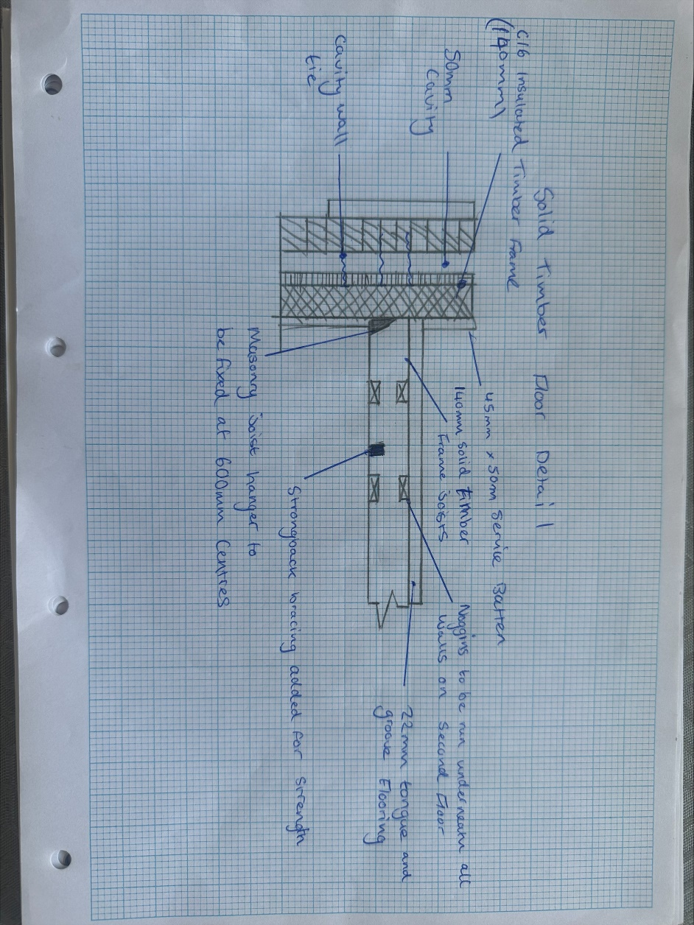
The first floor has a traditional solid timber joist with tongue and groove softwood flooring to be fixed to the joists. The joists can also be placed on hangers or built into the wall for the first floor.

A sketch of a solid timber joist detail is shown above. This sketch demonstrates a hanger that is utilised to join to the exterior wall. Around the joists, the hangars will be spaced 600mm centres apart. Construction of the first floor cannot start until all hangars are in place. To strengthen and support the joists above, an internal load-bearing wall would be constructed below. The joists can be lifted in and secured using a crane or forklift once the hangars are set up. The next addition is a strongback to add further support. Following would be to install the 22mm tongue and groove flooring. To prevent falls, the fixer would cover the stairwell temporarily with a piece of structural flooring.

Roof Structure
Considering that the specified roof is a trussed roof. There are many advantages and disadvantages of using such method.
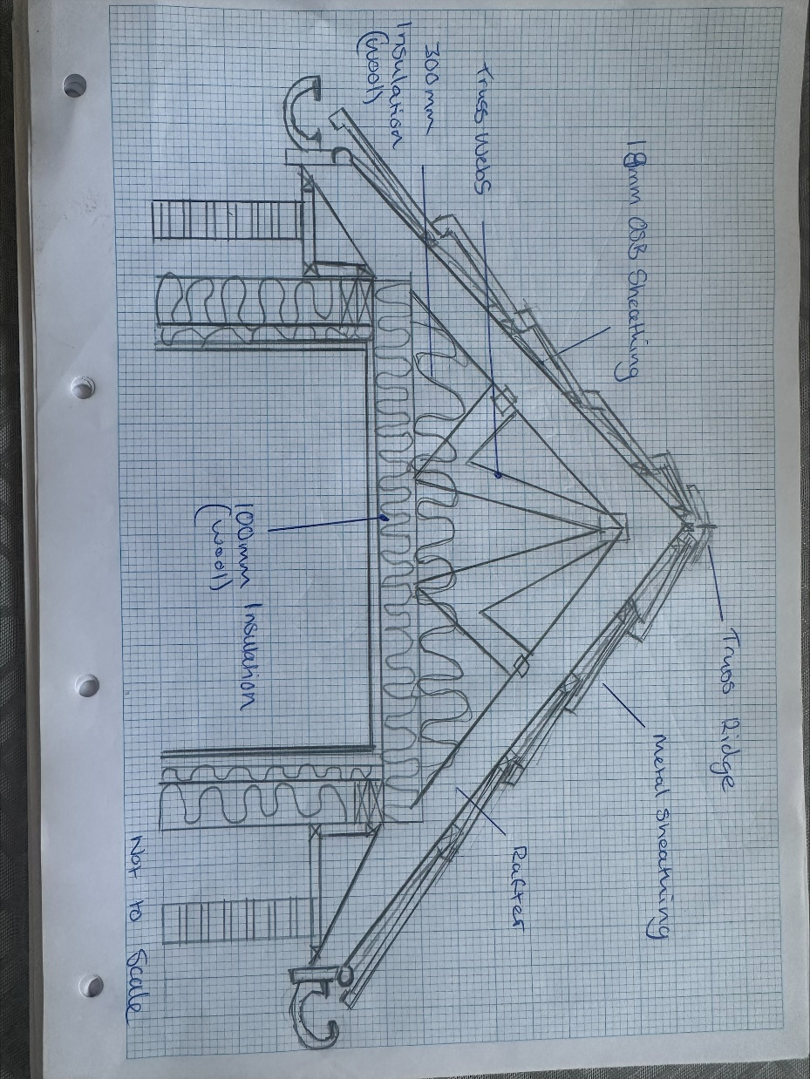
For instance, costs are typically much lower. Because roof trusses are produced by a timber frame company in an offsite factory that can minimise waste and shorter lengths of timber, using a timber frame can drastically lower your costs. Trusses that span the entire structure are more economical. Trusses also significantly speed up construction because they are produced off-site and brought to the construction site where they are craned into place. Truss repairs can typically be completed in a single day. (HPD Construction, 2021)

The main roof structure is non occupied therefore will be a standard fink truss that will consist of webbing, insulation and chords.

Eaves and Roof Covering
The edges of a roof that extend beyond a building's walls are called eaves. In order to defend against rain and other weather elements, they are the horizontal parts of the roof that extend past the vertical plane of the walls. The eaves of a house typically consist of the roof decking, fascia board, soffit, and gutter system. The fascia board is the vertical board that runs along the edge of the roof and supports the bottom of the roof's overhang. Roof decking is the material used to construct the roof. The soffit, which is typically composed of wood, vinyl, or aluminium, is the exposed underside of the overhanging eaves. It can be vented to allow air to circulate in the roof space and prevent moisture build-up. The gutter system is installed along the eaves to collect and channel rainwater away from the building's foundation. (Straughan, 2023)

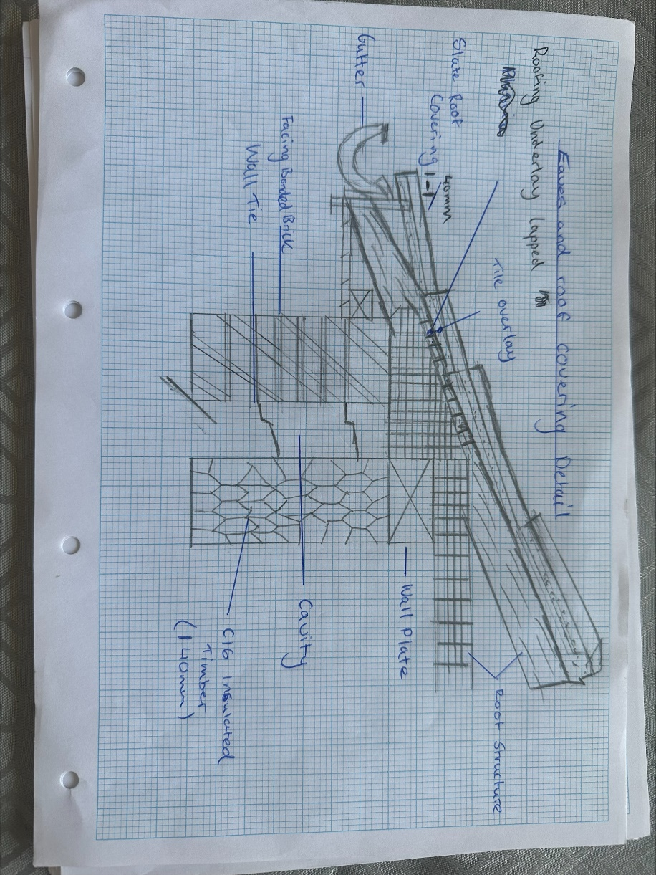

Construction Process
Please see the above roof section and eaves covering detail. Firstly, the trusses would be designed and manufactured from a timber frame specialist company. To comply with Approved Document A – Structure, the design would allow for the correct loadings. Once first floor construction is finished, the trusses can be craned into place and fixed. Sheathing is laid on top of the trusses and lapped to be tight. The roof sheathing not only acts as a water-repellent layer, but it also allows the roof to “breathe”. This means that it helps release any trapped moisture from underneath. Next, a roof batten is fixed at 600 centres which provides fixing points. On this scheme we are using a metal sheathing. The next step is to add the soffit and fascia. The main purpose of fascia and soffit boards are aesthetics. However, they also have another purpose which is giving a solid form of protection. To comply with Approved document F - Ventilation, you must have ventilated soffit board to run underneath the overhang of the trusses and an air gap. Additionally, it keeps the trusses dry and prevents moisture build-up. Condensation would gather if there was no ventilated soffit board, resulting in moisture damage to the trusses.

Alternative Roof Construction Method
The client is looking to utilise the roof space and allow for an attic room. Having already submitted a planning application that does not include an attic room in their drawings, the client would need to go back to the local planning authority for permission to make a change to the drawings. If this was to be accepted the current roof construction would not work due to the truss webs (see below image of fink truss) being in the way. (Roof Costs, 2022)

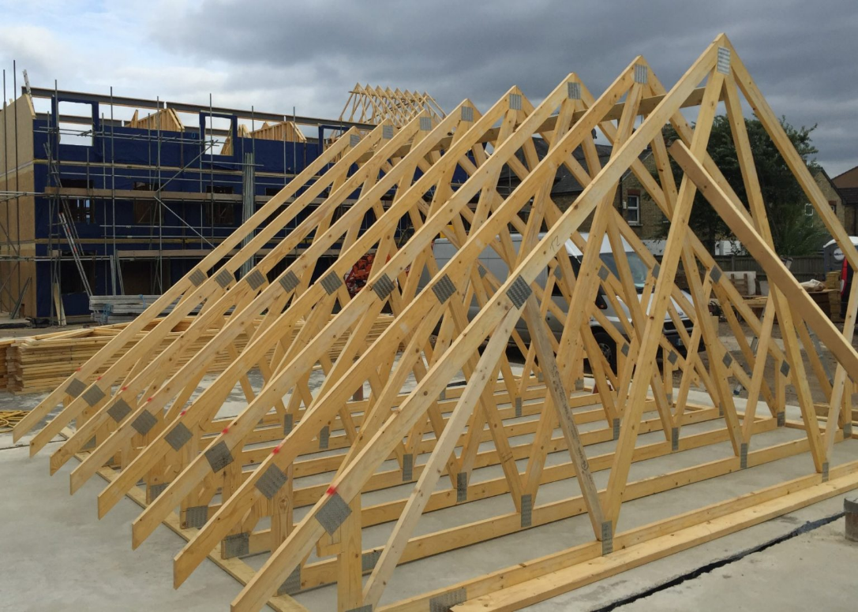
Truss Web

Therefore, the roof construction would need to change to attic trusses. Attic trusses are designed so that no bracing fills the space in the middle of the truss so that you can make a room. Trusses should be fixed to the wall plate which sits on top of the inside skin of the external wall, held by straps. Trusses are fixed by being vertically screwed into the wall plate followed by attaching truss clips to the wall plate. Purlin beams are used to strengthen the structure. All trusses must be plumb and spaced at equal centres of approximately 400mm. However, this is pending further design details provided by the timber frame specialists. This can accommodate for plasterboard ceilings. The planning drawings specify Velux windows which will be needed in the attic room. (Cavallari, 2023)

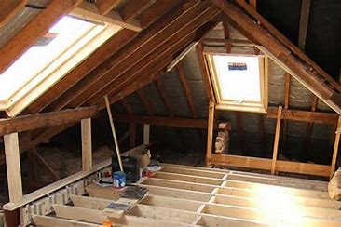
Attic truss (Roofing, n.d.)

Offsite Construction
The client has been approached by an offsite construction company offering solutions on this scheme. The phrase “off-site construction” refers to completing works involved in a project at a different location as to where it will be permanently installed. This method is also known as prefabrication or modular construction.
Modular construction is becoming more and more popular in modern construction. This is a type of off-site construction in which building components are prefabricated at a factory, transported to the site, and fixed together. This is quite advantageous since it enables sitework and groundwork to be done concurrently and implies that the majority of the work may be completed in a factory. This will make the build go much faster while maintaining its efficiency. Additionally, by doing less work on site, it will need less labour, which will save expenses. Even if someone still needs to perform the work, more and more people are drawn to the concept of working in a permanent location. (Real Projectives, 2019)
Another benefit is that it primarily minimises waste, just like it does in factories. According to recent UK research, modular building can reduce waste by up to 90%. Modular construction's difficult financial implications are a negative. The costs are typically higher in the early stages of development compared to other methods of building because it is centred on speeding up the total process.

Bibliography
Britannica, 2020. Britannica. [Online]
Available at: https://www.britannica.com/technology/reinforced-concrete
[Accessed 13 04 2023].
Catnic, 2023. Catnic. [Online]
Available at: https://catnic.com/products/lintels/stainless-steel-lintels
[Accessed 20 04 2023].
Cavallari, D., 2023. [Online]
Available at: https://www.homequestionsanswered.com/what-is-an-attic-truss.htm#:~:text=An%20attic%20truss%20is%20a%20support%20feature%20found,lateral%20stresses%20from%20wind%2C%20snow%20loads%2C%20and%20debris.
[Accessed 21 04 2023].
HPD Construction, 2021. HPD Consult. [Online]
Available at: https://www.hpdconsult.com/advantages-and-disadvantages-of-timber-roof-trusses/?utm_content=cmp-true
[Accessed 20 04 2023].
LABC, 2018. LABC. [Online]
Available at: https://www.labc.co.uk/news/raft-foundation-basics
[Accessed 20 04 2023].
NHBC, 2023. NHBC. [Online]
Available at: https://nhbc-standards.co.uk/6-superstructure-excluding-roofs/6-1-external-masonry-walls/6-1-17-dpcs-and-cavity-trays/
[Accessed 20 04 2023].
Real Projectives, 2019. The Advantages and Challenges of Modular Construction. [Online]
Available at: https://www.realprojectives.com/the-advantages-and-challenges-of-modular-construction/
[Accessed 21 04 2023].
Roof Costs, 2022. Roof Costs. [Online]
Available at: https://roofcosts.co.uk/replace-roof-trusses-cost/
[Accessed 24 04 2023].
Roofing, T. A., n.d. Pinterest. [Online]
Available at: https://www.pinterest.co.uk/pin/loft-conversion-in-selby--390898442653858305/
Straughan, D., 2023. Todays Home Owner. [Online]
Available at: https://todayshomeowner.com/roofing/guides/what-are-roof-eaves/
[Accessed 21 04 2023].

