Assessment Component 1
TASK 1 – Blogs 2 entries

MODULE TITLE: Population Health and Digital Health Promotion
CODE: LCHS7009
LECTURER: Dr Besty Jose

STUDENT NAME: Mihaela Sandu Rizea
STUDENT ID NR: 2126225

Mental Health and Workforce Wellbeing in the NHS

The ShinyMind APP
Empowering NHS Workers Through Digital Innovation

ADVANTAGES The digital App benefits from evidence-based resources, being co-produced with the help of NHS specialists, it is proactive and empowering, it is cost-effective, and can be used 24/7 (NHS, N.d; Storey, 2022; ).

THE SHINYMIND APP The ShinyMind project was initiated by psychotherapist Rebecca Howard, and goes back to 2017 when started with an internal NHS project ‘Your mindset, Your Choice’. The project developed into a digital app launched in 2021, and includes 150+ proactive and interactive resources offered for free to all NHS staff (ShinyMind website, 2025). The App is prescribed by clinicians as a ‘Wellbeing Prescription’ being named by Howard ‘a hug in an app’ and a ‘coach in your pocket’(Your ShinyMind Wellbeing Prescription - ShinyMind).
The App was designed in collaboration with NHS to support over 500,000 nurses, midwives and care support workers across England, representing an alternative to conventional treatments, therapies and medication (Craig, 2025).

.

OVERVIEW According to World Health Organisation (2025) the Mental health is responsible for $1 trillion in annual productivity losses worldwide as around one billion people are living with a mental disorder.
It is estimated that for 2022, the burden of mental health for England reached 300 billion pounds(Statista, 2024).
As reflected by statistical reviews, anxiety, stress, depression or other mental illnesses, were the leading reason for sickness absences, representing 24.7% from all other causes in January 2025 which is the equivalent of 638,900 full time days (NHS Digital, 2025) and explains why the staffs’ mental health is a growing concern for NHS (NHS Employers, 2024). Absenteeism and high turnover, are costing NHS reduce quality care services (Engage Britain, 2023). As result, starting with 2020 NHS set up mental health and wellbeing hubs to help staff to coop and manage better their health. This aligns with WHO’s initiative to launch in 2020 a Global Strategy on Digital Health to promote healthy lives and wellbeing for everyone, considering the benefits for the overall health (WHO, 2025).

DISADVANTAGES The App can improve by reflecting more the ethnic background of the users, and find ways to link its users with real peer groups. Other aspects that can be interpreted as negatives: digital exclusion, users need a smart phone in order to use the App, and some possible evaluation gaps with impact on clinical outcome because the users might not be seen by a specialist for a longer period.
The NHS staff have been provided with free access to other Apps such as Bright Sky, Unmind or a 24/7 support by texting SHOUT at 85258.

REFERENCES



HOW THIS APP HELP? The app it is a personal, confidential, and evidence-based digital tool available 24/7, proven to help staff to build confidence, reducing stress and anxiety, empowering people to understand themselves better and improve wellbeing. Through its 150+ interactive masterclasses, the app allows users to learn how to manage stress, develop self-awareness, reflect and grow(Our story - ShinyMind).
An independent evaluation of the results after using ShinyMind App show that 25% of users said they feel a ‘lot better’ and 94% a ‘bit better’. Furthermore, the sickness absence as result of anxiety or stress, reduce to 3% within users vs 6% non-users. There was also reported a reduction in employee turnover rate to 3% users vs 18% non-users (Storey, 2022).

SHINYMIND APP


REFERENCES

- Craig, R., (2025) Rebeca Howard, Shiny Mind Available at: We waste so much money trying to implement something that doesn't work. - MIP Accessed on: 24th October 2025
- Empowering ShinyMinds Available at: ShinyMind - Mental Health & Wellbeing App co-created with the NHS
- Engage Britain, (2023) Million suffer poor care due to overstretched NHS and social care staff Available at: Millions suffer poor care as NHS and social care staff are overstretched Accessed on: 26 October 2025
- Hindman J, Zugai J, Raeburn T (2024), "Digital applications potential to support the mental well-being of nurses: an integrative review". Mental Health and Digital Technologies, Vol. 1 No. 2 pp. 212–227, doi: https://doi.org/10.1108/MHDT-12-2023-0006 Available at: Digital applications potential to support the mental well-being of nurses: an integrative review | Mental Health and Digital Technologies | Emerald Publishing Accessed on 26th October 2025
- Moreira RS, Merces MCD, Almeida AAE, Rossi TRA, Maia HF, D'Oliveira-Júnior A. Mental health of nursing professionals: Internet-based interventions. Rev Bras Med Trab. 2023 Aug 8;21(2):e2022801. doi: 10.47626/1679-4435-2022-801. PMID: 38313083; PMCID: PMC10835398. Available at: Mental health of nursing professionals: Internet-based interventions - PubMed Accessed on: 27th October 2025
- NHS, (Nd) Available at: NHS leaders say thank you to staff with the ShinyMind app this Mental Health Awareness Week | Humber Teaching NHS Foundation Trust Accessed on: 26th October 2025
- NHS Charities Together, (2024) Three in four NHS staff struggled with their mental health in the past year Available at: Three in four NHS staff struggled with their mental health in the past year | NHS Charities Together Accessed on: 26th October 2025
- NHS Employers, (2024) Mental health in the workplace Available at: Mental health in the workplace | NHS Employers Accessed on: 23th October 2025
- NHS England Digital, (2025) NHS Sickness absence rate, January 2025 NHS Sickness Absence Rates, January 2025 - NHS England Digital
- NHS England, (N.D) Supporting our NHS people Available at: NHS England » Staff mental health and wellbeing hubs Accessed on: 25Th Octobre 2025
- NHS Staff Survey, (2024) National Results Available at: National results across the NHS in England | NHS Staff Survey Accessed on 27th October 2025
- Nottinghamshire Alliance Trainning Hub, The Shiny Mind App (2023) Available at: ShinyMind App Accessed on: 27th October 2025
- Phuke, M.J., Zagade, T., Mohite, V.R.,Salunkhe, J., Ingale, S.,Choudhari, S.K. (2024) Intervention package on stress management: Improving comprehensive well-being among nurses. Journal of Integrative Nursing 6(4):p 201-208, Oct–Dec 2024. | DOI: 10.4103/jin.jin_101_24 Available at: Journal of Integrative Nursing Accessed on: 26th October 2025
- Statista, (2024) Mental Health in the United Kingdom (UK) – statistics and facts Available at: Mental health in the United Kingdom (UK) - statistics & facts | Statista

Simmons, N. et al, (2023) Experiences of Using Mental Health Apps to Support Psychological Health and Wellbeing. Journal of Applied Social Science Available at: Experiences of Using Mental Health Apps to Support Psychological Health and Wellbeing - Natalie Simmons, Lewis Goodings, Ian Tucker, 2024 Accessed on: 27th October 2025
- ShinyMind, 2023. ShinyMind App: Empowering NHS Staff Wellbeing. Available at: https://www.shinymind.co.uk Accessed on: 27th October 2025
- Storey, K., (2022) The Pawer of Shine, Available at: ShinyMind - Proven Innovation Accessed on: 27th October 2025
- World Health Organisation (WHO), (2025) World Mental Health Today Available at: content Accessed on: 25th October 2025
- World Health Organization (WHO) (1986) Ottawa Charter for Health Promotion. Geneva: WHO.

LONELLINESS AS A PUBLIC HEALTH CONCERN
The social network is associated with brain structure and could thus affect cognitive function (Smith et al, 2018). Loneliness is increasingly recognized as a serious public health concern (NHS, 2025), linked to mental and physical health deterioration, increased mortality, and reduced quality of life (Holt-Lunstad et al., 2015), worldwide is known 1 in 6 people are affected by loneliness (WHO,2025). There are concerning evidences about the impact on older adults, people with disabilities, and those experiencing social isolation (Cacioppo et al, 2018). Moreover increased exposure to loneliness has been associated with negative impact on wellbeing and health. A significant number of researches has shown loneliness increases the likelihood of early mortality, poor physical health, putting individuals at risk of poor mental health including depression.
Just in England more than 2 million of older adults age 75+ are leaving alone (NHS, 2025; HelpDementia, 2025).
Studies results demonstrate that both loneliness and social isolation increases the risks of mortality within older population (Barnes et al., 2021).

Best2Buddies App and Loneliness, a Public Health Concern
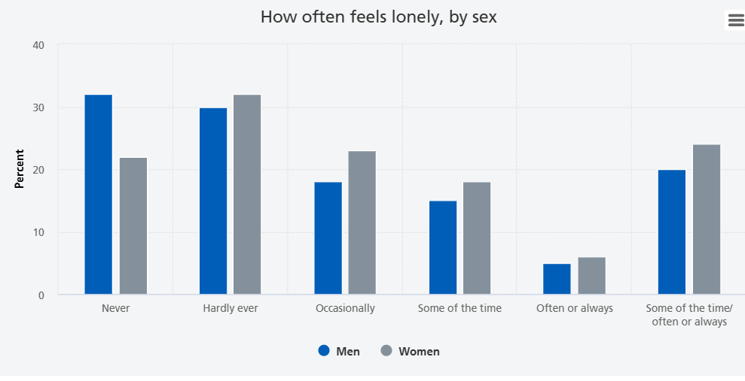

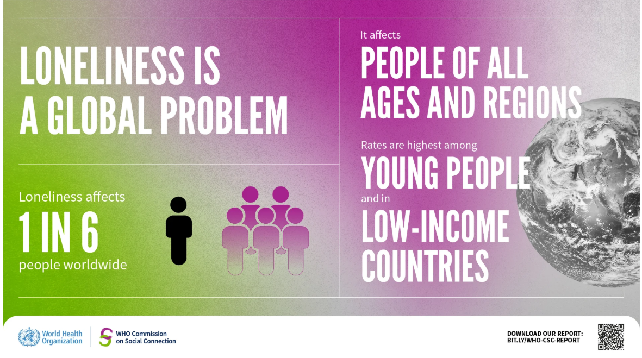

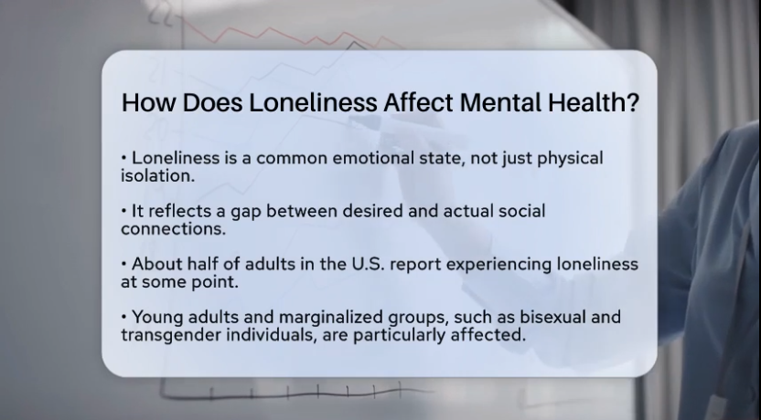
Bing Videos

This blog introduces Best2Buddies App, a digital app designed to support users affected by Loneliness and critically examines its potential. It includes a short overview, positives and negatives, and evidence-based recommendations by comparing with other digital option available.

The Best2Buddies it is a digital ecosystem designed for individuals living alone which might experience loneliness, depression, anxiety or cognitive tiredness. The system includes the digital app available on an Personal Assistant Device (PAD), two wearable sensor patches and a smart bracelet. The digital app it is a modular and scalable platform, featured with two personal assistants that receive health data collected through the patches and has the ability to adapt and support users with daily tasks, emotional and social engagement. It can also use contextual prompts to simulate companionship, guide through personalised wellbeing masterclass, and even connect with social matching platforms for group chats and real social interaction groups.


Meet Best2Buddies
The PAD was designed as a picture frame which can be positioned on the wall in the most accessible area of the users’ house, and has similar features with the SENTAI voice companion.


According to the WHO vision, the health system should be focused on interconnectedness (Benis et al, 2021; WHO, 2025). The interoperable digital health ecosystems capable of secure health data exchange and processing, are considered the future in healthcare. The Best2Bodies digital health ecosystem is designed to meet the users specifical needs, it is adaptable and interconnected.
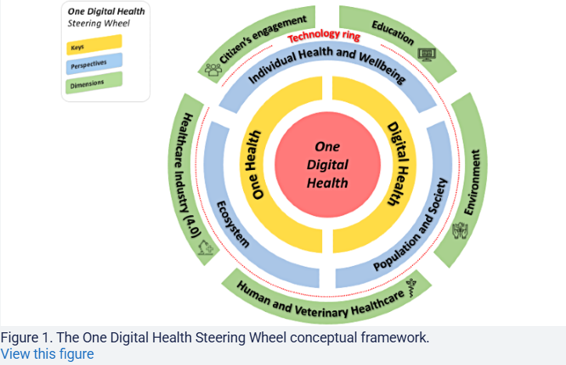

MAIN FEATURES
- TWO personal assistants: ECare focused on mental health, and ECoach proactive, goal-orientated and tracking daily progress
- Health monitoring integration: two patch sensors to read cortisol levels, heart rate, sleep quality, cognitive load indicators such as reaction time, speech patterns
- Social matching and activity hub: group chat rooms, optional in person meet-ups for walks or activities
- Emergency and crisis layer: SOS protocol with contact list

ADVANTAGES The Best2Bodies digital health ecosystem enable proactive care and early intervention, help to build self-esteem, reduce isolation and foster meaningful connection, increases safety and responsiveness. The evaluation should consider the ethical aspects and how are the users rights respected (Zarif, 2022) as there should be a significant balance between the health benefits and the individual privacy.
DESADVATAGES and RECOMMENDATIONS The innovation must show more consideration for privacy concerns, sharing data with third party came with confidentiality issues, the users should not feel trapped or having limited freedom, thus internet connectivity dependency can create more risks. The digital health ecosystem should integrate clear interconnected clinical pathways.

REFERENCES

- Barnes, T. L., Ahuja, M., MacLeod, S., Tkatch, R., Albright, L., Schaeffer, J. A., and Yeh, C. S. (2022). Loneliness, Social Isolation, and All-Cause Mortality in a Large Sample of Older Adults. Journal of Aging and Health, 34(6-8), 883-892. https://doi.org/10.1177/08982643221074857 (Original work published 2022) Available at: Loneliness, Social Isolation, and All-Cause Mortality in a Large Sample of Older Adults - PubMed Accessed on: 26th October 2025

- Benis, A., Tamburis, O., Chronaki, C. and moen, A., (2020) One Digital Health: A Unified Framework for Future Health Ecosystems. Journal of Medical Internet Research. Available at: Journal of Medical Internet Research - One Digital Health: A Unified Framework for Future Health Ecosystems Accessed on: 22th October 2025

- Cacioppo, J.T., Cacioppo, S., Capitanio, J.P. and Cole, S.W., (2018) The Neuroendocrinology of Social isolation Published in final edited form as: Annu Rev Psychol. 2014 Aug 22;66:733–767. doi: 10.1146/annurev-psych-010814-015240 Available at: The Neuroendocrinology of Social Isolation - PMCAccessed on: 27th October 2025

- Holt-Lunstad, J., Smith, T. B., Baker, M., Harris, T. and Stephenson, D. (2015). Loneliness and Social Isolation as Risk Factors for Mortality: A Meta-Analytic Review: A Meta-Analytic Review. Perspectives on Psychological Science, 10(2), 227-237. https://doi.org/10.1177/1745691614568352 (Original work published 2015) Available at: Loneliness and social isolation as risk factors for mortality: a meta-analytic review - PubMed Accessed on 27th October 2025

- Holland and Barrett (2022) Apps for Loneliness Available at: hollandandbarrett.com/the-health-hub/conditions/mental-health/apps-for-loneliness/?msockid=137f816716e46afe272090c217a96b8a Accessed on: 28th October 2025

- Iyawa, G.E., Herselman, M. and Botha, A., (2016) Digital Health Innovation Ecosystems: From Systematic Literature Review to Conceptual Framework Available at: Digital Health Innovation Ecosystems: From Systematic Literature Review to Conceptual Framework - ScienceDirect Accessed on: 26th October 2025

- NHS, (2023) Health Survey for England 2021 part 2 Available at: Loneliness and wellbeing - NHS England Digital Accessed on: 27th October 2025

- NHS, (N.d.) Better health Every mind matters Available at: Urgent support - Every Mind Matters - NHS Accessed on: 29th October 2025

- NHS, (2022) Felling Lonely Available at: Get help with loneliness - NHS Accessed on: 28th October 2025
- Smith, E.B., Brands, R.A., Brashears, M.E. and Kleinbaum, A.M., (2020) Social Network and Cognition. Annual Reviews Vol. 46:159-174 (Volume publication date July 2020) https://doi.org/10.1146/annurev-soc-121919-054736 Available at: Social Networks and Cognition | Annual Reviews Accessed on: 24th October 2025
- Zarif, A., (2022) The ethical challenges facing the widespread adoption of digital healthcare technology Available at: The ethical challenges facing the widespread adoption of digital healthcare technology - PMC Accessed on: 27th October 2025

- Digital Health and Data Thematic Innovation Ecosystem - Advancing Digital Health, Available at: Digital Health & Data Thematic Innovation Ecosystem - Advancing Digital Health
- World Health Organisation (WHO), (2025) The World Health Assembly endorses the extension of the Global Strategy on Digital Health to 2027 and approves the next phase for 2028–2033 The World Health Assembly endorses the extension of the Global Strategy on Digital Health to 2027 and approves the next phase for 2028–2033 Accessed on: 26th October 2025
- Sentai, (2025) Sey Hi to Sentai Available at: Sentai - Voice-Enabled Digital Companion for Independent Living Accessed on: 28th October 2025

Stark, A.L., Geukes, C., and Dockweiler, C., (2022) Digital Health Promotion and Prevention in Settings: Scoping Review Available at: Journal of Medical Internet Research - Digital Health Promotion and Prevention in Settings: Scoping Review Accessed on: 27th October 2025

WHO, (2025) Loneliness is a global problem Available at; Loneliness is a global problem Accessed on: 27th Octobre 2025

