Component 2- Written Report Schizophrenia

By Nadejda Iachimovschi

Student ID: 2026016
Module code: BMHP6006
Assignment: Task2
Lecturer’s name: Alice Clayton

Introduction
In the United Kingdom, around one in six people will require treatment for mental ill conditions throughout their lives. One person out of a hundred experienced a schizophrenic episode. This report aims to introduce the reader to schizophrenia diseases, the method of diagnostics, treatment, recovery processes and challenges in mental health fields. The report reflects the importance of understanding symptoms and classification methods and how classification systems help in the diagnostic process using The International Classification of Diseases and The Diagnostic and Statistical Manual of Mental Disorders. It also shows the method and challenges in the diagnosis process and the impact of misdiagnoses on patients’ lives. The author presents a historical part of schizophrenia and displays progress in understanding diseases. Additionally, give details of the formal process involved in the diagnosis of the patient and the tools used by professionals. As well as describe the treatments which currently are available and how practical patients can use medication, therapy, or other alternative treatments. Moreover, it demonstrates the importance of assessment in the stable phase for patients to improve their well-being and to take steps toward an independent life. Also, the report highlights challenges in mental health fields, particularly for schizophrenia patients and gives recommendations for future improvements.

Definition and Classification
Schizophrenia is a severe mental disorder which is characterised by clinically significant disturbance in an individual's behaviours, cognition, or emotional regulation. (World Health Organisation,2022). Psychologists used to define abnormality by statistical infrequency, deviation from social norms, failure to function adequately and deviation from ideal mental health. (Saul Mcleod, 2023)
Emil Kraepelin progressed the bases for classification systems in the late 19th century in his ‘Compendium der Psychiatry’ first published in 1883. He assumed that, like numerous medical conditions, it is possible to classify specific mental health disorders by their symptoms, diagnose them and predict their course(psychology.jrank.org,2023).
Classification systems used by professionals to diagnose mental health problems are:
- The International Classification of Diseases (ICD)
- The Diagnostic and Statistical Manual of Mental Disorders (DSM)
In the United Kingdom, ICD-10 is used to diagnose Schizophrenia. International Statistical Classification of Diseases and Related Health Problems 10^{th,} Chapter V Mental and behavioural disorders (F00-F99) include psychological development disorders. This chapter is divided into different blocks. Schizophrenia, schizotypal and delusional disorders are situated in the block (F20-F29).” This block brings together schizophrenia, as the most important member of the group, schizotypal disorder, persistent delusional disorders, and a larger group of acute and transient psychotic disorders. Schizoaffective disorders have been retained here despite their controversial nature (ICD-10. 2010).”
Another classification system, as mentioned above, is: “The American Psychiatric Association’s Diagnostic and Statistical Manual of Mental Disorders (DSM). In the Diagnostic and Statistical Manual of Mental Disorders (DSM 5), Schizophrenia is situated in section two (Diagnostic Criteria and Codes). Codes related to different forms of schizophrenia are F21, F20.81, F20.9, F25.0, F25. (Ramos,2022).
Both classification systems are essential sources of information for workers in health and social care fields and play crucial roles in psychology practice, designed to help practitioners make the correct diagnosis, which is most important in the recovery process. However, research shows that ICD does not take into consideration cultural variables. Cultural differences can impact symptoms of disorders, and psychologists who give diagnoses need to ensure that cultural variables do not possibly explain the presentation of symptoms. DSM-5 does inform mental health practitioners that they must not make diagnoses without studying the cultural variables possibly affecting the correct assessment and diagnosis of disorders (Paniagua,2018).

Diagnosis
Successful diagnosis is complicated and can be an essential step in the treatment and management of schizophrenia. The correct diagnosis is critical in improving the patient’s life; however, if a mental health practitioner makes a wrong diagnosis, that can not just not enhance the health of the patient but also lead to more health problems. That way, the right diagnoser is very important, and professionals use all tools to diagnose correctly.
Professional diagnosis of schizophrenia is monitoring symptoms for one month and analysis of patients’ history symptoms for at least six months. There is not a single test which can conclude schizophrenia diagnoses. If the practician in mental health can see clear signs of schizophrenia symptoms, future steps to investigate and give the proper diagnosis will follow. Professional screening is the first step when service users are questioned about previous medical and family history to see if the patient has any history of mental health issues or substance abuse, which can explain or be the reason for the patient’s symptoms. A mental health professional will decide if a service user has schizophrenia using classification systems. The International Classification of Diseases (ICD-10) and The Diagnostic and Statistical Manual of Mental Disorders (DSM-5). The criteria that lead to Schizophrenia diagnosis is that the patient has at least one of the positive symptoms, which is hallucinations, hearing voices or seeing things that do not exist; paranoia, psychosis, distorted perceptions, beliefs, and behaviours; and two negatives, like social withdrawal, isolation, lack of motivation, poor eye contact (Correll and Schooler, 2020). Mental health professionals also consider the patient’s cultural traditions and physical health to be sure that the origin, tradition or physical health problems can not explain symptoms that can lead to schizophrenia disorder diagnoses. Furthermore, to exclude other causes of patients’ symptoms, primary health care will do labs and tests to exclude any abnormality in the body which can lead to symptoms of schizophrenia (fig.1). Why is it so important to do different tests and labs? Even if no lab or test can show directly that the patient has or does not have schizophrenia, it is essential to investigate if the patient does not have different mental or physical disorders which have similar symptoms to schizophrenia. There are other mental disorders which have the same symptoms as Schizophrenia, for example, brief psychotic,
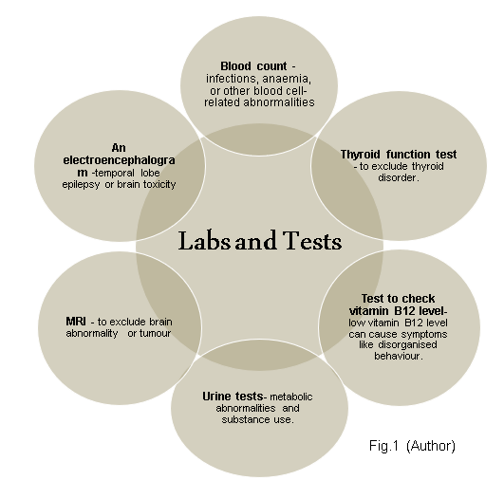
post-traumatic stress, autism spectrum, delusional and bipolar disorder with psychotic or catatonic features. Furthermore, physical health illnesses also can cause similar symptoms to schizophrenia. They include substance use, dementia, thyroid disorder, delirium, Wilson’s disease, porphyria, and brain tumours (Pugle,2021). However, Schizophrenia continues to be a severe illness which is hard to diagnose but harder in the early stage when treating patients can give more positive results. Research shows that one of the efficient tools for early diagnosis, evaluation of treatment and confirmation of prognosis is machine learning techniques(Filippis, Carbone, Gaetano, Bruni, Pugliese, Segura-Garcia and De Fazio (2019). In diagnoses, the process involves General Practice, mental health practitioners, psychiatrists, friends, and family members. If the patient had a schizophrenic episode, they might need support and advice to go to the GP or, if it is severe, to go to the accident and emergency (A&E) department to the patient, where a psychiatrist will be available. Social Services can advise families how to request that a mental health assessment be carried out for relatives who experience schizophrenic episodes and refuse to get help(NHS,2023). Even if the professional diagnosis is so crucial in patient recovery, after diagnoses, patients can experience stigma and discrimination.” 60% of people with schizophrenia face discrimination, stigma from other individuals, and human rights abuses at some point(Zauderer,2023).” Research shows that the health of people who were diagnosed with schizophrenia is viewed negatively by the population. Common stigmas for schizophrenic patients are that they are aggressive, unpredictable, very violent and mentally ill characters(Imhoff, 2016). labels play a substantial part in mental health stigma and must be carefully considered when trying to decrease stigma and increase well-being for the population with mental health conditions(Kundert,2022).

Treatment
Schizophrenia is treated by a combination of medicine and therapy. However, treatments are chosen to be appropriate to individuals. Most of the time, patients are treated with antipsychotic medicines and cognitive behavioural therapy (NHS 24, 2023). Treating Schizophrenia needs a long-term plan with medication, therapy and sometimes hospitalisation to help manage the condition. In treating patients with schizophrenia, a team can be formed by a social worker, nurse, or psychologist. Still, most of the time, the psychiatrist with experience in treating schizophrenia guides treatment. As a treatment, antipsychotic is the most prescribed drug.
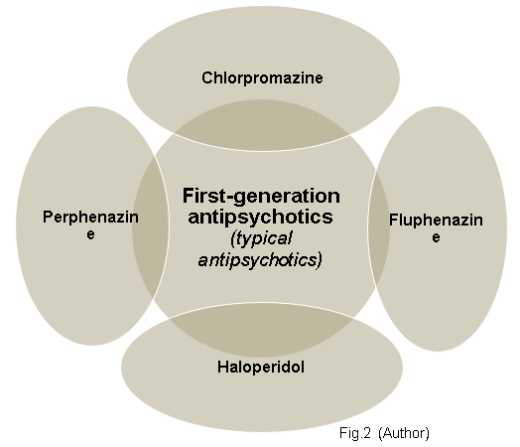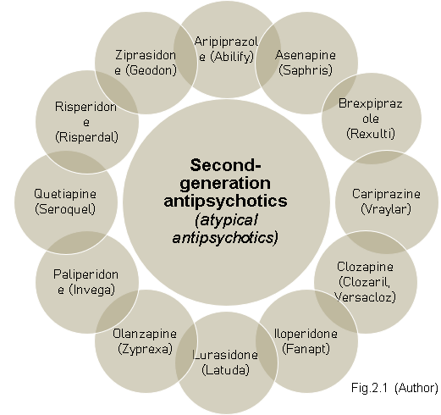
It is used to control symptoms by modifying the brain neurotransmitter dopamine. The goal is to reduce symptoms and signs with low doses, and psychiatrists can modify doses or change with different until there is an improvement in symptoms. However, medicines like antidepressants and anti-anxiety can be prescribed. Some improvement in the reduction of symptoms can be seen after several weeks. If the patient resists medication, the doctor can change them with injections instead of pills. In our day, antipsychotics are classified into first-generation (fig.2) and second-generation(fig2.) (National Library of Medicine,2023). First-generation antipsychotics are cheaper; however, second-generation antipsychotics do not have as many serious side effects as first-generation. As mentioned above, another option for medication treatment is an injection. Depending on the medication, they can be given every two to four weeks. Common medications that are available as an injection Fig2.2(Mayo Foundation for Medical Education and Research, 2023).

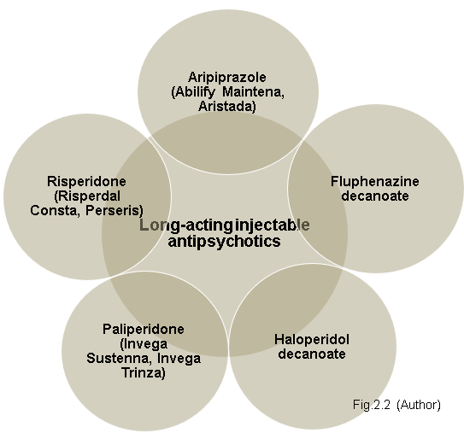
Another option for people who have schizophrenia is psychosocial interventions. Effective care options for people with schizophrenia are psychoeducation, family therapy, cognitive-behavioural therapy, and psychosocial rehabilitation (e.g., life skills training). Facilitated assisted living, supported housing and supported employment are essential to care (Chokhawala and Stevens,2023). Furthermore, for the patient who does not respond to the abovementioned treatment, electroconvulsive therapy (ECT) may be considered. Grover, Sahoo, Rabha and Koirala, 2018 noted that electroconvulsive therapy is helpful not just in medication resistance for patients with schizophrenia but also in managing catatonia, suicidal behaviour, severe agitation, and various other situations. Even if different types of treatment are available and people are supposed to have access to care, statistics show that in practice, two in three people who have psychosis never receive the proper healthcare they need to treat their illness, including those with schizophrenia and just one of three people with the schizophrenic disorder ever recover in full (Zauderer,2023). However, in the present understanding, schizophrenia disorder is much better understood and treated than it was in the past. History shows that in the past, people who showed symptoms of schizophrenia were considered demon possession, evil spirits or similar things, and their treatment was exorcism or, even worse, trepanation to let evil spirits out. The idea that schizophrenia was a spiritual and moral, not a medical issue, was dominant for hundreds if not thousands of years. Just in 1887, Dr. Emile Kraepelin gave the formal description of schizophrenia as a mental illness using the term "dementia praecox". However, in 1911, psychiatrist Eugene Bleuler first used the term "schizophrenia"(George,2023). Journals and books show that there is enormous progress in understanding schizophrenia, and research continues to be done to find better treatment for people with mental disorders. The importance of improving the early diagnosis system and treatment is seen in statistics. With all progress is made, 50% of individuals with schizophrenia hospitalised, unimproved or die (Mostly Suicide)( schizophrenia.com, 2023).
Stable Phase
Schizophrenia patients will continue with treatment and in the stable phase. Assessment and monitoring are required to identify patient benefit from adjustment in the treatment process. Gool is to that symptoms decrease, or control of symptoms is constant and maintain or improve the patient’s functioning and quality of life. Clinical assessment is required to be made in a stable phase. It is repeated every six months for the patient who takes the first generation of antipsychotics and after twelve months for a patient with a second generation of antipsychotics. However, for the elderly or other patients with increased risk, assessments should be done every three months. Furthermore, the physical condition of the patient requires to be monitored, considering drug toxicology. Professionals can do other assessments depending on the prescribed medication (American Psychiatric Association,2004). Besides medicines and physiological assessment, psychosocial treatments in stable phase rehabilitation are essential when service users need support to be close to a more independent life and back to normal functioning (MindPlus,2023). Most schizophrenia patients, after clinical improvement, continue to experience deficits in function (Li, D., Tsui, M. C., Yuan, G., Zhang, G., & Tsang, H. W.,2014). Psychological treatment is chosen based on the particular circumstances of patients’ needs and social context. Rehabilitation or psychosocial interventions have been developed to balance psychotherapy and psychopharmacological treatments. Rehabilitation interventions encourage self-determination and empowerment (Kern, Glynn, Horan and Marder,2009). Typically, Rehabilitation treatment includes three interventions Fig.3.
Cognitive remediation for schizophrenia patients plans to develop social and metacognition, attention, memory, and executive utility (Wykes, Huddy, Cellard, McGurk, Czobor,2011). Cognitive remediation, therefore, aims to limit the impact of cognitive impairment on everyday functioning (Kurtz,2012).
Psychoeducation programs aim to help patients in theiar families understand the signs and symptoms of schizophrenia and teach how to adopt a constructive attitude when experiencing psychoses. Hence, patients can take action that positively impacts theiar lives (Bäuml, Froböse, Kraemer, Rentrop, Pitschel-Walz, 2006). Psychoeducation helps schizophrenic people to ask for and accept help and improve the quality of life for them and their families.

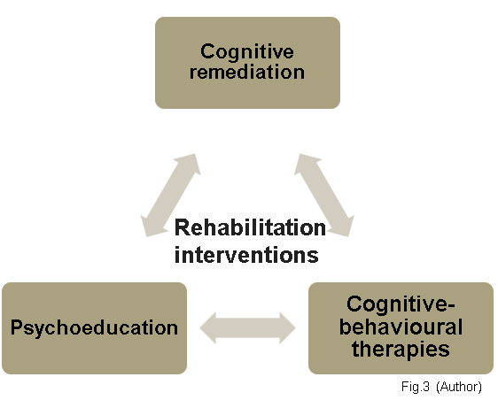Cognitive-behavioural therapies (CBT) are a critical part of non-medication interventions for schizophrenia. They constitute a group of therapies, and the main methods used are social skills training and cognitive therapy. The aim is for schizophrenia patients to have more control over theiar lives and to live independently (Turkington, Dudley, Warman, Beck,2004).
“According to most studies, the impact of cognitive remediation on social functioning is more important when combined with other rehabilitation techniques and when therapy is based on learning strategies (Morin and Franck,2017).

Recommendation for future practice
Although is seen progress in medication and treatment of patients with schizophrenia, a lot of challenges remain unresolved.
Second-generation medication has some significant advantages over first-generation, but the choice in long-term implications remains unclear. A substantial number of patients have no benefit from them, and alternative treatments have still not been discovered. Patient dosages are randomised, and doses of medication are given based on experience and without clear evidence of positive results (KANEI and MALHOTRA,2003). More clinical tests and investigations should be done to reduce this challenge for more precise treatment. That will help manage patients’ desires, reduce medication costs, and invest in research for new, more effective treatments for the future. Studies show that “at 2021/2022 prescribing levels in England, this increase equates to an additional cost to the NHS of £336,011 per year, contributing to its overall additional cost of antipsychotics at £32,993,568 per year ( Wickware,2022).”
Research in early diagnosis of schizophrenia should be done. People early diagnosed have more chance to recover, have reduced severity, and personal and social consequences are easier to manage by the patient and their family. A solution can be to do more research about biological markers that will help the early recognition of the psychotic disorder and to find developed studies that were already done but remain theoretical (HÄFNER and MAURER1,2006). The efficiency of interventions administered in the early course was published by McGorry et al., Lewis et al. and Bechdolf et al., and statistics show reduced psychotic episode experience. However,” mental illness as a whole receives less than 1% of the research funding that cancer does(livingwithschizophreniauk,2017).”
Moreover, research over the past several years indicates that another severe problem in the mental health sector that needs to be solved is misdiagnosis. Statistics show that more than a third of patients with severe psychiatric conditions were misdiagnosed, with 23.71% being schizophrenia patients. Studies show that not just factors like the instability of the patient, history and overlap of symptoms contribute to misdiagnosis but also the experience and knowledge of the professionals involved (Ayano et al.,2021). More training for mental health professionals should be done. Investition should be done not just in research but also in professionals who work with patients to make patients feel confident in the diagnosis. All patients must have a psychological assessment with at least two psychiatrists before being diagnosed with schizophrenia to avoid misdiagnosis and future complications as consequences. Professionals in Mental health should have mental and financial support to improve and develop new skills to improve care for service users.
Stigma is another challenge that has a substantial negative impact on the lives of schizophrenia patients. Society believes that there is progress in understanding mental health problems. However, in reality, stigma continues to be a problem. Media often expose schizophrenia patients as violent and out of control. Cultural and family prejudgment, mental illness is considered a weakness, and the patient can be blamed by the family instead of receiving support. Schizophrenia patients can experience self-stigma, thinking that they are incompetent or dangerous to people around them. Employers hesitate to hire people with schizophrenia; this fact is demonstrated by statistics that show that “only around 13% of people living with schizophrenia in the UK are in any work (livingwithschizophreniauk,2017).” A way to reduce stigma in society is education. Most of the time, people’s reaction is because they can not understand and do not know how to react or behave to schizophrenia patient. A way to reduce stigma can be to network with people who had or still have schizophrenia to share experiences and filings. Reducing stigma among the population is a responsibility of everyone. Statistics show that at some time during their life, about 1 in 100 people will suffer an episode of schizophrenia. That indicates that nobody can be sure that one day can be in place of schizophrenia patients, and improving the lives of people with schizophrenia today will make a massive difference in the future.

Conclusion
It can be seen from the information above that schizophrenia is an illness that requires a complex investigation, not just in the diagnosis process but also in treatment. Schizophrenia is not a disease where doctors can prescribe just medication, and patients will recover. The first step in the recovery process is the correct diagnosis. To not fail this step, the patient should have all investigations like psychological and physical assessments and have a second opinion from another clinician. The treatment method available today has progressed from the past, and a range of antipsychotic medications available in pills and in injections in combination with therapy have a positive impact in reducing the symptoms of patients. However, it continues to be a challenge to prescribe a medication dose, and there still are not enough resources to have a medication that will help patients with side effects. The patient with schizophrenia has to continue treatment and is in a stable phase. It is essential to have a program to integrate them into independent life to have a job and improve their well-being. However, the information above shows that just a small number of patients go back to independent living. Stigma among the population is still a severe problem that affects the lives of people with schizophrenia.
It seems to me that schizophrenia is a disease still not known well enough for more effective treatment, and I consider that investigations should concentrate on finding a solution for early diagnosis. As mentioned above, early diagnoses should be done so patients can manage their illnesses.
In conclusion, research should be done to find a solution to the number of early-diagnosed patients, as mentioned above. Investments should be made to help mental health professionals improve and develop new skills to reduce the number of misdiagnosed patients. Moreover, to educate the society to reduce stigma among the population. That can improve the quality of life of people with schizophrenia and improve care services for future generations.

Reference:
Ayano G., et al. (2021) Misdiagnosis, detection rate, and associated factors of severe psychiatric disorders in specialized psychiatry centers in Ethiopia Available at: https://www.ncbi.nlm.nih.gov/pmc/articles/PMC7856725/ https://pubmed.ncbi.nlm.nih.gov/16122813/ (Accessed at:15November 2023)
Bäuml J., Froböse T., Kraemer S., Rentrop M., Pitschel-Walz G. (2006) Psychoeducation: a basic psychotherapeutic intervention for patients with schizophrenia and their families Available at: https://pubmed.ncbi.nlm.nih.gov/16920788/ (Accessed at:14 November 2023)
Bechdolf A., Veith V., Schwarzer D., et al. (2005) Cognitive-behavioural therapy in the prepsychotic phase Available at: https://pubmed.ncbi.nlm.nih.gov/16122813/ (Accessed at:15 November 2023)
Chokhawala K. and Stevens L. (2023) Antipsychotic Medications Available at: https://www.ncbi.nlm.nih.gov/books/NBK519503/ (Accessed at:08 November 2023)
Correll C. and Schooler N.R. (2020) Negative Symptoms in Schizophrenia: A Review and Clinical Guide for Recognition, Assessment, and Treatment Available at: https://www.ncbi.nlm.nih.gov/pmc/articles/PMC7041437/ (Accessed at:04 November 2023)
Diagnosis - Schizophrenia (2023) Available at: https://www.nhs.uk/mental-health/conditions/schizophrenia/diagnosis/ (Accessed at:08 November 2023)
Emil Kraepelin (2023) Available at: https://psychology.jrank.org/pages/365/Emil-Kraepelin.html (Accessed at:04 November 2023)
Facts and Figures (2017) Available at :https://livingwithschizophreniauk.org/facts-and-figures/ (Accessed at:15 November 2023)
Filippis R., Carbone E.A, Gaetano R., BruniA., Pugliese V., Segura-Garcia C. and De Fazio (2019) Machine learning techniques in a structural and functional MRI diagnostic approach in schizophrenia: a systematic review, Neuropsychiatric Disease and Treatment Available at: https://doi.org/10.2147/NDT.S202418 (Accessed at:08 November 2023)
Grover S., Sahoo S., Rabha A. and Koirala R., (2018) ECT in schizophrenia: a review of the evidence Available at: https://www.cambridge.org/core/journals/acta-neuropsychiatrica/article/abs/ect-in-schizophrenia-a-review-of-the-evidence/E7B1748FF190E0463F3A07A9FFEBF4AD (Accessed at:10 November 2023)
HÄFNER H. and MAURER K. (2006) Early detection of schizophrenia: current evidence and future perspectives Available at: https://www.ncbi.nlm.nih.gov/pmc/articles/PMC1636122/ (Accessed at:15 November 2023)
How Rehabilitation Helps in the Treatment of Schizophrenia(2023) Available at: https://mind.plus/how-rehabilitation-helps-in-the-treatment-of-schizophrenia/ (Accessed at:10 November 2023)
ICD-10, (2010) Schizophrenia, schizotypal and delusional disorders(F20-F29) Available at https://icd.who.int/browse10/2010/en#/F20-F29 (Accessed at:04 November 2023)
Imhoff R. (2016) Zeroing in on the Effect of the Schizophrenia Label on Stigmatizing Attitudes: A Large-scale Study Available at: https://www.ncbi.nlm.nih.gov/pmc/articles/PMC4753605/ (Accessed at:08 November 2023)
KANEI J. and MALHOTRA A. (2003) The future of pharmacotherapy for schizophrenia Review Available at: https://www.ncbi.nlm.nih.gov/pmc/articles/PMC1525084/ (Accessed at:15 November 2023)
Kern R.S., Glynn S.M., Horan W., Marder S. (2009) Psychosocial treatments to promote functional recovery in schizophrenia. Available at: https://pubmed.ncbi.nlm.nih.gov/19176470/ (Accessed at:12 November 2023)
Kundert C. (2022) Diagnostic labels: helpful or harmful? Available at: https://www.nationalelfservice.net/diagnosis/diagnostic-labels/ (Accessed at:08 November 2023)
Kurtz M.K. (2012) Cognitive remediation for schizophrenia: current status, biological correlates and predictors of response Available at: https://pubmed.ncbi.nlm.nih.gov/22853789/ (Accessed at:14 November 2023)
Lewis S., Tarrier N., Haddock G., et al. (2002) Randomized, controlled trial of cognitive-behaviour therapy in early schizophrenia: acute phase outcomes. Available at: https://pubmed.ncbi.nlm.nih.gov/12271807/ (Accessed at:15 November 2023)
Li, D., Tsui, M. C., Yuan, G., Zhang, G., & Tsang, H. W. (2014) Measuring perceived rehabilitation needs of people with schizophrenia in mainland China. Administration and Policy in Mental Health and Mental Health Services Research, 41(5), 636-646.
McGorry P.D., Yung A.R., Phillips L.J. et al. (2002) Randomized controlled trial of interventions designed to reduce the risk of progression to first-episode psychosis in a clinical sample with subthreshold symptoms. Available at: https://pubmed.ncbi.nlm.nih.gov/12365879/ (Accessed at:15 November 2023)
Morin L. and Franck N., (2017) Rehabilitation Interventions to Promote Recovery from Schizophrenia: A Systematic Review Available at: https://www.ncbi.nlm.nih.gov/pmc/articles/PMC5467004/#B16 (Accessed at:14 November 2023)
Paniagua F.A. (2018) ICD-10 Versus DSM-5 on Cultural Issues Available at: https://journals.sagepub.com/doi/10.1177/2158244018756165 (Accessed at:04 November 2023)
Pugle M. (2021) How Schizophrenia Is Diagnosed Available at: https://www.verywellhealth.com/how-schizophrenia-is-diagnosed-5114038 (Accessed at:04 November 2023)
Ramos L.B.N.C. (2022) DSM-5 TR Available at: https://www.academia.edu/87962793/DSM_5_TR_English_ (Accessed at:04 November 2023)
Schizophrenia (2023) Available at: https://www.nhsinform.scot/illnesses-and-conditions/mental-health/schizophrenia/ (Accessed at:08 November 2023)
Schizophrenia (2023) Available at:https://www.mayoclinic.org/diseases-conditions/schizophrenia/diagnosis-treatment/drc-20354449 (Accessed at:08 November 2023)
Schizophrenia Facts and Statistics (2023) Available at:http://schizophrenia.com/szfacts.htm (Accessed at:10 November 2023)
TREATING SCHIZOPHRENIA (2004) Available at: https://psychiatryonline.org/pb/assets/raw/sitewide/practice_guidelines/guidelines/schizophrenia-guide.pdf (Accessed at:12 November 2023)
Turkington D., Dudley R., Warman D.M., Beck A.T. (2004) Cognitive-behavioral therapy for schizophrenia: a review Available at: https://pubmed.ncbi.nlm.nih.gov/15334983/ (Accessed at:14 November 2023)
Wickware C. (2022) Data show ‘spiralling’ antipsychotic price increases of up to 1,200% in past five years Available at: https://pharmaceutical-journal.com/article/news/data-show-spiralling-antipsychotic-price-increases-of-up-to-1200-in-past-five-years (Accessed at:15 November 2023)
Wykes T., Huddy V., Cellard C., McGurk S.R., Czobor P. A. (2011) A meta-analysis of cognitive remediation for schizophrenia: methodology and effect sizes Available at: https://pubmed.ncbi.nlm.nih.gov/21406461/ (Accessed at:12 November 2023)
Zauderer S. (2023) 39 Schizophrenia Statistics & Facts (Prevalence) Available at: https://www.crossrivertherapy.com/research/schizophrenia-statistics (Accessed at:10 November 2023)

