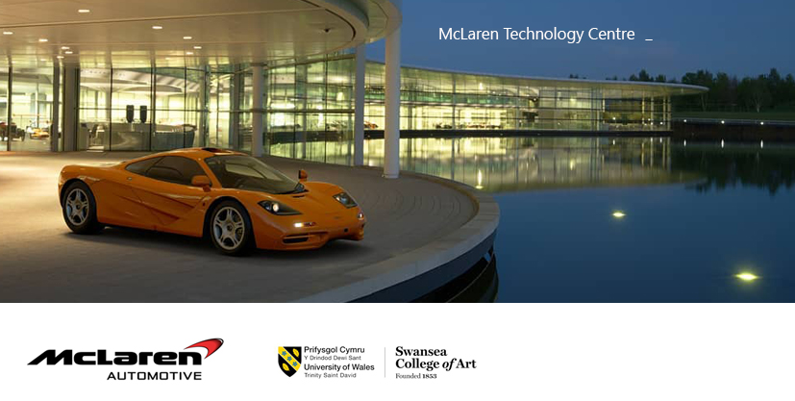
Dear all,

I’m delighted to confirm you that we are officially going to visit the
Amazing MTC in Woking, Surrey, home of McLaren Automotive.
If you are receiving this email is because you have been shortlisted for this trip
And your name is down for an exclusive factory & facilities tour at the MTC.

This is going to be a fantastic experience on his own, and for the second year Automotive and Transport Design students, the chance to be introduced officially
To this year live project’s brief.
We are meeting at 8.30 am of Friday the 8th of March 2019 in Alex (your
Design Studio) and we are leaving at 9.00 am with CYMRU Coaches from the
Parking Bay in front of the GLYNN VIVIAN ART GALLERY (opposite ALEX).

Please be punctual as it is a long journey and we must be in Woking by 2pm at the latest.
I’m sure it will be a fantastic experience and well worth the long journey.

Kind Regards

Sergio Fontanarosa
Programme Director - BA/MDes Automotive & Transport Design

