MARKETING ENVIRONMENT ANALYSIS AND STRATEGIC GROWTH REPORT: TATA STEEL'S TRANSITION TOWARDS LOWER-CARBON PRODUCTS

Student Name: SIDDHARTH JANGIR
Student ID: 2538969
Date: 24.06.2026

Table of Contents
Task 1: Marketing Environment Analysis 3
Natural Environment 3
Technological Environment 4
Task 2: Strategic Growth and Competitive Positioning 5
Application of the Ansoff Matrix 6
Product Development Strategy for Lower-Carbon Steel 7
Achieving Competitive Advantage through Differentiation 8
Task 3: Critical Reflection on AI Usage 10
Reference List 12

Task 1: Marketing Environment Analysis
Organisations in carbon-intensive industries are increasingly adopting the shift to a low carbon economy as a key strategic priority. Tata Steel is among the world's biggest steel producers and is under growing pressure from regulators, investors, customers and society as a whole to become more environmentally friendly, without compromising on competitiveness. Kotler and Armstrong (2010) claim that the external marketing environment factors need to be closely tracked by organisations as they provide opportunities and threats for an organisation's strategic decision making. Tata Steel has two key external players to consider for its transition to less carbon intensive products: the Natural Environment and the Technological Environment. Technological developments are helping to create innovative solutions to help achieve decarbonisation goals, whereas environmental issues are fuelling the demand of sustainable methods of steel production.

Natural Environment
As per Panchali (2024), Natural Environment has emerged as one of the most impacting factors on Tata Steel's strategic course. Steel is a major contributor to global carbon dioxide emissions, with about 7–9% of the total emissions coming from the global steel industry. Hence, there is a growing expectation from governments, investors and customers that steel manufacturers be more environmentally accountable (Tata Steel, 2026). The increasing environmental awareness has made sustainability a marketing problem and a brand strategy that impacts brand reputation, customer choice and future competitiveness.
The global climate change programs and commitments for going net zero are one such environmental pressure. Governments face pressure from international commitments like the Paris Agreement to set ambitious targets for reducing carbon. International commitments, including the Paris Agreement, have put pressure on governments to set ambitious targets for reducing carbon emissions, particularly from industries with high emissions. To tackle this challenge, Tata Steel has pledged to decarbonize its operations and become a net zero by 2045 (Dutta 2025). Such promises from a marketing point of view have a positive impact on the confidence of stakeholders and the expression of environmental responsibility. In automotive, construction and infrastructure, customers are looking more and more for suppliers who are able to help achieve their own sustainability targets.
The traditional steelmaking process relies on coal and other limited natural resources, which poses challenges for sustainability in the long term. The urgency to apply circular economy concepts in the value chain through various waste reduction and resource efficiency measures has grown, and stakeholders are demanding that organisations take action in this area (Wang et al., 2025). To overcome these challenges, Tata Steel has diversified its business into recycling of scrap and sustainable manufacturing processes. These efforts not only lessen the impact on the environment, but also boost the company's sustainability profile in the market.
With a growing demand for products that are eco-friendly, Tata Steel has a huge opportunity in this market. Research indicates that sustainability is now tied tightly to a company's reputation and expectations amongst stakeholders and if industrial customers can see a strong environmental performance from their suppliers, they will likely choose them accordingly. (Hotak, 2026) By developing lower carbon steel products, Tata Steel is able to carve out a niche for itself among its competitors and thus improve its market position. Green Steel products may offer premium price in certain markets where environmental performance is of great importance. So environmental issues can provide opportunities at the same time as they provide challenges for market growth and differentiation.
These investments drive up production costs, and can be at odds with profitability goals and sustainability goals. Therefore, Tata Steel needs to be mindful of balancing the environmental aspects with business reality. The other challenge has to do with the increasing transparency of environmental claims. Expectations of transparency about sustainability performance have never been higher, which is a threat from greenwashing allegations (Khan, 2024). When environmental claims are not seen as true, or backed up with measurable results, organisation reputation can be severely impacted. The Tata Steel, therefore, needs to provide evidence for its sustainability communications and have reliable reporting systems in place.

Technological Environment
In addition to pressures from the environment, the Technological Environment is also a critical factor that helps Tata Steel move towards low carbon products. The current steel production process is still very carbon-intensive (Mallett and Pal, 2022) and therefore technological innovation is crucial to reach sustainability goals. This means that technological advances are able to offer opportunities to organisations to lower emissions and boost operational efficiency.
Hydrogen steelmaking is one such technological advancement. The traditional steel production process is based on blast furnace technology using a large amount of coal, which is a major source of carbon emissions. One alternative is hydrogen technology, in which the coal in the reduction process is replaced, which significantly reduces emissions (Ramakrishnan, 2024). As part of its long-term decarbonisation plan, Tata Steel has been actively looking into hydrogen-based production methods. In terms of marketing, the use of new low carbon technologies improves the company's environmental image and its capacity to respond to the changing needs of consumers.
Furthermore, digital technologies and AI are reshaping the way that industry’s function. AI systems can help to reduce energy waste, enhance production efficiency, and optimize energy use. The predictive maintenance technologies can help companies to reduce equipment failures and optimize resource use (Sun et al., 2024). These technological advances not only help achieve sustainability goals, but also lower the costs of operations. Thus, technology isn't just an environmental solution; it can also be a value creation tool for the business. Finally, the Technological Environment helps to differentiate products. In today's era, where customers have a heightened awareness of environmental issues, they are increasingly looking for proof of sustainable innovation when choosing suppliers, especially in industries that are increasingly being held accountable for their environmental practices. This differentiation can strengthen customer loyalty, increase stakeholder perceptions and provide customers with a barrier to competitive imitation.
While there are benefits to technological adoption, it comes with some risks as well. Emerging technologies need significant capital to be implemented and may experience implementation problems prior to realizing commercial scalability (Kohitlhetse and Chiririwa, 2026). In addition, technological developments are also constantly changing, and it's unclear what solutions will ultimately prevail. Climate change concerns and the scarcity of resources, together with the expectations of the stakeholders, are changing the market demand and creating incentives for sustainable innovation. At the same time, technology advances offer the means for emission reduction and differentiation of low-carbon products. These environmental actors, in combination, provide opportunities and challenges which will affect Tata Steel's future growth and competitive position in an increasingly sustainability aware market place.

Task 2: Strategic Growth and Competitive Positioning
The environmental analysis revealed that the global steel industry is undergoing significant changes in the competitive environment due to the growing pressures of climate change and the rapid pace of technological advancements. Industrial customers, investors and governments are increasingly demanding from Tata Steel that it not only be carbon neutral, but also be increasingly efficient and profitable. All these changes bring challenges and opportunities that will need a well-thought-out growth strategy. The growth matrix by Ansoff suggests that an organisation can grow in four ways; market penetration, market development, product development and diversification.

Application of the Ansoff Matrix
The Ansoff Matrix helps business people to recognize growth opportunities in terms of existing and new products in existing and new markets. Market penetration means to grow sales in the existing market with current products.
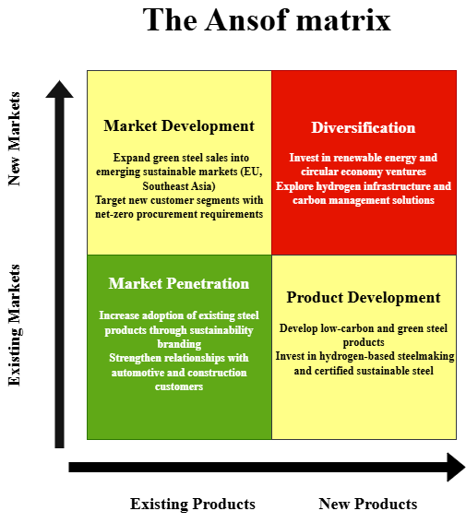
Figure 1: Ansoff Matrix
(Source: Self-Developed)
Based on the Ansoff Matrix, Tata Steel should consider Product Development as its growth strategy to move towards a low carbon business model. While market development and market penetration focus on existing customer bases and markets, product development directly responds to the growing demand of stakeholders for sustainable steel products, and builds on the company's existing customer base in both construction and automotive industries (Ferreira and de Sá, 2024.). The strategy centers on investments in hydrogen-based steelmaking and certified sustainable production processes with the aim of developing low-carbon and green steel products. Such technology and capital is needed, but it can create a great opportunity for differentiation in the highly sustainability-focused market.

Product Development Strategy for Lower-Carbon Steel
The proposed growth approach is to increase Tata Steel's product mix of lower carbon steel by making continuous investments in sustainable production processes and eco-friendly product innovation (Qomaro, Nasrulloh and Salleh, 2024). This reflects the evolution of markets whereby sustainability has become more and more a key purchasing criterion for industrial customers.
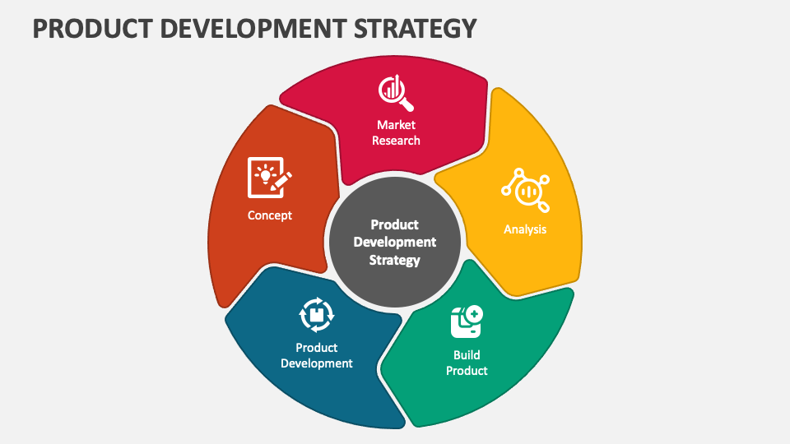
Figure 2: Product Development Strategy
(Source: Rua and Santos, 2022)
The development of green steel products with low-emission manufacturing processes is one of the great opportunities. Environmental laws and legislation are becoming more stringent around the world and big industrial customers are announcing their plans to achieve net-zero supply chains. Environmental laws and regulations are tightening globally, and large industrial buyers are pledging to implement their net-zero supply chains. In the case of automobiles, suppliers are increasingly being asked by automotive manufacturers for concrete cuts in carbon emissions across the entire value chain (Zhang et al., 2025). Tata Steel can provide these industries with preferred suppliers by providing them certified lower carbon steel products.
The implementation of green steel enables value creation which is different from the competition based on conventional price. Steel product has traditionally been a commodity, which has offered less opportunity to differentiate. Lower-carbon steel helps customers enhance their environmental performance, ESG reporting and meet regulatory requirements. This will enable Tata Steel to generate customer value and also minimize direct competition.
Technological innovation is a key enabler to this strategy. Emissions can be lowered by substantial investments in steelmaking using hydrogen, integrating renewable energy into the system, and carbon capture. At the same time, AI and digital technologies can maximize energy use and enhance the efficiency of resources and minimise operational losses (Mallett and Pal, 2022). The technological developments not only help meet environmental goals, but they also aid in long-term cost savings.
Costs of implementing new technologies could impact profitability in the short term. This means Tata Steel will need to be careful in making decisions around investment and maximise the value to customers through sustainability efforts. Although the obstacles are great, Product Development is still a suitable growth strategy to face the environmental and technological pressures that were described in task 1. Tata Steel is not just responding to the changes in the regulatory landscape; it's actively driving them. Instead of simply responding to regulatory shifts, Tata Steel is innovatively and sustainably influencing market demand.

Achieving Competitive Advantage through Differentiation
Although the Ansoff Matrix can help to define the correct growth path, Tata Steel has to develop a viable option to achieve a sustainable competitive advantage. According to Porter's Generic Strategies, organisations can compete by being low-cost leaders, differentiation or focus. In the present context where sustainability is a hot topic of discussion in the industrial markets, Tata Steel is best suited to take a Differentiation Strategy.
Differentiation is the concept of developing value for a product or service which a competitor can't easily match. At the level of lower carbon steels, Tata Steel has the potential to stand out with its environmental measures, technology and sustainability attributes. Environmental responsibility is becoming an important source of competitive advantage as customers more and more consider environmental, social and governance aspects in their procurement processes (Dutta, 2025). Companies with quantifiable carbon reduction performance will no doubt be able to appeal to carbon-conscious customers and investors.
An important way of differentiating is to secure environmental certification, and to disclose transparent carbon footprint information on steel products. Customers are looking for evidence as opposed to marketing when judging sustainability performance. Transparent reporting of environmental credentials and independently verified environmental credentials can boost trust and brand credibility (Sun et al., 2024). This not only minimizes the chances of being accused of greenwashing, but also enhances Tata Steel's image as a responsible industry player.
Further, technological leadership can help to differentiate. Hydrogen-based steel production and advanced low-carbon production technologies provide opportunities to gain first-mover advantages in new markets for sustainable steel. The early adoption of innovative technologies could make Tata Steel appear more as an industry leader to customers, while also making it more difficult for other companies to offer the same sort of technologies. To create the Tata Steel's communication of how lower carbon products can help customers meet their sustainability goals, ensure regulatory compliance, and enhance corporate reputation (Wang et al., 2025). It is important to make the case for the value of the product or service to the customer, instead of just the environmental benefits, to improve market acceptance and to build better relationships with key stakeholders.
Achievement of sustainable competitive advantage requires not only a good performance in the environment but also the ability to respond to changing market demands and technological innovations. The strategy allows innovation in the creation of green steel products and also gives the organisation a chance to use its existing customers and market knowledge. Differentiation Strategy based on environmental performance and technological innovation and transparency of sustainability credentials can be used as a way to gain competitive advantage (Panchali, 2024). Combining sustainable product development and strategic differentiation at Tata Steel will help to further strengthen its market position, deliver long-term value for customers and enable sustainable growth in a carbon conscious global economy.

Task 3: Critical Reflection on AI Usage
This report has been developed using Artificial Intelligence (AI) technology to assist in research, information collection, content structuring and idea generation. The use of AI tools was instrumental in the identification of the key concepts, summarisation of information content related to Tata Steel's sustainability efforts and initial recommendations with respect to the use of marketing tools such as marketing environment analysis and Ansoff Matrix. These were helpful in making the initial report preparation more efficient.
While AI systems can produce information very quickly, they might make incorrect claims or give outdated information or references, often called "hallucination". The risks are minimised by cross-checking all information produced by AI with credible academic journal articles, Tata Steel's sustainability reports, industry publications, and pertinent textbooks. Specifically, there was a focus on confirming assertions related to carbon emissions and other sustainability goals and technological advancements in the steel sector. In this process, there were some statements, which did not have any supporting evidence, or presented generalised conclusions without providing sufficient context. The issues were addressed by checking the authoritative sources and replacing the information that is not supported by the evidence-based analysis (Kohitlhetse and Chiririwa 2026). This verification process highlighted the importance of human judgement in ensuring the reliability and academic quality of AI-assisted work.
To ensure the distinction between AI-supported activities and the author's contribution, their work is clearly marked. The main uses of AI were to help come up with initial ideas, finding relevant marketing concepts, and proposing report structures. AI helped summarise complex information relating to environmental sustainability and technological innovation within the steel industry (Hotak, 2026). The choice of Tata Steel as the case organisation, the evaluation of environmental and technological factors, the justification for the adoption of a Product Development strategy and the evaluation of the competitive advantage was based on both the literature and evidence gathered from credible sources, but was subject to personal interpretation.
While AI can be helpful in marketing analytics, it also comes with some ethical and professional implications. While AI can enhance productivity and aid in decision-making, overreliance on these systems could hinder critical thinking and lead to the inclusion of inaccurate information in business reports. As such, users should be held accountable for their use of AI, the verification of information, and the provision of credible evidence to support conclusions. In the field of marketing analysis, a marketer's job is not to be replaced by AI, but rather to be supported by it. When using AI in marketing analysis, it should be considered as a complementary tool to improve the efficiency of the research process. Proper use of AI demands ongoing monitoring, analysis and awareness of the principles of academic honesty and integrity in professional work to ensure quality, credibility, and ethics.

Reference List
Dutta, S.K., 2025. Towards an outcome-based approach in ESG reporting: sustainability drive of Tata Steel. IIM Ranchi journal of management studies, 4(2), pp.107-126.
Ferreira, A.P.P.F.S. and de Sá, M.M.B.P., 2024. The importance of the Ansoff matrix for the study of the information services market. The Canadian Journal of Information and Library Science, 47(2), pp.78-84.
Hotak, F., 2026. The Role of Entrepreneurial Leadership in Driving Global Expansion: Ratan Tata’s Strategic Vision for the TATA Groups: The Role of Entrepreneurial Leadership in Driving Global Expansion. Journal of İstanbul School of Technology, 2(1), pp.1-15.
Khan, F.A., 2024. Sustainable business management: Balancing profit and purpose. Journal of Management Science Research Review, 2(1), pp.24-32.
Kohitlhetse, I. and Chiririwa, H., 2026. Emerging Trends and Opportunities in Hydrogen-Based Direct Reduction for Sustainable Low-Carbon-Emission Steelmaking. Processes, 14(10), p.1529.
Kotler, P. and Armstrong, G., 2010. Principles of marketing. Pearson education.
Mallett, A. and Pal, P., 2022. Green transformation in the iron and steel industry in India: Rethinking patterns of innovation. Energy Strategy Reviews, 44, p.100968.
Panchali, J., 2024. Tata Steel’s Acquisition of Bhushan Steel: Steeling the Competition. Vikalpa, 49(2), pp.181-189.
Qomaro, G.W., Nasrulloh, N. and Salleh, A.Z., 2024. Leveraging The Ansoff Matrix for Strategic Growth in Packaged Food Micro-Enterprises. Dinar: Jurnal Ekonomi dan Keuangan Islam, 11(1), pp.51-66.
Ramakrishnan, H., 2024. Carbon Neutrality, Carbon Footprint and Circular Economy Indian Initiatives to Combat Carbon Footprint. ACADEMICIA: An International Multidisciplinary Research Journal, 14(5), pp.25-43.
Rua, O.L. and Santos, C., 2022. Linking brand and competitive advantage: The mediating effect of positioning and market orientation. European research on management and business economics, 28(2), p.100194.
Sun, M., Pang, K., Barati, M. and Meng, X., 2024. Hydrogen-based reduction technologies in low-carbon sustainable ironmaking and steelmaking: a review. Journal of Sustainable Metallurgy, 10(1), pp.10-25.
Tata Steel, 2026. Integrated report and annual account [Online]. Available at: https://www.tatasteel.com/ [Accessed on: 18th June, 2026]
Wang, H., Zhou, J., Gu, K. and Dong, F., 2025. Can new quality productivity drive the low-carbon transformation of carbon-intensive industries? Macro and micro evidence from China. Energies, 18(13), p.3278.
Zhang, J., Guo, H., Yang, G., Wang, Y. and Chen, W., 2025. Sustainable transition pathways for steel manufacturing: Low-carbon steelmaking technologies in enterprises. Sustainability, 17(12), p.5329.

