

Cloud-Based Web Services
ACCA6024

Cloud Computing Report

Submitted by:
Anthony Smith 1704559

Submitted to:
Mike Dacey & Dr Tim Bashford

May 2021

Table of Contents
1.Introduction 2
1.1 What is Cloud computing? 2
1.1.2 Benefits and drawbacks of the Cloud 2
1.1.2.1 Benefits 2
1.1.2.2 Drawbacks 3
1.1.3 Cost implications 4
1.1.4 Reliability and scalability 6
1.1.4.1 Scalability 6
1.1.4.2 Reliability 7
1.1.4.3 The importance of scalability and reliability 7
2. Virtual machines and Containers 7
2.1 Adoption of Docker 8
3. Process of producing node.js applications 9
References 12

1.Introduction
The evolution of file storage has enabled computer users to reduce saved data on local harddrives and outsource the information to distant servers across the internet. For the casual user, this is ideal as it lessens the need to purchase new storage or delete important data to free up space on the harddrive. However, organisations for many years have implemented a similar system that allowed the business access to processing and storage. Incorporating internet capabilities in this way reduces cost, as the business only pays for storage they use. Additionally the benefits can far outweigh just simple storage availability, an organisation can have access to essential programs and applications saving them time, money, and office space. This is known as Cloud Computing.

What is Cloud computing?
Cloud computing is the accumulation of networked computer hardware that provides online services via the internet. An important feature of the cloud is the employment of virtual machines, which subdivides the power, memory, and storage of a mainframe computer into smaller systems. Each one having their own running O/S. This allows resources to be shared and distributed across the cloud.
There are three components that are fused together to form the bases of the cloud: Infrastructure as a service(IaaS) – Large online organisations like Amazon, Microsoft and Google rent out computing infrastructure to other businesses at a monthly cost; Platform as a Service (PaaS) – Allows software developers to create applications online for specific clients; Software as a Service (SaaS) - Customers use software over the internet [1].
Organisations of all size and type can profit from cloud computing and it would be difficult to find a modern business that is not utilising some form of cloud-based application. Whenever a business moves into adopting cloud computing for operational purposes, it is prudent to know how the change would benefit the business. It is also sensible to be aware of the possibility of drawbacks that a move into cloud computing could bring.

1.1.2 Benefits and drawbacks of the Cloud
Due to the significant shift in the way corporations can decide to operate, the best practise would be to evaluate the impact of cloud computing. The organisation should consider the positives and negatives of the cloud business model before recycling office servers and desktop software.

1.1.2.1 Benefits
Cloud computing has many important factors that draw in businesses to adapt the new system over any previous working model. They are:
Flexibility – Using cloud technology access can be possible from almost everywhere. The need to be in an office is no longer a necessity. Employees can work from home or while travelling and this in turn can increase productivity. Depending on the function type of business, some months may be busy, while other months may be less intense, with cloud computing it is possible to pay for only the resources that are being used each month. This is achieved by selecting a flexible package from the chosen provider.
Data Recovery – Data recovery from physical servers and hard drives can be difficult, in some cases it may not be possible if the damage is to extensive. This could lead to the loss of very important client files or business related data. With Cloud computing, this dilemma will not be so relevant as data is usually stored in various locations on multiple servers. Therefore, data will be more secure, even if a server becomes problematic, the data will be backed up and available on another server.
Maintenance – With a conventional server based system, organisations will carry out regular maintenance checks on the whole system and replace costly components that have stopped working or need upgrading. Implementing a cloud computing system will eliminate the need for maintenance, as everything will be handled by the supplier. This removes the costs and concern that would be involved ensuring that the maintenance is carried out.
Access – Access to all authorised documentation can be quick easy using the cloud computing system. Most cloud services possess a simple user interface, which can be accessed remotely across the network.
Security – Cloud computing contains highly secure encryption and login security systems, which increases the protection against data theft. If a breach in security occurs, the organisation can simply delete the confidential information remotely or move the files to a more secure account. Infringing the security measures on cloud systems is very difficult, which is why the user is assured data security.
Performance – Most cloud computing services run on a worldwide network, which are regularly upgraded with the latest advancements. This can lead to a positive effect on network latency and make greater website scaling available. [2] [3]

1.1.2.2 Drawbacks
Although there are many positives to be had using the cloud computing system, unfortunately it is not suitable for everyone. Depending on what the organisation wants to achieve using cloud computing will inevitably dictate a positive or negative outcome.
Performance-intensive operations such as Video editing or music recording suites are not appropriate for the cloud. Other types of Software that requires highly powered desktop computers like graphic design programs may also struggle in this environment. Small businesses that consist of a limited customer base or supply a product that has little market demand, may find certain attributes that come with cloud computing excessive.
For organisations that will venture into cloud computing, need to be aware of the following risks involved:
- Technical issues
Although data can be accessed from anywhere and at any moment, there are still incidents of malfunction that can make retrieving this data difficult. Technology is always prone to error anomalies and cloud computing is no different. The big providers of cloud services maintain high standards of maintenance but can still run into unforeseen problems.
- Downtime
Cloud computing relies on the availability of an internet connection. For large organisations this may not be a problem, but for smaller businesses, internet dependency can cause major turmoil. If the internet service suffers from outages or slow speeds, cloud computing will struggle to achieve the business mandate. When the internet is offline, the business is offline.
- Security
Companies who adopt cloud computing, surrender all sensitive business information to a third-party provider, Therefore, imposing risk to the business. Even though most large cloud computing companies can offer higher levels of security, they are still prone to external hacks, due to usage of username and password logins. As the information can be accessed from anywhere on the internet business data can be compromised.
- Costs
Cloud computing can be a cheaper solution for large businesses as it can replace expensive software and systems and is known as SaaS (Software as Service applications). But for smaller organisations who have to tailor the cloud based software to meet their requirements may pay a premium for the service. An organisation should also look closely at pricing plans to ensure the plan is right for the business. A tiered contract adapts to the limit of members who will use the cloud service. If the business exceeds the contracted limit, the next tier can double in price.
- Inflexibility
When choosing a cloud service, the organisation needs to be aware of the contract they are signing up to. Some cloud providers do not allow easy transfer from one system to another, which can force the customer to remain locked into a service. The organisation must retain ownership of all data and ensure the vendor conforms to current standards.
- Customer support
Response time given by customer support services for average contracts can take 48hrs. Unfortunately for the organisation who is experiencing problems, it can have a detrimental affect on the business. For the bigger cloud computing providers, the system of supporting their customer base has improved, but this technical support service comes at a price. Google now have a response time of four hours, but this cloud platform currently costs $100 per month. When choosing a cloud computing plan, the business should make sure that certain options they will require are selected. Technical support which can include email, phone, live chat and forums will all increase the fees that the business will pay. [4] [5]

1.1.3 Cost implications
Transferring from traditional on site operations to cloud services is a complex matter that needs careful investigation to ensure all migration factors are accounted for. As mentioned in previous sections of this report the total outlay can be a positive or a negative aspect of cloud computing and a need to expand on the costs involved is imperative.
Before deciding if cloud computing is financially viable, an organisation needs to consider the costs included In the current infrastructure of the business. Those direct costs will include hardware and software, physical server costs, software licence, maintenance, spare parts, network and internet, storage and more. All of these costs will be visible on the balance sheet and can be easily calculated.
After those costs are calculated, a comparable cloud infrastructure that will include all the specifications required to run the business application can be selected. The provider will base fees on the three main factors, which are network costs, computing costs and storage cost and charge premiums depending on the amounts of each, the customer would need. Each cloud computing company such as Google Cloud, Microsoft Azure and Amazon AWS provide their own price calculator for the potential customer to fill out, clarifying the requirements [Fig 1.1] [6].

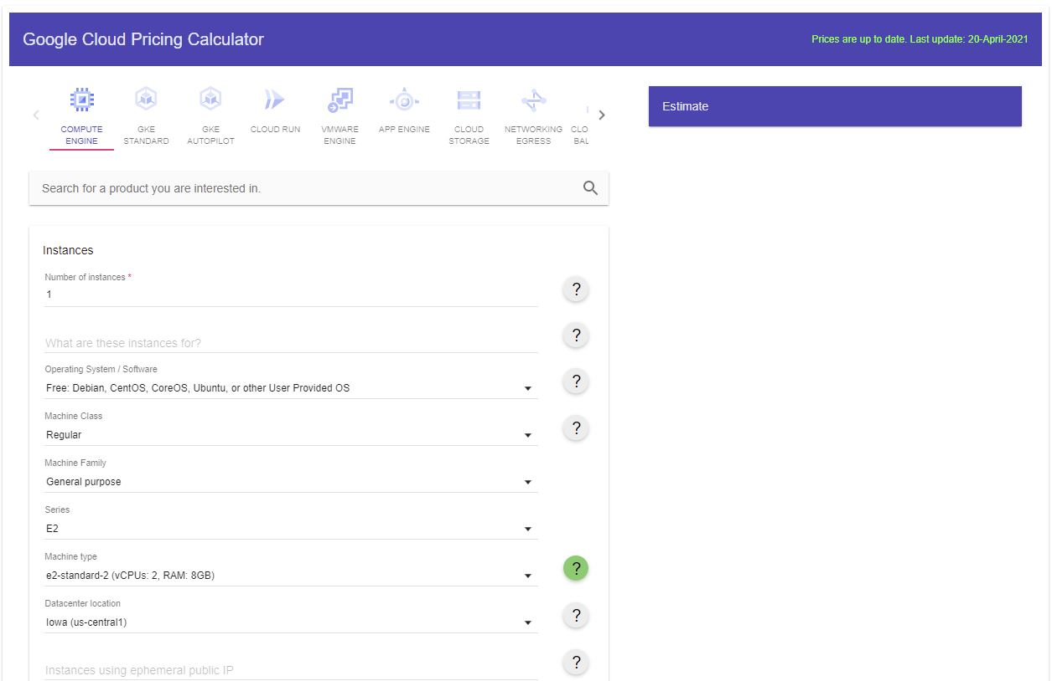

[Fig 1.1] Google Cloud price calculator [7].
Often, sign-up fees and transfer fees for the data are provided by the cloud vendor for free, but while money has not been an issue in this situation, the time it can take to transfer data will. It can take several weeks to months to transfer data to the cloud and in this time, access to data may not be possible or customers of the business may go elsewhere.
Several cloud vendors charge a small fee whenever a customer wants to access the data, and organisations often forget they exist when planning expenditure. While cloud services can reduce IT expenses, through 2020 80% of businesses overspent when it came to cloud services, this was mainly down to lack of management strategy [Fig 1.2].
The cost of cloud computing can also depend on the role the organisation has to offer. For example, costs can get very expensive if a service that an organisation provides is based on analytics. Transactional costs increase as data use increases [8].

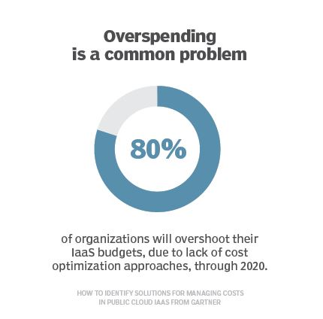

[Fig 1.2] Cloud overspend.

1.1.4 Reliability and scalability
Since 2019, at least 90% of companies are on the cloud and 60% of those are running on hosted cloud services [9]. With the increasing demand for cloud computing, the system used by organisations must be able to react and grow without losing the quality of service.

1.1.4.1 Scalability
Scalability in the cloud is not just about adding or removing resources, there are more adaptations of scalability that are just as important.
Cloud elasticity – This refers to how resources can be added or removed from the cloud service on demand. It needs to be seamless and allow access to the right amount of resources required.
Vertical scaling – upgrading a single resource, such as storage space to a server without the need to shut down the system.
Horizontal scaling – building out a system by adding additional components. This process can ensure the service provided to an organisation is reliable and available. This can be achieved by adding processing power or memory to the server utilised by the organisation and linking additional servers to it without causing to much stress on the system.
Auto scaling – cloud providers such as Amazon Web Service provide auto-scaling as an option, which allows consistent performance without taking into account the demand on resources.
There are several benefits to implementing a scaling strategy:
- Convenient – increase and decrease storage as needed.
- Flexible and fast – limits delays in service when adapting to changing demands.
- Cost-effective – reduces the need for hardware or office space to store it
- Fault-tolerant – data can be scaled to assist redundancies and to aid recovery.
- Time-saving – organisations do not need to upgrade system software or replace older hardware. It can also free up time spent on fixing errors and other issues.

1.1.4.2 Reliability
Reliability of the cloud service is very important to organisations, as trust in the consistency of the operations is paramount. Unfortunately, no system is 100% reliable, but with proper planning and notifications, faults can be addressed much quicker and with little disruption as possible.
Measures need to be put in place so that:
- Downtime is kept to a minimum.
- Products and services remain available.
- Redundant resources start automatically if the system experiences a fault.
- Workers remain unaware that something has gone wrong to keep work rate up.
Some of the issues that organisations can have with cloud services, can be attributed to cloud service users themselves. But in cases where it is the provider who is at fault, service level agreements are provided stating that reasonable effort will me made to deliver 99.9% uptime. If this is not met the business involved may receive a service credit [10] [11].

1.1.4.3 The importance of scalability and reliability
Scalability and reliability are just two components, that once combined will create a cloud computing service that has high availability. This means that the products and services that are supplied to a business will be accessible at anytime and anywhere. Functionality will be reliable, and the system will scale to the demands of the business, without loss in performance.

2. Virtual machines and Containers
The top two approaches for improving scalability, reduce costs and deploying software across multiple machines are containers and virtual machines (VMs). Both of those approaches are computer software that can build self-contained virtual packages., but here is where the similarity ends. The following points will highlight the differences between VMs and containers:
Virtual Machines
- Measured in gigabyte.
- Contain their own operating system.
- Hardware is virtualised to run multiple functions / operating systems at once.
- VMs can abstract, spilt, duplicate and emulate entire servers, operating systems, desktops, databases and networks.
- Requires hypervisor to sperate resources from the physical drive so they can be partitioned and dedicated to VMs.
- Requires significant RAM and CPU power.
- Moving VMs between clouds can be difficult.
- Possibility to update apps and operating system without disturbing user involvement.

Containers
- Measured in megabyte.
- Holds a microservice or app and everything it needs to run.
- Provides a way to run isolated systems on a single server or host OS.
- Only take seconds to run, due to the small memory size.
- Containers sit on top of a physical server.
- Portable across multiple environments.
- Containers virtualize an operating system so that multiple workloads can run on a single operating system.
- Designed to run on same OS. Containers based on different operating systems will need a different host.
- Due to the operating system being shared, security threats in the kernel is a danger to all containers in the host computer. [12] [13] [14]

2.1 Adoption of Docker
Docker is a containerization platform, which lets developers wrap applications into containers and by adopting Docker, makes the process simpler, safer and more manageable. Docker’s increase in popularity is down to the features and the containerization technology within it, and as of 2020 it has received 105 billion container downloads and still increasing. From a 2018 article based on docker, evidence showed that companies with more hosts were more likely to adopt docker [Fig 1.3]. 47% had employed Docker with a host levels of over 1000, compared to 19% with less than 100 hosts.

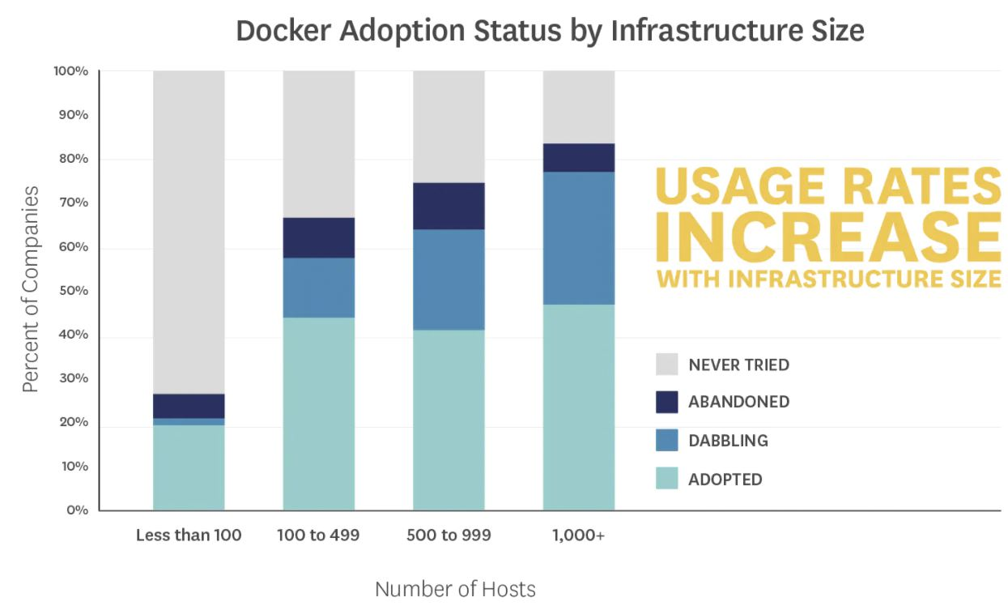

[Fig 1.3] Adoption of docker based on infrastructure size [15].

As mentioned in previous chapters of this report, Docker uses containerization to virtualize the operating system, and containers have become more efficient than hypervisor systems. Instead of virtualizing hardware, containers sit on top of a single Linux instance, which creates a small vessel containing the application. Therefore, most of the components that make up the virtual machine is left behind. Docker can easily be transferred allowing portability, due to the lightweight and self-sufficient container.
Docker is also extremely flexible when it comes to the cloud, as the container can be moved from one cloud vendor to another. This will give the organisation more choice on which vendors to deal with when choosing the cloud infrastructure [15] [16] [17] [18].
The adoption of docker has continued to surge, mainly for the development of its own customised container which enables the following:
- Improved and seamless portability – Docker containers do not need modifications to run on any desktop and cloud environment.
- Lighter weight and more granular updates – Only one procedure can run in each container, this allows the user to build an application that can continue to run, while a section is taken down for an update or repair.
- Automated container creation – Docker can automatically build a container based on application source code.
- Container versioning – Gives options to roll back to a previous container or to track a container. Information of who built the version and how can also be provided.
- Container reuse – Existing containers can be used as templates for building new containers.
- Shared container libraries – Developers can access an open-source registry containing thousands of user-contributed containers [16].

3. Process of producing node.js applications
Node.js allows the programmer to write server-side applications and is lightweight, efficient and has the ability to use JavaScript on both frontend and backend development. Node.js utilises push technology over websockets, which allows web applications to possess real-time and two-way connections. Both the client and server can commence communication, allowing for the data to exchange openly.
Node package manager is a tool that comes with Node.js installations and contains reusable components (modules) that can aid the developer in creating wrappers, web and service applications and many more.
To create a Node.js application and utilise Docker, the following procedures need to be carried out to ensure success of a comprehensible code.
Firstly, as developers it is important that Node.js and npm are both installed, npm generally needs a separate installation through command prompt or Git Bash. The developer should create two directories: nodewebserver and nodewebservice, and within the working directory, package.json needs to be created. This is achieved by using the npm init command.
When this command is executed, questions will appear that require answers, but this can be done through default answers. Modules will also need to be installed, which will be stored in the package.json file. These dependencies are required for production and development purposes. The most useful npm module to employ is express.js, which is the standard development framework for node.js applications. Express validator will be installed within the webservice directory required for validating requests.
With docker installed, a dockerfile needs to be included as this text document that contains all the commands a developer could call on to assemble an image. For setup purposes docker-compose and .dockerignore also need to be downloaded.
Within the root directory, a tsconfig file will be added to specify the root files and the compiler options that are required to compile the project. A tsconfig file was also included in the webservice folder along with package.json. Extra development tools were also needed such as nodemon, a tool that enables the restart automation when file changes occur and npm-run-all, a tool to run multiple scripts in parallel or sequential. Typescript is also installed to deliver extra layers of syntax and transcompiles to standard JavaScript, allowing scripts to run on all browsers.
When setup is complete the creation of an express object needs to take place and given a port number to start the service app. A lambda function can be used to notify the developer that service has started.
Within the package.json, commands need to be added to compile the typescript file and run the service. Build, Run and Start code need to be added to the scripts function to ensure the functionality of the service is employed.
To add routes and to process data, a service.ts file was created. This file will include the port number, imported express functionality and a callback message. This is initiated with the npm run start command. Once this file is operational, express will invoke HTTP methods such as GET, POST and DELETE. Functions which can then be added are included with two arguments, Request and Response. Request is the incoming HTTP data and Response is the outgoing response used to send data back to the requestor.
When adding data that will populate the database, within the service.ts file the POST method will be used.
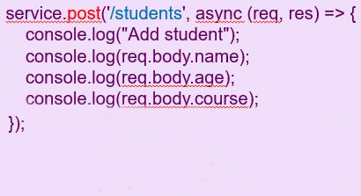
It is then possible to test this function via software such as Postman, which gives the option of inputting data and sending it back to the webservice as a Response.
To run the webservice and database functions, docker must be running, by entering docker-compose up in the command prompt. It will be evident that docker is functioning successfully, as the last loaded line will indicate the service is listening and on which port.
Building on to the webserver functionality, a similar process to creating the webservice is used.Package.js and other npm commands are installed into the webserver folder to commence operations. Inside the webserver folder, a newly created server.ts file will be available to include all server side content. This content is generally for static web pages such as css, images or js files.
The inclusion of Ajax code can be used to allow features that is unavailable in other applications. Ajax is chosen because a developer can:
- Update web pages without reloading the page.
- Read data from web server, after the page has loaded.
- Send data to a web server, in the background. [19]

With successful setup of the webserver and webservice functions, communication with HTTP would issue a code based on the success of a clients requests made to the server. If success was guaranteed a code of 200-299 would be given, if service errors or server errors occurred, then a code of 400-499 or 500-599 was displayed to the developer.

References

[1] | HOW IT WORKS TEAM, “Cloud storage:What is it and how does it work?,” 25 Apr 2019. [Online]. Available: https://www.howitworksdaily.com/cloud-storage-what-is-it-and-how-does-it-work/#:~:text=Cloud%20storage%20involves%20stashing%20data,on%20their%20own%20hard%20drives.. [Accessed 20 Mar 2021].
[2] | teQwise, “Why is cloud computing so important?,” 3 Apr 2018. [Online]. Available: https://www.teqwise.com/news/why-is-cloud-computing-so-important-2/. [Accessed 27 Mar 2021].
[3] | Microsoft, “What is cloud computing?,” 2021. [Online]. Available: https://azure.microsoft.com/en-in/overview/what-is-cloud-computing/#benefits. [Accessed 27 Mar 2021].
[4] | G. Suciu, F. Puuican, A. Apostu and et.al, “Study on advantages and disadvantages of Cloud Computing - the advantages of Telemetry Applications in the Cloud,” Bucharest, 2013.
[5] | S. Ward, “The Disadvantages of Cloud Computing,” 20 Nov 2019. [Online]. Available: https://www.thebalancesmb.com/disadvantages-of-cloud-computing-4067218. [Accessed 20 Mar 2021].
[6] | M. Chan, “How to calculate the true cost cloud migration,” 2 Feb 2017. [Online]. Available: https://www.networkworld.com/article/3164444/how-to-calculate-the-true-cost-of-migrating-to-the-cloud.html. [Accessed 13 Apr 2021].
[7] | Google, “Google Cloud pricing calculator,” 20 Apr 2021. [Online]. Available: https://cloud.google.com/products/calculator/. [Accessed 21 Apr 2021].
[8] | L. Rosencrance, “Breaking down the cost of Cloud Computing,” 16 Nov 2020. [Online]. Available: https://whatis.techtarget.com/Breaking-Down-the-Cost-of-Cloud-Computing. [Accessed 18 Apr 2021].
[9] | N. Gavlov, “25 must-know cloud computing statistics in 2020,” 4 Dec 2020. [Online]. Available: https://hostingtribunal.com/blog/cloud-computing-statistics/#gref. [Accessed 12 Apr 2021].
[10] | Lucid Content Team, “Cloud computing 101: the interrelationship of scalability, reliability and availability,” 2021. [Online]. Available: https://www.lucidchart.com/blog/reliability-availability-in-cloud-computing. [Accessed 20 Apr 2021].
[11] | CloudHealth, “How Reliable is Cloud Computing?,” 16 Oct 2018. [Online]. Available: https://www.cloudhealthtech.com/blog/how-reliable-is-cloud-computing. [Accessed 20 Apr 2021].
[12] | D. Chamberlain, “Containers vs Virtual Machines,” 16 Mar 2018. [Online]. Available: https://blog.netapp.com/blogs/containers-vs-vms/#:~:text=Virtual%20machines%20and%20containers%20differ,to%20run%20multiple%20OS%20instances.. [Accessed 21 Apr 2021].
[13] | Red Hat, “Containers vs VMs,” 2021. [Online]. Available: https://www.redhat.com/en/topics/containers/containers-vs-vms. [Accessed 21 Apr 2021].
[14] | A. Strong, “Containerization vs Virtualization: Whats the difference?,” 1 Nov 2019. [Online]. Available: https://www.burwood.com/blog-archive/containerization-vs-virtualization. [Accessed 21 Apr 2021].
[15] | DataDog, “8 Surprising Facts about Real Docker Adoption,” Jun 2018. [Online]. Available: https://www.datadoghq.com/docker-adoption/#:~:text=Docker%20Usage%20Rates%20Increase&text=That%20trend%20holds%20true%20today,are%20currently%20dabbling%20with%20Docker.. [Accessed 22 Apr 2021].
[16] | IBM, “Docker,” 6 Jan 2020. [Online]. Available: https://www.ibm.com/cloud/learn/docker. [Accessed 22 Apr 2021].
[17] | S. Vaughan-Nichols, “What is Docker and why is it so darn popular?,” 21 Mar 2018. [Online]. Available: https://www.zdnet.com/article/what-is-docker-and-why-is-it-so-darn-popular/. [Accessed 22 Apr 2021].
[18] | J. St-Cyr, “Are Docker and Kubernetes the right fit for my team?,” 2021. [Online]. Available: https://www.sitecore.com/knowledge-center/getting-started/should-my-team-adopt-docker. [Accessed 22 Apr 2021].
[19] | W3 schools, “Ajax introduction,” 2021. [Online]. Available: https://www.w3schools.com/js/js_ajax_intro.asp. [Accessed 28 Apr 2021].

