Describe the main themes depicted in the Mappa Mundi Hereford and briefly describe the map’s purpose as a manuscript in medieval times.

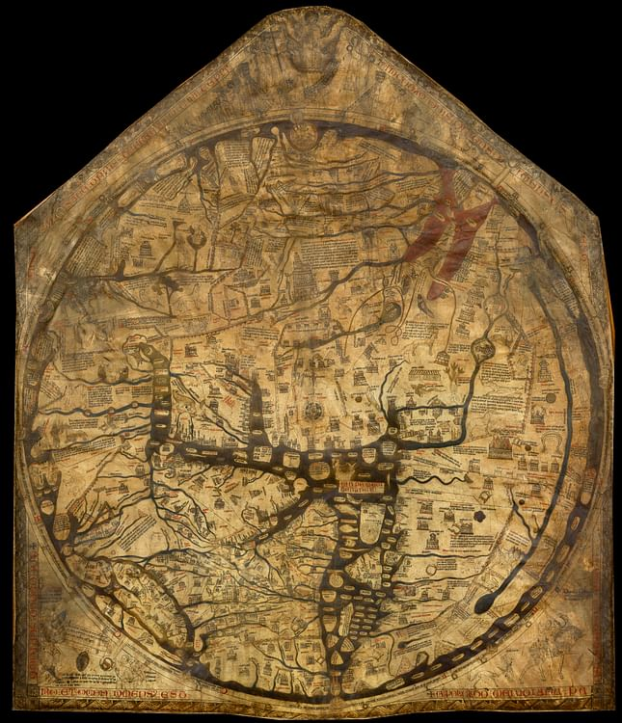
The Mappa Mundi from Hereford Cathedral Herefordshire

The Mappa Mundi (meaning in Latin, cloth of the world), found in Hereford Cathedral, was drawn between 1290 and 1310 and is widely thought to have been in Hereford since that time. There are many smaller Mappae Mundi, mainly found in books and most are of a much simpler style but the Hereford Mappa Mundi is the largest known surviving medieval map of the world. It was drawn on vellum (calf skin) amounting to approximately 5ft high by 4ft wide and although it is now various shades of mainly brown and black with some red, it would have been vibrant with colour when first drawn. It was mostly drawn using black ink but there would have been gold leaf and red used for emphasis. It was nearly sold in 1989 to raise money for renovations but after a public outcry it was saved and is now housed in a special building along with a medieval chained library, also a rarity. The Mappa Mundi has been described by Bednarski as ’far from being a purely cartographic work is, as we will see, a hybrid, multimedia text with complex ideological and visual underpinnings’. This essay will describe the main themes demonstrated on the world map and it will discuss the theories behind its purpose within the cathedral.
The circular map drawn using the traditional T-O method, demonstrates the three known inhabited continents of the northern hemisphere. Asia in the top half with Europe to the left bottom and Africa to the right, although the map is transcribed in gold lettering as Africa over Europe and vice versa. This appears to be a mistake but it is thought by most to be intentional, either demonstrating that Africa was part of Europe or, as Arrowsmith states, ‘the reversed golden display lettering symbolising the true and un-mirrored vision of spiritual enlightenment.’ Furthermore, East is to the top of the map, Jerusalem in the middle as a circle and Britain is in the bottom left corner. All this appears incongruous to the modern eye but Mappae Mundi were not drawn to be navigational charts and their functions were to illustrate various principles. By the time of drawing of the Mappa Mundi, it was well known in educated circles that the world was a sphere. The circled world would have been drawn first (the compass hole can be seen on the original wooden framework to which the map was fixed, known as a triptych) and an artist would have drafted the coastlines, rivers, places, beasts and people leaving space for the 1,000 texts. The rivers and seas would have been coloured blue and green with red for the red sea. A second artist would have added the cities in the form of buildings which are drawn with some accuracy and with some emphasis on the more important areas at that particular time for example Lincoln where the map is thought to have been drawn or at least copied and the relatively newly built Conway and Caernarvon castles. Aswell as towns and buildings, the geographers illustrated other aspects of God’s world by depicting twelve different types of winds representing the weather and seasons with pictures and texts, thus demonstrating the living world as understood by the medieval citizens.
As well as demonstration of geographical knowledge, the map has many biblical references although Harvey states ‘the bible contributes less than we might expect to what is shown on the Hereford Map’. At the apex of the map with the world at his feet, is Christ (showing his wounds of crucifixion) sitting with saints to his right, awaiting entry to heaven and sinners to his left, about to enter the gates of hell on the Day of Judgement. The circle of Jerusalem is quite common on other Mappae Mundi and may have been drawn as a direct reference to a verse in Ezekiel 5.5 ‘Thus saith the Lord God: This is Jerusalem. I have set it in the midst of nations and countries that are round about her.’ An image of the crucifixion is just above Jerusalem, much worn either by fingers touching, pointing or kissing,(the image of Hereford also has the same type of wear). It is suggested that lay persons copied behaviour shown by people in authority, so the touching of Jesus on the cross may have been mimicking the priests who used the map to teach.
There are only few other references to the New Testament except a few cities that may have been visited by St Paul. Beyond Palestine, according to Harvey, the events depicted are mainly from the books of Genesis and Exodus. The Garden of Eden at the eastern edge of the map and a very prominent Noah’s Ark which may give reference to the T-O element of the map as God granted Noah’s three sons the continents of Asia, Africa and Europe, The Tower of Babylon and Sodom and Gomorrah are also given some precedence. The Exodus of the Israelites and their passage through the red sea to the promised land is represented with drawings along their route. The head of Moses is depicted with horns, a common misinterpretation from medieval time which originated from a mistranslation by Vulgates, of Moses descending the mount following his meeting with God. There are some illustrations of early Christian history for example, Alexander the Great and Colussus of Rhodes to name a few but it is felt that biblical instruction was not the chief illustrator’s main project. Mythical stories for example, Jason and the Golden Fleece and even Glastonbury and South Cadbury in Britain, the supposed site of Camelot were also included.
The writing on the map is mainly in Latin with some Anglo Norman texts which most likely would have been directed at the educated community. The bottom left corner of the map depicts Emperor Augustus giving a scroll to three named surveyors saying they are to measure the world. Below this, written in Anglo Norman, is a verse asking for prayers for the map maker named Richard of Holdingham. In this verse the map is named as an ‘estorie’ meaning ‘a history’ which again gives credence to the theory that it was to be used as a teaching aid. To the bottom right is depicted a huntsman on horseback looking back saying ‘Passe avant’ (go ahead) There is much discussion about what this picture is describing, perhaps it is to symbolise life’s journey and gods purpose which ties in with the surround of the map where the four letters MORS (in Latin means Death)are written and is a reminder to the readers that despite the intriguing and exciting wonders illustrated, their destiny is inevitable.
There are monsters and strange creatures displayed on the map mostly around the exterior edge with ten monstrous races from Africa who are also depicted. These strange people include Marmini who have four eyes and Blemmyes who have no heads but mouths and eyes in their chests. They were thought to be well known to the medieval people possibly through story telling from travellers and from carved corbels in churches and cathedrals. Many of the animals, although exotic and not native to Britain, would have been heard of although some were not accurately drawn as they probably had never been seen by the illustrator.
There is much debate on why the Mappa Mundi was commissioned and sited in Hereford and its purpose. One theory is that Richard of Swinfield, (Bishop of Hereford,1282-1317) who originated from Lincoln, moved to Hereford having copied an original Mappa Mundi that has since been lost. The map then may have been adapted to include some local influences which explains why relatively seemingly unimportant local areas in terms of world history were included. Valerie Flint put forward another theory suggesting that Hereford wanted to demonstrate its reputation as a cathedral by having a status symbol which the Mappa Mundi would have provided. She also suggested that it may have been produced in order to aid Richard of Swinfield’s campaign to have Thomas Cantilupe (Bishop of Hereford 1275-82) canonised. They had been close friends and Richard had been with Thomas when he died in Normandy bringing back his bones and heart as relics. This quest may have been helped by having a large Mappa Mundi placed by his tomb or behind the alter as an alterpiece. Again there has been much discussion about where it was originally placed but no definitive answer has yet been given and the theories continue to be put forward. As there was much emphasis on the subject of the Exodus in the map this could also have highlighted the importance of pilgrimage to Thomas Cantilupe’s tomb. Almost certainly, the map would have been used as a teaching aid as monastic and Cathedral schools taught, using large maps for geography but it may also have been used as a teaching aid to preaching and an object of contemplation. Harvey also suggested that the texts were there for those that could read and the pictures were for the illiterate but it meant that the learning was taking place in a pious environment.

The Mappa Mundi as has been described above, provided a wealth of information in the subjects of geography, ancient and Christian history, mythology general knowledge and as quoted by Arrowsmith ‘it is a world where history and geography ,time and space, destiny and creation come together under one divine scheme.’ There has been much speculation and discussion over where and precisely when it was made but there is minimal evidence available and none at all as to why it was produced although there are many theories. Discussions will no doubt continue but as Thomas de Wesselow has stated ’Whatever its precise purpose, it was evidently designed to amaze and impress.

BIBLIOGRAPHY

Arrowsmith, Sarah, Mappa Mundi. Hereford’s Curious Map , (Eardisley: Logaston Press,(2015),
Bedarski,Alexander, ‘ (Post-)industrial optics: The role of the Hereford Mappa Mundi in Christopher Meredith’s Shifts’, ORBIS Litterarum, 78.6 (2023) p.483-498.[accessed 19 November 2023]
Biblical Archeology Society, The Horns of Moses(2023)< http://www.biblicalarchaeology.org/the horns of moses>[accessed 19 November 2023].
Flint, Valerie, ’The Hereford Map: Its Author(s), Two Scenes, and a Border’, Transactions of the Royal Historical Society,Vol 8, (1998), p.19-44,[accessed 20 November 2023
Harvey,P.D.A, Mappa Mundi. The Hereford World Map,Hereford: Hereford Cathedral, (2010),
Rudy, Kathryn, How medieval users handled their manuscripts, <htps://www.youtube.com/how medieval users handled their manuscripts |Professor Kathryn Rudy, Inaugural lecture>[accessed 19 October 2023]
Stirling, John, The Bible. Revised Standard Version , Ezekiel chapter 5 verse 5 ( Great Britain: Collins Clear-type Press,1952)
The History Notes, The Mappa Mundi on Show Again (2011) < https://www.the-history-notes.blogspot.com/2011/06/hereford-mappa-mundi-on-show-again>[accessed 19November 2023]
de Wesselow,Thomas, ‘Locating the Hereford Mappamundi’ Imago Mundi, Vol.65, part 2,(2013), (p.180-206) [accessed 20 November 2023]
Wikipedia, Hereford Mappa Mundi (2023) ,<http://www.wikipedia.org/Hereford Mappa Mundi > [accessed 19 November 2023]

The History Notes, The Mappa Mundi on Show Again (2011) < https://www.the-history-notes.blogspot.com/2011/06/hereford-mappa-mundi-on-show-again>[accessed 19November 2023]
Sarah Arrowsmith, Hereford’s Curious map,(Eardisley: Logaston Press,2015), p.1-3
P.D.A.Harvey, Mappa Mundi. The Hereford World Map, (Hereford: Hereford Cathedral, 2010), p.9-11
The History Notes, The Mappa Mundi on Show Again (2011)
Alexander Bedarski,’ (Post-)industrial optics: The role of the Hereford Mappa Mundi in Christopher Meredith’s Shifts’, ORBIS Litterarum, 78.6 (2023) 483-498.[accessed 19 November 2023]
lbid
Sarah Arrowsmith, Mappa Mundi. Hereford’s Curious Map, p.6.
Wikipedia, Hereford Mappa Mundi (2023) ,<http://www.wikipedia.org/Hereford Mappa Mundi > [accessed 19 November 2023]
Arrowsmith, Mappa Mundi. Hereford’s Curious Map, p.10
P.D.A.Harvey, Mappa Mundi. The Hereford World Map, (2010) p.25
lbid
Arrowsmith, Mappa Mundi. Hereford’s Curious Map, p.4
Arrowsmith, Mappa Mundi. Hereford’s Curious Map, p.13-14
Harvey, Mappa Mundi. The Hereford World Map, p.67
John Stirling, The Bible. Revised Standard Version , Ezekiel chapter 5 verse 5 ( Great Britain: Collins Clear-type Press,1952)
Kathryn Rudy, How medieval users handled their manuscripts, <htps://www.youtube.com/how medieval users handled their manuscripts |Professor Kathryn Rudy, Inaugural lecture>[accessed 19 October 2023]
Harvey, Mappa Mundi. The Hereford World Map, p.15
Biblical Archeology Society, The Horns of Moses(2023)< http://www.biblicalarchaeology.org/the horns of moses>[accessed 19 November 2023].
Harvey, Mappa Mundi. The Hereford World Map, p.84
Harvey, Mappa Mundi. The Hereford World Map, p.27
Arrowsmith, Mappa Mundi. Hereford’s Curious Map, p.1
Arrowsmith, Mappa Mundi. Hereford’s Curious Map, p.43
Arrowsmith, Mappa Mundi. Hereford’s Curious Map, p.8
Valerie Flint, ’The Hereford Map: Its Author(s), Two Scenes, and a Border’, Transactions of the Royal Historical Society,Vol 8, (1998), p.19-44, p.34[accessed 20 November 2023]
Harvey, Mappa Mundi. The Hereford World Map, p.28
lbid
Arrowsmith, Mappa Mundi. Hereford’s Curious Map, p.13
Harvey, Mappa Mundi. The Hereford World Map, p.33
Thomas de Wesselow, ‘Locating the Hereford Mappamundi’ Imago Mundi, Vol.65, part 2,(2013), (p.180-206) (p.180) [accessed 20 November 2023]

