Contents
Introduction 1
Burj Khalifa – Detail 1
Construction to the Burj Khalifa 2
Burj Khalifa – Construction method 3
Burj Khalifa – Environmental impact 4
Burj Khalifa – Original design 4
Empire state building - Detail 5
Empire state building – Original design 5
Empire state building – Environmental impact 5
Comparing and contrasting concrete and steel frame 6
Durability and climate resistance 8
Production 10
References 11

Introduction
Throughout our own research, select two existing buildings from around the world, one being concrete frame and the other steel frame. The concrete frame building I have decided to do my research on is the Burj Khalifa. As for the steel, the building I have decided on this as the Empire State building. During my report I will be covering the detail of their original design planning, construction method and potential in consideration of social and environmental sustainability at the site of the build.

Burj Khalifa – Detail
Formerly known as Burj Dubai or Dubai Tower, which was changed to Burj Khalifa when the tower officially opened on January 4th 2010. Construction projects in Dubai were once on the verge of halting due to the attack of Financial Crisis, it

was only because Abu Dhabi provided funds to Dubai in the hard time, this is the main reason for Dubai to rename the tower Burj Khalifa.
https://thetowerinfo.com/buildings-list/burj-khalifa/
The architectural height of Burj Khalifa is 828 meters or 2717 feet, this is measured to the top of the spire, as its spire is considered an architectural element of the tower. Before 2010, Burj Khalifa's height had long been kept as a secret to prevent it from being surpassed by potential competitors.
https://thetowerinfo.com/buildings-list/burj-khalifa/
With the building of the tower, it has attracted plenty of job opportunities, revenue to the city and tourist attraction worldwide. One massive benefit of the tower was that it kept a lot of the population in employment. A rise in tourist coming to the city as fanatics of the building as it being one of the most iconic engineering known to man.
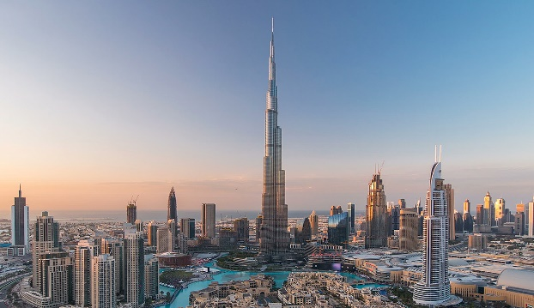 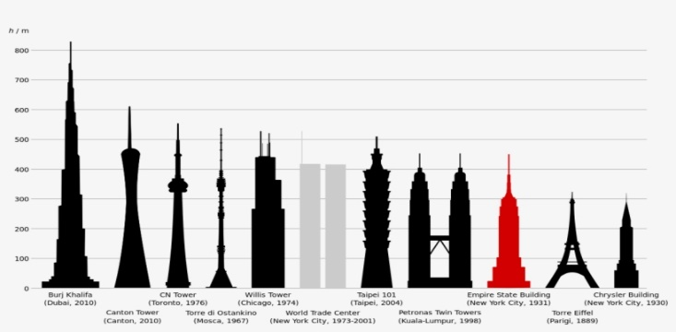Google images Google images
Burj Khalifa holds the following records:
- Tallest building in the world
- Tallest free-standing structure in the world
- Highest number of stories in the world
- Highest occupied floor in the worl
- Highest outdoor observation deck in the world
- Elevator with the longest travel distance in the world
https://www.burjkhalifa.ae/en/the-tower/facts-figures/

Construction to the Burj Khalifa
- Excavation started - January 2004
- Piling started - February 2004
- Superstructure started - March 2005
- Level 50 - June 2006
- Level 100- January 2007
- Level 110 - March 2007
- Level 120 - April 2007
- Level 130 - May 2007
- Level 141 - (world’s tallest building) July 2007
- Level 150 (world’s tallest free-standing structure) - September 2007
- Level 160 (world’s tallest man-made structure) - April 2008
- Completion of spire pipe jacking & Burj Khalifa tops out - January 2009
- Cladding completed - September 2009
- Grand inauguration - January 4, 2010

https://www.burjkhalifa.ae/en/the-tower/design-construction/

Burj Khalifa retains a record-breaking 330,000 cubic m (11.6 million cubic ft) of concrete, 39,000 m/t of reinforced steel, 103,000 square m (1.1 million square ft) of glass, 15,500 square m (166,800 square ft) of embossed stainless steel, and the tower took 22-million-man hours to build.

https://www.burjkhalifa.ae/img/FACT-SHEET.pdf
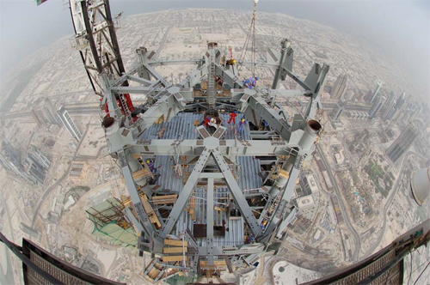 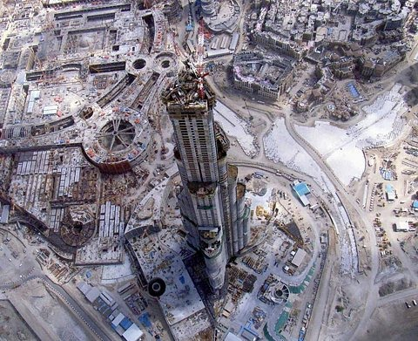Google images Google images
In addition to its aesthetic and functional advantages, the spiralling “Y” shaped plan was utilised to shape the structural core of Burj Khalifa. This design helps to reduce the wind forces on the tower, as well as to keep the structure simple and enhance ‘constructability’.
https://www.burjkhalifa.ae/img/FACT-SHEET.pdf

Burj Khalifa – Construction method
Designers intentionally constructed the structural concrete in Burj Dubai as "Y" shaped in plan with the purpose of minimizing the effect of wind forces on the tower along with the intension to retain the structure simple and support constructability. The structural system is defined as a "buttressed" core. Every section contains its own high performance concrete corridor walls and perimeter columns and supports the others through a six-sided central core, or hexagonal hub. So, a tower is built with enormously rigid lateral and torsion capacity. An inflexible geometry is utilized with the tower that organized all the common central core, wall, and column elements. With the support of reinforced concrete structure, the building becomes stronger as compared to steel-frame skyscrapers.
https://www.linkedin.com/pulse/details-design-construction-process-burj-khalifa-g-k
The core walls vary in thickness from 1300mm to 500mm. The core walls are typically linked through a series of 800mm to 1100mm deep reinforced concrete or composite link beams at every level. The utilization of high strength concrete and concrete technologies was critical in the constriction of the project.
https://global.ctbuh.org/resources/papers/download/1301-brief-on-the-construction-planning-of-the-burj-dubai-project-dubai-uae.pdf
Table below is a summary of types of concrete used for both the vertical and horizontal members.
Level | Concrete grade
Level | Vertical | Horizontal
L154~L156 | C60/14 | C50/20
L101~L126 | C80/14 | C50/20
B2~L101 | C80A/20 | C50/20
https://global.ctbuh.org/resources/papers/download/1301-brief-on-the-construction-planning-of-the-burj-dubai-project-dubai-uae.pdf

Burj Khalifa – Environmental impact
Taking all of this into account, we must also consider the environmental consequences of this structure which took six years to build. The project’s designers claim that the building and its planned botanical gardens and series of man-made lakes were designed to be as environmentally sustainable as possible, when one considers that Dubai is located in a part of the world that has very scanty rainfall and some of the hottest summers on the planet. It was constructed to withstand the extreme temperature ranges of this Persian Gulf city-state, where external temperatures during the summer can average more than 50 degrees. Another possibly favourable ecological “by-product” of the massive edifice is the large amount of water produced by condensation and so far collected from the air

conditioning systems used to keep the entire structure pleasantly cool (estimated at around 15,000 litres).
https://www.greenprophet.com/2010/01/burj-dubai-environment/

Burj Khalifa – Original design
In develpoing the intiail concept for Burj khalifa, Adrian Smith (architect for builiding the Burj Khalifa, photo shown below) searched for elements within the exsisting context and culture of the area to reflect on and draw the inspiration from. Within the middle east and in Dubai, there are strong influences of onion domes and pointed arches, and there are patterns that are ethnic to the region, some of which are flower like with three elements, others with six and so on.
https://global.ctbuh.org/resources/papers/download/462-burj-dubai-designing-the-worlds-tallest.pdf
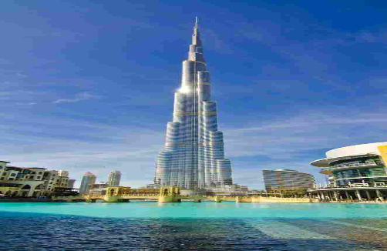 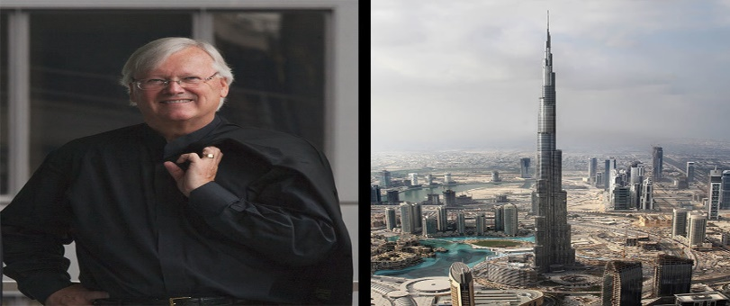google images google images

Empire state building - Detail
In 1930 Construction of the Empire State Building begins on March 17. Occupying a central spot on Fifth Avenue, it is to be the world’s first 100+ story building. With the direction of architects Shreve, Lamb & Harmon Associates and builders Starrett Bros

& Eken, the framework rises 4 ½ stories per week. Empire state building was completed in a record-breaking 1 year and 45 days.
https://www.esbnyc.com/about/history

Empire state building – Original design
Raskob and his partners purchased the 34th street parcel of property in 1929 for $16 million and quickly hired architect William F. Lamb, of the firm Shreve, Lamb and Harmon, who completed their original drawings for the Empire State Building in just two weeks. The logic of Lamb’s plans was simple. He organised the space in the centre of the building as compactly as possible containing vertical circulation, toilets, shafts and corridors, and as the height of the building increased, the size of the floors and number of elevators decreased.

Empire state building – Environmental impact
- Reducing Loads: The building’s 6,500 double pane insulating windows were removed and rebuilt to include a third layer of glass and a reflective film. Heat loss through windows is reduced to a third of previous, and solar heat gain is cut in half.

- Efficient Technology: Because of the reduced cooling load (solar gain reduction and reduced lighting), a smaller air-conditioning plant is required. This meant that energy-efficient developments could be made to the existing equipment, rather than replacing it.

- Controls: State-of-the art digital monitoring and control of building systems will be used. Sensors will automatically monitor the need for fresh air, reducing heating and cooling loads by reducing the amount of fresh air brought into the building to only that which is necessary.

In addition to cost savings and greatly reduced pollution and greenhouse gas emissions attributable to the building, the renovation will deliver an enhanced environment for tenants, including improved air quality, better lighting conditions, and superior thermal comfort resulting from better windows, more efficient radiators, and individual controls.
http://www.greeneducationfoundation.org/green-building-program-sub/case-studies/895-empire-state-building.html#:~:text=In%20addition%20to%20cost%20savings,from%20better%20windows%2C%20more%20efficient
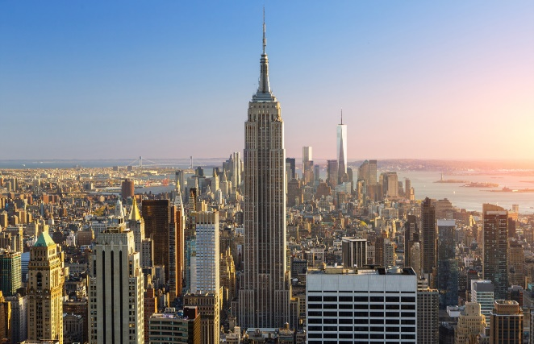 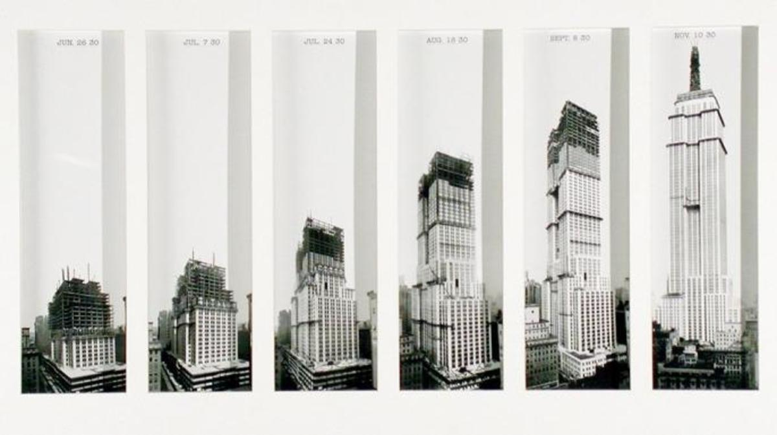Google image Google image

Comparing and contrasting concrete and steel frame
Cost
Structural Steel: A large majority of all steel manufactured today comes from recycled materials. This recycling usage makes the material much cheaper when compared to other materials. Although the price of steel can fluctuate, it typically remains a less expensive option compared to reinforced concrete.
Concrete: A large cost benefit to concrete is the fact that its price remains relatively consistent. On the other hand, concrete also requires ongoing maintenance and repairs, meaning added costs throughout its lifetime.

Strength
Structural Steel: Structural steel is extremely strong, stiff, tough, and ductile, making it one of the leading materials used in commercial and industrial building construction.
Concrete: Concrete is a composite material consisting of cement, sand, gravel and water. It has a relatively high compressive strength, however it lacks tensile strength. Concrete must be reinforced with steel rebar to increase a structure’s tensile capacity, ductility and elasticity.
Fire resistance
Structural Steel: Steel is inherently a non-combustible material. However, when heated to extreme temperatures, strength can be significantly compromised.
Concrete: The composition of concrete makes it naturally fire resistant and in line with all International Building Codes. When concrete is used for building construction, many of the other components used in construction are not fire resistant.
Sustainability
Structural Steel: Structural steel is nearly 100% recyclable as well as 90% of all Structural Steel used today is created from recycled steel. Due to its long lifespan, steel can be used as well as adapted multiple times with little to no compromise to its structural integrity. When manufactured, fabricated and treated properly, structural steel will have a minimal impact on the environment.
Concrete: The elements within concrete are natural to our environment, reducing the harm to our world. Concrete may be crushed and used in future mixtures. This type of recycling can reduce a presence of concrete in landfills.

Versatility
Structural Steel: Steel is a flexible material that can be fabricated into a wide array of designs for endless applications. The strength to weight ratio of steel is much higher when compared to other affordable building materials. Steel also offers many different aesthetic options that different materials.
Concrete: Although concrete can be moulded into many different shapes, it does face some limitations when it comes to floor-to-floor construction heights and long, open spans.
Corrosion
Structural Steel: Steel may corrode when it encounters water. If left without proper care, it could affect the safety and security of a structure.
Concrete: With proper construction and care, reinforced concrete is water resistant and will not corrode. However, it is important to note that the steel reinforcement inside should never be exposed. If exposed, the steel becomes compromised and can easily corrode, compromising the strength of the structure.
https://blog.swantonweld.com/steel-vs.-concrete-which-comes-out-on-top

Durability and climate resistance
Burj Khalifa
While durability is important for almost any concrete structure, it is certainly an issue where the world’s tallest building is concerned. At 828 meters high, Burj Khalifa

Tower in Dubai must be supported by a base of 192 piles descending more than 50 meters underground. This foundation is exposed to harsh groundwater. As the
building designers looked for materials that would help Burj Khalifa achieve a 100-year service life, they chose MCI-2005 out of several products evaluated for use in the substructure. MCI-2005 would give the substructure added protection from its exposure to extreme chlorides in the groundwater, increasing the service life of this critical foundation, and in turn helping to sustain the rest of the tower. By using MCI-2005 in severe environments like those surrounding Burj Khalifa, buildings will have a stronger resistance to corrosion and therefore possess greater durability. Increased durability will mean fewer repairs, greater structural integrity, and a longer service life, all leading to a more sustainable structure with the use of MCI.
https://www.forconstructionpros.com/concrete/equipment-products/rebar-accessories-equipment/article/12283920/durability-the-cornerstone-of-sustainable-construction#:~:text=While%20durability%20is%20important%20for,more%20than%2050%20meters%20underground.
With the Burj Khalifa being so high from the ground, ultimately the wind would be a massive issue. When wind swirls around a building it forms small whirl winds called vortices. These alternating pockets of air pressure create forces on the building that can cause it to rock from side to side. The higher you go up the building, there are 27 different shapes and each of them will generate slightly different vortices to the ones above or below so you are never getting large forces of wind on the building as they are always coming off at different rates, so the wind never really gets organised and this is a tactic known as ‘confusing the wind’.
https://www.youtube.com/watch?v=UIYzc1ALhVY&t=78s

Empire state building
Skyscrapers constructed after the 1930s were made of concrete reinforced with steel, as opposed to just steel, which gave them the tensile strength of steel and the compressive strength of rock. They can resist both stretching and squeezing forces.
The earliest steel skyscrapers, like the Empire State Building, which date from the 1930s are least likely to remain standing in 7,000 years because they are constructed almost exclusively of steel, meaning they have exceptional tensile strength but are quite rigid and inflexible.

https://www.punctualabstract.com/2018/11/14/skyscraper/#:~:text=The%20earliest%20steel%20skyscrapers%2C%20like,are%20quite%20rigid%20and%20inflexible.
Thanks to a scrupulously well-planned retrofit, the owners of the Empire State Building have been able to reduce the structure’s emissions by 40% over the last decade. They are now determined to cut emissions a further 40% by 2030, an ambition borne forward, in part, by the conviction that the building must remain what it has always been.
Completed in 2010, the Empire State Building’s US$31.1 million deep energy retrofit has been a rousing success. In addition to slashing emissions, the retrofits are saving $4 million annually on electricity, and expectations are that the project will “pay for itself twice over”.

Production

Concrete
1 Extraction
Materials are extracted / quarried / recovered and transported to the cement plant.
2 Crushing and milling
The raw materials, limestone, shale, silica and iron oxide are crushed and milled into fine powders.
3 Mixing and preheating
The powders are blended (the ‘raw meal’) and preheated to around 900° C using the hot gases from the kiln. The preheating burns off the impurities.
4 Heating
Next the material is burned in a large rotary kiln at 1500° C. Heating starts the de-carbonation where CO2 is driven from the limestone. The partially fused resulting is known as clinker. A modern kiln can produce around 6000 tons of clinker a day.
CaCO3 (limestone) + heat -> CaO (lime) + CO2
5 Cooling and final grinding
The clinker is then cooled and ground to a fine powder in a tube or ball mill. A ball mill is a rotating drum filled with steel balls of different sizes (depending on the desired fineness of the cement) that crush and grind the clinker. Gypsum is added during the grinding process to provide means for controlling the setting of the cement.
The cement is bagged transported for concrete production.
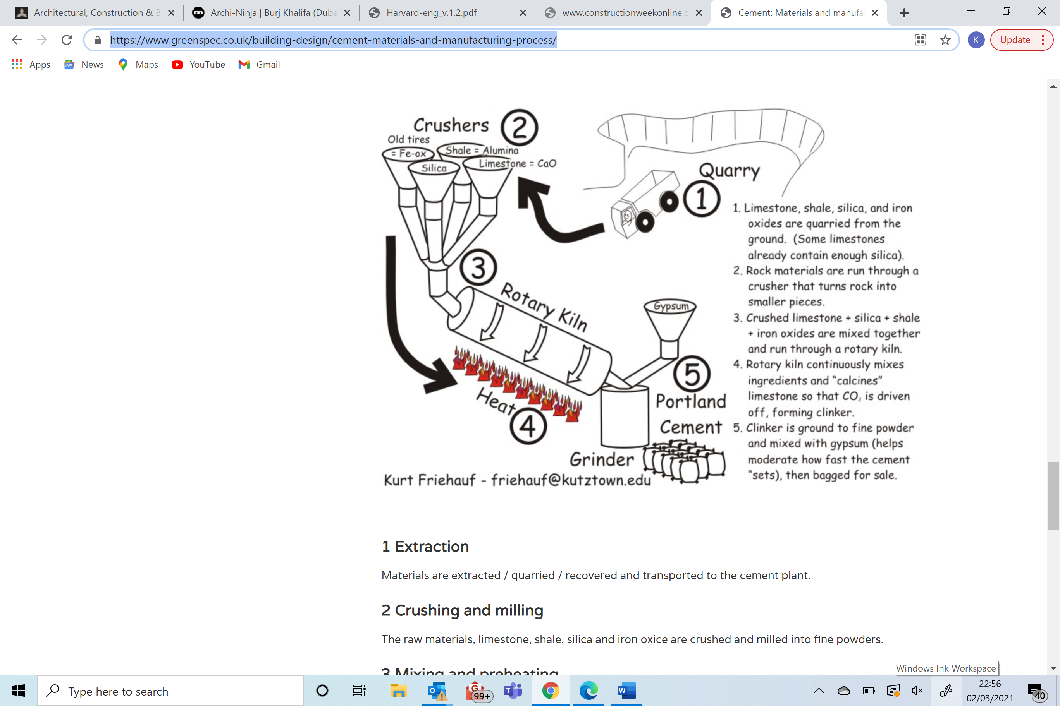
https://www.greenspec.co.uk/building-design/cement-materials-and-manufacturing-process/
Steel
- First, the raw iron ore is crushed and sorted. There are several different refining processes, all designed to sort out the best grades of iron, usually around 60 percent.
- Ore is the loaded into a blast furnace from the top and heated, while hot air is blown into the furnace from the bottom. The reaction that takes place begins to remove impurities as pure iron sinks to the bottom of the furnace.
- The molten iron is drawn off and is further heated to allow the inclusion of other substances, such as manganese, that deliver different properties to the finished steel product.
Once the steel has been created, it is formed into several different configurations, depending on how it will be used.

References
- Burj-khalifa, buildings-list available at thetowerinfo (2021)
- Burj-khalifa, buildings-list available at thetowerinfo (2021)

- Facts figures, the tower, available at Burjkhalifa.ae

- Design construction, the tower, available at burjkhalifa.ae

- Fact sheet, image, available at burjkhalifa.ae

- Fact sheet, image, available at burjkhalifa.ae

- Abdelrazaq, Ahmed, 2008, CTBUH 2008 9th World Congress, Dubai

- Abdelrazaq, Ahmed, 2008, CTBUH 2008 9th World Congress, Dubai

- Burj Dubai environment, 2010, available at greenprophet.com

- Abdelrazaq, Ahmed, 2008, CTBUH 2008 9th World Congress, Dubai

- Steel vs concrete, Swanton Welding 2020, available at Swanton Welding.com

- Steel vs concrete, Swanton Welding 2020, available at Swanton Welding.com

- cement-materials-and-manufacturing-process, building design, available at greenspec.co.uk

Burj-khalifa, buildings-list available at thetowerinfo (2021)
Burj-khalifa, buildings-list available at thetowerinfo (2021)
Facts figures, the tower, available at Burjkhalifa.ae
Design construction, the tower, available at burjkhalifa.ae
Fact sheet, image, available at burjkhalifa.ae
Fact sheet, image, available at burjkhalifa.ae
Abdelrazaq, Ahmed, 2008, CTBUH 2008 9th World Congress, Dubai
Abdelrazaq, Ahmed, 2008, CTBUH 2008 9th World Congress, Dubai
Burj Dubai environment, 2010, available at greenprophet.com
Abdelrazaq, Ahmed, 2008, CTBUH 2008 9th World Congress, Dubai
Steel vs concrete, Swanton Welding 2020, available at Swanton Welding.com
cement-materials-and-manufacturing-process, building design, available at greenspec.co.uk

