Cycle 1 Professional and Pedagogic Studies: Leading the Learning: what, how and why am I teaching?

The foundation phase is a unique concept for Wales based on the fact that early years learning should be a solid foundation of future learning through a suitable curriculum for Wales. The foundation phase contains 7 areas of learning that are spread out over a range of topics. These areas are Personal and Social Development, Well-being and Cultural Diversity Language, Literacy and Communication skills, Mathematical Development, Welsh Language Development, Knowledge and Understanding of the World, Physical Development and Creative Development. The basis of the foundation phase is pupil centred, meaning the pupils are at the focal point of the learning environment and they should be allowed the freedom to lead their own learning experiences. This is done through the creative freedom of play, where pupils succeed the most through experimental learning. This is backed up by the Welsh Assembly Government as they believe that “Children learn through first‐hand experiential activities with the serious business of ‘play’ providing the vehicle. Through their play, children practise and consolidate their learning, play with ideas, experiment, take risks, solve problems, and make decisions individually, in small and in large groups. (WAG, 2008, p. 4)”.
Curriculum reform has been an essential step towards improving education in wales. This is due to the importance now being placed on young people having access to the necessary skills they will require in future employment to allow them to have a successful future. The curriculum will consist of 4 core purposes; ambitious capable learners, enterprising creative contributors, ethnical informed citizen and healthy confident individuals. These will be the core and aspirations of and for the school’s own curriculum and will allow the schools to fully support their learners in a localised manner. The curriculum reform in Wales is a response to research findings and a general dissatisfaction with the level of accountability, the narrowing of learning, lack of autonomy and stifling of creativity within our education system. Professor Donaldson visited over 60 schools initially and listened to the voice of the profession, children, young people, businesses and the community. Teachers voiced that they wanted to “have more power to make decisions about how to teach and what to teach within the curriculum” (Donaldson, 2015). He also considered Estyn reports, government policies and documents and independent reviews and hence the Successful Futures document was born.
Following the Great Debate, “A Curriculum for Wales – A Curriculum for Life” was published and pioneer schools were established in order to pilot different approaches to its implementation. This also allowed a period of consultation for the profession and an opportunity for teachers themselves to work on the four core purposes and six areas of learning. Teachers were able to refine “What’s Matter” statements and develop key progression steps in learning. Over the course of the past 5 years, the development of the reform has been monitored, evaluated and refined and has moved forward. The Government published the “Education in Wales:Our National Mission” in 2017 which quite clearly instils in learners the ambition to reach their potential and the need for them to acquire the skills to live in an ever changing world. These changes have ultimately resulted in the new Curriculum for Wales which will be statutory for all learners in September 2022.

The foundation phase pedagogic principle ‘good teaching and learning means a blend of approaches including direct teaching’, is in my opinion, going to be very effective towards a young person’s learning journey as it will ensure all learners needs are me. Poon (2013) agrees with me as she believes that blended learning can ‘influence students' perceptions of the learning environment and, subsequently, their study experiences, learning outcomes, and ultimate academic achievement’. There are many different teaching methods that can be used daily. For examples, direct teaching, kinaesthetic learning, differentiated instruction, game-based learning etc. These are the main methods of teaching and learning that I used during my time on teaching practice. I used direct teaching during my experience and the children were comfortable with this method of teaching. This would mainly be used during the introduction and teaching of the lesson but would normally be avoided during the activity part. The style of direct teaching I used was the ‘Personal Model’ style. This was effective for the children because they could see me leading by example, therefore they could model my actions and perfect the skill they were learning. This approach was highly effective for the majority of the class, but on the other hand, it did not have such a positive effect on the lower ability children as they would not always engage with the lesson, and therefore not be able to interpret instructions and fully understand what is required of them.
Another teaching and learning method I used was kinaesthetic learning. This method is a hands-on approach, that involved in this instance creativity and movement through a physical learning environment. For example, during my teaching practice, the children were given an activity to complete which required them to build towers out of blocks. They were instructed to complete this task in pairs, and one tower must be 1 block taller than the other. They were given a tray full of blocks and had to complete the activity independently without the consistent support of the teacher. This allowed the children to gain social skills through partner work. This is important as Dewey, (1938) believes that “learning is a social activity - it is something we do together, in interaction with each other, rather than an abstract concept”. Problem solving also allowed them creative freedom to build the tower and high or as wide as they liked. This had a positive effect on the class, and it engaged every child and allowed them to take control of their own learning. Montessori (1946) agrees with me, as she believes that ‘the hand is the instrument of intelligence. The child needs to manipulate objects and to gain experience by touching and handling.’
I also used a game-based learning method during my practice through the form of an enhanced activity. This game was also related to the current theme and encouraged the pupils to enjoy and learn cohesively. Froebel (1912) believes that “play is the highest expression of human development in childhood for it alone is the free expression of what is in a child's soul”. The game involved developing physical skills by throwing bean bags into different sized buckets. It also developed mathematical and literacy skills by having pupils match the right coloured bean bag to the same coloured bucket. The pupils would then have to count how many bean bags they had in each bucket and record them into a table. This had an extremely positive effect on the pupils, as they were all extremely enthusiastic to complete this activity. The role of the More Knowledgeable Other (Vygotsky, 1978) is key for this activity as it encourages the pupils to help each other and check each other's work to ensure it is correctly completed. This would allow the more able pupils to become MKO’s and correct other pupil’s work.
During my time of teaching practise, I differentiated between 3 groups in a year group. These were lower ability consisting of one pupil, middle ability consisting of most of the year group, and higher ability consisting of two pupils. During lessons I would use the method of differentiated instruction to allow the needs of every level of child to be met consistently. Each level of differentiation would meet the same learning objective but there would be different types of activities for each ability. For example, during a maths lesson regarding 3D shapes I explained to the class that they would have to test if a shape could roll or not and record their answers. For the lower ability pupil, I gave her a sheet with images of 3D shapes and the names of the shapes, and she was asked to match them together. For the middle ability pupils, I instructed them to test if shapes rolled or not and they would have to write the name of the shape next to the image using a word bank and also write if the shape rolled or not. For the higher ability group, they were asked to do the same activity as the middle group but also write examples of each shape underneath.

The foundation phase pedagogic principle ‘good teaching and learning ranges within and across areas of learning and experience’ can be a useful tool during teaching and learning. Barnes (2015) agrees with this as he believes that ‘when the skills, knowledge and attitudes of a number of different disciplines are applied to a single experience, problem, question, theme or idea, we are working in a cross-curricular way’. This is used to blend different areas of the curriculum together for the children to grasp a wider range of knowledge. It is also sometimes inevitable to teach cross-curriculum as some topic allow a wide range of areas to be involved in the lesson. For example, during my teaching practice I taught a lesson of PE, where the children were learning different types of animal movement. This linked to topic work the children had been learning during their language lesson, so they could associate the movements with the animals they had already gained knowledge about. This was positive as it engaged the children vastly and allowed them to ask more detailed questions regarding the movements. They also used their previous knowledge and experiences to create a sequence of movements that suited the style of each animal. This is backed up by “building on prior pupil knowledge and looking forward to the next steps in the curriculum, cross and extra-curricular links made explicit, practical teaching activities to teach testing and application of knowledge and problem solving” (Siraj and Taggart, 2014). I also believe that informing the children that the lesson is cross-curriculum can gain benefits as they will be aware of the type of learning they will be part-taking in.

The foundation phase pedagogic principle ‘good teaching and learning sets tasks and selects resources that build on previous knowledge and experience and engage interest’ in my opinion, is a strong principle that should be considered for every lesson taught as it increases children’s knowledge and understanding and engages them vastly. Phillips (1995) agrees with this as he believes “This prior knowledge influences what new or modified knowledge an individual will construct from new learning experiences”. During my professional teaching practice (PTE) I followed a scheme that encouraged the principle of building on previous knowledge and experience. For example, during my Welsh lessons I used the same resources for each lesson as it provided the children with familiarity and engaged them highly. The children knew the subject they were going to be gaining more knowledge about and got excited when the resources were brought out for use during the activity. This is due to the children beginning to rise into the concrete operational stage (Piaget, 1936), as they associate the resources with an enjoyable lesson, they recall having days before. Another example of the principle is using the same task or subject to build on previous knowledge by teaching the same topic for the whole week. During my practice, I taught 3D shapes every day for a week, with the results showing that at the end of the week, the children had a far greater knowledge of the subject matter. I continued this learning into the next week by setting up an enhanced provision task for the children to complete independently, drawing on their built-up knowledge to help them complete the task. By this stage I had a sound understanding of each child’s level of understanding and was able to build upon this, thus sustaining the interest and motivation of every child.
During planning I would model a planning sheet given to me by the class teacher. This would be the basis of every lesson and the learning objectives would be taken from the foundation phase framework. This framework consists of 7 areas of learning, with many elements and aspects within. It was implemented to meet the diverse needs of all children and provided steady progression throughout its four-year span. Going forwards, children were granted the freedom to take control of their own learning. This was done through pupil voice, by asking the children what they want to learn about and what their interests were, then during planning, tailoring the lesson objectives towards those interests. Pupil voice has an extremely positive impact on the child’s learning as it encourages engagement and promotes positivity towards the lessons. ESTYN (2015) agrees with this as they believe that “pupil participation and building positive relationships are an integral part of the school’s vision and ethos”. An example of pupil voice that I witnessed during my PTE was that the pupils got to choose between themselves, which animals they would like to put into the tufty tray for an enhance activity. This engaged all the pupils to find out more about animals that were linked to their topic.
On the other hand, there are also challenges that arise to this pedagogical principle as there are a number of difficulties such as, is it challenging enough, appealing enough to the whole class, meeting the learning objective, appropriate to the curriculum and if it can be used long term. To make it sufficiently challenging, teachers must be able to differentiate between at least three groups per year group if appropriate in order to ensure all children are progressing. To appeal to all the class, I witnessed the use of the ‘genius hour’ model (see appendix 1) during my PTE. This could be an excellent way to engage all children and encourage participation of work that appeals to every individual. To meet the learning objective of the lesson, the class teacher would only need to ensure that the skill is the central focus, and not the context. The context could suit the need of the child. To make the topics appropriate to the curriculum, the teacher would have to provide links to six areas of learning and the four core purposes.
An example of a planning model used during my PTE is for Mathematical Development, there is a general pedagogy used for the class, followed by the lesson objectives, then the lesson plan. The lesson is split into four sections; warm up, introduction, activity and plenary. This is consistent for each day/week. I used this model during my planning because it was consistent for the children to learn from as they were already use to it and it was suitable to my teaching style as I liked to teach the introduction at one place in the classroom, then move to another place for the children to complete the activity.
The new Curriculum for Wales is without doubt based on the experiential learning model. Pupil’s learning is essentially placed within authentic contexts in order to make learning meaningful and relevant. It is a far cry from the hugely teacher lead and directed model which has been prevalent in our schools for so long and which has without doubt excluded and demotivated so many learners. This new curriculum is primarily based on the acquisition of skills and a blended learning approach. The twelve identified pedagogical principles enable teachers to identify the ways in which pupils best learn and in doing so meet their need on an individual and a group basis. It has the potential to engage all learners and fire imagination and a love for learning. However, this is challenged by some; “although the students may become more engaged, they may not actually learn enough to thrive in this complex world that they're coming in to” (William, 2019).
This approach is richly experimental at this stage and does not come without its challenges. The most significant of these challenges is probably its implementation. Some teachers will find fear in the lack of restraint and boundaries which have been the driving force in the National Curriculum. Enabling pupils to lead their own learning whilst still maintaining focus and a clear understanding of learning undertaken and understood is unchartered territory for many. It will be a leap of faith and require a determination on the part of the profession to make this succeed for all our learners.
Overall, I believe that the three pedagogical principles discussed and utilised in my practice, when used appropriately, successfully engage and motivate learners to progress through their early learning journey. The pedagogical principle ‘good teaching and learning sets tasks and selects resources that build on previous knowledge and experience and engage interest’ caters for the needs and abilities of all learners, sustaining motivation levels through the course of each lesson. The pedagogic principle ‘good teaching and learning ranges within and across areas of learning and experience’ can lead to a broader understanding of subject knowledge and ultimately, allow children to maximise their potential. The pedagogic principle ‘good teaching and learning means a blend of approaches including direct teaching’ has a positive impact on teaching and learning as it means that every child benefits from an approach which suits their learning style.
The new curriculum for Wales is a skills-based approach to learning which is going to allow pupils to lead their learning and teachers the autonomy to decide how best their pupils learn.

Appendix 1
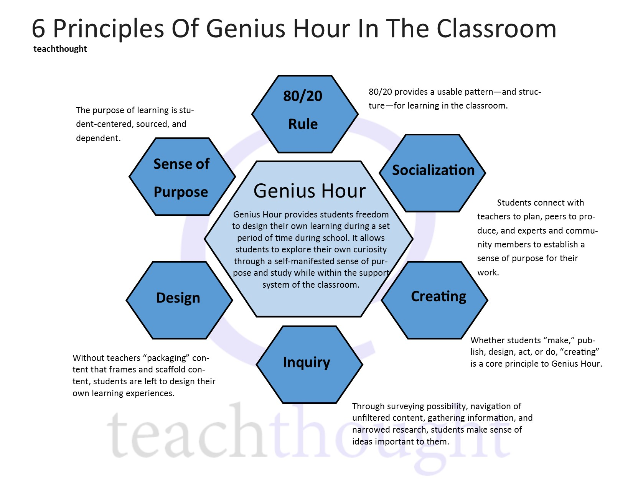

References
Barnes, J., 2015. Cross-curricular learning 3-14. Sage. Pg 11.
Byrne, R (2017) The Benefits of Cross-Curricular Learning. Accessed on March 25th 2020. Available at https://www.kidsdiscover.com/teacherresources/the-benefits-of-cross-curricular-learning/
Chery (2019), The Concrete Operational Stage of Cognitive Development. Accessed 25th March. Available at https://www.verywellmind.com/concrete-operational-stage-of-cognitive-development-2795458
ESTYN (2015), Pupil participation: a best practice guide. Accessed 26th March 2020. Available at https://www.estyn.gov.wales/sites/www.estyn.gov.wales/files/documents/Pupil%20participation_0.pdf
Friedrich Fröbel (1912). “Froebel's Chief Writings on Education”
Heick, T (2019) 6 Principles Of Genius Hour In The Classroom. Accessed 26th March 2020. Available at https://www.teachthought.com/learning/6-principles-of-genius-hour-in-the-classroom/
https://hwb.gov.wales/curriculum-for-wales/introduction
https://teach.com/what/teachers-know/teaching-methods/
Maria Montessori (1946). The 1946 London Lectures, Volume 17 of Montessori series, Published in 2012.
McLeod (2019). Constructivism as a theory for teaching and learning. Accessed 25th March 2020. Available at https://www.simplypsychology.org/constructivism.html
Phillips, D.C., 1995. The good, the bad, and the ugly: The many faces of constructivism. Educational researcher, 24(7), pp.5-12.
Poon, Joanna 2013, Blended learning: an institutional approach for enhancing students' learning experiences, Journal of online learning and teaching, vol. 9, no. 2, pp. 271-288. Available at: http://dro.deakin.edu.au/eserv/DU:30057995/poon-blendedlearning-2013.pdf Accessed 24th March 2019.
Siraj, I. & Taggart, B. (2014). Exploring Effective Pedagogy in Primary Schools: Evidence from Research. London: Pearson. Pg 16.
Successful Futures (2015). Looking at the Curriculum and Assessment Arrangements in Wales, A summary of Professor Graham Donaldson’s report. Accessed on 24th March 2020. Available at https://gov.wales/sites/default/files/publications/2018-03/succesful-futures-a-summary-of-professor-graham-donaldsons-report.pdf
WAG [Welsh Assembly Government] (2008) Foundation phase: framework for children's learning for 3 to 7‐year olds in Wales (Cardiff, Welsh Assembly Government), Pg 4.
Welsh Government (2015) Curriculum for Wales: Foundation Phase Framework (2015) Accessed on March 25th 2020. Available at https://hwb.gov.wales/storage/d5d8e39c-b534-40cb-a3f5-7e2e126d8077/foundation-phase-framework.pdf
William, D (2019) Wales' new curriculum. Accessed 26th March 2020. Available at https://www.bbc.co.uk/news/uk-wales-48677436

