UNIVERSITY OF WALES TRINITY SAINT DAVID

LCDB7011 – Quantitative Research Methods
The Operational and Psychological Impacts of Inter-Visit Travel Time on Community Care Staff:
Evidence from UK Community Care Organisations
Student Name: Aklima Begum

Student ID: 2503750

Programme: Doctor of Business Administration (DBA)
Module: Quantitative Research Methods
Main-text word count: approximately 7,331 words

Contents
1. Introduction 4
1.1 Background and Context 4
1.2 Research Problem and Gap 6
1.3 Research Aim 6
1.4 Research Objectives 7
1.5 Research Questions 7
1.6 Research Hypotheses 7
1.7 Significance of the Study 8
2. Critical Literature Review 8
2.1 Community and Domiciliary Care as a Distinctive Work Environment 8
2.2 Inter-Visit Travel and Travel-Time Pressure 9
2.3 Job Demands, Time Pressure and Work-Related Burnout 10
2.4 Burnout and Turnover Intention 12
2.5 The Job Demands–Resources Framework 13
2.6 Critical Synthesis and Research Gap 14
2.7 Conceptual Framework and Hypothesis Development 15
3. Methodology 16
3.1 Research Philosophy 16
3.2 Research Approach 16
3.3 Research Design 16
3.4 Population and Unit of Analysis 17
3.5 Data Source 17
3.6 Variables and Measurement 18
3.6.1 Inter-Visit Travel-Time Pressure 18
3.6.2 Work-Related Burnout 18
3.6.3 Turnover Intention 18
3.7 Additional Variables 19
3.8 Sample Size 19
3.9 Data Analysis Strategy 19
3.10 Reliability, Validity and Bias 20
3.11 Ethical Considerations 20
3.12 Methodological Limitations 21
4. Results 21
4.1 Introduction 21
4.2 Sample Characteristics and Descriptive Statistics 21
4.3 Reliability Analysis 23
4.4 Normality Assessment 23
4.5 Hypothesis Testing 23
4.5.1 H1: Travel-Time Pressure and Burnout 24
4.5.2 H2: Burnout and Turnover Intention 24
4.5.3 H3: Travel-Time Pressure and Turnover Intention 24
4.6 Regression Analysis 24
4.7 Supplementary Analyses 25
4.8 Summary of Results 25
5. Discussion 26
5.1 Overview of the Main Findings 26
5.2 Inter-Visit Travel-Time Pressure and Burnout 26
5.3 Burnout and Turnover Intention 27
5.4 Why Was H3 Not Supported? 28
5.5 Interpretation Through the JD-R Framework 29
5.6 Practical and Managerial Implications 29
5.7 Critical Interpretation 30
6. Conclusion and Recommendations 30
6.1 Conclusion 30
6.2 Practical and Managerial Recommendations 31
6.3 Limitations 31
6.4 Future Research 32
6.5 Contribution of the Study 32
References 33
Appendix A: Proposed Questionnaire for Future Empirical Data Collection 35
Participant Information 35
Section A: Eligibility and Participant Profile 35
Section B: Work and Inter-Visit Travel Characteristics 36
Section C: Inter-Visit Travel-Time Pressure 37
Section D: Work-Related Burnout 38
Section E: Turnover Intention 38
Appendix B: SPSS Reliability Analysis 39
Appendix C: Normality Test 42
Appendix D: Correlation Analysis 42
Appendix E: Regression Analysis 43
Appendix F: One-Way ANOVA 44
Appendix G: Independent-Samples t-Test 45

1. Introduction

1.1 Background and Context
Adult social care is a substantial component of health and social care provision in England, supporting individuals who require assistance to maintain independence and quality of life within their own homes and communities. Domiciliary care forms an important part of this system because care workers frequently deliver support across multiple service-user locations during the same working day. This creates working conditions that differ considerably from those experienced in fixed-site residential care. In addition to providing direct care, domiciliary care workers must repeatedly travel between service users while working within predetermined visit schedules.
Workforce sustainability remains a significant challenge within adult social care. Skills for Care estimated that the overall turnover rate across adult social care was 23.1% in 2024/25, representing approximately 335,000 leavers. Domiciliary care recorded a turnover rate of 22.2%, while care workers themselves experienced particularly high turnover. Domiciliary care services also recorded a vacancy rate of 9.7%, the highest among the main care-service categories (Skills for Care, 2025). These figures demonstrate that recruitment and retention remain important strategic concerns despite recent improvements in overall workforce stability.
The nature of domiciliary care may create distinctive operational pressures that contribute to these workforce challenges. Unlike employees based in a single workplace, community care workers may need to complete several journeys during one shift while maintaining scheduled arrival times. Transportation is therefore part of the working environment rather than simply the means through which employees commute to work. Recent research examining home-care workers' experiences of transportation found that travelling between service users could generate additional time pressure, stress and occupational-health challenges, particularly where travel conditions were unpredictable (Liaset et al., 2024).
This distinction between travel duration and travel-time pressure is important. A relatively long journey does not necessarily create pressure when sufficient time is allocated between visits. Conversely, even a short journey can become demanding when the scheduled interval is inadequate, traffic or parking conditions are unpredictable, or workers feel compelled to shorten one activity to arrive at the next visit on time. Inter-visit travel-time pressure can therefore be understood as an organisational job demand arising from the relationship between actual travel requirements and the time available to meet those requirements.
These operational pressures may have psychological and organisational consequences. Burnout is particularly relevant because sustained job demands can contribute to physical and emotional exhaustion. The Job Demands–Resources (JD-R) perspective provides a useful theoretical explanation for this relationship, proposing that persistent job demands consume employees' psychological and physical resources and can contribute to an energy-depletion or health-impairment process. Within domiciliary care, repeated pressure to move between service users while maintaining demanding schedules may therefore contribute to work-related burnout (Bakker, Demerouti and Sanz-Vergel, 2023).
The organisational implications extend beyond employee wellbeing. Retention remains a major concern within social care, and contemporary workforce evidence indicates that working arrangements and wellbeing are relevant to employees' decisions to remain in their roles. The Department of Health and Social Care's Adult Social Care Workforce Survey identified working patterns, travel costs or distance, and feeling burnt out or stressed among reported reasons for employees leaving domiciliary care settings (Department of Health and Social Care, 2025b). More broadly, Skills for Care identifies workforce burnout as a significant retention concern and reports that workers travelling greater distances to work have higher turnover rates (Skills for Care, 2025).
However, commuting distance and inter-visit travel represent different phenomena. The latter occurs repeatedly during the working day and is embedded directly within care scheduling and service delivery. Existing research provides evidence concerning transportation experiences, workload, burnout and workforce retention, but comparatively limited quantitative evidence integrates these issues to examine whether perceived inter-visit travel-time pressure is associated with work-related burnout and turnover intention among community care workers.
This creates an important research problem for community care organisations. If travel-time pressure represents a significant job demand associated with employee burnout and withdrawal intentions, workforce wellbeing and retention may not be addressed adequately through individual resilience interventions alone. Organisational practices concerning scheduling, journey-time allocation, visit planning and workforce management may also require consideration. Examining these relationships quantitatively can therefore contribute to both workforce-management knowledge and managerial practice within community care.

1.2 Research Problem and Gap
Existing research shows that domiciliary care workers face particular challenges arising from travel between service-user visits and tightly organised schedules. Although previous studies have considered working conditions, workforce pressures and staff retention in adult social care, less attention has been given to the pressures created specifically by the journeys between consecutive home-care visits. In particular, quantitative evidence remains limited on whether these travel-related pressures are associated with care workers’ burnout and their intentions to leave their organisation.
The present study addresses this gap by bringing these constructs together within a single quantitative framework. Rather than treating travel simply as journey duration, the research focuses on perceived inter-visit travel-time pressure, reflecting the extent to which workers experience inadequate time, scheduling pressure and travel-related difficulty when moving between consecutive service-user visits.

1.3 Research Aim
The aim of this study is to examine the relationships between inter-visit travel-time pressure, work-related burnout and turnover intention among community care workers in the UK.

1.4 Research Objectives
- To assess the level of perceived inter-visit travel-time pressure experienced by community care workers.
- To examine the relationship between inter-visit travel-time pressure and work-related burnout.
- To investigate the relationship between work-related burnout and turnover intention.
- To determine whether inter-visit travel-time pressure is associated with turnover intention.

1.5 Research Questions
RQ1: What level of inter-visit travel-time pressure is experienced by community care workers?
RQ2: What relationship exists between inter-visit travel-time pressure and work-related burnout?
RQ3: What relationship exists between work-related burnout and turnover intention?
RQ4: What relationship exists between inter-visit travel-time pressure and turnover intention?

1.6 Research Hypotheses
H1: Inter-visit travel-time pressure is positively associated with work-related burnout among community care workers.
H2: Work-related burnout is positively associated with turnover intention among community care workers.
H3: Inter-visit travel-time pressure is positively associated with turnover intention among community care workers.

1.7 Significance of the Study
The study has both academic and practical significance. Academically, it connects an operational characteristic specific to community-based care delivery with psychological and workforce outcomes. Applying the JD-R perspective enables inter-visit travel-time pressure to be considered as a specific job demand rather than merely a logistical inconvenience.
Practically, understanding these relationships may help community care organisations identify whether workforce wellbeing and retention difficulties are associated with aspects of scheduling and travel management. The findings may therefore inform managerial consideration of realistic journey-time allocation, scheduling practices, employee wellbeing and workforce-retention strategies.
The study is deliberately exploratory in scale. Quantitative analysis is undertaken using a small, simulated dataset of 30 cases for the purpose of examining the proposed relationships and demonstrating appropriate application and interpretation of quantitative techniques in SPSS. Consequently, findings are interpreted cautiously and are not presented as statistically representative of the entire UK community care workforce.

2. Critical Literature Review

2.1 Community and Domiciliary Care as a Distinctive Work Environment
Community and domiciliary care differ structurally from institutional forms of care because work is distributed across multiple service-user locations rather than delivered within a single workplace. Frontline workers must therefore combine direct care responsibilities with repeated travel, time-sensitive schedules and changing environmental conditions. These characteristics make transportation and scheduling integral components of the work itself rather than peripheral commuting activities.
The workforce context makes these working conditions particularly important. Recent evidence from England indicates that recruitment and retention remain substantial concerns within adult social care. The Department of Health and Social Care's Adult Social Care Workforce Survey found that 58.5% of responding domiciliary-care locations considered staff retention challenging, compared with 53.9% of residential-care locations. Domiciliary-care providers also reported greater difficulties with staff morale. Among reasons attributed to staff leaving were better working hours elsewhere, inflexible working patterns, travel cost or distance, and burnout or stress (Department of Health and Social Care, 2025b).
These findings indicate that retention cannot be understood solely as a pay issue. Although remuneration remains highly important, the organisation of work also appears relevant. This distinction is particularly significant in domiciliary care because workers' schedules involve geographical movement between service users. Consequently, operational decisions concerning visit allocation, journey time and scheduling potentially influence not only service efficiency but also employees' experience of work.
Nevertheless, national workforce statistics provide only partial insight into this issue. Skills for Care (2025) found that workers travelling longer distances to work tended to experience higher turnover rates. However, its analysis measured distance between workers' home addresses and employers' addresses and explicitly could not account for travel between individual care locations in domiciliary services. This represents an important measurement limitation because commuting to work and travelling repeatedly between service users during paid working activity are conceptually different phenomena.

2.2 Inter-Visit Travel and Travel-Time Pressure
Transportation is an unavoidable feature of most domiciliary-care work, yet historically it has received less attention than direct care activities. Recent research has begun to address this omission. Liaset et al. (2024) examined home-care workers' experiences of different modes of transportation and demonstrated that transportation conditions could have both positive and negative occupational-health consequences. Traffic congestion, parking difficulties, weather conditions and time spent preparing for journeys were among the factors that could increase stress and time pressure.
This study is particularly relevant because it treats transportation as part of the occupational environment rather than simply as movement between locations. However, its methodology also reveals an important limitation for the present research problem. Liaset et al. (2024) used focus-group interviews with only 14 home-care workers from a home-care unit in Trondheim, Norway. The qualitative design generated rich contextual understanding but cannot establish the magnitude of statistical relationships between transportation pressure and psychological outcomes. Its Norwegian context also limits direct transferability to the organisational and commissioning arrangements of UK domiciliary care.
The distinction between travel time and travel-time pressure is therefore important. Travel time represents the duration of a journey, whereas travel-time pressure concerns whether workers perceive the available time as sufficient for completing that journey while maintaining their scheduled responsibilities. Two employees may undertake identical 20-minute journeys but experience very different levels of pressure if one has 30 minutes available and the other has only 15 minutes.
Travel-time pressure may therefore arise through an interaction between journey requirements and organisational scheduling. Traffic congestion, parking difficulties and geographical distance may increase the required journey time, while tightly scheduled visits determine the time available. The resulting mismatch may create pressure to arrive late, reduce breaks or accelerate other activities.
This conceptualisation shifts the issue from transport logistics towards work design. Rather than asking simply whether community care workers travel long distances, the more relevant organisational question is whether travel requirements can realistically be accommodated within their working schedules.

2.3 Job Demands, Time Pressure and Work-Related Burnout
The psychological implications of travel-time pressure can be understood within the broader literature on job demands. Time pressure represents a demand because employees must mobilise additional physical or psychological effort to achieve required outcomes within constrained periods. Persistent exposure to such demands may progressively exhaust workers' resources.
Evidence from care-related occupations supports this relationship. Rahnfeld, Wendsche and Wegge (2023) conducted a prospective two-wave study of geriatric nurses and examined time pressure and social conflict as job demands alongside resources such as job control, supervisor support and person-organisation fit. Their results identified time pressure as an important job demand associated with exhaustion. Importantly, the prospective design provides stronger temporal evidence than a conventional cross-sectional survey because work characteristics and outcomes were assessed across two time points.
However, the study concerned geriatric nursing rather than domiciliary care and conceptualised general occupational time pressure rather than pressure arising specifically from inter-visit travel. This distinction matters because community-care workers face an additional geographical component: completing one care episode does not automatically place the worker at the location of the next one. Consequently, travel may represent a distinct source of time pressure that is insufficiently captured by general workload measures.
Burnout is relevant in this context because it represents more than temporary tiredness following a demanding shift. Work-related burnout concerns sustained physical and psychological exhaustion associated with work. In community care, repeated schedule pressure may accumulate across numerous visits and journeys, potentially reducing opportunities for recovery during the working day.
The relationship should nevertheless not be assumed to be deterministic. Travel-time pressure is unlikely to produce the same psychological outcome for every employee. Job control, supervisory support, workload, experience and other organisational resources may modify how workers respond to demanding schedules. Rahnfeld et al. (2023), for example, found evidence that resources such as job control and supervisor support could influence relationships involving time pressure and exhaustion. Therefore, travel-time pressure should be regarded as one potentially important job demand rather than a complete explanation of burnout.

2.4 Burnout and Turnover Intention
Turnover intention refers to an employee's conscious inclination or intention to leave an organisation or occupation. Although intention does not necessarily result in actual departure, it is an important workforce indicator because withdrawal decisions generally develop before employees leave.
A substantial body of healthcare research links burnout with turnover intention. Özkan's (2022) meta-analytic review combined 44 studies examining burnout and turnover intention among nurses and other healthcare employees. The analysis found meaningful relationships between burnout dimensions and turnover intention, with medium effects for several burnout dimensions. Meta-analysis provides stronger cumulative evidence than reliance on an individual study because results are synthesised across multiple samples.
More recent evidence continues to support this relationship. Zheng et al. (2024) examined the relationship between burnout and turnover intention among nurses and identified close connections between elements of burnout and intentions to leave. Although nursing differs from domiciliary care, such findings support the broader proposition that sustained psychological strain can have workforce consequences.
Evidence specifically involving home-care workers is particularly valuable. Hung and Chiu (2023), in a cross-sectional study of 285 home-care aides found that lower work-related burnout was associated with greater intention to stay, alongside employment and job-related factors. This provides more contextually relevant support for linking burnout with workforce retention. However, the research was conducted in Taiwan, meaning that employment arrangements, funding structures and labour-market conditions differ from those of UK community care.
Similarly, Lee and Oh (2023), using data from 998 home-care workers, found that working conditions and occupational hazards were related to stress and turnover intention. The relatively large sample and regression-based analysis strengthen the quantitative evidence that organisational conditions matter for workforce outcomes. Yet this research was conducted within the Korean long-term-care system and did not isolate inter-visit travel-time pressure as the focal job demand.
These studies collectively suggest that burnout and turnover intention are connected, but they also illustrate an important contextual limitation in the evidence base. Much of the quantitative home-care evidence comes from non-UK systems, while UK evidence frequently operates at provider or sector level rather than directly testing worker-level relationships.

2.5 The Job Demands–Resources Framework
The Job Demands–Resources (JD-R) framework provides the theoretical basis for connecting the principal constructs in this study. The framework distinguishes between job demands, which require sustained physical or psychological effort, and job resources, which help employees achieve work objectives, manage demands or support development (Bakker, Demerouti and Sanz-Vergel, 2023).
Within the present research, inter-visit travel-time pressure is conceptualised as a job demand. Workers must expend effort to manage geographical movement, unpredictable traffic or parking conditions and scheduled arrival requirements while continuing to fulfil direct care responsibilities.
Work-related burnout represents the potential psychological strain associated with sustained exposure to this demand. Turnover intention subsequently represents a possible organisational withdrawal response.
The theoretical pathway can therefore be expressed as:
Inter-Visit Travel-Time Pressure → Work-Related Burnout → Turnover Intention
Rahnfeld et al. (2023) provide useful empirical support for this logic by demonstrating that time pressure was associated with exhaustion and that exhaustion predicted organisational and professional leaving intentions among geriatric nurses. Their findings also indicated indirect relationships between job demands and leaving intentions through exhaustion.
Nevertheless, the JD-R framework should not be applied mechanically. Community-care workers experience multiple simultaneous demands, including emotional labour, workload, client complexity, working hours and employment insecurity. Resources such as autonomy, supervisory support and collegial relationships may also buffer demands. The present study therefore does not claim that travel-time pressure is the sole cause of burnout or turnover intention. Instead, JD-R provides a theoretically defensible basis for examining travel-time pressure as one specific and comparatively under-examined operational demand.

2.6 Critical Synthesis and Research Gap
The reviewed evidence reveals three connected but incompletely integrated bodies of research.
First, home-care research demonstrates that transportation forms an important component of frontline working conditions. Recent qualitative evidence identifies traffic, parking, transportation mode and journey-related activities as potential sources of time pressure and stress. However, this literature provides limited quantitative evidence concerning the psychological consequences of specifically perceived inter-visit travel-time pressure.
Second, occupational and healthcare research provides stronger quantitative evidence linking time pressure and other job demands with exhaustion or burnout. Yet general measures of workload or time pressure may not capture the distinctive inter-visit geographical demands experienced by community-care workers.
Third, considerable evidence associates burnout with turnover intention. Evidence from home-care settings also suggests that working conditions and burnout are relevant to intentions to stay or leave. However, much of the quantitative evidence originates outside the UK, creating questions about contextual transferability.
A further limitation is visible within current UK workforce evidence. Skills for Care (2025) analyses travel distance in relation to turnover but acknowledges that its measure concerns travel from workers' homes to employers and cannot capture journeys between individual domiciliary-care locations. Provider-level government surveys similarly provide valuable evidence of recruitment and retention challenges but cannot substitute for worker-level analysis. The Department of Health and Social Care (2025b) explicitly acknowledges that provider perceptions of issues such as morale may differ from responses obtained directly from workers.
The research gap is therefore not an absence of studies concerning transportation, burnout or turnover. Rather, it concerns the limited integration of these constructs within worker-level quantitative research focused specifically on inter-visit travel-time pressure in community care.
The present study responds to this gap by quantitatively examining whether perceived inter-visit travel-time pressure is associated with work-related burnout and turnover intention. This narrower formulation avoids overstating originality while providing a clear empirical contribution appropriate to the study's scale.

2.7 Conceptual Framework and Hypothesis Development
Drawing on the reviewed evidence and JD-R framework, three relationships are proposed.
Time pressure has been identified as an occupational demand associated with exhaustion, while transportation research indicates that journeys between home-care visits can generate time pressure and stress. It is therefore proposed that:
H1: Inter-visit travel-time pressure is positively associated with work-related burnout among community care workers.
Evidence from healthcare and home-care research consistently associates burnout with intentions to leave or reduced intentions to remain. Therefore:
H2: Work-related burnout is positively associated with turnover intention among community care workers.
Finally, poor working conditions and demanding work arrangements have been associated with workforce withdrawal intentions. Travel-time pressure may therefore also have a direct relationship with turnover intention:
H3: Inter-visit travel-time pressure is positively associated with turnover intention among community care workers.
These hypotheses provide the basis for the quantitative analysis undertaken in SPSS.

3. Methodology

3.1 Research Philosophy
This study adopts a post-positivist philosophy, appropriate for examining theoretically specified relationships between measurable constructs while recognising that organisational and psychological phenomena cannot be observed with perfect objectivity. Travel-time pressure, burnout and turnover intention are represented through numerical indicators that remain subject to measurement error (Creswell and Creswell, 2023; Saunders, Lewis and Thornhill, 2023).
Post-positivism also supports cautious interpretation of statistical evidence. Relationships are treated as probabilistic rather than absolute, and statistical association is not assumed to demonstrate causality. This position therefore aligns with the quantitative and hypothesis-driven nature of the study.

3.2 Research Approach
A deductive approach was adopted. Deduction begins with theoretical propositions and evaluates them through empirical analysis (Saunders, Lewis and Thornhill, 2023). Drawing on the Job Demands–Resources (JD-R) framework and the literature reviewed in Section 2, three hypotheses were developed:
H1: Inter-visit travel-time pressure is positively associated with work-related burnout.
H2: Work-related burnout is positively associated with turnover intention.
H3: Inter-visit travel-time pressure is positively associated with turnover intention.
These hypotheses provide direct alignment between the theoretical framework, research questions and statistical analysis.

3.3 Research Design
A quantitative cross-sectional analytical design was adopted because the research examines relationships between measurable variables (Creswell and Creswell, 2023). The design enables descriptive, correlational and regression analysis at a single point in time.
However, cross-sectional analysis does not establish temporal ordering or causality. Accordingly, terms such as association, relationship and statistical prediction are used rather than claiming that travel-time pressure causes burnout or turnover intention (Saunders, Lewis and Thornhill, 2023).

3.4 Population and Unit of Analysis
The conceptual target population comprises frontline UK community and domiciliary-care workers whose roles require travel between multiple service users. The individual care worker is the unit of analysis because the study focuses on perceived travel-time pressure, work-related burnout and turnover intention.
Conceptually, eligible workers would be adults undertaking frontline community or domiciliary care involving inter-visit travel. Workers based exclusively in fixed residential settings would not meet the inclusion criteria because inter-visit travel is not a routine feature of their work.

3.5 Data Source
For this quantitative methods assessment, a synthetic dataset of 30 cases was constructed to enable the application and interpretation of statistical procedures in SPSS. The cases represent hypothetical community-care workers and include demographic, employment and item-level variables relating to the three study constructs.
The cases do not represent responses collected from actual participants. Consequently, the numerical findings are illustrative and cannot be generalised to the UK community-care workforce. The dataset instead provides a controlled basis for demonstrating data screening, descriptive analysis, reliability assessment, assumption testing, correlation and regression.

3.6 Variables and Measurement

3.6.1 Inter-Visit Travel-Time Pressure
Inter-visit travel-time pressure is the principal independent variable and represents perceived pressure arising when the time available between consecutive visits is insufficient relative to journey requirements.
The construct is represented by seven questionnaire items (TTP1–TTP7) using a five-point Likert-type response format from 1 = strongly disagree to 5 = strongly agree. The items address experiences including inadequate journey time, feeling rushed, travel delays, disrupted breaks and concern about late arrival. Following reliability assessment, the items were combined into the composite variable TTP_MEAN, with higher scores indicating greater travel-time pressure.
As this is a context-specific measure rather than an established validated scale, Cronbach's alpha assesses internal consistency but does not independently establish construct validity (Pallant, 2020).

3.6.2 Work-Related Burnout
Work-related burnout was measured using the work-related burnout subscale of the Copenhagen Burnout Inventory (CBI) (Kristensen et al., 2005).
Work-related burnout represents the principal psychological outcome for H1 and a predictor of turnover intention for H2. Seven items (WB1–WB7) were represented using a 0–100 scoring structure and combined to create the composite burnout variable (BURNOUT). Higher scores represent greater work-related burnout.

3.6.3 Turnover Intention
Turnover intention represents the employee's reported inclination to consider leaving their employment. Five items (TI1–TI5) were represented using a five-point Likert-type scale. Item TI4 was negatively worded and therefore reverse-coded as TI4R before calculating the composite TURNOVER score. Higher composite scores represent stronger turnover intention.

3.7 Additional Variables
Demographic and employment variables included age group, gender, employment status, weekly working hours, number of visits per working day, typical inter-visit travel duration, travel-payment arrangements and mode of transport. These variables were primarily used to describe the dataset, with gender and employment status additionally examined through supplementary group comparisons.

3.8 Sample Size
The analysis used 30 cases, reflecting the scale and methodological purpose of the assessment. This sample permits demonstration of fundamental SPSS procedures but limits statistical power and precision. Effect estimates and significance tests are therefore interpreted cautiously, and the study avoids unnecessarily complex multivariable or mediation modelling. A larger empirical sample would be required for population-level conclusions.

3.9 Data Analysis Strategy
All analyses were conducted using IBM SPSS Statistics.
The dataset was initially screened for coding errors, impossible values and missing data. Frequencies and percentages were used to describe categorical variables, while means, standard deviations and ranges summarised the principal composite variables.
Internal consistency of the travel-time pressure, burnout and turnover-intention measures was assessed using Cronbach's alpha, with coefficients of approximately .70 or above generally indicating acceptable internal consistency (Pallant, 2020).
Normality was examined using the Shapiro–Wilk test and graphical inspection. Pearson's correlation was used where relevant assumptions were satisfied, while Spearman's rank-order correlation provided a non-parametric alternative where normality was not supported (Pallant, 2020).
The three hypotheses were evaluated using bivariate correlation at α = .05. Simple linear regression was additionally conducted to examine whether travel-time pressure statistically predicted burnout. Model interpretation considered R², the overall F-test and regression coefficients. Statistical prediction was not interpreted as evidence of causality.
Finally, an independent-samples t-test and one-way ANOVA were conducted as supplementary analyses to examine differences in burnout by gender and employment status.

3.10 Reliability, Validity and Bias
Methodological quality was supported through consistent coding, systematic construction of composite variables, reliability testing and assessment of statistical assumptions.
However, reliability and validity are distinct. Strong internal consistency does not establish that a measure accurately captures the underlying real-world construct. Further empirical validation would require procedures such as expert review, pilot testing and potentially factor analysis using an appropriately sized sample (Saunders, Lewis and Thornhill, 2023; Pallant, 2020).
The use of synthetic data also represents an important source of limitation. Although it removes participant non-response within this exercise, simulated observations cannot provide empirical validation of the proposed relationships.

3.11 Ethical Considerations
No real participants were recruited, and no personal or sensitive participant information was collected. Therefore, participant confidentiality and informed-consent risks do not arise from the present synthetic dataset.
An empirical extension of the study would nevertheless require voluntary informed consent, anonymity and secure data management. Particular care would be required because burnout and intention to leave may be sensitive within an employment relationship (Saunders, Lewis and Thornhill, 2023).
Transparency is maintained by explicitly identifying the dataset as synthetic rather than presenting the cases as genuine participant responses.

3.12 Methodological Limitations
Three limitations are central. First, the small sample of 30 cases limits statistical power and precision. Second, the synthetic dataset prevents generalisation of the numerical findings to actual community-care workers. Third, the cross-sectional analytical structure cannot establish temporal or causal relationships.
Accordingly, the analysis primarily demonstrates a theoretically coherent quantitative design and appropriate application of SPSS techniques. Future empirical research should test the framework using a larger independently recruited sample and appropriately validated measures.

4. Results

4.1 Introduction
This section presents the quantitative analysis conducted using SPSS. Descriptive statistics, reliability and normality tests were followed by correlation and regression analyses to examine the proposed hypotheses. Supplementary t-test and ANOVA analyses were also conducted. Given the small constructed dataset (N = 30), the findings are interpreted cautiously and are not generalised to the wider UK community-care workforce.

4.2 Sample Characteristics and Descriptive Statistics
Table 4.1 presents the demographic and work-related characteristics of the sample.
Table 4.1. Sample Characteristics (N = 30)
Characteristic | Category | n | %
Age | 18–24 | 7 | 23.3
 | 25–34 | 9 | 30.0
 | 35–44 | 7 | 23.3
 | 45–54 | 4 | 13.3
 | 55–64 | 2 | 6.7
 | 65+ | 1 | 3.3
Gender | Female | 21 | 70.0
 | Male | 9 | 30.0
Employment | Full-time | 12 | 40.0
 | Part-time | 6 | 20.0
 | Zero-hours | 8 | 26.7
 | Agency/bank | 4 | 13.3
Travel time | <10 minutes | 5 | 16.7
 | 10–19 minutes | 13 | 43.3
 | 20–29 minutes | 9 | 30.0
 | 30–39 minutes | 3 | 10.0
Paid travel time | Yes | 12 | 40.0
 | No | 8 | 26.7
 | Sometimes | 10 | 33.3
Transport | Car | 21 | 70.0
 | Public transport | 4 | 13.3
 | Walking | 2 | 6.7
 | Combination | 2 | 6.7
 | Other | 1 | 3.3
The sample was predominantly female (70.0%), with the largest age group being 25–34 years (30.0%). Full-time employment represented the largest employment category (40.0%). Inter-visit travel was predominantly between 10 and 29 minutes, while cars were the most common mode of transport (70.0%). Full details of the work-pattern characteristics are retained in the SPSS output.
Table 4.2. Descriptive Statistics for Main Variables
Variable | N | Minimum | Maximum | Mean | SD
Travel-time pressure | 30 | 1.29 | 4.86 | 3.31 | 1.00
Burnout | 30 | 0.00 | 96.43 | 59.05 | 25.51
Turnover intention | 30 | 1.00 | 5.00 | 3.59 | 1.28
Travel-time pressure had a mean of 3.31 (SD = 1.00), burnout 59.05 (SD = 25.51), and turnover intention 3.59 (SD = 1.28). The variation across these measures provided a basis for subsequent inferential analysis. As the dataset was constructed for this quantitative methods exercise, these values should not be interpreted as population estimates for UK community-care workers.

4.3 Reliability Analysis
Internal consistency was assessed using Cronbach's alpha.
Table 4.3. Reliability of Study Measures
Construct | Items | Cronbach's α | Interpretation
Travel-time pressure | 7 | .893 | Good
Burnout | 7 | .898 | Good
Turnover intention | 5 | .939 | Excellent
All three scales demonstrated strong internal consistency, with alpha coefficients ranging from .893 to .939. These values exceeded the commonly applied .70 criterion, supporting the use of the composite measures in subsequent analyses. However, high internal consistency does not independently establish construct validity.

4.4 Normality Assessment
Normality was assessed using the Shapiro–Wilk test and inspection of Q–Q plots.
Table 4.4. Shapiro–Wilk Normality Tests
Variable | W | df | p | Decision
Travel-time pressure | .965 | 30 | .422 | Approximately normal
Burnout | .960 | 30 | .306 | Approximately normal
Turnover intention | .863 | 30 | .001 | Non-normal
Travel-time pressure and burnout showed no significant departure from normality. Turnover intention was significantly non-normal (p = .001). Consequently, Pearson's correlation was used to examine travel-time pressure and burnout, while Spearman's correlation was used for relationships involving turnover intention.

4.5 Hypothesis Testing
Table 4.5. Summary of Hypothesis Tests
Hypothesis | Relationship | Test | Coefficient | p | Decision
H1 | Travel-time pressure ↔ Burnout | Pearson | r = .523 | .003 | Supported
H2 | Burnout ↔ Turnover intention | Spearman | ρ = .585 | <.001 | Supported
H3 | Travel-time pressure ↔ Turnover intention | Spearman | ρ = .155 | .414 | Not supported

4.5.1 H1: Travel-Time Pressure and Burnout
Pearson's correlation identified a statistically significant moderate positive relationship between travel-time pressure and burnout, r(28) = .523, p = .003. Higher travel-time pressure was therefore associated with higher burnout. H1 was supported.

4.5.2 H2: Burnout and Turnover Intention
Spearman's correlation identified a statistically significant moderate positive relationship between burnout and turnover intention, ρ = .585, p < .001, N = 30. Higher burnout was associated with stronger turnover intention. H2 was supported.

4.5.3 H3: Travel-Time Pressure and Turnover Intention
The relationship between travel-time pressure and turnover intention was weak and statistically non-significant, ρ = .155, p = .414, N = 30. Therefore, H3 was not supported.
Overall, travel-time pressure was significantly associated with burnout, and burnout was significantly associated with turnover intention, but travel-time pressure was not directly associated with turnover intention. This pattern may indicate a more complex relationship among the constructs; however, it does not establish mediation or causality.

4.6 Regression Analysis
Simple linear regression was conducted to examine whether travel-time pressure statistically predicted burnout.
Table 4.6. Regression Model Predicting Burnout
Statistic | Result
R | .523
R² | .274
Adjusted R² | .248
F | 10.542
df | 1, 28
p | .003
The regression model was statistically significant, F(1,28) = 10.542, p = .003, and travel-time pressure accounted for 27.4% of the observed variance in burnout.
Travel-time pressure was a significant positive predictor of burnout (B = 13.334, SE = 4.107, β = .523, t = 3.247, p = .003, 95% CI [4.921, 21.746]). Thus, a one-unit increase in travel-time pressure was associated with an estimated 13.33-point increase in burnout within the fitted model.
Inspection of the P–P plot and residual scatterplot did not indicate serious violations of residual normality, linearity or homoscedasticity. Nevertheless, the regression demonstrates statistical prediction rather than causality, and approximately 72.6% of the variance in burnout remained unexplained.

4.7 Supplementary Analyses
An independent-samples t-test examined gender differences in burnout. Female cases had a mean burnout score of 57.82 (SD = 24.53), compared with 61.90 (SD = 29.02) for male cases. Levene's test was non-significant (p = .618), and there was no statistically significant gender difference, t(28) = −0.396, p = .695, Cohen's d = −0.158.
A one-way ANOVA examined burnout across employment categories. Mean burnout was highest among full-time cases (67.56) and lowest among agency/bank cases (45.54). However, the overall difference was not statistically significant, F(3,26) = .895, p = .457, η² = .094. Post-hoc comparisons were therefore not required.

4.8 Summary of Results
The analysis supported two of the three hypotheses. Travel-time pressure was positively associated with burnout (H1), while burnout was positively associated with turnover intention (H2). The direct relationship between travel-time pressure and turnover intention was not statistically significant (H3).
Regression analysis further showed that travel-time pressure accounted for 27.4% of the observed variance in burnout. Supplementary analyses found no significant differences in burnout by gender or employment status. Overall, the findings highlight burnout as a potentially important component of the proposed relationship between operational work pressures and workforce outcomes, while not establishing a causal or mediating pathway.

5. Discussion

5.1 Overview of the Main Findings
This study examined relationships between inter-visit travel-time pressure, work-related burnout and turnover intention in community care. Two of the three hypotheses were supported. Travel-time pressure demonstrated a moderate positive relationship with burnout (r = .523, p = .003), supporting H1, while burnout was positively associated with turnover intention (ρ = .585, p < .001), supporting H2. H3 was not supported because the direct relationship between travel-time pressure and turnover intention was weak and non-significant (ρ = .155, p = .414).
Regression analysis further showed that travel-time pressure accounted for 27.4% of the observed variance in burnout. Overall, the findings suggest that the relationship between operational working conditions, psychological strain and withdrawal intentions may be more complex than a simple direct pathway.

5.2 Inter-Visit Travel-Time Pressure and Burnout
The significant positive relationship between travel-time pressure and burnout supports H1 and is consistent with evidence linking occupational time pressure with exhaustion. Within the Job Demands–Resources (JD-R) framework, inter-visit travel-time pressure can be conceptualised as a job demand because workers expend physical and psychological effort moving between service users while meeting scheduled arrival times. Insufficient or unpredictable journey time may require workers to increase their pace, manage delays and compromise opportunities for recovery (Bakker, Demerouti and Sanz-Vergel, 2023).
Liaset et al. (2024) provide contextual support for this interpretation. Their home-care study identified transportation as an important component of working conditions, with traffic and parking contributing to stress and predictability influencing workers' experiences.
The present study extends this argument by distinguishing travel-time pressure from travel duration itself. A relatively long journey may not create substantial pressure where adequate time is allocated, whereas a shorter journey can become demanding when the scheduled interval is insufficient. This distinction positions travel-time pressure as an organisational feature of work design rather than simply a consequence of geographical distance.
However, travel-time pressure explained only 27.4% of the observed variance in burnout, leaving 72.6% unexplained. Burnout therefore cannot be attributed to travel pressure alone. Other demands, including workload, emotional labour, client complexity and working hours, together with resources such as autonomy and supervisory support, are also likely to be relevant. This is consistent with the broader JD-R proposition that burnout reflects the interaction of multiple demands and resources.

5.3 Burnout and Turnover Intention
H2 was supported by a moderate positive relationship between burnout and turnover intention (ρ = .585, p < .001). This was the strongest of the three hypothesised associations and is consistent with previous home-care and healthcare evidence.
Hung and Chiu (2023), studying 285 home-care aides, found that lower work-related burnout was associated with stronger intention to remain in home care. Hallaran and Jessup (2023) similarly identified burnout as relevant to intention to leave, alongside role stress, work-family conflict, organisational commitment and job satisfaction. Lee and Oh (2023), using data from 998 home-care workers, also found that working conditions and occupational hazards were associated with stress and turnover intention. Collectively, these findings demonstrate that burnout is important but operates within a wider organisational context.
The relationship is also relevant to the English adult-social-care context. Department of Health and Social Care (2025a) reported that 34% of workers agreed they would leave their organisation or employer once they could find another job. Among workers considering leaving, 67% identified the impact of work on health and wellbeing, including stress and burnout, as a reason.
The present result therefore reinforces the importance of considering employee wellbeing within workforce-retention strategies rather than treating retention solely as a recruitment issue.

5.4 Why Was H3 Not Supported?
H3 produced one of the most analytically significant findings. Travel-time pressure had only a weak, non-significant relationship with turnover intention (ρ = .155, p = .414).
This does not necessarily conflict with evidence that difficult working conditions contribute to withdrawal intentions. Instead, turnover decisions may reflect several interacting factors. Möckli et al. (2025), in a multicentre study of 1,898 home-care workers, identified leadership, predictability, job satisfaction and other work-environment characteristics as relevant to intention to leave. Lee and Oh (2023) similarly identified wages, working hours, work intensity and occupational conditions as relevant factors.
Consequently, workers experiencing travel-time pressure may not necessarily intend to leave where other resources, rewards or commitments compensate for that demand. Conversely, turnover intention may arise from factors unrelated to travel.
The observed pattern nevertheless raises an important theoretical possibility: travel-time pressure was associated with burnout, and burnout was associated with turnover intention, despite the absence of a significant direct travel-pressure–turnover relationship. This is compatible with a possible indirect role for burnout, but the current analysis does not establish mediation. Formal mediation testing with an appropriately powered empirical sample would be required.
Rather than representing an undesirable result, the rejection of H3 therefore challenges a simplistic assumption that operational pressure translates directly into intention to leave and suggests a more complex relationship requiring further investigation.

5.5 Interpretation Through the JD-R Framework
Overall, the findings provide partial support for applying the JD-R framework to inter-visit travel in community care. Travel-time pressure was conceptualised as a job demand, burnout as psychological strain and turnover intention as a potential withdrawal response. The significant relationship between travel-time pressure and burnout is consistent with the JD-R health-impairment process, whereby sustained demands consume employees' physical and psychological resources (Bakker, Demerouti and Sanz-Vergel, 2023).
However, the non-significant direct relationship between travel-time pressure and turnover intention demonstrates that the framework should not be interpreted deterministically. Resources such as predictable scheduling, job control, supportive leadership, adequate staffing and social support may influence workers' responses to operational demands. Möckli et al. (2025), for example, identified leadership and predictability as relevant to leaving intentions.
The managerial issue is therefore not simply whether travel occurs, since travel is inherent to domiciliary care, but how travel is organised and managed within the working day.

5.6 Practical and Managerial Implications
The findings have practical implications for community-care management, although they should be treated as propositions rather than population-level recommendations from this small, constructed dataset.
First, travel should be explicitly incorporated into workload and scheduling decisions. Managers should consider realistic journey duration, geographical sequencing, traffic variability and parking rather than allocating visits according only to direct care time.
Second, greater attention should be given to schedule predictability. Liaset et al. (2024) highlight the importance of predictable transportation arrangements, suggesting that realistic and consistent journey allocation may function as an organisational resource.
Third, the relationship between burnout and turnover intention indicates that workforce-retention strategies should incorporate employee wellbeing. Organisational pressures arising from scheduling and workload should therefore be addressed alongside recruitment and retention initiatives.
Importantly, burnout should not be treated solely as an individual resilience problem. Where sustained pressure originates from work design, interventions focused only on individual coping may leave the underlying organisational demands unchanged.

5.7 Critical Interpretation
The statistically significant findings for H1 and H2 should not be overstated. Association does not demonstrate causality, and the small, constructed dataset limits statistical power, precision and generalisability. The findings should therefore be viewed primarily as demonstrating the analytical plausibility of the proposed conceptual relationships, rather than providing definitive evidence about the UK community-care workforce.
The contribution lies in identifying a theoretically meaningful pattern worthy of larger-scale empirical investigation: travel-time pressure was associated with burnout, burnout was associated with turnover intention, but a direct travel-pressure–turnover relationship was not demonstrated.

6. Conclusion and Recommendations

6.1 Conclusion
This study examined the relationships between inter-visit travel-time pressure, work-related burnout and turnover intention in community care, using the Job Demands–Resources (JD-R) framework as the theoretical foundation.
Two of the three hypotheses were supported. Travel-time pressure was significantly and positively associated with burnout (r = .523, p = .003), while burnout was positively associated with turnover intention (ρ = .585, p < .001). Regression analysis further showed that travel-time pressure accounted for 27.4% of the observed variance in burnout. However, the direct relationship between travel-time pressure and turnover intention was weak and non-significant (ρ = .155, p = .414), meaning H3 was not supported.
These findings suggest that inter-visit travel should be considered not only as a logistical requirement of community care but also as a potential occupational demand when workers experience insufficient time between visits. The pattern of results also indicates that the relationship between operational pressure and workforce outcomes may be more complex than a simple direct pathway. However, the analysis does not establish causality or mediation.

6.2 Practical and Managerial Recommendations
Community-care organisations should incorporate realistic travel requirements into workload and scheduling decisions. Visit allocation should consider journey duration, geographical location, traffic and parking rather than focusing solely on direct care time.
Managers should also monitor persistent scheduling pressure, including repeated late arrivals, insufficient travel allowances and compressed intervals between visits. Greater schedule predictability and realistic journey allocation may help reduce unnecessary operational pressure.
The significant relationship between burnout and turnover intention also highlights the importance of employee wellbeing in workforce-retention strategies. Organisations should address potentially preventable organisational pressures alongside recruitment and retention initiatives rather than treating burnout solely as an individual resilience issue.

6.3 Limitations
Several limitations should be acknowledged. First, the analysis used a small, constructed dataset of 30 cases, limiting statistical power and preventing generalisation to the wider UK community-care workforce. The results demonstrate quantitative analytical procedures and theoretically plausible relationships rather than population-level empirical evidence.
Second, the cross-sectional analytical design cannot establish temporal or causal relationships. The significant associations therefore should not be interpreted as evidence that travel-time pressure causes burnout or that burnout causes turnover intention.
Third, the model focused on only three constructs. Other factors, including workload, emotional demands, pay, autonomy, supervisory support and employment conditions, may contribute to burnout and turnover intention. Indeed, 72.6% of the observed variance in burnout remained unexplained by the regression model.
Finally, although the measures demonstrated strong internal consistency, reliability alone does not establish construct validity.

6.4 Future Research
Future research should test the conceptual framework using a larger empirical sample of community and domiciliary-care workers across multiple UK organisations. This would improve statistical power and generalisability and enable more sophisticated multivariable analysis.
The observed pattern also provides a basis for formally investigating whether burnout mediates the relationship between travel-time pressure and turnover intention. Longitudinal research would be particularly valuable for examining how operational pressures, psychological strain and withdrawal intentions develop over time.
Future studies should additionally consider job resources such as schedule control, supervisory support, autonomy and predictable journey allocation. Combining worker-reported measures with objective scheduling and journey-time data could also provide a stronger assessment of the relationship between actual travel conditions and perceived travel-time pressure.

6.5 Contribution of the Study
The study contributes to the proposed research framework by positioning inter-visit travel-time pressure as a component of community-care work design rather than merely a logistical issue. The distinction between journey duration and the organisational time available to complete that journey is particularly important.
From a managerial perspective, this identifies scheduling and travel allocation as potentially modifiable aspects of work organisation. From a research perspective, the findings provide a foundation for further empirical investigation into how operational work demands, employee wellbeing and workforce retention interact within community care.

References
Bakker, A.B., Demerouti, E. and Sanz-Vergel, A. (2023) ‘Job Demands–Resources Theory: Ten years later’, Annual Review of Organizational Psychology and Organizational Behavior, 10, pp. 25–53. doi: 10.1146/annurev-orgpsych-120920-053933.
Creswell, J.W. and Creswell, J.D. (2023) Research Design: Qualitative, Quantitative, and Mixed Methods Approaches. 6th edn. Thousand Oaks, CA: SAGE Publications.
Department of Health and Social Care (2025a) Executive summary: adult social care workforce and work-related quality of life. London: Department of Health and Social Care. Available at: GOV.UK (Accessed: 20 July 2026).
Department of Health and Social Care (2025b) Adult Social Care Workforce Survey: April 2025 Report. London: Department of Health and Social Care. Available at: GOV.UK report (Accessed: 15 August 2026).
Hallaran, A.J. and Jessup, S.J. (2023) ‘Examining predictors of intention to leave in home care and differences among types of providers’, Journal of Nursing Management, 2023, Article 4120204. doi: 10.1155/2023/4120204.
Hung, Y-N. and Chiu, T-Y. (2023) ‘Examining the relationship between personality traits, work experience, burnout, and intention to stay among home care aides in Taiwan’, BMC Geriatrics, 23, Article 434. doi: 10.1186/s12877-023-04136-1.
Kristensen, T.S., Borritz, M., Villadsen, E. and Christensen, K.B. (2005) ‘The Copenhagen Burnout Inventory: A new tool for the assessment of burnout’, Work & Stress, 19(3), pp. 192–207.
Lee, S. and Oh, G. (2023) ‘Working conditions affecting home care workers’ stress and turnover intention’, Journal of Applied Gerontology, 42(4), pp. 717–727. doi: 10.1177/07334648221148163.
Liaset, I.F., Fimland, M.S., Mathiassen, S.E. and Redzovic, S. (2024) ‘On the move: understanding home care workers’ experiences of using various modes of transportation at work in an occupational health perspective’, BMC Health Services Research, 24, Article 1565. doi: 10.1186/s12913-024-12071-z.
Möckli, N., Villiger, B., Simon, M., Meyer-Massetti, C. and Zúñiga, F. (2025) ‘Work environment and work context factors associated with homecare workers’ intention to leave: an analysis of a national, multicenter cross-sectional study’, Journal of Nursing Management, 2025, Article 1554741. doi: 10.1155/jonm/1554741.
Özkan, A.H. (2022) ‘The effect of burnout and its dimensions on turnover intention among nurses: a meta-analytic review’, Journal of Nursing Management, 30(3), pp. 660–669. doi: 10.1111/jonm.13525.
Pallant, J. (2020) SPSS Survival Manual: A Step by Step Guide to Data Analysis Using IBM SPSS. 7th edn. London: Routledge.
Rahnfeld, M., Wendsche, J. and Wegge, J. (2023) ‘Job demands and resources as drivers of exhaustion and leaving intentions: a prospective analysis with geriatric nurses’, BMC Geriatrics, 23, Article 167. doi: 10.1186/s12877-023-03829-x.
Saunders, M.N.K., Lewis, P. and Thornhill, A. (2023) Research Methods for Business Students. 9th edn. Harlow: Pearson.
Skills for Care (2025) The State of the Adult Social Care Sector and Workforce in England, 2025. Leeds: Skills for Care. Available at: Skills for Care report (Accessed: 26 July 2026).
Zheng, J., Feng, S., Feng, Y., Wang, L., Gao, R. and Xue, B. (2024) ‘Relationship between burnout and turnover intention among nurses: a network analysis’, BMC Nursing, 23, Article 921. doi: 10.1186/s12912-024-02624-2.

Appendix A: Proposed Questionnaire for Future Empirical Data Collection
Note: This questionnaire represents the proposed data-collection instrument for an empirical extension of the study. It was not administered to participants in the present assessment, which used a synthetic dataset.
Inter-Visit Travel-Time Pressure, Work-Related Burnout and
Turnover Intention among Community Care Workers in the UK.

Participant Information
This questionnaire is designed to examine how travelling between service-user visits may relate to work-related burnout and employees’ intention to leave their organisation. The questionnaire is intended for frontline community or domiciliary care workers who travel between service users as part of their work. Participation is voluntary. Responses should be anonymous and used only for academic research purposes.
Please answer the questions based on your current or recent experience of community/domiciliary care work.

Section A: Eligibility and Participant Profile
A1. Are you currently working as a community or domiciliary care worker in the UK?
☐ Yes
☐ No
A2. Does your work normally require you to travel between two or more service users during a working day?
☐ Yes
☐ No
Participants answering No to either A1 or A2 should not continue to the main questionnaire.
A3. Age group
☐ 18–24
☐ 25–34
☐ 35–44
☐ 45–54
☐ 55–64
☐ 65 or above
☐ Prefer not to say
A4. Gender
☐ Female
☐ Male
☐ Non-binary / another identity
☐ Prefer not to say
A5. How long have you worked in community/domiciliary care?
☐ Less than 1 year
☐ 1–2 years
☐ 3–5 years
☐ 6–10 years
☐ More than 10 years
A6. What is your current employment arrangement?
☐ Full-time
☐ Part-time
☐ Zero-hours contract
☐ Agency/bank worker
☐ Other
A7. Approximately how many hours do you normally work each week?
☐ Less than 10 hours
☐ 10–19 hours
☐ 20–29 hours
☐ 30–39 hours
☐ 40 hours or more

Section B: Work and Inter-Visit Travel Characteristics
B1. Approximately how many service-user visits do you normally complete during a working day?
☐ 1–3
☐ 4–6
☐ 7–9
☐ 10–12
☐ 13 or more
B2. What is your typical travel time between consecutive service-user visits?
☐ Less than 10 minutes
☐ 10–19 minutes
☐ 20–29 minutes
☐ 30–39 minutes
☐ 40 minutes or more
B3. What is your main method of travelling between service users?
☐ Car
☐ Public transport
☐ Walking
☐ Bicycle/e-bike
☐ Combination of methods
☐ Other
B4. Are you normally paid for the full time you spend travelling between service-user visits?
☐ Yes
☐ No
☐ Sometimes
☐ Unsure
B5. How often does the actual journey between visits take longer than the travel time shown or allowed in your schedule?
☐ Never
☐ Rarely
☐ Sometimes
☐ Often
☐ Very often
B6. How often do you arrive late at a service-user visit because of travel-related difficulties?
☐ Never
☐ Rarely
☐ Sometimes
☐ Often
☐ Very often

Section C: Inter-Visit Travel-Time Pressure
Please indicate how much you agree or disagree with each statement.
Scale: 1 = Strongly disagree; 2 = Disagree; 3 = Neither agree nor disagree; 4 = Agree; 5 = Strongly agree.
TTP1. The time allocated between service-user visits is often insufficient for the journey required.
TTP2. I often feel rushed when travelling from one service-user visit to the next.
TTP3. The actual journey between visits often takes longer than the travel time allowed in my schedule.
TTP4. Traffic, parking or other travel delays make it difficult for me to keep to my scheduled visit times.
TTP5. I feel pressure to finish one service-user visit quickly so that I can reach the next visit on time.
TTP6. Travelling between visits makes it difficult for me to take adequate breaks during my working day.
TTP7. I worry about arriving late for service-user visits because insufficient travel time has been allowed.

Section D: Work-Related Burnout
For the final questionnaire, use the work-related burnout subscale of the Copenhagen Burnout Inventory (CBI) (Kristensen et al., 2005) in its authorised/original wording and response format.
The construct should measure experiences such as physical and emotional exhaustion associated with work; feeling worn out at the end of the working day; exhaustion caused by work; and frustration or tiredness associated with work.
The individual CBI items should be coded as WB1–WB7.

Section E: Turnover Intention
Please indicate your agreement with the following statements.
Scale: 1 = Strongly disagree; 2 = Disagree; 3 = Neither agree nor disagree; 4 = Agree; 5 = Strongly agree.
TI1. I frequently think about leaving my current organisation.
TI2. I am likely to look for a job with another organisation in the near future.
TI3. If I had a suitable alternative job opportunity, I would consider leaving my current organisation.
TI4. I intend to continue working for my current organisation for the foreseeable future.
TI5. I expect that I may leave my current organisation within the next year.
For scoring purposes, TI4 is reverse coded. A higher overall score represents greater turnover intention.

Appendix B: SPSS Reliability Analysis

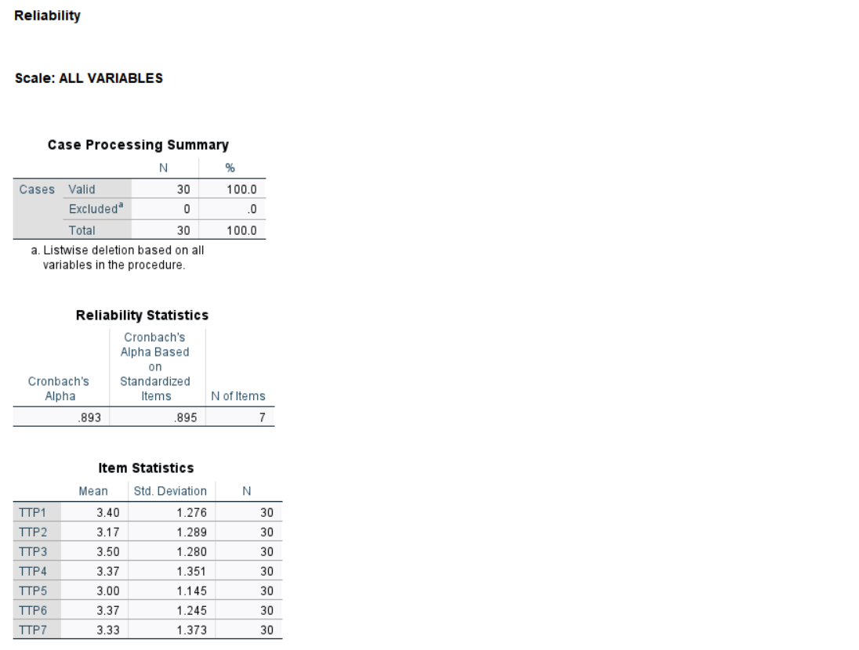
Figure A1. Reliability Statistics for the Travel-Time Pressure (TTP) Scale



Figure A2. SPSS Reliability Analysis for the Work-Related Burnout Scale (7 items)

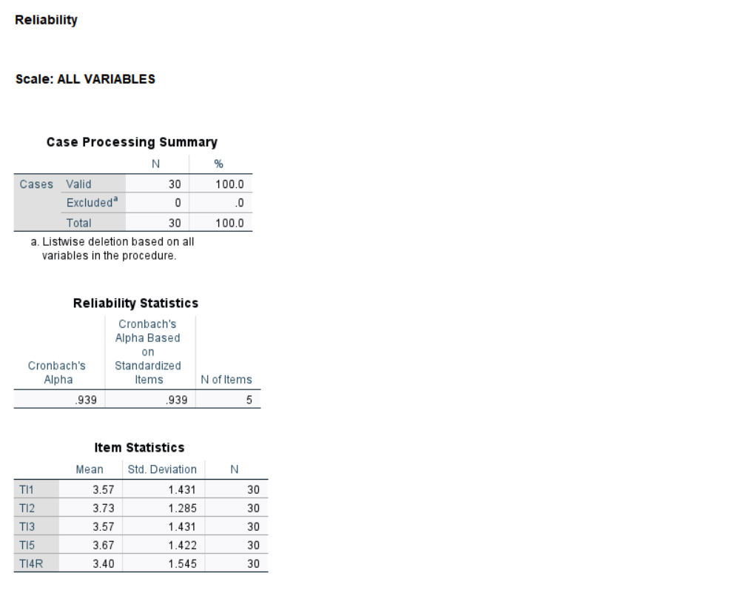

Figure A3. SPSS Reliability statistics for the Turnover Intention scale.

Appendix C: Normality Test

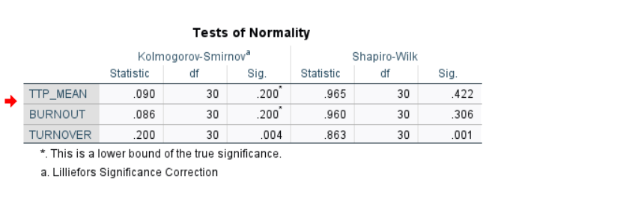

Appendix D: Correlation Analysis
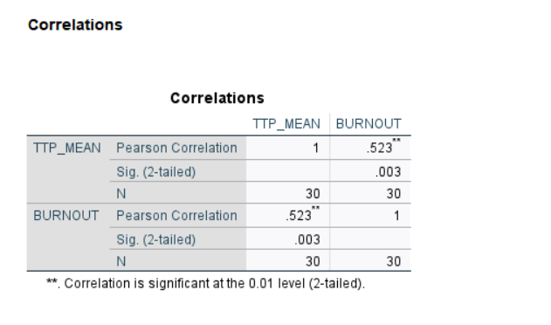

Appendix E: Regression Analysis

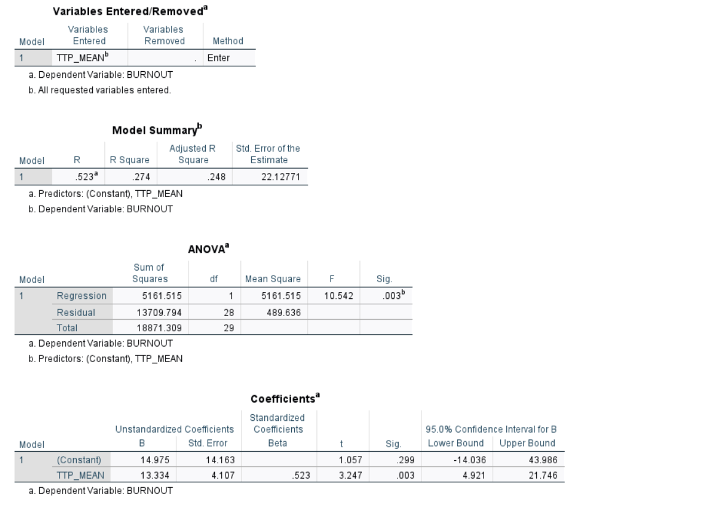

Appendix F: One-Way ANOVA

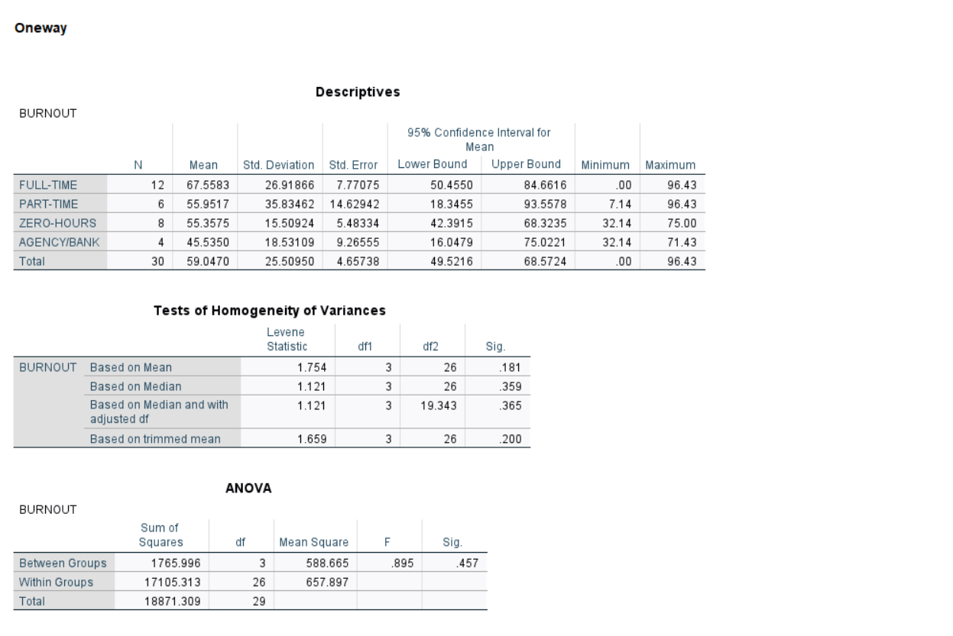

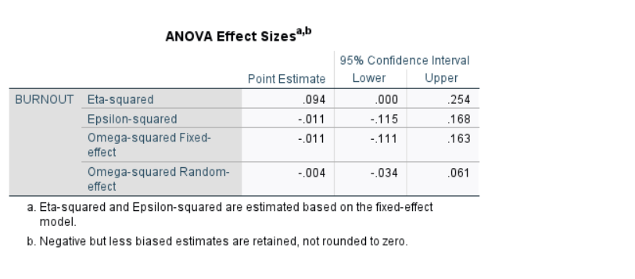

Appendix G: Independent-Samples t-Test



