Student name | Luke Church
Student number | 2533137
Module No | BMSK4012
Module title | Enterprise and Intrapreneurship

Contents

Executive Summary 2
Introduction and Business Identity 3
Personal Skills and Suitability 4
Market Analysis 4
Target Market 5
PESTLE Analysis 6
5. SWOT Analysis 6
6. Competitor Analysis 7
7. Unique Selling Proposition (USP) 8
9. The 7Ps Marketing Mix 9
10. Revenue Streams 10
11. Operations Plan 11
12. Financial Information 12
13. Conclusion 15
References 17
Appendix 19

- Appendix A – Curriculum Vitae
- Appendix B – Competitor Comparison
- Appendix C – Start-up Costs
- Appendix D – 12-Month Cash Flow Forecast
- Appendix E – Profit Forecast
- Appendix F – Marketing Examples
- Appendix G – SWOT Analysis
- Appendix H – PESTLE Analysis
- Appendix I – 7Ps Marketing Mix
- Appendix J – Risk Assessment
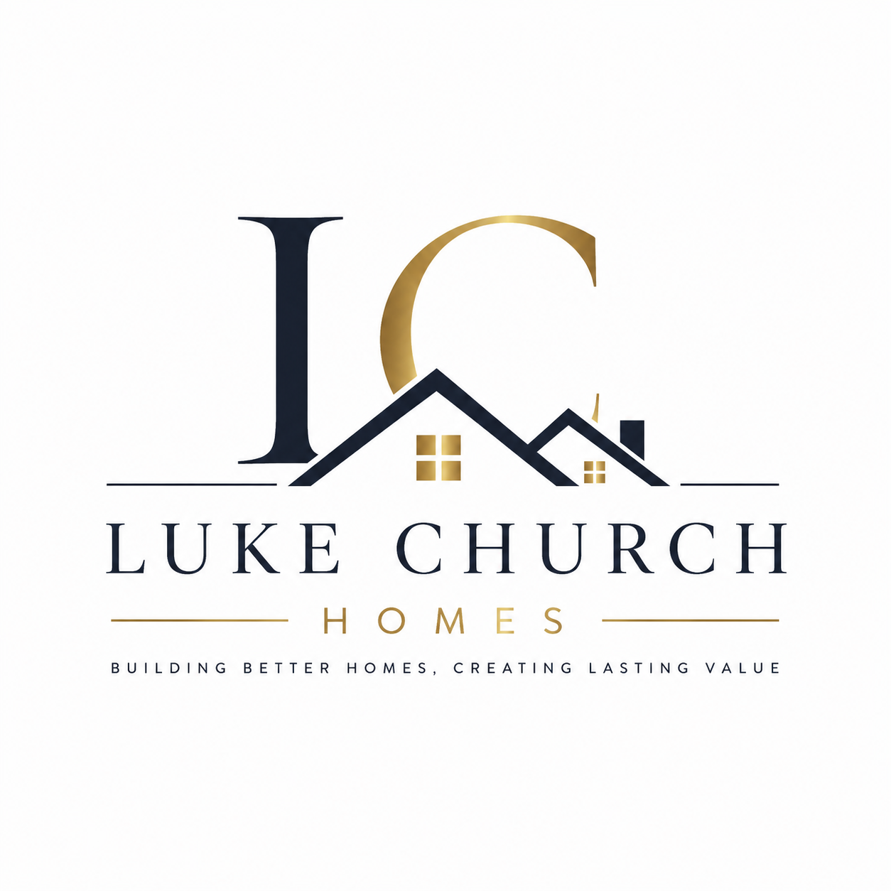

Executive Summary
Luke Church Homes is a property investment business specialising in purchasing, renovating and selling residential properties in Pontyclun and the surrounding areas. The business creates value by identifying properties with investment potential, completing quality renovations where required, and selling them for a profit.
The business will also purchase properties directly from homeowners seeking a quick and straightforward sale. By combining local market knowledge, financial planning and effective project management, Luke Church Homes aims to maximise returns while maintaining high standards of workmanship and customer service.
The target market includes first-time buyers, families, property investors and homeowners looking to sell efficiently. Marketing will focus on online property platforms, social media, estate agent partnerships and customer referrals to build a strong local reputation.

Introduction and Business Identity
Luke Church Homes is a property investment business specialising in purchasing, renovating where appropriate, and selling residential properties across Pontyclun and the surrounding areas. The business aims to meet demand for quality housing while providing buyers and sellers with a professional, reliable and efficient service.
The business will operate as a sole trader, allowing the owner to retain full control over operations and decision-making (HM Revenue & Customs, 2024). Although the owner is personally responsible for business liabilities, risks will be managed through careful financial planning, appropriate insurance and accurate record keeping (HM Revenue & Customs, 2024).
Strong communication, negotiation, organisation and project management skills will support successful property transactions and positive client relationships (Royal Institution of Chartered Surveyors, 2024).
Luke Church Homes will identify residential properties with investment potential, complete market research and financial analysis before purchase, carry out renovations where necessary, and sell properties for a profit. The business will also purchase properties directly from homeowners seeking a quick and straightforward sale.
Marketing will focus on online property platforms, social media, estate agent partnerships and professional networking. Digital property investment software and electronic record-keeping systems will support efficient administration and enable the business to respond quickly to market opportunities.
The long-term objective is to build a trusted reputation within the local property market, develop a profitable property portfolio, and increase the number and value of residential projects completed each year.

Personal Skills and Suitability
Luke Church has a range of skills suited to running a property investment business. His knowledge of the local property market and residential renovations will help identify investment opportunities, assess risks and make informed business decisions. Careful planning and market research before each purchase will support profitable investments (Royal Institution of Chartered Surveyors, 2024).
Strong organisation and project management skills are essential for coordinating estate agents, solicitors, contractors, surveyors and suppliers. Effective project management will help ensure renovation work is completed on time, within budget and to a high standard.
Communication and negotiation skills will support property purchases, price negotiations, obtaining competitive quotations from contractors and building long-term professional relationships. Attention to detail will help ensure property valuations, legal documents and financial information are reviewed carefully before decisions are made.
To continue developing the business, Luke plans to improve his knowledge of property finance, taxation and market trends through professional guidance, industry research and ongoing learning. This commitment to continuous development will support sustainable business growth.
SMART Objectives
- Purchase and successfully sell at least two residential properties within the first 12 months, achieving a profit on each sale.
- Build an online presence by reaching 1,000 local followers across Facebook, Instagram and LinkedIn within six months through regular property updates and project showcases.
- Generate £500,000 in property sales within the first 12 months while maintaining profitability.
- Receive at least 20 positive customer reviews and establish partnerships with 10 local professionals within the first 12 months.

Market Analysis
The UK residential property market continues to play an important role in the economy, with demand from first-time buyers, families and property investors despite changing interest rates and wider economic conditions (Office for National Statistics, 2024). Well-presented, competitively priced properties remain attractive, while many homeowners continue to seek a professional and efficient selling process.
Luke Church Homes will operate across Pontyclun and the surrounding areas, including Talbot Green, Llantrisant, Llanharan and Miskin. These locations have been selected because they combine strong housing demand, good transport links and continued residential development, creating opportunities for profitable property investment. According to the Office for National Statistics (2024), Rhondda Cynon Taf has a population of over 240,000, providing a substantial customer base for residential property sales.
The business will identify properties with strong investment potential through market research, property valuations and financial analysis before purchase. Renovations will be completed where appropriate to increase property value, improve buyer appeal and maximise returns. Careful planning and project management will help control costs while maintaining high standards of workmanship (Royal Institution of Chartered Surveyors, 2024).
Strong relationships with estate agents, surveyors, solicitors, mortgage brokers and contractors will help identify investment opportunities and complete transactions efficiently. By combining local market knowledge with disciplined financial planning and quality renovations, Luke Church Homes aims to establish a profitable and sustainable property investment business within Rhondda Cynon Taf.

Target Market
The main target market includes first-time buyers, families, property investors and homeowners looking to sell their properties quickly and efficiently. The business will focus on customers seeking quality residential homes at competitive prices, as well as homeowners who value a professional and straightforward selling process. The target market will primarily be in Pontyclun, Talbot Green, Llantrisant, Llanharan, Miskin and the surrounding areas, where there is consistent demand for residential property (Brassington & Pettitt, 2019).
First-time buyers and families are likely to value renovated, move-in-ready homes, while property investors will be attracted to properties with strong investment potential. Homeowners seeking a quick sale will benefit from a simple purchasing process and clear communication. By understanding these customer groups, Luke Church Homes can tailor its services and build long-term relationships within the local property market.

PESTLE Analysis
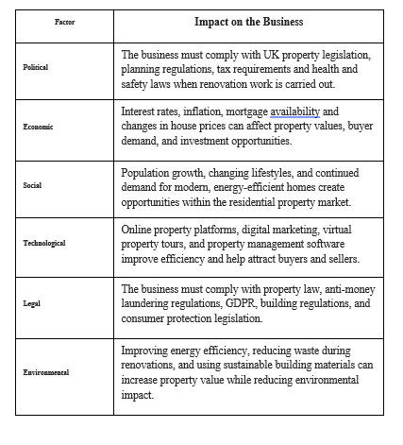
5. SWOT Analysis
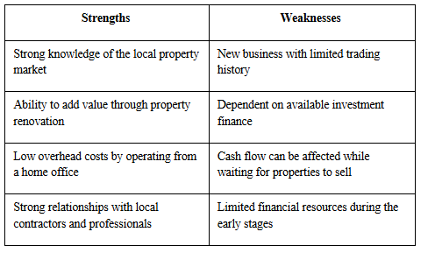

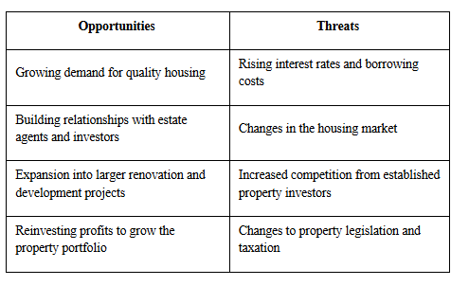
The business recognises that rising interest rates and increased competition could reduce profitability. To minimise these risks, properties will only be purchased after detailed financial analysis demonstrates a satisfactory profit margin. Maintaining relationships with local estate agents will also provide early access to investment opportunities before competitors. A contingency fund has also been included within the financial plan to reduce the impact of unexpected renovation costs or market changes.
6. Competitor Analysis
Luke Church Homes will compete with local estate agents, property investment companies and independent property developers operating across Pontyclun, Talbot Green, Llantrisant and the surrounding areas. Many competitors have established reputations, strong local knowledge and existing networks of buyers, sellers and investors.
Luke Church Homes will differentiate itself by selecting properties with strong investment potential, completing high-quality renovations where appropriate and providing a professional, honest and transparent service. The business will focus on realistic property valuations, efficient project management and clear communication to build trust with buyers and sellers.
Strong relationships with estate agents, solicitors, surveyors, mortgage brokers and contractors will help identify investment opportunities and support efficient property transactions. Unlike estate agents, Luke Church Homes purchases, renovates and sells properties, allowing the business to add value before resale and increase profit potential.
Although larger competitors benefit from established reputations, Luke Church Homes will compete through personalised service, flexible appointment times and quicker decision-making. Marketing through online property platforms, social media, professional networking and customer referrals will support brand awareness and help establish a trusted local reputation. A comparison of local competitors is provided in Appendix B.
7. Unique Selling Proposition (USP)
Luke Church Homes will differentiate itself by offering a professional, honest and transparent property investment service focused on quality, reliability and customer satisfaction. The business will carefully select residential properties with strong investment potential, complete high-quality renovations where appropriate, and provide buyers with well-presented, move-in-ready homes.
Unlike larger property investment companies, Luke Church Homes will offer a personalised service, maintain clear communication and build strong relationships with buyers, sellers and professional partners throughout each transaction. Decisions will be based on thorough market research, realistic property valuations and careful financial planning to support sustainable business growth.
By combining local market knowledge with efficient project management, the business aims to build a trusted reputation while delivering value to buyers and sellers. This personalised approach will encourage repeat business and customer referrals, creating a competitive advantage.
8. Marketing Strategy
Luke Church Homes will use a combination of digital marketing, professional networking and local advertising to attract buyers and homeowners looking to sell their properties. Building a strong reputation and increasing brand awareness will be essential during the first year.
The business will advertise properties through major online property platforms and social media channels such as Facebook and Instagram, where completed renovation projects, property updates and customer testimonials will be shared. Social media provides a cost-effective way to reach local buyers and sellers, build brand awareness and interact directly with potential customers while allowing marketing performance to be monitored and adjusted.
A professional website will provide information about the business, available properties and contact details. Relationships with local estate agents, solicitors, surveyors, mortgage brokers and contractors will generate referrals and provide access to new investment opportunities. Customer recommendations and positive feedback will also be encouraged to strengthen trust and support future business growth.
Marketing activities will be reviewed regularly to ensure the budget is focused on the promotional channels that generate the highest number of enquiries and successful property transactions.

9. The 7Ps Marketing Mix
The 7Ps marketing mix considers product, price, place, promotion, people, process, and physical evidence when planning how a service will be delivered and marketed (Kotler & Armstrong, 2021).

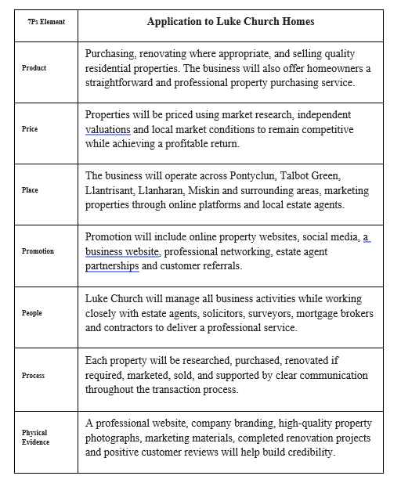

10. Revenue Streams
The primary source of income for Luke Church Homes will be the sale of residential properties purchased, renovated where appropriate and sold for a profit. Market research and financial analysis will be completed before each purchase to ensure a positive return on investment.
As the business grows, profits will be reinvested to purchase additional properties, increasing the number of projects completed and supporting long-term growth.

11. Operations Plan
Luke Church Homes will operate from a home office, helping to keep overhead costs low while allowing more investment to be directed towards property purchases and renovation projects. The owner will manage all aspects of the business, including property sourcing, market research, financial planning, negotiations, project management, marketing, and administration.
Customer Journey

- Customer contacts Luke Church Homes.
- Property valuation arranged.
- Offer made to seller.
- Purchase completed through solicitors.
- Renovation work undertaken.
- Property professionally photographed.
- Property advertised.
- Buyer found.
- Sale completed.
- Follow-up communication and referral request.
Potential investment properties will be identified through estate agents, online property platforms, auctions, and professional contacts. Before purchasing a property, market research, property valuations and financial analysis will be completed to assess profitability and minimize financial risk. Completing detailed market and financial analysis before purchase reduces investment risk and helps ensure that renovation costs and expected selling prices will generate an acceptable profit.
Where renovation work is required, reliable local contractors will be appointed to complete improvements within agreed budgets and timescales. Where renovation work is required, Luke Church will complete some renovation work personally where appropriate, drawing on his experience in construction and property refurbishment. This may reduce labour costs, improve profit margins and provide greater control over the quality and timescale of projects. Specialist work, including electrical, gas and any work requiring certification, will always be completed by qualified contractors to ensure compliance with UK legislation and building regulations.
Once renovations are complete, properties will be professionally photographed, marketed through estate agents, online property websites and social media, and sold to suitable buyers. Throughout the process, the business will maintain clear communication with buyers, sellers, solicitors, surveyors, and mortgage brokers to support efficient transactions.
Regular financial monitoring, accurate record keeping, and ongoing market research will help the business control costs, identify new investment opportunities, and support sustainable long-term growth.

12. Financial Information
Luke Church Homes will initially be funded through personal savings, providing the capital required to purchase residential properties, complete renovations where necessary, and cover operating costs during the first year. As the business grows, additional funding may be obtained through mortgage lending, property investment finance or joint venture partnerships to support larger property purchases and renovation projects. Profits generated from completed property sales will be reinvested to support future business growth and expand the property portfolio. The financial forecasts are based on realistic assumptions using average residential property values within Pontyclun and the surrounding areas. It is assumed that four properties will be purchased, renovated where required and successfully sold during the first year. This forecast is based on completing one property approximately every three months. This allows sufficient time for sourcing, purchasing, renovation, marketing and selling each property while maintaining quality standards. Income is only generated once each property sale is completed, which explains why there is no income during the early months while properties are being purchased, renovated and marketed. The forecasts also include estimated purchase costs, renovation costs, legal fees and ongoing operating expenses.


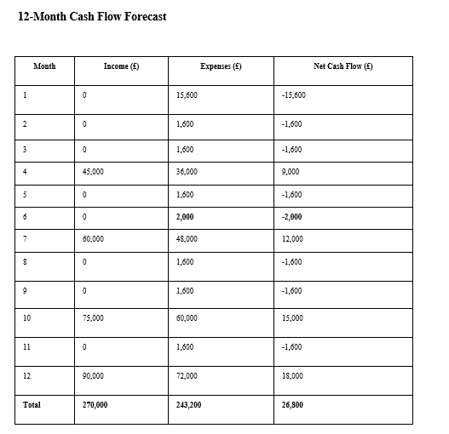
If property sales take longer than expected, cash flow could become restricted. To reduce this risk, the business will maintain a contingency fund and carefully manage renovation expenditure. Purchasing only properties with strong resale potential will further reduce financial risk.

The forecast shows expected negative cash flow during the early months due to start-up costs and investment expenditure before any properties are sold. Positive cash flow is expected once completed properties are sold, allowing profits to be reinvested into future investment opportunities and supporting the long-term growth of the business. Although these figures are estimated, the forecasts have been prepared using current local property values, expected renovation costs and realistic selling prices, making them achievable if market conditions remain stable.

Break-even Analysis
Average profit per completed property sale: £15,000
Estimated annual fixed costs: £19,200
Break-even calculation:
£19,200 ÷ £15,000 = 1.28
This means the business must complete approximately two profitable property sales each year to cover its annual fixed operating costs. Any additional profitable sales will contribute directly to the overall profitability and future growth of the business.

Profit Forecast

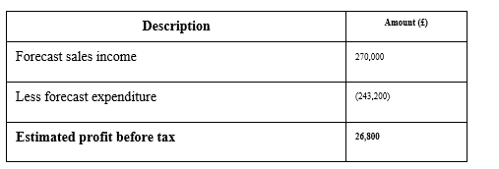

The financial forecast indicates that Luke Church Homes has the potential to become profitable during its first year if suitable investment opportunities are secured; renovation costs are carefully managed, and properties are sold at expected market values. Although all figures are estimated, regular financial monitoring and budgeting will help the business respond to changes in market conditions, property values, renovation costs, and interest rates.

Health and Safety
Health and safety will be a priority, particularly during property inspections and renovation projects.
The business will:
• Ensure all contractors comply with UK health and safety legislation.
• Carry out property risk assessments before renovation work begins.
• Use qualified and insured tradespeople.
• Maintain appropriate public liability and business insurance.
Legal Requirements
The business will register with HM Revenue & Customs for Self-Assessment and maintain accurate financial records in accordance with UK tax legislation (HM Revenue & Customs, 2024). All property transactions will comply with relevant property law, anti-money laundering regulations, consumer protection legislation, and data protection requirements. Contracts, legal documentation, and client information will be securely managed throughout each transaction.
Business Policies
The business will operate clear policies covering:
• Honest and transparent property valuations.
• Confidential handling of client information.
• Compliance with all legal and regulatory requirements.
• Professional handling of complaints and disputes.
These policies will support professional and complaint business operations.
13. Conclusion
This business plan demonstrates that Luke Church Homes has strong potential to become a successful property investment business within Pontyclun and the surrounding Rhondda Cynon Taf area. Continued demand for quality residential housing, combined with careful property selection, market research and financial planning, provides opportunities to generate sustainable profits and establish a strong reputation within the local property market.
The business will focus on purchasing properties with good investment potential, completing high-quality renovations where appropriate, and selling well-presented homes that meet the needs of buyers. By maintaining effective relationships with estate agents, solicitors, surveyors, mortgage brokers and contractors, the business will be well positioned to identify opportunities and complete property transactions efficiently.
Overall, Luke Church Homes has a realistic and achievable business model supported by clear objectives, effective marketing, sound financial planning, and a commitment to providing a professional, honest and reliable service. These factors provide a strong foundation for long-term success and sustainable business growth. Continued monitoring of market conditions, interest rates and renovation costs will enable the business to adapt and remain profitable as it grows.

References
Brassington, F., & Pettitt, S. (2019). Principles of marketing (8th ed.). Pearson.

Chartered Institute of Personnel and Development. (2024). Profession Map. https://www.cipd.org/uk/profession-map/
HM Revenue & Customs. (2024). Working for yourself. https://www.gov.uk/working-for-yourself
Kotler, P., & Armstrong, G. (2021). Principles of marketing (18th ed.). Pearson.
National Residential Landlords Association. (2024). Property investment and landlord guidance. https://www.nrla.org.uk/
Office for National Statistics. (2024). Housing and population statistics for the UK. https://www.ons.gov.uk/
Office for National Statistics. (2024). Rhondda Cynon Taf population and demographic data. https://www.ons.gov.uk/
Rightmove. (2026). UK property market trends and insights. https://www.rightmove.co.uk/
Rightmove. (2026). House prices in Pontyclun. https://www.rightmove.co.uk/
Rosário, A., & Casaca, J. A. (2024). Relationship marketing and customer retention: A systematic literature review. Studies in Business and Economics, 18(3), 44–66. https://doi.org/10.2478/sbe-2023-0044
Royal Institution of Chartered Surveyors. (2024). Residential property market insights and guidance. https://www.rics.org/
UK Government. (2024). Buying and selling property. https://www.gov.uk/browse/housing
UK Government. (2024). Money laundering regulations and estate agency guidance. https://www.gov.uk/government/collections/money-laundering-regulations
Zoopla. (2026). UK property market information and house price data. https://www.zoopla.co.uk/
Zoopla. (2026). Sold house prices in Pontyclun. https://www.zoopla.co.uk/

Appendix

A –
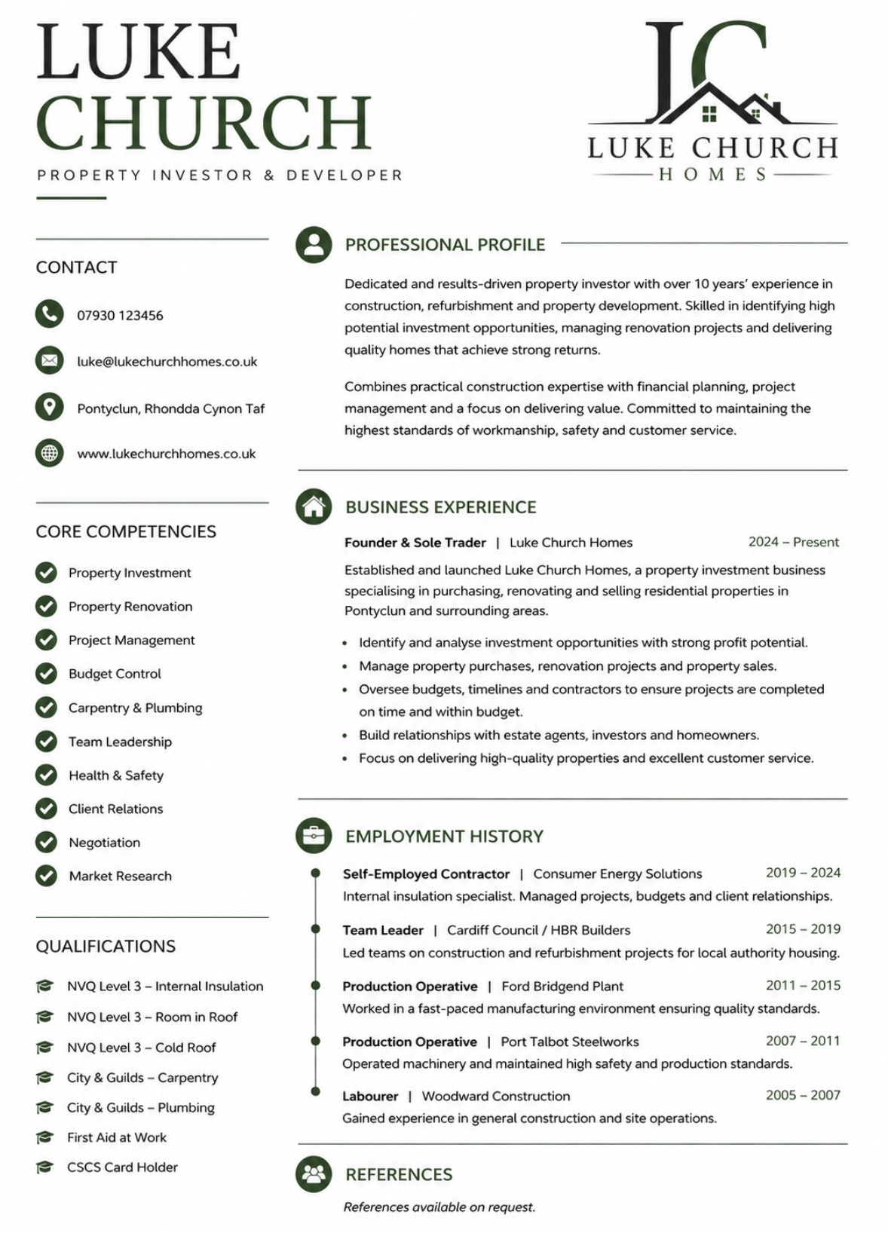
Appendix B – Competitor Comparison
Competitor | Average Fees | Google Rating | Services | Strength | Weakness
Peter Alan | Higher | 4.5 star | Sales & Lettings | Well known | Higher fees
Darlows | Medium | 4.3 star | Sales & Valuations | Large branch network | Less personal
Allen & Harris | Higher | 4.4 star | Sales | National reputation | Less flexible
Luke Church Homes | Competitive | New business | Buying, renovating & selling | Personal service, renovation expertise | New business



Appendix C –
Item | Cost (£)
Initial property deposit | 20,000
Legal fees | 2,000
Survey fees | 800
Insurance | 600
Marketing | 1,200
Office equipment | 800
Business registration & administration | 300
Contingency fund | 2,300
Total | 28,000

Appendix D –
Month | Income (£) | Expenditure (£) | Balance (£)
Jan | 0 | 25,000 | -25,000
Feb | 0 | 18,000 | -43,000
Mar | 90,000 | 62,000 | 28,000
Apr | 0 | 12,000 | 16,000
May | 0 | 10,000 | 6,000
Jun | 0 | 9,000 | -3,000
Jul | 80,000 | 56,000 | 21,000
Aug | 0 | 9,000 | 12,000
Sep | 0 | 8,000 | 4,000
Oct | 100,000 | 34,200 | 69,800
Nov | 0 | 0 | 69,800
Dec | 0 | 0 | 69,800

Appendix E

Description | Amount (£)
Sales income | 270,000
Less total expenditure | (243,200)
Estimated profit before tax | 26,800

Appendix F- Facebook business page

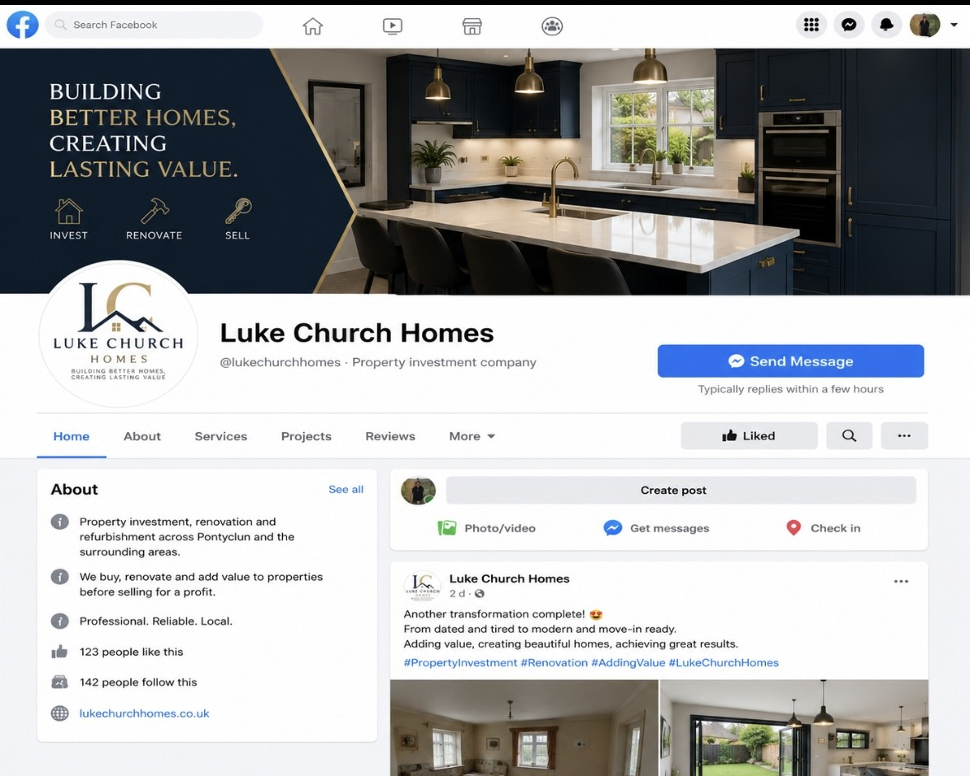

Instagram business page

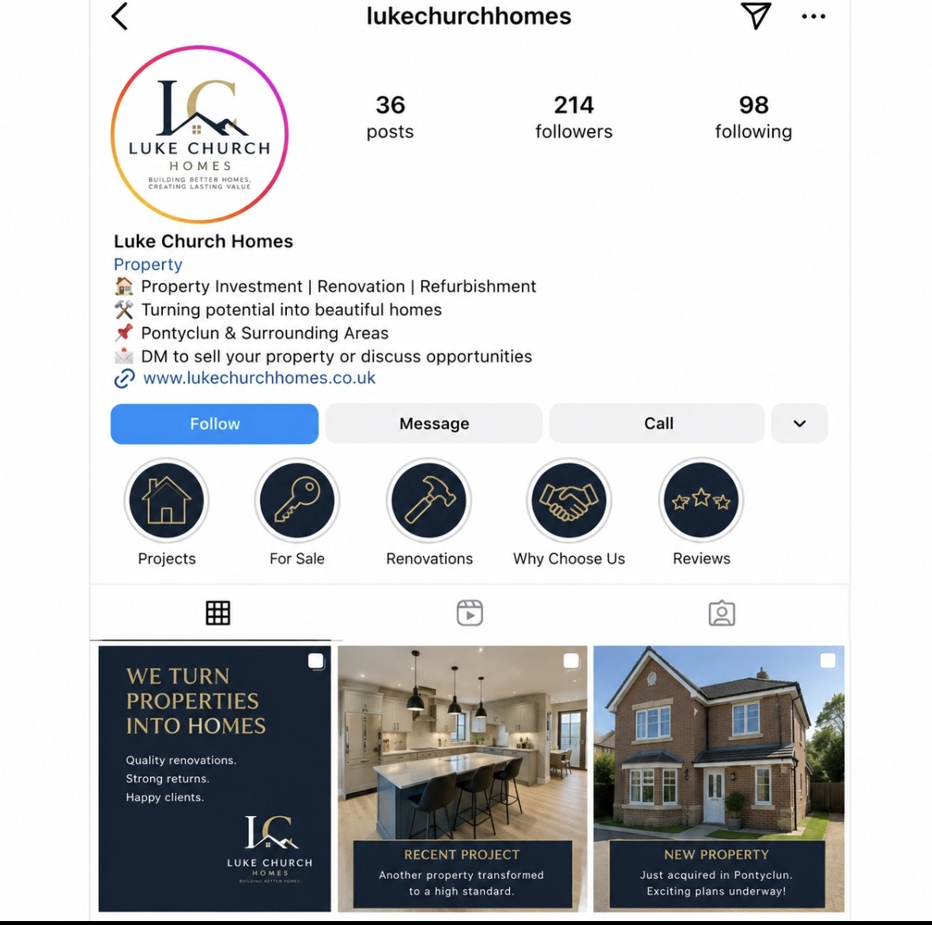

Company logo

Business card



Appendix G – SWOT Analysis

Appendix H – PESTLE Analysis

Factor | Impact on the Business
Political | The business must comply with UK property legislation, planning regulations, tax requirements and health and safety laws when renovation work is carried out.
Economic | Interest rates, inflation, mortgage availability and changes in house prices can affect property values, buyer demand, and investment opportunities.
Social | Population growth, changing lifestyles, and continued demand for modern, energy-efficient homes create opportunities within the residential property market.
Technological | Online property platforms, digital marketing, virtual property tours, and property management software improve efficiency and help attract buyers and sellers.
Legal | The business must comply with property law, anti-money laundering regulations, GDPR, building regulations, and consumer protection legislation.
Environmental | Improving energy efficiency, reducing waste during renovations, and using sustainable building materials can increase property value while reducing environmental impact.

Appendix I – 7Ps Marketing Mix

Appendix J – Risk Assessment



