Introduction

In this case study, I will be learning outlining the main structural elements for the office building provided. I will be looking at the drawings and annotating and also looking at the systems of enclosure for the type of building I have chosen.

Strip foundation

This is the most popular type of foundation, and it is used to construct the majority of homes in the United Kingdom. Trenches of at least 150mm depth are dug and filled with concrete, forming a concrete strip around the perimeter of the property. As long as the foundation depth is over 150mm, the distance from the front wall face to the edge of the foundation will be identical to or less than the depth of the foundation.

When considering installing a strip foundation, the location of trees should be avoided as the moisture they utilise will cause the earth to rise and sink.

Trench fill foundation

Trench fill foundations are smaller than strip foundations but have a higher concrete thickness. Using a foundation such as this is quite straight forward. These foundations are best suited in clay and chalk soils because the sides of the trench play an important role in supporting the building. As a large amount of concrete is poured into the footings to fill the entire trench, this method removes the need for bricks below the surface and is quicker than strip foundations.

Engineered foundation.

This choice covers a wide range of foundations, many of which are referred to as engineered foundations since they usually require the assistance of a structural engineer to determine the best solution. Forming these foundations requires building deeper trenches and filling them with more cement, generally with polystyrene sheets to prevent movement. If the trenches need to be deeper than 2.5m, it is necessary to build new foundations because the amount of concrete required becomes extremely costly, and the depth increases the risk of workers being injured.

Engineered foundations are generally more expensive and time demanding to construct, however they are a good option for constructing on tricky grounds.

Some engineered foundations include
- Isolated spread footing
- Ground beam foundation
- Raft foundation
- Mat foundation

My choice- Ground beam foundation

The foundation that would be most suitable for this building is the engineered foundation, more specifically I think a ground beam foundation.

The Ground beam is a beam that is typically installed at the foundation level to support building walls, steel joists, and other structural elements. In this case it will be supporting the steel skeleton. Ground beams are usually resting directly on the ground; however, they can also be supported by end piers.

A ground beam is suitable for this building because in a ground beam foundation, steel is used which can be attached to a steel frame.

Structural Elements

The main elements of the primary structure for this office block that I have chosen is a steel frame building, with blockwork internally for the wall. It has a layer of DPC and foam insulation, then brickwork and cladding on the outside. I chose concrete screed on ground floor. After this is screeded, I chose to put an underlay and laminate flooring above the concrete. On the second floor for the flooring, I have also chosen a laminate flooring finish on top of slimdek steel beams. For the roof I have chosen a black specialist EPDM rubber roof. And for the columns on top of the roof to secure the solar panels in place have chosen steel spiral columns.

Wind load management

The resulting force exerted on the heights when the wind blows on a building is known as the 'wind load.' In order to avoid structural collapse, the building's structural design must safely and efficiently absorb wind forces and transfer them to the foundations.

When wind engineering is used to analyse tall buildings, the major load will normally be wind, which is mainly a horizontal force. The structural systems that absorb wind loads are usually distinct from those that absorb dead loads and other internal gravity loads.

Wind loads are typically determined by the wind velocity and the shape (and surface) of the building, which makes them difficult to anticipate.

A glass-clad building with a very smooth profile, as well as a circular building compared to a square design, will tend to deflect the wind significantly more successfully than one with a sculpted or textured profile such as a brick finish or a pebble dash finish.
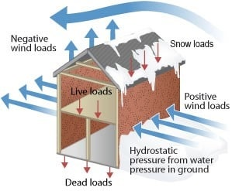
A vinyl cladding finish is the type of finish that I have chosen for this building because it is a large square building it may be more vulnerable to problems with wind. The interior finish would be blockwork

Types of primary structure

There are many types of primary structures that can be used for various buildings, however in my opinion for this building there are only 3 choices that I would choose from. These are

- Concrete frame-
Because concrete is stronger than many other building materials, it is commonly used to construct buildings such as high-rise structures and parking garages. The support structure of a building is constructed using reinforced concrete columns, concrete slabs, and concrete beams is known as concrete frame construction. Although most reinforced concrete is readily available, casting it on the construction site can be a time-consuming procedure. Unfortunately, many building structures need the casting of concrete components on-site. As a result of the curing process, it takes longer to complete than some of the other types of frameworks, this is one of the main disadvantages. One of the main advantages is that it can be shaped in to practically any shape.

- Light gauge steel.

Once the construction begins, all the materials arrive at the job site ready to be installed, so no cutting is required. This helps to improve the speed of construction. Steel is used for the rafters, joists, studs, and plates. A galvanised coating is applied to every piece of steel to protect it from the elements. This material is currently being used in more commercial buildings, but it is also becoming increasingly frequent in domestic properties.

When choosing light gauge steel for a building structure, there are several benefits. Having a high strength compared to the weight of the building, a low construction cost, and the ability to be erected fast are only a few of them. I would have chosen this for the office block however I think that the regular steel frame is a better option because it is stronger and will cope with wind loads better.

- Steel frame

Primary structure choice and why-

The primary structure choice that I decided to use is a steel frame building. It's usually used for larger structures. Steel columns and trusses are used to construct these types of structures, which can readily support greater roofs and levels. Many high-rises use this method since it is straightforward to carry materials up high with a crane before welding them all together. This would be convenient to the office building in the case study because the steel frame will be very strong in comparison to other choices. This helps out with things such as the wind and snow load of the building.

Steel frames have the advantages of being strong and malleable enough to withstand tornadoes and hurricanes and the assembly is straightforward to weld to speed up the construction process, all the components are easily available. This material can also be recycled and reused in the future which is important to think of as economic benefits in construction. One of the downsides is that it is prone to corrosion in humid environments, which should not be a problem in Wales.

Floor

On the ground floor I have chosen to have a concrete floor which can be brought in on a cement truck, and then screeded across the bottom and levelled out and wait for it to dry. For the 1st and 2nd floors, I have chosen a slimdek steel beam system. This is a system that consists of asymmetric steel beams which carry a 225mm concrete slab on top. The steel beams will fix into the beams on the first and second floors. These slimdek beams can span up to 7.5m for each beam.
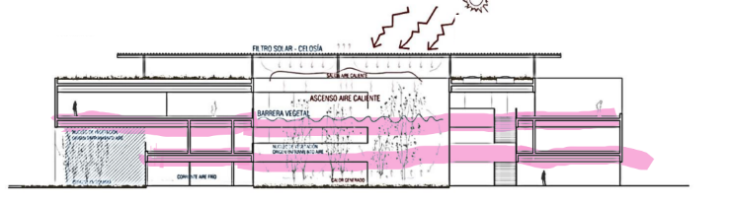

Beams

Steel framing is used to construct a wide range of structures. They can include things like offices, schools, factories, and warehouses which is why I decided to use a conventional steel frame for this office building.

Firstly, the foundations of the steel frame must be built. I have chosen the ground beam foundation as I think it is most suitable for the office block ad also goes well with the steel frame. The placement of the steel columns must then be specified. This is done by considering the maximum load of the building. The erection of the steel beams must then take place, this can be done easily with a crane and a couple of people to bolt and weld the beams into the columns.

The steel studs in buildings are made by joining pieces of metal in an L-beam pattern. Grooves are cut into the outside sections of the beam so that it can be joined to other metal pieces with bolts, screws, or other fasteners. Steel buildings are made up of steel studs that serve as the building's support system, which are then covered in a heavy layer of concrete. It is important to ensure that the steel studs are attached to the concrete to provide extra stability and support to the building After the frame is constructed and fixed together, it will become like a skeleton for the office building for the case study.

Walls

For the walls of the office block, I have decided to block the internal side of the wall up to the asymmetric steel beams. A layer of foam insulation and DPC (damp proof courses) up the wall. I would choose a brick finish for the exterior side of the wall, however I would have wooden sheafing across the exterior brickwork ready for the smooth vinyl cladding finish on the building. This will help with things such as the wind load and modernise the look of the office building. Also , it will be a very good insulator.
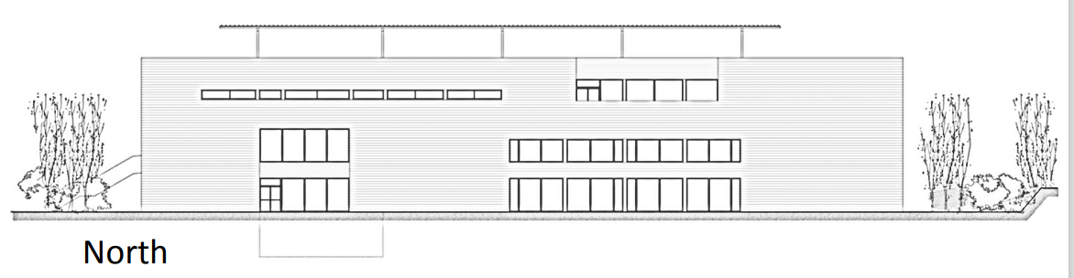

Roof

For the roof, I have decided to choose an Ethylene Polypropylene Diene Monomer (EPDM). This is more commonly known as a rubber roof. I have chosen this roof because it is very versatile and flexible. And if it is properly maintained it can last up to 50 years. This will be laid over a sterling OSB board and fixed don with the correct adhesives, the adhesives are rolled on to the board and the EPDM roof is rolled on top of it. I have also chosen a black colour as it will help to absorb the heat and sun for the solar panels.
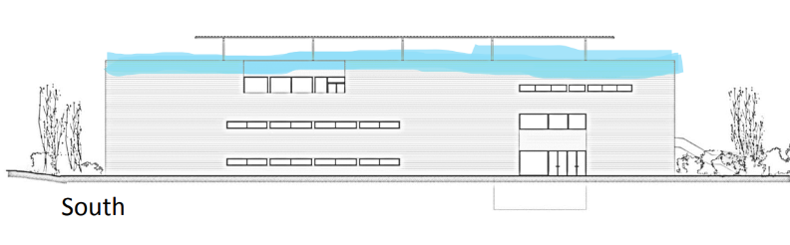

Columns (under solar panel)

For the columns on the roof. I decided to use round steel columns to match the steel frame. However, I have chosen round steel columns because not only are they are strong enough to hold the solar panels up but also decrease the wind load for the panels because of the rounded shape.

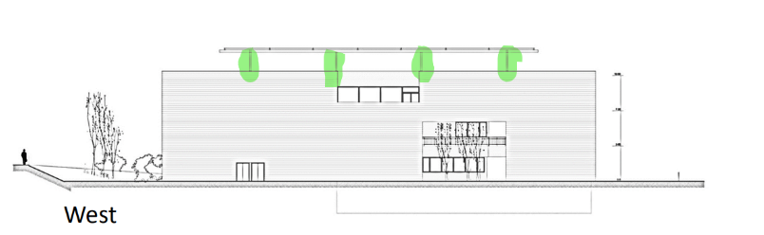

A good system of enclosure is essential with steel buildings. This term is used for any part of the building that separates the internal ad external environment. Enclosures can also be called building envelopes. There are a number of ways to enclose a building. The preferred method I would choose as enclosure for the building is outlined as internal and external walls.

Internal walls
For the internal system of closure I have chosen to use partition walls. The way that I have chosen to do these walls step by step would be firstly, mark out for the stud wall, then for the stud wall use a 90mm CLS timber. Once this is done, mark out with a plaster board where the fixings are going to be. You put one plasterboard on one side of the partition wall, then insulate it with forma insulation in the middle before plaster boarding the other side. Once this is done, it can be dry lined or skimmed. I would also have double glazed windows in each room to try and bring out the building envelope performance.

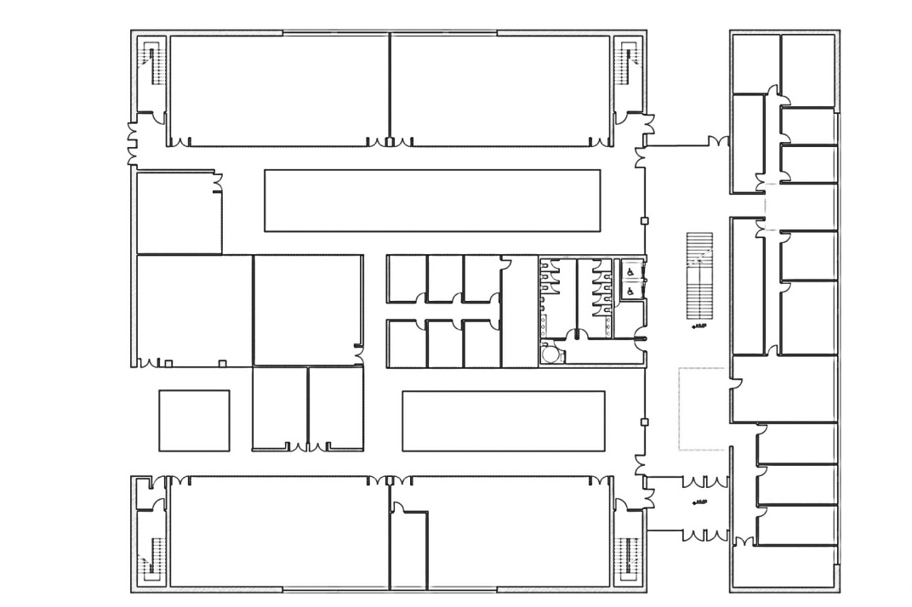

External walls
The difference in building the external walls is firstly, you begin with a steel beam foundation which is attached to the vertical steel beam. The back should be filled with 100 – 150mm blocks all the way to the top. It will then have foam insulation and damp proof coursing DPM and then it should be bricked on the outside with engineering brick. The grounds should then be attached to the brick wall by using an SDS drill and then bolted on and fixed with vinyl cladding.

References
(DOC) THE IMPACT OF ICT IN CONSTRUCTION INDUSTRY | Bakut J Kach-zachiang - Academia.edu
Information and communications technology in construction - Designing Buildings
EPDM Rubber Roofing Systems: The Complete Guide (restoremastersllc.com)
https://theconstructor.org/structural-engg/types-of-loads-on-structure/1698/#:~:text=Wind%20load%20is%20required%20t

Wind load - Designing Buildings

https://www.letsbuild.com/blog/types-of-building-structures#:~:text=%20Types%20of%20building%20structures%20%201
What is ground beam? Advantages of Ground Beam - Civil Engineering (civiltoday.com)
ttps://theconstructor.org/structural-engg/types-of-loads-on-structure/1698/#:~:text=Wind%20load%20is%20required%20to%20be%20considered%20in,sufficient%20to%20accommodate%20the%20effect%20of%20these%20forces.

