Technology and Environment 1
Eco Bricks Project
Reflective Report

Zeke Hann

Group:
Benjamin Howells
Iestyn Bentley
Reuben Dutch

Word count: 1056

Objectives
During this project we were asked to work in groups of 3 or 4 students. The group I was part of included Ben Howells, Iestyn Bentley, Reuben Dutch and myself. As a group we were asked to design the structure. Produce 3no posters to be exhibited in Y Fforwm library. We were also asked to help create a Christmas tree made from the similar materials to exhibit in Swansea’s Waterfront Museum.
The brief for the project was to build either a statue or a homeless shelter. The design needed to contain as many Eco Bricks as we could use, up to 300. It was to be made from reused and/or recyclable materials. It also needed to stand at least 1.2m tall and stay standing without any support.

Sustainability Aims
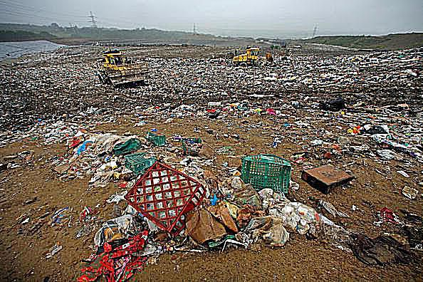
The consumer single use throw-away culture of today’s society in the UK disposes of 100 million tons of waste every year, 31 million is household waste. The amount waste the UK throws away grows by around 3% each year. A fifth of a typical households’ waste is paper and card, two-thirds of which is recycled. Supermarkets give away an estimated 17.5 billion plastic bags per year (cite). With this being the tip of the iceberg, our aim was to reduce the amount of waste thrown into landfill. We aimed to do this by following the Eco Fig 1 Landfill. Thought Co (2019) Bricks Project’s Regenerative Principles and use reclaimed, recycled or recyclable materials in our shelter design. We aimed to use as many eco bricks as possible.
We looked at taking the same principles in to making the Christmas tree exhibit, with a principle of not only showing the public eco bricks, but also showing and educating people of how much non reusable materials society uses and recyclable waste is dumped in to landfill each year.

Environment
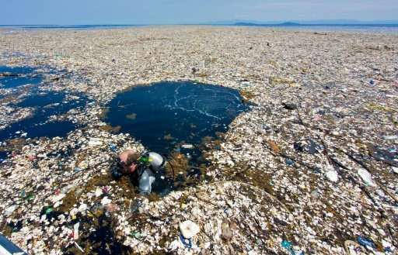
As humanity continues to grow, using up all the finite natural resources. The one-use culture can no longer continue, with us choking our atmosphere with greenhouse gases and our oceans in plastic. There has never been a greater time for society to change its way of thinking to be more greener and sustainable.
The homeless shelters can be used in various environments dependant on their current needs. They can be used in more temporary pop up fashion, being placed on grassed area at the side of roads or Fig 2 Plastic Island PHYS (2019) church grounds, quickly and easily transported in to place in the evening for that night and removed the next morning. This would give the homeless more protection against attacks, and more them away from places they would be less welcome.
We chose a to illustrate a more permanent solution to bridge the gap between people living on the street and in permanent homes. We picked the Strand car park in Swansea city centre. It’s used solely as a during the day and quieter nights but has a permanently placed GRP single storey building, operated by the St. Johns ambulance service. It would be easy and quite cheap to retrofit the building and to serve as a permanent settlement where the homeless are given the shelters on a semi-permanent basis to gets them used to looking after property again and reduce the likelihood of them returning to the streets.

Construction
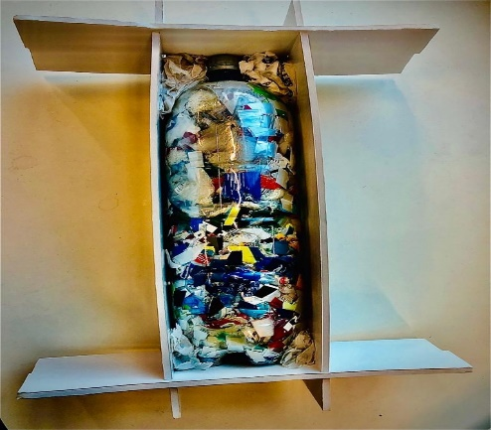
The shelter has a 3m x 2m layout plan, it has a 2m x2m internal bedroom and a 1m x 2m canopy. It’s made up of six of the hollow arches and the filled in ones to make the bedroom space, the four remaining arches were used for the canopy.
The floor is laid down first, the arches are then lined up on top and fixed into place, with the completely filled in arch at the rear, six arches, the doorway arch and then the remaining three arches. The unslotted is left for fixing later. All the lengths of timber are then slotted length ways into the arches, after this the eco bricks are placed in their compartments. The outer, inner skins and unslotted arch are then fixed to in place.
Fig 3 Bottle Model Ben Howells (2019)

Materials/Structural Methodology
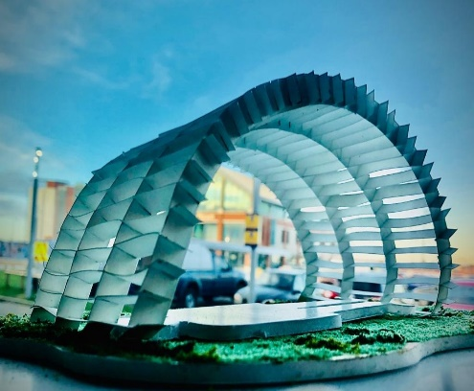
We spoke about a few different designs, this included a cubed shelter and a statue made of bottles, before finally deciding on a Romanesque arch shaped shelter. The theory was that an arch would be sturdier in bad weather. The slots cut into the arches and bracing beams would give a tighter joint that was less likely to wobble in the wind and with no need to use mechanical fixings. A canopy was added to protect the user against the weather should they chose to spend time outside, it would also encourage them not to smoke inside.
The materials we were going to use changed throughout the design process. We started wanting to use cardboard Fig 4 Shelter. Ben Howells (2019) for the entire shelter, but soon realised that cardboard wouldn’t be strong enough to support the weight of the eco bricks and needed something sturdier. We decided 9mm timber sheets cut in to shape would be more suitable for the arches and bracing beams. The floor is made reclaimed pallets, it raises the shelter up out of any water that might be pooling and allows the floor to be insulated. We took inspiration from buildings like WWFs Living Planet Centre.

Envelope/Skin
To cover and make the structural arch water and wind tight, for short term temporary shelters, the out skin could possibly be made by using a reclaimed tarpaulin sheet, tied down by rope and sheets of cardboard to line the inside. As we chosen to design a more permanent shelter, we decided to use the feather edge boards, fixed horizontally over the shelter, with the overlaps facing downwards and fixed with screws. Some hard-plastic sheets were cut into strips and fixed length ways over the top both inside and out to form sky lights to give natural light inside. The inside is lined with thin wooden sheets.

Lessons Learned
During my life I always tried to live responsibly and be as sustainable as I possibly could, I have a reusable coffee cup, recycle as much of my household waste and donate anything I no longer need. I thought I was doing my bit for the planet. That was until this project, I could use less plastic, energy and single use items. I learnt more about the use of dry joints and how to reduce the use of harmful glues.

References
C.B. Environmental (2018) 20 Fact About Waste and Recycling. Available at: http://www.cbenvironmental.co.uk/docs/recycling%20activity%20v2%20.pdf (Accessed 4th December 2019)
Eco Bricks Project (2017) Regenerative Principles. Available at: https://www.ecobricks.org/pricniples (Accessed 6th December 2019)

Howells, B. (2019a) Fig 3 Bottle Model. (Accessed 4th December 2019)

Howells, B. (2019b) Fig 4 Shelter Model. (Accessed 4th December 2019)

PHYS.ORG (2017) Fig 2 Trash Islands. Available at: https://www.phys.org/news/2017-11-trash-islands-cenral-america-ocean.html (Accessed 6th December 2019)

Thought Co. (2019) Fig1 Landfill. Available at: https://www.thoughtco.com/municipal-waste-and-landfills-overview-1434949 (Accessed 7th December 2019)

WWF (2016) Living Planet Centre. Available at: https://www.wwf.org.uk/get-involved/living-planet-centre (Accessed 6th December)

Bibliography
Kilbert, C.J. (2013) Sustainable Construction: Green Building Design and Delivery. 3rd Ed. Hoboken: John Wiley & Sons Ltd

