
INTERNATIONAL BUSINESS

- A Case Study of Samsung



Module Name: International Business
Module Number: LCMB7014
Student Name: Harmeet Singh Aatli
Student Number: 2226228

Table of Contents
Introduction 3
Describe, explain and discuss the internationalisation strategy of Samsung using analytical frameworks, management-specific factors, country-specific factors and industry-specific factors 4
Provide proper examples and demonstrate the role of MNE capabilities and resources in a global context 9
Illustrates the entry styles for different countries for the firm 11
Critically analyse the appropriate entry mode for Samsung in the host country 13
Various moves can be taken by the organisational management team to manage the country’s risk 15
Conclusion 17
References 18
Appendices 23
Appendix 1 – International Market Entry Strategies 23

Introduction
In order to complete this study successfully and make it more knowledgeable the case study of Samsung has been chosen. This is a globally recognised company that leads the electronics business the entire world. The home country of the selected company is South Korea and the host country is Brazil. This selected company is trying to expand its business into the host country with the help of different marketing strategies and improve the business revenue. Through different business frameworks analytical tools and approaches this company is trying to accept the environmental, social, political, economic and other factors for the enhancement of the business globally. This study is going to explain the internationalisation strategy of Samsung with the help of analytical frameworks. Different management-specific factors are also going to be discussed in this study to provide core knowledge about the case study. Country-specific factors and industry-specific factors will also be explained in this study to understand the different marketing approaches of the chosen company. Different significant roles of Multinational enterprises will also be demonstrated in this study to incorporate more knowledgeable pieces of information in this study. This study will also demonstrate entry styles into different countries are also going to be included in this study to make this study more informative and viable. Different types of entry modes selected by the MNE in the target market will also be discussed in this study. All the discussed information will help in future for the further development of the study significantly. After analysing all the marketing approaches and defining the objectives strategic recommendations will be demonstrated in this study to represent it appropriately and improve the study information.

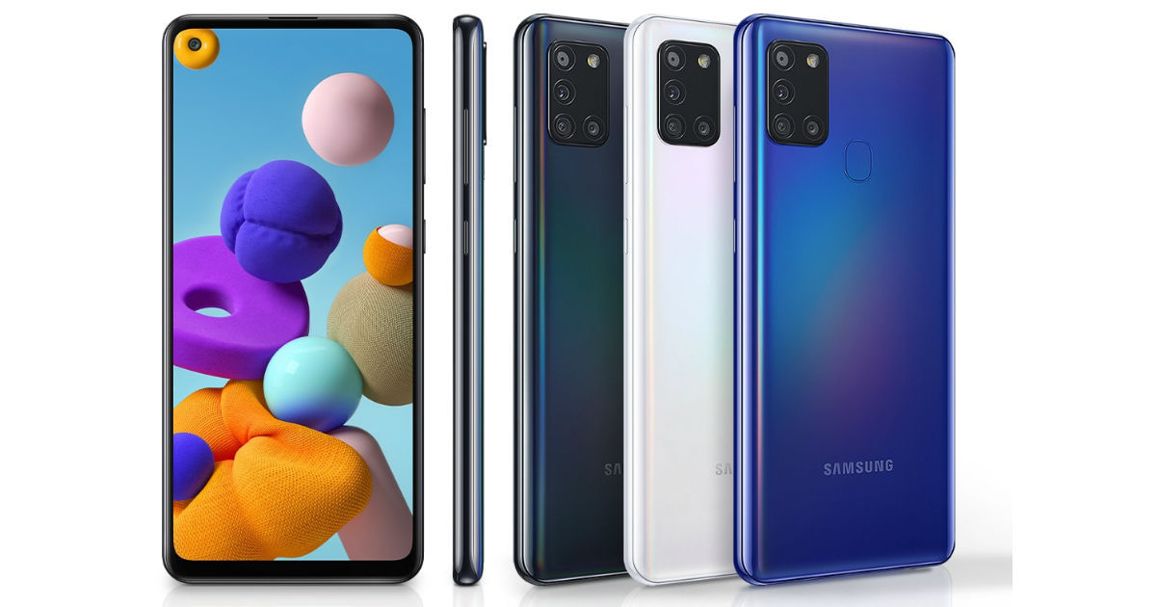
Figure 1: Samsung Logo and its Products (Phone)
Source: (Samsung, 2023)

Describe, explain and discuss the internationalisation strategy of Samsung using analytical frameworks, management-specific factors, country-specific factors and industry-specific factors
Samsung, being one of the biggest electronics and technology companies in the world, has chosen Brazil to expand its business operations. However, there are certain aspects of the internationalisation process of a business organisation which need to be studied to develop a clear insight into what it takes to effectively expand a business into a host country.
Analytical Frameworks for Internationalisation
Here, two effective frameworks can be aligned with Samsung’s desire to expand into the foreign market such as the Uppsala Model and The Network Theory.
Uppsala Model: This model is one of the biggest models for international expansion of businesses around the world which suggests that a commercial entity should increase its interest and commitment to a particular foreign market. This model talks about some specific stages which can help Samsung strengthen its hold on the Brazilian electronic and technological sector. Samsung is responsible for setting up several responsibilities and presence in the major cities and technological hubs of Brazil (Hult, 2020). Cities like Rio de Janeiro, Brasília, São Paulo, Fortaleza, Manaus and so on can become the major centres for Samsung to make its presence felt in the Brazilian business landscape. The second step suggested by the Uppsala Model is to gather experience about the foreign market dynamics by learning the market behaviour and consumer behaviour. In this case, Samsung may prefer to perform a market segmentation in Brazil and focus on the behavioural aspects of its primary and secondary target segments. The next step of internationalisation as suggested by the Uppsala Model is to study the consumer behaviour and market dynamics in markets similar to the host country (Cisneros-Reyes, 2021). Brazil, being a Latin American country, may force Samsung to study the market dynamics of other Latin American countries. Samsung can take references from its Argentina operations due to its proximity to the Brazilian market.
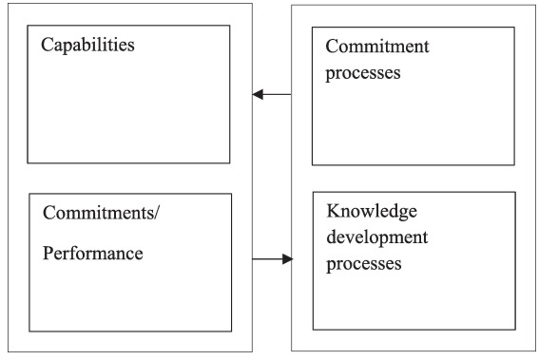
Figure 2: Uppsala Model
Source: (Schweizer, 2021)
The Network Theory: This theory can also help Samsung expand its business network in Brazil as it focuses on the significance of strategic relationships and business networks. First and foremost, following this theory would make Samsung learn from the local business community by developing a strategic alliance with them (Zahoor, 2020). Samsung can very well tie up with popular electronic and technological organisations of Brazil such as Xiaomi, Motorola, Google and so on to develop a better understanding of the actual demands of Brazilian customers from a smartphone brand. In this case, Samsung can also arrange a specific consumer engagement drive to hear directly from them about their needs and preferences. This theory also outlines the fact that it is significantly essential to establish a strong connection with the Government of the host country and arrange the proper supply network before stepping into that market. Samsung should also arrange regular strategic meetings with the Brazilian Government about their foreign trade policies and restrictions (Sedziniauskiene, 2019). Adhering to this theory can lead to a successful market expansion of Samsung in Brazil which is one of the biggest countries in the World and the biggest market in Latin America.
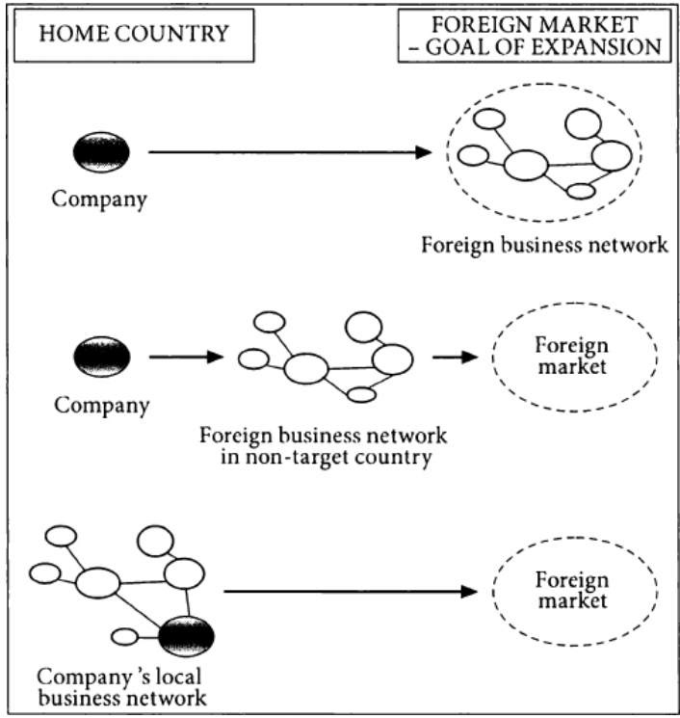
Figure 3: The Network Theory
Source: (Ratajczak-Mrozek, 2019)
Management-specific factors
Management is the key aspect of a business which defines its strategic planning and integrated market performance. Samsung will also need to assess the management-specific factors before expanding into the Brazilian market and the company should primarily assess the supply chain network in the country. A large portion of Brazil is covered by the Amazon rainforest which is largely inaccessible and there are several mountains and locations which have poor communication (Sabaitytė, 2022). Samsung needs to ensure a relentless supply network in these regions before entering into the country as serving only the major urban hubs will not provide the desired outcome of the expansion process. Then the company will also need to study the distribution channels in the country which will play a key role in the success of their venture. The company should assess the e-commerce sector of Brazil and develop strategic partnerships with some popular e-commerce platforms for the marketing and selling process. Amazon Brazil, Magazine Luiza, Casasbahia, Americanas and so on are some of the most popular e-commerce platforms in Brazil and Samsung should partner with as many of these companies as possible for the smooth distribution of its products in Brazil's smartphone and electronic industry (Lazarenko, 2019). Samsung should also prioritise cybersecurity in its management planning before expanding into the Brazilian market. In this case, the company should tie up with the cybersecurity teams of the Brazilian Government and seek their assistance to make a comprehensive data security plan for the security of its consumers. The company should also emphasise the CSR practices in the country to develop a strong bond with the surrounding community (Lazarenko, 2019). Brazil is a country with a huge poverty rate and Samsung should contribute to the philanthropic works to uplift the state of common people in the country.
Country-specific factors
After assessing the management-specific factors, Samsung should think about the country-specific factors in Brazil. Some of the salient features of the country should be understood by the company before entering into its business landscape. First and foremost, Samsung will need to understand the consumers' preference and their thinking process. The socio-cultural aspects of Brazil should also be focused on by the company (Alola, 2021). Samba, the biggest carnival in Brazil should also be aligned with the extended commercial policies of Samsung in Brazil. The company should provide significant benefits for its customers during the Samba season and also during the Christmas season. Samsung should also understand the language factors of the country as Portuguese is used by the overwhelming majority of Brazil's population. However, there are some differences in accent and choice of words from the Portuguese languages used in Portugal. Hence, Samsung should keep in mind these differences when labelling its products in Brazil and also when promoting its products through online and offline promotion channels (Magaloni, 2020). Brazil also has some infamous regions in its major urban hubs popularly known as 'Favelas'. These regions have higher crime rates in Brazil which is a significant headache for the Government (Magaloni, 2020). Hence, Samsung should also keep this in mind before expanding its operations in the country.
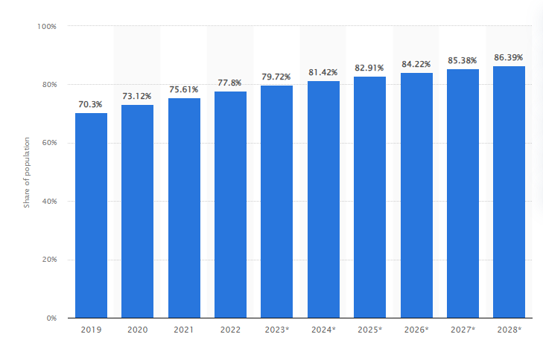
Figure 4: Smartphone Usage in Brazil
Source: (Bianchi, 2023)
Industry-specific Factors
Samsung should also focus on industry-specific factors before expanding its operations in Brazil. Brazil's smartphone usage should be one of the key criteria of thinking for the company. In this regard, the statistics of mobile internet usage in Brazil can be discussed. In Brazil, almost 80% of the country's total population access the internet from smartphones (Bianchi, 2023). This also resonates with the overwhelming number of the population that uses smartphones which has made Brazil one of the biggest markets in the world. Samsung should study these numbers and plan its commercial strategies accordingly to churn out the maximum advantage from this large market (Oh, 2019). The competitive landscape of Brazil's smartphone sector should also be researched by Samsung to strengthen its database about the competitors' behaviour. Motorola, Apple, Realme, Xiaomi and Google Pixel are the most popular smartphone brands in the country which constitute almost 49% of the market. Samsung should also chalk out a comprehensive plan for its service and support for the consumers and they will need to make it as effective as its competitors in the market (Gold, 2022). This will strengthen the customer experience of the company in Brazil.
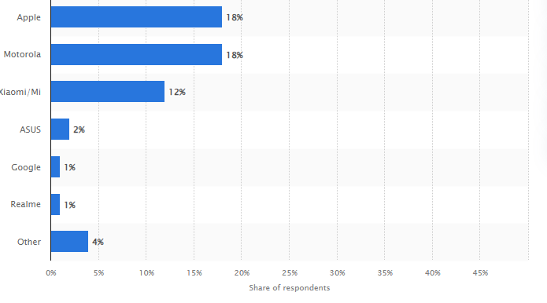
Figure 5: Popular Smartphone brand in Brazil
Source: (Bashir, 2023)

Provide proper examples and demonstrate the role of MNE capabilities and resources in a global context
Multinational enterprises conduct their business processes in their home country as well as in other foreign countries. Multinational enterprises improve their production, goods and services in countries where they can easily get labour and resources at a cheap price. In order to get economic benefits, the MNE obtain the raw materials and other goods from the place where the rate of the product is low (Rana, 2023). Economic scale is a process of cost advantages which helps in getting huge benefits in businesses. The MNE increases their production in a large magnitude to achieve a lower cost per unit delivered. The MNEs also look to prepare the base of the business in the country where the governmental factors are less effective, service tax is low, concessions can be extended, and political involvement is tolerable (Reinecke, 2019). All these factors help to manage the industrial growth of the companies and improve business efficiency. Therefore, it can be stated that the MNE chooses that area from where it can get economic benefits at a lower cost and can provide quality goods and services to the customers.
The MNE also communicate with the stakeholders to manage all the resources for business production. Meeting with the stakeholders helps to get available resources of raw materials and manage the business production successfully. Improved communication is one of the major strategies to get available resources for required products and increase business production (Nguyen, 2019). The MNE also merged with another company to get the available resources and produce a large volume of products. The merger acquisition process is quite helpful for the company to increase business revenue and enhance business performance. Through this process, the MNE which is planning to expand business globally can easily get resources and improve business revenue. In order to meet the business requirements and fulfil the consumers’ demands the MNE must have the available resources to expand the business in the foreign market (Christofi, 2021). The chosen company Samsung manages supply chain execution to get available resources and improve sustainability. This company develops an efficient and cost-effective supply chain to meet the customer’s needs and business requirements as well.
The MNE helps to establish the markets and manage the business ecosystem. All the enterprises located globally help to locate the problems and reduce the complexities of improving the business. MNEs can increase the economy of the country and represent it in the global market successfully. The MNEs are responsible for enhancing the business revenue and creating more economic value for the company (De Vasconcellos, 2019). In this study, the chosen company merged with many other companies to decrease the business risk of encountering the marketing trends successfully. Through marketing capabilities, the chosen company provides huge benefits to the country and improves the organizational framework. In order to improve marketing capabilities internationally the MNE chooses different marketing tools and strategies, to understand the knowledge and processes. According to the case study, Samsung processes innovative marketing strategies and utilises the marketing tools and knowledge to reduce the complexities and improve business efficiency. Multinational enterprises need to follow the current trends and involve the strategic management process for the enhancement of the business (Qi, 2020). The MNE maximises the involvement of the stakeholders in encountering any business problems and getting available resources for product development.
Multinational companies manage business operations within more than two countries and increase business revenue. The warehouses of multinational companies are located in more than two countries increasing the net revenue of the countries and improving the organizational framework. Multinational companies make direct investments in foreign markets to lead the business successfully and improve organizational growth (Katsikeas, 2020). Through effective business operations, the MNE provides huge benefits to consumers. It is necessary to have available resources of raw materials as well as an economy to conduct the business successfully and manage the business operation. With the help of supply chain execution, a multinational company can easily improve the business process and enhance economic benefits (Katsikeas, 2020). The chosen multinational company Samsung has excellent marketing capabilities which help the company to lead the business in the international market successfully. The marketing tools and strategies help in managing the business complexities and providing excellent services to customers throughout the world. This company has significantly managed different CSR activities that enhance the organizational growth of this company globally.
The MNE also manages different HRM practices that help to lead this company towards success. Involvement in the different HRM practices helps the company to improve business strategies and increase business revenue. Various HRM practices play a significant role in the MNEs’ expansion of business globally (Wu, 2020). Improvement of HRM practices makes the organization able to increase employee engagement and improve communication among the stakeholders and management team of the company. The involvement of HRM practices within multinational companies helps the company to improve employee satisfaction by providing training opportunities to them and increasing their working interests in foreign countries (Paul, 2019). In compliance with the case study, it can be stated that the chosen company improves HRM practices to expand its business opportunities and increase the involvement of the employees in the foreign market. It can help the organization to manage the organizational business successfully and meet the market demands.

Illustrates the entry styles for different countries for the firm
In order to expand the business globally, the firms need to follow different marketing strategies and accept various market development factors. This selected company provides different electronic devices and smart appliances to customers throughout the world. Choosing the best entry mode for a company in the new market relies on how nicely the business strategies are put in order with the production and allocation process (Paul, 2020). The chosen multinational enterprise enters into the new market and expands its business through different marketing strategies that help this company to enable effective marketing approaches for business purposes. There are different marketing strategies that a company can follow to enter into a new market globally. This chosen company first sets a new market to enter and then learns from it to enter into another market and follows all the outcomes to avoid failure. The learning from earlier entries of markets can help the MNE to expand the business successfully. This chosen firm has selected a “wholly subsidiary strategy” that helps to keep control over the business experience. The company puts maximum investment in its equity assets and in this method, the company processes overall control over the foreign market (Pratono, 2019). The Samsung company gets many advantages from using this market entry method and can easily expand its businesses. This selected company can have full control over its business operation in the foreign market. On the other hand, the MNE does not need to express its competitive advantages or technological aspects to others as the company itself manages all activities and subsidiaries in the foreign market.
Another global market entry strategy is the “Exporting strategy” which has also been followed by the Samsung Company. This method represents how the selected company will export its business to a new country and to which country it will export. Samsung has two factories in Brazil, which are mostly concentrated on smartphone manufacturing (Samiee, 2019). In this market, the South Korean company gets tariff breaks and benefits for processing provincial electronics manufacturing. According to the case study, it can be explained that Samsung tried to enter into the Brazilian market and expand the business successfully. Samsung is a leading mobile vendor in Brazil and it has been leading its business in the Brazilian market for over a decade.
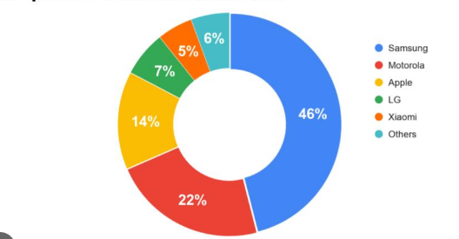
Figure 6: Measurement of the Brazilian smartphone market
Source: (Flurry.com, 2023)
According to the figure it can be clearly stated that Samsung is the highest mobile phone-selling company in Brazil. The net revenue of Samsung devices in the Brazilian market is 30 billion in Brazilian reals (Flurry.com, 2023). This MNE possesses different marketing entry styles and keeps researching the results to make the entry mode effective. Multinational enterprises follow a joint venture process to enter into new countries and get effective results. According to the strategy two or more organizations merge to share the operational cost and get shareable benefits from the business profits. This merging process also helps multinational companies to mitigate the risk and get long-term benefits equally. Therefore, Samsung has established merger alliances with Microsoft, AOL Time Warner and Sprint in the scope of marketing and technology (Samsung, 2023). Following of joint venture strategy can be effective when the local company can be chosen for partnership. It is an effective process to enter into a new market, get benefits and reduce risk factors.
In Brazil Samsung expanded its partnership with Array, AppLovin’s suit and solution are partners of Samsung which helps the company to lead its business successfully and increase marketing revenue. This company has also followed different marketing mix tools that help in understanding the environmental, social, economic, political and legal aspects (De Vasconcellos, 2019). These are all important to grow business in the foreign markets and get benefits. This multinational company faced many issues in entering the new markets. Huge competitors are one of the challenging factors for entering into new markets. The local merging partners become pleased if the collaborative venture is triumphant in the markets if not then it becomes hard for the company to survive in the foreign market. On the other hand, the lack of available financial resources is also an issue for improving the marketing revenue in the new market (Calzolari, 2021). Samsung researched all the basic challenges and planned appropriately to conduct the business successfully and enter the new foreign market. This chosen multinational enterprise must understand the market trends of the host country, local systems, cultural values, government rules and regulations to meet the business needs in the new market and obtain the business objectives successfully.

Critically analyse the appropriate entry mode for Samsung in the host country
Choosing the appropriate entry mode for the expansion process is key to leveraging the maximum market advantage of the host country. Samsung will also need to choose the appropriate entry mode before entering into the Brazilian smartphone sector. Judging the size of Samsung’s business and its range of operations in the global context of business, it can be suggested that the company choose the wholly owned subsidiary method for market entry. The company will enjoy some significant advantages from this entry method due to its greater sense of control and brand consistency (Lupton, 2021); (Tien, 2019)[Refer to Appendix 1]. This will involve the company taking complete control of its business operations in the Brazilian market and also the decision-making power. Hence, Samsung should discuss with its policymakers as well as the representatives from the Brazilian Government about a possible business establishment in the country with a complete brand identity and brand value. The major advantages of a wholly owned subsidiary entry mode should be discussed in this project in the context of Samsung to develop a better understanding of how the company will benefit from Brazil's market (Lupton, 2021).
First and foremost, it can be safely said that this business strategy is deemed as the most suitable for Samsung because it will provide the company with absolute market control which is overtly necessary for an organisation of Samsung's stature. Samsung will be able to implement all its commercial policies like budgeting, promotion and so on if it has control over its day-to-day operations in the host country. The company will also enjoy a bigger sense of freedom in its operations as there will not be any kind of dependency on local partners. A big organisation like Samsung has a clear global brand identity which the company will not be willing to compromise during the market entry (Phillips, 2021). Hence, this entry mode will provide a consistent branding to Samsung in Brazil's market that will help Samsung maintain a unified global branding. This will also eradicate the fine lines of difference between Samsung's branding from one country to another. The third advantage of a wholly owned subsidiary is the smooth integration of operations in the new country market. Samsung, being a multinational company, has a global supply chain which the company will be willing to align with its new country market. Hence, Samsung will need to choose this entry mode as it provides smooth and integrated operational qualities to a company during internationalisation.
One of the biggest aspects of operational integration is the transfer of expertise, in this case, technological input, innovations and so on (Rahman, 2020). Samsung will need to transfer all its offerings to the country market of Brazil from its international business fraternity. This process will also be smoothened by the chosen entry method, a wholly-owned subsidiary. Samsung's local operations in Brazil will also need to benefit its global presence and that's why the company will need to maintain a strong alignment in its global operations and transfer of technological advancements across its markets. However, there are also some critical things which Samsung needs to keep in mind before proceeding with the wholly-owned subsidiary method. First and foremost, the budget should be set aligning with its desired outcome from the new country market. Without appropriate budgeting, the company will struggle to generate the desired market advantages in Brazil. Samsung should also prioritise the recruitment process and give importance to local talents as they are familiar with the micro and macro-environment of the country. In a nutshell, Samsung will get huge benefits from Brazil's smartphone market if it proceeds with the wholly-owned subsidiary method (Tien, 2019).

Various moves can be taken by the organisational management team to manage the country’s risk
A new market provides a company with a wide array of opportunities which intrigues a business organisation to expand its commercial operations in that country. However, there is a serious threat of unknown market risks in a new country which can harm the business operations of the company in many ways and the very reason for the expansion will be nullified. Hence, it is necessary to develop a comprehensive understanding of how Samsung can mitigate the market risks associated with Brazil before its expansion to provide more security in its business (Daniels, 2019). There are two types of market risks such as internal risks and external risks. A business organisation can control the internal risks to some extent but for the external risks, the only way out is prevention. Hence, Samsung should first and foremost prepare its management and employees to prevent external risks in Brazil. The political stability in Brazil is a major risk for a company of Samsung’s stature and it can also harm its facilities. Research, made in 2021, suggests that the political stability index in Brazil is -0.49 which is on the weaker side of the index (Bank, 2021). This also means that the country is politically unstable and there is an increased likelihood of political fiascos and tensions.
Now, Samsung, being a new entry to its market, will be significantly impacted if any political tension arises in Brazil. The frequent demonstrations against the Government are also a major headache for the business sector of that country and Samsung will also need to maintain a diplomatic relationship with the Government to avoid any such scenarios. For example, if any political debacle or fiasco harms the facilities of Samsung in Brazil, then the company can get some compensation from the Government if the two parties maintain a strong bond (Sharma et al. 2020). There are also various commercial acts in Brazil which need to be maintained by Samsung to develop a strong relationship with the Government and the policymakers of the country. In this case, the Foreign Trade Act can be mentioned which is the principal framework for the foreign entrants in the Brazilian market. Another major law to be kept in mind by Samsung is the rectified labour laws in Brazil which suggests that the companies cannot outsource their core operations in Brazil (Novais, 2022). Hence, it is one of the biggest factors for Samsung which also reiterates the urgency of recruiting local talents and local services in its operations in the country.
Brazil also has a “Law of Economic Freedom” to attract foreign investments to the country. This law can also be a solution measure for Samsung if it encounters a financial risk in Brazil during its commercial operations. The changes in these economic laws will also eradicate the judiciary risks for Samsung within the country as it limits the interference of courts in mandatory contractual terms within the country (Nambisan, 2019). The company should form a dedicated department to oversee these regulatory compliances within Brazil so that they do not encounter any kind of government-level risks. Unwanted activities from the Government also damage the brand reputation of a company which Samsung cannot afford in its new market.
Now, there will be a discussion about the internal risks for Samsung which the company needs to mitigate effectively. First and foremost, management-level issues need to be identified and rectified by the company after the finalisation process of establishing its business in Brazil (Shenkar, 2021). As per the previous discussion about legal compliances, it can be safely suggested that the outsourcing laws in Brazil will restrict Samsung from outsourcing its core operations. Hence, the company will need to integrate some local operations in key areas. This will not only enable the company to comply with the legal frameworks but also will reduce risks associated with supply networks (Bouncken, 2021).
Supply chain networks will also come with other challenges for the company and diversification of the network will be one of the biggest challenges. This will force Samsung to establish various supply networks which will eradicate the dependency on a particular source. Here, the supply chain network also included the supply of manpower to work for the company. Hence, Samsung should search for local talents across the country instead of limiting to only the major cities. It will also be important for the inclusion and diversity of the company to uphold its brand reputation (Bahoo, 2020). Brazil is a country with people from different races, ethnicities and skin complexions. Although the majority of the Brazilian population speaks Portuguese, the tribes use different languages. Some significant developments are being made to the lifestyle of the tribal people of the country which increases their access to education and the service sector. Samsung should also provide them with significant opportunities to work for the company which will also increase its brand image. This will create positive public relations in the world which will increase its brand value leading to bigger revenues.
Innovation and creativity can be used by the company as effective tools to mitigate risks from the market. The changing scenario of the contemporary business world can be properly negotiated with diverse teams producing innovative and creative products and services in an organisation. The company should also implement a comprehensive recruitment and employee management process to eradicate the risk of losing talent (Ratten, 2020). First and foremost, the recruitment department will need to be on the same page with the values and culture of the organisation. In this case, the human resource department can help the company to identify the appropriate candidate. After recruitment, the training process also needs to be effective and the company should provide adequate benefits to the talented employees to keep hold of them. Failing to retain talented employees will always harm the business operations of the company and the revenue will also be hit drastically (Akpan, 2022). Samsung can establish a strong foundation if the company takes these measures to mitigate its external and internal risks in the market.

Conclusion
In conclusion, it can be safely inferred from the above project that market expansion is a lengthy process and a company needs to be consistent in its approach to successfully enter the market of the host country. A detailed discussion has been made about the different potential strategies of Samsung during its internationalisation process in Brazil. Analytical frameworks for the internationalisation of business such as the Uppsala Model and the Network Theory have been integrated into the discussion. The demonstration of different MNE capabilities and resources in a global contest has been made for Samsung. Different entry modes in a foreign market have been discussed and the wholly owned subsidiary method has been chosen as the most appropriate mode for Samsung to enter the market in Brazil. In the final segment, the risks associated with market entry in Brazil and its potential solution measures for Samsung have been discussed in the project.

Bibliography
Akpan, I. U. E. a. A. B. 2., 2022. Small business awareness and adoption of state-of-the-art technologies in emerging and developing markets, and lessons from the COVID-19 pandemic.. Journal of Small Business & Entrepreneurship, 34(2), pp. 123-140.
Alola, A. a. S. A. S., 2021. Clean energy development in the United States amidst augmented socioeconomic aspects and country-specific policies.. Renewable Energy, Volume 169, pp. 221-230.
Bahoo, S. A. I. a. P. A., 2020. Corruption in international business: A review and research agenda.. International Business Review, 29(4), p. 101660.
Bank, T. W., 2021. Language Resources. [Online]
Available at: https://www.worldbank.org/en/language-resources
[Accessed 19 12 2023].
Bashir, U., 2023. Most popular smartphone brands in Brazil 2023. [Online]
Available at: https://www.statista.com/forecasts/1371001/most-popular-smartphone-brands-in-brazil
[Accessed 19 12 2023].
Bianchi, T., 2023. Mobile phone internet user penetration in Brazil 2019. [Online]
Available at: https://www.statista.com/statistics/254653/mobile-internet-user-penetration-in-brazil/.
[Accessed 19 12 2023].
Bouncken, R. K. S. a. R.-T. N., 2021. Knowledge-and innovation-based business models for future growth: Digitalized business models and portfolio considerations.. Review of Managerial Science, 15(1), pp. 1-14.
Calzolari, T. G. A. a. B. A., 2021. The adoption of circular economy practices in supply chains–An assessment of European Multi-National Enterprises. Journal of Cleaner Production,, Volume 312, p. 127616.
Christofi, M. V. D. a. C. J., 2021. Micro-foundational ambidexterity and multinational enterprises: a systematic review and a conceptual framework. International Business Review, 30(1), p. 101625.
Cisneros-Reyes, Y., 2021. Evolution of Uppsala Model, a Literature Review through the years.. Journal of Management Studies and Social Science Research, pp. 214-228.
Daniels, J. R. L. a. S. D., 2019. International business: Environments and operations. s.l.:Pearson.
De Vasconcellos, S. G. I. a. P. R., 2019. Organizational creativity as a crucial resource for building international business competence. International Business Review, 28(3), pp. 438-449.
Flurry.com, 2023. country-profile-the-brazilian-smartphone-market.. [Online]
Available at: https://www.flurry.com/blog/country-profile-the-brazilian-smartphone-market/
[Accessed 19 12 2023].
Gold, N. T. F. a. M. Y., 2022. Firm-Level Attributes, Industry-Specific Factors, Stakeholder Pressure, and Country-Level Attributes: Global Evidence of What Inspires Corporate Sustainability Practices and Performance.. Sustainability, 14(20), p. 13222.
Hult, G. G.-P. M. a. L. K., 2020. The theoretical evolution and use of the Uppsala Model of internationalization in the international business ecosystem.. Journal of International Business Studies, Volume 51, pp. 38-49.
Katsikeas, C. L. L. a. Z. A., 2020. Revisiting international marketing strategy in a digital era: Opportunities, challenges, and research directions.. International Marketing Review, 37(3), pp. 405-424.
Lazarenko, Y. G. O. G. S. a. V. I., 2019. Towards an integrated approach to improving innovation management system of mining companies.. In E3S web of conferences , Volume 105, p. 04042.
Lupton, N. B. D. a. J. A., 2021. Taking advantage of institutional weakness? Political stability and foreign subsidiary survival in primary industries.. Multinational Business Review, 29(4), pp. 501-521.
Magaloni, B. F.-V. E. a. M. V., 2020. Killing in the slums: Social order, criminal governance, and police violence in Rio de Janeiro.. American Political Science Review, , 114(2), pp. 552-572.
Nambisan, S. Z. S. a. L. Y., 2019. Global platforms and ecosystems: Implications for international business theories.. Journal of International Business Studies, Volume 50, pp. 1464-1486.
Nguyen, H. H. T. a. L. H., 2019. Corporate social responsibility in Vietnam: Opportunities and innovation experienced by multinational corporation subsidiaries.. Social Responsibility Journal, 16(6), pp. 771-792.
Novais, A. D. A. C. L. S. L. A. P. a. L. P., 2022. Practical Law UK Signon.. [Online]
Available at: https://uk.practicallaw.thomsonreuters.com/0-503-8385?transitionType=Default&contextData=(sc.Default)&firstPage=true.
[Accessed 19 12 2023].
Oh, C. K. M. a. S. J., 2019. Paths and geographic scope of international expansion across industries.. International Business Review, 28(3), pp. 560-574.
Paul, J. a. M. E., 2020. Toward a 7-P framework for international marketing. Journal of Strategic Marketing, 28(8), pp. 681-701.
Phillips, R. P. H. a. P. R., 2021. Group subsidiaries, tax minimization and offshore financial centres: Mapping organizational structures to establish the ‘in-betweener’advantage.. Journal of International Business Policy, Volume 4, pp. 286-307.
Pratono, A. a. R. R., 2019. International alliance strategies: a case study of the Indonesian medical device industry.. Globalization and Development: Entrepreneurship, Innovation, Business and Policy Insights from Asia and Africa, pp. 381-400.
Qi, X. C. J. H. J. a. L. Y., 2020. Motivations for selecting cross-border e-commerce as a foreign market entry mode. Industrial Marketing Management, Volume 89, pp. 50-60.
Rahman, K., 2020. Mehdi Rasouli Ghahroudi, Yasuo Hoshino, and Stephen Turnbull authored FOREIGN DIRECT INVESTMENT Ownership Advantages, Firm Specific Factors, Survival and Performance.. Japanese Journal of Administrative Science,, 31(3), pp. 133-137.
Rana, M. a. M. G., 2023. Twenty-five years of business systems research and lessons for international business studies.. International Business Review,, 28(3), pp. 513-532.
Ratajczak-Mrozek, M., 2019. The Network Model of internationalisation – research gate. [Online]
Available at: https://www.researchgate.net/publication/257614949_The_network_model_of_internationalisation
[Accessed 19 12 2023].
Ratten, V., 2020. Coronavirus and international business: An entrepreneurial ecosystem perspective.. Thunderbird International Business Review, 62(5), pp. 629-634.
Reinecke, J. a. D. J., 2019. Political CSR at the coalface–The roles and contradictions of multinational corporations in developing workplace dialogue.. Journal of Management Studies, 58(2), pp. 457-486.
Sabaitytė, J. M.-K. I. Z. V. a. V. A., 2022. Framework for electronic business development as a prerequisite for top management to gain sustainable competitive advantage.. International journal of learning and change,, 14(5-6), pp. 625-645.
Samiee, S. a. C. S., 2019. International marketing strategy in emerging-market exporting firms. Journal of International Marketing,, 27(1), pp. 20-37.
Samsung, 2023. [Online]
Available at: https://www.samsung.com/in/
Schweizer, R. a. V. J.-E., 2021. Non-linear internationalization and the Uppsala model – On the importance of individuals.. Journal of Business Research,, 140(1), p. 583–592.
Sedziniauskiene, R. S. J. a. Z. A., 2019. Networks’ impact on the entrepreneurial internationalization: A literature review and research agenda. Management International Review, Volume 59, pp. 779-823.
Shenkar, O. L. Y. a. C. T., 2021. International business. s.l.:Routledge.
Tien, N. a. N. N., 2019. Comparative Analysis of Advantages and disadvantages of the Modes of Entrying the International Market.. International journal of advanced research in engineering and management, 5(7), pp. 29-36.
Wu, B. a. D. P., 2020. Internationalization of SMEs from emerging markets: An institutional escape perspective.. Journal of Business Research, Volume 108, pp. 337-350.
Zahoor, N. A. O. K. Z. a. W. G., 2020. Collaboration and internationalization of SMEs: Insights and recommendations from a systematic review.. International Journal of Management Reviews, 22(4), pp. 427-456.

Appendices

Appendix 1 – International Market Entry Strategies

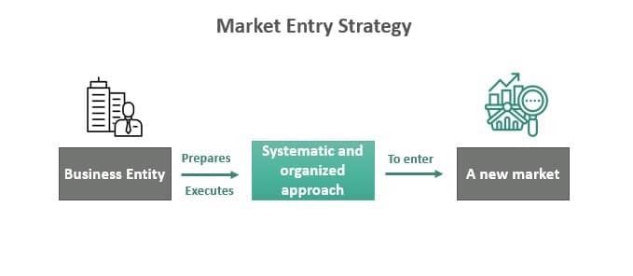
Wholly owned subsidiary method for market entry
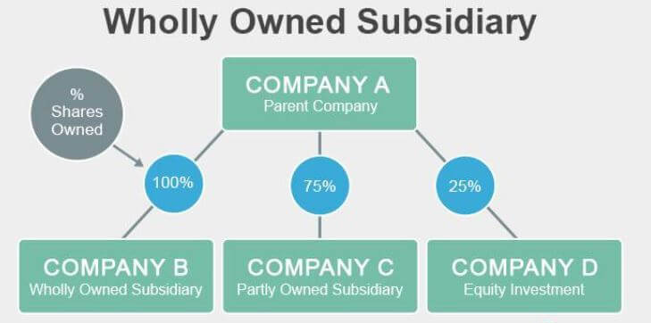
Advantages
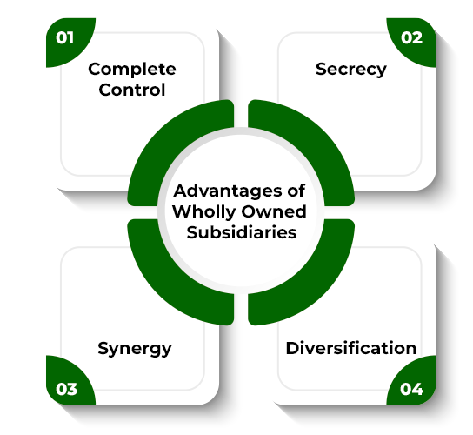
Source: (Tien, 2019)

