

BA BUSINESS MANAGEMENT
ASSESSMENT 2- Coursework

Module: DATA HANDLING AND BUSINESS INTELIGENCE
Code: LCBB5000
Lecturer: DR XAVIER MATIENI
Name: DANIELA CRISTINA AFILIU
Student ID: 2127996

SUBMITTED ON THE 9th May 2024

Table of Contents

Task 1

- How was the Sales Trend over the months?……………………………..3
- What are the most frequently purchased products?……………………………..4
- How many products does the customer purchase in each transaction?......6
- What are the most profitable segment customers?……………………….7

- How was the Sales Trend over the months?

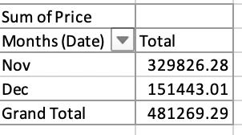

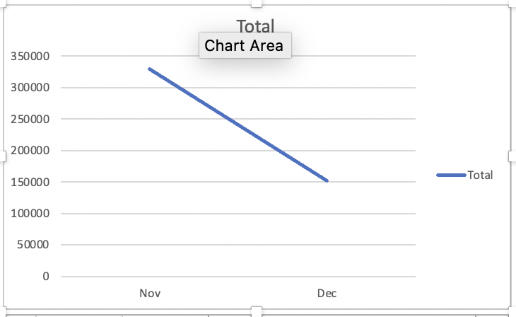

- What are the most frequently purchased products?

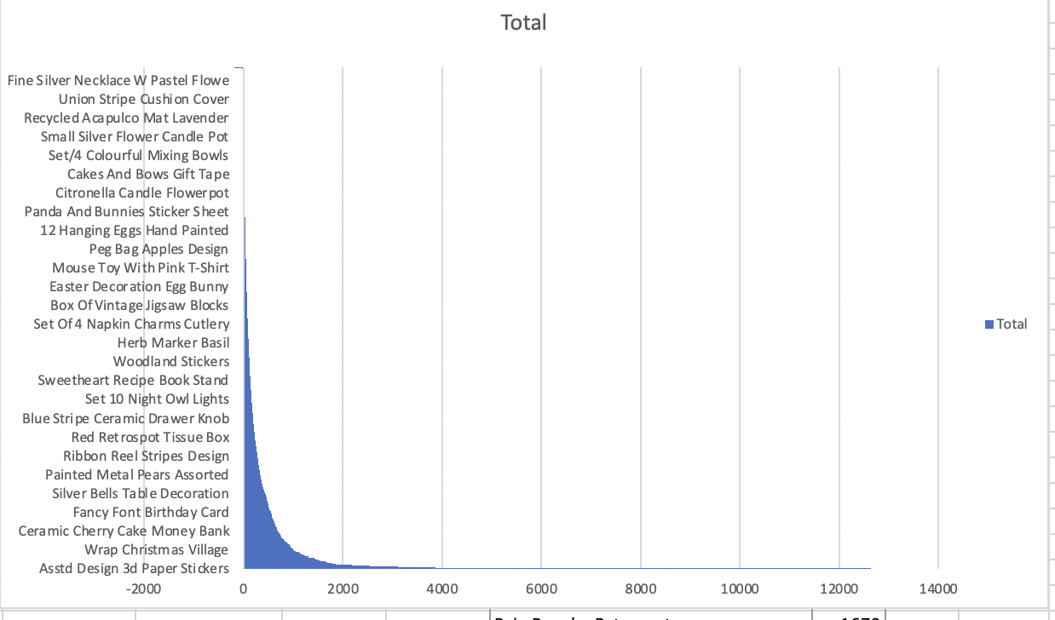
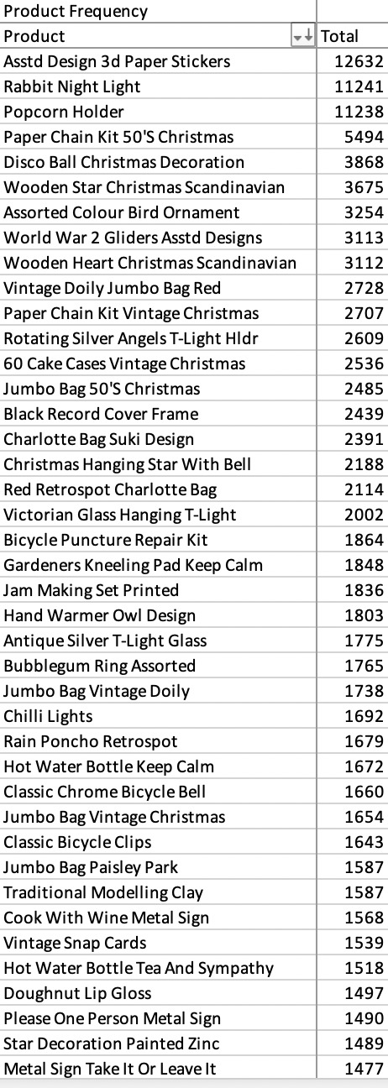

- How many products does the customer purchase in each transaction?
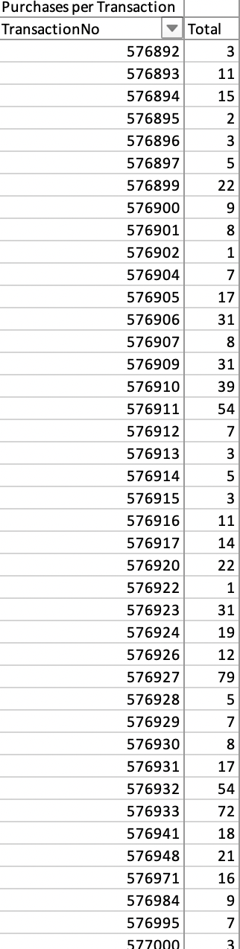

- What are the most profitable segment customers?



