
Applied Leadership and Management in the Workplace
Module Assignment Submission
Student Name: | Lauren King
Student Number: | 2418617
Module No: | BMSK5012
Module Title: | Understanding and Engaging in the Customer Experience

Statement of Confirmation of Authenticity
By the act of making this submission, the student declares that this is the work of the student named above. The work has not, in whole or in part, been knowingly presented elsewhere for assessment, or where assessment has been built on a previous assessment, this has been identified. Where materials have been used from other sources it has been properly acknowledged.
If this statement is untrue, the student acknowledges that an assessment offence has been committed.
Attention is drawn to the plagiarism and unfair practice policies of both the University and of ILM.

Table of Contents
BMSK5012 1
1. Introduction 3
2. Understanding Customer Relationships 3
2.1 Customer Loyalty 3
2.2 Customer Value 4
2.3 Managing Expectations 6
The Kano Model 7
Basic Needs 7
Performance Needs 8
Delighters 8
Application to Kings K9 Cuts 8
The MoSCow Model 8
2.4 Customer Centrality 9
2.5 Segmentation 10
2.6 Customer Relationship Management 11
3. Understanding Operational Quality Systems 12
3.1 Quality Models & Theories 12
3.2 Deming’s System of Profound Knowledge 12
3.3 Garvin’s Eight Dimensions of Quality 13
4. Connecting Quality to Customer Experience Outcomes 13
5. Conclusion 14
6. Recommendations 14
7. References 17

Introduction

As the owner of Kings K9 Cuts Dog Grooming Salon, I see first-hand how customer experience shapes satisfaction, loyalty, and long-term relationships. In a small service business, every interaction matters - from the way customers are greeted to the consistency of grooming outcomes, and the reassurance provided throughout the appointment. Understanding what customers value, how they form expectations, and what influences their trust is essential for delivering a reliable and positive experience.
This assignment explores key elements of customer experience that directly relate to my business, including customer loyalty, customer value, expectation management, customer centrality, segmentation, and Customer Relationship Management (CRM). It also examines operational quality through two theories that best support Kings K9 Cuts: Deming’s System of Profound Knowledge, which helps strengthen process consistency and continuous improvement, and Garvin’s Eight Dimensions of Quality, which explain how customers judge service quality. Together, these perspectives provide a practical foundation for analysing current practice and identifying opportunities to enhance reliability, trust, and long-term customer relationships within the salon.
Delivering a strong customer experience is increasingly recognised as a source of competitive advantage in service industries, particularly where trust, consistency, and emotional reassurance influence customer decision-making.

Understanding Customer Relationships

Customer Loyalty
Customer loyalty is a core element of customer experience, reflecting the extent to which customers remain committed to a brand, repurchase services, and advocate for the organisation. Loyalty is both behavioural - repeat purchasing, and attitudinal, which involves deeper emotional attachment, trust, and willingness to recommend. Attitudinal loyalty is more resilient and strongly linked to long-term retention and advocacy, making it essential for service-based businesses.
In an online statement, Geeksforgeeks (2024) stated that loyalty develops through several key factors. Trust is critical, especially in services where customers rely on professional expertise and consistent delivery. Trust grows through reliable performance, transparent communication, and fulfilling promises. Customer satisfaction also strengthens loyalty when expectations are met or exceeded, influenced by interaction quality, professionalism, and effective issue resolution. Perceived value contributes further, encompassing not only price but convenience, reassurance, personalisation, and the overall experience.
Emotional connection is increasingly recognised as a powerful driver of loyalty. Customers who feel understood and valued are more likely to form strong attachments and engage in advocacy through word of mouth and online reviews. This is particularly relevant for Kings K9 Cuts, where many customers return because they feel their dogs are understood, handled gently, and treated with consistent care.
Dhas, T. (2023) advises that consistency also plays a major role. Predictable service reduces uncertainty and reinforces trust, making customers more confident in returning. Quality systems such as Deming’s principles support this by reducing variation and strengthening process reliability.
Finally, loyalty is reinforced through relationship-building strategies such as personalised communication and proactive engagement. CRM systems enable organisations to track customer behaviour and preferences, supporting tailored interactions that make customers feel recognised and appreciated.
Overall, customer loyalty is shaped by trust, satisfaction, perceived value, emotional connection, and consistent service delivery. Organisations that actively nurture these elements are better positioned to build strong relationships and achieve long-term success.

Customer Value
Customer value reflects the balance between the benefits customers perceive and the costs they incur when engaging with an organisation. It includes functional, emotional, social, and experiential elements, all of which shape satisfaction, loyalty, and long-term relationship strength. When perceived benefits outweigh sacrifices such as price, time, or effort, customers experience high value and are more likely to return and recommend the service.
Service quality is a major driver of value. High-quality service increases confidence, reduces uncertainty, and enhances emotional reassurance. Models such as SERVQUAL highlight reliability, responsiveness, assurance, empathy, and tangibles — all central to how customers judge value. For a grooming salon, consistent, safe, and personalised care reduces perceived risk and strengthens value, while poor communication or inconsistency increases perceived sacrifices.
Convenience also contributes significantly. Clear communication, flexible booking, short waiting times, and streamlined processes reduce customer effort and frustration, making the service feel easier and more worthwhile. Emotional value further enhances perceptions, especially in trust-based services. When customers feel cared for and understood, emotional reassurance strengthens attitudinal loyalty and can outweigh minor inconveniences or price differences. At Kings K9 Cuts, streamlined booking, reminders, and predictable appointment flow reduce customer effort and strengthen perceived value.
Social value influences customers who prefer businesses aligned with their identity or values, such as ethical practices or community involvement. Fair and transparent pricing also shapes value; customers seek alignment between cost and quality rather than simply the lowest price.
Cantella, V. (2022) explains that expectation management plays a crucial role. When organisations set clear, realistic expectations and consistently meet them, perceived value increases. Unmet expectations create value gaps even when service quality is objectively high. Personalisation further enhances value by tailoring services to individual needs. CRM systems support this by storing customer preferences and enabling more relevant interactions.
In summary, customer value is shaped by service quality, convenience, emotional reassurance, social alignment, pricing fairness, expectation management, and personalisation. Organisations that actively strengthen these dimensions deliver higher-value experiences, supporting satisfaction, loyalty, and long-term relationship success.
The Customer Value Pyramid below illustrates how Kings K9 Cuts delivers value across functional, emotional, life-changing, and social impact levels.

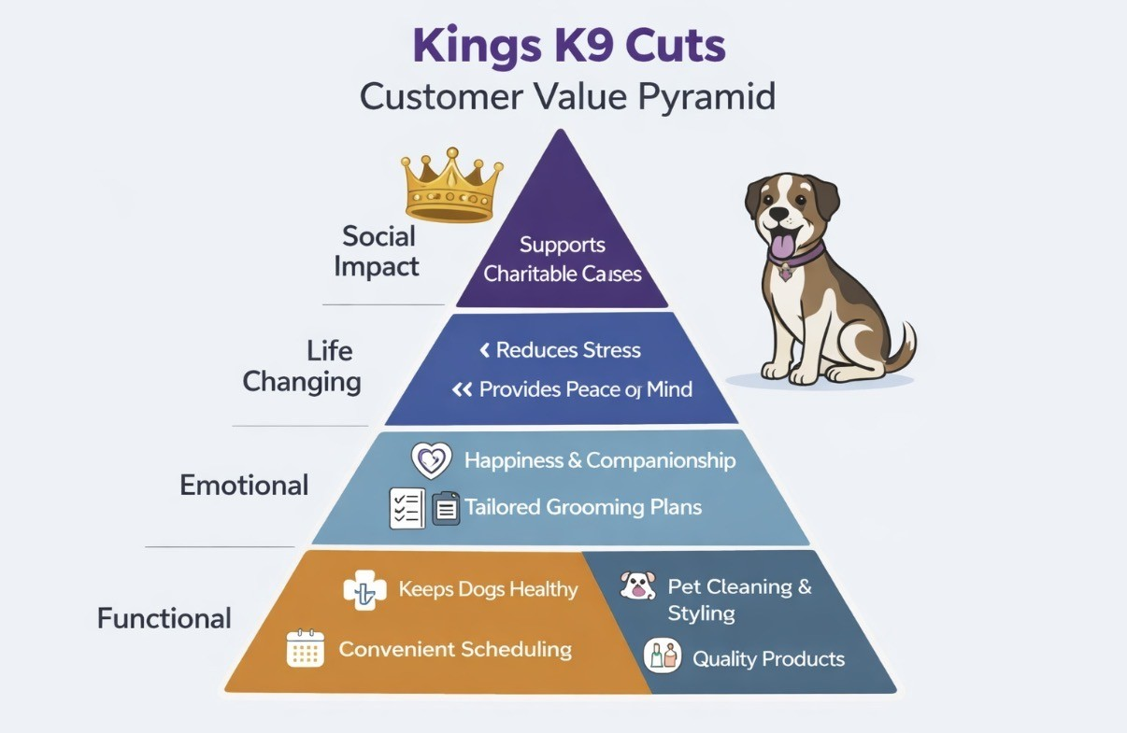

The Customer Value Pyramid reinforces how Kings K9 Cuts creates value across multiple levels of the customer experience. By combining functional reliability with emotional reassurance, life-changing support, and wider social impact, the model demonstrates that customer value extends beyond the grooming outcome itself. This layered perspective highlights how personalised care, consistent processes, and trust-building interactions contribute to stronger satisfaction, loyalty, and long-term relationship development within the salon.

Managing Expectations
Managing customer expectations is essential for creating positive and consistent customer experiences. Expectations shape how customers judge service quality, value, and satisfaction, meaning organisations must actively guide and align these expectations throughout the customer journey. When expectations are met or exceeded, customers feel reassured and satisfied; when they are not, dissatisfaction and mistrust can quickly develop.
Parasuraman, A. (1985) explains how customer expectations are influenced by past experiences, word-of-mouth, online reviews, and the organisation’s own communication. Marketing messages, website information, and staff interactions all signal what customers should anticipate. If these signals are unclear or unrealistic, customers may form expectations the organisation cannot meet, creating an expectation–performance gap. Even high-quality service can feel disappointing if it does not match what the customer believed they would receive.
Clear, honest communication is therefore central to managing expectations. Providing accurate information about processes, pricing, timings, and outcomes helps customers understand what will happen and reduces uncertainty. Zeithaml (2022) concludes that transparency builds trust and prevents misunderstandings. Consistency also plays a major role; when customers receive the same standard of service each time, their expectations stabilise, making the experience more predictable and satisfying. Quality systems such as TQM and Six Sigma support this consistency by reducing variation and ensuring reliable processes. Huettich, J. (2023).
Parasuraman (1985) suggests that personalisation further strengthens expectation management. Different customers have different needs and tolerance levels, so tailoring communication and service delivery helps align expectations more closely with individual preferences. CRM systems support this by enabling organisations to track customer behaviour and provide more relevant information.
Finally, managing expectations requires ongoing communication during the service journey. If circumstances change or delays occur, proactive updates help maintain trust and prevent frustration. When organisations handle changes professionally and transparently, customers are more likely to remain satisfied even if the original expectations cannot be fully met. For example, if a dog requires additional time or a change in grooming approach, Kings K9 Cuts provides proactive updates, helping maintain trust and prevent misunderstandings.
Overall, effective expectation management involves clear communication, consistency, personalisation, and proactive updates. Organisations that excel in these areas create more predictable and positive experiences, strengthening satisfaction and positive, long-term customer relationships.

The Kano Model
The Kano Model explains how different types of customer needs influence satisfaction and helps organisations prioritise improvements.

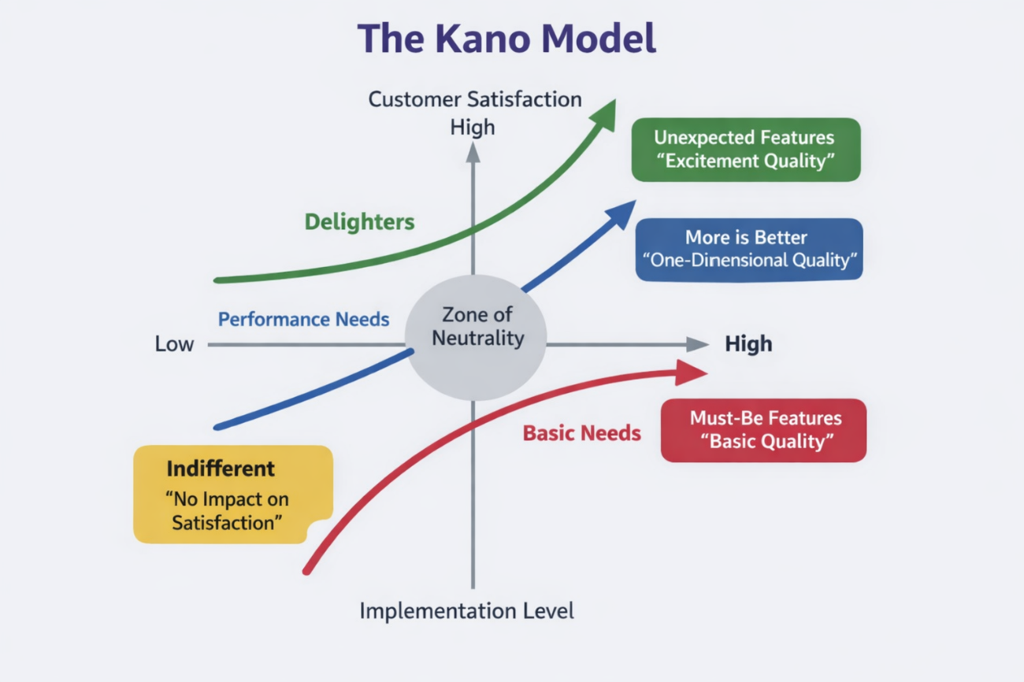

Basic Needs
Basic (must-be) needs are expected by customers. Their absence causes dissatisfaction, but meeting them does not increase satisfaction. For Kings K9 Cuts, these include safety and hygiene, correct handling, and reliable appointment management.

Performance Needs
Performance needs have a linear relationship with satisfaction: the better they are delivered, the happier customers become. At Kings K9 Cuts, this includes efficiency and responsiveness such as reduced waiting times, clear communication, and consistent grooming quality.

Delighters
Delighters exceed expectations and create strong positive emotional responses. Examples for Kings K9 Cuts include personalised updates, small finishing touches, or involvement in charitable activities.

Application to Kings K9 Cuts
Using the Kano Model helps the business focus resources effectively by ensuring basic standards are consistently met, performance areas are improved, and selected delighters are added to strengthen satisfaction and loyalty.

The MoSCow Model
The MoSCoW Prioritisation Method is a useful tool for identifying which service features or improvements should be prioritised based on their importance to customer experience and operational effectiveness.
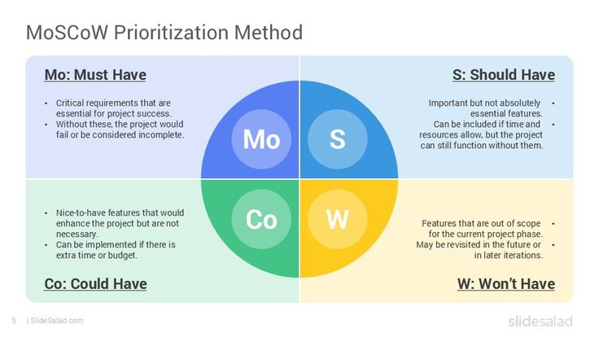
The MoSCoW prioritisation model enables structured decision-making by distinguishing essential requirements from desirable enhancements.
- Must-Have features are critical for service delivery and customer satisfaction (e.g., safety checks, reliable scheduling).
- Should-Have features add significant value but are not vital for immediate operation (e.g., automated reminders).
- Could-Have features offer potential improvements if resources allow (e.g., loyalty programme integration).
- Won’t-Have features are deferred or excluded due to limited relevance or feasibility. (for example, creative grooming).
For Kings K9 Cuts, the MoSCoW method supports decision-making by clarifying which aspects of the grooming experience are essential for customer satisfaction. Must-Have elements include safety, hygiene, and professional handling; Should-Have elements include flexible booking or reminder messages; Could-Have features involve photo updates or loyalty rewards; and Won’t-Have items represent ideas that are out of scope for the current stage of business development.

Customer Centrality
Customer centrality is an organisational approach that places the customer at the core of decision making, processes, and behaviours. Customer-centric organisations design their operations, culture, and value propositions around customer needs, preferences, and expectations, ensuring that every part of the business contributes to creating value and strengthening relationships. Laboisse, P. (2021).
A customer-centric approach begins with understanding who customers are and what they value. This requires gathering insights through feedback, behavioural data, and direct interactions. When organisations understand customer motivations and pain points, they can tailor services more effectively and adapt as needs evolve.
Customer centrality also involves aligning internal processes with customer priorities. Decisions about service design, communication, and workflow should directly support customer satisfaction — for example, simplifying booking, improving clarity, or reducing waiting times. This alignment relies on leadership commitment and a culture that values empathy, responsiveness, and accountability. Protheroe A. (2014).
Payne & Frow (2017) advise that cross-functional collaboration is another key element. Because customer experience spans multiple touchpoints, integrated processes are essential for delivering seamless and consistent service. Personalisation further strengthens customer centrality by recognising customers as individuals rather than generic segments. Customer Relationship Management systems support this by storing detailed customer profiles that enable more relevant and meaningful interactions.
Johnston & Kong (2011) advise that customer-centric organisations measure success using customer-focused metrics such as satisfaction, loyalty, retention, and advocacy. These indicators show how well the organisation meets customer needs and where improvements are required.
In summary, customer centrality is a strategic orientation that prioritises customer needs in organisational culture, processes, and decision-making. It relies on deep customer understanding, aligned operations, collaboration, personalisation, and customer-focused performance measures to deliver consistent, high-value experiences that support satisfaction and long-term loyalty.

Segmentation
Customer segmentation is the process of dividing customers into meaningful groups based on shared characteristics so organisations can tailor services and communication more effectively. It supports customer centricity by recognising that customers differ in needs, expectations, and behaviours (Payne & Frow, 2005). Segmentation strengthens the customer experience because personalised interactions increase perceived value, improve satisfaction, and support long-term loyalty.
Four main segmentation types are commonly used in service environments. Demographic segmentation groups customers by characteristics such as age or household type (Kotler, 1985). Geographic segmentation considers location and accessibility. Psychographic segmentation focuses on attitudes, values, and lifestyle, which strongly influence expectations in trust-based services (Holbrook, 1999). Behavioural segmentation groups customers by usage frequency, loyalty, or benefits sought and is often the most effective for small service businesses (Zeithaml, 1988).
Segmentation must be applied critically. Over-segmentation can create unnecessary complexity, while inaccurate or outdated customer data can lead to misaligned communication or poor service fit (Payne & Frow, 2005). Small businesses must therefore prioritise segmentation bases that are practical, meaningful, and aligned with operational capacity.
Segmentation is highly relevant to Kings K9 Cuts. Breed-based segmentation supports planning for different coat types, grooming needs, and temperaments. Behavioural segmentation distinguishes regular maintenance clients from occasional visitors, helping tailor communication and expectation management. Psychographic segmentation identifies owners who need reassurance versus those who prioritise efficiency. Service-need segmentation (e.g., puppies, elderly dogs, nervous dogs) ensures processes and communication are adapted to individual requirements. These approaches improve scheduling accuracy, enhance perceived value, and strengthen loyalty.
Segmentation links directly to Customer Relationship Management, as CRM systems store customer data and support personalised communication. Together, segmentation and CRM enable Kings K9 Cuts to deliver consistent, tailored, and high-quality customer experiences.

2.6 Customer Relationship Management
Customer Relationship Management supports customer centricity by ensuring that customer needs and behaviours are understood and used to inform service delivery (Payne & Frow, 2005). In service environments, CRM enables personalised, consistent, and high-value experiences that enhance satisfaction, loyalty, and advocacy.
CRM typically includes three components:
- Operational CRM — manages day-to-day interactions such as bookings, reminders, and communication.
- Analytical CRM — uses customer data to identify patterns, segment customers, and support decision-making.
- Strategic CRM — aligns customer insights with organisational goals and service design (Shah et al., 2006).
Together, these components create a complete picture of the customer journey and support tailored service delivery.
Barney N. (2025) suggests that CRM strengthens customer experience by storing detailed information such as service history, preferences, behavioural patterns, and communication needs. This supports personalisation, expectation management, and consistent delivery — reinforcing your earlier point that personalisation increases emotional connection and long-term loyalty. CRM also improves operational efficiency by reducing errors, supporting accurate scheduling, and ensuring staff have access to relevant information at each touchpoint.
However, CRM is only effective when data is accurate, up-to-date, and embedded into organisational culture. Poor data quality can lead to miscommunication, unmet expectations, and reduced trust (Payne & Frow, 2005). Small businesses may also face challenges such as limited resources or inconsistent data entry, so CRM must be simple enough to maintain yet robust enough to generate meaningful insight.
Customer Relationship Management is highly relevant to Kings K9 Cuts. The business relies on trust, reassurance, and personalised care. CRM supports this by storing information such as behaviour notes, coat condition, preferred grooming styles, health considerations, and owner communication preferences. This enables tailored interactions — for example, providing reassurance to anxious owners or adapting processes for nervous or elderly dogs. CRM also supports behavioural segmentation by identifying regular maintenance clients, occasional visitors, and first-time customers, allowing communication and expectation management to be adapted accordingly. Automated reminders, follow-up messages, and personalised updates further strengthen loyalty and perceived value.
According to Barney (2025), Customer Relationship Management also links directly to operational quality systems, which form the next part of your assignment. By reducing variation, improving consistency, and supporting data-driven decision-making, CRM becomes a foundation for delivering reliable, high-quality customer experiences.

Understanding Operational Quality Systems

Quality Models & Theories
Quality theories provide structured approaches for improving service reliability, reducing variation, and ensuring that customer needs are consistently met. In service environments, these frameworks help organisations understand what “quality” means from both operational and customer perspectives. Two theories are particularly relevant to King's K9 Cuts: Deming’s System of Profound Knowledge, which focuses on process stability and continuous improvement, and Garvin’s Eight Dimensions of Quality, which explain how customers evaluate service quality. Together, these theories offer a balanced foundation for improving both operational consistency and customer perception.

Deming’s System of Profound Knowledge
Deming’s System of Profound Knowledge provides a comprehensive framework for understanding and improving organisational quality. It consists of four interrelated components: appreciation for a system, knowledge of variation, theory of knowledge, and psychology (Deming, 1986). These principles emphasise that quality problems arise primarily from processes rather than individuals, meaning organisations must focus on improving systems rather than assigning blame.
For Kings K9 Cuts, Deming’s theory is highly applicable because grooming outcomes depend on consistent processes, safe handling, and predictable workflows. Knowledge of variation is particularly relevant: inconsistent coat assessments, unpredictable appointment lengths, or variable communication can reduce customer trust. By standardising procedures — such as pre-groom checks, safety protocols, and communication routines — the business can reduce variation and deliver more reliable experiences.
Deming’s emphasis on continuous improvement also aligns with the needs of a small grooming salon. Regular reflection on customer feedback, reviewing workflow challenges, and making small incremental changes support safer, smoother, and more predictable service delivery. His focus on psychology reinforces the importance of understanding both customer and dog behaviour, ensuring that interactions are empathetic, reassuring, and professional. Overall, Deming’s theory provides Kings K9 Cuts with a practical foundation for strengthening operational reliability and customer trust.

Garvin’s Eight Dimensions of Quality
Garvin’s Eight Dimensions of Quality offer a customer-focused framework for understanding how service quality is perceived (Garvin, 1987). The dimensions — including performance, reliability, conformance, durability, serviceability, aesthetics, and perceived quality — highlight that quality is multidimensional and shaped by customer expectations and experiences.
For Kings K9 Cuts, Garvin’s model is particularly valuable because customers judge grooming services not only by the technical outcome but also by emotional reassurance, professionalism, and communication. Reliability relates to consistent grooming results and predictable appointment timings. Serviceability reflects how effectively issues such as matting, behavioural challenges, or unexpected delays are managed. Aesthetics relate to the salon environment, cleanliness, and presentation, all of which influence perceived professionalism. Perceived quality is shaped by communication clarity, reassurance, and trust, which is essential in a service involving animal care.
Garvin’s model helps Kings K9 Cuts identify which aspects of the service experience matter most to customers and where improvements will have the greatest impact. While Deming supports process consistency, Garvin ensures that improvements align with customer expectations and strengthen satisfaction and loyalty.

Connecting Quality to Customer Experience
Outcomes
Deming, W. E. (1986) suggests that operational quality systems directly shape the customer experience because they determine how consistently, safely, and reliably services are delivered. High-quality processes reduce variation, prevent errors, and create predictable service outcomes, all of which strengthen trust, satisfaction, and perceived value. Operational reliability becomes a foundation for positive customer experiences.

Quality frameworks such as TQM, Six Sigma, Deming, Juran, and Garvin provide structured approaches for improving processes and embedding continuous improvement. Their shared focus on reducing defects, standardising procedures, and involving employees in quality enhancement directly supports customer expectations of professionalism, clarity, and reliability.
Critically, quality systems enhance customer value by improving functional and emotional aspects of the service. When processes are stable and communication is clear, customers perceive greater reassurance, reduced risk, and higher overall value. Quality also supports personalisation by ensuring core processes are consistent while allowing flexibility for individual needs.
For Kings K9 Cuts, quality systems underpin safe handling, consistent grooming outcomes, accurate scheduling, and clear communication. By integrating quality principles with CRM and segmentation, the business can deliver experiences that are reliable, personalised, and aligned with customer expectations, strengthening loyalty and long-term relationships.

Conclusion
This assignment has demonstrated that customer experience is shaped by multiple interconnected factors, including loyalty, value, expectations, customer centrality, segmentation, and CRM. Together, these concepts highlight the importance of understanding diverse customer needs, delivering personalised interactions, and ensuring consistent, trustworthy service delivery. For Kings K9 Cuts, these elements are particularly significant because customers rely on the business not only for functional grooming outcomes but also for emotional reassurance, safety, and professionalism.
Operational quality systems play a critical role in supporting these customer experience principles. Models such as TQM, Six Sigma, Deming, Juran, and Garvin provide structured approaches for improving reliability, reducing variation, and aligning processes with customer expectations. After evaluating these frameworks, TQM and Six Sigma emerge as the most suitable for Kings K9 Cuts due to their practicality, customer focus, and ability to strengthen consistency and operational efficiency.
By integrating customer experience concepts with appropriate quality models, Kings K9 Cuts can enhance satisfaction, build stronger positive relationships, and support long-term loyalty. A combined approach that prioritises personalisation, clear communication, and continuous improvement will enable the business to deliver high-value, predictable, and emotionally reassuring experiences that meet the needs of both dogs and their owners.

Recommendations
Kings K9 Cuts can strengthen customer experience and operational reliability through the following targeted actions, aligned with TQM, Six Sigma, CRM, segmentation, and quality theory.
Adopt a TQM-based continuous improvement approach - implement simple review cycles and standardised procedures to reduce variation and enhance consistency, reflecting Deming’s (1986) emphasis on organisation-wide quality. Use checklists and SOPs to support predictable grooming outcomes.
Apply Six Sigma to key operational processes - use DMAIC to improve scheduling, coat assessments, and workflow efficiency. Six Sigma’s structured method reduces defects and variation (Pyzdek & Keller, 2014), supporting clearer expectation management and more reliable service delivery.
Strengthen CRM for personalisation and expectation management - ensure customer records consistently capture behaviour notes, coat condition, and communication preferences. CRM supports personalised service and improved insight (Payne & Frow, 2005). Tailor communication for maintenance clients, occasional visitors, and first-time owners.
Standardise communication to improve clarity and trust - use consistent templates for booking confirmations, guidance, and aftercare. Clear communication strengthens perceived quality and professionalism (Garvin, 1987). Provide structured updates for nervous dogs and elderly dogs.
Use segmentation to tailor service delivery - apply behavioural, breed-based, and service-need segmentation to personalise grooming experiences (Kotler, 1985; Payne & Frow, 2005). Develop tailored processes for puppy grooms, reactive dogs, and high-maintenance coats.
Introduce simple quality monitoring tools - use grooming outcome reviews, safety logs, and post-service reflections to support continuous improvement (Deming, 1986; Pyzdek & Keller, 2014). Apply Garvin’s dimensions to assess reliability, professionalism, and perceived quality.

References
Barney N, Hashemi-Pour C, Chai W. What is CRM (customer relationship management)? Search Customer Experience. Published February 12, 2025. https://www.techtarget.com/searchcustomerexperience/definition/CRM-customer-relationship-management
BBC Bitesize. What is customer satisfaction? BBC Bitesize. Published 2026. https://www.bbc.co.uk/bitesize/guides/zy79b82/revision/1

Edvardsson, B., & Tronvoll, B. (2022). The palgrave handbook of Service management. Springer International Publishing AG.

Cantella, V. (2022). Managing expectations (so they don’t manage you). In Science of People. https://www.scienceofpeople.com/managing-expectations/

Dhas, T. (2023). At the workplace, consistency is a crucial component of success. It demands maintaining a consistent and dependable approach to duties, obligations, and behaviours. In Linkedin.com. https://www.linkedin.com/pulse/power-consistency-workplace-advantages-disadvantages-tena-dhas/

EMEA, S. (2023). Customer centricity: What is it and how to achieve it? In Salesforce. https://www.salesforce.com/eu/blog/customer-centricity-how-to-achieve/

Freedman, M. (2024). Your best asset: What makes customer loyalty so important? In business.com. https://www.business.com/articles/what-makes-customer-loyalty-so-important/

Freedman M. What Makes Customer Loyalty So Important. business.com. Published February 15, 2016. https://www.business.com/articles/what-makes-customer-loyalty-so-important/
GeeksforGeeks. (2024). Customer loyalty: Meaning, types, importance and strategies. In GeeksforGeeks. https://www.geeksforgeeks.org/marketing/customer-loyalty-meaning-types-importance-and-strategies/
Huettich, J. (2023). Managing customer expectations: The complete guide. In Official Teamly Blog - Official Teamly Blog - Your Project Management Resource. https://www.teamly.com/blog/managing-customer-expectations/
Laboisse, P. (2021). Five steps to achieve Customer-Centricity and success for your company. Forbes. https://www.forbes.com/councils/forbesbusinessdevelopmentcouncil/2021/12/30/five-steps-to-achieve-customer-centricity-and-success-for-your-company/

Lucas DevSamurai. Understanding the MoSCoW prioritisation | How to implement it into your project. Atlassian Community. Published August 30, 2023. Accessed July 5, 2026. https://community.atlassian.com/forums/App-Central-articles/Understanding-the-MoSCoW-prioritization-How-to-implement-it-into/ba-p/2463999

Protheroe A. (2014) Customer relationship management platform selection guide. Infotech.Com. https://www.infotech.com/sem/lp2/customer-relationship-management-platform-selection-guide?utm_source=bing&utm_medium=cpc&_bt=&_bk=customer%20relationship%20management%20platform&_bm=b&_bn=o&_bg=1300723429771877
Dr W Edwards Deming, 1982 & 1986, Out of the crisis: productivity and competitive position, Cambridge University Press, Cambridge.
Garvin, David .A, “Competing on the Eight Dimensions of Quality”, Harvard Business Review, November-December 1987.
Five Forces CRM Model - CIO Wiki. Cio-wiki.org. Published 2024. Accessed July 19, 2026. https://cio-wiki.org/wiki/Five_Forces_CRM_Model
‌Juran, J. and Gryna, F. , 1988. Juran’s Quality Handbook. 4th edition. McGraw-Hill Education.
Parasuraman, A., Zeithaml, V.A. and Berry, L.L. (1985) ‘A conceptual model of service quality and its implications for future research’, Journal of Marketing, 49(4), pp. 41–50.
Payne & Frow (2017) Payne, A. and Frow, P. (2017) Strategic Customer Management: Integrating Relationship Marketing and CRM. 2nd edition. Cambridge: Cambridge University Press.
Porter, M. E. (1985). Competitive advantage: Creating and sustaining superior performance. Free Press.
Pyzdek, T., & Keller, P. A. (2014). The Six Sigma handbook: A complete guide for Green Belts, Black Belts, and managers at all levels (4th ed.). McGraw-Hill Education.
Shah, D., Rust, R. T., Parasuraman, A., Staelin, R., & Day, G. S. (2006). The path to customer centricity. Journal of Service Research, 9(2), 113–124.
Zeithaml VA. Consumer Perceptions of Price, Quality, and Value: A Means-End Model and Synthesis of Evidence. Journal of Marketing. 1988;52(3):2-22. doi:10.1177/002224298805200302

