Module name: Hotel Placement Research Project
Module code: BMIH6008
TOPIC: WASTE NOT, WANT NOT: ASSESSING AND ENHANCING SUSTAINABLE PRACTICES ACROSS DEPARTMENTS AT DOUBLETREE BY HILTON
Student name: Georgiana Pangonis
Student number: 2245303
Institution: Hospitality and Tourism Management, Institute of Management and Health
Supervisor: Ka Po Chong
Date: 26.02.2025

Declaration
I hereby state that the chosen research study has been conducted in an authentic manner and represents any individual efforts and analysis. In completion of the study and addressing the study objectives, no external tools including artificial intelligence have been utilised. The sources and materials used for the research conduction have been appropriately acknowledged through citations. Only Grammarly has been used for strengthening the authenticity of the research.

Acknowledgement
I am deeply grateful to all those who contributed to this research. I especially thank my supervisors, module leaders, and peers for their invaluable support and guidance, which were critical to the successful completion of this study. Finally, I would like to thank my family and friends for their unwavering faith in me and their constant encouragement throughout this endeavour.
Abstract
The research has been conducted to address the scope, methods, barriers and interventions pertaining to sustainability approaches within the hospitality industry. UK hospitality faces an increasing concern of waste generation, especially food wastes. Hotels are major contributors in mixed-waste generation of which a significantly lower portion is recycled. The study has integrated the issue of rising waste with negative environmental impacts involving high energy consumption, increased carbon emission and inefficient use of technologies.
Scope of the study
Introduction chapter focussed on the study background with analysis of the aim and objectives pertaining to the research questions. The chapter has highlighted the rationale for conducting the study in respect to the key issue identified as stated in the problem statement. The entire content of the study has been demonstrated in this chapter.
The literature review section has drawn elaborately in relevant information that addressed the research objectives. In order to analyse the related information, thematic analysis has been chosen for the research. The chapter has been divided into four relevant themes for exploring the scope of sustainability in the context of the UK hospitality sector. The chapter identified key barriers that hotels face in incorporating eco-friendly strategies along with interventions strategies to address the same. The literature review section has incorporated relevant theoretical applications for assessing the sustainability application in hotel service delivery to its guests. The conceptual framework has outlined the core idea and objectives of the study aligned with the research objectives.
The methodology chapter has outlined the data collection and analysis processes. The chapter has focused on the way secondary data has been collected and used for addressing the research questions. For this purpose, a research onion framework by Saunders has been applied. The chapter includes the philosophy, approach, data collection methods and ethical considerations relevant in the study conduction.
Key Findings
- Sustainability plays a pivotal role in cost optimisation and increasing operational efficiency at Double Tree Hotel by Hilton.
- Sustainability incorporation in daily practices have positively impacted the business operations for the chosen hotel.
- Cost pressures, gaps in management and constraints to change are the key barriers in sustainability implementation within service delivery for guests.
- Utilisation of Government support, providing green training to employees and efficient utilitarian technologies have been identified as the key mitigation measures in respect to the identified barriers.
Conclusion
The research conduction has inferred that Double Tree Hotel by Hilton needs to strengthen its suitable business practices. For this purpose, the business needs to focus on increased energy efficiency, training and knowledge sharing among staff and increased investment in eco-friendly hotels operations. Furthermore, collective engagement among all stakeholders including the guests have been concluded significant for Double Tree Hotel by Hilton.
Recommendations
The key recommendations derived from the study includes the need for better implementation of environmental regulations in service delivery by hotels to its guests. Furthermore, the research has drawn light on the significant role of the Government in bridging the gap between planning and practice of eco-friendly service delivery of Double Tree Hotel by Hilton.
Table of Contents
Chapter 1: Introduction 7
Background of the Study 7
Overview of the case study 7
Rationale of the Research 8
Aim, Objectives and Research Questions 8
Aim 8
Objectives 8
Research Questions 8
Key Themes to be explored 9
Chapter 2: Literature Review 10
Analysis Based on Themes 10
Importance of Sustainable Practices in the Hospitality Sector 10
Effects of Sustainable Practices on the Hospitality Industry 11
Issues in the Implementation of Sustainable Approaches in the Hospitality Business 11
Mitigation Strategies against the Identified Issues 12
Theoretical Framework 12
Lean Management Theory 12
Waste Minimisation Theory 13
Literature Gap 14
Chapter 3: Methods 15
Research Onion 15
Research Philosophy 15
Research Approach 16
Research Design 16
Data Collection Process 16
Data Analysis Process 16
Ethical Considerations 16
Chapter 4: Findings and Discussion 18
Findings 18
Introduction 18
Detailed Presentation of the Results 18
Summary 22
Discussion 22
Introduction 22
Objective reporting and discussion 23
Implications for DoubleTree by Hilton 28
Limitations of the study 28
Chapter 5: Conclusion and Recommendations 28
Conclusion 28
Recommendations 30
Investment in energy-efficient technologies 30
Digital transformation 31
Green training 32
Implementation of eco-friendly regulations 33
Reference List 34
Appendices 43
Appendix 1: Sustainable Tourism 43

Chapter 1: Introduction

Background of the Study
The UK tourism sector generates approximately 3.4 million tonnes of waste annually with 48% recycled waste (Wastemanaged.co.uk, 2026). These factors are believed to be useful for attracting environmentally conscious consumers and providing them with a sustainable stay experience (Lee and Huang, 2023). The management of DoubleTree by Hilton has also been seen to adopt sustainable practices in its daily activities. It has adopted the ‘Travel with Purpose’ strategy, which has been suitable for ensuring sustainability in the check-in, staying and dining facilities (Travelwithpurpose.hilton.com, 2026). The UK government drives SDG-aligned, sustainable hospitality through the Environment Act 2021. This has targeted a 50% reduction in per capita residual waste by 2042 and Net Zero by 2050.

Overview of the case study
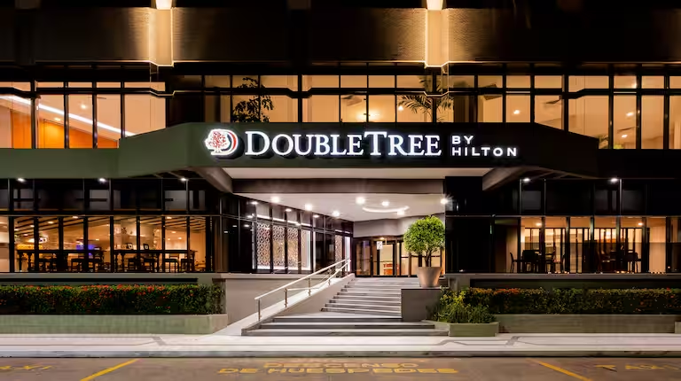
Figure 1: Case study on DoubleTree by Hilton
(Source: Stories.hilton.com, 2026a)
Hilton Hotels Group is one of the leading organisations in the United Kingdom that provides dedicated hospitality services to consumers. The firm has been able to achieve the 1st rank as the best workplace in the global marketplace with the help of well-managed 1.3 million rooms across all its properties (Hilton.com, 2026). Hilton is identified as the major hospitality leader reducing waste through its ‘Travel with Purpose’ ESG strategy that aims for a 50% reduction in waste by 2030 (Stories.hilton.com, 2026a). Currently, the selected brand has faced food waste reduction issues. However, Hilton has adopted the Green Ramadan Program that takes part in reducing food waste over 20% in participating hotels.

Rationale of the Research
This study is significant in identifying the current sustainability issues within the UK hospitality and hotel sector. More specifically, focusing on the current sustainability issues in DoubleTree by Hilton Coventry. This can enhance the credibility of the firm to collect the long-term profitability and save the surplus amount of operational cost (Muyiwa-Ajayi, Sobowale and Augoye, 2024). These can be invested in enhancing the quality of the consumer experience and attracting the eco-conscious customers. There have been some gaps in the previous research works, which failed to address the needs and requirements for enhancing sustainability. On this note, DoubleTree Coventry has been faced with some challenges in its daily operations, including complicated waste management and infrastructure issues. This research will focus on addressing these issues and evaluating the importance of sustainability maintenance in the chosen hospitality facility in the UK.

Aim, Objectives and Research Questions

Aim
The aim of the research is to analyse the sustainable practices across different departments at DoubleTree by Hilton in the UK market.

Objectives
- To assess the importance of sustainable practices at DoubleTree by Hilton in the UK market.
- To evaluate the effects of maintaining sustainability in the daily practices of DoubleTree by Hilton in the UK local market.
- To address the issues that can hamper the sustainable practices at DoubleTree by Hilton in the United Kingdom.
- To recommend a set of strategies to mitigate the identified issues in implementing the sustainable practices at DoubleTree by Hilton in the UK.

Research Questions
- Why is it important to maintain sustainable practices at DoubleTree by Hilton in the UK?
- What are the effects of including sustainability in the regular operations of DoubleTree by Hilton in the UK local market?
- Which issues can have a negative influence on the sustainable approaches of DoubleTree by Hilton in the UK local market?
- How can the management of DoubleTree by Hilton mitigate the identified issues in ensuring sustainability in the regular operations of DoubleTree by Hilton?

Key Themes to be explored
- Importance of Sustainable Practices in the Hospitality Sector
- Effects of Sustainable Practices on the Hospitality Industry
- Issues in the Implementation of Sustainable Approaches in the Hospitality Business
- Mitigation Strategies against the Identified Issues

Chapter 2: Literature Review

Analysis Based on Themes

Importance of Sustainable Practices in the Hospitality Sector
The research of Karvounidi, Alexandropoulou and Fousteris (2024) has been useful to understand the importance of maintaining sustainable practices in the hospitality facilities. It has been seen that the sustainability practices are crucial for the managerial staff to enhance energy efficiency in regular operations. However, Heydari, Heydari and Amini (2023) stated that the authorities, in this case, are required to focus on determining the patterns of energy consumption and identifying the factors that can influence the same. This type of approach is useful for reducing the number of negative impacts on the environment.
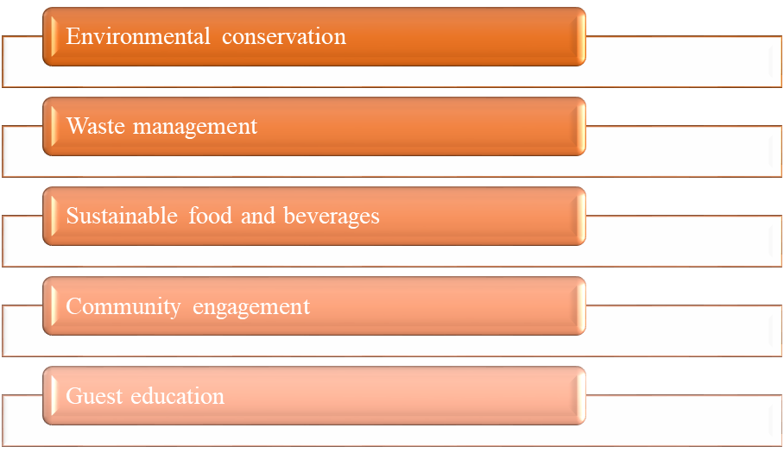
Figure 2: Sustainable practices in the UK hospitality sector
On the other hand, Kholijah (2024) has recorded in an investigation that the incorporation of green practices in the hospitality sector is effective for increasing the credibility of the facilities to address the changing market preferences. However, Diaz-Farina, Díaz-Hernández and Padrón-Fumero (2023), stated that the management of different organisations within the hospitality sector can respond appropriately to reduce the scale of waste production. This is expected to be useful for the hospitality facilities to reduce the operational costs. The UK government has set a legally binding target for net-zero carbon emission by 2050 (Parliament.uk, 2026). This has impacted the hospitality sector to increase pressure of sustainable practices with 80% of the UK public concerned about climate change.

Effects of Sustainable Practices on the Hospitality Industry
According to Velaoras et al., (2025), sustainable practices assist in enhancing the financial performance of the hospitality industry. In this aspect, Savale et al., (2023) opined that growing consumer demand for eco-friendly options directly influences businesses to increase sustainable practices. As a result, the hospitality industry is directly boosting revenue and reducing operational costs. This has impacted diverse departments of the hospitality sector by influencing them to adopt eco-friendly practices. For instance, Whitbread UK has collaborated with the Diversey Care providers to enhance the use of chemical cleaning and sanitising products (Whitbread.co.uk, 2026). As a result of the use of 24-pack cartridges, the brand reduced packaging waste and shipping emissions.
On the other hand, Stecula and Mateusz (2025) argued that rapidly growing concerns about the sustainable experiences of the tourists reduce amenity options, which may be perceived negatively by the guests. However, Mansoor, Jam and Khan (2025) argued that educating guests on the importance of sustainable practices in the hospitality industry can be effective in enhancing customer engagement. The Scarlet Hotel has focused on engaging consumers in communicating the importance of maintaining sustainable approaches within the hospitality facilities. In this case, they are also providing the consumers with luxury experiences based on eco-friendly practices (Scarlethotel.co.uk, 2026). These practices are effective for different departments of the hospitality sector that reduce long-term operational costs and meet customer demand.

Issues in the Implementation of Sustainable Approaches in the Hospitality Business
It can be understood from the research work of Tanveer, Yusliza and Fawehinmi (2024) that green human resource management and other operational practices can face different issues. The primary issue in this context can be the high initial cost for the implementation of environmentally friendly approaches in the hospitality industry. The high initial cost for the implementation of sustainable practices in a hotel business can create financial risks for the organisation. The higher implementation costs in the selected business sector can also increase the training and operational expenditure for the concerned hospitality businesses (Hyasat, Al-Weshah and Kakeesh, 2022). Lisini Pub Co in Scotland has encountered this issue in its daily operations, which affected its credibility in real-time transactions (Netzeronow.org, 2026). Contrarily, the lack of quality in the guest experiences is also encountered to have a negative influence on the incorporation of eco-friendly propositions of different hospitality facilities. The investigation of Singh et al., (2023) has determined that the lack of service quality in the hospitality sector can decrease the scale of consumer satisfaction. This can reduce the amount of loyalty among the potential consumer base within the local and international markets. As a result, the changing market situations and shifts in consumer preferences can be found to be conflicting with each other (PJ et al., 2023). This can lead to abandoning the green measures and avoiding negative reviews from customers.

Mitigation Strategies against the Identified Issues
The governing bodies of the hotel and hospitality industry should take proper measures to mitigate the identified issues through the inclusion of sustainable practices. It has been mentioned in the research outcomes of Julião, Reis and Duarte (2025) that the most suitable approach for the hospitality industry in the mentioned accord can be to include low-cost initiatives. Although the measures can be projected to incur a low budget, the impacts of the initiatives are required to be of strong influence. This type of constructive approach can have a positive impact on gradually reducing the operational expenses of the organisations (Omowole et al., 2024). The management should focus on improving the brand image and green visibility in the market to enhance the scale of consumer loyalty and satisfaction. The investigations of Lin, Nugraha and Hsu (2025) have been crucial for understanding the fact that adherence to sustainable development goals and green initiatives can increase the scale of customer loyalty. The eco-friendly approaches of the hospitality facilities in the market can contribute to enhancing the brand image with greater efficiency.

Theoretical Framework

Lean Management Theory
The theory of Lean Management is a philosophical approach for a business organisation that can guide the maximisation of customer value. This is expected to be done with the help of minimising the produced wastes. This can lead the management of the concerned firm towards improving organisational efficiency and creating value for buyers (Ghouri and Falah, 2023). There are a few aspects linked to the Lean Management Theory that can positively influence the lean management procedure.
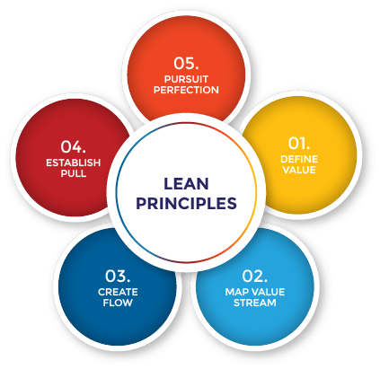
Figure 3: Lean Management Theory
(Source: Theleanway.net, 2026)
This includes the identification of value, mapping the value stream, creating the flow of value, establishing a stable workflow and improving perfection in operations and consumer engagement approaches (Knaster, Pereira and Shalloway, 2024). The practical application of Lean Management Theory can help the authorities of a workplace to engage the active employees to determine and fix the internal issues (Hines et al., 2022). Contrarily, the lean management incurs a prohibitive cost for implementation. It can also increase pressure on the employees, which can disrupt the supply chain due to the low level of inventory management.

Waste Minimisation Theory
The Waste Minimisation Theory is useful for reducing the amount of waste from the sources used as raw materials to produce a product or a service. This can be effective for reusing the wasted material through recycling (Awogbemi, Kallon and Bello, 2022). The core objective of the Waste Minimisation Theory is to reduce the amount of waste from the production line and ensure appropriate disposal of the same.
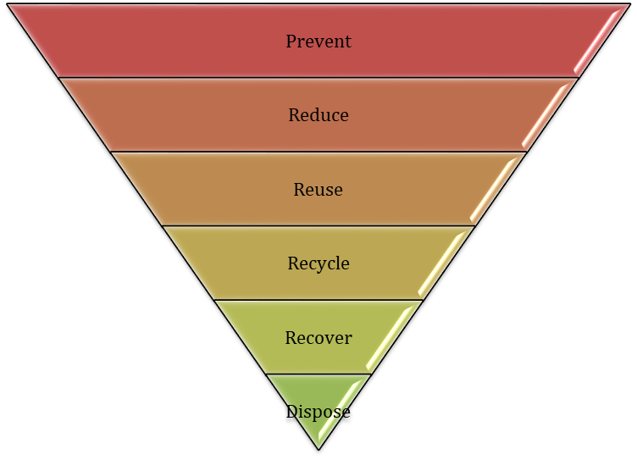
Figure 4: Waste Minimisation Theory
The practical implementation of the Waste Minimisation Theory can contribute to lowering the cost of waste disposal and gradually decreasing the cost of purchasing raw materials (Tseng et al., 2025). On the note of contradiction, the application of Waste Minimisation Theory has a few technical limitations that can have a negative influence on the waste reduction process.

Literature Gap
The past literature lacks a clear idea of the issues that can have a negative impact on adherence to the green initiatives in the hospitality sector. Existing research focuses on sustainability trends, theoretical frameworks and general industry challenges. However, there is clear absence of empirical analysis on how the selected hotel contributes to reduce waste and support the wider sustainable agenda of the UK.

Chapter 3: Methods

Research Onion
The investigation has applied the Research Onion framework for proceeding with the selection of the most suitable methodology.
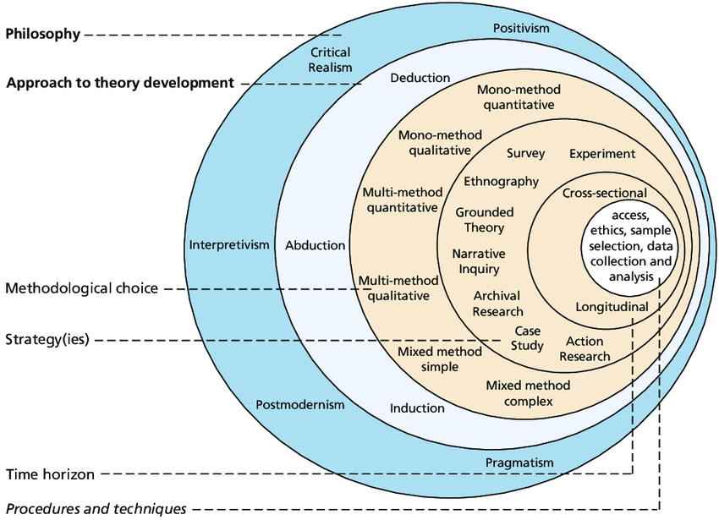
Figure 5: Research Onion
(Source: Saunders, Lewis and Thornhill, 2007)
This framework is suitable for guiding research to enhance coherence and robustness in the methodological approaches in an investigation (Ghazinoory, Zadegan and Phaal, 2025). Application of the research onion is useful for clarifying the choices of methods for promoting consistency (Saunders, Lewis and Thornhill, 2007). In return, it can boost the rigour of the analysis. Further, the systematic structure of the research can enhance the validity, flexibility and adaptability of the outcomes.

Research Philosophy
The interpretivism research philosophy has been used in this research to study and interpret all the elements of the research to understand the human interests. It has been useful for encouraging in-depth analysis of the most suitable dataset (Ikram and Kenayathulla, 2022). It has been beneficial for the research to fathom the hidden meanings of the collected information. In terms of supporting deeper interpretation of human experiences and organisational behaviour, this philosophy will be beneficial.

Research Approach
The deductive research approach has been implemented in this investigation to incorporate a certain themes or conceptual understanding. This approach is crucial for evaluating their validity and reliability for proceeding forward with the evaluation process (Fife and Gossner, 2024). The outcomes of the deductive reasoning can be beneficial for the research to analyse the collected set of information to form a new and suitable theory and a framework.

Research Design
The descriptive research design has been crucial in this research to foster a better scale of observation. It is suitable to link the outcomes with the most suitable patterns that can discover the appropriate findings. The process of leveraging observation is suitable for increasing efficiency in the data collection process (IYANUOLUWABlessing, Henry and Micheal, 2024). This can contribute to maintaining a cost-effective and comprehensive approach to improve validity in the outcomes of the research.

Data Collection Process
Collecting the most important set of information is the foundational step for gathering crucial evidence to make informed decisions (Khalid et al., 2023). Such a constructive approach is expected to be useful for the investigation to validate the conclusions. The secondary qualitative data collection process has been helpful in this assignment to collect the most relevant data. This approach has helped to save time and resources for collecting information and addressing the patterns in it (Cheong et al., 2023). It can lead to maintaining the significance of the collected information with the topic of research.

Data Analysis Process
Analysing the collected data is the most crucial step for recognising the patterns that can influence the outcomes of the investigation. This research has applied the thematic analysis method for linking the results of the research with the themes and objectives of the investigation. The thematic analysis process is credible for getting a clear understanding of the insight that can communicate the consequences of conducting research (Ahmed et al., 2025). The thematic analysis procedure is effective for maintaining flexibility in the data collection and analysis process. It can lead to enhancing the research skills and accommodating various levels of experience, which can contribute to improving the quality of the results.

Ethical Considerations
The research has strictly adhered to the collection of informed consents that can foster clarity and brevity in conducting the entire process with greater efficiency. The collected data and the coherent patterns have been taken into proper custody and protection till the time of the official publication of the report. The UK Data Protection Act 2018 will assist in managing ethical consideration by enforcing principles of fairness, transparency and accountability in data processing.

Chapter 4: Findings and Discussion

Findings

Introduction
This chapter will focus on the identification and illustration of major findings pertaining to sustainable practices in the DoubleTree Hotel by Hilton. The discussion associated with the key findings will be based on secondary qualitative data. The key findings are aligned with the objectives of the study, and information is gathered from authentic, peer-reviewed sources. The information will be presented in the form of a thematic analysis that addresses the questions undertaken for the study. Four prominent themes have been created pertaining to the research objectives focusing on sustainable practices, their impact on the Hilton Hotel, associated challenges and intervention strategies.

Detailed Presentation of the Results
Theme 1: Significance of sustainable practices at DoubleTree by Hilton
Incorporation of green practices enhances credibility in hotel services. It facilitates energy efficiency, cost reduction and automation of service delivery in hotels. In the contemporary period, adopting sustainable practices aids waste management and optimised resource utilisation. In this context, the incorporation of sustainable practices at DoubleTree by Hilton will increase staff engagement and communication of information to the guests. It motivates green consumerism and addresses dynamic customer needs through hotel services (Stecula and Mateusz, 2025). In the long term, this strategy helps in bridging the gap among the key stakeholders engaged in optimised service of the hotel group. Therefore, sustainable practices play a crucial role in optimised service delivery by hotels.

Figure 6: Sustainable tourism certification of Double Tree Hotel by Hilton
(Source: Doubletree-queensferry.co.uk, 2026)
The review of sustainability practices in the hotel industry is relevant in the context of the DoubleTree Hotel by Hilton. Hilton Group of Hotels are developed with Sustainable Design Checklists for better operations and energy efficiency (Travelwithpurpose.hilton.com, 2026). The plan involves providing sustainable amenities to guests, such as electronic charging devices and Digital Keys. In its strategy, Hilton Group of Hotels focus on the reduction of plastic waste through local sustainable practices.
In the specific context of the DoubleTree Hotel, eco-friendly practices involve the 'Hilton Light Stay' initiative that emphasises energy tracking, water and waste management. DoubleTree Hotel has leveraged the use of phosphate and chlorine-free cleaning products and microplastic laundry detergents to support its ethical and sustainable hospitality goals (Doubletree-queensferry.co.uk, 2026). Ferry toll Car Park provides electric charging facilities to guests (Doubletree-queensferry.co.uk, 2026). DoubleTree Hotel by Hilton has adopted the above initiatives to enhance sustainable practices.
In addition, DoubleTree Hotel by Hilton implements the 'Light Stay' corporate management system. It facilitates better performance tracking and the adoption of sustainable practices across all its hotels. Light Stay provides real-time data on efficient energy use, water and waste management (Etedge-insights.com, 2026). This initiative has helped DoubleTree by Hilton to reduce its environmental impact and maximise integrity in operations. In addition, the hotel has established its 'Green Team' for strengthening the eco-accreditation journey (Axiomhospitality.com, 2026). The team has secured 'Green Tourism Gold' as a part of its Greengage Eco Smart certifications (Axiomhospitality.com, 2026). Therefore, sustainable practices play a significant role in the service delivery of DoubleTree Hotel by Hilton.
Theme 2: Impact of sustainability in the daily practices of DoubleTree Hotel by Hilton
In accordance with the review of secondary data sources, key insights have been generated regarding the impact of sustainable practices on daily hotel operations. The hospitality industry, by adopting eco-friendly measures, has been able to boost total revenue and reduce operational costs (Velaoras et al., 2025). There is a wider preference among global tourists to choose hotels that support environmentally friendly amenities and focus on energy-efficient techniques. In daily practices, sustainability improves management and facilitates quicker service delivery by the hotels (Jam and Khan, 2025). Diverse departments within a hotel can be streamlined with higher innovation and digital transformation strategies.
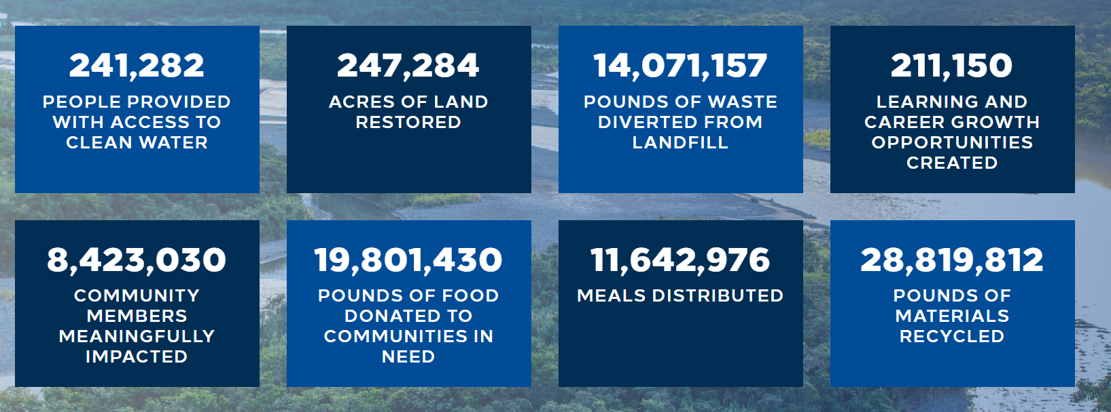
Figure 7: Community initiatives by Double Tree Hotel of Hilton
(Source: Coventrybuildingsocietyarena.co.uk, 2026)
Sustainability in the daily practices of DoubleTree by Hilton improves its service delivery for guests. Each room has seen the installation of LED lights and TV screens. Energy-efficient LED lighting will be implemented in the entire hotel to implement wider sustainability goals and reduce plastic usage (Coventrybuildingsocietyarena.co.uk, 2026). Furthermore, USB-C ports will be installed in public arenas of the park to create future-proof public spaces.
The sustainability initiatives adopted by the hotel have positively impacted its services. At present, DoubleTree by Hilton operates with 213 rooms with diverse facilities designed for guests (Travelweekly.com, 2026). The positive impact of sustainable operations is evident from most reviews by its guests (Google.com, 2026). The commitment towards the satisfaction of guests and creating memorable experiences for them has been acknowledged by most travellers through their reviews.
The creation of new lounges and eco-friendly suites has resulted in an increase in investments for DoubleTree Hotel in strengthening its guest experience (Cwgrowthhub.co.uk, 2026). Furthermore, building future-proof space design by adding certain new rooms will increase the number of visitors on a daily and annual basis for DoubleTree Hotel by Hilton (Cwgrowthhub.co.uk, 2026). Therefore, sustainability in daily practices has positively impacted the operations of the hotel.
Theme 3: Barriers in maintaining sustainable practices at DoubleTree by Hilton
The management of Hilton Hotel, especially in DoubleTree, has encountered some challenges in reducing the amount of food waste. In this accord, the authorities have found problems related to complicated waste management systems throughout the hospitality facility. It has been proven that having a complicated waste management process in the UK hospitality industry can have a negative impact on maintaining sustainability in internal operations. This can increase the amount of operational costs and gradually enhance the environmental damages (Gerassimidou, Dora and Iacovidou, 2022). Other than this, the increasing amount of food waste can also lead to financial losses, which can contribute to reducing the goodwill of the company in changing market situations.
Furthermore, some operational issues have also been identified in the regular operations of DoubleTree Coventry by Hilton UK. This issue is linked to the sudden shift of the highlighted hospitality facility to embrace electric vehicle (EV) charging stations. A supporting company named eEnergy, which provides charging stations to the DoubleTree Coventry by Hilton UK, has certified the increasing number of EV charging stations (Eenergy.com, 2026). This can lead to a reduction in the attention of the organisation towards the parking and servicing procedures for conventional combustion engine vehicles. It can be anticipated that this insight can help to understand that the sudden shifts towards technology and sustainable practices can lead to a reduction in the number of consumers (Jones et al., 2024). This type of change in the conventional business approaches in the UK hospitality sector can lead to disrupting the stay of those individuals who prefer conventional combustion engine vehicles.
These challenges are perceived to have a negative influence on the flow of operations in DoubleTree Coventry by Hilton in the UK. The governance of the chosen hospitality establishment should take proper initiatives to mitigate these issues and ensure appropriate development in its regular business procedures.
Theme 4: Mitigation strategies to address identified issues at DoubleTree by Hilton
It is believed that the highlighted issues can lead the management of DoubleTree Coventry by Hilton in the UK local market towards different adverse situations. The authorities have taken a few effective measures that are expected to be crucial for reducing the complications in the waste reduction and management processes. In this accord, the decision-makers of DoubleTree Coventry have launched a Zero Waste Menu throughout all its flagship hotels. This approach has been implemented in the chosen hospitality facility since the 24th of April in the fiscal year 2024. This is expected to be appropriate for reducing the waste generation and landfilling process by 50% by the end of the financial year 2030 (Stories.hilton.com, 2026b). This type of constructive approach within the UK hospitality industry is believed to be useful for setting an example for other facilities to engage the workforce appropriately for reducing waste. It is expected to encourage the operational efficiency of the entire hotel industry in the UK as well.

Figure 8: Zero-waste menu by Double Tree Hotel by Hilton
(Source: Stories.hilton.com, 2026b)
In addition to this, the authorities of the selected hospitality facility have also taken sufficient measures to ensure proper care for all types of vehicles for the consumers. In this accord, a proper parking lot with CCTV coverage is arranged for the visitors. This also incorporates proper safety and security of the motor vehicles in the on-site parking. The employees also keep the vehicles under proper registration and records on arrival to ensure better safety (Bywater.co.uk, 2026). It is believed to be useful for addressing the needs of consumers to ensure the security of all types of vehicles within the facility.

Summary
This chapter of this research has incorporated the basic patterns and information that were collected from the secondary qualitative sources. All the information has been gathered based on the themes that are created according to the themes of the investigation.

Discussion

Introduction
The chapter presents a critical discussion of the findings in relation to the objectives and questions framed for the study. Similar to the findings chapter, the discussion has been organised around four main themes evaluating the role of sustainability in the Double Tree Hotel by Hilton. As per the findings, it has been revealed that sustainability has played a key role in increasing investments and the number of guests for Double Tree Hotel by Hilton. However, certain barriers have been highlighted that hinder the adoption of sustainability by the chosen hotel group. In this respect, mitigation strategies have been established to address the highlighted issues.

Objective reporting and discussion
Theme 1: Significance of sustainable practices at DoubleTree by Hilton
Sustainable practices adopted by hotels play a crucial role in the reduction of environmental impact and carbon footprint. More than 20% of greenhouse gas emissions come from the hotel industry (Arici et al., 2023). Therefore, the incorporation of green practices and sustainable consumerism fosters competitive hotel operations. In addition, sustainable sourcing among the hotels has been significant for the reduction of supply chain complexities and emissions. Several hotel chains in the UK have claimed to reduce carbon emissions by saving more than £1 billion in utility costs (Deloitte.com, 2026). Sustainable practices play a crucial role in hotel businesses across the globe, and specifically in the UK.
In addition to the market performance of hotels, sustainability measures increase positive attitudes among guests to efficiently choose hotels. It translates to green purchasing behaviour influenced by environmental awareness among people (Sultana, Amin and Islam, 2022). In the context of the hospitality sector, perceived knowledge is critical for enhancing sustainable choices in consumerism. It helps in increasing preference for hotels equipped with eco-friendly facilities.
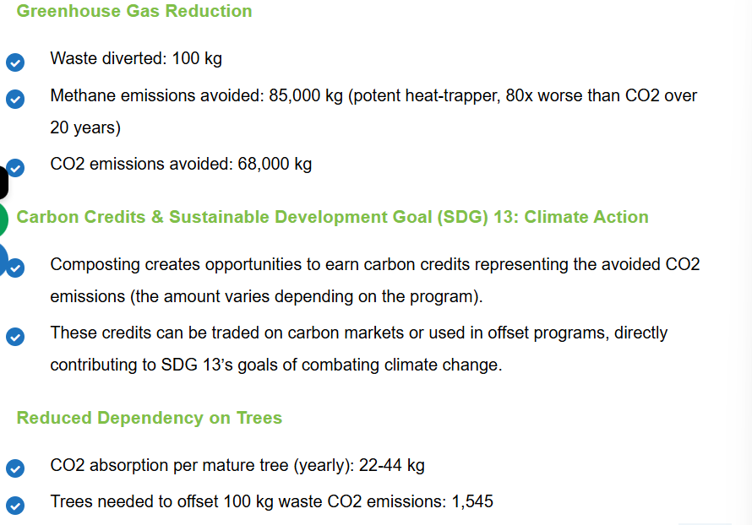
Figure 9: Sustainable Waste Management in DoubleTree
(Source: Ecepl.com, 2026)
In the specific context of the Double Tree Hotel by Hilton, sustainable practices have resulted in potential partnerships and collaborations. It has partnered with Earth Care Equipment (ECEPL) to deploy KC100, which functions as a state-of-the-art Organic Waste Converter (OWC) (Ecepl.com, 2026). This innovative solution has provided the hotel with the facility to reduce environmental impact and logistics costs. Furthermore, Double Tree Hotel focuses on better training for its staff, scientific waste management and segregation with advanced automated composting processes (Ecepl.com, 2026). The initiatives align with the Environmental Sustainability Policy of the Hilton Family of Hotels. It involves engagement among team members for active involvement in incorporating energy-efficient measures and reducing carbon dioxide emissions (Sxsw.com, 2026). Therefore, sustainable practices play a significant role in the operations of DoubleTree Hotel by Hilton.
Theme 2: Impact of sustainability in the daily practices of Double Tree Hotel by Hilton
Based on the findings, the sustainability adopted in daily practices by Double Tree Hotel positively impacts its sales and the number of visits made by guests. Based on a survey report published by the World Sustainable Hospitality Alliance, 70% of global travellers prefer to stay at a place that is equipped with eco-friendly facilities (Sustainablehospitalityalliance.org, 2026). Moreover, implementation of such practices results in higher cost savings by 30% and an increase in brand reputation and competitiveness of a hotel (Sustainablehospitalityalliance.org, 2026). The above data implies the influence of sustainable measures in shaping profitable plans for the hotel industry.

Figure 10: Planet Conscious Amenities
(Source: Sustainablehospitalityalliance.org, 2026)
In the context of Double Tree Hotel by Hilton, sustainability in daily practices leads to a better integration between environmental and social impacts. The hotel has strengthened its commitment towards fighting climate change and aligning carbon reduction targets with the Paris Climate Agreement (Conferencehotelgroup.com, 2026). With respect to social impact, Double Tree Hotel by Hilton fosters inclusive growth by enabling participation among staff to optimise time, skill and resources for better incorporation of sustainable goals.
In order to manage waste, Double Tree hotel has adopted an 'MCA' recycling method that identifies waste into 10 distinct categories (Conferencehotelgroup.com, 2026). Based on this segregation, the hotel has implemented high-quality microfibre by Raypath to clean all washable surfaces (Coventryehotel.com, 2026). Therefore, sustainability plays an influential role in the business operations of DoubleTree Hotel by Hilton. The sustainable initiatives undertaken by DoubleTree Hotel will increase preference among young visitors. Travellers among the Gen Z age group should adopt pro-environmental travel behaviour with the rise of eco-friendly practices in hotel chains (Ribeiro et al., 2025). These values enhance environmental concern among people and positively shape their consumerism and general purchasing habits. Moreover, it increases awareness in society and the community regarding eco-friendly choices. Thus, the impacts of sustainability are diverse with respect to the hotel business operations.
Theme 3: Barriers to maintaining sustainable practices at DoubleTree by Hilton
Despite prominent merits, sustainable practices in hotels are associated with key barriers. For instance, collaboration and partnership with external entities and suppliers can lead to financial barriers. Transactional hindrances may delay implementation of sustainable plans in the hotel business (Guerra-Lombardi, Hernández-Martí and Padrón-Fumero, 2024). Implementation of eco-friendly tools leads to additional challenges of a high-cost burden. Financial constraints increase due to high operational costs, fluctuations in guest preference and higher training costs (Hospitalityinsights.ehl.edu, 2026). It is increased by external barriers such as lower decision-making power and regulatory hurdles.
In addition, a lack of quality service and human resource management is another challenge faced by hotels in implementing sustainable practices. Absence of proper organisational policies and a concrete plan to implement sustainable practices leads to barriers (Munawar et al., 2022). Management of swift transition to eco-friendly practices by addressing the dynamic needs of guests is a significant challenge in sustainable hotel practices. Rise in dynamism in consumer preferences and fluctuations in the hospitality industry increase the challenges of sustainable practices adoption in hotels.
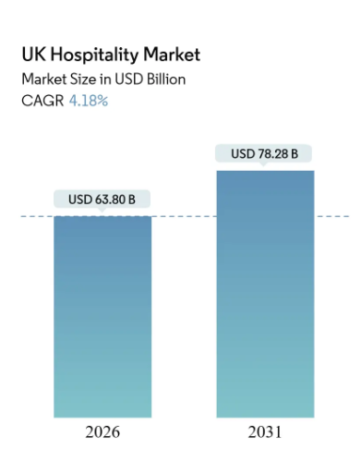
Figure 11: UK Hospitality Market Share
(Source: Mordorintelligence.com, 2026)
The current hospitality market in the UK has a total market share of £46.35 billion, which is further predicted to reach £56.87 billion by 2031 (Mordorintelligence.com, 2026). It indicates an annual growth rate of 4.18% (Mordorintelligence.com, 2026). In consideration of this dynamic and competitive hospitality industry, delivering services of unique quality becomes a prominent challenge. Moreover, automation and innovation are easily imitable by several hotels in the UK market. Implementation of the 'Hotel Sustainability Basics' initiative encourages collective action by more than 5000 hotels to incorporate eco-friendly guest service (Reportlinker.com, 2026). It has helped in reshaping hotel experiences by setting new standards for automated and eco-friendly hospitality services. It forms a prominent challenge for Double Tree Hotel by Hilton to retain its customer share and leverage the application of sustainable hospitality practices within the UK local market.
Theme 4: Mitigation strategies to address identified issues at DoubleTree by Hilton
With respect to the identified challenges, the prominent mitigation measure is comprehensive regulations and support from the UK Government. At present, the UK Government has implemented tax relief such as a discount of £1000 from pubs placed across the nation (Researchbriefings.files.parliament.uk, 2026). In the leisure sector, the UK Government has implemented a relief scheme for retail properties. These government initiatives will have a positive role in reducing cost burdens in the hotels and hospitality sector of the UK. Furthermore, the Government has unveiled the Tourism Recovery Plan for developing the experience of guests and eco-friendly operations in hotels across the nation (Gov.uk, 2026). Thus, the government has a pivotal role in developing the hotel business in the UK.
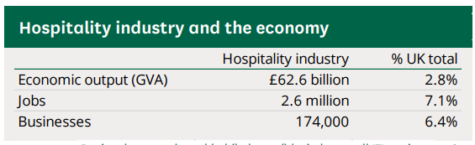
Figure 12: Economy of UK Hospitality industry 2025
(Source: Researchbriefings.files.parliament.uk, 2026)
Improvement of hotel management is important in developing the service delivery across UK-based hotels. Strong focus on innovation, renovation and redevelopment facilitates higher investments and planning in UK-based hotels. For instance, the conversion of the Customs House Building in London into luxury hotel rooms demonstrates the role of sustainability and space management in the UK-based hospitality sector (Lexology.com, 2026). In addition, the incorporation of artificial intelligence and digital transformation helps in responsible service delivery and addressing the dynamic needs of the guests across the UK.
In order to successfully implement eco-friendly practices in hotels, employee training is crucial. Training employees regarding the need for environmental safety will help in the quick adoption of sustainable practices (Salama et al., 2022). It involves the appraisal of sustainable performance among hotel staff, the provision of rewards for leveraging sustainable practices and spreading awareness regarding eco-friendly strategies among guests.
Implementation of benchmarks is a major intervention towards raising sustainable practices across hotels. Green Lodging Trends (GLTR), for example, measures best sustainability practices across hotels (Gstc.org, 2026). It encompasses 20,000 hotels of all sizes (Gstc.org, 2026). Implementation of such metrics will help in addressing the common barriers towards implementation of eco-friendly practices in hotel services. Hence, the above-mentioned strategies will be crucial for Double Tree Hotel by Hilton in strengthening its sustainable guest services.

Implications for DoubleTree by Hilton
The findings and their detailed discussion have significant implications for sustainable guest services by DoubleTree by Hilton. Staff training can be adopted and better implemented by the chosen hotel to enhance its service delivery. Green training of employees encourages sustainable transformation in the hospitality industry (Xue et al., 2022). Furthermore, it helps in a better understanding of sustainable practices, resulting in better performance and higher satisfaction of the guests (Barreto and Mayya, 2023. In addition, Double Tree Hotel may adopt performance metrics in the context of sustainable business practices. Such a metric enables better tracking of progress towards enhancing sustainable service delivery by hotels (Bianco, Bernard and Singal, 2023). Thus, the above implications are significant for Double Tree Hotel by Hilton.

Limitations of the study
The primary limitation of the study is the absence of any primary data, such as interviews or survey responses, in understanding sustainable practices in hotels. It leads to higher subjectivity and lower authenticity in addressing the research objectives (Dale, Arber and Procter, 2025). In addition, the research focused on a particular case study of the Double Tree Hotel, which reduced its scope. The study was constrained by limited data and official figures of the Double Tree Hotel by Hilton.

Chapter 5: Conclusion and Recommendations

Conclusion
The conduction of the study has been able to address the undertaken objectives. In retrospect to the significance of sustainable practices in service delivery by Double Tree Hotel of Hilton, it has been inferred that prioritisation of energy efficiency for meeting sustainable objectives. For this purpose, strengthening management and training of the hotel staff have been considered pivotal. It helps in collective action and engagement of guests in waste reduction. It has been concluded that such measures result in the reduction of negative influence on the environment. Furthermore, brand reputation and quality of consumer service delivery are improved with the adoption of a sustainable approach.
In addition to energy efficiency and reduction of environmental footprint, sustainable practice plays a significant role in reduction of total cost and facilitates automation of service delivery. In specific context to Double Tree Hotel by Hilton, the key inference writes down that staff engagement, transparency and promotion of accountability among guests are important steps towards maximisation of sustainability. It promotes green consumerism and helps in addressing changing demands of guests. Initiatives involving checklists for sustainable design, energy tracking mechanism and installation of electronic charging set up have been concluded as efficient measures adopted by Double Tree Hotel to implement sustainability in their daily business operations. It has been concluded that such measures increase positive attitudes among guests by enhancing green purchasing behaviour. Simultaneously it increases preferences among travellers for hotels equipped with eco-friendly facilities. Therefore, the inferences have been aligned to the first objective of the study pertaining to significance of sustainable practice at Double Tree Hotel by Hilton.
In respect to the analysis of sustainable practices in the hospitality sector, it has been derived that daily incorporation of eco-friendly practices improves financial performance of hotels. The inference points out that with the adoption of such techniques, hotels have been able to increase their revenue and reduce the operational costs. It has helped in diversification of functions and service delivery by hotels. The collaboration between hospitality sectors and energy saving forms have positively enhanced waste management and brand development. The inference sheds light on increased customer and guest awareness regarding sustainable behaviour. In situations where luxury services are provided, hotels are ensuring that they are associated with minimal environmental damage.
In the context of Double Tree Hotel by Hilton, it has been inferred that eco-friendly and community initiatives encompass core sustainability practices. The hotel has installed energy efficient technologies in its rooms and corridors. The study has drawn insights regarding the positive impacts of such techniques by analysing the reviews provided by guests. It has implied increasing commitment of the hotels towards increasing satisfaction of their customers and creating memorable experiences for them within ethical business operations. In addition, the inference has pointed out that the hotel has been able to integrate environmental and social commitment with its sustainable measures. Moreover, it has shown increasing adherence to international climate regulations such as the Paris Climate Agreement. The study has inferred the impacts of sustainable measures adopted by Double Tree Hotel by Hilton specifically on guests belonging to the Gen Z age group. Therefore, the conclusion as addressed the second research objective pertaining to sustainability impacts the daily business practices of Double Tree Hotel by Hilton.
In relation to the identification of major challenges in adoption of sustainable strategies by hotels, it has been understood that higher initial cost is a prominent challenge. The research pointed out that implementation of energy efficient techniques in service delivery to guests involve excessive costs and financial pressures. The study integrated the inflated cost of implementing eco-friendly techniques with increased cost of green training to the hotel staff. It results in long term barriers of sustainable hospitality services and increases the operational costs. The research has provided key insights from relevant case studies regarding the degrading credibility of real-time transactions in hotels.
In the specific aspect to Double Tree Hotel by Hilton, the research has pointed out barriers that include complicated waste management systems. In addition, a sudden shift towards increasing electric vehicle (EV) charging stations has led to a reduced focus on sustainability awareness among consumers. There are possibilities of reduced number of visits by guests who prefer conventional stays in hotels. Moreover, lack of appropriate Government intervention and legal regulatory backing enhances the gap in sustainable service delivery of Double Tree Hotel by Hilton. Hence, the above inference has addressed the third study objective pertaining to the evaluation of challenges in incorporating sustainable practices within the service delivery of Double Tree Hotel by Hilton.
It has been concluded from the mitigation strategies that Governing bodies and regulatory agencies need to play a crucial role in addressing the identified challenges of sustainability in implementation in the hospitality sector. In addition, the adoption of such measures need to be associated with lowered costs and higher operational efficiency in the service delivery of hotels. Inner management needs to be improved with green training, knowledge sharing and better awareness among staff and guests. Building of brand loyalty must be integrated with transparency in strategising sustainable business operations.
Specific focus on Double Tree Hotel by Hilton inferred that initiatives such as zero-waste menu, installation of LED lights and electric vehicle charging stations are positive interventions towards addressing barriers in sustainable service delivery of the hotel. Incorporation of safety measures and tracking of progress in eco-friendly hotel operations have been concluded as prominent initiatives of the chosen hotel. In addition, adoption of sustainability benchmarks such as Green Lodging Trends have potential to enhance sustainable business operations of the hotel. Thus, the above inference has been aligned to the fourth objective involving the mitigation strategies to address the barriers faced in sustainable business operations of Double Tree Hotel by Hilton.

Recommendations

Investment in energy-efficient technologies
Double Tree Hotel by Hilton needs to increase its investment in energy-saving technologies. It involves the utilisation of renewable sources such as geothermal and solar energy. Leveraging 'district heating technology' has enabled hotels to position themselves as leaders in sustainable energy solutions (Sesi.stanford.edu, 2026). The UK is expected to reach 148 GW of renewable electricity by 2035 in compliance with its net zero goals (Theguardian.com, 2026). Similarly, DoubleTree Hotel can adopt renewable technologies for setting a benchmark in eco-friendly operations for serving its guests. It will help the hotel in reducing water consumption, waste of food and resources and in improving guest experience. Technologies for tracking the progress and reporting any gaps can be built by the hotels for increased optimised service.
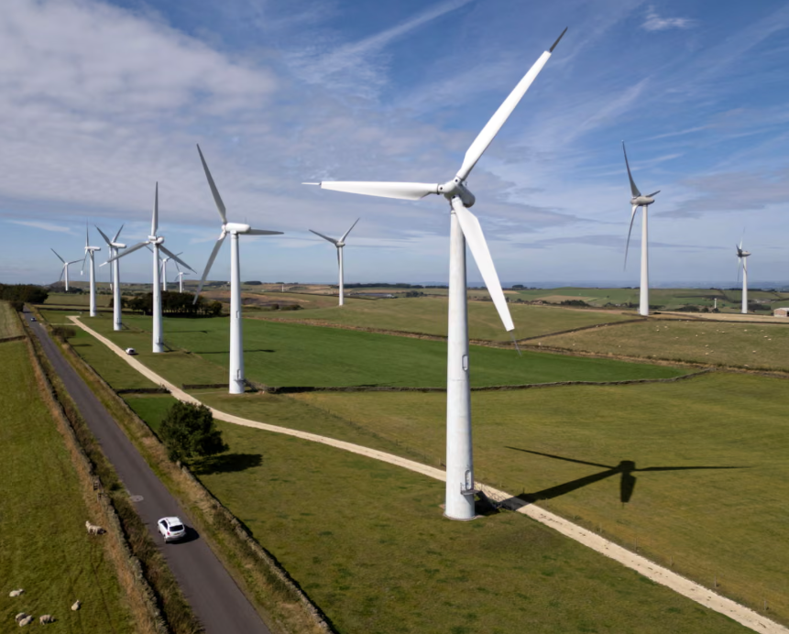
Figure 13: 148GW of renewable electricity by 2035 in the UK
(Source: Theguardian.com, 2026)
The action plan for implementing the above strategy by Double Tree Hotel of Hilton will involve the implementation of innovative designs, modernisation and utilisation of automation systems. Furthermore, adoption of passive technologies involving natural ventilation, use of high thermal mass structures and energy-efficient corridors will play a pivotal role in shaping sustainable strategies of Double Tree Hotel by Hilton. In addition, scientific waste management and streamlining of hotel operations need to be adopted by the chosen hotel to maximise its eco-friendly tourism practices. Therefore, the reduction of energy usage facilitates cost-cutting techniques by DoubleTree Hotel and Hilton.

Digital transformation
Adoption of digital transformation will play a significant role in improving operational efficiency, higher satisfaction of guests and better competitiveness within the UK-based hospitality sector. It is estimated that the market size of UK digital transformation is 25.65 billion in 2022 that is predicted to further rise by 27.7% between 2023 and 2030 (Grandviewresearch.com, 2026). Digital transformation enhances hotel performance and streamlines customer behaviour towards eco-friendly consumerism (Marques and Marques, 2023). Moreover, it helps in quicker operations and team engagement for enhancing the guest experience. It leads to automation of conventional hotel management work, such as housekeeping and inventory management. It has a direct role in enhancing sustainability as it results in lower waste generation and better service delivery for the guests. It will help in better market positioning by Double Tree Hotel by Hilton in the UK local market.
DoubleTree by Hilton can implement mobile and digital check-ins and AI-powered assistants to provide convenient and extraordinary services to the guests. The hotel may incorporate other techniques such as augmented reality (AR) and virtual reality (VR) to transform the stay experiences of guests. Other facilities, such as self-service kiosks and automated platforms to detect and address staff shortages, are other potential techniques that can be utilised by Double Tree Hotel by Hilton. It will help in a higher preference for the hotel among customers and a more convenient feeling for the guests.

Green training
Double Tree Hotel by Hilton can take measures to improve the sustainable self-efficacy of its hotel staff. Green training involves a higher focus on sustainable goals in daily hotel operations. In addition, green training builds a cheerful outlook and motivates hotel employees to implement eco-friendly practices within their service delivery (Alola, Cop and Tarkang 2022). Similarly, implementation of this practice in the Double Tree Hotel will keep its staff informed and will help in increasing their abilities to accomplish sustainable business operational goals. It will offer a good opportunity in marketing and positioning of the hotel among UK-based hotel groups. Thus, eco-friendly staffing of staff is a significant measure.
In order to implement this strategy, Double Tree Hotel needs to establish a green incentives policy for encouraging sustainable practices among staff. It can establish a regular green learning scope for its staff and awareness for the guests. It will help in increasing predictive job satisfaction for strengthening the green performance of Double Tree Hotel by Hilton. The hotel may adopt this strategy to bridge the gap between awareness, action and capacity of the hotel staff to implement sustainable practices in service delivery for its guests. Thus, green training plays a significant role in the operational efficiency of hotels.

Implementation of eco-friendly regulations
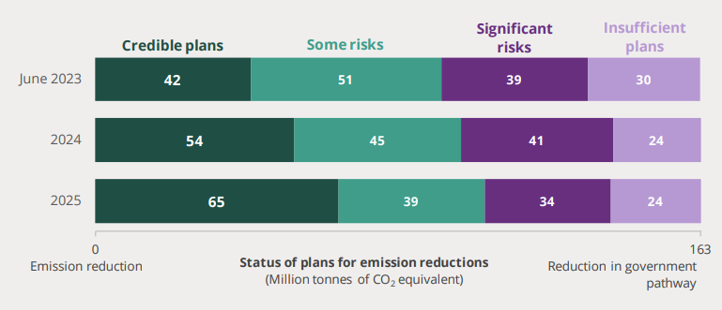
Figure 14: Recent Developments on NetZero in the UK
(Source: Commonslibrary.parliament.uk, 2026)
Implementation of eco-friendly regulations will enable Double Tree Hotel by Hilton to utilise basic sustainability indicators in its performance. The UK Government has formulated a Clean Power strategy by 2030 and has formulated a Carbon Budget Delivery Plan to meet emissions reduction targets (Commonslibrary.parliament.uk, 2026). Regulatory measures promote higher commitment and accountability towards sustainable practices and enhance social responsibility (Özgit and Akanyeti, 2022). Therefore, Double Tree Hotel will be able to better manage its staff and increase ethical consumerism among guests with strengthened regulations and indicators. The hotel may adopt performance assessment on a regular basis to measure the progress in adopting and implementing eco-friendly measures for guest service.
In order to implement the regulations for sustainable service delivery, Double Tree Hotel by Hilton may establish a separate managerial board to track progress in respect to the environmental regulations. Initial plans may involve steps to minimise hotel waste and increase water conservation and optimum resource usage. For this purpose, Double Tree Hotel by Hilton may consider installation of recycling plans to reduce environmental footprint. Providing proper guidance to the staff and increasing awareness among guests are ways to incorporate eco-friendly regulations in daily service delivery of Double Tree Hotel by Hilton.

Reference List
Ahmed, S.K., Mohammed, R.A., Nashwan, A.J., Ibrahim, R.H., Abdalla, A.Q., Ameen, B.M.M. and Khdhir, R.M., (2025). Using thematic analysis in qualitative research. Journal of Medicine, Surgery, and Public Health, 6, p.100198. DOI: https://doi.org/10.1016/j.glmedi.2025.100198
Alola, U.V., Cop, S. and Tarkang, M.E., (2022). Green training an effective strategy for a cleaner environment: Study on hotel employees. Journal of Public Affairs, 22(3), p.e2489. DOI: 10.1002/pa.2489
Arici, H.E., Cakmakoglu Arıcı, N. and Altinay, L., (2023). The use of big data analytics to discover customers’ perceptions of and satisfaction with green hotel service quality. Current Issues in Tourism, 26(2), pp.270-288. https://radar.brookes.ac.uk/radar/file/
Awogbemi, O., Kallon, D.V.V. and Bello, K.A., (2022). Resource recycling with the aim of achieving zero-waste manufacturing. Sustainability, 14(8), p.4503. DOI: https://doi.org/10.3390/su14084503
Axiomhospitality.com, (2026). DoubleTree by Hilton Bath leading the way with three eco-certification achievements. Available at: https://www.axiomhospitality.com/doubletree-by-hilton-bath-leading-the-way-with-three-eco-certification-achievements/ [Accessed 28 January 2026].
Barreto, N. and Mayya, S., (2023). A systematic review on training and development in the hotel industry. International Journal of Management, Technology, and Social Sciences (IJMTS), 8(2), pp.22-52. DOI: https://doi.org/10.5281/zenodo.7816694
Bianco, S., Bernard, S. and Singal, M., (2023). The impact of sustainability certifications on performance and competitive action in hotels. International Journal of Hospitality Management, 108, p.103379. DOI: https://doi.org/10.1016/j.ijhm.2022.103379
Bywater.co.uk, (2026). Doubletree by Hilton Hotel Coventry. Available at: https://www.bywater.co.uk/venue/doubletree-by-hilton-hotel-coventry/ [Accessed 29 January 2026].
Cheong, H.I., Lyons, A., Houghton, R. and Majumdar, A., (2023). Secondary qualitative research methodology using online data within the context of social sciences. International Journal of Qualitative Methods, 22, p.16094069231180160. DOI: https://doi.org/10.1177/16094069231180160
Commonslibrary.parliament.uk, (2026). The UK’s plans and progress to reach net zero by 2050. Available at: https://commonslibrary.parliament.uk/research-briefings/cbp-9888/ [Accessed 29 January 2026].
Conferencehotelgroup.com, (2026). Culture of CARE DoubleTree by Hilton Brussels City. Available at: https://www.conferencehotelgroup.com/img/hotels/files/7053/Sustainable%20Actions%202021.pdf [Accessed 19 January 2026].
Coventrybuildingsocietyarena.co.uk, (2026). Transformation underway for the Doubletree by Hilton Hotel at Coventry Building Society Arena. Available at: https://www.coventrybuildingsocietyarena.co.uk/news/transformation-underway-for-the-doubletree-by-hilton-hotel-at-coventry-building-society-arena [Accessed 27 January 2026].
Coventryehotel.com, (2026). Sustainability certification in Coventry. Available at: https://www.coventryehotel.com/en/theme/sustainability-certification-43/ [Accessed 18 January 2026].
Cwgrowthhub.co.uk, (2026). Milestone for multi-million-pound refurbishment at Coventry Building Society Arena’s on-site Doubletree hotel. Available at: https://cwgrowthhub.co.uk/milestone-multi-million-pound-refurbishment-coventry-building-society-arenas-site-doubletree/ [Accessed 24 January 2026].
Dale, A., Arber, S. and Procter, M., (2025). Doing secondary analysis. Taylor & Francis.
Deloitte.com, (2026). Sustainability in the hospitality industry. Available at: https://www.deloitte.com/uk/en/Industries/consumer/blogs/sustainability-in-the-hospitality-industry.html [Accessed 23 January 2026].
Diaz-Farina, E., Díaz-Hernández, J.J. and Padrón-Fumero, N., (2023). Analysis of hospitality waste generation: Impacts of services and mitigation strategies. Annals of Tourism Research Empirical Insights, 4(1), p.100083. DOI: https://doi.org/10.1016/j.annale.2022.100083
Doubletree-queensferry.co.uk, (2026). Sustainability Commitment at Doubletree Queensferry. Available at: https://doubletree-queensferry.co.uk/sustainability/ [Accessed 29 January 2026].
Ecepl.com, (2026). Case Study: Hilton DoubleTree’s Sustainable Waste Management. Available at: https://www.ecepl.com/case-study-hilton-doubletrees-sustainable-waste-management/ [Accessed 21 January 2026].
Eenergy.com, (2026). Hilton are lighting up the road for all to follow. Available at: https://www.eenergy.com/success-stories/doubletree-by-hilton/ [Accessed 26 January 2026].
Etedge-insights.com, (2026). Building a sustainable future: How Hilton monitors its environmental performance globally. Available at: https://etedge-insights.com/resources/brands-speak/building-a-sustainable-future-how-hilton-monitors-its-environmental-performance-globally/ [Accessed 30 January 2026].
Fife, S.T. and Gossner, J.D., (2024). Deductive qualitative analysis: Evaluating, expanding, and refining theory. International Journal of Qualitative Methods, 23, p.16094069241244856. DOI: https://doi.org/10.1177/16094069241244856
Gerassimidou, S., Dora, M. and Iacovidou, E., (2022). A tool for the selection of food waste management approaches for the hospitality and food service sector in the UK. Resources, 11(10), p.80. DOI: https://doi.org/10.3390/resources11100080
Ghazinoory, S., Zadegan, M.G. and Phaal, R., (2025). Research Design Unlocked! Roadmapping for Integration of Paradigms, Strategies, and Tools. Journal of Open Innovation: Technology, Market, and Complexity, p.100688. DOI: https://doi.org/10.1016/j.joitmc.2025.100688
Ghouri, A. and Falah, K.A.A., (2023). Integrating lean management, sustainability, circular capabilities, and waste minimization to optimise operational performance in manufacturing. Operational Research in Engineering Sciences: Theory and Applications, 6(2), pp.99-122. DOI: https://doi.org/10.31181/oresta/060206
Google.com, (2026). DoubleTree by Hilton Coventry. Available at: https://www.google.com/travel/search? [Accessed 25 January 2026].
Gov.uk, (2026). Hospitality strategy: reopening, recovery, resilience. Available at: https://www.gov.uk/government/publications/hospitality-strategy-reopening-recovery-resilience/hospitality-strategy-reopening-recovery-resilience [Accessed 13 January 2026].
Grandviewresearch.com, (2026). U.K. Digital Transformation Market (2023 - 2030). Available at: https://www.grandviewresearch.com/industry-analysis/uk-digital-transformation-market-report [Accessed 30 January 2026].
Gstc.org, (2026). Green Lodging Trends Report 2024 by Greenview. Available at: https://www.gstc.org/green-lodging-trends-report-2024-by-greenview [Accessed 11 January 2026].
Guerra-Lombardi, V., Hernández-Martín, R. and Padrón-Fumero, N., (2024). Drivers, barriers and key practices of corporate sustainability strategy implementation in hotels. International Journal of Hospitality Management, 120, p.103791. DOI: https://doi.org/10.1016/j.ijhm.2024.103791
Heydari, M., Heydari, A. and Amini, M., (2023). Energy Management and Energy Consumption: A Comprehensive Study. World Information Technology and Engineering Journal, 10(04), pp.22-28. https://papers.ssrn.com/sol3/Delivery.cfm?abstractid=4515915
Hilton.com, (2026). Welcome to Hilton. Available at: https://www.hilton.com/en/corporate/ [Accessed 22 January 2026].
Hines, P., Butterworth, C., Greenlee, C., Jekiel, C. and Taylor, D., (2022). Turning the lean world upside down. International Journal of Lean Six Sigma, 13(5), pp.989-1024. DOI: http://dx.doi.org/10.1108/IJLSS-09-2021-0166
Hospitalityinsights.ehl.edu, (2026). Hotel sustainability: Challenges and solutions. Available at: https://hospitalityinsights.ehl.edu/hotel-sustainability-challenges-and-solutions [Accessed 17 January 2026].
Hyasat, A.S., Al-Weshah, G.A. and Kakeesh, D.F., (2022). Training needs assessment for small businesses: The case of the hospitality industry in Jordan. Geo Journal of Tourism and Geosites, 40(1), pp.20-29. DOI: https://doi.org/10.30892/gtg.40102-798
Ikram, M. and Kenayathulla, H.B., (2022). Out of touch: comparing and contrasting positivism and interpretivism in social science. Asian Journal of Research in Education and Social Sciences, 4(2), pp.39-49. DOI: https://doi.org/10.55057/ajress.2022.4.2.4
IYANUOLUWABlessing, A., Henry, Z. and Micheal, D., (2024). Data Collection and Analysis Techniques. https://www.researchgate.net/profile/Aborisade-Blessing/publication/387534832_Data_Collection_and_Analysis_Techniques/links/677333a2117f340ec3e65c57/Data-Collection-and-Analysis-Techniques.pdf
Jones, C.R., Elgueta, H., Chudasama, N., Kaklamanou, D., East, D. and Cruden, A.J., (2024). Modelling public intentions to use innovative EV chargers employing hybrid energy storage systems: a UK case study based upon the technology acceptance model. Energies, 17(6), p.1405. DOI: https://doi.org/10.3390/en17061405
Julião, B.J., Reis, M.S. and Duarte, B.P., (2025). A Systematic Lean-Driven Framework for Warehouse Optimization. Systems, 13(9), p.813. DOI: https://doi.org/10.3390/systems13090813
Karvounidi, M.D., Alexandropoulou, A.P. and Fousteris, A.E., (2024). Towards sustainable hospitality: enhancing energy efficiency in hotels. International Research Journal of Economics And Management Studies IRJEMS, 3(6). DOI: 10.56472/25835238/IRJEMS-V3I6P145
Khalid, A.F., Grimshaw, J.M., Parakh, N.D., Charide, R., Rab, F. and Sohani, S., (2023). Decision-makers’ experiences with rapid evidence summaries to support real-time evidence informed decision-making in crises: a mixed methods study. BMC Health Services Research, 23(1), p.282. DOI: https://doi.org/10.1186/s12913-023-09302-0
Kholijah, S., (2024). Analysis of economic and environmental benefits of green business practices in the hospitality and tourism sector. Involvement International Journal of Business, 1(1), pp.60-74. DOI: https://doi.org/10.62569/iijb.v1i1.7
Knaster, R., Pereira, S. and Shalloway, A., (2024). The Lean-Agile Way: Unleash business results in the digital era with value stream management. Packt Publishing Ltd.
Lee, H.H. and Huang, P.Y., (2023). Food waste and environmental sustainability of the hotel industry in Taiwan. Sustainability, 15(21), p.15459. DOI: https://doi.org/10.3390/su152115459
Lexology.com, (2026). UK Hotels Sector 2026: Renovations, AI and Experience‑Led Stays. Available at: https://www.lexology.com/library/detail.aspx?g=423f5481-0c8a-4fb2-98de-f316fd44ba5a [Accessed 12 January 2026].
Lin, C.C., Nugraha, K.S. and Hsu, Y.J., (2025). The Effect of Sustainable Development Goals on Customer Satisfaction, Customer Loyalty and the Role of Brand Image in Green Hotels. Advances in Management and Applied Economics, 15(1), pp.1-7. DOI: https://doi.org/10.47260/amae/1517
Mansoor, M., Jam, F.A. and Khan, T.I., (2025). Fostering eco-friendly behaviors in hospitality: engaging customers through green practices, social influence, and personal dynamics. International Journal of Contemporary Hospitality Management, 37(5), pp.1804-1826. DOI: http://dx.doi.org/https://doi.org/10.1108/IJCHM-07-2024-1023
Marques, J. and Marques, R.P., (2023). Digital transformation of the hotel industry: Theories, practices, and global challenges. Springer Nature.
Mordorintelligence.com, (2026). United Kingdom Hospitality Market Size and Share. Available at: https://www.mordorintelligence.com/industry-reports/hospitality-industry-in-the-united-kingdom [Accessed 16 January 2026].
Munawar, S., Yousaf, H.Q., Ahmed, M. and Rehman, S., (2022). Effects of green human resource management on green innovation through green human capital, environmental knowledge, and managerial environmental concern. Journal of Hospitality and Tourism Management, 52, pp.141-150. DOI: https://doi.org/10.1016/j.jhtm.2022.06.009
Muyiwa-Ajayi, T.P., Sobowale, A. and Augoye, O., (2024). The financial impact of sustainable investments on corporate profitability. International Journal of Multidisciplinary Research and Growth Evaluation, 5(1), pp.1372-1377. DOI: https://doi.org/10.54660/.IJMRGE.2024.5.1.1372-1377
Netzeronow.org, (2026). Lisini: A Family Legacy Embracing Net Zero in Hospitality. Available at: https://netzeronow.org/post/lisini-hotel-restaurant-net-zero-journey [Accessed 27 January 2026].
Omowole, B.M., Olufemi-Philips, A.Q., Ofodili, O.C., Eyo-Udo, N.L. and Ewim, S.E., (2024). Conceptualizing green business practices in SMEs for sustainable development. International Journal of Management & Entrepreneurship Research, 6(11), pp.3778-3805. DOI: 10.51594/ijmer.v6i11.1719
Özgit, H. and Akanyeti, İ., (2022). Environmental regulations versus sustainable tourism indicators: a pathway to sustainable development. Worldwide Hospitality and Tourism Themes, 14(4), pp.393-402. DOI: https://doi.org/10.1108/WHATT-03-2022-0033
Parliament.uk, (2026). Written evidence submitted by UK Hospitality. Available at: https://committees.parliament.uk/writtenevidence/105468/pdf/#:~:text=In%20taking%20steps%20towards%20sustainability,policies%20for%20sustainability%20are%20found. [Accessed 27 January 2026].
PJ, S., Singh, K., Kokkranikal, J., Bharadwaj, R., Rai, S. and Antony, J., (2023). Service quality and customer satisfaction in hospitality, leisure, sport and tourism: An assessment of research in web of science. Journal of Quality Assurance in Hospitality & Tourism, 24(1), pp.24-50. DOI: https://doi.org/10.1080/1528008X.2021.2012735
Reportlinker.com, (2026). Sustainability in Hospitality: A Global Movement Takes Hold. Available at: https://www.reportlinker.com/article/7529 [Accessed 15 January 2026].
Researchbriefings.files.parliament.uk, (2026). Government support for the hospitality sector. Available at: https://researchbriefings.files.parliament.uk/documents/CDP-2025-0147/CDP-2025-0147.pdf [Accessed 14 January 2026].
Ribeiro, M.A., Seyfi, S., Elhoushy, S., Woosnam, K.M. and Patwardhan, V., (2025). Determinants of generation Z pro-environmental travel behaviour: the moderating role of green consumption values. Journal of sustainable tourism, 33(6), pp.1079-1099. DOI: https://doi.org/10.1080/09669582.2023.2230389
Salama, W., Nor El Deen, M., Albakhit, A. and Zaki, K., (2022). Understanding the connection between sustainable human resource management and the hotel business outcomes: Evidence from the green-certified hotels of Egypt. Sustainability, 14(9), p.5647. DOI: https://doi.org/10.3390/su14095647
Saunders, M., Lewis, P. and Thornhill, A. (2007) Research Methods for Business Students. 4th Edition, Financial Times Prentice Hall, Edinburgh Gate, Harlow.
Savale, T.K., Byram Anand, P., Perumalla Varalaxmi, A.B. and Quaye, J.A., (2023). Green Marketing Strategies: Assessing Consumer Perception and Adoption of Eco-friendly Products. Remittances Review, 8(4). DOI: https://doi.org/10.33182/rr.v8i4.171
Scarlethotel.co.uk, (2026). Sustainable Luxury: How the Scarlet Hotel is leading the Eco-Friendly Hospitality Revolution. Available at: https://www.scarlethotel.co.uk/journal/sustainable-luxury-how-scarlet-hotels-is-leading-the-eco-friendly-hospitatlity-revolution [Accessed 30 January 2026].
Sesi.stanford.edu, (2026). District Energy In Cities. Available at: https://sesi.stanford.edu/sites/g/files/sbiybj29541/files/media/file/unep-report-district-energy-in-cities-1.pdf [Accessed 11 January 2026].
Singh, V., Sharma, M.P., Jayapriya, K., Kumar, B.K., Chander, M.A.R.N. and Kumar, B.R., (2023). Service quality, customer satisfaction and customer loyalty: A comprehensive literature review. Journal of Survey in Fisheries Sciences, 10(4S), pp.3457-3464. https://www.researchgate.net/profile/Vikas-Singh-49/publication/371809524_Service_Quality_Customer_Satisfaction_And_Customer_Loyalty_A_Comprehensive_Literature_Review/links/64965cd18de7ed28ba5231c4/Service-Quality-Customer-Satisfaction-And-Customer-Loyalty-A-Comprehensive-Literature-Review.pdf
Stecuła, K. and Naramski, M., (2025). Virtual reality as a green tourism alternative: Social acceptance and perception. Sustainability, 17(17), p.7722. DOI: https://doi.org/10.3390/su17177722
Stories.hilton.com, (2026a). Hilton in South East Asia Committed to Reducing Environmental Footprint through Sustainable Initiatives.. Available at: https://stories.hilton.com/apac/releases/hilton-focus-on-sustainability-in-south-east-asia [Accessed 22 January 2026].
Stories.hilton.com, (2026b). Hilton Launches Zero Waste Menus Across Flagship UK Hotels. Available at: https://stories.hilton.com/emea/sustainability/hilton-launches-zero-waste-menus-across-flagship-uk-hotels [Accessed 27 January 2026].
Sultana, N., Amin, S. and Islam, A., (2022). Influence of perceived environmental knowledge and environmental concern on customers' green hotel visit intention: mediating role of green trust. Asia-Pacific Journal of Business Administration, 14(2), pp.223-243. DOI: https://doi.org/10.1108/APJBA-08-2021-0421
Sustainablehospitalityalliance.org, (2026). Building Green and Resilient Hotels: Investing in our Planet. Available at: https://sustainablehospitalityalliance.org/building-green-resilient-hotels-ifc/ [Accessed 22 January 2026].
Sxsw.com, (2026). Hilton Family of Hotels Sustainability Backgrounder. Available at: https://www.sxsw.com/wp-content/uploads/2016/07/EmbassyDTSustainability.pdf [Accessed 20 January 2026].
Tanveer, M.I., Yusliza, M.Y. and Fawehinmi, O., (2024). Green HRM and hospitality industry: challenges and barriers in adopting environmentally friendly practices. Journal of Hospitality and Tourism Insights, 7(1), pp.121-141. DOI: https://doi.org/10.1108/JHTI-08-2022-0389
Theguardian.com, (2026). UK’s clean electricity growing too slowly to meet climate targets, report says. Available at: https://www.theguardian.com/environment/2025/jul/14/uks-clean-electricity-growing-too-slowly-to-meet-climate-targets [Accessed 31 January 2026].
Theleanway.net, (2026). The Five Principles of Lean. Available at: https://theleanway.net/The-Five-Principles-of-Lean [Accessed 29 January 2026].
Travelweekly.com, (2026). DoubleTree by Hilton Hotel Coventry. Available at: https://www.travelweekly.com/Hotels/Coventry-England/DoubleTree-by-Hilton-Hotel-Coventry-p51285763 [Accessed 26 January 2026].
Travelwithpurpose.hilton.com, (2026). Our Hotels. Available at: https://travelwithpurpose.hilton.com/our-hotels/ [Accessed 30 January 2026].
Tseng, M.L., Li, S.X., Lim, M.K., Bui, T.D., Yuliyanto, M.R. and Iranmanesh, M., (2025). Causality of circular supply chain management in small and medium-sized enterprises using qualitative information: a waste management practices approach in Indonesia. Annals of Operations Research, 355(2), pp.1685-1726. DOI: https://doi.org/10.1007/s10479-023-05392-5
Velaoras, K., Menegaki, A.N., Polyzos, S. and Gotzamani, K., (2025). The role of environmental certification in the hospitality industry: Assessing sustainability, consumer preferences, and the economic impact. Sustainability, 17(2), p.650. DOI: https://doi.org/10.3390/su17020650
Wastemanaged.co.uk, (2026). UK Tourism Waste & Litter Statistics. Available at: https://www.wastemanaged.co.uk/our-news/summer/tourism-waste-uk/ [Accessed 28 January 2026].
Whitbread.co.uk, (2026). Premier Inn CleanProtect hotel hygiene regime will help guests stay with confidence. Available at: https://www.whitbread.co.uk/premier-inn-cleanprotect-hotel-hygiene-regime-will-help-guests-stay-with-confidence/ [Accessed 24 January 2026].
Xue, B.W., Lin, H.H., Chen, C.C., Lee, P.Y. and Hsu, C.H., (2022). How to improve the problem of hotel manpower shortage in the COVID-19 epidemic environment? Exploring the effectiveness of the hotel practice training system. Environmental Science and Pollution Research, 29(48), pp.72169-72184. DOI: https://doi.org/10.1007/s11356-022-21262-2

Appendices

Appendix 1: Sustainable Tourism
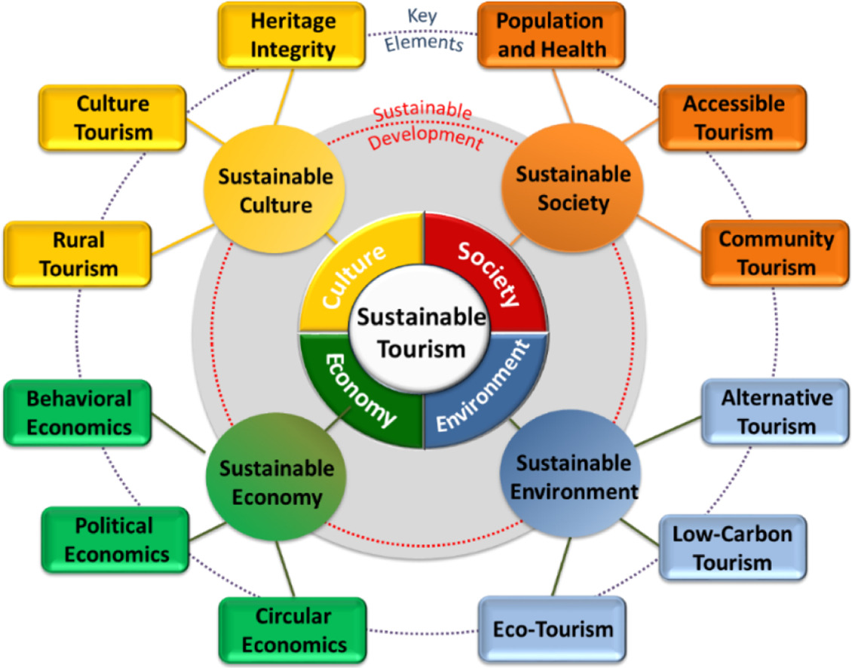
(Source: https://www.shankariasparliament.com/current-affairs/gs-i/sustainable-tourism)

