Student Name: Saima Kausar

Student Number:2407682

Lecturer's Name: Olufemi Oluranti

Module Number:BMHP 5015

Component -2

Table of Contents

Introduction
Job Advertisement
Analysis of the Job Role and Required Employability Skills
Evaluation of My Current Skills and Competencies
Personal Development Action Plan and Timeline
Building My Personal Brand
Promoting My Professional Identity
Building a Professional Network for Successful Employment
Conclusion
References
Appendices

Assessment 2 Report: Building Your Personal Brand for Sustainable Employment

Part I

Introduction

In this report, I will talk about my career goal of becoming a Support Worker in the health and social care sector. I have chosen this role because I enjoy helping people and I would like to make a positive difference in someone's life. A Support Worker helps people who need support because of their age, disability, illness or mental health. They help people with everyday tasks and encourage them to live as independently as possible. Looking after my elderly parents and in-laws has helped me understand how important, good care, patience and respect are. Also, studying Health and Social Care at university has increased my interest in this career and has helped me learn more about the responsibilities of a Support Worker.

Part II

Job Advertisement
For this report, I have chosen the job of a Support Worker because it is the career I would like to do in the future. I have always enjoyed helping other people, especially my family, and I believe this job matches my personal values and the skills I am learning at university.
The job advertisement I chose explains that a Support Worker helps people who need support because of illness, disability, old age or mental health problems. The main duties include helping people with personal care, supporting them with everyday activities, encouraging them to be as independent as possible, writing clear records, following safeguarding procedures and working with other health and social care professionals. (Moran, Enderby and Nancarrow, 2010)
The person specification also explains the personal qualities needed for this role. These include good communication skills, patience, support, teamwork, flexibility and being able to treat people with dignity and respect. These are all very important because every person has different needs and should receive the best possible care. (Taylor and And Others, 1996)
I chose this advertisement because it gives a clear idea of what employers are looking for in a Support Worker. Although I have not worked as a Support Worker before, I already have experience caring for elderly members of my family, which has helped me develop many of the qualities needed for this role. I also believe my Health and Social Care degree is helping me build the knowledge and confidence I need to work in this profession.
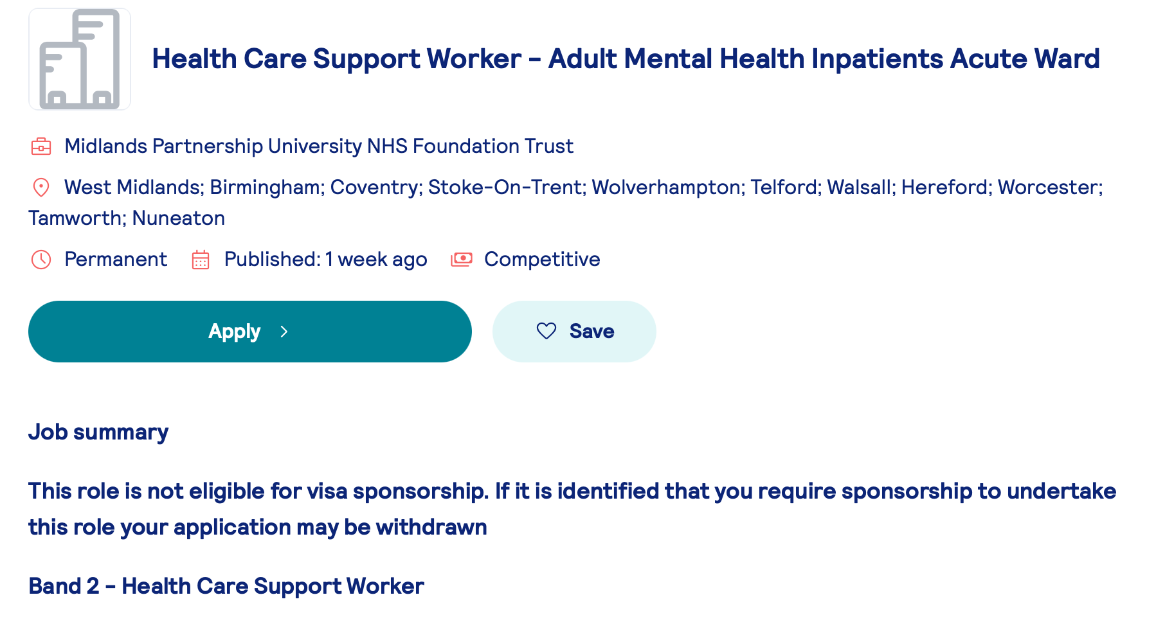Figure 1: Screenshot of Support Worker Job Advertisement

Part III

Job Role Employability Skills
To be a good Support Worker, a person needs many different skills. These skills are important because they help Support Workers provide safe, respectful and person-centred care. Every person they support is different, so they need to be able to adapt and meet each person's individual needs.
One of the most important skills is communication. A Support Worker needs to listen carefully to people, speak clearly, and make sure everyone understands each other. Good communication helps build trust between the Support Worker and the person receiving care. It also helps when talking to family members, nurses, doctors and other professionals so that everyone is working together to provide the best care. (Lishman, 2020)
Another important skill is teamwork. Support Workers do not work alone. They work with other health and social care professionals to make sure people receive the support they need. Being a good team member means sharing information, helping colleagues when needed, and respecting everyone's role.
Patience and empathy are also very important. Some people may need extra time to complete everyday tasks or may become upset because of their illness or disability. A Support Worker needs to stay calm, be understanding and treat everyone with kindness and respect. Showing empathy helps people feel valued and supported.
Problem solving is another useful skill because every day can be different. Sometimes unexpected situations happen, and a Support Worker must stay calm, think carefully and make safe decisions while following workplace policies.(Thompson,N.,et al 2009)
Finally, time management and organisation are important because Support Workers often have many responsibilities during their shift. They need to support different people, complete paperwork and make sure everything is done on time without affecting the quality of care.
I believe these skills are very important because they help Support Workers provide safe and high-quality care. They also help build good relationships with the people they support and make a positive difference in their daily lives.

Part IV

Evaluate Your Own Skills
To become a good Support Worker, I think it is important to understand my current skills, experience, and the areas where I need to improve. I have not worked in health and social care professionally yet, but I believe my university studies and my personal caring experience have helped me develop skills that are important for this role.
I am currently studying Health and Social Care at university. During my course, I am learning about person-centred care, safeguarding, equality and diversity, communication, and professional practice. My studies have helped me understand how important it is to support people with respect, kindness, and dignity.
One of my main strengths is my personal experience of caring for elderly family members. My elderly parents and in-laws live with me, and they need daily support because of their health problems. They receive PIP, and I help them with their everyday needs, support them emotionally, and make sure they are safe and comfortable. (Watson,C.,et al 2020) Although this is not paid care work, it has taught me many important skills such as patience, responsibility, empathy, and understanding. I have learned how important it is to listen to people and respect their needs and feelings.
I also believe I am a caring, reliable, and hardworking person. I enjoy helping others and I feel proud when I can make someone’s life easier. I am willing to learn new skills and improve myself so I can become a better Support Worker.
However, I know there are some areas where I need more development. As I do not have professional care experience, I need to gain more practical knowledge and complete training such as the Care Certificate, First Aid, Manual Handling, Medication Awareness, and Safeguarding. These will help me feel more confident and prepared for working in a care environment.
To improve my skills, I will take advice from my university tutors, placement supervisors, and experienced care workers.
By using my personal caring experience, my university learning, and professional training, I hope to become a confident and caring Support Worker who can provide good support to people who need help.

Part V

Action Plan and Timeline
To achieve my career goal of becoming a Support Worker, I have made a five-year plan to help me develop my skills, knowledge, and experience. This plan will help me become a better care worker and provide good support to people who need help.
Short-Term Goals (0–12 Months)
My first goal is to complete my Health and Social Care degree successfully. During this time, I will continue learning more about person-centred care, safeguarding, communication, and professional practice. I plan to apply for Support Worker jobs or voluntary work so I can gain practical experience and understand the role better.
I also to important training courses such as the Care Certificate, First Aid, Safeguarding A, complete Manual Handling, Infection Control, and Basic Life Support. These courses will help me improve my confidence and prepare me for working in a care setting. I will also improve my CV, create a professional LinkedIn profile, and ask my university tutors for advice about job applications and interviews.
Medium-Term Goals (1–3 Years)
In the next one to three years, I hope to get a permanent job as a Support Worker. I will use the knowledge I have gained from my university course and training to support service users in a safe and respectful way. I will continue learning through workplace training and listen to feedback from my managers and colleagues to improve my skills.
I would also like to learn more about areas such as dementia care, autism, learning disabilities, or mental health support. Developing knowledge in these areas will help me understand different needs and provide better care.
Long-Term Goals (3–5 Years)
Within five years, my aim is to become an experienced and confident Support Worker. I would like to take on more responsibilities, such as supporting new staff members or progressing to a senior Support Worker role. I will continue improving my skills by attending training courses and keeping my knowledge updated.
In the future, I may consider progressing into higher roles such as Team Leader, Assistant Practitioner, or Social Worker by completing further education and qualifications. My main goal is to have a rewarding career where I can support people, make a positive difference in their lives, and continue developing myself professionally.

Part VI

Building Your Personal Brand
Building a good personal brand is important because it helps employers understand my skills, values, and interest in working in health and social care. (Musch,K.,et al 2023) As I continue my Health and Social Care degree, I want to build a positive reputation based on being caring, reliable, respectful, and willing to help others. These qualities are important for a Support Worker and will help me when applying for jobs in the future. (Banks,S.,et al.2008)
One way I will develop my personal brand is by creating and keeping a professional LinkedIn profile. This will allow me to share my education, skills, achievements, training, and any work experience I gain in the future. I also plan to attend university careers events, workshops, and networking opportunities to meet people working in the health and social care sector and learn from their experiences.

Promoting My Professional Identity
Promoting my professional identity is important because it will help me find employment as a Support Worker. Employers look for people who are caring, reliable, professional, and committed to supporting others. Although I do not have professional experience in health and social care yet, I can show my skills and potential through my Health and Social Care degree and my personal experience of caring for my elderly family members at home.
To present myself professionally, I will create a clear and well-organised CV that includes my university education, skills, and caring experience. I will also write a suitable cover letter for each job application, explaining why I am interested in the role and how my experience has prepared me for working as a Support Worker.
By presenting myself in a professional way and showing that I am willing to learn and improve, I hope to increase my chances of gaining employment and developing a successful career as a Support Worker.

Building a Network for Successful Employment
Building a professional network is important for developing my career in health and social care. (Ward V.,et al 2014) Networking can help me learn from experienced people, get advice, find job opportunities, and understand more about the changes happening in the care sector. It can also help me become more confident and improve my professional skills.
As a Health and Social Care student, I plan to build my network by creating good relationships with my university lecturers, classmates, and placement supervisors. They can share their knowledge and experiences with me and help me prepare for my future career. I also plan to attend university careers events, recruitment fairs, and health (h and social care workshops where I can meet employers and other professionals. Cranley,L.A.,et al. 2019)
I will also use LinkedIn to follow health and social care organisations and learn about new developments, job opportunities, and professional advice. When I start working in the care sector, I hope to build positive relationships with my colleagues and managers. Their support, guidance, and feedback will help me improve my skills and become better at my job.

Conclusion
This report has explained my aim to become a Support Worker in the health and social care sector. It has discussed the responsibilities of the role, the skills needed for the job, and my own strengths and areas where I need to improve. Although I do not have professional care experience yet, my Health and Social Care degree and my personal experience of caring for elderly family members have helped me develop useful knowledge and skills for my future career.
The report has also shown the importance of continuing to learn and improve through training, gaining practical experience, and developing skills such as communication, teamwork, and problem-solving. My five-year action plan has helped me set clear goals to support my development and become a confident and caring Support Worker.
Overall, I am committed to achieving my goal of becoming a Support Worker. I know that gaining the right knowledge, skills, and experience will take time, effort, and continuous learning. I am motivated to follow this career path because I want to support people who need help and provide safe, respectful, and person-centred care.

Reference:

Figure 1: Midlands Partnership University NHS Foundation Trust (2026) Health Care Support Worker - Adult Mental Health Inpatients Acute Ward. Available at: https://www.totaljobs.com/job/health-care-support-worker-adult-mental-health-inpatients-acute-ward/midlands-partnership-university-nhs-foundation-trust-job107600069 (Accessed: 8 July 2026).
Topping, M., Douglas, J. and Winkler, D., 2023. “Let the people you’re supporting be how you learn”: a grounded theory study on quality support from the perspective of disability support workers. Disability and Rehabilitation, 45(25), pp.4259-4271.

Moran, A., Enderby, P. and Nancarrow, S. (2010). Defining and identifying common elements of and contextual influences on the roles of support workers in health and social care: a thematic analysis of the literature. Journal of Evaluation in Clinical Practice, 17(6), pp.1191–1199. doi:10.1111/j.1365-2753.2010.01505.x.
Taylor, M. and And Others (1996). The Community Support Skill Standards: Tools for Managing Change and Achieving Outcomes. Skill Standards for Direct Service Workers in the Human Services. ERIC. [online] Available at: https://eric.ed.gov/?id=ED400646 [Accessed 13 July 2026].
Lishman, J. (2020). Communication in Social Work. www.torrossa.com, [online] pp.1–240. Available at: https://www.torrossa.com/it/resources/an/5203317 [Accessed 13 July 2026].
Hilton, M.L. and Pellegrino, J.W. eds., 2012. Education for life and work: Developing transferable knowledge and skills in the 21st century. National Academies Press.
Cranley, L.A., Keefe, J.M., Taylor, D., Thompson, G., Beacom, A.M., Squires, J.E., Estabrooks, C.A., Dearing, J.W., Norton, P.G. and Berta, W.B., 2019. Understanding professional advice networks in long-term care: an outside-inside view of best practice pathways for diffusion. Implementation Science, 14(1), p.10.
Ward, V., West, R., Smith, S., McDermott, S., Keen, J., Pawson, R. and House, A., 2014. The role of informal networks in creating knowledge among health-care managers: a prospective case study. Health services and delivery research, 2(12).
Banks, S. and Gallagher, A., 2008. Ethics in professional life: Virtues for health and social care. Bloomsbury Publishing.
Musch, K.L., Tyler, L.S., Vest, T.A. and Ivey, M.F., 2023. A personal brand strategy to elevate the new practitioner’s career. American Journal of Health-System Pharmacy, 80(21), pp.1531-1534
Thompson, N. and Campling, J., 2009. People skills (pp. 207-224). Basingstoke: Palgrave Macmillan..

