Thermodynamics question: Cooling of refrigerant-134a by water (Steady-flow system)

Refrigerant-134a is to be cooled by water in a condenser. The refrigerant enters the condenser with a mass flow rate of 6 kg/min at 1 MPa and 70°C and leaves at 35°C. The cooling water enters at 300 kPa and 15°C and leaves at 25°C. The condenser is not well insulated, and it is estimated that 10% of heat given up by the refrigerant is lost to the surroundings. Neglecting any pressure drops, determine:

$$\left\{\begin{matrix}The mass flow rate of the cooling water required. \\ The heat transfer rate from the refrigerant to water.\end{matrix}\right.$$

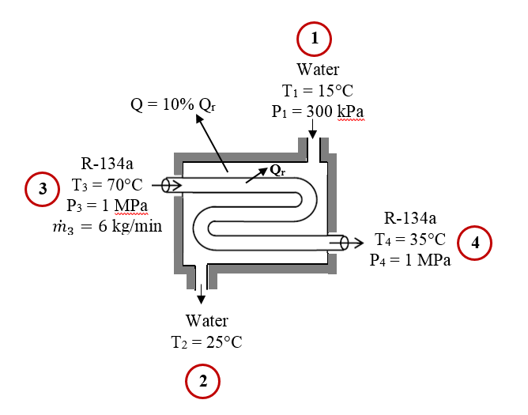
(Superheated vapour)
(Sat. liquid)
(Sat. liquid)
(Sat. liquid)

Notes:
- Kinetic and potential energy changes are negligible.
- There are no work interactions.
- Water exists as a compressed liquid at both the inlet and the exit since the temperatures at both locations are below the saturation temperature of water at 300 kPa (133.52°C). You will then approximate the compressed liquid as a saturated liquid at the given temperatures.
- The refrigerant enters the condenser as a superheated vapour at 70°C and leaves as a compressed liquid at 35°C.
- You will need to use table A-4, A-11 and A-13.

