Digital Skills And Research Methods

Self-Assessment Report
Name: Daniella Espiand
Student Number: 1708021
Group Number: 6
Certificate in Skills for the Workplace
Tutor Name: Renuga Jayakumar
Contents

Introduction……………………………………………………………………………..1
Smart Phones and Tablets………………………………………………………..2-4
Electronic mail………………………………………………………………………….5
Social Media……………………………………………………………………………..5-9
Conclusion………………………………………………………………………………..10
References………………………………………………………………………………..11

Introduction

Technology from today has well embrace society and the workplace. Its permits businesses to work quickly and efficiently. Technology such as video conferencing and virtual offices have discarded the boundaries of the workplace that before limited expansion of businesses. With the usage of modern business technology business and companies will be able to target a bigger customer base and progress to higher levels.

Modern day technology can improve massively communication in the workplace. Todays technology allows workers to send messages instantly, workers are no longer limited to using phone calls or inter-office mail to be able to communicate with another person. An interesting article is by Karehka Ramey 6/11/12 she says “Modern technology is simply an advancement of old technology. The impact of technology in modern life is unmeasurable, we use technology in different ways and sometimes the way we implement various technologies do more damage than good”. I found this article relevant to this point because it explains clearly the affect of technology on us and how it can help us progress.
1
Smart Phones and Tablets
There are many mobile phones in which one can choose. I have a Samsung galaxy phone. I choose this phone especially as I find the design of the phone stylish and unique. I preferred the features of the Samsung galaxy over the other phones for the following reasons:

Camera: The quality of the pictures I take on my phone is exceptional compared to my sons iPhone. According to Gordon Kelly 10/10/17 he says “Apple and Samsung both adopted much bigger displays this year and the former even had its display made by the latter.
- Galaxy S8 – 5.8- inch Super AMOLED, 2960 x 1440 pixels (570 ppi pixel density), 1000 nits,83.6% screen-to-body ratio
- iPhone X – 5.8 inch 18.5:9 True Tone OLED, 2436 x 1125 pixels (458 ppi), 625 nits, 82.9%, screen-to-body ratio”.

Another advantage of having a smart-phone is that you can communicate with your clients and send emails while on the go. No need to carry your heavy PC in your bag anymore because the phone permits you to do all your tasks anytime and anywhere. Also, not only can you access your work life on a smartphone you can also access your personal life and keep in contact with loved ones that are not around you just with a click of a button you can connect with someone whose 1000 of miles away from you.

2
2
I particularly like smartphones this is because there are so many features that can be accessed easily such as:

- Online Banking: Online Banking is very useful as you can access your bank account at anytime and anywhere
- Google Map: Google maps is a life saver I’m someone who easily gets lost but with a click of a button I can find my way to anywhere with Google Maps.
- Parking Payment: When paying my parking use an app called Ringo it allows me to pay for my parking online this app is very useful because not all parking machines accept debit/credit card, but Ringo allows you to pay with your debit/credit card.

I also use a tablet which is an iPad with the tablet I enjoy the following things:

- Read: As I spend some time reading before, I go to sleep my tablet permits me to read some books digitally which is also good for the planet as paper is not wasted.
- Record videos: This allows me to occupy myself but also the kids as we can spend some family time creating videos.
- Work: My tablet as permits me to access my work without the hassle of using my PC
- Watch TV: The thing that I particularly enjoy about using my tablet is being able to watch tv online and on the go I can watch my favourite series on Netflix or check the latest results of the day football match without having to be stuck at home for the whole day.
iPad’s can also improve communication in the workplace according to Andy Walton 13/01/19 it says “The iPad offers a wide range of ways to communicate with colleagues, no matter where you are. Its built-in Face time video-calling app or third-party Skype app allows much more flexibility than a standard phone call, while conferencing apps such as WebEx let you run a full-scale conference call from anywhere you can access an Internet connection. Apps such as Basecamp take things one step further still, offering a complete suite of collaboration and project management tools”.
3
The most important differences are in between both devices is that my mobile phone is small compared to my tablet so this makes it easier to transport around and takes less space it can also fit in my handbag. However, the tablet cannot fit inside my bag, so it requires an extra bag to transport it around. But the tablet is used for relaxation and to capture unforgettable family memories. Each of the devices have their precise purpose. On the other hand, the downsides to those devices is I cannot read for a long time on my phone as it makes my eyes hurt, just as I cannot walk with an iPad in my bag for a long period of time.

4
Electronic Mail

There is multiple email account provider. But Gmail and Yahoo are part of the most frequently used providers they vary in different ways. According to Niro Reg 16/4/17 he says “The key difference between Google and Yahoo is that Google has a large market share and has a wider scope whereas Yahoo has a small market share and is a good option for entertainment”.

What is the difference between Google and Yahoo?

Google vs Yahoo
Google offers more products than Yahoo.(Books, Adwords, Admob) | Yahoo has many products.
Rank
Google is ranked no.1 in Alexa. | Yahoo is ranked no. 6 in Alexa.
Shares
Google has more shares according to comScore. | This has fewer shares according to comScore.
Social Networking
Google+ and YouTube are its social networking sites. | Tumblr and Flickr are its social networking sites.
Entertainment
Games are not available. | Games are available.
Algorithm
Algorithm is known to be better. | Algorithm is good.
Search Results
This gives good-quality and relevant sites. | This gives well-established sites.
Links
This builds valuable links. | This uses established sites.
Ease of Access
Google instant is available for faster results. | There is more attraction for users with interactive features like news, sports, etc.
Scope
The scope is wider. | The scope is smaller in comparison.

According to Niro Reg
5
Social Media
Social media is very useful in the workplace because it allows you to communicate with various people that are not in the same town or country as you. According to Margaret Rouse 13/01/19 “Social media is the collective of online communications channels dedicated to community- based input, interaction, content-sharing and collaboration”. Social media has started to take over every aspect of our lives not surprisingly the workplace as well. In the workplace social media takes a big part of it this is because it is used for product marketing, promoting brands, also to communicate to existing clients and to create new companies.

Social media is used frequently for crowdsourcing. Clients may utilise this tool to propose innovating ideas for future products or adjustments for existing ones. In projects that involve IT the usage of crowdsourcing usually involves blending IT services and business.
According to Jessica Miller Merrell 9/07/15 she says “An internal social network can provide endless information regarding employee satisfaction and other similar trends. The amount of data that is available to employers from employee activity search and interests can help organizations learn more about employee interest, engagement levels, peak work times and productivity, and types of content a conversation”.

6
6
The 4 main social media sites are
- Twitter: Twitter is a multi-usage platform where you can blog it allows registered members to broadcast tweets (short posts) According to Deborah Lee Soltesz 13/01/19 “Individuals, businesses and organizations can use Twitter to promote themselves, drawing attention to events”.
- LinkedIn: LinkedIn is a platform created for professionals. It permits you to build your professional portfolio. According to Judi Light Hopson 13/01/19 “The LinkedIn professional online community promotes networking with individuals and groups. By signing up to share information about yourself, you enter a unique realm of professional relationship online”.
- YouTube: YouTube is a free video sharing platform that facilitates to watch online videos. Users can upload their own videos to share to anyone watching YouTube. According to Tom Gresham 13/01/19 “Video has become an integral part of internet users’ online experience, and no site hosts more videos than YouTube, The site boasts more than 3 billion views per day, making it an excellent place for marketers to find customers”.
- Facebook: Facebook is a free social networking platform that allows you to communicate with friends, relatives and colleagues it also permits you to promote your business and ideas. According to Edward Mercer 13/01/19 he says, “Beyond the company’s own value, however, Facebook also has an entire interface designed for businesses, complete with business profile pages and an advertising system that allows marketers to target their ads based on the wealth of information users provide about themselves on the site”.

7
Twitter

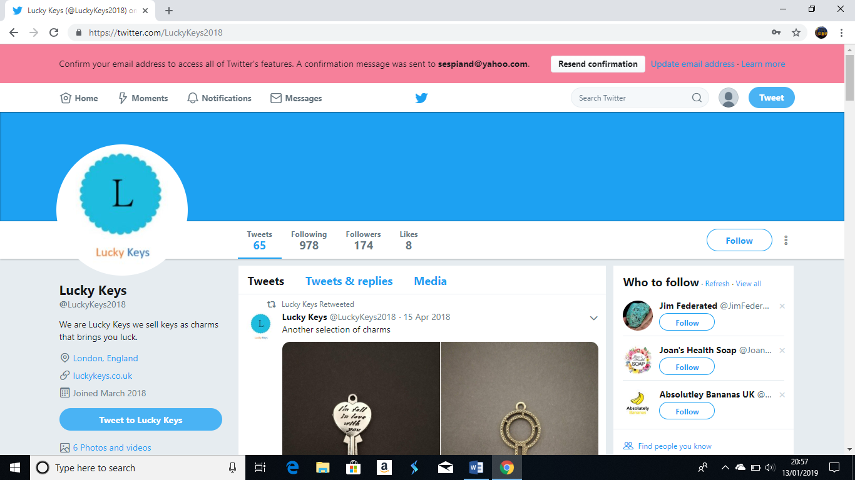

LinkedIn

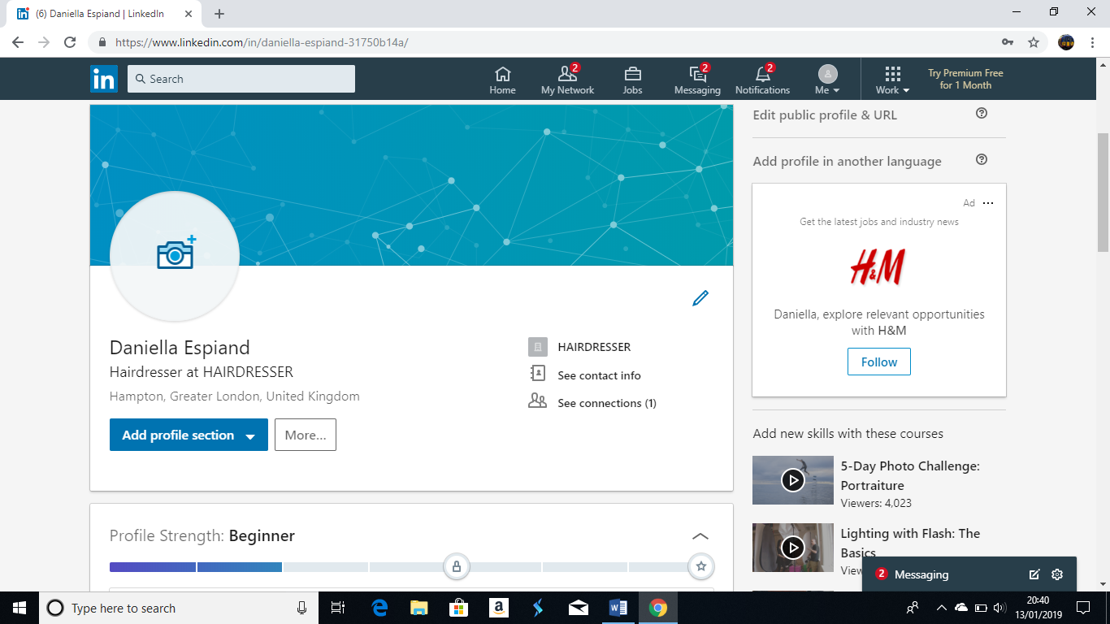
8

Facebook

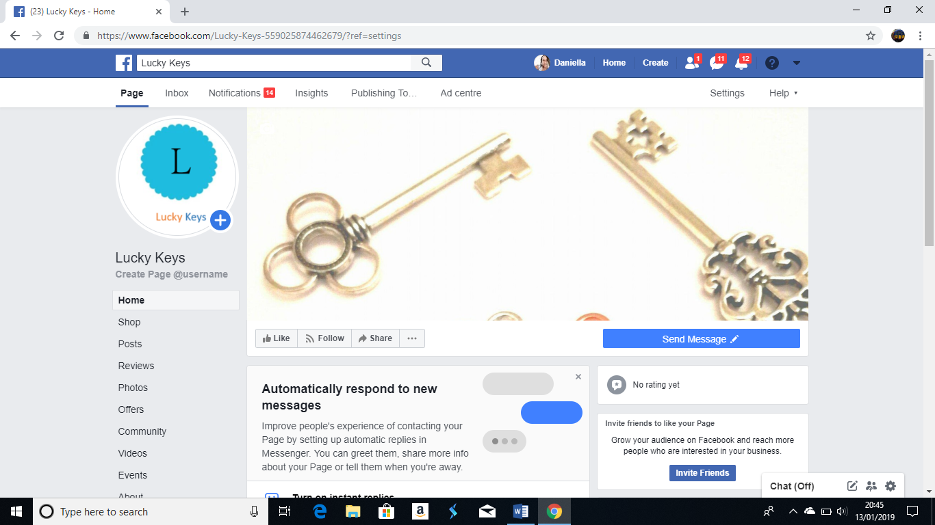
9
Conclusion
Modern technology has permitted society to progress massively. The focal point on communication, tablets, smart phones and social media, modern technology is permitting the world to get closer together. Companies are known able to expand dramatically within a short timescale and they no longer rely on usual media to advertise or put across their message. In the same way people can now follow or obtain any information from all parts of the world. Twitter allows the user to see anything from live updates on airline timing to the next football match. The world is heading towards “Information streams”. The user does no longer have to fetch the information the information comes to them.

Social media does create some concern on overload of information and security breach, not like the standard media, social media does not have a coherent pattern as to how much or how little information that’s needing to be conveyed. Another area of concern is security where people can access to other user’s information illegally. Although all those small issues are occurring social media is become more and more popular as many platforms and people can collaborate together no matter where you’re from your ethnicity with social media you can get your views heard and expressed like everyone else.
10

Social also permits small entrepreneurs to get their business known without social media lots of small businesses known today wouldn’t have been successful like they are right known. This is because it is free to use, and you can access it at any moment without having to hassle on top of it you can connect with other people with the same interest as you.
References
11

- Karehka Ramey 2012, Modern Technology Advantages and Disadvantages www.useoftechnology.com
- Gordon Kelly 2017, iPhone X vs Galaxy S8: What’s the Difference? www.forbes.com
- Andy Walton 2019, The Advantage of an iPad www.smallbusiness.chron.com
- Niro Reg 2017, Difference Between Google and Yahoo www.differncebetween.com
- Niro Reg 2017, Google And Yahoo Comparison Table www.differencebetween.com
- Margaret Rouse 2019, Definition of Social Media www.whtis.techtarget.com
- Jessica Miller Merrell 2015, 5 Benefits of Social Networks at Work www.workology.com
- Deborah Lee Soltesz 2019, What Are the Benefits of Twitter www.techwalla.com
- Judi Light Hopson 2019, The Role of LinkedIn in Business www.smallbusiness.chron.com
- Edward Mercer 2019, The Importance of Facebook www.smallbusiness.chron.com
- Tom Gresham 2019, The Importance of YouTube in Marketing www.smallbusiness.chron.com

