International Meetings Management for the Hotel Industry

Module code: BMIH6007
Senior Lecturer: Kathryn Flynn
Student name: Ioana Dobre
Student number: 2224087

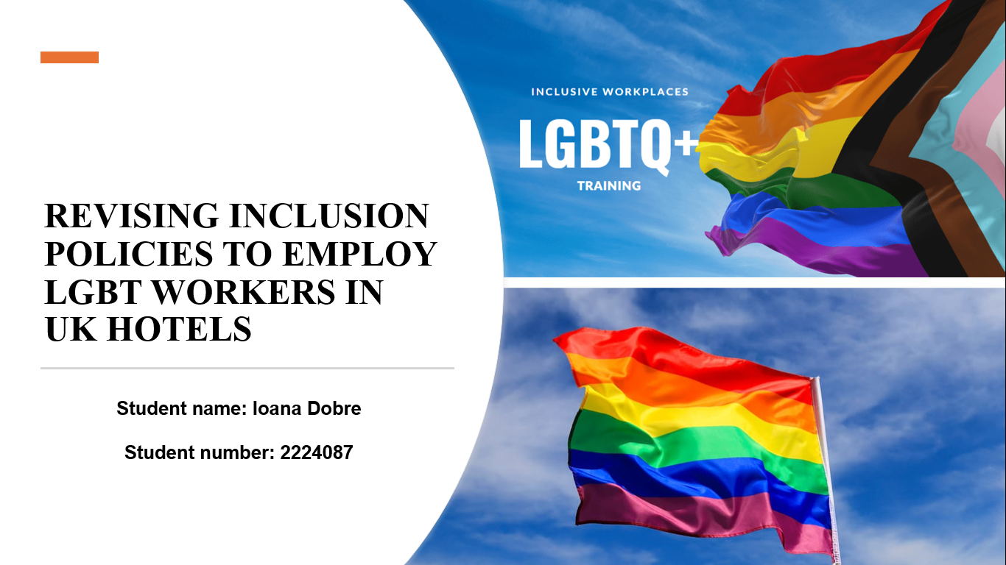

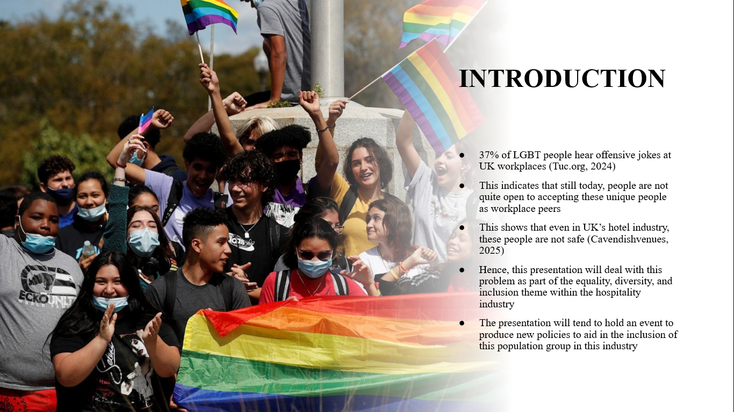

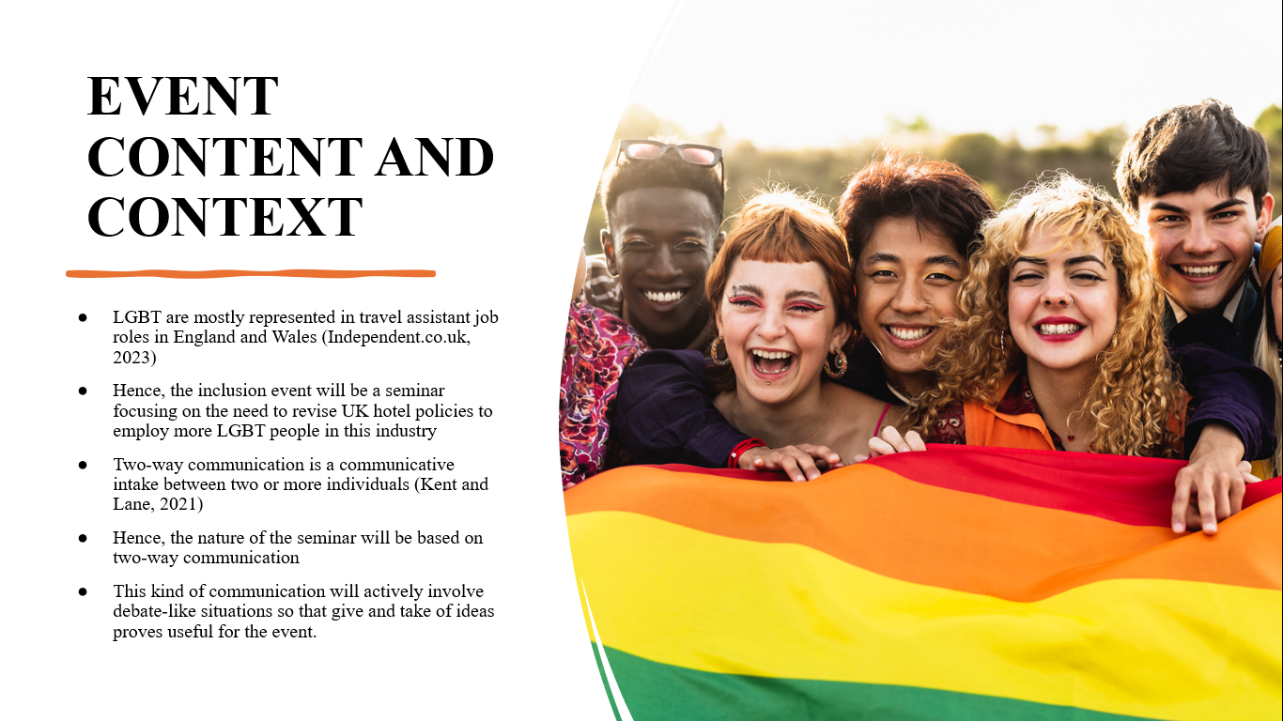

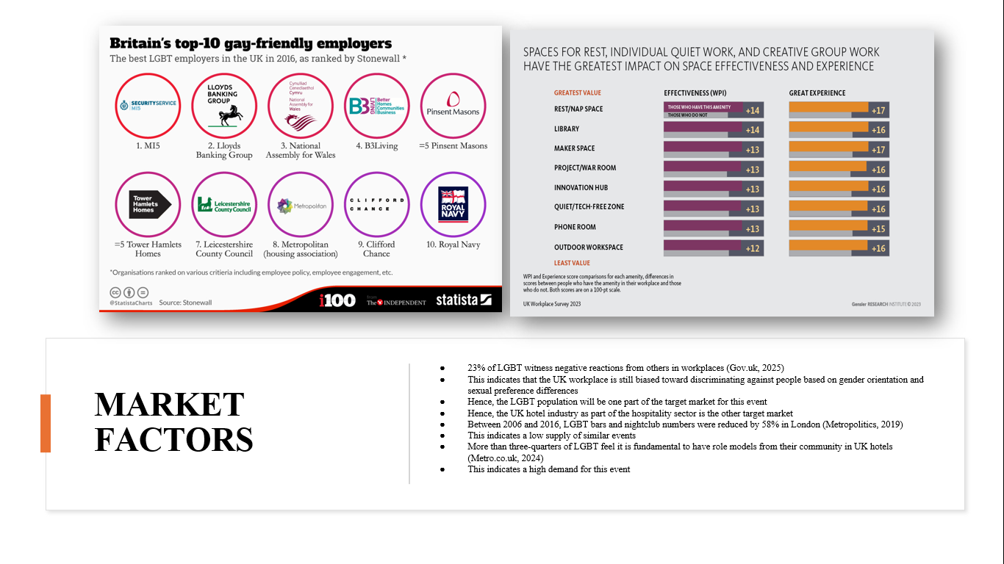

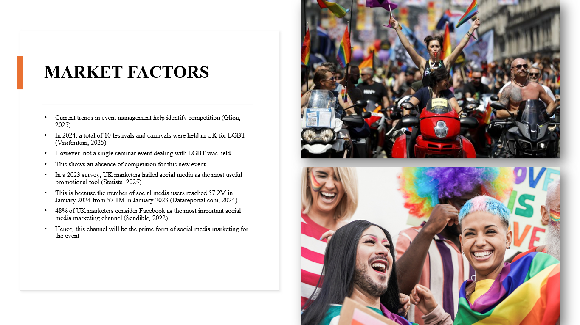

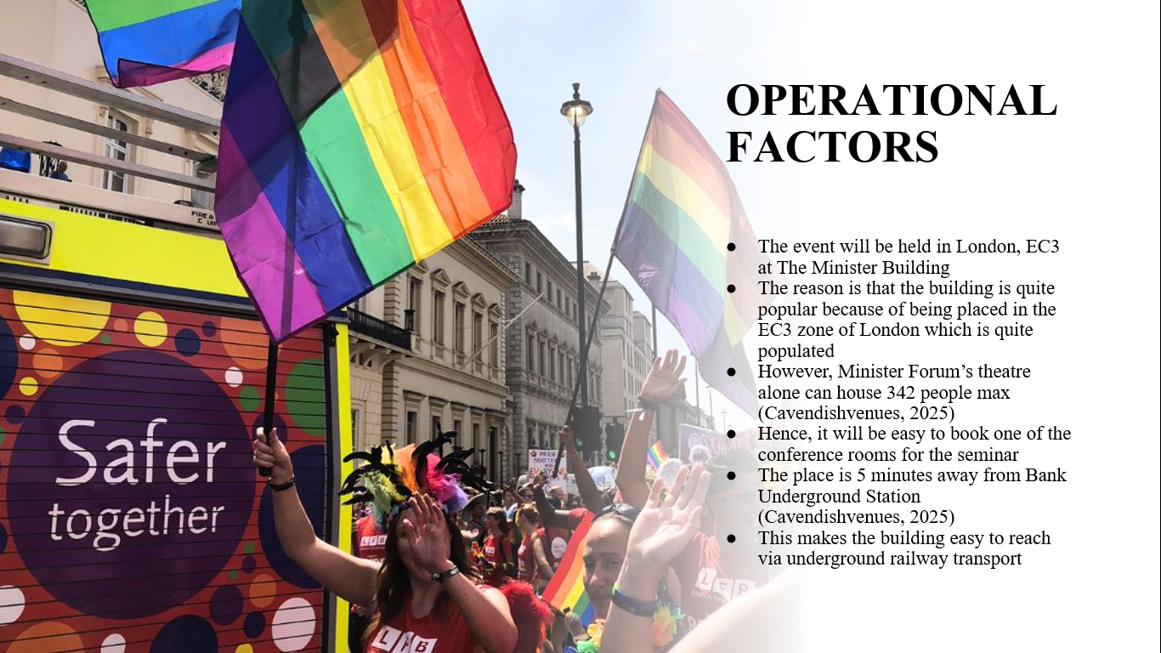

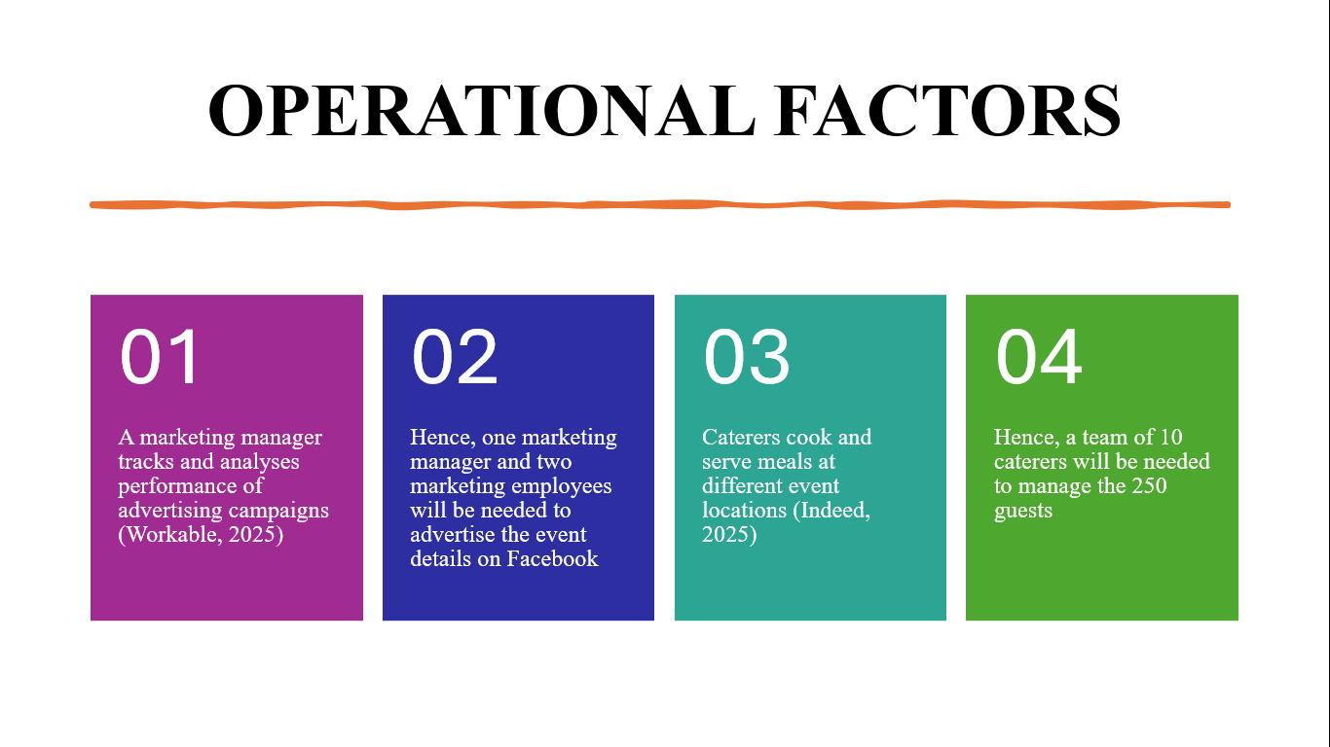

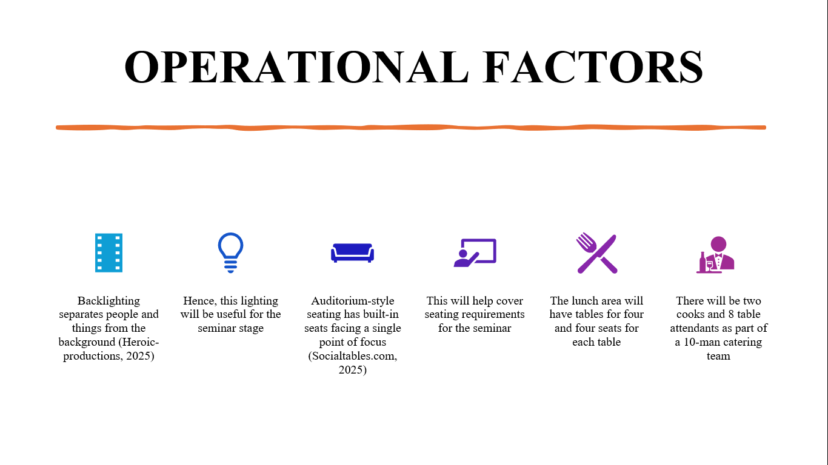

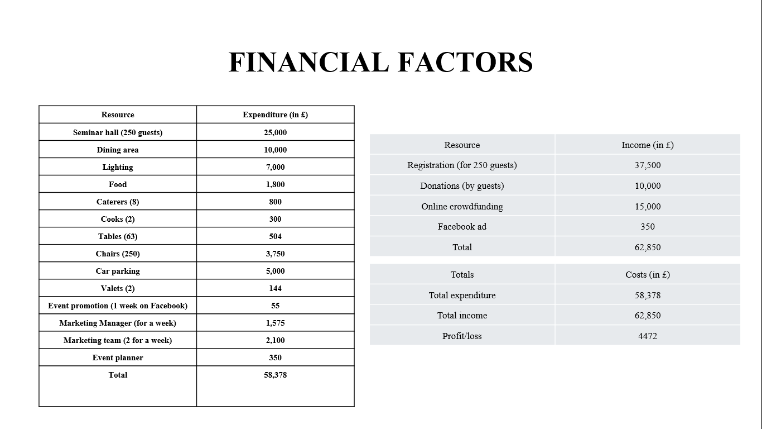
\

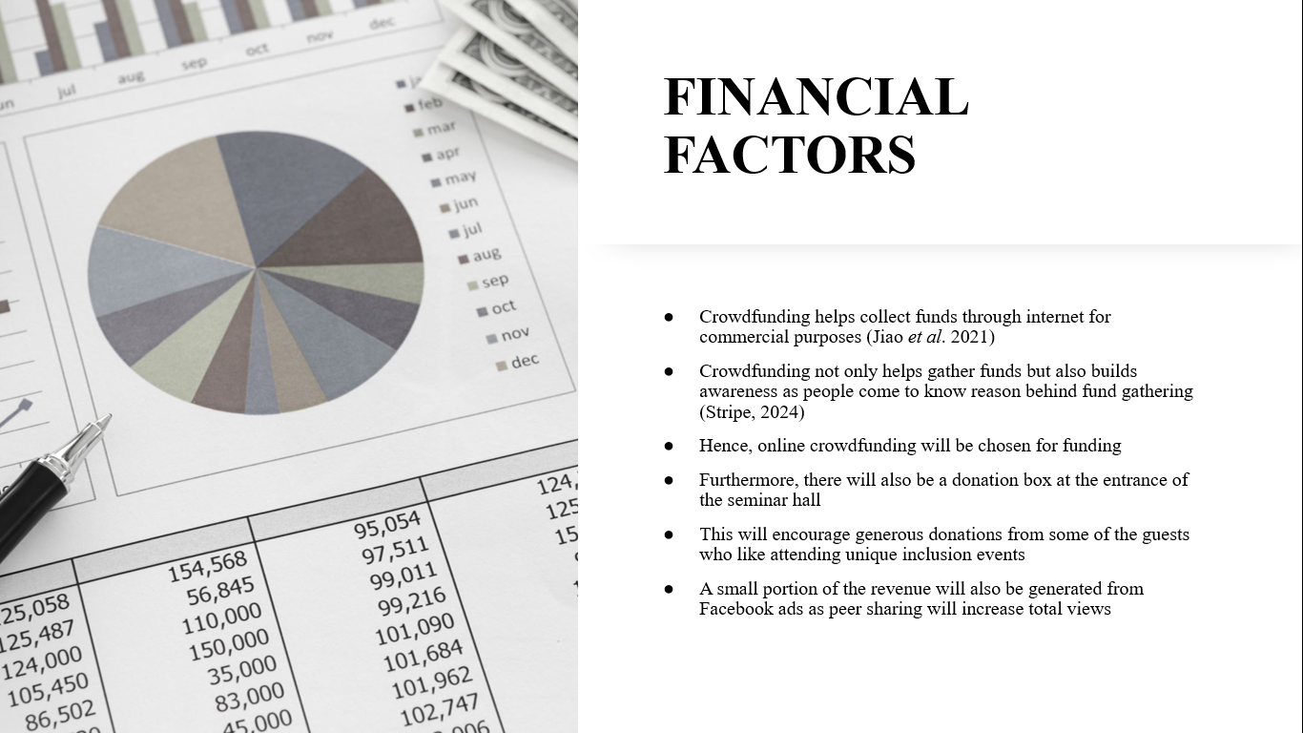

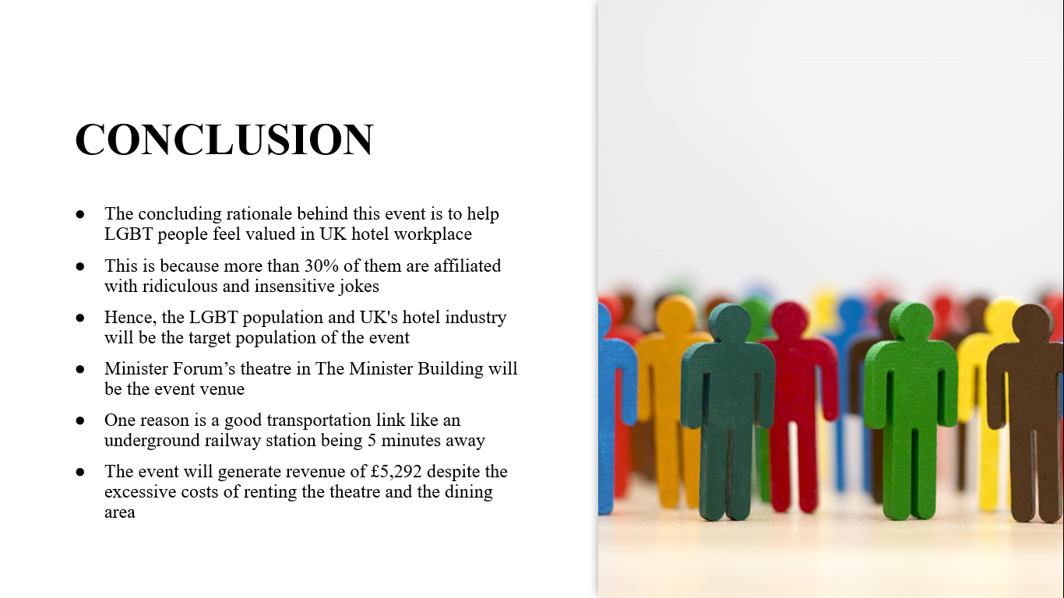

- Sendible, 2022. Which Social Media Channels are Best for Your Brand’s Marketing Goals. Available at: https://www.sendible.com/insights/the-best-social-media-channels [Accessed on 23rd January 2025].
- Socialtables.com, 2025. 8 Must-Know Types of Seating Arrangements for Events. Available at: https://www.socialtables.com/meeting-event-design/types-of-seating-arrangements/ [Accessed on 23rd January 2025].
- Statista, 2025. Digital marketinCavendishvenues, 2025. Find Us. Available at: https://www.cavendishvenues.co.uk/find-us# [Accessed on 23rd January 2025].
- Cavendishvenues, 2025. The Minster Building. Available at: https://www.cavendishvenues.co.uk/venues/the-minster-building [Accessed on 23rd January 2025].
- Datareportal.com, 2024. Digital 2024: The United Kingdom. Available at: https://datareportal.com/reports/digital-2024-united-kingdom [Accessed on 23rd January 2025].
- Metropolitics, 2019. Culture and the nighttime economy. Available at: https://metropolitics.org/Culture-and-the-Nighttime-Economy-A-Conversation-with-London-s-Night-Czar-and.html [Accessed on 23rd January 2025].
- Glion, 2025. Current trends in event management and how to stay ahead. Available at: https://www.glion.edu/magazine/trends-in-event-management/ [Accessed on 23rd January 2025].
- Gov.uk, 2025. National LGBT Survey Summary Report 2018. Available at: https://assets.publishing.service.gov.uk/media/5b3cb6b6ed915d39fd5f14df/GEO-LGBT-Survey-Report.pdf [Accessed on 23rd January 2025].
- Heroic-productions, 2025. Conference and Event Lighting: Considerations, Color Schemes & Tips. Available at: https://www.heroic-productions.com/event-lighting/ [Accessed on 23rd January 2025].
- Indeed, 2025. Caterer Job Description: Top Duties and Qualifications. Available at: https://www.indeed.com/hire/job-description/caterer [Accessed on 23rd January 2025].
- Independent.co.uk, 2023. New data reveals most popular occupations of lesbian, gay and bisexual people. Available at: https://www.independent.co.uk/news/uk/home-news/ons-data-gay-lesbian-bisexual-jobs-b2436332.html [Accessed on 23rd January 2025].
- Jiao, H., Qian, L., Liu, T. and Ma, L., 2021. Why do people support online crowdfunding charities? A case study from China. Frontiers in psychology, 12, p.582508.
- Kent, M.L. and Lane, A., 2021. Two-way communication, symmetry, negative spaces, and dialogue. Public Relations Review, 47(2), p.102014.
- Metro.co.uk, 2024. I am an LGBTQ+ chef — this is why the UK’s hospitality sector needs a shakeup. Available at: https://metro.co.uk/2024/06/13/im-lgbtq-chef-this-hospitality-needs-a-shake-20978547/ [Accessed on 23rd January 2025].
- g in the United Kingdom (UK) - statistics & facts. Available at: https://www.statista.com/topics/4019/digital-marketing-in-the-uk/ [Accessed on 23rd January 2025].
- Stripe, 2024. What is crowdfunding? Here are four types for startups to know. Available at: https://stripe.com/in/resources/more/four-types-of-crowdfunding-for-startups-and-how-to-choose-one [Accessed on 23rd January 2025].
- Tuc.org, 2024. Bullying, harassment, and discrimination of LGBT people in the workplace. Available at: https://www.tuc.org.uk/research-analysis/reports/bullying-harassment-and-discrimination-lgbt-people-workplace [Accessed on 23rd January 2025].
- Visitbritain, 2025. Unmissable events celebrating LGBTQIA+ and other historically underrepresented communities in Britain. Available at: https://www.visitbritain.org/news-and-media/destination-news-and-inspiration/unmissable-events-celebrating-lgbtqia-and-other [Accessed on 23rd January 2025].
- Workable, 2025. Marketing Manager job description. Available at: https://resources.workable.com/marketing-manager-job-description [Accessed on 23rd January 2025].

