

LOCATION: Swansea | LLEOLIAD: abertawe
LEVEL 5 | LEFEL 5
EXAMINATION PERIOD | CYFNOD ARHOLIADAU
JanuaRy 2025 | Ionawr 2025

MODULE CODE: ACDA5001

Electrical Engineering

TIME: 2 HOURS
answer ALL THE questions

Equipment or materials required – Calculator
Adnoddau neu ddefnyddiau sydd eu hangen - Cyfrifiannell

ANSWER ALL THE QUESTIONS

Question 1 [25 marks]
- An Alternating voltage, used to power an AC motor is described by the equation $V=100Sin (150πt-0.25)$. Determine the following parameters to evaluate the motor’s power supply characteristics.
- Peak to peak voltage [2 Marks]
- RMS voltage [2 Marks]
- Frequency [2 Marks]
- Phase angle in degree [2 Marks]
- A coil with an inductance of $0.1H$ and a resistance of $5Ω$ is used in a relay circuit. When this circuit is switched on to a 220V supply. Calculate the steady state current in the circuit and the rate of rise of current at t=0 and at $t=2τ$and analyse the results. [where $τ=\frac{L}{R}$] [13 Marks]
- Describe eddy current loss in a transformer. List one technique to minimise eddy current loss. [4 Marks]
Question 2 [25 marks]
- A supply voltage of $V_{1}=25V$ is given to the circuit shown in fig:1. Apply Circuit Analysis to:
- Calculate the load current. [9 Marks]
- Determine the value of load resistor for maximum power transfer across the load. [3 Marks]
- Draw a simplified circuit diagram for the circuit shown in fig.1 [3 Marks]
- Calculate the Maximum power transferred across the load ($P_{L})$. [4 Marks]
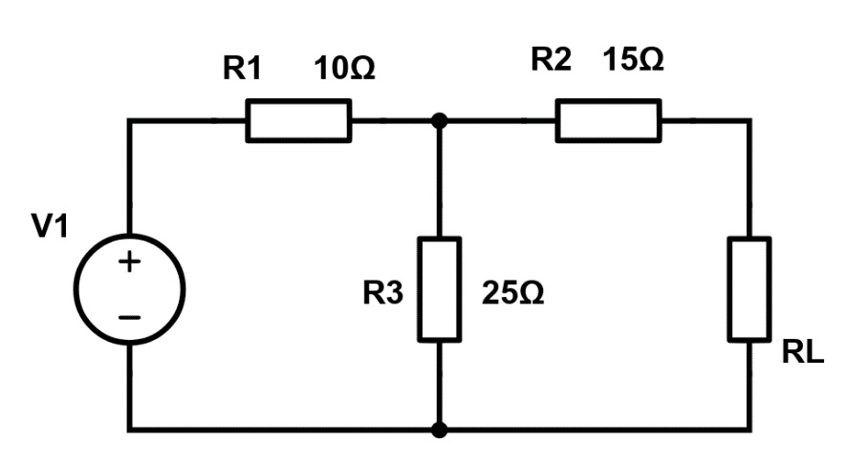
Fig: 1
- Describe the functions of the following components used in DC machines
- Field System [3 Marks]
- Armature [3 Marks]
Question 3 [25 marks]
- A $400V$, three phase star connected alternator supplies a delta – connected load as shown in fig: 2. Each phase of which has a resistance of $30Ω$ and inductive reactance of $40Ω$. Analyse the system and:
- Calculate the current supplied by the alternator, [7 Marks]
- Determine the output power of the alternator, [4 Marks]
- Calculate the Apparent power (kVA) of the alternator. [3 Marks]
Neglect the losses in the line between the alternator and the load.
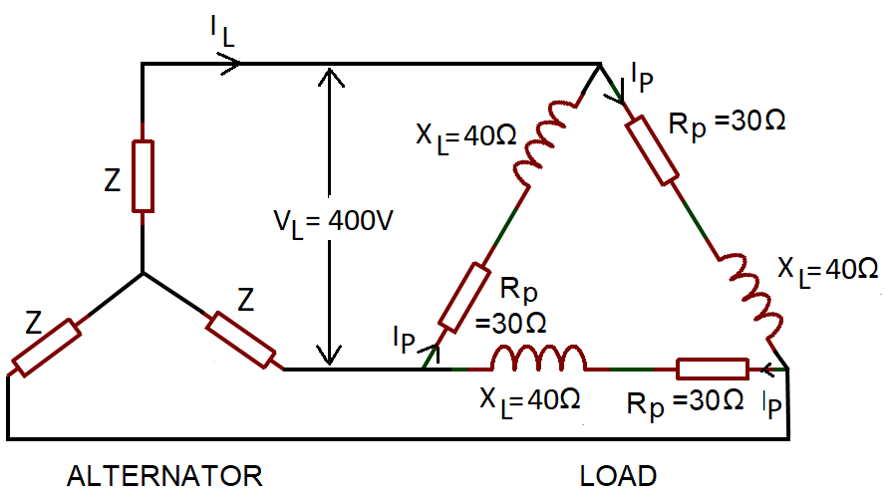
Fig: 2
- A 415V, three phase AC motor has a power output of 12.75kW and operates at a power factor of 0.77 lagging and with an efficiency of 85%. If the motor is delta-connected, Apply you knowledge to determine the following,
- Input Power [3 Marks]
- Line current [3 Marks]
- A generator is connected to a $60Ω$ load and supplied with a current of 8A. If the armature resistance is 5$Ω.$ Calculate the terminal voltage and the generated e.m.f. [5 Marks]

Question 4 [25 marks]
- A RLC series circuit consists of $R=75Ω$, $L=125mH$ and $C=200μF$. The circuit is excited by a sinusoidal source of voltage $115V, 60Hz$. Using Complex functions analyse and determine the following.
- Impedance in the circuit [7 Marks]
- Current across the circuit [2 Marks]
- Voltage across each element [6 Marks]
- Apparent power [2 Marks]
- Active Power [2 Marks]
- Reactive power [2 Marks]
- Construct a Phasor diagram to represent the circuit [4 Marks]

Diwedd/End

