Christmas Menu
Hotel Placement- Food and Beverages
BMIH4002
Ana Maria Morteanu
Student Id: 2127610
Lecture’s: Ffion Cumberpatch

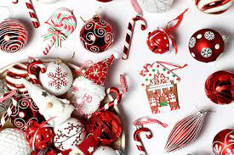

Trinity Hotel Christmas Party’s Menu
The holiday season is a time for enjoyment, celebration, and goodwill. In the cosy surroundings of the Trinity Hotel, you will discover an aura of warmth from our open fires, cheer, and friendliness while the chilly north wind blows and howls outside.
Happy Holidays and a Prosperous New Year!
Christmas packages 2022 | Standard room double | Family room/twin room
2 pers.-3 nights  23.12.22-26.12.22 | £ 350 | £ 400
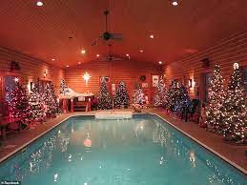
* Extra tariffs for children:
0 – 7 free of charge
7 – 14 half prices
14 – 18 full prices
Free entry to the indoor pool

Take advantage of a black-tie Christmas dinner with live music and a free glass of prosecco upon arrival.

CHRISTMAS DAY MENU

3 courses + a glass of fizz on arrival

Christmas Day Starters
Tomato Soup
Served with croutons
Camembert en Croutes
Encased in an all-butter puff pastry, topped with cranberry sauce and served with a bread roll
Prawn Cocktail
Served with a slice of brown bloomer

Intermediate
Champagne Sorbet

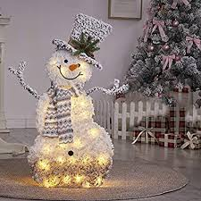
Christmas Day Mains
All our roasts unless otherwise stated are served with crispy roast potatoes, Yorkshire pudding, stuffing, a pig in blanket, root vegetable mash, honey roasted parsnips, carrots, garden peas, brussels sprouts and our signature red wine gravy
Choose from:
Turkey
Beef
Gammon
Trio of Meat Roast
ROASTED SIRLOIN, Roast potatoes, seasonal vegetables, Yorkshire pudding & a rich gravy
CRISPY PORK BELLY Mashed potato, green vegetables & a garlic & sesame sauce
SEA BASS New potatoes, capers, salsa verde & sautéed green beans
GOATS’ CHEESE & CHIVE RISOTTO Asparagus, spinach, peas & broad beans dessert
Christmas Day Desserts
Traditional Christmas Pudding
Packed with cider & rum-soaked fruit and served with a warm brandy sauce
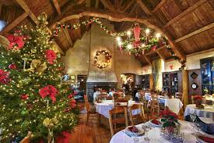
Ice Cream Sundae with After Eight
Three scoops of vanilla ice cream, layered with After Eight chocolate mints chocolate sauce, mint flavoured sauce and topped with a whip of cream
Price per adult £89.99
Price per child (under 12) 39.99
For more information and booking please contact us at www.trinityhotel.co.ukYou can find us on   

References:
Is this America's most festive home? Log cabin boasts 220 Christmas trees and 60,000 ornaments | Daily Mail Online www.dailymail.co.uk/news/article-7806393/Is-Americas-festive-home-Log-cabin-boasts-220-Christmas-trees-60-000-ornaments.html [online] accessed on 11.11.2022
Hotel Cindrel Paltinis Romania, www.hotelcindrel.ro [online] accessed on 11.11.2022
Christmas and New Year Greetings Sample for Hotel Guests - Email | SMS | Social Media | Postcard (setupmyhotel.com) ,setupmyhotel.com/formats/fo/289-xmas-and-new-year-wishes.htm [online] accessed on 11.11.2022
www.tabletable.co.uk/en-gb/christmas-day-menu [online] accessed on 11.11.2022
theroyaltobyhotel.co.uk/app/uploads/2022/08/The-Royal-Toby-Christmas-Brochure-2022.pdf [online] theroyaltobyhotel.co.uk/christmas/ accessed on 11.11.2022. www.google.co.uk/search?q=google+logo&sxsrf=ALiCzsYa [online] accessed on 11.11.2022.

