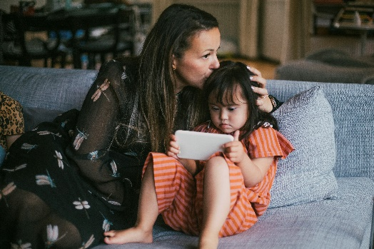
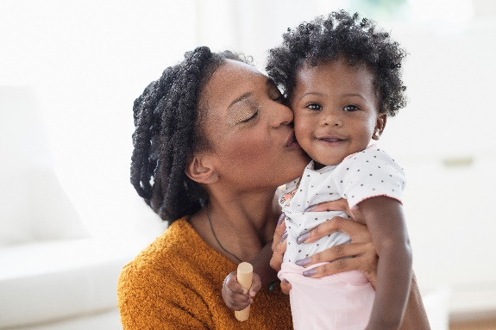
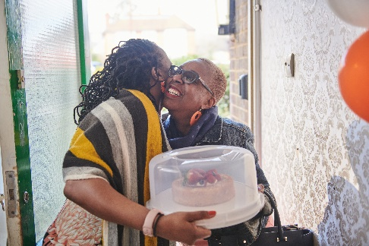


2017445
Elaine Avsar
ECAY6004
Assessment 2

Portfolio


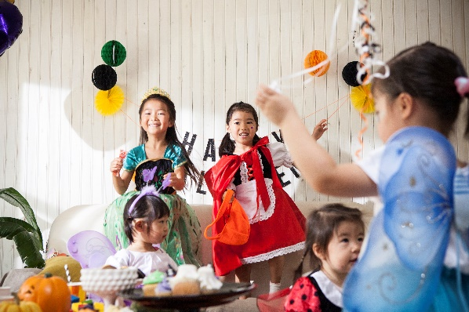


Identify 2 images which represent families in the 21st century. Then compare and contrast these images to explore, in depth, how social media can influence current representations of family within society.

Table of Contents
Same-sex Couple and their Family in the 21st Century 2
Heterosexual Couple and their Family in the 21st Century 4
Compare and Contrast Images 6
Social Media and Family 8
Reference List 11

Same-sex Couple and their Family in the 21st Century


Image: EY Matters (2021).
This image depicts two adult males and four children of varying ages, all white. The men would appear to be around 40 years of age. Three out of the four children exhibit outward signs of disability. A young boy aged approximately eight years of age is sat in an adapted, cushioned chair. The older boy, possibly a young teenager is sitting in an electric wheelchair. Next to him is a teenage girl who has the facial characteristics of a person with Down Syndrome and the younger girl does not appear to have any physical disabilities. Whilst neither man’s left hand can be seen, it can be argued that these men are married or cohabiting, and they are the fathers to these children. It is not possible to ascertain from the image if any of these children are genetically related to one or the other of the men, so there is a possibility that these children are adopted or fostered. Everyone in the picture is smiling and relaxed and seem happy in front of the camera. All but the younger boy in the adapted chair are looking directly at the person taking the picture. The background to the image is plain so they are possibly inside their home or in a photography studio for a family portrait. All of the family members are dressed casually; the men are in jeans and t-shirts. The girls are wearing dresses and the boys, jeans and casual tops. The two men are bending down slightly to be closer to the children’s level and both have protective arms around them rather than each other.
The rationale for choosing this image is that the UK government states, ‘[p]rospective adopters from every walk of life are warmly welcomed and supported in a system that is never threatening or judgemental.’ (Department of Education, 2021). This acknowledges the different forms families can take in the UK in the 21st century. Adoption has been legally binding for families in England and Wales since 1926 and is therefore well established as a family form. The current legislation is the Adoption and Children Act 2002.

Heterosexual Couple and their Family in the 21st Century


Image: Felstead, B. (2023)
This image depicts an adult male holding a young boy, an adult female holding a baby and a young girl stood next to the female adult. This appears to be a picture of a young, white family; the couple being approximately early 30s in age. Although the woman’s left hand is not visible to the camera, the man is wearing a plain band ring on his left ring finger, suggesting that they are a married couple. It can be argued that the adults are the parents of these children.
The family appear fashionably but fairly conservatively dressed. The man is wearing a smart suit; the woman a dress and what appear to be designer shoes. The young boy is dressed in a smart/casual shirt and trousers and the young girl is wearing a dress, long socks, and Mary Jane shoes. Their outfits suggest they are at a formal gathering. The family are standing in a churchyard, evidenced by the headstones behind them, and the houses visible in the background suggest they are in an affluent area somewhere in England. The baby in the woman’s arms is dressed in a traditional, long gown so according to the location and the outfit, it would appear the family are celebrating the baby’s Christening.
In this image, the family appear happy and whilst the picture appears to be of a professional standard, the image is of an unguarded moment as not all family members are looking directly at the camera, and they appear relaxed.
According to figures by the Office for National Statistics (ONS, 2022) the largest religion in the UK is Christianity, and the greatest number of marriages are between heterosexual, white couples. The rationale for using this image is that this is still an accurate reflection of the family in England and Wales as a whole.

Compare and Contrast Images

Marriage in the UK is now legally available to both opposite and same-sex couples. The Marriage (Same Sex Couples) Act 2013 was passed in England and Wales in 2013, with the first same-sex marriage taking place the following year. Prior to this, from 2005 onwards same-sex couples could only legally enter into a civil partnership. The wearing of the wedding band is symbolic of the cultural norm associated with marriage in the UK (Lokman Hakim and Hashim, 2015) and whilst only the man in the second image can be seen to be wearing a wedding ring, there is a possibility the others are too. As the first image is from an article after 2013, the two men could indeed be married. Adoption for same-sex couples has been possible in the UK since 2002. This move towards a greater acceptance of single-sex adoption is reflected in the European Values Survey (Takacs et al., 2016). The UK is considered a liberal welfare state and the survey found more people agreed for than against the statement ‘[h]omosexual couples should be able to adopt children’. It is interesting to note that single-sex couples were legally permitted to adopt children before they were permitted any legal recognition of their relationship. It could therefore be argued that a higher value was placed on legal marriage than on children awaiting adoption.
McCarthy and Edwards (2011) would describe the opposite-sex couple in the second image as the nuclear or traditional family; a further definition of which provided by McKie and Callan (2012, p.17) describes ‘[a] household of two generations, generally parents and children’. Traditionally this term has applied to heterosexual couples but taking the definition provided, if the children in the first image are legally adopted, then this would equally apply to them too. The historical difference here is the previously held heteronormative value applied to the nuclear family, that is, a union between a man and a woman and their children. Historically same-sex couples with children have been referred to as ‘families of choice’ however lesbian, gay, and bisexual families have suggested they are uncomfortable with the term as it does not sufficiently address the heteronormativity issue (McCarthy and Edwards, 2011).
Comparing the two images, the dynamic between the two couples is quite different. In the second image, the man’s arm around the woman’s shoulder could be interpreted as a display of power; his assertion as head of the household (McCarthy and Edwards, 2011, p.160). Through a feminist lens, this suggests ‘gender coding’ McKie and Callan (2012, p.60); the resultant deferential response by the woman suggests she embodies the mother figure, holding the baby. In comparison, the two men in the first image have their arms around the children, not each other. Neither appears to be exerting power over the other and therefore there seems to be no power differential. One study looking at parenting differences and similarities between gay and heterosexual couples found that without the pressure to fulfil gendered roles, gay couples were more likely to equally share parenting (Feinberg, 2003).
In both images both the adults and the children are all wearing gender stereotypical clothing (Lippmann, 2017; Xue, 2023). According to Workman and Freeburg (2000), we are socialized to learn and implement the norms regarding what is considered appropriate clothing according to the setting. Furthermore, it takes only twelve seconds to form an impression of an individual’s standing and credibility according to how they are dressed for a particular occasion (Furnham et al., 2013; Regan, 2018). Having determined that the family in the second image is likely at a traditional religious ceremony, their dress is representative of the symbolic interaction therein, as Goffman describes in The Presentation of Self in Everyday Life (1959). The casual dress worn by the family in the first image suggests a more relaxed, less formal interaction.
Arguably the greatest contrast between the two images is that three of the four children in the first image display outward signs of physical disability and possible learning disability/differences, whilst the children in the second image do not. According to research carried out by the charity for equality for disabled people, Scope, ‘disabled households with at least 1 disabled adult or child, face extra costs of £975.00 per month on average.’ Scope (2023). The family in the first image have at least three children with disabilities so even with any government welfare benefits they may be entitled to, their living costs would be significantly higher than the average household. It could therefore be argued that they do not have the funds for the luxury designer clothes as seen in the second image.
In comparing the two images, the professional photography, the family’s clothing, their demeanour, along with the location, all suggest that the family in the second image is fairly wealthy and is at least middle class (Savage et al., 2013). It is not as easy to ascertain the class or wealth status of the family in the first image. However, the family would also appear to be middle class due to their ability to provide for four children, at least three of whom have additional needs.

Social Media and Family

The use of the internet in the UK continues to grow annually. According to information from January to February 2020 (ONS, 2021) 96% of UK households had internet access, which was an increase from the previous year. ‘Social media refers to a set of online tools that support social interaction between people.’ Dworkin et al., (2018). The most well-known apps for social media use are Instagram, Facebook, YouTube and TikTok. One established phenomenon influencing representations of family within society is the rise of Mumpreneurs ( Instamoms. These are mothers who use social media, in this case Instagram, to share their parenting methods and tips, also known as ‘sharenting’. This is a source of income for these women as they invariably promote and share links to online stores, for which they receive a percentage of each sale (Garrido et al., 2023). However, there is now a concern that the actions of these women is disproportionately hurting their own families; ‘[t]here is evidence of the risk of overexposure of children to social media by parents working as influencers, especially Instamoms, given the number of followers of these profiles on Instagram’ Garrido et al., (2023). There are both legal and wellbeing concerns as mothers using their children in these monetized posts online are in effect involving them in child labour and infringing on their privacy. In one study (Garrido et al., 2023) all of the children profiled were under the age of thirteen, which is the age most social media apps allow users to create a profile, and the posts which received the most attention were those in which the children featured. The use of images and videos is creating a permanent online record of these children’s lives; a record they can not consent to, and adolescents are subsequently particularly uncomfortable with their mother’s ‘over-sharenting’ Garrido et al., (2023). The role of an influencer is to influence, and more women are taking to over-sharenting due to this phenomenon. One disturbing outcome of the sharing of young babies and children’s images is the production of Artificial Intelligence (AI) media featuring these images. Additionally, these children’s faces are being superimposed onto silicon dolls for sale for nefarious use (Roper, 2022).
Another impact of social media on family relates to social comparison theory (Chae, 2015). In Chae’s (2015) study, women were prone to compare their own parenting ability to celebrity mothers and their apparent superior parenting skills. Previous research has shown that in a bid to become part of the successful group, people will embrace the same methodology (Festinger, 1954) before they invariably start judging their own capabilities (Chae, 2015). Women who are already susceptible to poor mental health post-partum are particularly self-judgemental regarding their capabilities as mothers (Sun et al., 2023). Unsurprisingly exposure to social media was found to exacerbate post-partum poor mental health due to the social comparisons they were making between themselves and ‘successful’ content creators (Sun et al., 2023).
Social media is also known to affect the family as a social unit. The phenomenon known as ‘phubbing’, that is phone snubbing, is being linked with a breakdown in communication between family members. Phubbing is best described as when one person pays more attention to their smartphone than to the person they are in conversation with, in person. Al-Saggaf and O’Donnell (2019) found that ‘people phub more frequently those who are closely related to them’ and that it is ‘perceived as rude, offensive, and a violation of social norms.’ In particular one study found older adults were far more negatively affected by their family members phubbing them (Kadylak et al., 2018).
For all the research on the negative effects on family due to social media, there are also positive results. Research by Gruebner et al., (2022) found families with children with disabilities were able to seek out support from other families via social media apps which provide groups and group chat facilities. Not only are parents able to support one another by sharing their experiences with the medical world for example, but they are also able to foster a sense of empowerment within themselves, as they are able to learn more about the situation they find their family in (Gruebner et al., 2022). Research by Coyne et al., (2014) has determined that contrary to the presumption that adolescents only use their smartphones to communicate with peers, there has been a positive increase in communication amongst family members. This is referred to as the ‘stimulation method’ as it stimulates conversation (Coyne et al., 2014). Not only are families able to create shared memories via social media use within the family but it can also be a means to start a discussion. The same research has also shown that family systems theory indicates shared use of social media ‘could strengthen family ties.’ Coyne et al., (2014).

Reference List

Adoption and Children Act 2022, c. 38. Available at: https://www.legislation.gov.uk/ukpga/2002/38/contents (Accessed: 7 December 2023).
Al-Saggaf, Y., O’ Donnell, S. B. (2019) Phubbing: perceptions, reasons behind, predictors and impacts. Human Behavior and Emerging Technologies, 1(2), pp. 132-140.
Chae, J. (2015) “Am I A Better Mother Than You?” Media and 21st-Century Motherhood in the Context of the Social Comparison Theory. Communication Research, 42(4), pp. 503–525.
Coyne, S. M., Padilla-Walker, L. M., Fraser, A. M., Fellows, K., Day, R.D. (2014) Media Time = Family Time. Journal of Adolescent Research, 29(5), pp. 663-688.
Department for Education (2021) Adoption strategy Achieving excellence everywhere. Available at: https://assets.publishing.service.gov.uk/media/61001896d3bf7f044ee52330/_Adoption_strategy_.pdf (Accessed: 7 December 2023)
Dworkin, J., Rudi, J. H., Hessel, H. (2018) The State of Family Research and Social Media. Journal of Family Theory and Review, 10(4), pp. 796-813.
Feinberg, M. E. (2003) The Internal Structure and Ecological Context of Coparenting: A Framework for Research and Intervention. Parent Science Practice, 3(2), pp. 95-131.
Festinger, L. (1954) A Theory of Social Comparison Processes. Human Relations, 7, pp. 117-140.
Furnham, A., Chan, P. S., & Wilson, E. (2013) What to wear? The influence of attire on the perceived professionalism of dentists and lawyers. Journal of Applied Social Psychology, 43(9), pp. 1838–1850.
Garrido, F., Alvarez, A., González-Caballero, J. L., Garcia, P., Couso, B., Iriso, I., Merino, M., Raffaeli, G., Sanmiguel, P., Arribas, C. (2023) Description of the Exposure of the Most-Followed Spanish Instamoms’ Children to Social Media. International Journal Environmental Research Public Health, 20, p. 2426.
Goffman, E. (1959), The Presentation of Self in Everyday Life. New York: Doubleday.
Gruebner, O., van Haasteren, A., Hug, A., Elayan, S., Sykora, M., Albanese, E., Naslund, J., Wolf, M., Fadda, M., von Rhein, M. (2022) Digital Platform Uses for Help and Support Seeking of Parents With Children Affected by Disabilities: Scoping Review. Journal of Medical Internet Research, 24(12).
Hannover, B., & Kühnen, U. (2002) ‘The clothing makes the self’ via knowledge activation. Journal of Applied Social Psychology, 32, pp. 2513–2525.
Kadylak, T., Makki, T. W., Francis, J., Cotten, S. R., Rikard, R. V., & Sah, Y. J. (2018) Disrupted copresence: Older adults' views on mobile phone use during face-to-face interactions, Mobile Media & Communication, 6(3), pp. 331–349.
Lippmann, W. (2017) Public opinion. London: Routledge.
Lokman Hakim, N. B. H., Hashim, H. Z. (2015) A Recognizable Symbol of the Wedding Ring as a Communication Object to Portray Marital Status. In: Hassan, O., Abidin, S., Legino, R., Anwar, R., Kamaruzaman, M. (eds) International Colloquium of Art and Design Education Research (i-CADER 2014). Singapore: Springer.
Marriage (Same Sex Couples) Act 2013, c. 30. Available at: https://www.legislation.gov.uk/ukpga/2013/30/contents/enacted (Accessed: 7 December 2023).
McCarthy, J. R., Edward’s, R. (2011) Key Concepts in Family Studies. London: Sage
McKee, K., Callan, S. (2012) Understanding Families, A Global Introduction. London: Sage.
ONS (2021) Internet access – households and individuals, Great Britain: 2020. Available at: https://www.ons.gov.uk/businessindustryandtrade/itandinternetindustry/bulletins/internetusers/2020#:~:text=1.-,Main%20points,aged%2075%20years%20and%20over. (Accessed: 7 November 2023).
ONS (2022) Religion, England and Wales: Census 2021. Available at: https://www.ons.gov.uk/peoplepopulationandcommunity/culturalidentity/religion/bulletins/religionenglandandwales/census2021 (Accessed: 7 November 2023).
Regan, A. R., Gurung, M. B., Leet, M., Punke, E. (2018) Dressing “in code”: Clothing rules, propriety, and perceptions, The Journal of Social Psychology, 158, pp. 553-557.
Roper, C. (2022) Sex Dolls, Robots and Woman Hating, The Case for Resistance. Victoria: Spinifex Press.
Savage, M., Devine, F., Cunningham, N., Taylor, M., Li, Y., Hjellbrekke, J., Le Roux, B., Friedman, S., Miles, A. (2013) A New Model of Social Class? Findings from the BBC’s Great British Class Survey Experiment. Sociology, 47(2), pp. 219-250.
Scope (2023) Extra Costs, Available at:https://www.scope.org.uk/campaigns/extra-costs/ (Accessed: 7 December 2023).
Sun, Y., Chia, S. C., Shi, Y. (2023) How Exposure to Online Parenting Content Relates to Mothers’ Self-Discrepancy and Postpartum Mental Health. Health Communication, 38(12), pp. 2782-2794.
Takacs, J., Szalma, I., Bartus, T. (2016) Social Attitudes Toward Adoption by Same Sex Couples in Europe. Archives of Sexual Behavior, 45, pp. 1787-1798).
Workman, J. E., Freeburg, E. W. (2000) Part I: Expanding the definition of the normative order to include dress norms. Clothing & Textiles Research Journal, 18, pp. 46–55.
Xue, Z., Li, Q., Zhao, J., Zeng, X. (2023) An investigation into the relationship between clothing colors and gender stereotyping in children. Journal of Retailing and Consumer Services, 76.

Images:
EY Matters (2021) Available at: https://www.eymatters.co.uk/in-conversation-garry-ratcliffe/ (Accessed: 7 December 2023).
Felstead, B. (2023) Available at: https://www.instagram.com/p/CxTbZ1SKe4W/?igshid=MzRlODBiNWFlZA== (Accessed: 7 December 2023).

