MBA-MASTERS OF BUSINESS ADMINISTRATION
Marketing Management Assessment 1
Module LCMB 7001
Student ID:1711420
Names: Sarah Kokunda
Lecturer: Tashara Balendran.

Table of Contents
Introduction 3
Overview of Unilever 4
Communication with Customers 5
Shannon Weaver Communication Model 5
Integrated marketing communication..............................................................................................7
Customer Journey Map 8
Branding and Brand Equity 11
Keller’s Brand Equity Model 12
Customer touch point 15
Position strategies 16
Differentiation strategy of Dove 16
Total Quality Service Model 17
Conclusion 18
References 19

Introduction
In the contemporary business world marketing has become a core function in any organisation. Marketing management deals with managing all the marketing aspects, setting organisational objectives, organising the plans, directing employees, making managerial decisions and executing the marketing plans to meet customers’ satisfaction. Customer’s satisfaction is one of the core considerations for a business to remain competitive in the market (Rudkowski et al.2018). To ensure customer satisfaction, the organisation goes through several steps in the customer journey map. It also uses several touchpoints to make interaction with the customers.
This report involves the organisational approach to maximise customer satisfaction. It will analyse the communication systems of the company Unilever through Shannon Weaver communication model. To analyse the branding and brand equity it will conduct a Keller’s equity model. It will provide a customer journey map where the company emphasizes on the customer touchpoints to provide better customer experience. The total quality management model will demonstrate managerial activities of the company to ensure quality in the products and services that drive customers’ satisfaction.

Overview of Unilever
Unilever Plc is a multinational consumer products company founded in 1929 in the United Kingdom. It is headquartered in London. It serves a wide range of consumer products including food, ice cream, minerals and supplements, wellbeing vitamins, tea, coffee, toothpaste, beauty products, pet food and personal care. The company is the largest manufacturer of soap in the world. Currently it is delivering its products in 190 countries with a strong distribution channel. As of 2020 its net revenue was €6.073 billion. Unilever is a public limited company enlisted in London Stock Exchange (LSE), Euronext, NYSE, FTSE 100 component. The company has three major divisions; Beauty care, Foods & Refreshment and Home care. It has numerous brands including Dove, Sunsilk, Knorr, Lux, Lipton etc. Unilever has research and development centres in the United Kingdom, the US, the Netherlands, India and China. Its corporate mission is to create vitality to human life. Its objective is to provide nutrition, hygiene and personal care to the people. Its major competitors are Procter & Gamble, Nestle USA, Mars and Johnson & Johnson.

Communication with Customers
Communication is the process of exchanging information, ideas and thoughts among individuals. Communication in marketing involves direct marketing, advertising, promoting, branding, packaging, PR activities, printed materials, sponsorships, presentations and online presence. Its main objective is to create preference and demand for the products by the target audiences (Finne and Grönroos, 2017). An effective marketing communication enables organisations to increase customers' engagement to the brand.
Unilever applies the code ‘Advertising and Marketing Communication Practice’ approved by the International Chamber of Commerce (ICC) as the main basis for communicating with its customers (Hadden et al., 2017). It aims at informing the customers about the benefits and values of the products that are offered by its brands. Unilever applies the International Chamber of Commerce (ICC) code ‘Advertising and Marketing Communication Practice' in its communication system.

Shannon Weaver Communication Model
According to Reddy (2019), the Shannon Weaver model of communication analyses how the sender and receiver communicate with each other and which factors affect the entire communication process. Unilever uses this model to interact with their customers and identify the distorting factors that hinder the effective communication with customers. This model consists of several steps that are stated below:
Sender: The sender is the one who has the information and wants to convey the information with others. The sender initiates the communication process by selecting the necessary information and mediums to transmit a message. In the case of Unilever, the marketing department is responsible for interacting with customers and so it takes the initiative about what information to share and to whom they want to communicate (Talukdar, 2017). For instance, the marketing department promotes its Dove products to the targeted customers by selecting which information to convey, which channel to use and how to convey the information.
Encoding: Encoding is the way that the sender uses to transmit the message. In this method, the information is converted into a deliverable message so that it can reach the customers through the channel. In the encoding process, Unilever transforms the ideas about Dove in a deliverable format so that the customer can get the right knowledge of the products as well as get attracted to the products. For that, the marketing department makes promotional videos and graphics including the essential information in them.
Media: The media involves the channels through which the information is collected from the sender and delivered it to the receiver. The right choice of media is extremely crucial in communicating with customers otherwise the company may not effectively convey its messages to its targeted customers (Reddy, 2019). Unilever utilises the electronic mediums such as Television to advertise its products. Besides, it also remains active in social media platforms such as Instagram, Facebook, Twitter etc. where it posts about its latest products and daily updates to keep interaction with customers.
Decoding: Decoding is the way with which the receiver interprets the encoded message delivered by the sender and assigns meaning to it. With promotional video, Unilever conveys the information whereas the customers interpret the information based on their perception. Moreover, since Unilever conducts operations in multiple countries, the difference in language can lead to misinterpretation. Therefore, the customers decode the foreign language so that they can understand the right message.
Receiver: The receiver is the one who gets the message delivered by the sender. The sender initiates the communication process to effectively convey a message to the receiver. In the case of Unilever, the targeted customers who watch the advertisements of the products act as the receiver (Shaw, 2019). When the company makes TV advertisements, it may be watched by almost all the people. But in such cases, every receiver may not be the targeted customers of Unilever.
Feedback: After gaining the information, the receiver provides reactions and responses to the message. Feedback is the influential way of interacting with customers and making them realise that their opinion also matters to the company. Unilever attends every essential feedback from the customers and media reports to improve the products and services.
Noise: Noise includes the distorting factors for which the receiver cannot get the right message sent by the sender (Gillespie and Schiffman, 2018). Sometimes, the noise may be caused by internal factors of the company such as wrong choice of words, channels etc. Moreover, the customers may not interpret the message correctly which interrupts the effective communication.

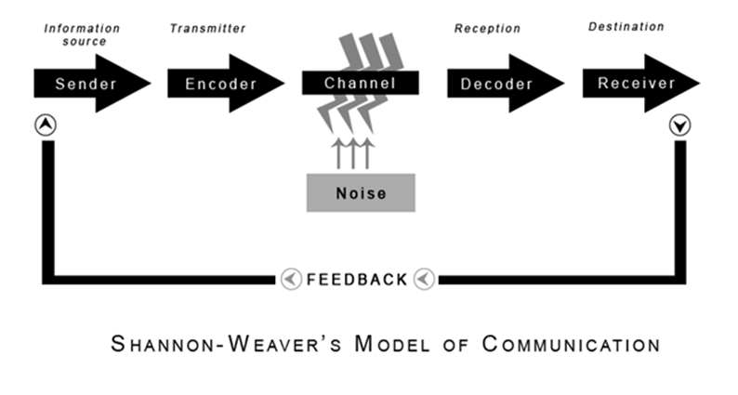
Integrated marketing communication
It is related to those process under which all the elements of the communication marketing and united wholly. There are many elements present in the marketing such as promotion, advertising, brand equity and many more (Brown, Crosno and Tong, 2019). It is essential for the organisation to develops coordination between these elements. Marketing is related to those frameworks which is used by the company to stimulate the demand of the product in the market. It is compulsory for the management of the Unilever to develop the effective marketing framework. These framework helps the company to gain competitive advantage of the industry. There are many aspects of the marketing which are describes below.
Sales Promotion: - it is one of the most important factors of brand promotion under which the purchaser of product and services get extra product at the time of actual sale. It is very important marketing framework because it increases the sale of the company and generates huge revenue.
Advertisement: - It is the process under which the merits of a product convey to the buyers with the help of different types of marketing tools such as television marketing, radio marketing and many more. It is one of the most important factors which impacts the success and failure of the product
Personal selling: - It is related to those technique of marketing under which the marketer personally reached at the door step of the customers and sell their product and services of the organisation by giving positive description of the product. It is required for the company to engage those employees to conduct the personal selling of the product which is having superior communication skills. includes direct interaction between the employees and customers of the organisation and the employees need to convince the customers. Unilever conducts personal selling of their products in many countries where the wages of the workers is less and becomes advantage over digital marketing in term of cost

Customer Journey Map
According to Iakimova (2019), customer journey map is a diagram that visualises several stages that a customer goes through interacting with the company. Unilever performs data driven research and visually represents different stages in customer journey on the basis of customer sentiment and touch point. To remain competitive with the company, create several customer journeys maps on the basis of a 360-degree view of how customers interact with the company.
Stages of customer journey
The customer journey goes through seven stages where the company creates customer interaction and engagement.
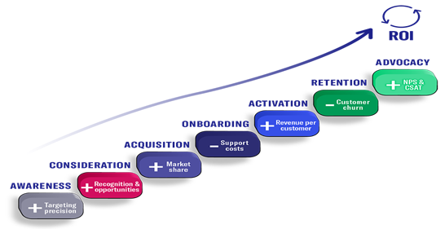
Figure: Stages of Customers Journey.
Awareness
Is the primary stage in the customer’s journey map. Awareness means introducing new or existing products to potential customers. At this stage Unilever identifies two types of customers. The first type are customers who need the products but not yet decided to select the product that will meet their requirement. The company shows the prospect that helps customers to select brands or products and provides relevant information about the products (Rahman, Aziz and Hughes, 2020). The second type is the customers who know about their required products or services but do not decide the brand. To create awareness among these customers Unilever creates unique contents highlighting issues and requirements of the customers. For instance, Dove created an application for mobile and PC devices that is designed to help women to pick a competing body wash from the product lines.
Consideration
The second stage in the customer journey map is all about enlarging the association between the company and the customers. At this stage the company carries out research to identify customer’ demand and then develop contents in the awareness stage (O'Connor, 2021). The company conveys to potential customers that its products will meet their needs. Brand awareness helps the company to introduce itself to the customers whereas consideration helps to size the brand against the competitors. Unilever localises its products to adapt to customer perceptions like Dove and Sunsilk. Dove’s strategy is to assist women to feel more comfortable in their skin. This helps the company to differentiate its products and services.
Acquisition
After consideration is the acquisition strategy where the company acquires existing companies in the target markets to capture the acquired company’s customers. It is an effective way of expanding business operations and markets. Unilever has acquired 48 companies as of now including 25 companies in the last 5 years which indicates that the company adopts acquisition strategy as its expansion strategy (Gillespie and Schiffman, 2018). It enables the company to have easy access to the customers in the target markets.
Onboarding
This stage customers make decisions to use the products. Unilever considers this stage as the most significant stage in the customer journey map. Proper penetration at this stage determines whether the customers stay long term or short term with the brand. The purpose of this stage is to get the customers to the company or brands. Unilever aims at delivering value to its customers as early as possible so that customers are encouraged to buy its products and services (Barari, et al., 2021). While launching a new product in the market the company offers free or discounted product trials to attract potential customers towards the products.
Activation
At this stage the customers have detailed information about the products or services so that they can make an informed decision. After analysing many options customers select a few possibilities and make a decision to purchase specific products. Unilever provides international quality products and discounts up to 20% on the purchase (Rudkowski et al.2018). While making a decision to purchase a product customers consider the quality, price and offers. It often allows customers to get products with small size as an offer and a lucky draw coupon when they purchase a bulk number of products. Thus, the company manipulates its customers to shift towards its brands.
Retention
This is critical stage in journey as customers’ retention is difficult attracting them to the brand (Rudkowski et al.2018). Dove maintain customer retention by keeping quality of the products and its reputation. It often conducts campaign named “Against counterfeiting campaign” and also applies trademark stamp on its products to counterpart the copyright issues. By doing this the brand shows that its care and protection to its loyal customers. Unilever offers the customers to provide feedback through “approval rating” to anticipate future hurdles. It believes that constant communication is the key to gaining customer loyalty. It helps the brand to gain customer satisfaction and loyalty.
Advocacy
If the customers get effective support in all stages, they become fans of the brand or product. Such customers can do best marketing for the brand by advocating to others. It means customers who have experienced better service from any brand will share their experience with others (Rudkowski et al.2018). Thus, the surrounding people will be attracted to the brand. Unilever believes word of mouth (WOM) is the influential marketing form of marketing. The company nurtures and nudges its customers so that they willingly advocate for its brands. For instance, Dove arranged a customer advocacy campaign where customers were asked to refer two of their friends. The customers got a hamper of products and their referred friends got product sample packs to drive sales. The campaign offered 70 digital influencers to attend Dove’s beauty blogger summit with product demonstration, free spa treatments and expert lectures from professionals. The campaign delivered more than 1.4 million blog posts within 1 month and 74,000 Facebook likes were also recorded (Dimitrov, 2020).

Branding and Brand Equity
Branding is a marketing process of communication and creating a unique symbol, design or pattern that differentiates a company from others. It is a strategy designed by an organisation to shape and create an image in customers’ minds. Its main objective is to retain and attract loyal customers and other stakeholders by providing the promised products and services. According to Hunt (2019), branding allows a business to develop relationships with its stakeholders that eventually turn into loyalty to the company. Unilever is an international company that underlines many brands having reputation in the global market.
Brand equity refers to the value of the brand in the market. it indicates the value premium that the company generates from its products with its recognizable name that differentiates itself from others. Customers tend to willingly pay high prices for a branded product. That’s why businesses like Unilever focus on branding to increase its value. The brand Dove was valued approximately $5.1 billion in 2021. The brand is committed to help the women in realizing their beauty potential by creating quality products that deliver best care for beauty.

Keller’s Brand Equity Model
Numerous factors affect the strengths of a product or brand. Organisation needs to identify these factors while launching a new product and creating brand image for the product. Brand equity model is designed by a company to develop strategies for creating the brand value (Theurer et al., 2018). Keller’s brand equity model is a significant tool that is used to analyse the factors in branding and positioning. It is also known as customer-based brand equity.
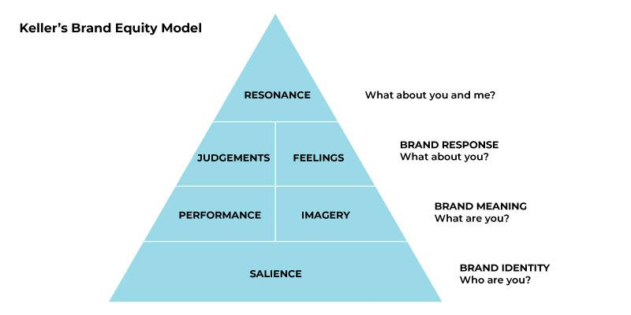
Figure: Keller’s Brand Equity Model
This model is based on four steps in a pyramid. Unilever undergoes all the four levels for branding its products and brand name.
Brand Identity
Brand identity is the stage where the company makes strategies to create brand awareness or salience. At this stage Unilever introduces new products to the customers that they are unaware of. As a leading company Unilever stream merger and acquisition to create brand identity in aa new markets. The company has acquired 48 companies around the world. It has successfully captured the retail market in 190 countries (Duman, Ozbal and Duerod, 2018). It has numerous brands with extensive product lines. Although the company sells its products under different brand names its logo is the most recognizable symbol across the world. Its logo is composed of 25 icons that form a U shape which is easily recognizable to the customers of all over the world.
Brand Meaning
Once customers are aware of the brand they want to know more about the brand and its products’ quality. They want to know whether the brand is reliable or not. In the case of Unilever, customers from different parts of the world know about the brand. Its brand image puts in a situation that customers can easily rely on the products offered by the brand. This stage is divided into two parts given in below:

Brand performance: Global companies like Unilever have created its brand image worldwide by its performance over time (Świtała et al., 2018). The company offers quality products that meet customers from all over the world. It focuses on product features, prices, durability, style & design and customer service.
Brand Imagery: Brand imagery means how customers consider the brand and how they make decisions to interact with the brand. For instance, Unilever has a profound brand image in the global consumer market. Customers have reliability and trust on the brand image of the company.
Brand Response
Brand response is linked to customers’ behaviours and reactions towards the brand or products. Their response generally falls under two categories; judgments and feelings. Customers tend to make judgement to the brand centred into four categories; quality, credibility, consideration and superiority (Lawrence, Rasche and Kenny, 2019). Unilever offers scopes to the customers to provide their feedback about the products and services. Customers respond about how they feel about using the products.
Brand resonance
Brand resonance is the most critical and desirable step in the Keller’s equity model. It indicates how the customers identify themselves with the brand (Hänninen and Smedlund, 2019). It is achieved when customers have a long-lasting relationship with the brand and its products. As a leading company around the world Unilever has gained loyalty and higher customer engagement to its products. The company has built profound relationships with its customers in a way that they not only keep coming back to the brand but also advocate the brand and its products.

Customer touch point
Every company wants to improve customer experience by providing better service than other competitors. Organisation considers several interactive points defined as customer touchpoints. These points are the interactions between the customers and the company during the customer journey.
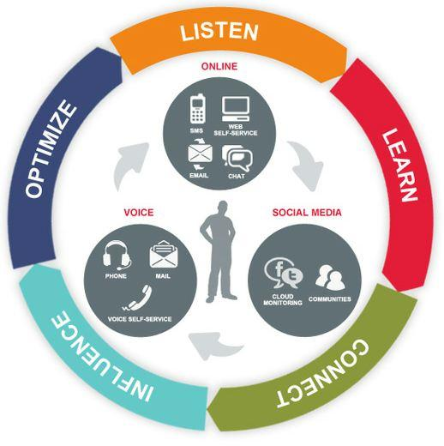
Figure: Customer Touch Points.
Unilever and its brand Dove use different touchpoints to connect and interact with the potential and existing customers. The company uses digital tools as the touchpoints in the customer journey. Dove uses mail and mobile phone devices to connect with the customers (Ieva and Ziliani, 2018). It often needs customers’ information and details to keep in touch with them.
It also observes customers’ activities in social media to identify their perception about the brand and its products. It also offers ratings for the services where customers are free to provide ratings for the services. It also provides help line services by which women can consult with beauty professionals to learn about the usage of facial products (Berendes et al., 2018). Customers are also provided the opportunity to express their feelings and experience on the social media platform. These touchpoints are used by the company to reach the potential customers and existing customers to determine their requirements.

Position strategies
According to Singh and Samuel (2020), positioning is a process of creating a strong image of a product or service by influencing customers' perception and maintaining a powerful market position in the competitive market. Unilever takes into consideration its strengths and weaknesses as well as the needs of the customer to have effective positioning strategies. The company focuses on maintaining quality standards and affordable pricing strategy according to the preferences of the targeted customers that can assist the company to have a favourable brand positioning in consumers’ mind (Iyer et al., 2019).
Unilever positioned dove products as a personal care product that relates to the beauty standards of women. Dove has established its own distinctive brand identity and also successfully managed to strengthen its position in the competitive market. Dove’s USP lies in the beauty soaps that moisturize the skin mostly and provide more comfortable feeling within the women regarding their skin.

Differentiation strategy of Dove
Differentiation is an approach of offering innovative products that appeals to the customer most and the product becomes the preferable choices for the customer. Unilever uses a differentiation strategy to have a competitive advantage in the market (Gorondutse and Abdullah, 2017). The company focuses on attracting customers with their specially designed products. Dove has differentiated itself as a beauty bar in the competitive market by its unique features. The company has a unique marketing campaign targeting young and aspirational women. It has successfully communicated with the people of all ages with its differentiation strategy focused on women esteem.

Total Quality Service Model
The total quality service model defines the managerial approach for a long-term and sustainable success through achieving customer satisfaction (Abbas, 2020). A company integrates and implements various critical factors to achieve customer satisfaction.
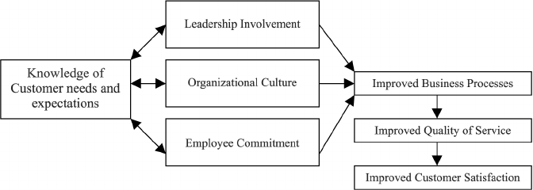
Figure: Model of Total Quality Service.
Unilever uses strategies, customer data and effective communication systems to integrate the quality discipline in the activities and culture of the company. It focuses on the customers demand as customers ultimately determine the quality level (Shams, 2017). In the competitive market organisations are compelled to foster quality management according to the customers’ requirements. To satisfy the customers’ needs Unilever conducts market research through online surveys and online activities. Here the leaders of the company have a significant role in creating a quality-oriented culture within the workplace. Unilever holds a culture that encourages its employees to ensure maximum quality in the activities and services. The brand Dove produces high quality hair products and soaps that are produced with the commitments of serving women the best care for their skins (Margossian, 2019). Its employees are committed to serve the customers with best quality products and services to provide better customer experience.

Conclusion
Marketing management involves connecting and serving both the potential and existing customers. Business organisations focus on satisfying the customers as they are the key factors that determine the profitability and sustainability of the organisation (Rudkowski et al.2018). This report involves the evaluation of customer relationship management of the company Unilever and its brand Dove to foster customer satisfaction. Throughout the customer journey the brand focuses on customer satisfaction and creating brand awareness. The company needs to focus more on the customer retention rather than the raising customer awareness. This will lead the company to achieve long-term objectives and increase its brand image as loyal customers often play as advocates in the marketing of the brand.

Recommendation
It is recommended to the managers of the Unilever that it develops effective communication channels in their organisation which helps their employees to coordinate with each other. These communication channels help the organisation to attract their customers.

References
Abbas, J., 2020. Impact of total quality management on corporate sustainbility through the mediating effect of knowledge management. Journal of cleaner production, 1(224), pp. 118-806.
Barari, M. et al., 2021. A meta- analysis of customer engagement behaviour. International Journal of Consumer Studies, 4(45), pp. 457-477.
Berendes, C. I., Bartelheimer, C., Betzing , J. H. & Beverungen, D., n.d. Data -driven customer journey mapping in local high streets : adomain -specfic modelling language. s.l.:s.n.
Czinkota, M. R., (2011). International marketing. Hampshire: Cengage Learning.
Dimitrov, L. O., 2020. Customer journey and customer lifecycle marketing: Creating Loyality and maximizing revenues -a theoretical and practical analysis(Doctoral dissertation Technische Hochschule ). s.l.:s.n.
Duman, T., Ozbal, O. & and Duerod, M., 2018. The role of effective factors on brand resonance: Measuring customers-based brand equity for the Sarajevo brand. Journal of destination marketing & management, Volume 8, pp. 359-372.
Finne, A. & and Gronroos, C., 2017. Communication in use customer -intergrated marketing comunication European Journal of Marketing. [Art] (European Journal of Marketing).
Gillespie , D. J. & and Schiffman, R., 2018. A critique of the Shannon -Weaver theory of communication and its implication for nursing. Research and theory for nursing practice , 2(32), pp. 216-225.
Gorondutse, A. H. & Abudullah, H. H., 2017. Influence of differentiation stratergy on perfomance of hotels the moderating role of enviromental munificence. Journal of Business & Retail Management Research, 4(11), pp. 150-161.
Hunt, S. D., 2019. The ethics of branding customers relationships brand -equity strategy and branding as a societal institution. Journal of Business Reaserch, Issue 95, pp. 408-416.
Iyer, P., Davari, A., Zolfagharian, M. & and Paswan, A., 2019. Marketing orientation positioning strategy and branding performance. Indusrial Marketing Management, Issue 81, pp. 16-29.
Lanier, J. D., Wempe, W. F. & and, S. M., 2019. Supply chain power and real earnings management : stock markets perceptions financial performance effects and implications for suppliers. Journal of Supply Chain Management, 55(1), pp. 48-70.
Lawrence, J., Racsche, A. & Kenny, K. eds., 2019. Sustainability as opportunity: Unilevers sustainable living plan. In: In Managing Sustainale Business. Springer: Dordrecht, pp. (435-455).
Margossian, C. C., 2019. Areview of automatic differentation and its efficient implemetation. Wiley interdisciplinary reviews: datamining and knowledge discovery, 4(9), p. 1305.
Rahman, M., Aziz, S. & Hughes, M., 2020. The product -markert perfomance benefits of enviromental policy:why customers awareness and firm innovativeness matter. Business strategy and the Evironment, 29(3), pp. 2001-2018.
Reddy, M. M., 2019. Communication forms employed by the Baptist church and seventh day Baptist church. Gender and Behaviour, 17(3), pp. 13794-13805.
Sheeham, B., 2011. Marketing management, Lausanne, Switzerland: AVA Pub.
Singh , A. K. & Samuels , C., 2020. Positioning strategy implementation barries: adecision making approach based on resource theory. InternationalJjournal of Managementand Decison Making , 4(19), pp. 473-504.

Hänninen, M. and Smedlund, A., 2019. On retail digital platforms suppliers have to become responsive customer service organizations. Strategy & Leadership.
Iakimova, E., 2019. Systematic Approach to the Service Design in the Winery: Touch Points and Customer Journey Map.
O'Connor, A., 2021. Developing Municipal Employment Services With the Customer Journey Map Methodology.
Shams, S.R., 2017. Transnational education and total quality management: a stakeholder-centred model. Journal of management development.
Shaw, P., 2019. Sadharanikaran Model vs Mathematical Model: Analysing their Relevance in Context of social media. Bodhi: An Interdisciplinary Journal, 7, pp.105-126.
Switala, M., Gam rot, W., Reformat, B. and Bilińska-Reformat, K., 2018. The influence of brand awareness and brand image on brand equity–an empirical study of logistics service providers. Journal of Economics & Management, 33, pp.96-119.
Talukdar, H., 2017. The Different Models of Communication-Their Differences, Lacks and Integrity, and their Association to Real Life Communication. Asian Journal of Research in Social Sciences and Humanities, 7(8), pp.36-50.
Theurer, C.P., Tumasjan, A., Welpe, I.M. and Lievens, F., 2018. Employer branding: a brand equity‐based literature review and research agenda. International Journal of Management Reviews, 20(1), pp.155-179.

