University of Wales Trinity Saint David
Wales Institute of Science and Art


Analytical assessment of engine internal components

Contemporary Powertrain Design
ACHA 6006

Ben Ellis-Jones
2204298
16/03/2025

Contents
1 Introduction 1
1.1 Brief background on engine component analysis and fatigue failure. 1
1.2 Justification for increasing RPM and fatigue analysis of engine components. 1
1.3 Objectives of the report 1
1.3.1 Calculate forces experienced by engine components. 1
1.3.2 Asses stresses and fatigue safety factors. 1
1.3.3 Extend RPM range to 9000 RPM 1
1.3.4 Compare standard and cross plain fireing orders 1
1.3.5 Propose redesign solutions 1
2 Methodology 2
2.1 Engine charictoristics 2
2.2 rod 2
2.3 pin 2
2.4 bolt 2
3 Analysis of Forces and Stresses 2
3.1 Torques 2
3.2 Power 2
3.3 Rod 2
3.4 Pin 2
3.5 Bolt 2
4 Fatigue Safety Factor and Goodman Diagrams 2
4.1 Rod 2
4.2 Pin 2
4.3 Bolt 2
5 Extension of RPM Range and Effect on Safety Factors 2
5.1 Interpolation of pressure data up to 9000 RPM. 2
6 Redesign of Connecting Rod Bolts 3
7 Comparison of Crankshaft Configurations 3
8 Discussion and Critical Analysis 3
9 Conclusions and Recommendations 3
11 References 4

Introduction

Brief background on engine component analysis and fatigue failure.

Fatigue is a complex phenomenon that is affected by a number of factors, such as the surface finish of the component, environmental effects, heat treatments, presence of stress concentration factors, and more. Unlike static failures, fatigue failure occurs when a component experience repeated cyclic stresses, leading to failure at stress levels well below its ultimate tensile strength (UTS). (Altair Hyperlife, n.d.)
This means that it is important to carefully analyse components subjected to fluctuating loads so that the desired reliability can be built into these components, and over-engineered or under-engineered components can be avoided.
In modern internal combustion engines (ICE), the durability of components are critical factors in vehicle sales. Key engine components such as connecting rod, connecting Rod Bolts and Gudgeon pins experience cyclic loading due to high-speed rotational motions in a ICE unit. The alternating stresses that are generates in a ICE often lead to fatigue failure. It generally begins with the formation of microcracks at stress concentration points, such as bolt threads, keyways, and fillets. Over time, these microcracks propagate , ultimately leading to catastrophic failure if not addressed (Hottinger Bruel & Kjaer, n.d.) (Sim Scale, 2023)

Why is reliability important
Fatigue failure is estimated to be responsible for 90% of all metallic failures. A survey taken out by Meg Bernazzi had a sample size of 500 drivers all of which were in the market to buy a car (some looking at new cars and some looking in the 2nd hand market). The survey had the people rank a number of factors for vehicle purchase from most to least important. “36% of total shoppers cited reliability as a top three factor driving vehicle selection” with other high performing factors being the price to purchase the vehicle, driving feel and Brand. Reliability “ranked higher as a concern than safety ratings (20%)”, this study puts into perspective the importance of reliability to the automotive market. (Bernazzani, 2021)

Justification for increasing RPM and fatigue analysis of engine components.
Increasing RPM can help generate more power output because it will create more combustion cycles per second. However, this increase in speed also generates higher mechanical stresses and fatigue loads, which creates the need for component adaptations to ensure the durability of the ICE remains up to standard. Engineering techniques such as Goodman diagrams and finite element analysis (FEA) help evaluate fatigue safety factors (FSF). By modifying component geometry, material composition, and stress distribution it is possible to have the same and higher FSF values at higher RPMs.
Fatigue analysis is particularly crucial in motorsport and high-performance applications, where components operate under extreme conditions and must endure prolonged cyclic loading without failure. (Krishnakumar Krishnasamy, 2022)

Objectives of the report

Calculate forces experienced by engine components.
The forces acting on key engine components, such as the connecting rod, Gudgeon pin, and connecting rod bolts, have been calculated using kinematic equations learnt in the lectures for this module and pressure data provided. These forces are essential in understanding the dynamic loading conditions that impact engine performance and durability.

Asses stresses and fatigue safety factors.
Using the calculated forces, stress analysis will be performed to determine tensile, compressive, and shear stress components acting on engine parts. Goodman diagrams and fatigue safety factors (FSF) will be used to assess the risk of failure and component longevity under cyclic loading conditions.

Compare standard and cross plain firing orders
The torque characteristics of a standard flat-plane crankshaft and a cross-plane crankshaft will be analysed and compared.

Extend RPM range to 9000 RPM
By interpolating pressure data, the data will be extended from 0-6000RPM to 0-9000 RPM. This report will investigate the impact increased RPM has on tensile, compressive, and shear stresses and Fatigue safety factor and methods to accommodate for the higher stresses.

Propose redesign solutions
Based on stress and fatigue analysis, design modifications will be proposed to enhance component durability and efficiency. This may include material selection, geometric optimizations. The code will then be adapted to generate new Fatigue safety factors.

Literary review
Ferguson and Kirkpatrick’s published work highlight the complex stress states experienced by connecting rods. (Ferguson, 2016)
The text explains that these components undergo complete load reversal during operation. During the power stroke, connecting rods experience high compression, while during the intake stroke, they transition to high tension. This loading reversal creates challenging fatigue conditions and is the reason connecting rod Bolts frequently become failure points. (Sarihan, 2020) (B.Heywood, 2018)

Methodology

Brief explanation of Important Variables
All graphs used in this study were generated using a MATLAB script. Pressure Data from 1000 and 6000 RPM at 1000RPM intervals was provided and used along with geometry and mass figures to calculate all the variables below.

Inertia Force Variables
- Reciprocating mass (Kg) - sum of the mass of the components in an internal combustion engine that move in a straight-line motion rather than rotating.
- Inertia force (N) - force required to accelerate the reciprocating mass.
- Inertia torque (Nm).
- Effects of RPM Increase: As RPM increases, inertia force increases quadratically due to higher acceleration values.
- Flat vs. Cross-Plane: A flat-plane crankshaft experiences more significant inertia force oscillations, leading to increased vibrations compared to a cross-plane design.

Piston Force Variables
- Cylinder pressure (Pa) - gas pressure acting on the piston.
- Gas force (N) - pressure force acting on the piston head.
- Effects of RPM Increase: At higher RPM, combustion occurs faster, increasing peak pressure and force applied to the piston.
- Flat vs. Cross-Plane: Flat-plane engines may see more aggressive pressure pulses due to even firing, while cross-plane setups distribute forces more evenly.

Net Force and Friction Variables
- Net force (N).
- Side force (N) - force component perpendicular to the piston motion.
- Friction force (N) - friction between the piston and cylinder wall.
- Effects of RPM Increase: Increased piston speed raises frictional forces, leading to higher heat generation and wear.
- Flat vs. Cross-Plane: Cross-plane designs typically have lower lateral forces, reducing friction losses and improving durability.

Fatigue Safety Factor (FSF)
- Stress acting on the component (Pa) – Range and mean.
- Fatigue safety factor.
- Effects of RPM Increase: Stress range increases at higher RPMs, reducing safety factor and increasing failure risk.
- Flat vs. Cross-Plane: Flat-plane crankshafts tend to experience greater cyclic stress variations, increasing the potential for fatigue failure.

Crank Torque Variables
- Crank torque (Nm) - net torque on the crankshaft combining inertia and gas torques.
- Effects of RPM Increase: Increased RPM enhances torque fluctuations and requires stronger materials to withstand forces.
- Flat vs. Cross-Plane: A flat-plane crankshaft generates more fluctuations, whereas a cross-plane design provides smoother power delivery.

Engine Power Output
- Torque output (Nm) - average crankshaft torque multiplied by the number of cylinders.
- Brake power (bhp) - engine power output considering all losses.
- Effects of RPM Increase: Power output increases with RPM but is limited by frictional and thermal losses.
- Flat vs. Cross-Plane: Flat-plane engines tend to rev higher but suffer from higher vibrations, while cross-plane engines produce smoother, more consistent power delivery.

Analysis of Forces and Stresses
In order to calculate the Fatigue Safety Factor (FSF) calculation have to be made for the allowable Stress range and the actual/experienced stress range.

Torques
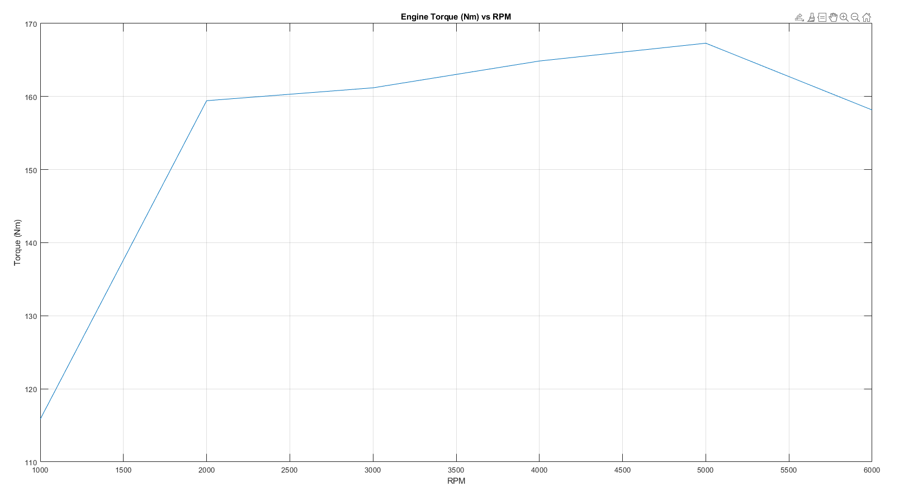
Engine Torque

The true torque figure sourced from (Ford Authority, n.d.) is 160 (to the nearest integer), The peak value calculated is 167(to the nearest integer). This graph follows the expected pattern, because data has been calculated every 1000 RPM. Whilst this does not affect the max number, adding more data points would allow the graph to more accurately represent the torque curve.
By increasing the RPM, both the maximum and the minimum Inertia Torque is increased.
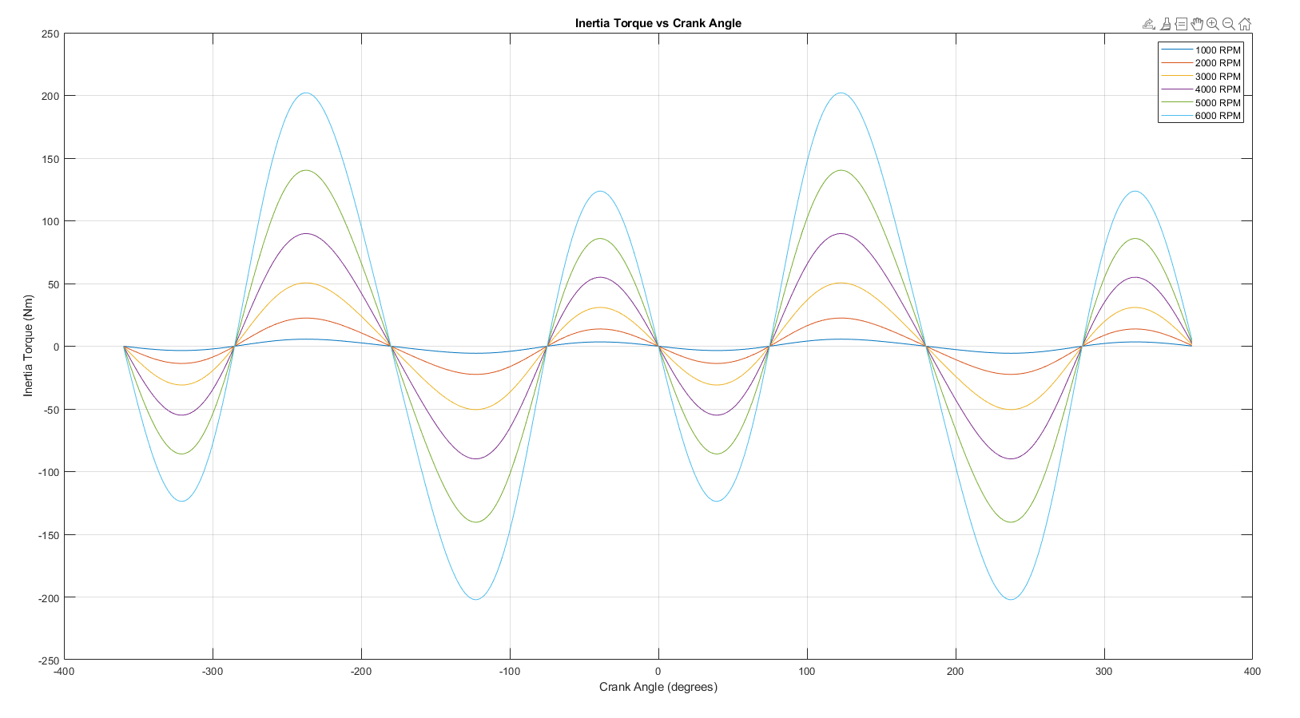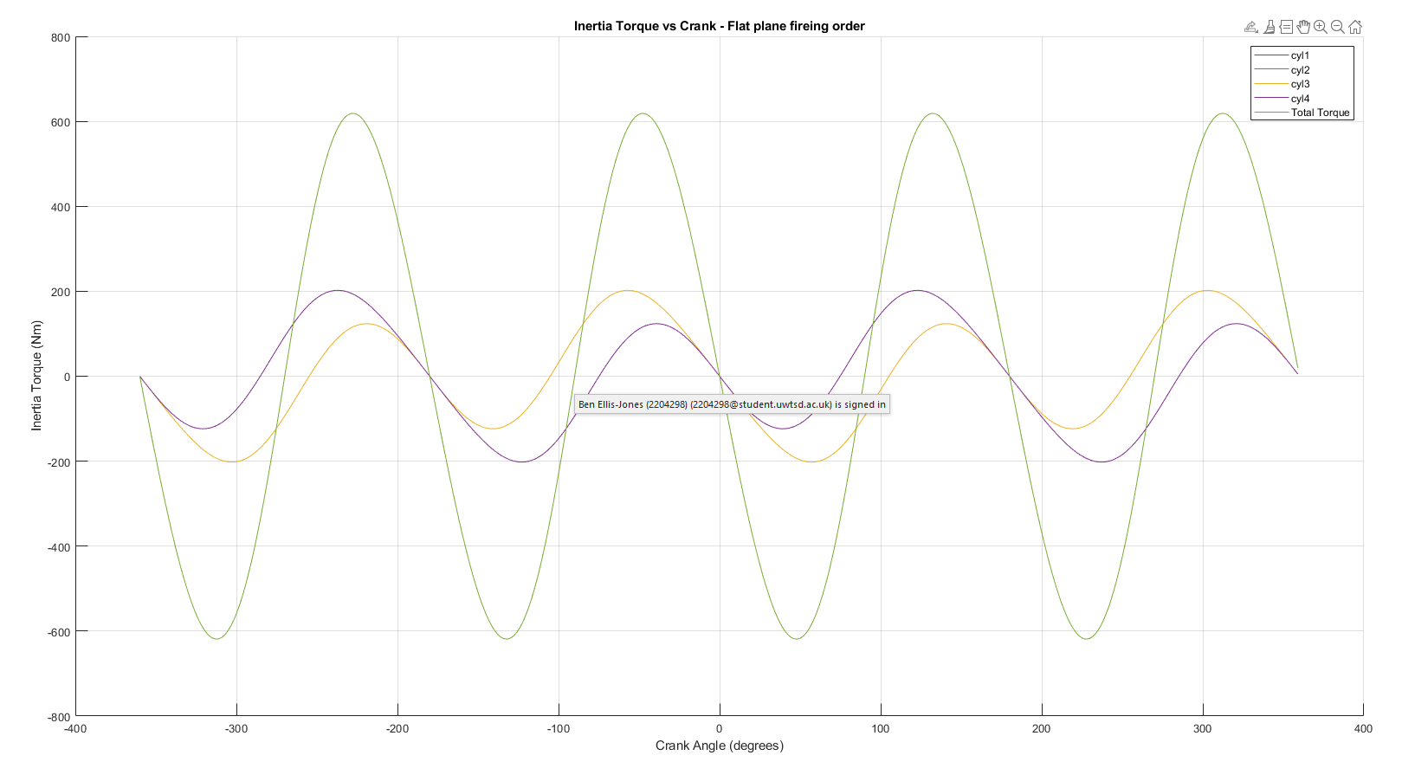
Inertia Torque per piston Inertia torque-Flat Plain
The Flat plain Crank shaft has a cylinder offset of 180 degrees. This means that cylinder 1 and 3 will have aligned crank angles. This explains why cylinders 1 and 2 are not visible on the graph as they are overlapped by cylinders 3 and 4. This figure shows the net inertia force produced by this Flat plain crank shaft alternates from 618.7 Nm to -618.7 Nm.

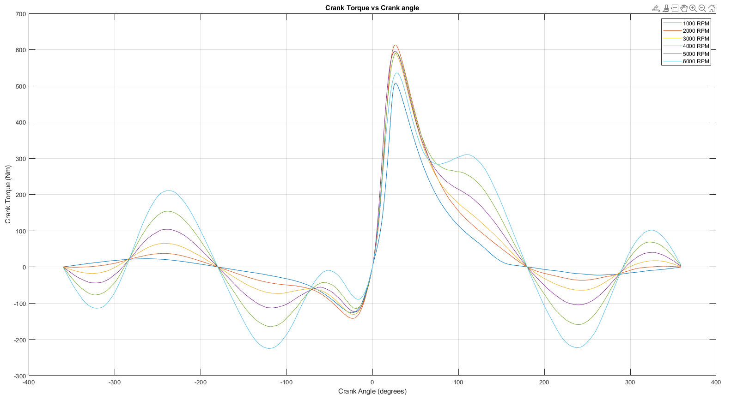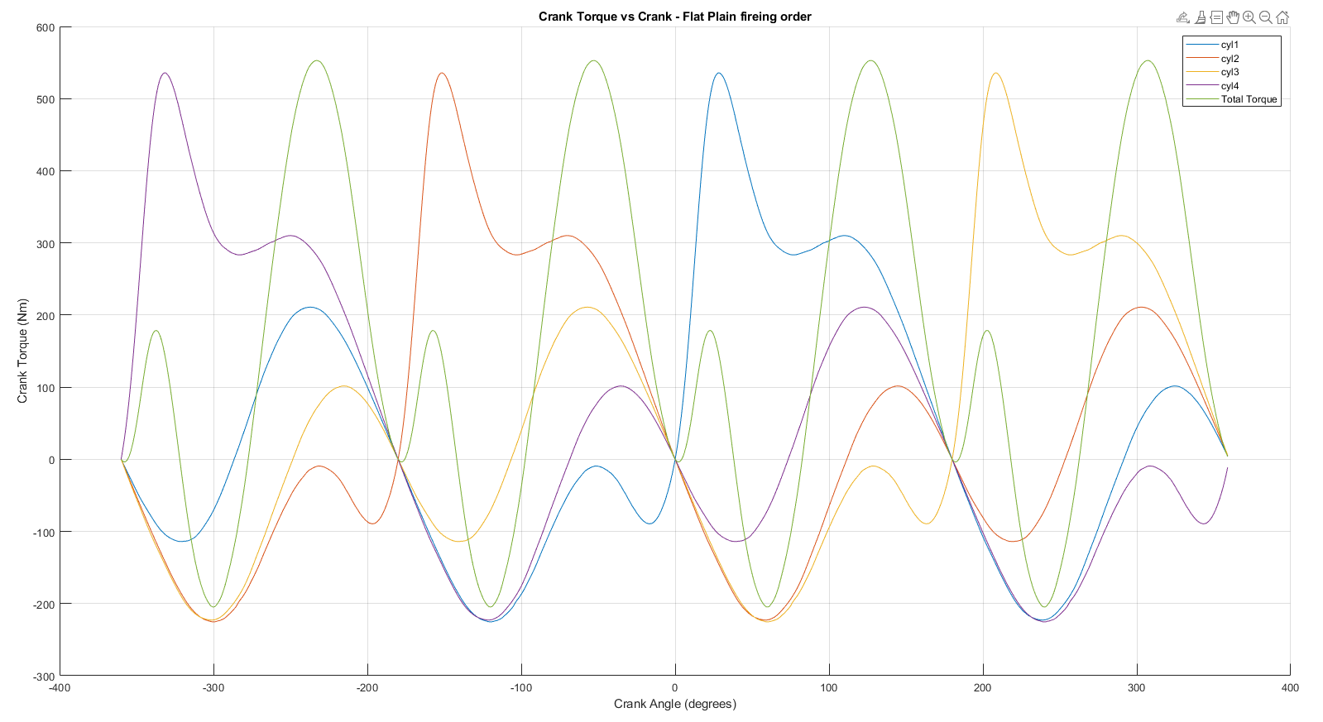
Crank Torque per cylinder Crank Torque – Flat Plain
Crank torque is the Net Torque acting on the crank shaft.

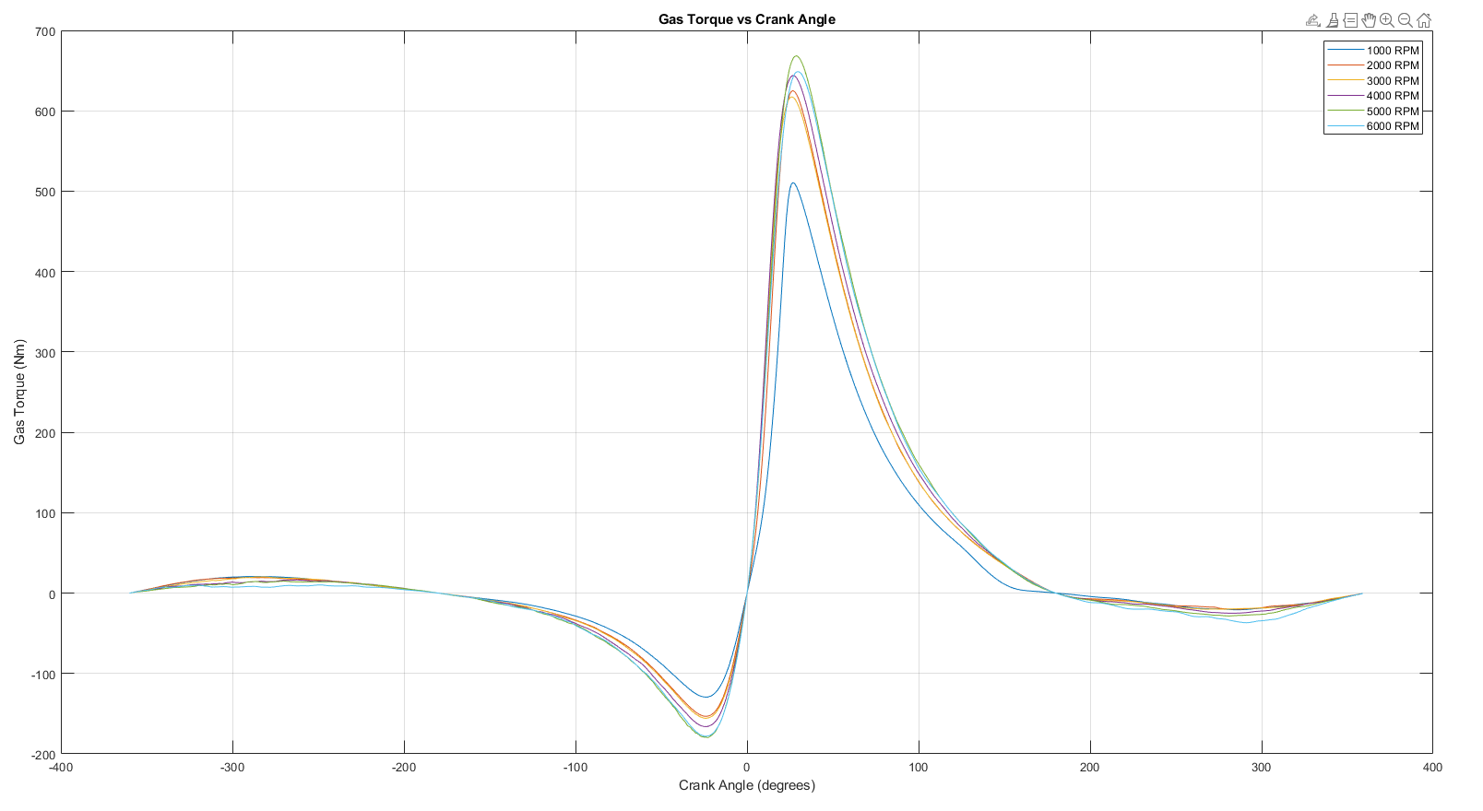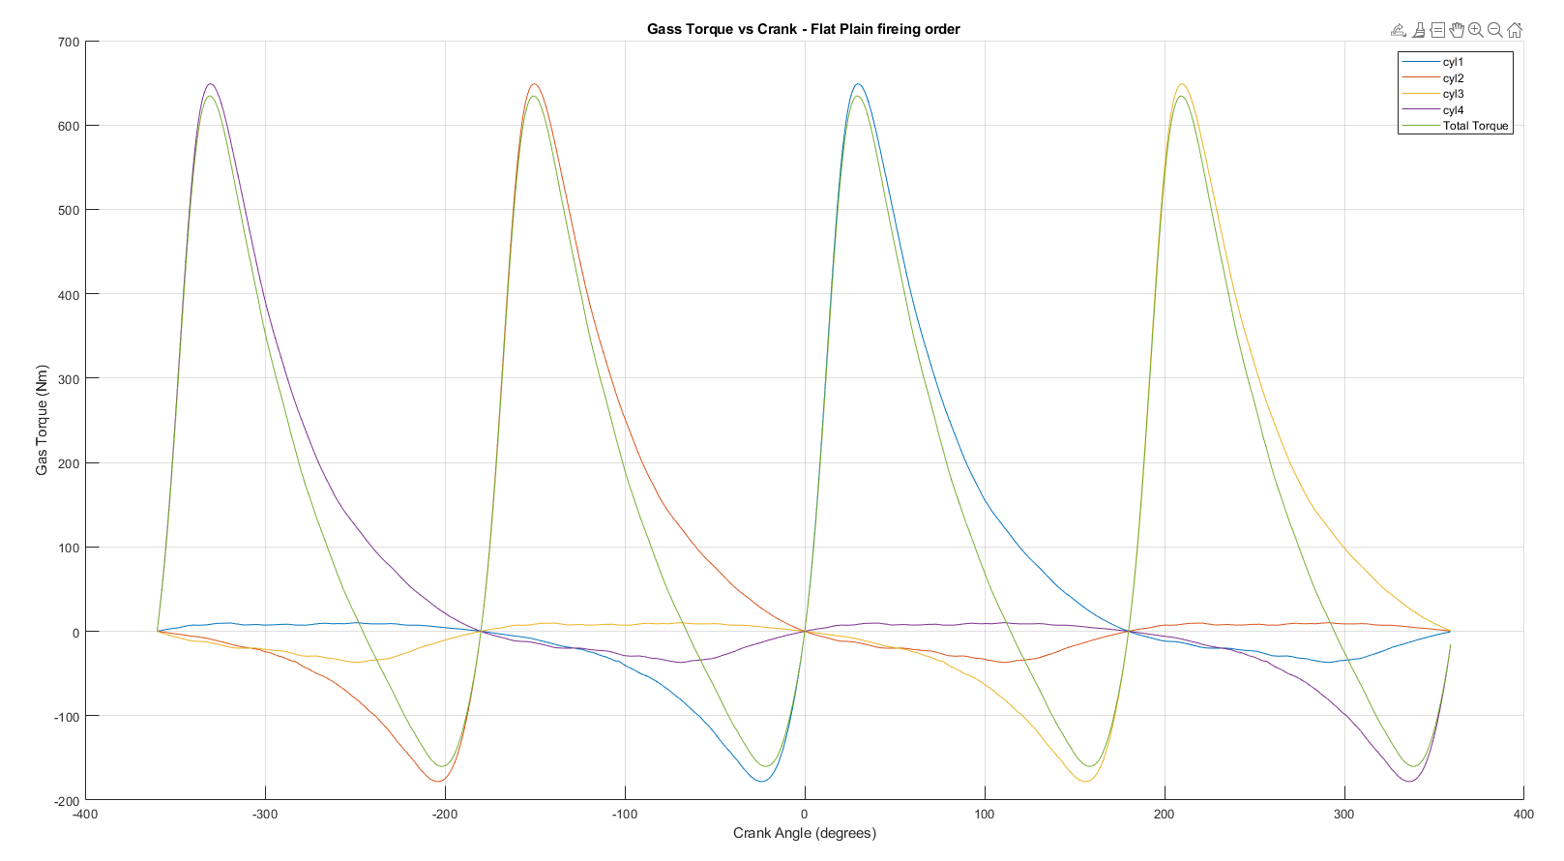
Gass torque per cylinder Gass torque – Flat Plain

Fatigue Safety Factor and Goodman Diagrams
The goodman diagram is a visual representation of how capable a part is at withstanding the stresses of its operation, It is used to evaluate whether a component will fail due to fatigue under repeated loading conditions. In the diagram, one line plotted for the allowable range and actual stress at every RPM. The allowable stress range is simply the ultimate tensile strength (UTS) of the material in torsion to the UTS in compression (its upper and lower limit). The actual stress is the calculated value for the stress acting on the component. If the actual stress is significantly lower than the material’s UTS, the Fatigue Safety Factor (FSF) will be high, indicating a low risk of fatigue failure. On the other hand, if the actual stress is close to or exceeds the material’s endurance limit, fatigue failure is more likely, reducing the FSF and potentially requiring design modifications to improve durability.
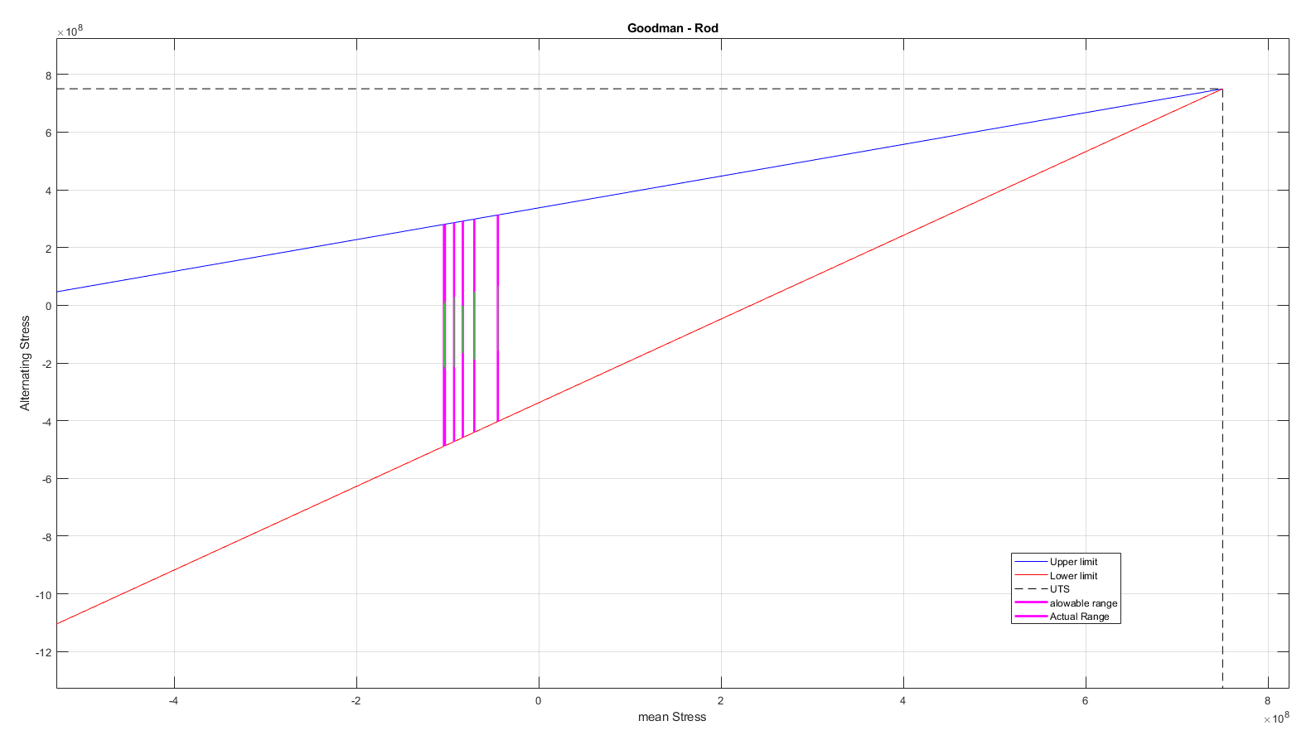

Pin
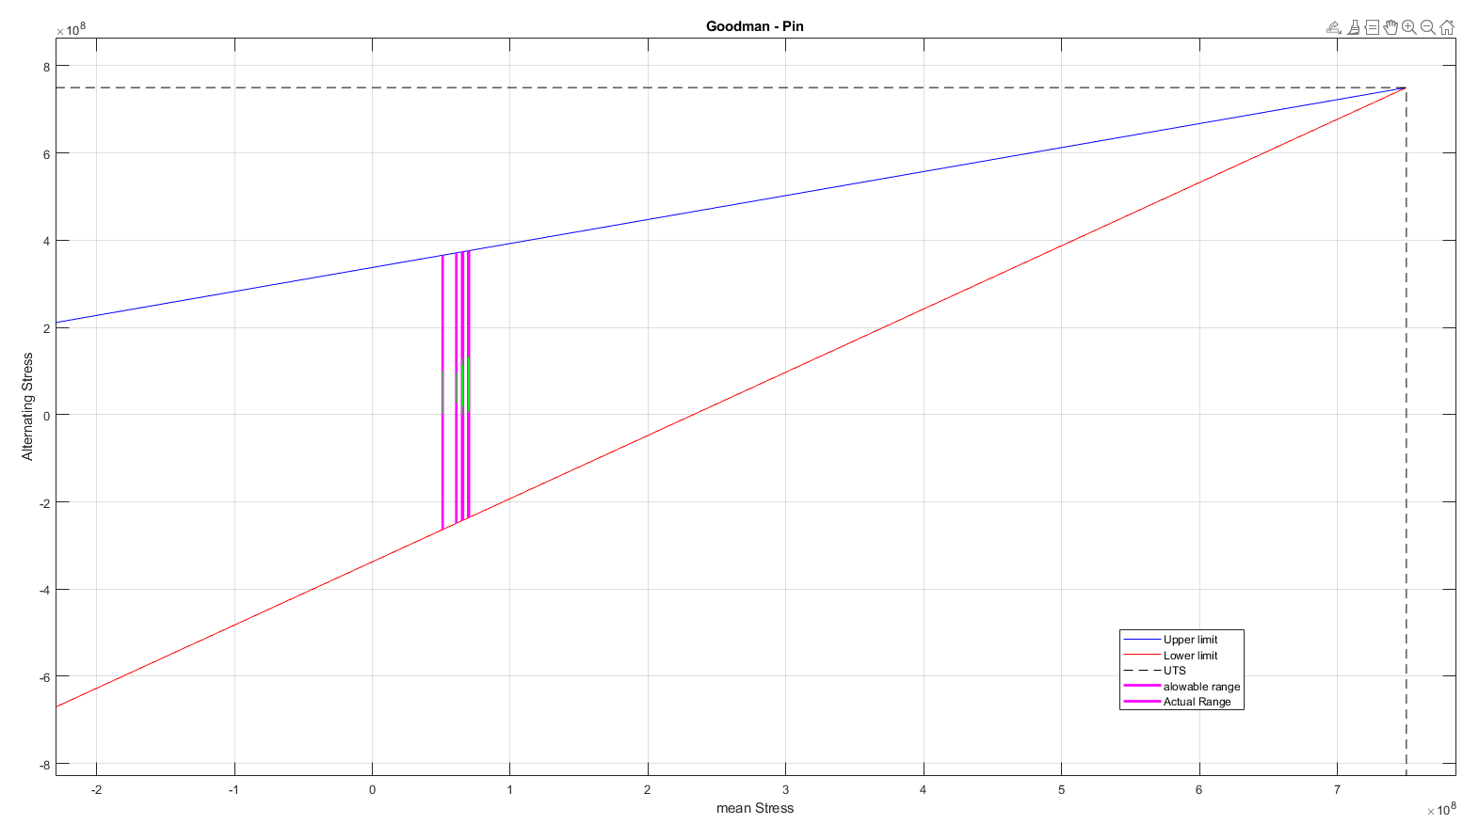

Bolt
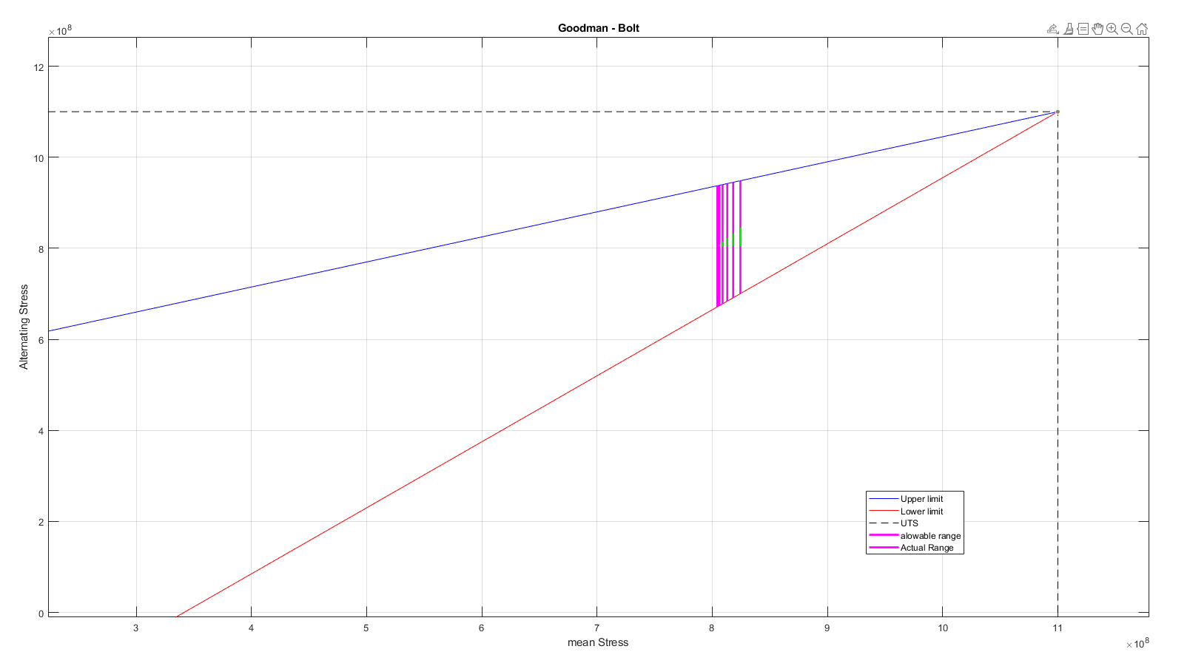

Comparison of Crankshaft Configurations
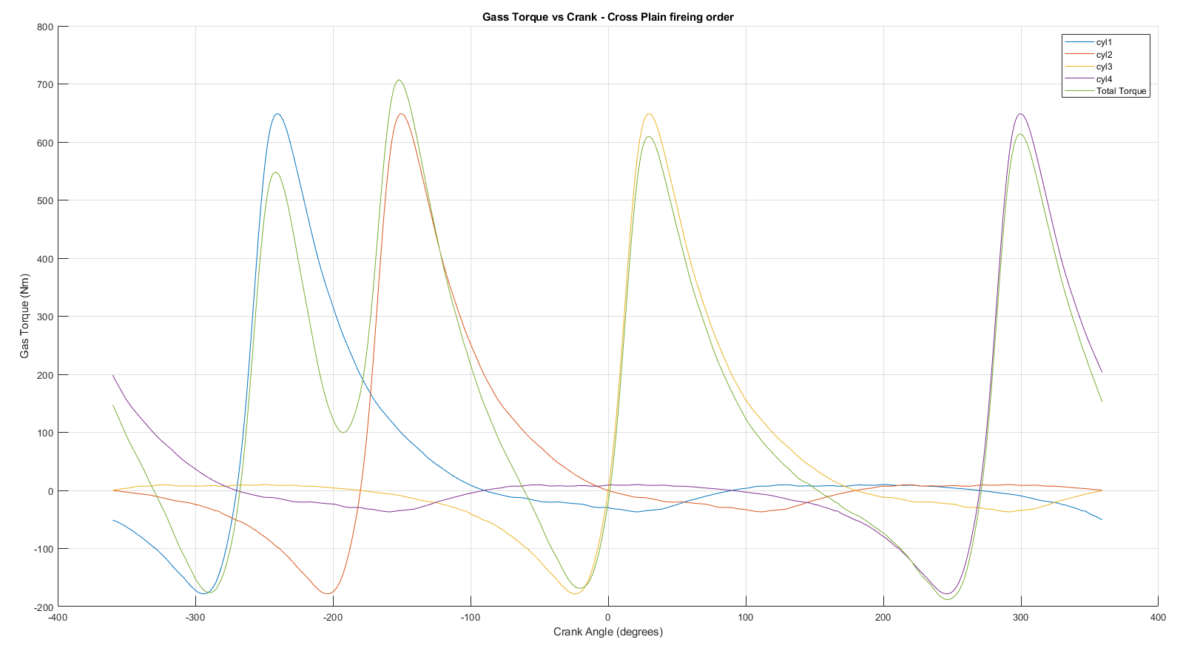
Gass torque -cross plain

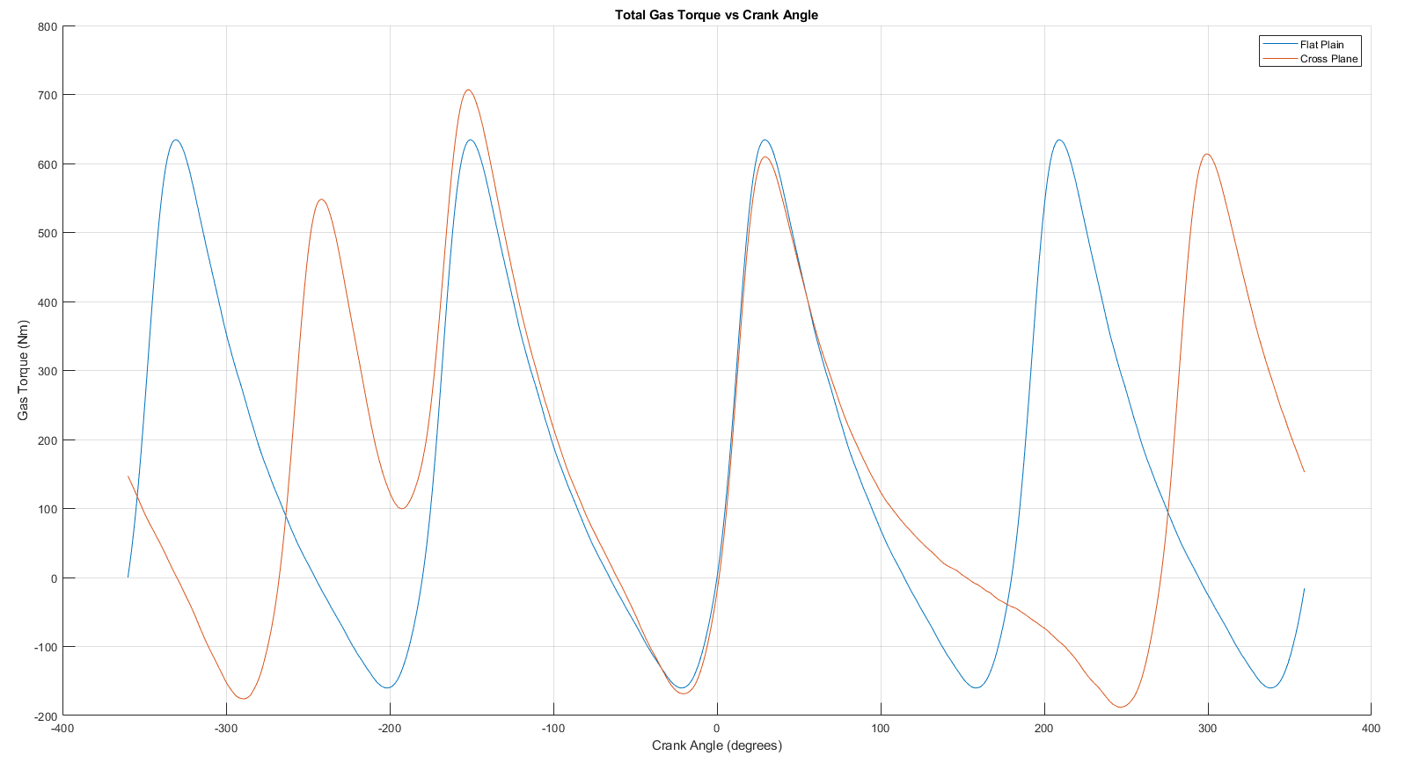
Gass torque cross vs flat

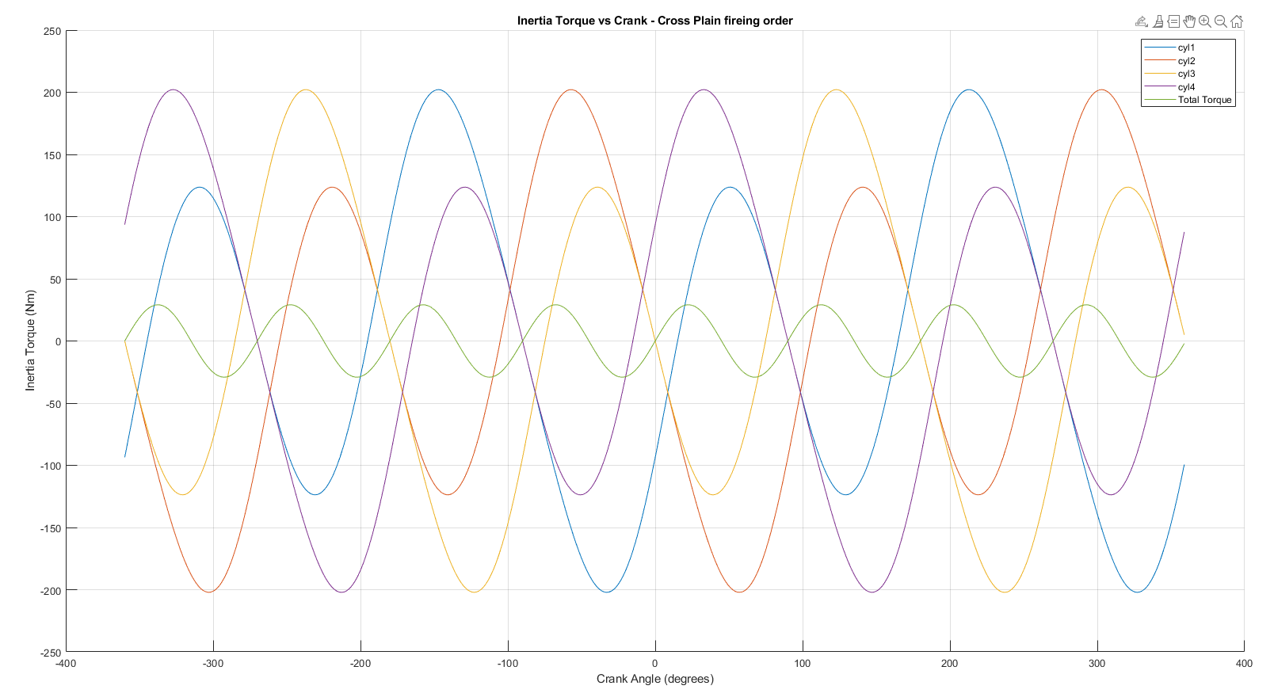
Inertia coss plane

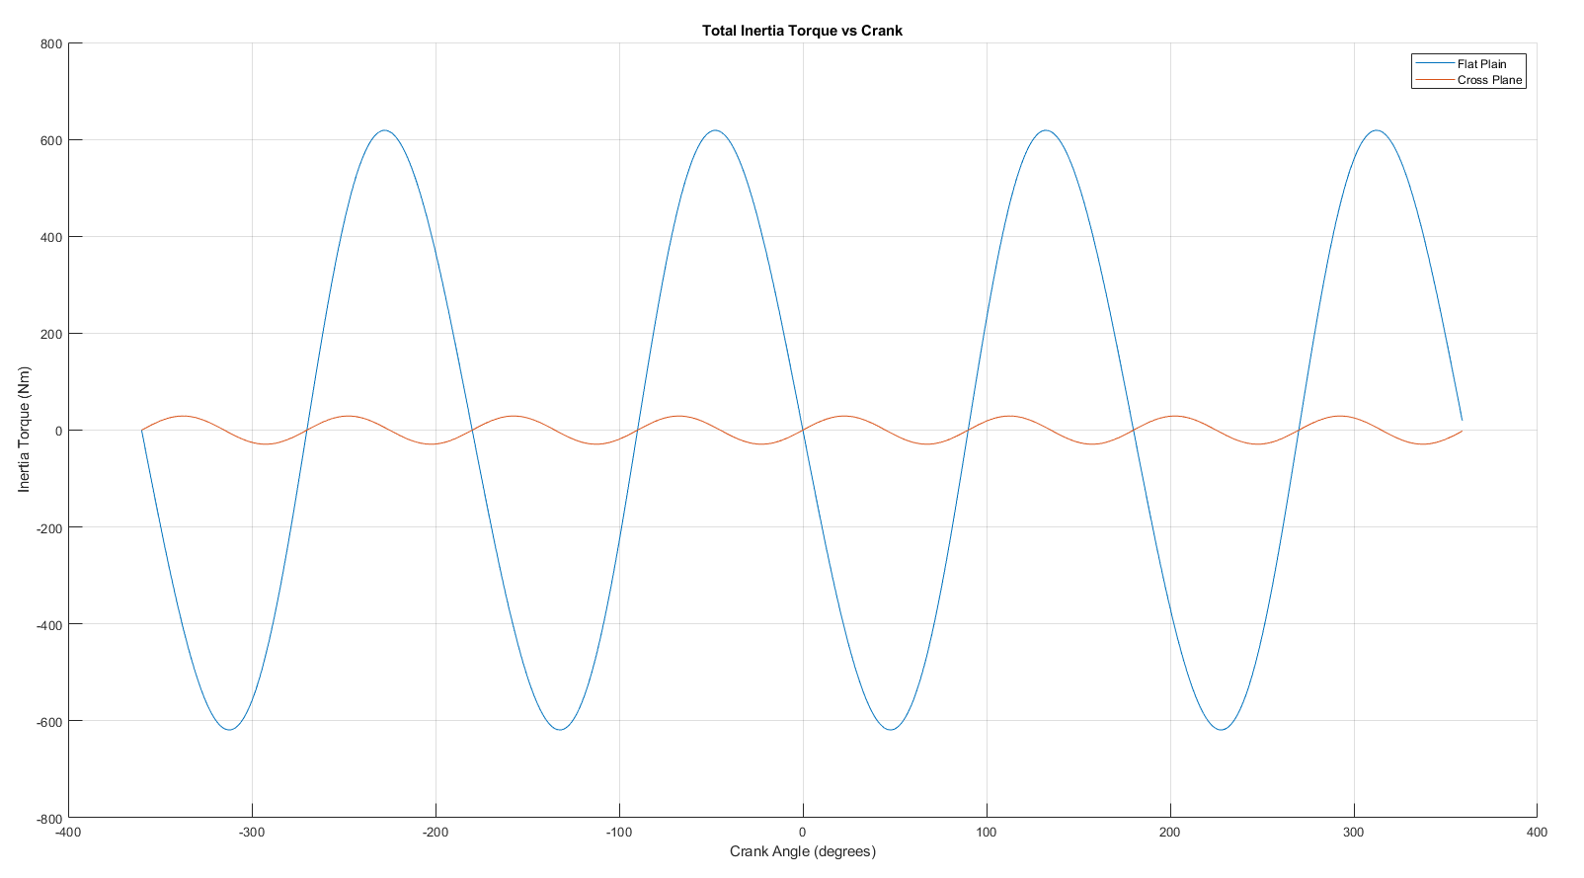
Inertia cross vs flat
Figure x clearly shows that the cross plane crank shaft significantly reduces the Inertia torque.
The difference in inertia force smoothness between cross-plane and flat-plane crankshafts comes down to mass balancing, firing order, and second harmonic forces. A flat-plane crankshaft has crankpins arranged 180° apart, meaning two pistons move up while the other two move down simultaneously. This creates larger inertia force fluctuations because the second harmonic waves do not have any destructive interference (they do not cancel each other out). Instead, these waves constructively superpose, leading to greater engine vibrations and a rougher inertia torque curve.
a cross-plane crankshaft has crankpins arranged 90° apart, which distributes the reciprocating mass motion more evenly over the crankshaft rotation. This arrangement helps partially cancel secondary forces, leading to smoother torque output and lower overall inertia torque fluctuations. The staggered nature of piston movement prevents large simultaneous force peaks, improving engine refinement, reducing vibrations, and enhancing drivability.
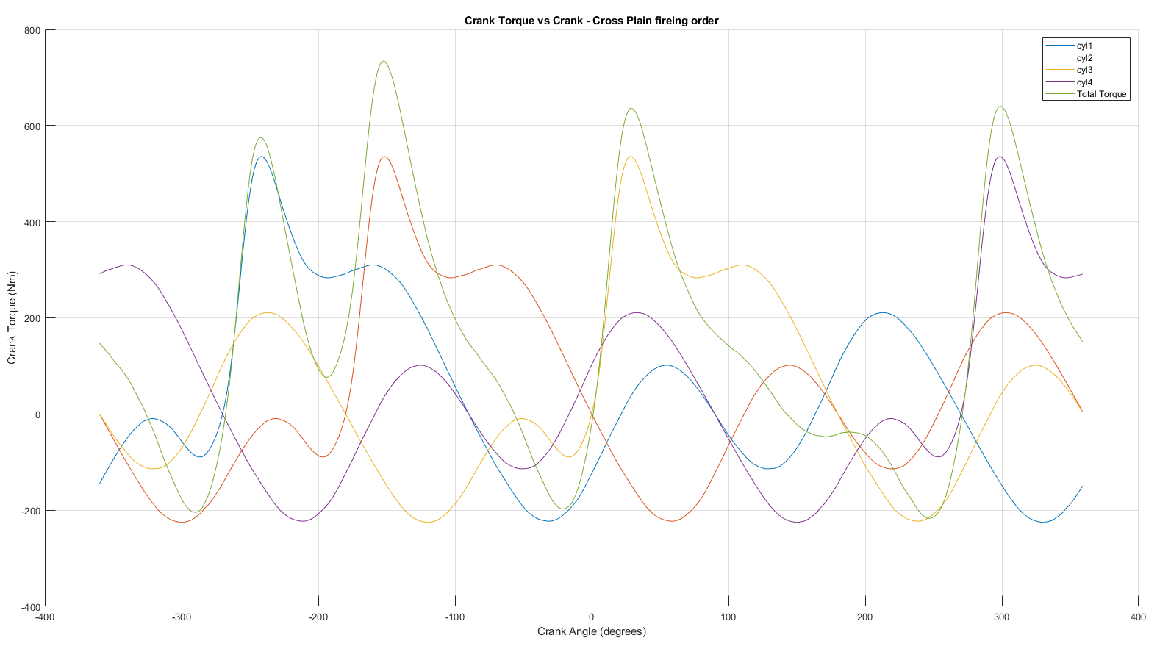
Crank - cross

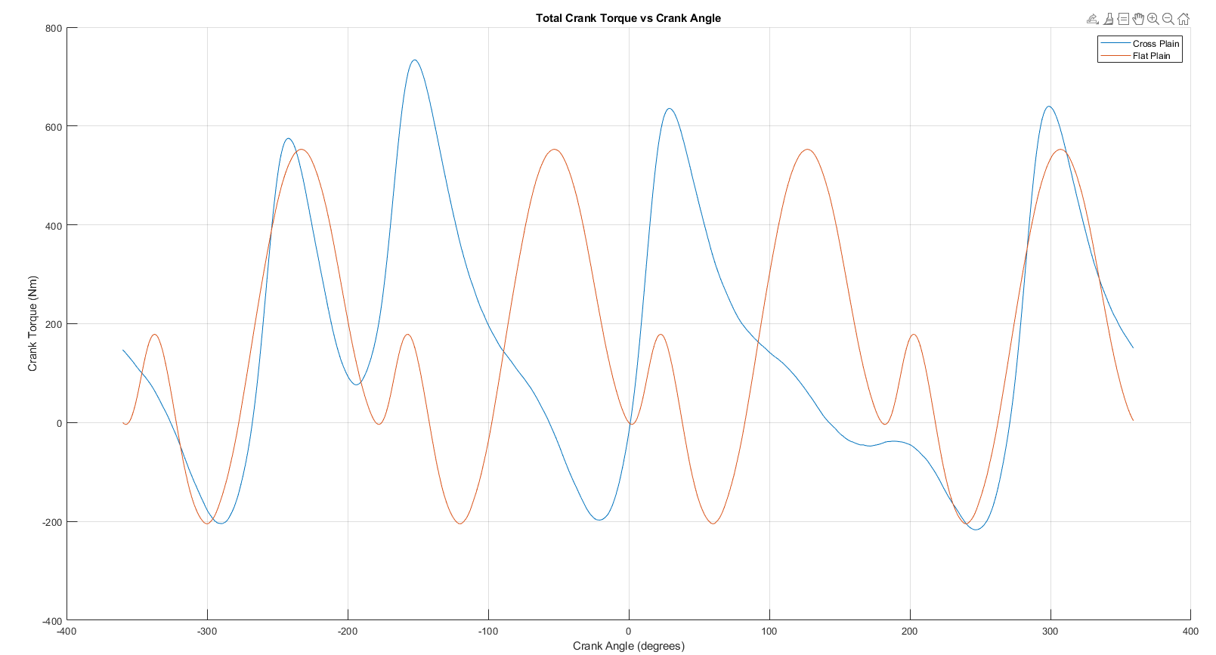
Crank cross vs flat
Figure x shows the smoothed total Crank torque acting on the crank shaft from all 4 cylinders combined. The flat plain has a cyclic pattern of 2 distinct peaks. The torque has a trough between the 2 peaks and has a harsher nature than the cross plain configuration which has a much smoother more refined torque acting on the crank shaft.

Extension of RPM Range and Effect on Safety Factors

The factor of safety decreases As the RPM increases because no adaptation has been made to accommodate for the added stress that the components are under.
The Gudgeon pin calculation produced output that I was not expecting as the FSF rises between 3000 and 7000 RPM before beginning to decrease until 9000 RPM.

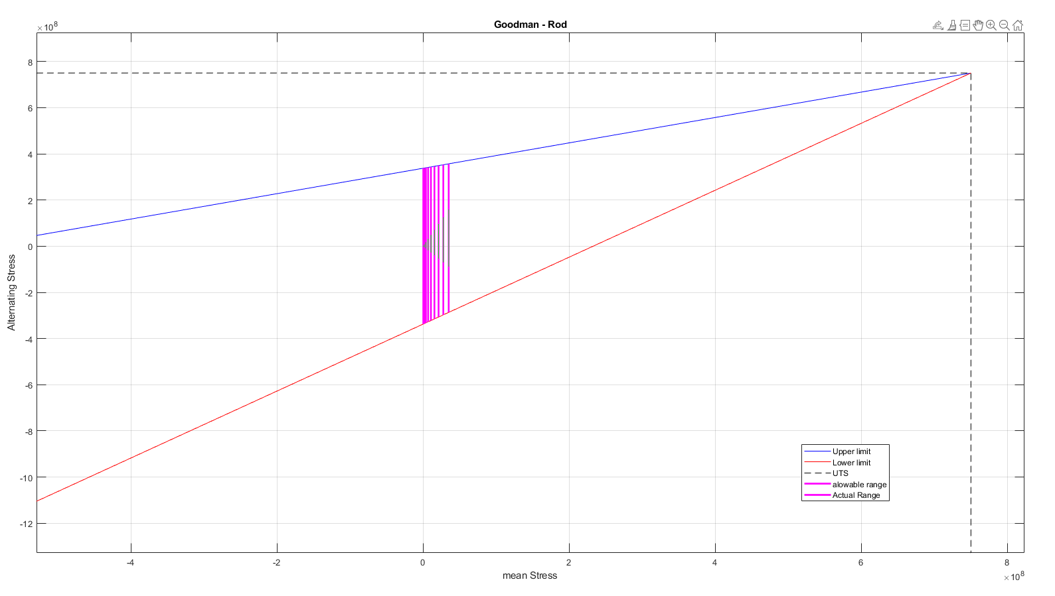
Rod_9k
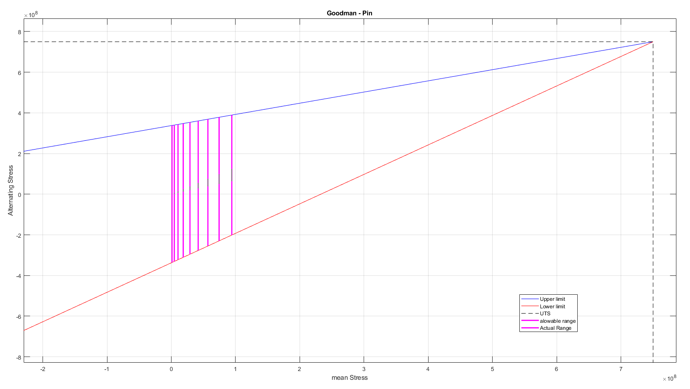
Pin_9k
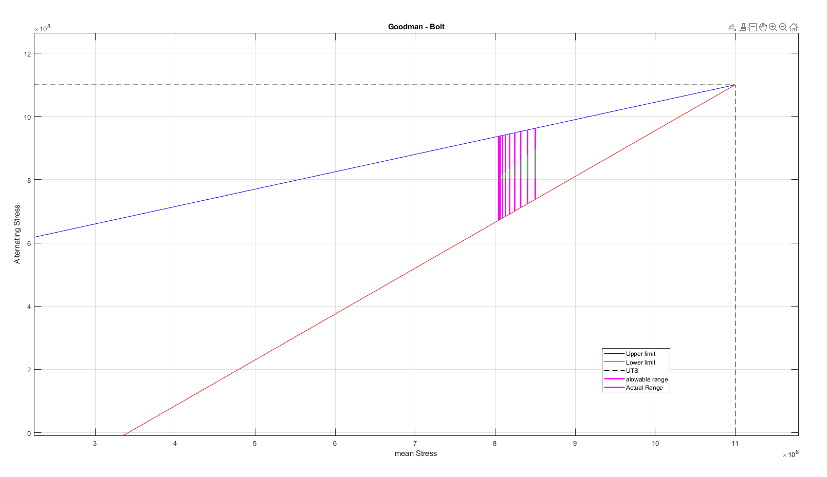
Bolt_9k

Stress concentration factor

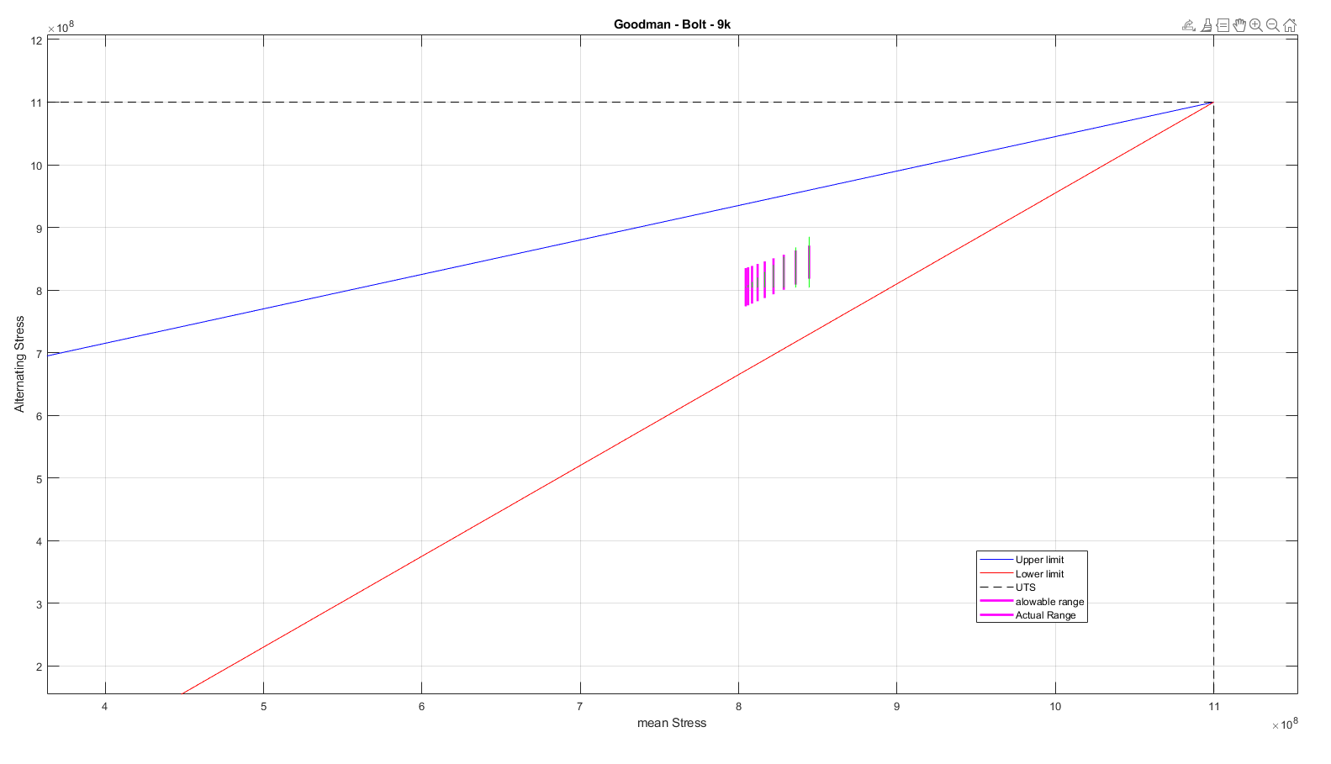

This is the goodman diagram going up to 9000 RPM when Stress concentration factors are taken into account. This graph shows that the actual stress is within the allowable stress range when the engine is operating at 1000 – 7000 RPM But when the engine is operating at high RPMs, 8000 and 9000, the actual stress on the component is higher than the allowable range. This means that the part will fail and the connecting rod bolt will need adaptation to run this engine at 9000RPM.

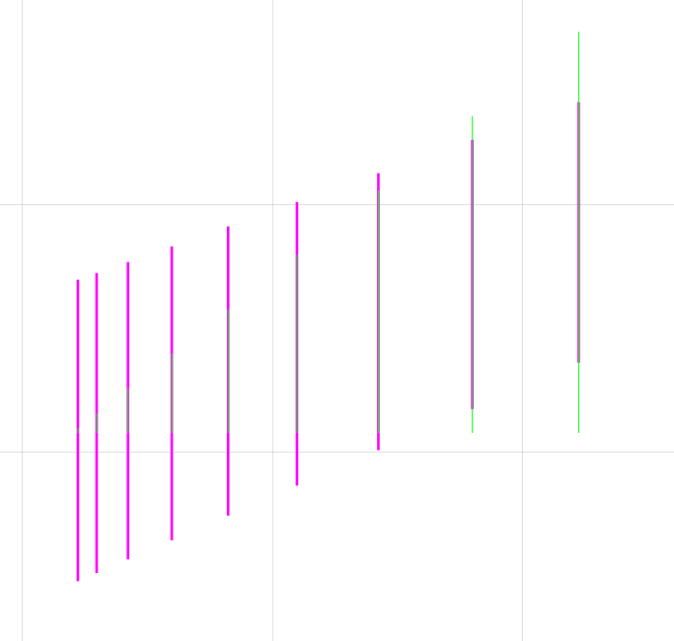

Redesign of Connecting Rod Bolts

In order to increase the FAF of a component without changing the load case, geometry and material alterations are used. Since the applied stresses remain unchanged, improving the material’s resistance to fatigue failure is essential.

Material
Material properties such as the ultimate tensile strength and the Youngs modulus directly affect the FSF. A material with a higher UTS will have a larger allowable range so under the same actual stress values will be less likely to fail. A material a higher young’s modulus gives the material a greater ability to withstand deformation. When a material deforms significantly under load, stress concentrations can develop around notches, sharp edges, and fillet transitions, increasing the likelihood of crack initiation so a material with a higher young’s modulus will have a higher FSF.

geometry
Threads are common locations for stress concentrations, and a longer threaded length increases the engagement area between the bolt and the connecting rod, allowing the load to be more evenly distributed. This reduces the likelihood of fatigue crack initiation at any single point, enhancing fatigue life.
Increasing the cross-sectional area of the bolt will raise the FSF because stress is inversely proportional to cross-sectional area, a larger bolt diameter directly reduces the maximum applied stress leading to a higher FSF and improved resistance to cyclic loading. (Yasin capar, n.d.)

As the RPM is increased, the FSF is decreasing. By increasing the threaded length, the FSF increases.

Discussion and Critical Analysis

Conclusions and Recommendations
This report has analysed the impact of increasing engine RPM, changes to the connecting rod bolt geometry on key internal components, assessing forces, stresses, and fatigue safety factors to determine the feasibility of extending the RPM range to 9000. The study highlights that increasing the maximum RPM increases power output, it also significantly raises mechanical stresses, inertia forces, and fatigue loading on critical components such as the connecting rod, Gudgeon pin, and connecting rod bolts.
The fatigue analysis, using Goodman diagrams and safety factor assessments, indicates that Connecting rod bolts remain within acceptable stress limits up to approximately 7000 RPM. However, at 8000 and 9000 RPM, the fatigue safety factors drop below acceptable limits. And demonstrates how geometry changes can help to raise the FSF.
The comparison between flat-plane and cross-plane crankshafts shows that flat-plane configurations exhibit higher inertia torque fluctuations, leading to increased vibration and stress concentrations. On the other hand, cross-plane crankshafts provide smoother torque delivery and reduced cyclic loading, making them a more durable choice for high-performance applications.

References
Altair Hyperlife, n.d. Other Factors Affecting Fatigue. [Online]
Available at: https://2023.help.altair.com/2023/hwdesktop/hlife/topics/solvers/os/analysis_fatigue_other_factors_r.htm
[Accessed 15 3 2025].
B.Heywood, J., 2018. access engineering library .com. 2nd edition, 2018 ed. New York: McGraw-Hill Education.
Bernazzani, M., 2021. Car Gurus. [Online]
Available at: https://dealers.cargurus.com/drc/reliability-is-a-top-factor-for-shoppers-deciding-what-vehicle-to-purchase?userIsDeveloper=false&googleAnalytics=UA-4745999-10&dealerLeadCreationInCgJmx=false&livePersonAccountId=61801890&livePersonCampaignId=LP_DIV_170310
[Accessed 15 03 2025].
Ferguson, C. a. K. A., 2016. Internal Combustion Engines: Applied Thermosciences. 3rd ed. Hoboken, NJ: Wiley.
Ford Authority, n.d. Ford 1.6L Sigma Engine. [Online]
Available at: https://fordauthority.com/fmc/ford-motor-company-engines/ford-sigma-engine-family/ford-1-6l-sigma-engine/
[Accessed 15 03 2025].
Hottinger Bruel & Kjaer, n.d. Reliability Prediction for Components in Fatigue. [Online]
Available at: https://www.hbkworld.com/en/knowledge/resource-center/articles/reliability-prediction-for-components-in-fatigue
[Accessed 15 03 2025].
Krishnakumar Krishnasamy, D. S. T. D. B. M. G. T. M. M. S. S. S. K. M. M., 2022. Wiley online library. [Online]
Available at: https://onlinelibrary.wiley.com/doi/10.1155/2022/3982415
[Accessed 15 03 2025].
Sarihan, V. a. S. J., 2020. Optimization of connecting rod bolt design for high-performance engines. Journal of Materials Engineering and Performance, 29(3), p. 1.
Sim Scale, 2023. What is Fatigue analysis. [Online]
Available at: https://www.simscale.com/docs/simwiki/fea-finite-element-analysis/what-is-fatigue-analysis/
[Accessed 15 03 2025].
T. Rølvåga, B. H. M. B. F. B., 2020. Research Gate. [Online]
Available at: https://www.researchgate.net/publication/340146856_Fatigue_analysis_of_high_performance_race_engines
[Accessed 15 03 2025].
Yasin capar, n.d. Engineering Stress/Strain vs True Stress/Strain. [Online]
Available at: https://yasincapar.com/engineering-stress-strain-vs-true-stress-strain/
[Accessed 15 03 2025].

e as per handbook)

