Critically discuss the importance of gender and status, as well as the concepts of dominance and passivity in relation to Roman sexuality.
Gender and status transcend time; they have dictated sexual interaction in the highly stratified societies of historic and modern civilisations. However, they pale in comparison to the importance that Romans placed on the concepts of dominance and passivity in a sexual context. Traditional exertions of power, as typified by the wealthy controlling the poor and men controlling women, formed the foundation of sexual relations in Ancient Rome. Yet, taking a constructionist view, it is clear that Roman sexuality, encompassing sexual acts, desires and preferences, is culturally relative; ergo, the modern focus placed on heterosexuality and homosexuality did not exist – it was in-turn about the virility of a man in his sexually active position, paralleled with either a man or woman’s weakness, or vulnerability, in taking a passive position. These stereotypes held such gravitas not only in the private sphere, but public and more importantly legal one: such as, in the Digest it is recorded that men who had “used their bodies in a woman’s fashion” were prohibited from acting as advocates in Roman courts. Throughout this discussion both modern and ancient scholarship, ranging the stoic works of Foucault to the bawdy depictions of Martial, will be consulted in order to determine the importance of these concepts in relation to Roman sexuality.
Roman society, and its growth, depended upon contemporary considerations of gender and status. Considering literary, epigraphical and anthropological evidence it is apparent that it was expected for women to be younger than their male counterpart, in order for them to more easily wield power. According to contemporary political theorist and poet Hesiod, in his didactic poem ‘Works and Days’, a man should marry at approximately age 30 and a woman should be five years into adulthood. As a text intending to teach its readership, it may be assumed that marriage at such a late age was atypical because men could legally marry at 14 (having grown from their toga virilis to toga praetexta) and women at 12; clearly ideals were shifting: with childbirth often resulting in maternal mortality and young fathers rarely possessing enough authority to lead a family, this is unsurprising. Arguably, it was not just the sexual dominance of men, but public (as a father ruled over the family), which was vital to the Roman notion of sexuality. As Ovid, in ‘The Art of Love’, advises an innocent, impressionable female population to ‘put on an act… moan as though you were cuming’ to leave their husbands buoyed up by their enlarged egos: plainly the man’s sexual gratification takes precedent in Roman society.
Marriage, a sacred union between two, often fell victim to an achingly human tale, mired in the quotidian details of adultery. In the first instance of tiring with a wife, but not a marriage, was to participate in the socially acceptable outlet for male lust: to visit a meretrix (woman who earns, or prostitute). Contemporary satirist Horace describes Cato’s advice as ‘noble’ when he suggests this scenario, although by specifying that it is man whoring the implication is that gender is vital in determining whether adultery has been committed. In Ancient Rome, women were forbidden to have extramarital affairs; however, men (as paterfamilias) could bed their slaves and freed(wo)men but not another man’s wife. Moreover, men proved their virility not by excessively profligate behaviour, as giving in to base desires too often made a man look meek and effeminate, but taking a dominant position sexually. To penetrate vaginally or annually was manly; however, to perform cunnilingus was in effect to put a woman in a position of power, leaving you emasculated with os impurum (a filthy mouth). In source one the sexual act being performed embodies the influence that passivity had on Roman sexuality, as this art piece was used in the baths for its apotropaic qualities, it is intended to evoke humour which stir the evil spirits away. Clearly, in the Roman world, the phallus dominated in private roman scenes, it proposed power and purpose and was to be taken seriously as a dominant force. Tacitus records this notion when describing Valerius Asiaticus declaration in court: ‘Ask your sons, Suillus, he broke out; “they will tell you I am a man (virum)!”’. Valerius is clearly becoming increasingly vexed, as is indicated by the large mass of direct speech prior to the defendants outcry, however as it is clearly a social impropriety to discuss the intricacies of sex in a public sphere and embarrassing for another party to hear that a man has actively bed their sons, this is a last resort. Yet, in the position of dominance and high status there are exceptions to be made in what one can say and see. The secret museum, or secretum, created in 1795 secretum echoes this argument, as pieces of artwork and pottery from archaeological excavations depicting sexual scenes were locked away from public view for only a few elite members of society to see. Although this act arguably reflects Georgian political climate, one which demanded social restraint, it suggests that the interests in the Roman period revolved around sexually lewd acts with clearly active and passive participants.
Modern historian J. Renger suggests that marriage was largely monogamous, with polygamous relationships rather more commonplace amongst the elite, ruling classes. However, in an effort to preserve the oikos or familias, and to counter falling birth rates in 9 A.D. the Lex Papia Poppaea saw the legalisation of marriage in Roman society. Although Ovid in Amores attributes this institutional law being instigated to counter rising lascivious vice following the civil wars, A. M. Duff insinuates that the Italian born freedmen being conscripted to the war resulted in an inability to keep Rome free from a ‘foreign tinge’, with large numbers of barbarian slaves entering the Roman Empire. The suggestion that marriage is implemented as a eugenic policy, to encourage men to procreate with suitable women: wives, of Roman birth/blood highlights the emphasis on male dominance and the importance of status (in terms of ethnicity) in Roman sexuality. Not only is this argument harmonious with Augusts’ bid to restore the glory of former times by administering concrete reforms; but, if historian James Field’s proposal, that the total population of Italy was at least being maintained if not increased in size, is correct then it follows that the sexual ideals in Ancient Rome heavily relied upon the status of participants. However, whether the physical ideals of Roman women went against this notion is up for debate: did the desire to have a small waist and large hips result in higher levels of abortion. Martial mocked women with large boobs: “Breast-band! confine the swelling bosom of my mistress”, increased in size by milk for a baby, and consequently abortion was made illegal in the reign of Septimius Severus.
Dominance and passive sexual positions dictate what Roman sexuality is, to the greatest extent. Gender and status clearly have some influence, as they do in every society. However it is clear that power is the root of dominance, active roles the root of virility and virility the root of social standing. These concepts combine to form Roman sexuality, as factors they all play their roles; yet, the most important factors are certain.

Bibliography
Duff, A.M. (1928) Freedmen in the Early Roman Empire.191.
Field, J. The Purpose of the Lex Iulia et Papia Poppaea. The Classical Journal, Vol. 40, No. 7. Pp. 398 – 416.
Renger, J. (2006) Family. In: Brill’s New Pauly, Antiquity volumes edited by: Hubert Cancik and , Helmuth Schneider, English Edition by: Christine F. Salazar, Classical Tradition volumes edited by: Manfred Landfester, English Edition by: Francis G. Gentry. Consulted online on 08 March 2019.
Wiesehöfer, J. (2006) Marriage, Age at. In: Brill’s New Pauly, Antiquity volumes edited by: Hubert Cancik and , Helmuth Schneider, English Edition by: Christine F. Salazar, Classical Tradition volumes edited by: Manfred Landfester, English Edition by: Francis G. Gentry. Consulted online on 08 March 2019.

Ancient Sources
Digest 3.1.5.
Hesiod, Works and Days. 695-698
Horace Satires 1.2.28-35.
Ovid, Amores I, 8: II, 13, 14; A.D. Winspear adn L.K. Geweke, Augustus and Roman Reconstruction (Madison, 1935), 176 – 178.
Ovid The Art of Love 3.798-99.
Martial Epigrams 14.149.
Tacitus Annals 11.2.2
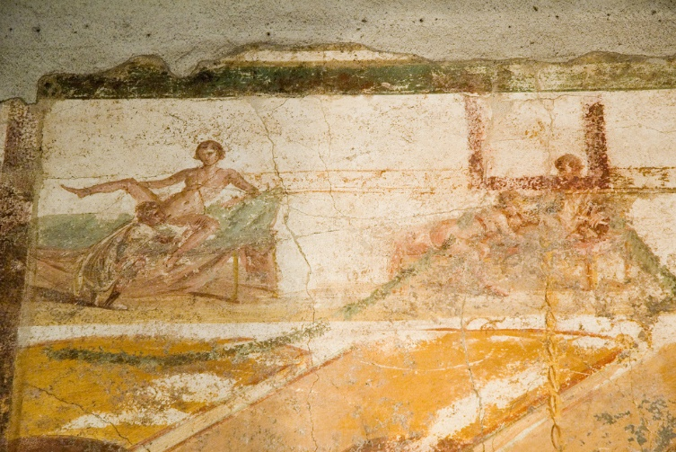
Appendix

Source 1. Pompeii, Suburban Baths, room 7, (AD 62-79)

Digest 3.1.5.
Hes. Op. 695-698
Ovid 3.798-99.
Horace 1.2.28-35.
Tacitus 11.2.2
Renger. 2006
Ovid. Amores I, 8: II, 13, 14
Field. (1945), vol.40, no.7, pp.388 - 416
Duff. (1928), 191.
Field. (1945).
Martial. 14.149.

