
Skills for the Workplace
Module Assignment Submission
Student Name: | Tamin Miah
Student Number: | 1818711
Module No: | BMSK4002
Module Title: | Effective Team Working and Communication  Part 2

Statement of Confirmation of Authenticity
By the act of making this submission, the student declares that this is the work of the student named above. The work has not, in whole or in part, been knowingly presented elsewhere for assessment, or where assessment has been built on a previous assessment, this has been identified. Where materials have been used from other sources it has been properly acknowledged. If this statement is untrue, the student acknowledges that an assessment offence has been committed.
Attention is drawn to the plagiarism and unfair practice policies of both the University and of ILM.

Table of Contents
Part 2 Communication 3
1.0 3
Communication Cycle 3
2.0 5
Assessing Own Communication Skills 7
Gap Analysis 9
PDP 10
Conclusion………………………………………………………………………………………………………………………….11
References 12
Appendix A 14
Appendix B…………………………………………………………………………………………………………………………16
Appendix C 19

Part 2 Communication

1.0

Communication Cycle

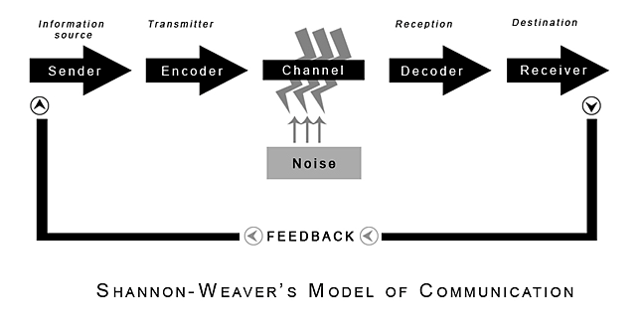
(Shannon and Weaver, 1949)
Communication can be defined as information being transferred from one person to another in the form of verbal, non-verbal and written communication (Skillsyouneed, 2020). The communication process involves a sender, a message and a recipient and is known as the communication cycle developed by Claude Elwood Shannon and Warren Weaver in 1949 (see above diagram). The cycle shows the stages of how messages are sent and received through communication (Mulder, 2017).
The model starts with sender which can be referred as the information source. This is the initial stage where the person who has the information decides the message they want to send, who they want to send it to, and which channel the message needs to be sent through such as by speaking, in writing, through body language etc (Drew, 2020).
The encoder is when the person converts their idea into communication so that it can be sent to the receiver. They can use communication tool such as phone call, text message or face-to-face meeting to do this. However, the encoder will need to consider for any factors that may interfere with their message at this stage such as distraction, other messages etc (Pressbooks, 2019).
The middle stage of communication is the channel which is the set-up of how the information is sent by the sender and transmitted to the receiver, this is also known as medium. For example, someone sending an email is using the internet as the channel (Drew, 2020).
However, during the channel stage the message can sometimes be interrupted by internal and external noise when being sent to the receiver. Internal noise is when a mistake occurs when a message is sent. For example, spelling mistake in a text or when the receiver misinterprets a sentence when reading a message. External noise happens when something is out of the sender and receivers’ control such as internet problem. Therefore, it is important to identify the noise and try to improve the message quality where possible (Drew, 2020).
Decoder stage would be the reverse process of the encoder stage. This is the reception part of the signal, which converts signal into a message and decodes the message into a format that can be understood by the receiver. Even if there is direct communication between people without technology use, there would still need to be decoding of the message. For example, reading out written words aloud so that one can make sense of it in their mind (David, 2014).
The receiver stage would be the destination part of the communication, where the target place of the transmitted message is received. For example, an email sent which is read by the receiver (Drew, 2020).
When the receiver responds to the message from the sender, this is when feedback occurs. The feedback from the receiver could be that the message was received or if they understood the message. The feedback stage would basically be the loop of the two-way communication in relation to the message response between the sender and receiver (Amudavalli, 2018).
Wilber Schramm produced the model of communication in 1954. His theory was based on the Shannon and Weaver communication cycle as well, where he believed the encoding and decoding are the two most important stages for a message to flow between two individuals. Schramm also highlighted that until the sender does not receive a feedback from the receiver, the communication is incomplete (Juneja, 2015).
The communication cycle was then further developed by David Berlo in 1960 who created the SMCR model which are source, message, channel and receiver. The model also focuses on the communication process but also looks at factors that influence the encoding and decoding stage including skills, attitudes, knowledge and culture (Janse, 2019).
Within a workplace, communication is essential so that an understanding can occur between managers and employees. Through effective communication, employees will also understand information clearly and act upon this accordingly which will also increase productivity. The communication can occur in many formats such as appraisals, training sessions, group meetings (Doyle, 2020).
When an employee or manager needs to communicate at work, they must ensure the message they deliver is clear and concise for other staffs to understand. Thus, it is important they follow the communication cycle so that the message is delivered, and important information is not missed out (Blekinsop, 2010).
There are two ways communication can occur at work and these are known as verbal and non-verbal communication. Verbal communication is when words and sounds are used to share information between individuals and can include both spoken and written. At work settings spoken communication can involve messages through meetings, telephone whereas written is through emails, reports, forms etc. Written or spoken communication must be clear and simple but within a professional manner so that it is understood by work members (Faizal, 2019).
Non-verbal communication occurs through signs of facial expressions, tone of voice, gestures and body language (Yourdictionary, 2020). An employee can observe the behaviour of another employee or manager through the non-verbal cues and understand their feelings. Therefore, it is important to display positive non-verbal communication in a workplace to develop trust and good working relationships amongst colleagues (Schwartz, 2020).
When the report writer worked in a retail setting, they had to make sure their facial expressions were positive in the store, and the customers were approached to in a friendly yet professional way so that the customers felt welcomed. The customers had to be spoken to in a clear manner with a calm tone of voice so that they felt that they are being looked after and attended to. This work experience enabled the report writer to display both verbal and non-verbal communication which they can apply to other work settings.
Listening is also a key skill required when communicating at work and can vary from one person to another. There are four types of listeners which are detached, passive, involved and active. Detached listeners would not be interested and seem bored, passive listeners appear calm and fake attention, involved listeners would make some direct eye contact and seem a bit engaged to the message said, active listeners focus completely on what is said and is engaged with full attention (LaMasters, 2019).
Within a workplace it is important to have active listening so that employees fully concentrate to what another employee/manager is saying and not just listen to the words. Through active listening employees can put forward their views/feedback which will enhance productivity and can also resolve conflicts amongst work colleagues which will enable stronger relationships. Employees will also feel self-empowerment if they are listened to at work which will make them feel comfortable to communicate at work (Kaplan, 2018).

2.0

Assessing Own Communication Skills

In this section the report writer assessed their own communication skill to see the type of communicator they are at work using the communication style questionnaire. There are four types of communication style which are Assertive, Passive, Passive Aggressive and Aggressive. The questionnaire showed that the report writer has the Assertive communication style (see Appendix A).
The report writer agrees that they are an assertive communicator as this communication style means that they can express themselves clearly and stand up for their point of view without upsetting others. Assertiveness also means that the report writer respects other people’s view and encourages others to express their views so that any conflicts can be resolved. The only issue with this style is that the report writer may come across as being arrogant to others for being open with their views (Mayoclinic, 2019).
Followed by this the report writer completed the Skills You Need (see Appendix B) online test to find out their strengths and weaknesses of their communication.
The Skills You Need test showed that the interpersonal skill score for the report writer is 69% which is average. This could be because even though the report writer can communicate fluently with people and get along with everyone, sometimes their anxiety can have an impact on the way they interact and build relationships with people. Therefore, this could be an area the report writer can improve on.
On the listening skills the report writer scored 56% which again is average. Even though the test comments the listening skill is satisfactory, the report writer does not feel this is completely true as they are a good listener to other people and are happy to listen and follow instructions at work. Friends and colleagues always say that the report writer is a good listener when it comes to sharing their problems or even just for a general chat.
The report writer scored 77% on emotional intelligence which is above average. This is a good skill to have as it shows the report writer can understand their own emotions as well as emotion of other people at work and be able to adapt to situations easily.
On the verbal communication, the report writer scored 73% which is above average. The report writer agrees that once they feel comfortable within a situation or at work then they can communicate positively with everyone and are happy to express views. However, sometimes the report writer can find certain words difficult to pronounce which can push them back in talking but this is something they can practise upon.
Communicating in groups is important within a workplace. The report writer scored 69% which is on average level. Even though they are happy to work in groups and can handle most situations, sometimes they could feel nervous to express ideas which can also impact their confidence level and therefore need to develop on this.
Furthermore, the report writer completed the Mind Tools questionnaire to see how good their communication skill is. The results showed that the report writer is a capable communicator (see Appendix C). The report writer can communicate effectively with people and can keep a conversation going. They listen to other people’s view and would think carefully before putting forward any answers.
Even though English is not the report writers first language they are able to speak fluently but can find certain words difficult to pronounce. Therefore, the report writer needs to identify areas they need to develop on and add it onto the gap analysis and personal development plan table below in order to help become an excellent communicator which will be required if they want to undertake future management position at work.

Gap Analysis

The report writer has identified the below gap analysis objectives they want to improve on to help with their communication skills:

Objective | Current Position | Deficiency | Action
What do I want to do? | What can I already do? | What am I lacking? | How do I fix this?
Improve on word pronunciation. | Can communicate at basic level | Pronouncing certain words | Practice words they cannot pronounce, watch online tutorials, ask friends/colleagues to help
Increase confidence in group situations. | Work in groups | Sometimes feel nervous and impacts confidence to express views | Watch how other people talk, learn techniques to help with nervousness, watch videos on group situations
Better presentation skills | Conducted first presentation | Nervousness in tone of voice, body language, background setting | Practise tone of voice and improve body language, ensure background setting is good for audience

PDP

The below table will show the goals the report writer has identified they want to achieve using the SMART Action plan which is specific, measurable, agreed, realistic, time-bound. (Udemy, 2019).

Objectives | Tasks | Success Criteria | Time Frame | Resources
List your Goals | What do you need to do to achieve these goals? | How will you identify your success? | When do they need to be done by? | Who or what do you need to help you?
Better word pronunciation | Use online speech tutorials, ask friends/colleagues to help pronounce word, keep practising | Pronounce word confidently, ask friends/colleagues for feedback | 30th January 2021 | Laptop, friends and colleagues  Cost £100
Improve anxiety | Use stress/anxiety treatment, speak to friends/colleagues/GP | Feel confident with situations that causes anxiety, better within self, more focused and calmer. | 30th May 2021 | Treatment, friends/colleague/GP  Cost £50
Develop interpersonal skills | Read online techniques on how to build on this skill, more communication with colleagues/friends | Ask friends/colleagues for feedback. | 30th May 2021 | Friends/colleagues  Wi-Fi connection,  Laptop  Cost £150

Conclusion

In conclusion, communication is important within a workplace so that tasks are completed sufficiently, and strong working relationships are built amongst colleagues. The communication cycle showed that the encoding and decoding stage needs to be understood properly by the sender and receiver for the communication cycle to be a smooth process.
The report writer identified the type of communicator they are along with strengths and weaknesses which they can develop on through an action plan. When they conducted their presentation, they received positive feedback for the presentation layout and the information was communicated clearly which the audience understood. However, there were areas which the report writer needs to improve on such as their tone of voice, body language, background settings. Overall, the report writer has attained good communication skills but can develop on this further for managerial positions or future presentations.

References

Amudavalli, A. (2018) Theories and model of Communication Available at: https://epgp.inflibnet.ac.in/epgpdata/uploads/epgp_content/library_and_information_science/knowledge_society/05._theories_and_models_of_communication/et/4305_et_et.pdf (Accessed: 18th May 2020).
Blenkinsop, P. (2010) The Communication Cycle. Available at: http://manyana-education.blogspot.com/2010/10/communication-cycle.html (Accessed: 15th May 2020).
David, b. (2014) The Shannon-Weaver model of communication Available at: https://prezi.com/9beeebjhhccy/the-shannonweaver-model-of-communication-has-been-called-th/ (Accessed: 18th May 2020).
Doyle, A (2020) Verbal communication skills list ad examples Available at: https://www.thebalancecareers.com/verbal-communication-skills-list-2059698 (Accessed: 18th May 2020).
Drew, C. (2020) Shannon-Weaver model of communication Available at: https://helpfulprofessor.com/shannon-weaver-model/ (Accessed: 14th May 2020).
Faizal, F. (2019) What is workplace communication & why does it matter? Available at: https://www.feedough.com/what-is-workplace-communication-why-does-it-matter/ (Accessed: 18th May 2020).
Janse, B. (2019) Berlo’s SMCR Model of Communication Available at: https://www.toolshero.com/communication-skills/berlos-smcr-model-of-communication/ (Accessed: 13th May 2020).
Juneja, P. (2015) Schramm’s model of communication Available at: https://www.managementstudyguide.com/schramm-model-of-communication.htm (Accessed: 18th May 2020).
Kaplan, E. (2018) Active Listening: the key to strong workplace relationships, productivity and personal empowerment. Available at: https://medium.com/@ellekaplan/active-listening-the-key-to-strong-workplace-relationships-productivity-and-personal-72650f32da4c (Accessed: 18th May 2020).
LaMasters, T. (2019) 4 types of listeners, Available at: https://forwardleader.org/2014/09/4-types-of-listener-what-type-are-you/ (Accessed: 18th May 2020).
Mayoclinic, (2019) Being assertive: reduce stress communicate better Available at: https://www.mayoclinic.org/healthy-lifestyle/stress-management/in-depth/assertive/art-20044644 (Accessed: 20th May 2020).
MindTools (2019) How good are your communication skills? Available at: https://www.mindtools.com/pages/article/newCS_99.htm (Accessed: 15th May 2020).

Mulder, P. (2017) Communication cycle model by Shannon and Weaver Available at: https://www.toolshero.com/communication-skills/communication-cycle-shannon-weaver/ (Accessed: 14th May 2020).
Pressbooks, (2019) Communication process: Encoding and Decoding Available at: https://ecampusontario.pressbooks.pub/commbusprofcdn/chapter/1-2/ (Accessed: 14th May 2020).
Schwartz, L. (2020) Nonverbal communication with workplace interactions Available at: https://smallbusiness.chron.com/nonverbal-communication-workplace-interactions-844.html (Accessed: 18th May 2020).
Shannon, C. and Weaver, W. (1949) The Mathematical Theory of Communication. Urbana: University of Illinois Press.
Skills You Need (2019) Interpersonal Skills Self-Assessment Available at: https://www.skillsyouneed.com/ls/index.php/343479 (Accessed: 15th May 2020).
Skills You Need (2020) What is communication? Available at: https://www.skillsyouneed.com/ips/what-is-communication.html (Accessed: 14th May 2020).
Udemy, (2019). Smart Action Plan: How to set SMART goals Available at: https://www.udemy.com/blog/smart-action-plan/ (Accessed: 21st May 2020).
Yourdictionary, (2020) Verbal communication Available at: https://www.yourdictionary.com/verbal-communication (Accessed: 18th May 2020).

Appendix A
Communication Style Questionnaire
This questionnaire is designed to help you assess your preferred communication style.
Thinking about your behaviour at work, write a score against each statement to represent which best typifies your behaviour where
4 = agree strongly, 3 = agree somewhat, 2 = disagree somewhat, and 1 = disagree strongly.
As with all questionnaires, the level of your honesty and self-awareness will impact on the accuracy of the outcome…so, be truthful to yourself!

- I express my opinions in an honest and appropriate manner. 4
- I can get angry and let this show. 2
- I find it difficult to say ‘no’. 3
- If I do not agree with a task that my boss has given me, I find a way of dragging my feet on it. 1
- I feel comfortable in asking for help from someone if they know more than me. 4
- I feel guilty if I leave on time for a valid reason and other people are still working. 2
- I can be sarcastic. 2
- I think my way of doing things is better than other people’s. 1
- If someone takes advantage of me, I find a way of evening the score. 1
- I feel I have a right to say no to other people’s requests and to negotiate a compromise. 3
- If I am in a large meeting, I find I do not speak up. 2
- I like to be in control of a situation. 3
- I stare people down. 1
- I make good eye contact with other people. 4
- If I am unsure about a task that I have been given, I find it uncomfortable to ask for help. 1
- I talk about other people behind their backs. 1
- When I have to deal with someone in authority, I find it difficult to look them directly in the eye. 1
- I am a good listener and equally other people listen to what I have to say. 4
- Rather than confronting someone about an issue, I would rather give them the cold shoulder or drop hints to other people that I am not happy. 1
- I am not afraid to be direct with someone, even if they think I am being rude. 2

Self-Assessment: Results

To assess your preferred communication style, transfer the scores you have given to each statement to the boxes below.
Then total each column downwards.
Look at the column where your score is the highest.
This is the communication style you use most of the time.

Q1 4 | Q3 3 | Q4 1 | Q2 2
Q5 4 | Q6 2 | Q7 2 | Q8 1
Q10 3 | Q11 2 | Q9 1 | Q12 3
Q14 4 | Q15 1 | Q16 1 | Q13 1
Q18 4 | Q17 1 | Q19 1 | Q20 2
Total 19 | Total 9 | Total 6 | Total 9
Assertive | Passive | Passive Aggressive | Aggressive

Appendix B

Skills You Need Communication Quiz

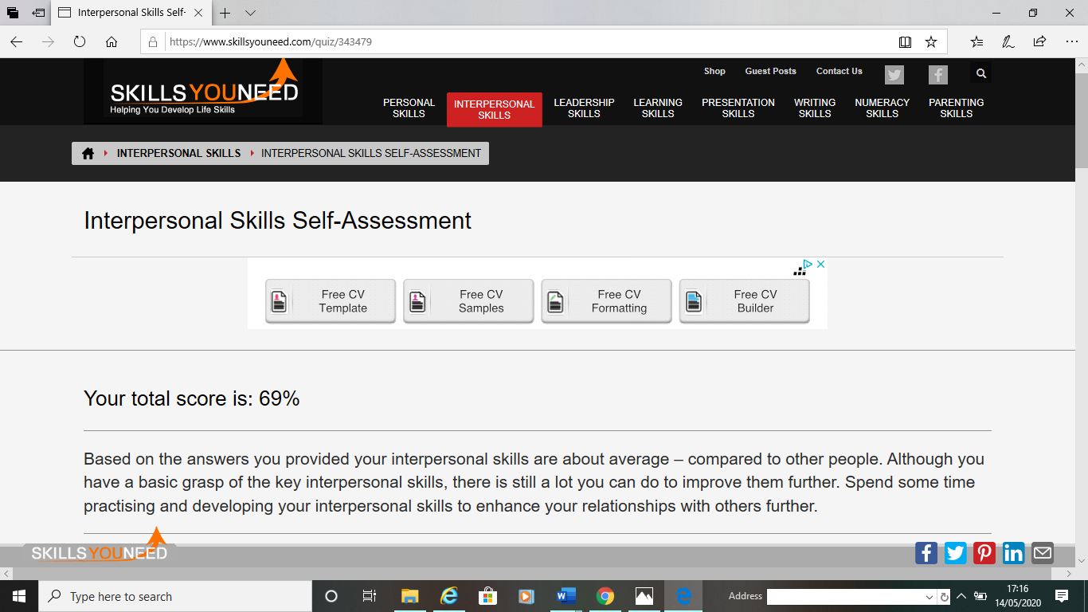

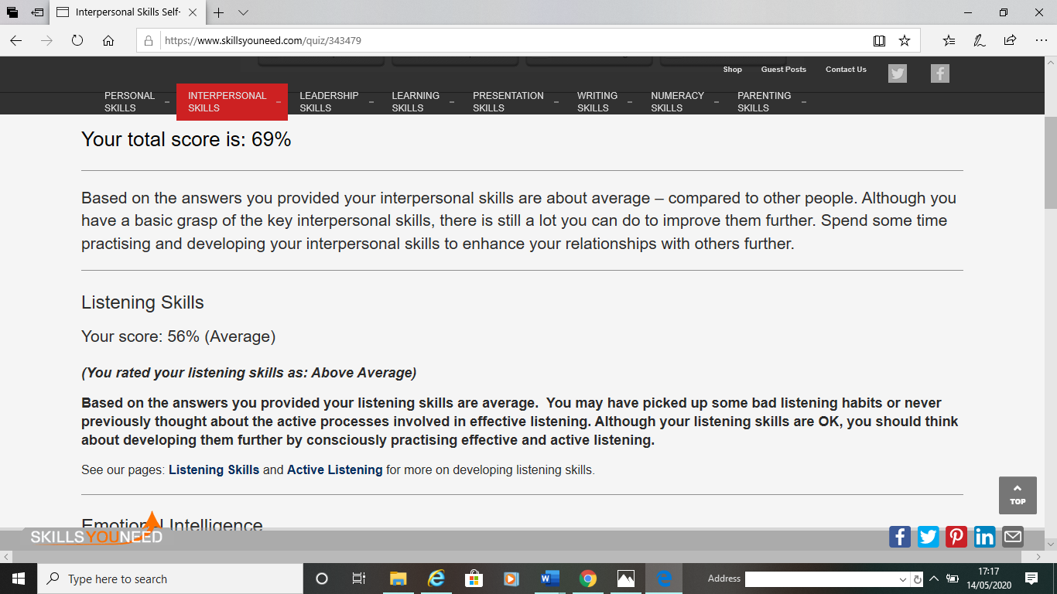

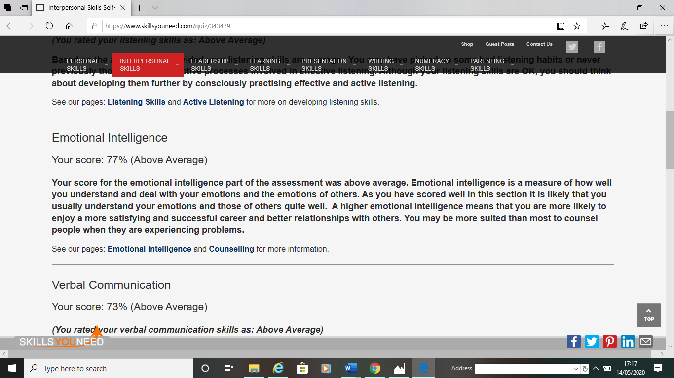

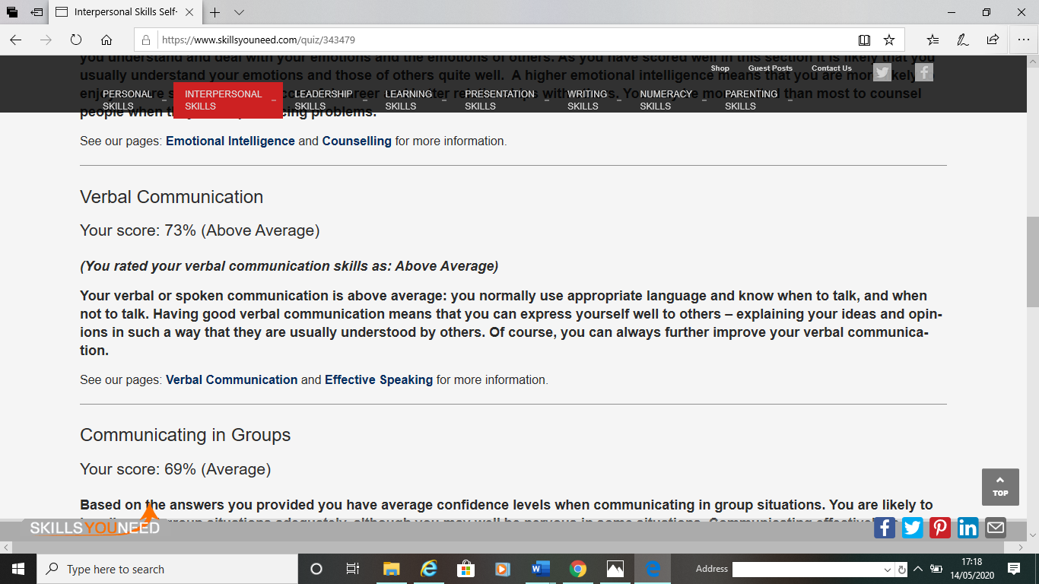

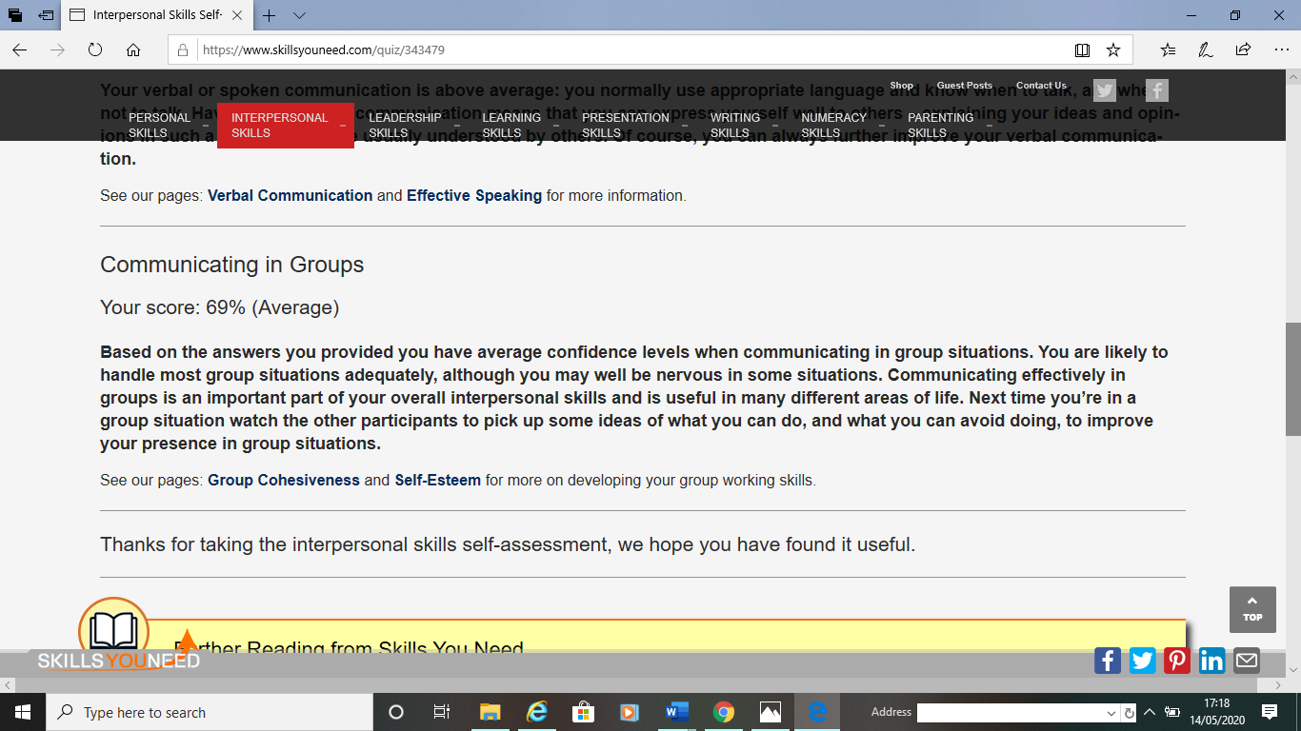

Appendix C

Mind Tools Communication Quiz



