Effective Team Work and Communication Assignment (Report)

Maria Jose Ayovi // Nº 2133891

Module: Effective Team work and Communication
Module code: BMSW4002
Module Leader: Lloyd Beharry
Submission day: 03.01.23

CONTENT:

- The communication History

- The three models of communication.

- Communication Skills.

- Communication of Technology: advantages and
disadvantages

- Reference

The communication History

The history of communication is very long, as old as humans have exited. Some of the oldest forms of human communication include making sounds, drawing, or painting, dancing, acting, and using symbols.

During the existence of Homo sapiens the sounds such as grunting or guttural sounds at a low pitch or high pitch would indicate either social communication, symbols and drew, by way of Rock drawing were murals that people painted on the walls of coves and canyons to tell the story of their culture, or event dancing around the fire or even the smoke signals were another way to send messages to people who were not close enough to use the body language. Also, the sound of the drum would inform them of concerns and events that they needed to know about. Later written communication arose when humans realized the need to record their activities of daily living, this progressed to meet the needs of barter and exchange of things. The ancient Egyptians were among the first to use paper made from the fibrous pith of pentane plants. Around 3000 b.c papyrus scrolls were also used by the Greeks and Romans which were long rolls of paper or paper like materials wrapped up, resembling paper kitchen towels. Later people discovered that they could write on wooden slabs covered with wax on which marks could be made with stick and erased if necessary. This departure was a step in the evolution of communication until it became the paper books and the alphabetic system we have today, which began as sheets of parchment, that is dry sheep and goat skins roughly sewn together.

The technical evolution of communication developed and changed over time, allowing humans to develop skills such as the creation of telegraph one of the biggest developments in communication it was a device that allowed the transmission of data, instantly, with magnetic needles suspended from threads in 1832 that the inventor was Barong Schilling Von Canstatt. And the first working telegraph was invested in 1816 and worked by Francis Ronaldo and used static electricity. As the years went by, science technology and we were increasing more electricity to the point of creating the first telephone in 1830, more later Motorola created a mobile during 1973 making the communication even better. The only issue was the smartphones had short battery live and were heavy mobiles.

By 1996, Nokia was realising pones with keyboards. For late on Android created a touchscreen by 2010. After that Steve Jobs launched the first phone to the words during 2007 before the iPhone.

The internet system was a revolutionise communication which started in 1990 helping the world be interconnect easily by computers. Internet is a tool which provide us a powerful to developed information, was the perfect support for the humanity communication and social connection by different part of the word, for example via electronic e-mails witch by 1991 was officially introduce to the word in 1991.

The three models of communication.

A communication model is a pictorial representation of the communication process, idea, thoughts, or concepts through diagrams. They can be considered to a system representation of the process that help us understand how communication can be carried out. One of the communications that is the first and most influential models it is Shannon and Weaver (1948) published with the theory of communication whish develop effective communication between sender and receiver. Also finding factors which affect the communication process called ¨Noise¨. with five basic components terms: source, transmitter, noise, channel, message, receiver, channel, information destination, encode and decode.



Sender: The originator of message or information source selects desire message.

Encoder: The transmitter which converts the message into signals.

Decoder: The reception place of the signal which converts signals into message. A reverse process of encode.

Receiver: The destination of the message from sender

For example.
Thomson made call to his assistant “come here I want to see you”. During his call, noise appeared (transmission error) and his assistant received “I want” only. Again, Assistant asked Thomson (feedback) “what do you want Thomson”.
Sender: Thomson.
Encoder: Telephone (Thomson)
Channel: Cable
Noise: Distraction in voice
Reception: Telephone (Assistant)
Receiver: Assistant.
Due to transmission error or noise, Assistant can’t be able to understand Thomson’s messages.
Schramm (1954) Criticized the Shannon-Weaver model because it assumed that communication always occurred linearly. Schramm’s felt that it was important to notice the impact of messages, Schramm model regards communication as a process between an encoder and a decoder. Most importantly, this model accounts for how people interpret the message. Schramm argued that a person’s background, experience, and knowledge are factors that impact interpretation. Besides, Schramm believed that the messages are transmitted through a medium. Also, the decoder will be able to send feedback about the message to indicate that the message has been received. He argued that communication is incomplete unless there is feedback from the receiver. According to Schramm’s model, encoding and decoding are vital to effective communication. Any communication where decoding does not occur, or feedback does not happen is not effective or complete.
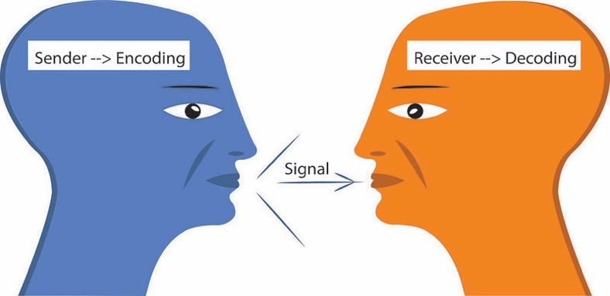
Berol’s (1960), model describes different components of the communication process. He argued that there are three main parts of all communication, which is the speaker, the subject, and the listener. He maintained that the listener determines the meaning of any message. Berol identified factors that influence the source of the message. First, communication skills refer to the ability to speak or write. Second, attitude is the person’s point-of-view, which may be influenced by the listener. The third is whether the source has requisite knowledge on a given topic to be effective. Fourth, social systems include the source’s values, beliefs, and opinions, which may influence the message.

The message can be sent in a variety of ways. There might be components that influence the message. the channel of the message relies on the basic five senses of sound, sight, touch, smell, and taste. Berol argued that for the receiver to understand and comprehend the message, there must be similar factors to the sender.

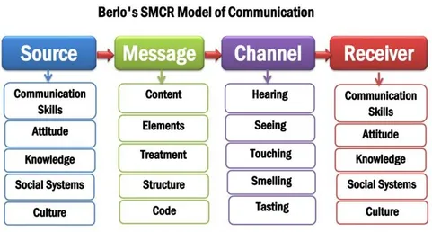

Communication Skills

The communication skills are the availabilities that we use to give and receive various types of information. Which sometimes can be difficult for the misunderstanding when we said something, and another person cannot understand the information we try to share. There are different communication skills the first one is verbal which can be oral or written, for communicate orally is necessary be clear using simple language and do not use complicated language if we do not the correctly pronunciation, another fact is speak slowly and choose the correctly words that say what you want to say as well the use of the body language which have to be connecting with the words. Also, empathy spiking is very important since you must put yourself in other person’s position, speak sincerely mean be natural do not make another feel less or talk to them like they are less, the resect too other is always important. In the verbal communication is essential keep the ayes-contact looking at people when you are speaking this shows the information that you are share is important as well when the people are taking to you that trismic that what they are saying you are following the conversation. The verbal written is when we understand and we use the appropriate language to the person we are communicate whit it, that mean following the rules of the letters.

Another skill is the listening which can be active or attentive, is the fact that we are listen attentively to a speaker, understand what they’re saying, respond and reflect on what’s being said, and retain the information for later. We have the empathetic listening which mean a dynamic and compassionate process that calls for more than taking in someone else’s words. Is communicating with that person showing them we care about they feelings and take the time to hear them out, for example a good empathetic listening is to be supportive, kind, and caring, that mean listen carefully without judgment the people and repeat key phrases to encourage the speaker to open.

In addition, we also have Non-verbal which we do not use words to be communicate with other person, just the communication can be by send it out a message in which we are using our eyes, mouths, hands, sometimes we use our facial expression when we are also writing our body language. Sometimes we are tending use words that contradict our language, for example I can pretend I am laughing when I just send it an emoji laughing. Other Non-verbal skill is the silence which is depending in the person mood or other option is that person have a condition. The Non-verbal communication included the body language as well, for example when a person does not feel comfortable the body language tends to tense up or wen someone tries to invade the space, but this happened more when stranger gets too close, as well the body posture tendent to transmit the other person who we feel or how we are thinking.

One of the more important No-verbal communication is the appearance is just the aye-contact communication that people make judgement by the way you dress or how yourself looks. That mean we should undertint how to dress depending on the chance, mean in the same way you are dressing when you going to a party with your friends you cannot use the same code for go to a meeting or an interview.

Communication of Technology: advantages and disadvantages

The communication technology facilitates communication between us, that mean by individuals or group for which cannot be physically present at the same location systems like a telephone, video call, email, fax, radio, television, and video with all these technologies we can be in contact even if we are in different part of the world. The advantages of communication technology is more efficient, faster method of communication during emergencies, availability to be in contact from anywhere in the word, the long distance communication is easier and communication made easier, for example with the technology that we have now in comparation before meaning that send a letter in a case of emergencies to your cousin who leave in Europe and you in south America will take 6 month to the individual receive it the letter.

The disadvantages of communication technology are getting harder to use for people of older generations, since the telephone system it is becoming more intelligent. Other disadvantage is social media which now the cyber-bullying and cyber-skyping, which is expanding, and the people think is normal, but the way bully have been around forever but with the technology they feel free of do their actions, and some point is not always reliable be in social media. As well make the communication less personal, now everything is got it more virtual and as well some time is no very clear and ensure whit who we are communicating with, because now everybody pretend be someone else.

This disadvantage in the technology is reducing the face-to-face contact and is provoking people physical and psychological problems like depression and anxiety, lack of confidence, eyestrain, and poor posture.

Other advantage and disadvantage that the communication technology affect to the student, is the internet platform which help the student sech and find they questions about the matter and as well give the option to the student be in contact whit the teacher and other students. The disadvantage is everything they see in social media make the misconduct and that give the power for them to be acting in the way they know everting.

Reference

Duck, Steve (2021) Communication in everyday life: a survey of communication. Los Angeles. Extract pp. 5-15.

Russell Howard “Human evolution” (updated Nov 30, 2022)
https://www.britannica.com/science/human-evolution
Accessed 6 December 2022.

Indeed ´Communication Skills: Definition and Examples´ (2022)
https://in.indeed.com/career-advice/resumes-cover-letters/communication-skills
Accessed 8 December 2022.

Chris Drew ´ All 8 Models of communication, Example! ´ (Oct 23, 2022)
https://helpfulprofessor.com/communication-models/
Accessed 8 December 2022.

