

Title- Human Resource Management Assessment- 1

Student name: Akashdeep singh

Student ID : 2239847

Programme :MBA- Master of Business Administration

Module : Human Resource Management

Module code : LCMB7000

Lecturer name : Gladius Kulothungan

Date : 23 August 2023

TABLE OF CONTENT

Page no.

- Introduction……………………………………………. 1

2. Review and evaluation

2.1 The United Kingdom’s labour market
review from 2018 to 2022. …………………………………. 3-4

  - United kingdom’s labour market present situation…..….4-6

3.Human Resource Strategy in The post
COVID-19 in External Environment. ……………6-7

4.Changes in Human Resources
strategies post Brexit…………………………………………. 7-8

5.Conclusion .………………………………………………. 8

6. References…………………………………………………9

1.Introduction

The labor market, often known as the job market, includes the dynamics of labor supply and demand. Employees make up the labor supply on the one hand, while employers create the demand. The economy of a country places a great deal of weight on this complex interaction between the capital, goods, and services markets. The equilibrium of the labor market has an impact on wages, workforce mobility, and overall economic performance. variations in industry preferences, economic situations, and technical breakthroughs are just a few examples of the reasons that might cause variations in demand and supply. Therefore, in order for firms, decision-makers, and investors to make wise choices that influence productivity, employment rates, and economic growth, it is crucial to understand and track labor market changes.

2. Review and evaluation

2.1 The United Kingdom’s labour market review from 2018 to 2022

The UK labor market experienced considerable changes between May and July 2018 and August and October 2018. The number of people aged 16 to 64 who are economically inactive decreased, despite increases in both employment and unemployment statistics. Approximately 32.48 million people had gainful employment, up 79,000 from the previous quarter and a sizeable 396,000 from a year earlier. The employment rate increased to 75.7%, singling a little improvement from the year before and reaching levels not frequently seen since 1971. On the other hand, there were 1.38 million unemployed people, up 20,000 from the previous quarter but down 49,000 from the year before. At 4.1%, the unemployment rate remained largely stable. During the period spanning August to October 2019, the United Kingdom recorded an estimated 800,000 job vacancies, indicating a decline of 18,000 vacancies compared to the preceding three months (July 2019). This trend represented the ninth consecutive quarter of decreasing job vacancies when compared to the previous three months. Additionally, the data revealed a decrease of 53,000 job vacancies in comparison to the same period in the previous year, signifying the fifth consecutive year of annual declines. These observations collectively suggest a sustained reduction in the availability of employment opportunities within the UK labor market, potentially reflecting shifting economic conditions, industry dynamics, and workforce trends. This pattern of diminishing vacancies highlights a dynamic aspect of the labor market that businesses and policymakers must closely monitor to anticipate potential impacts on workforce recruitment and overall economic performance. Early indicators for August 2020 underscore a decline of approximately 695,000 employees on UK payrolls compared to March 2020. Despite an uptick in the unemployment rate from May to July 2020, along with increased redundancies, the employment rate displayed growth, while the economic inactivity rate decreased. A significant reduction in youth employment and elevated youth unemployment marked the quarter. Though redundancies remained historically low, both quarterly and annual changes were the largest since 2009. The number of temporarily absent workers, including furloughed individuals, declined but remained over 5 million in July 2020. Around 250,000 were away from work due to the pandemic without pay. Total hours worked demonstrated limited recovery by July 2020. Vacancies increased, driven by smaller businesses adapting to COVID-19 measures. The Claimant Count surged by 120.8% since March 2020, reaching 2.7 million in August 2020. Employee pay growth declined, but the rate slowed in July, impacted by furloughed employees and reduced bonuses. Vacancies from June to August 2020 were 30% higher than the record low in the previous quarter. Despite challenges, the employment rate remained stable. The analysis suggests evolving dynamics in the labor market amidst pandemic-related disruptions.furthermore, The UK had 29.4 million paid employees in November 2021, up 257,000 from October 2021 and 424,000 from pre-COVID-19 February 2020 levels. By September 2021, survey responses suggest that only a small portion of people on turlough would likely be impacted by those made redundant after the furlough system ended. A rise in part-time employment, which increased the employment rate by 0.2% to 75.5%, was noted in the August-October 2021 Labour Force Survey. Although the pandemic disproportionately affected young people, who had lower employment, higher unemployment, and higher rates of inactivity, there was a shift in the fourth quarter, with increased employment and reduced unemployment rates. Between September and November 2021, there were a record 1,219,000 open positions, although the rate of vacancy growth moderated. The UK employment rate grew from August to October 2022 by 0.2 percentage points to 75.6%, but it is still below pre-COVID-19 levels. At the same time, the number of employees increased while the number of self-employed people shrank. With a monthly increase of 107,000, the number of paid employees for November 2022 reached a record 29.9 million. All age groups experienced higher unemployment for up to six months as a result of the unemployment rate's small increase of 0.1 percentage points to 3.7%. The rate of economic inactivity dropped by 0.2 percentage points to 21.5%, driven primarily by retirees in the 50 to 64 age group. The number of open positions remained historically high despite a quarterly decline of 65,000, reflecting industry uncertainty and economic challenges. Employee pay growth, including bonuses and excluding them, was 6.1%, with a substantial increase in the private sector at 6.9%, compared to 2.7% in the public sector. Over the year, total and regular pay in real terms declined by 2.7%, a notable drop but slightly smaller than the record fall in Q2 2022. Labor disputes led to 417,000 working days lost in October 2022, marking the highest count since November 2011.

2.2 United kingdom’s labour market present situation

The UK employment rate in April to June 2023 was 75.7%, a modest dip from January to March 2023 of 0.1 percentage points that was ascribed to a decline in full-time employees and self-employed people. Although this projection is tentative, pay-rolled employees climbed by 97,000 to 30.2 million in July 2023. People who have been unemployed for up to six months are to blame for the 0.3 percentage point increase in the unemployment rate from April to June 2023 to 4.2%. In April to June 2023, economic inactivity declined by 0.1 percentage points to 20.9%, driven by a decline in individuals absent from the workforce due to domestic or familial obligations. However, this period also saw a record-high number of people absent from the workforce because of long-term illness. Between January to March 2023 and April to June 2023, flows estimates showed a notable movement from economic inactivity into unemployment. Vacancies decreased by 66,000 in May to July 2023, marking the 13th consecutive quarterly fall. Regular pay growth reached 7.8%, the highest since comparable records began in 2001, while average total pay growth was 8.2%, influenced by NHS bonus payments. In real terms, annual growth for total and regular pay increased by 0.5% and 0.1% respectively. Labour disputes led to 160,000 working days lost in June 2023, with over half in the Health and Social Work sector.

Figure 1 - November 2022 to January 2023 headline measures and changes

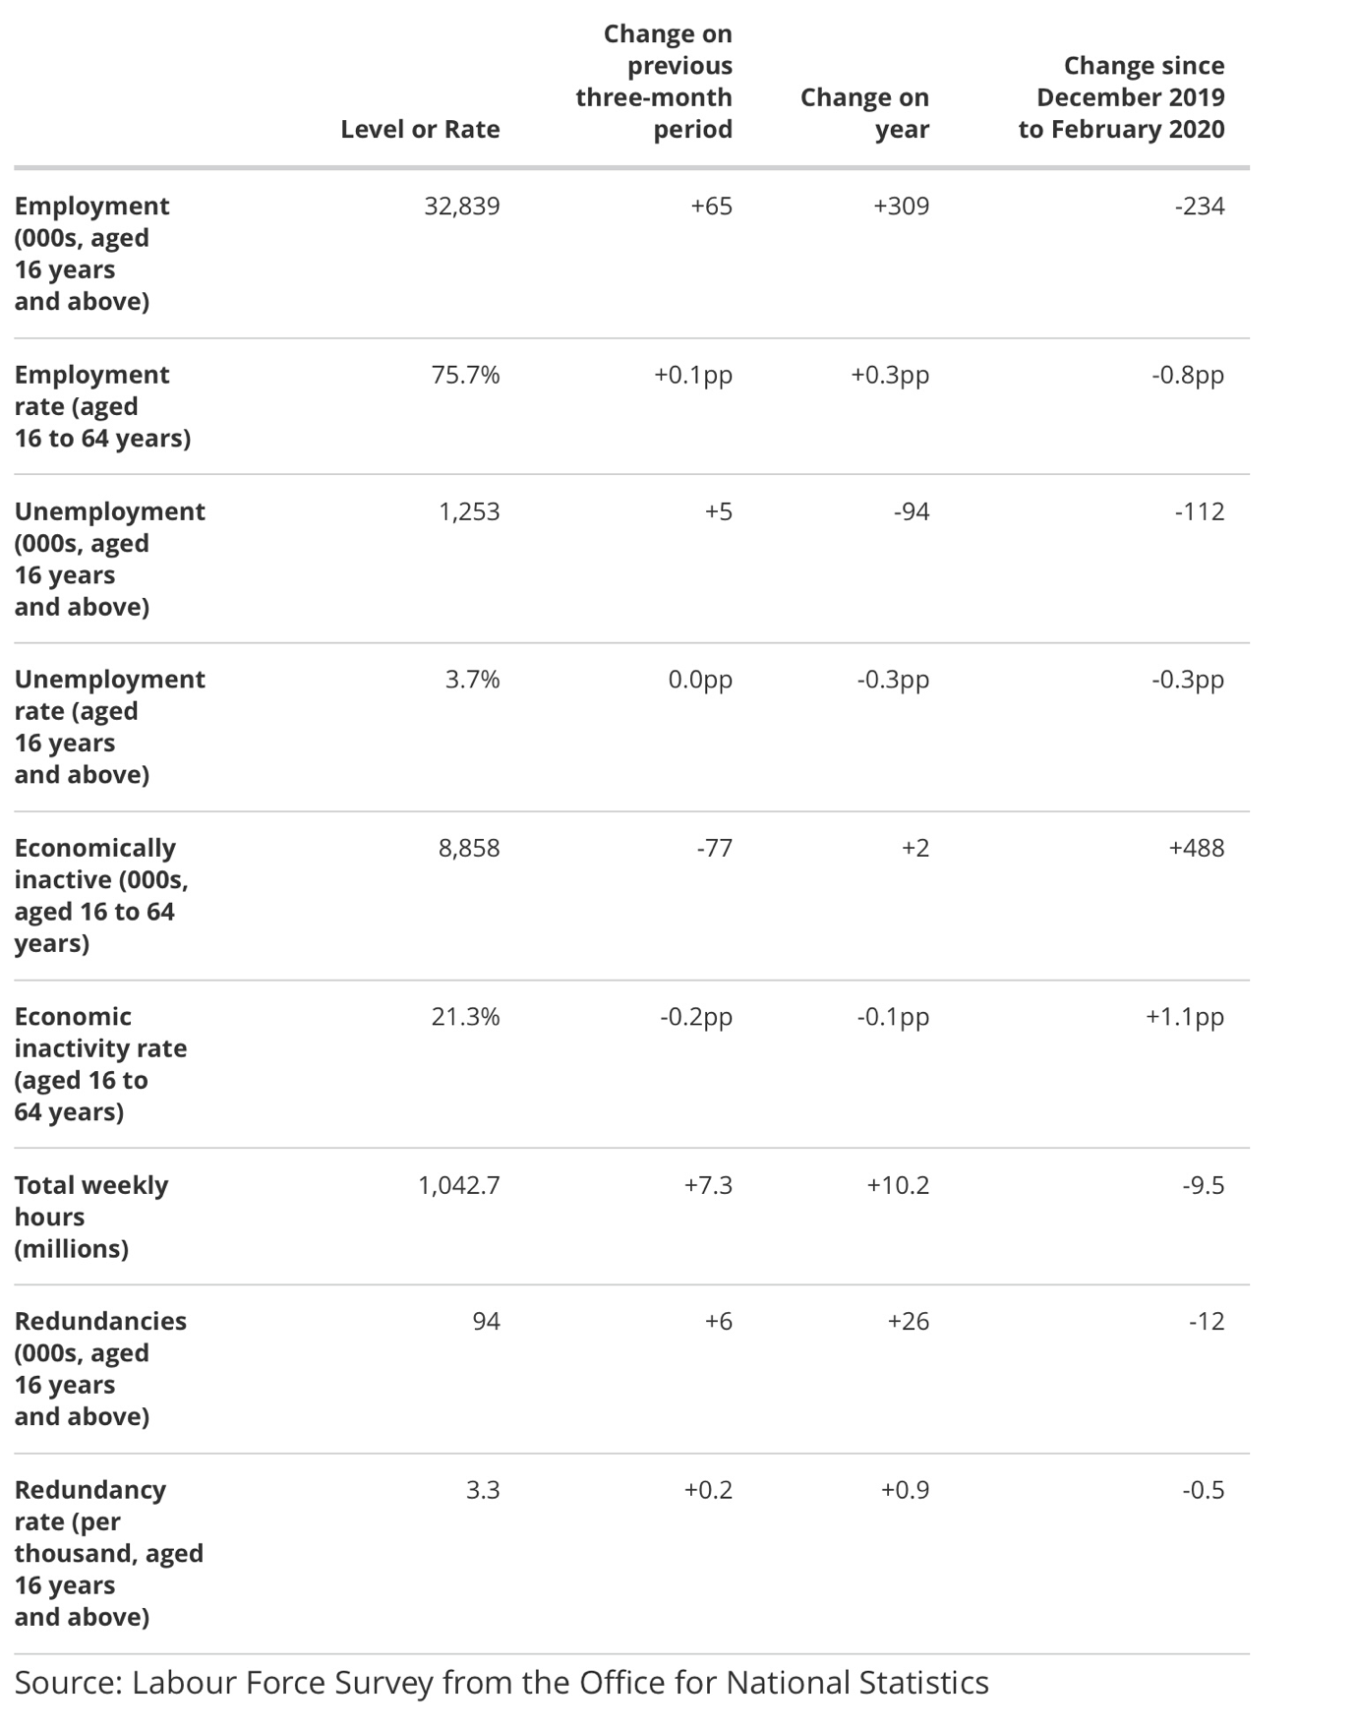
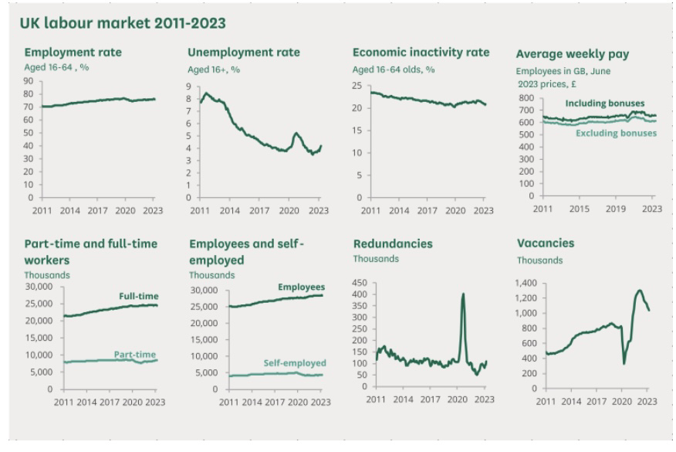
The employment count for those 16 and older reached 32.93 million from April to June 2023, while the employment rate for people in this age range fell slightly from 75.9% to 75.7% from the previous quarter. Even though employment levels showed a quarterly decline of 66,000 and an annual increase of 137,000, they were still 55,000 below pre-pandemic levels seen from January to March 2020. At the same time, the UK saw an unemployment rate of 4.2%, classifying 1.44 million people aged 16 and over as jobless. The unemployment rate increased over the previous quarter and the previous year, exceeding pre-pandemic levels by 63,000. Additionally, 8.69 million people between the ages of 16 and 64 were found to be economically inactive, yielding a 20.9% inactivity rate. Even while levels of inactivity decreased over the course of the year and the quarter, they were still higher than pre-pandemic levels by 247,000. The 108,000 documented redundancies, a 54,000 increase from the year before, were noteworthy. The number of open positions decreased over the course of the year, peaking at 1.02 million from May to July 2023, although this figure still above pre-pandemic levels by 219,000. In the three months before to June 2023, salaries fell in real terms, with a yearly change of -0.6% excluding bonuses and -0.2% including bonuses. However, nominal salaries continued to increase, increasing by 8.2% with bonuses and 7.8% without bonuses. This represents the largest yearly increase in nominal salary, excluding of bonuses, since comparable data were first kept in 2001.

3 Changes in Human Resources strategies post Covid

In December 2019, the World Health Organization received notification of the first coronavirus case (COVID-19), which led to the declaration of a Public Health Emergency of International Concern. The economic picture is now anticipated to be impacted by this global pandemic for some time.The most recent business surveys that are currently available for the UK and real-time indicators indicate a sharp fall in economic activity, while preliminary estimates for other nations show the scope of the effects on the actual economy thus far. The way the coronavirus is handled will also affect how well national statistics institutes (NSIs) can estimate the GDP, inflation, and labor market, as well as the state of the economy as a whole. In order to record the UK's economic activity in accordance with the most recent international guidelines, we are reacting to these problems.The government's response to the coronavirus epidemic and its effects has significantly impacted the UK labor market. While recent government initiatives have allowed for the furloughing of staff, many firms have had to shut down or adjust their working procedures. Additionally, the emergence of social distance has altered how people work or their capacity to hunt for and land a job. The coronavirus (COVID-19) pandemic's effects on the labor market provide significant conceptual measuring difficulties. For instance, more workers are likely to take time off work temporarily due to illness or workplace regulations like furloughing. The levels of employment documented during the pandemic may be significantly impacted by how these brief absences are categorised.Similar to how the introduction of social distance metrics and the modifications in business practices would affect people's capacity to search for and obtain jobs. The ratio of persons classed as economically inactive to those classified as jobless is expected to vary as a result of this. Following the COVID-19 epidemic, the field of human resource management has undergone a seismic change. With the dissolution of geographic boundaries brought about by remote work, businesses are now rethinking the value of having physical offices. The pandemic-accelerated digital revolution has expedited hiring, onboarding, and engagement through online platforms, promoting more effectiveness and accessibility. Organizations are dedicated to putting employee well-being first by emphasizing physical and mental health, encouraging work-life balance, and tackling burnout. Following the COVID-19 epidemic, the field of human resource management has undergone a seismic change. With the dissolution of geographic boundaries brought about by remote work, businesses are now rethinking the value of having physical offices. The pandemic-accelerated digital revolution has expedited hiring, onboarding, and engagement through online platforms, promoting more effectiveness and accessibility. Organizations are committed to putting employee well-being first by emphasizing physical and mental health, encouraging work-life balance, and tackling burnout. Companies are investing in up-skilling and re-skilling programs to give employees the skills they need for changing roles as they recognise the significance of adaptability. Data-driven decision-making has become more popular, helping HR departments forecast labor needs, spot talent shortages, and promote better strategy alignment.

4 Changes in Human Resources strategies post Brexit

As the United Kingdom faces the difficulties of Brexit, companies are using five important recruitment techniques to create a robust and adaptive workforce. Research from the Recruitment and Employment Confederation (REC) projects that the number of EU workers, who currently make up 7% of the workforce, would fall after Brexit, necessitating more staff retention. Due to issues including over-qualification, reluctance, or disability, recruiters and businesses struggle to find UK applicants for low- and medium-skill positions. UK firms are concentrating on engaging the domestic jobseeker market with creative strategies to solve this. While competitive salary is crucial, benefits packages that include flexibility, work-life balance, holiday incentives, fitness programs, and discounts are similarly valued by a third of employees. These extensive incentives not only entice new talent but also encourage loyalty and drive among current workers, boosting retention rates. By promoting cooperation, autonomy, problem-solving, creativity, and trust, a supportive workplace culture also helps to retain employees. Creating such a culture improves employee satisfaction and fosters a good brand perception that attracts fresh talent. Another strategy involves reshaping the approach to attracting EU workers, considering the transitional immigration period following the UK's departure from the European Union. Employers are providing clarity on the EU settlement scheme and workforce rights to in-still confidence in current and potential employees. The Great Repeal Bill, aimed at preserving and enhancing workers' rights post-Brexit, underscores the UK government's commitment to safeguarding and expanding labor protections beyond EU regulations. To draw in EU job seekers, it is crucial to communicate work and career options clearly, with job postings describing practical routes for professional advancement. In order to promote cooperation, combat bigotry, and provide assistance to employees from different backgrounds, an inclusive workplace culture is essential. Employers may successfully engage and keep competent EU workers by addressing these issues. The third option involves increasing the talent pool and employing an agile personnel strategy that is in line with shifting market circumstances. Reevaluating the necessary credentials and competencies enables the UK to make use of untapped talent pools. The skill pool may be further expanded by reevaluating recruitment procedures, such as refraining from using language that turns off female candidates or adopting other interview methods. Beyond gender, ethnic and generational variety are also pursued in the name of diversity. The workforce is enriched and corporate performance is improved by appreciating the worth of seasoned workers and those without a formal education. Re-onboarding and re-induction initiatives support workers returning after maternity, paternity, or caregiving absences, and flexible work schedules meet a range of demands, enhancing employee health and engagement. The fourth tactic focuses on recruiting young UK employees, particularly in fields where there is a dearth of skilled labor. Apprenticeships provide a solution by offering relevant skills and a range of employment options. Businesses may develop a trained and diverse workforce while addressing young graduates' job discontent by offering apprenticeships as a route to important skill acquisition without incurring student loan debt. Collaborations between corporations and academic institutions are essential for luring new talent to fields like engineering. The importance of industry leaders in promoting involvement and transformation is emphasised by this method. The final plan emphasise the value of alliances, knowledge, and foreign employment agencies. Sectoral cooperation, aided by trade associations, enables enterprises to highlight prospects and success tales, showcasing the possibility of development beginning with low-skill roles. By collaborating with nearby academic institutions, businesses may demonstrate kids the several professional paths they can choose. Whatever the result of Brexit, international-focused recruiting services are essential in enabling businesses to easily connect with talent across the UK, Europe, and the worldwide market. Cross-border services are made possible by the incorporation of recruiting agencies in several European nations, ensuring that firms have access to a large pool of potential applicants.

5 conclusion

In conclusion, the labour market, a key component of any economy, is always changing as a result of things like the state of the economy, technological improvements, and world events. The analysis of the UK labour market from 2018 to the present shows how closely employment, unemployment, and economic activity are related. Unprecedented difficulties brought on by the COVID-19 epidemic necessitated significant changes in human resources strategy. The labour market has changed since the epidemic, with remote work becoming more popular and employee wellbeing receiving more attention. Digital platforms have been utilised by businesses for hiring and onboarding, with an emphasis on up-skilling, data-driven decision-making, and fostering a healthy work-life balance. These changes, which affected how firms approach people management, were accelerated by the epidemic.
In addition, the labour market has become more complicated as a result of the UK's withdrawal from the European Union. Companies are adjusting by improving recruiting strategies, emphasising employee retention, offering a variety of benefits packages, and fostering inclusive work cultures. To fill skill shortages, strategies that appeal to both domestic and foreign job seekers are being used, along with collaborations with educational institutions. The capacity to negotiate the constantly shifting labour market is essential for businesses, politicians, and people alike in a period of rapid change. The strategic adaptability, data-driven insights, and forward-looking approaches covered here are vital tools for navigating the labour market's complex interaction of economic forces, technology advancement, and societal change.

References

- House of Commons Library. (2023, August 15). Title of the research briefing. Commons Library Research Briefing. Retrieved from https://commonslibrary.parliament.uk/research-briefings/cbp-9366/ (17 August 2023)

- Office for National Statistics. (2018). UK Labour Market: December 2018. Employment and Labour Market People in Work Bulletin. (p.2) https://www.ons.gov.uk/employmentandlabourmarket/peopleinwork/employmentandemployeetypes/bulletins/uklabourmarket/december2018/pdf (8 August 2023)

- Office for National Statistics. (2019). UK Labour Market: November 2019 (p. 2). Employment and Labour Market People in Work Bulletin. https://www.ons.gov.uk/employmentandlabourmarket/peopleinwork/employmentandemployeetypes/bulletins/uklabourmarket/november2019/pdf ( 8 August 2023)

- Office for National Statistics. (2020). UK Labour Market: September 2020 (pp. 2-3). Employment and Labour Market People in Work Bulletin. https://www.ons.gov.uk/employmentandlabourmarket/peopleinwork/employmentandemployeetypes/bulletins/uklabourmarket/september2020/pdf (9 August 2023)

- Office for National Statistics. (2021). UK Labour Market: December 2021 (p. 2). Employment and Labour Market People in Work Bulletin. https://www.ons.gov.uk/employmentandlabourmarket/peopleinwork/employmentandemployeetypes/bulletins/uklabourmarket/december2021/pdf ( 12 August 2023)

- Office for National Statistics. (2022). UK Labour Market: December 2022 (p. 2). Employment and Labour Market People in Work Bulletin. https://www.ons.gov.uk/employmentandlabourmarket/peopleinwork/employmentandemployeetypes/bulletins/uklabourmarket/december2022/pdf ( 14 August 2023)

- Office for National Statistics. (2023). UK Labour Market: August 2023. Employment and Labour Market People in Work Bulletin. https://www.ons.gov.uk/employmentandlabourmarket/peopleinwork/employmentandemployeetypes/bulletins/uklabourmarket/august2023/pdf ( 16 August 2023)

- Office for National Statistics. (2020, May 6). Coronavirus and the Effects on UK Labour Market Statistics. Employment and Labour Market People in Work Articles. Retrieved from https://www.ons.gov.uk/employmentandlabourmarket/peopleinwork/employmentandemployeetypes/articles/coronavirusandtheeffectsonuklabourmarketstatistics/2020-05-06 (18 August 2023)

- Spisak, A., & Isoukalis, C. (2023, February 3). Three Years of Brexit Casts Long Shadow Over UK Economy. Tony Blair Institute for Global Change. https://www.institute.global/insights/geopolitics-and-security/three-years-brexit-casts-long-shadow-over-uk-economy (18 August 2023)

