Pandemic- design and wireframe
By
Evgeni Manov
(2314194)

Table of Contents
1. Introduction 4
1.1 Background 4
1.2 Aim of the Project 4
1.3 Importance of Usability 5
1.4 Scope of the Project 5
1.5 Structure of the Report 6
2. Personas and User Experience Requirements 6
2.1 Introduction 6
2.2 Persona 1 – Emily Carter 6
2.3 Persona 2 – Ahmed Hassan 7
2.4 Persona 3 – Sarah Williams 8
2.5 Persona 4 – Daniel Morgan 9
3. User Research and Requirements Gathering 10
3.1 Research Approach 10
3.2 Questionnaire Findings 10
3.3 Interview Findings 11
3.4 Focus Group Findings 11
3.5 MoSCoW Requirements Analysis 12
3.6 Summary 13
4. Designing for Usability 13
4.1 Introduction 13
4.2 Visibility of System Status 14
4.3 Consistency and Learnability 14
4.4 User Control and Error Prevention 15
4.5 Accessibility Considerations 15
4.6 Fitts' Law and Mobile Interaction 16
4.7 Cognitive Load Management 16
4.8 Summary 17
5. Storyboards and Interface Design 17
5.1 Introduction 17
5.2 Main Menu Screen 18
(Figure 1. Main Menu Wireframe) 18
5.3 Role Selection Screen 19
(Figure 2. Role Selection Wireframe) 19
5.4 World Map Screen 20
(Figure 3. World Map Interface) 20
5.5 Research Centre Screen 21
(Figure 4. Research Centre Interface) 21
5.6 Outbreak Alert Screen 22
(Figure 5. Outbreak Alert Screen) 22
5.7 Game Results Screen 22
(Figure 6a. Game Results Interface-Victory) 23
(Figure 6b Game Results Interface- Defeat) 24
5.8 Navigation Flow 24
(Figure 7 Navigation Flow Diagram) 25
5.9 Summary 26
6. Prototype Testing, User Feedback and Peer Evaluation 26
6.1 Introduction 26
6.2 Testing Procedure 27
6.3 User Feedback 27
6.4 Identified Issues 28
6.5 Peer Evaluation 28
6.6 Recommended Improvements 28
6.7 Summary 29
7. Conclusion 29
8.References (IEEE Format) 30
Appendix 31
Appendix A – Sample Questionnaire 31
Appendix B – Interview Questions 33
Appendix C – Focus Group Discussion Guide 33
Appendix D – Full MoSCoW Analysis 34

1. Introduction

1.1 Background
Pandemic is one of the most successful cooperative board games ever created. Unlike traditional competitive games, Pandemic requires players to work together to prevent the spread of infectious diseases across the world. Players assume specialised roles and collaborate to treat diseases, establish research facilities and discover cures before global outbreaks reach catastrophic levels.
The popularity of mobile gaming has created opportunities to adapt traditional board games into digital formats. Mobile platforms offer convenience, accessibility and connectivity, allowing players to engage in cooperative experiences regardless of location. However, successful digital adaptation requires careful consideration of usability and user experience principles to ensure that gameplay remains engaging and accessible.
This project proposes a mobile adaptation of Pandemic designed specifically through the application of usability engineering principles. The prototype preserves the core mechanics of the original board game while introducing interface features optimised for touchscreen devices and modern mobile users.

1.2 Aim of the Project
The aim of this project is to design and evaluate a mobile version of Pandemic that supports effective cooperation, strategic decision-making and accessibility.
The specific objectives of the project are:
- To identify the requirements of potential users.
- To develop personas representing different user groups.
- To design a low-fidelity mobile prototype.
- To apply recognised usability engineering principles.
- To evaluate the prototype through user feedback and peer review.
- To identify improvements for future development.

1.3 Importance of Usability
Usability plays a critical role in the success of digital games. Pandemic requires players to monitor multiple information sources simultaneously, including outbreaks, player positions, resources and cure progress. Poor interface design can increase cognitive load, reduce situational awareness and negatively affect player performance.
According to [4], usability can be evaluated through five key characteristics:
- Learnability
- Efficiency
- Memorability
- Error Prevention
- User Satisfaction
These characteristics provide a framework for designing interfaces that support both novice and experienced players.

1.4 Scope of the Project
The scope of this project focuses on the design and evaluation of a low-fidelity mobile prototype rather than a fully functional software implementation.
The prototype includes:
Four-player cooperative gameplay.
Specialist player roles.
Global outbreak management.
Cure discovery mechanics.
Accessibility features.
Mobile-oriented interface design.
Features such as virtual reality support, artificial intelligence teammates and console versions were intentionally excluded because they fall outside the scope of the project.

1.5 Structure of the Report
This report is organised into seven main sections.
Section 2 introduces the personas and user experience requirements identified during the research process.
Section 3 describes the methods used to gather user requirements and presents the results of questionnaires, interviews and focus groups.
Section 4 discusses the usability engineering principles that informed the design process.
Section 5 presents the storyboard designs and explains the interface structure.
Section 6 evaluates the prototype through user feedback and peer review.
Finally, Section 7 summarises the findings and outlines recommendations for future development.

2. Personas and User Experience Requirements

2.1 Introduction
One of the most important stages of user-centred design is understanding the characteristics, expectations, goals and limitations of the intended users. According to [5], personas provide designers with realistic representations of target users and help ensure that design decisions remain focused on user needs rather than assumptions.
For the Pandemic Mobile Edition prototype, four personas were developed based on the results obtained during the user research phase. Each persona represents a different type of user who may interact with the system. The personas vary in terms of age, professional background, gaming experience, technical skills and accessibility requirements.
The purpose of these personas is to ensure that the prototype supports a diverse user population while remaining accessible, intuitive and engaging.

2.2 Persona 1 – Emily Carter
Personal Profile
Attribute | Description
Name | Emily Carter
Age | 24
Occupation | Medical Student
Education | Final Year Medicine Student
Gaming Experience | Intermediate
Technical Skills | High

Goals
Emily's primary goals when playing Pandemic include:
Monitoring disease outbreaks effectively.
Coordinating actions with teammates.
Making informed strategic decisions.
Preventing global outbreaks.
Discovering cures as efficiently as possible.
She values interfaces that present information clearly and support rapid decision-making.

User Experience Requirements
To achieve a positive user experience, Emily requires:
Real-time outbreak information.
Clear status indicators.
Efficient communication tools.
Rapid access to player abilities.
Minimal interface clutter.

2.3 Persona 2 – Ahmed Hassan
Personal Profile
Attribute | Description
Name | Ahmed Hassan
Age | 42
Occupation | Biomedical Researcher
Gaming Experience | Low
Technical Skills | High

Goals
Ahmed wishes to:
Understand the game quickly.
Learn role responsibilities efficiently.
Contribute meaningfully to the team.
Discover cures using research mechanics.
Improve his understanding of Pandemic's strategic systems.

User Experience Requirements
Ahmed requires:
Interactive tutorials.
Context-sensitive help.
Clear instructions.
Consistent navigation.
Role explanations.

2.4 Persona 3 – Sarah Williams
Personal Profile
Attribute | Description
Name | Sarah Williams
Age | 21
Occupation | Chemistry Student
Gaming Experience | Moderate
Accessibility Requirement | Colour Blindness

Goals
Sarah wants to:
Participate equally in gameplay.
Understand infection information easily.
Avoid accessibility barriers.
Enjoy the game without requiring assistance.

User Experience Requirements
Sarah requires:
Colour-blind mode.
High contrast settings.
Adjustable font sizes.
Alternative visual indicators.
Clearly labelled icons.

2.5 Persona 4 – Daniel Morgan
Personal Profile
Attribute | Description
Name | Daniel Morgan
Age | 26
Occupation | Data Science Graduate
Gaming Experience | Advanced
Technical Skills | Very High

Goals
Daniel wishes to:
Optimise team performance.
Predict future outbreaks.
Analyse disease trends.
Access detailed gameplay information.
Develop sophisticated strategies.

User Experience Requirements
Daniel requires:
Detailed analytics.
Efficient navigation.
Advanced statistics.
Real-time updates.
Comprehensive game information.

3. User Research and Requirements Gathering

3.1 Research Approach
A user-centred design approach was adopted to ensure that the Pandemic Mobile Edition prototype addressed the needs of potential users. User-centred design emphasises understanding user goals, behaviours, and expectations before making design decisions [3]. To gather requirements, three complementary methods were used:
Online questionnaires
Semi-structured interviews
Focus group discussions
Using multiple methods helped provide both quantitative and qualitative insights into user needs and gameplay preferences.

3.2 Questionnaire Findings
A questionnaire was designed to investigate gaming habits, accessibility requirements, and expectations regarding cooperative strategy games. Twenty participants completed the questionnaire.
The results showed that mobile gaming is highly popular among participants, with most respondents playing mobile games at least once per week. Furthermore, 80% of respondents reported previous experience with cooperative games, suggesting that teamwork-oriented gameplay would be familiar to the majority of users.
Participants were also asked which features they considered most important in a cooperative strategy game. Teamwork, communication, and strategic decision-making were consistently ranked as the highest priorities. In contrast, competitive features and cosmetic customisation were considered less important.
Accessibility emerged as another significant theme. Seventy-five percent of respondents indicated that accessibility options were either important or very important. Features such as adjustable text size, colour-blind support, and high-contrast themes were repeatedly mentioned.
The questionnaire findings suggested that the Pandemic prototype should prioritise communication, accessibility, and strategic gameplay over purely aesthetic features.

3.3 Interview Findings
Five semi-structured interviews were conducted to gain deeper insight into user expectations and frustrations.
Several participants highlighted the importance of clear tutorials and onboarding experiences. Users explained that strategy games often contain complex mechanics that can discourage new players if insufficient guidance is provided.
Communication was another recurring theme. Participants emphasised that cooperative games are most enjoyable when players can coordinate actions efficiently. As a result, communication tools were identified as a critical requirement.
Participants also expressed concerns regarding information overload. Pandemic requires users to monitor outbreaks, player locations, resources, and cure progress simultaneously. Interviewees suggested that information should be presented clearly and progressively to avoid overwhelming players.
These findings reinforced the need for intuitive navigation and effective information management.

3.4 Focus Group Findings
A focus group involving four participants was conducted to discuss initial design concepts and gameplay ideas.
Participants responded positively to the inclusion of specialist roles such as Doctor, Microbiologist, Chemist, and Data Analyst. They believed that role differentiation would encourage teamwork and increase player engagement.
The group also strongly supported the use of a global outbreak map. Participants felt that maintaining a worldwide perspective remained faithful to the original Pandemic board game and enhanced immersion.
However, concerns were raised regarding excessive notifications. Participants suggested that outbreak warnings should be prioritised and grouped where possible to reduce distraction.
The focus group findings confirmed that accessibility, communication, and strategic gameplay should remain central to the design.

3.5 MoSCoW Requirements Analysis
The MoSCoW framework was used to prioritise requirements according to their importance [8].
Must Have
The following requirements were considered essential:
Four-player cooperative gameplay
Global outbreak map
Specialist player roles
Disease outbreak system
Cure discovery mechanics
Accessibility settings
Interactive tutorial
Team communication features
Without these features, the application would fail to deliver the core Pandemic experience.
Should Have
These requirements would significantly improve usability:
Adjustable font sizes
Colour-blind mode
Statistics dashboard
Notification management
Role information screens
Could Have
These features provide additional value but are not critical:
Achievement system
Avatar customisation
Sound personalisation
Global leaderboards
Won't Have
The following features were excluded from the project scope:
Virtual reality support
AI-controlled teammates
Console versions
Competitive PvP gameplay
The MoSCoW analysis helped focus development on the features most closely aligned with user needs and project objectives.

3.6 Summary
The research phase successfully identified the requirements of potential users and informed the development of the personas and prototype. Communication, accessibility, and strategic gameplay emerged as the most important themes. These findings provided the foundation for the usability-focused design decisions discussed in the next section.

4. Designing for Usability

4.1 Introduction
Usability is a critical factor in the success of any interactive system. According to ISO 9241-11, usability refers to the effectiveness, efficiency, and satisfaction with which users achieve specific goals within a particular context of use [9]. In the case of Pandemic Mobile Edition, usability is especially important because players must continuously process information, collaborate with teammates, and make strategic decisions under pressure.
The design of the prototype was therefore guided by established Human-Computer Interaction (HCI) principles and usability frameworks. These included Nielsen's Usability Heuristics [4], Norman's Design Principles [2], WCAG 2.2 accessibility recommendations [7], and Fitts' Law [11].
The primary objective was to create an interface that is easy to learn, efficient to use, and accessible to a diverse range of users.

4.2 Visibility of System Status
One of Nielsen's most important usability principles is visibility of system status [4]. Users should always understand what is happening within the system and receive feedback regarding their actions.
In Pandemic, players constantly monitor infection levels, outbreaks, cure progress, and player turns. To support situational awareness, the prototype includes a persistent information panel displayed at the top of the World Map screen.
This panel provides information regarding:
Current infection rate
Number of outbreaks
Cure progress
Active player turn
Providing this information at all times reduces uncertainty and allows players to make informed decisions quickly.

4.3 Consistency and Learnability
Consistency reduces the amount of learning required when interacting with a system [10]. Users can transfer knowledge from one screen to another if layouts and controls remain predictable.
The Pandemic prototype maintains consistency through:
Standard button placement
Repeated navigation structures
Consistent terminology
Uniform icon design
For example, action buttons such as "Move", "Treat Disease", and "Research" always appear in the same location throughout gameplay.
This consistency supports learnability and helps novice users become familiar with the interface more quickly.

4.4 User Control and Error Prevention
Players should feel in control of their actions and be able to recover from mistakes when possible [4].
To support user control, the prototype includes:
Confirmation dialogs before ending turns
Cancel options during actions
Clear action descriptions
Feedback after completed actions
Error prevention is also important because incorrect decisions can have significant consequences during gameplay. To minimise mistakes, the system highlights valid actions and provides warnings when cities are approaching outbreak conditions.
These features reduce frustration and improve confidence.

4.5 Accessibility Considerations
Accessibility was identified as one of the most important requirements during the research phase. Consequently, accessibility considerations were integrated throughout the design process.
The prototype incorporates several accessibility features:
Visual Accessibility
Colour-blind mode
High contrast themes
Adjustable text sizes
Clear visual indicators
Disease types are identified using both colours and symbols to ensure that users with colour vision deficiencies can interpret information accurately.
Cognitive Accessibility
The interface uses:
Simple language
Consistent layouts
Clear instructions
Progressive disclosure of information
These features reduce cognitive workload and support users with varying levels of experience.
Motor Accessibility
The mobile interface includes large touch targets and generous spacing between controls, reducing the precision required for interaction.

4.6 Fitts' Law and Mobile Interaction
Fitts' Law suggests that larger targets can be selected more quickly and accurately than smaller ones [11]. This principle is particularly relevant for touchscreen devices.
To improve interaction efficiency, frequently used actions such as movement and disease treatment are displayed as large buttons located at the bottom of the screen. This placement allows users to access important controls easily using one hand.
Applying Fitts' Law reduces interaction errors and improves overall usability.

4.7 Cognitive Load Management
Pandemic requires players to manage multiple information sources simultaneously, including disease outbreaks, cure progress, player locations, and resource availability.
According to Cognitive Load Theory, excessive information can overwhelm users and reduce performance [12]. To address this issue, the prototype uses several strategies:
Information grouping
Clear visual hierarchy
Progressive disclosure
Minimalist screen layouts
Important information is prioritised while less critical details remain accessible through secondary menus. This approach helps users focus on strategic decision-making without becoming overwhelmed.

4.8 Summary
The Pandemic Mobile Edition prototype was designed using established usability engineering principles and accessibility guidelines. Visibility of system status, consistency, user control, error prevention, accessibility, and cognitive load management all influenced design decisions.
By applying these principles, the prototype aims to provide an experience that is easy to learn, efficient to use, and accessible to a diverse range of players. These usability considerations directly informed the storyboard and interface designs presented in the next section.

5. Storyboards and Interface Design

5.1 Introduction
Storyboards are an important part of the user-centred design process because they provide a visual representation of how users interact with a system. They allow designers to evaluate navigation structures, identify potential usability issues, and ensure that user requirements are reflected in the interface before development begins [13].
For the Pandemic Mobile Edition prototype, a low-fidelity storyboard approach was selected. Low-fidelity prototypes focus on functionality, information architecture, and user interaction rather than visual appearance [14]. This approach is particularly useful during the early stages of design because changes can be made quickly and with minimal cost.
The storyboard consists of six primary screens that support the core gameplay loop:
- Main Menu
- Role Selection Screen
- World Map Screen
- Research Centre Screen
- Outbreak Alert Screen
- Game Results Screen
Together, these screens represent the complete user journey from starting a game to achieving victory or defeat.

5.2 Main Menu Screen
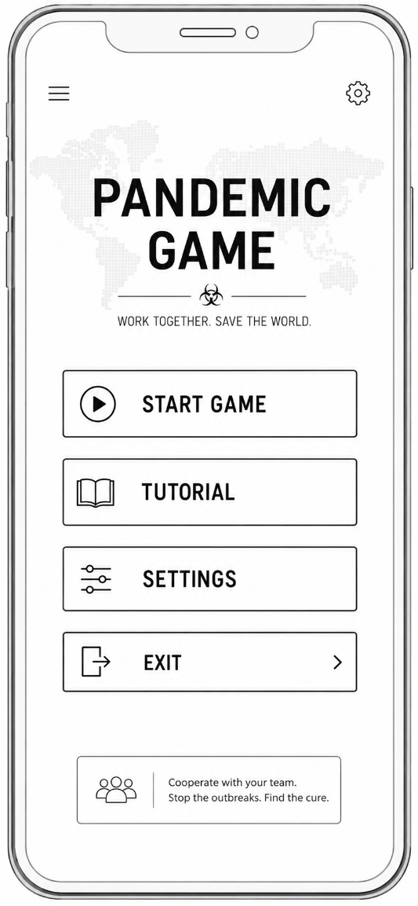

(Figure 1. Main Menu Wireframe)
Figure 1 illustrates the main entry point of the application. The screen provides access to the core functions of the system while maintaining a simple and uncluttered layout.
The Main Menu serves as the entry point to the application. Its primary purpose is to provide access to the most important functions while maintaining a simple and uncluttered layout.

5.3 Role Selection Screen
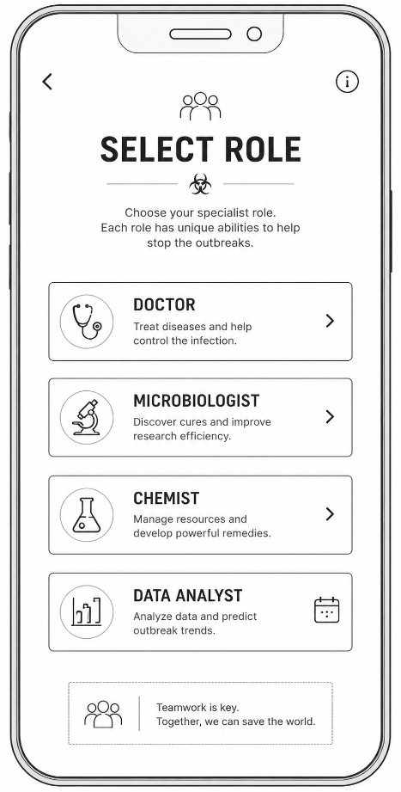

(Figure 2. Role Selection Wireframe)
Figure 2 demonstrates the role selection process where players choose between four specialist roles. Brief descriptions are provided to support learnability and reduce user confusion.

5.4 World Map Screen
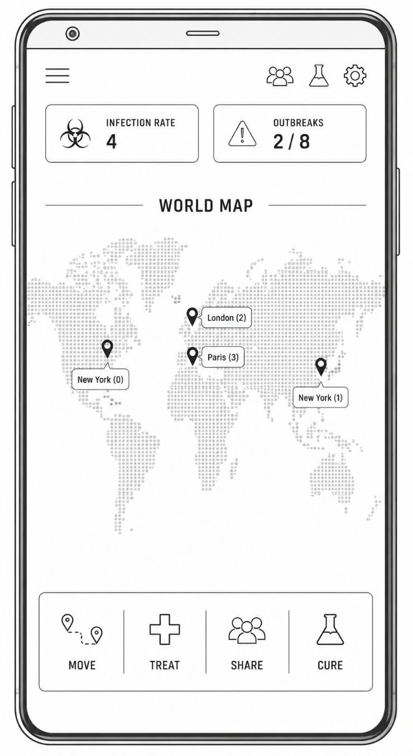

(Figure 3. World Map Interface)

Figure 3 presents the primary gameplay screen. Players can monitor outbreaks, infection levels and cure progress while accessing the most frequently used actions.

5.5 Research Centre Screen
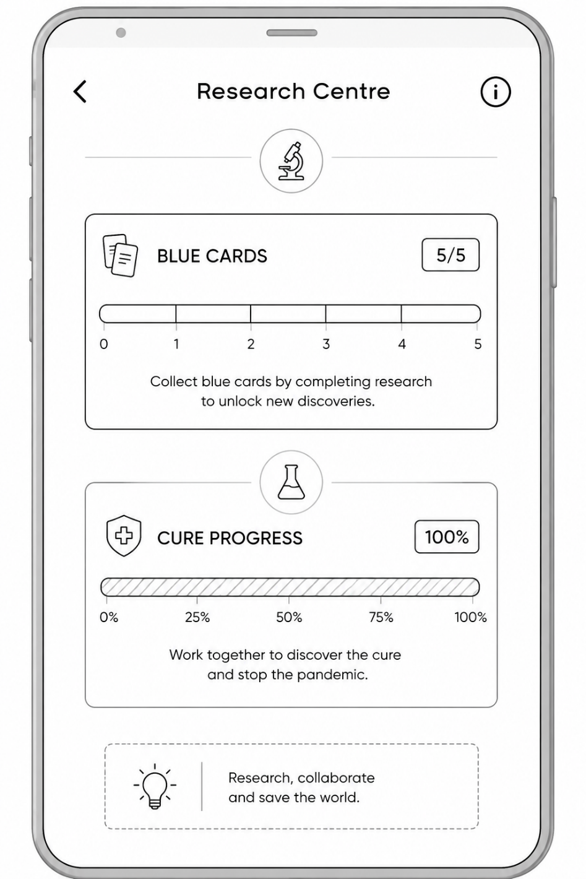

(Figure 4. Research Centre Interface)
Figure 4 illustrates the cure discovery screen. Progress indicators provide clear feedback regarding research activities and cure development.

5.6 Outbreak Alert Screen
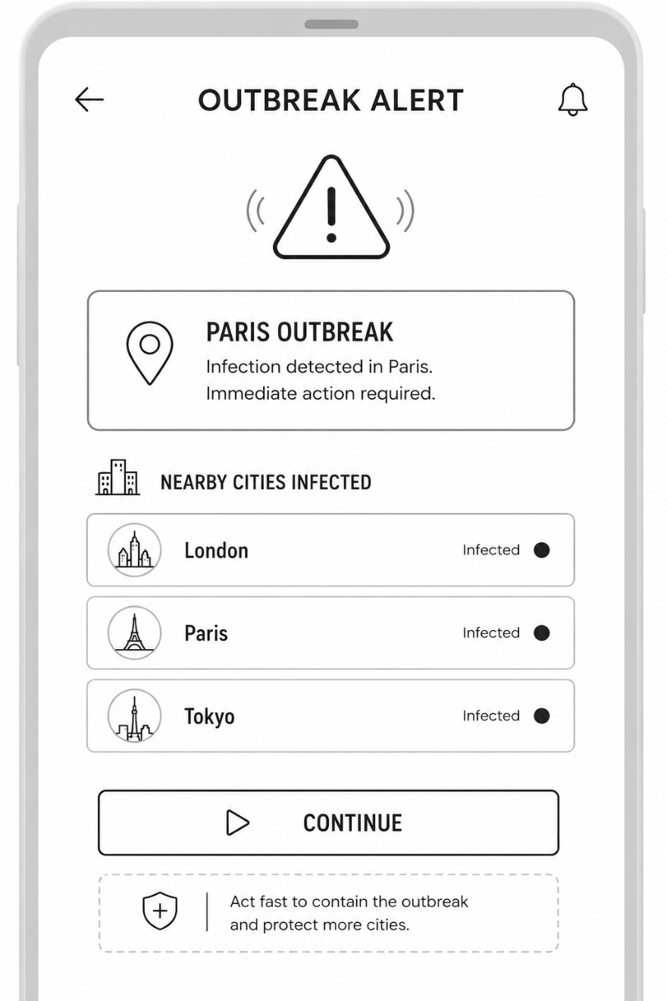

(Figure 5. Outbreak Alert Screen)

Figure 5 shows the outbreak notification interface used to communicate critical events and maintain visibility of system status.

5.7 Game Results Screen
The Game Results Screen provides closure at the end of a gameplay session.
Two possible outcomes are displayed:
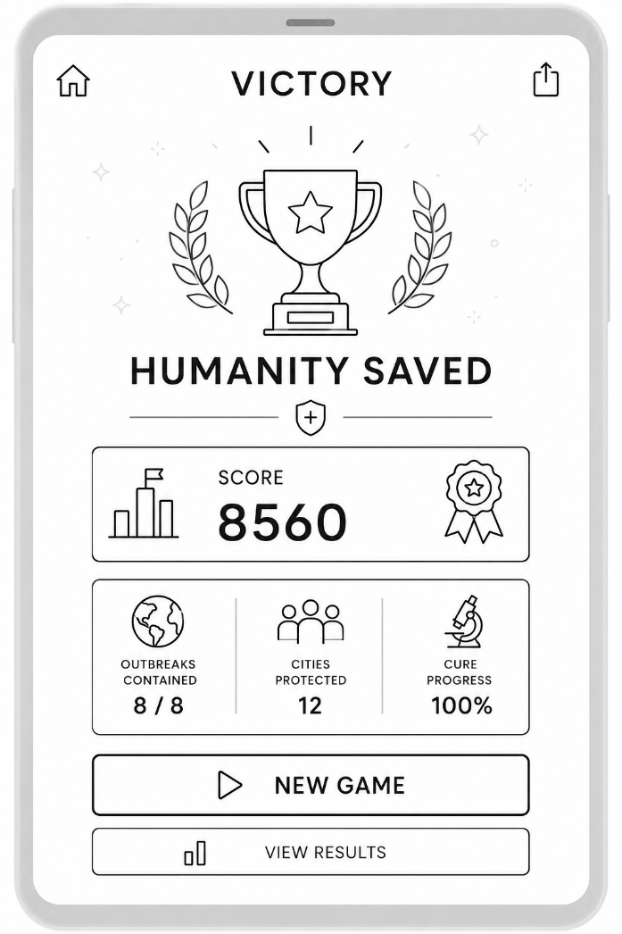

(Figure 6a. Game Results Interface-Victory)
Victory
Players successfully discover all cures and prevent global collapse.
The screen displays:
Final score
Number of outbreaks prevented
Cures discovered
Team performance statistics
Defeat
The game ends when outbreak limits are exceeded or other failure conditions are triggered.
The defeat screen explains the reason for failure and encourages users to try again.
Providing performance statistics supports learning and helps players improve future strategies.
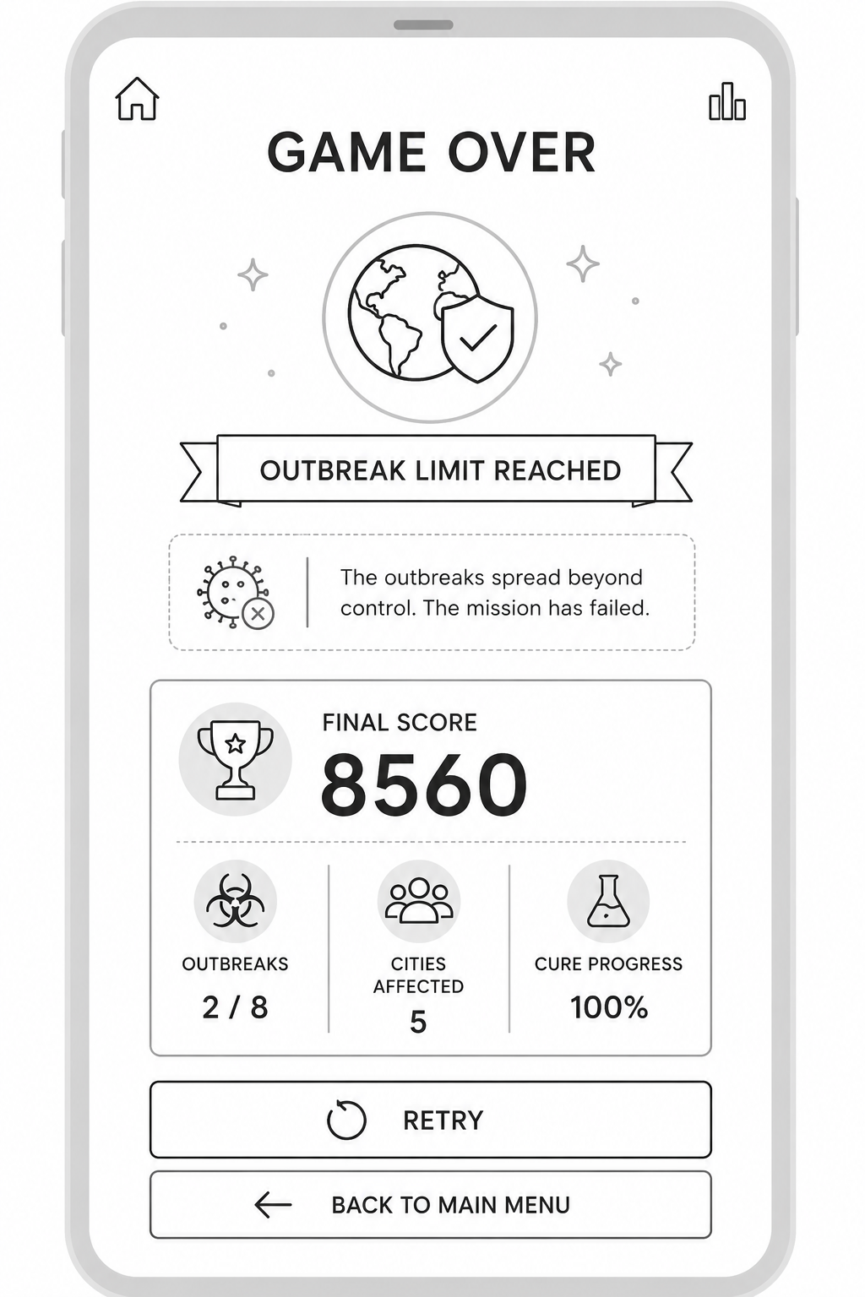

(Figure 6b Game Results Interface- Defeat)

5.8 Navigation Flow
The storyboard follows a straightforward navigation structure.
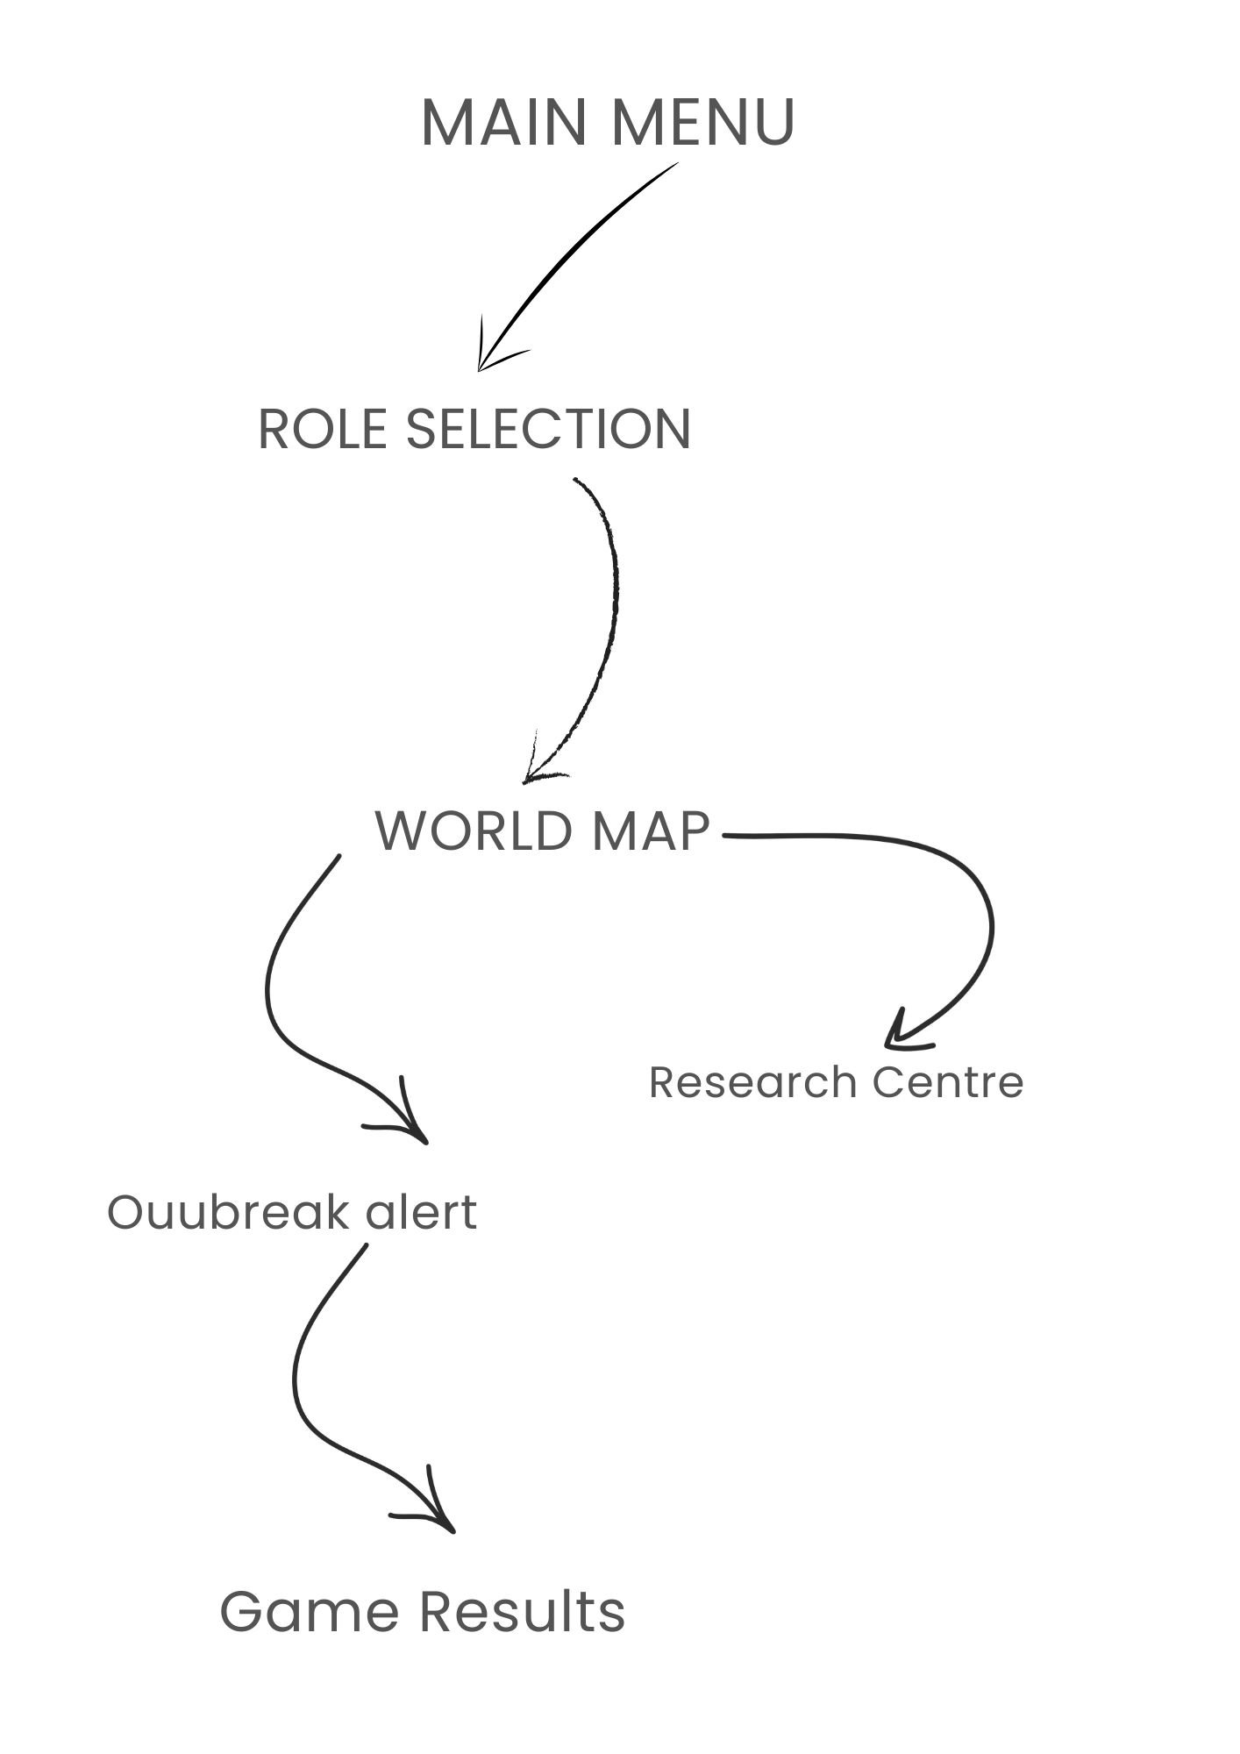

(Figure 7 Navigation Flow Diagram)

Figure 7 illustrates the primary navigation path through the Pandemic Mobile Edition prototype. The diagram demonstrates how users progress between major screens during gameplay.

This linear structure was selected because it reduces complexity and supports novice users.
Consistent navigation patterns also improve usability by reducing the amount of learning required when moving between screens.

5.9 Summary
The storyboard translates the user requirements identified during research into a practical mobile interface. Each screen supports specific gameplay objectives while applying established usability principles.
The resulting design provides:
Clear navigation
Accessible interaction
Effective information management
Support for cooperative gameplay
Reduced cognitive load
The storyboard therefore provides a strong foundation for future high-fidelity prototype development and implementation.

6. Prototype Testing, User Feedback and Peer Evaluation

6.1 Introduction
Prototype testing is an essential component of the usability engineering process because it allows designers to evaluate how effectively users can interact with a proposed system before full development begins. According to Nielsen [4], usability testing helps identify problems that may not be apparent during the design phase and provides valuable feedback for future improvements.
Following the completion of the storyboard prototype, an evaluation exercise was conducted to assess the usability, accessibility, and overall user experience of the Pandemic Mobile Edition design.
The evaluation focused on four key areas:
Learnability
Efficiency
Accessibility
User Satisfaction

6.2 Testing Procedure
A small group of eight participants representing different user types was asked to review the prototype and complete a series of common gameplay tasks.
Participants were required to:
- Start a new game.
- Select a specialist role.
- Locate a city experiencing infection.
- Treat a disease.
- Access the Research Centre.
- Respond to an outbreak alert.
- Complete a game session.
These tasks were selected because they represent the primary activities that users would perform during normal gameplay.

6.3 User Feedback
Overall feedback was positive, with most participants reporting that the interface was easy to understand and navigate.
Users particularly appreciated:
- The clear navigation structure.
- The visibility of important information.
- The role-based gameplay system.
- The accessibility options.

6.4 Identified Issues
Despite the generally positive feedback, several usability issues were identified.
Tutorial Complexity
Some participants felt that the cure discovery process was difficult to understand during their first interaction with the prototype.
As a result, additional tutorial content and contextual guidance were recommended.
Notification Overload
Several users reported that multiple outbreak warnings could become overwhelming when displayed simultaneously.
Participants suggested grouping notifications and prioritising the most critical alerts.

6.5 Peer Evaluation
Peer evaluation was conducted to assess the design from a usability perspective.
The reviewers agreed that the design successfully applied established usability principles. In particular, the accessibility features and consistent layout structure were identified as strengths.
However, reviewers recommended improving the visual presentation of outbreak alerts and adding more interactive tutorial elements for first-time users.

6.6 Recommended Improvements
Based on the findings from both user testing and peer evaluation, several improvements were proposed:
Introduce a more interactive tutorial system.
Improve outbreak visualisation through animation and stronger visual cues.
Implement notification filtering and grouping.
Expand accessibility options.
Provide additional role guidance for novice players.
These improvements would further enhance usability and improve the overall player experience.

6.7 Summary
The prototype evaluation demonstrated that the Pandemic Mobile Edition design effectively supports cooperative gameplay, accessibility, and strategic decision-making. Although several improvements were identified, the overall feedback suggests that the prototype provides a strong foundation for future development.
The evaluation also confirmed the value of applying usability engineering principles throughout the design process, as many of the positive findings directly related to decisions informed by user research and established HCI guidelines.

7. Conclusion
This report presented the design and evaluation of a mobile adaptation of the cooperative strategy game Pandemic. The project adopted a user-centred design approach to ensure that user needs remained central throughout the development process.
Four personas were created to represent a diverse range of users, including individuals with different levels of gaming experience and accessibility requirements. User research activities, including questionnaires, interviews, and focus groups, identified the importance of communication, accessibility, and strategic gameplay. These findings informed the development of functional and usability requirements, which were prioritised using the MoSCoW framework.
The prototype design was guided by established usability principles, including Nielsen's heuristics, Norman's design principles, WCAG accessibility guidelines, and Cognitive Load Theory. These principles influenced the design of the storyboard screens and helped ensure that the interface remained intuitive, accessible, and efficient.
Prototype testing and peer evaluation demonstrated that the design successfully supports cooperative gameplay while providing a positive user experience. Although improvements were identified, particularly in relation to tutorials and notification management, the overall findings were encouraging.
In conclusion, the Pandemic Mobile Edition prototype demonstrates how usability engineering principles can be applied to create an accessible and engaging mobile gaming experience. The design provides a strong foundation for future development and higher-fidelity prototyping.

8.References (IEEE Format)
[1] Y. Rogers, H. Sharp and J. Preece, Interaction Design: Beyond Human-Computer Interaction, 5th ed. Hoboken, NJ, USA: Wiley, 2019.
[2] D. Norman, The Design of Everyday Things, Revised and Expanded Edition. New York, NY, USA: Basic Books, 2013.
[3] ISO 9241-210:2019, Ergonomics of Human-System Interaction – Part 210: Human-Centred Design for Interactive Systems. Geneva, Switzerland: International Organization for Standardization, 2019.
[4] J. Nielsen, Usability Engineering. San Francisco, CA, USA: Morgan Kaufmann, 1994.
[5] A. Cooper, R. Reimann, D. Cronin and C. Noessel, About Face: The Essentials of Interaction Design, 4th ed. Indianapolis, IN, USA: Wiley, 2014.
[6] J. Lazar, J. H. Feng and H. Hochheiser, Research Methods in Human-Computer Interaction, 2nd ed. Cambridge, MA, USA: Morgan Kaufmann, 2017.
[7] World Wide Web Consortium (W3C), Web Content Accessibility Guidelines (WCAG) 2.2, W3C Recommendation, 2023.
[8] K. Wiegers and J. Beatty, Software Requirements, 3rd ed. Redmond, WA, USA: Microsoft Press, 2013.
[9] ISO 9241-11:2018, Ergonomics of Human-System Interaction – Usability: Definitions and Concepts. Geneva, Switzerland: International Organization for Standardization, 2018.
[10] B. Shneiderman, C. Plaisant, M. Cohen, S. Jacobs, N. Elmqvist and N. Diakopoulos, Designing the User Interface: Strategies for Effective Human-Computer Interaction, 6th ed. Boston, MA, USA: Pearson, 2016.
[11] P. M. Fitts, “The Information Capacity of the Human Motor System in Controlling the Amplitude of Movement,” Journal of Experimental Psychology, vol. 47, no. 6, pp. 381–391, 1954.
[12] J. Sweller, P. Ayres and S. Kalyuga, Cognitive Load Theory. New York, NY, USA: Springer, 2011.
[13] C. Snyder, Paper Prototyping: The Fast and Easy Way to Design and Refine User Interfaces. San Francisco, CA, USA: Morgan Kaufmann, 2003.
[14] M. Hassenzahl, Experience Design: Technology for All the Right Reasons. San Rafael, CA, USA: Morgan & Claypool, 2010.
[15] B. Tognazzini, “First Principles of Interaction Design,” Nielsen Norman Group, 2014.

Appendix

Appendix A – Sample Questionnaire
The following questionnaire was used to gather information regarding user expectations and gameplay preferences.
Section A – General Information
- What is your age group?
  - 18–24
  - 25–34
  - 35–44
  - 45+
- How often do you play mobile games?
  - Daily
  - Weekly
  - Monthly
  - Rarely
- Have you previously played cooperative strategy games?
  - Yes
  - No
Section B – Gameplay Preferences
- Which aspect of a cooperative game do you value most?
  - Teamwork
  - Strategy
  - Communication
  - Competition
- Which feature is most important in a mobile game?
  - Simple navigation
  - Visual design
  - Multiplayer functionality
  - Accessibility
- What frustrates you most when using mobile games?
  - Complicated menus
  - Small text
  - Poor navigation
  - Excessive notifications
Section C – Accessibility
- Do you consider accessibility features important?
  - Very Important
  - Important
  - Neutral
  - Not Important
- Which accessibility features would you prefer?
  - Colour-blind mode
  - Adjustable text size
  - High contrast mode
  - Screen reader support
Section D – Open Questions
- What would encourage you to continue playing a cooperative strategy game?
- What improvements would you like to see in a mobile version of Pandemic?

Appendix B – Interview Questions
The following questions were used during semi-structured interviews.
- What types of mobile games do you usually play?
- Have you played Pandemic or other cooperative board games before?
- What makes a mobile game easy to learn?
- Which interface features do you find most useful?
- What usability problems frustrate you most?
- How important is communication in cooperative games?
- What accessibility features do you consider important?
- What improvements would you recommend for a mobile Pandemic game?

Appendix C – Focus Group Discussion Guide
The focus group discussion explored participant reactions to the proposed Pandemic Mobile Edition prototype.
Discussion Topics
Gameplay
- Do the specialist roles feel meaningful?
- Does the cooperative gameplay encourage teamwork?
- Is the global outbreak theme engaging?
Interface Design
- Is the navigation structure clear?
- Is information easy to understand?
- Are the screens visually organised?
Accessibility
- Are accessibility options sufficient?
- Are disease indicators easy to recognise?
- Would colour-blind users be adequately supported?
User Experience
- What aspects of the design are most appealing?
- What improvements would you suggest?
- Would you be interested in playing this game regularly?

Appendix D – Full MoSCoW Analysis

Priority | Requirement | Justification
Must Have | Four-player cooperative gameplay | Core Pandemic mechanic
Must Have | Global outbreak map | Central gameplay element
Must Have | Specialist player roles | Supports teamwork
Must Have | Cure discovery system | Primary game objective
Must Have | Disease outbreak system | Core challenge
Must Have | Interactive tutorial | Supports learnability
Must Have | Accessibility settings | Required by research findings
Must Have | Team communication tools | Essential for cooperation
Should Have | Colour-blind mode | Improved accessibility
Should Have | Adjustable font sizes | Improved readability
Should Have | Statistics dashboard | Supports strategy
Should Have | Notification management | Reduces cognitive load
Should Have | Role information screen | Improves onboarding
Could Have | Achievement system | Increased engagement
Could Have | Avatar customisation | Personalisation
Could Have | Sound settings | User preference
Could Have | Global leaderboard | Additional motivation
Won't Have | Virtual Reality support | Outside project scope
Won't Have | AI-controlled teammates | Development complexity
Won't Have | Console version | Mobile-first design
Won't Have | Competitive PvP mode | Contradicts cooperative gameplay

