Games Development: Maze Game

Zach Port-Lincoln
P148020
Game development
13/12/2017

Abstract:
Is this short write up I will be going through the basics of the game and how it was made. You will also be able to see screenshots of the game in progress. I will also be saying what challenged me and what I would like to add or change if I could do this again.
Design Section:
In my game, you start off in a randomly generated part of the maze that changes every time. The objective of the game is to collect the hidden sphere and that will then generate the next maze around you. It will do this 3 times then it will end the game.
The rules are simple, without cheating, find the sphere, and walk on it to progress to the next level and then the end.
The main script, generates the maze dynamically, it adds a finish segment to the game, and it positions the player randomly, hides the mouse and brings it back when escape is pressed. It also plots a place for a sphere to be randomly spawned and then spawns it.
The other script is the collision detection where it will trigger when the player walks over it.

Maze 1: Maze 2: This shows that the random works.
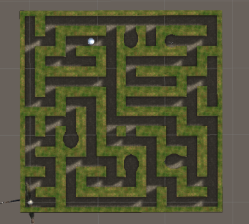
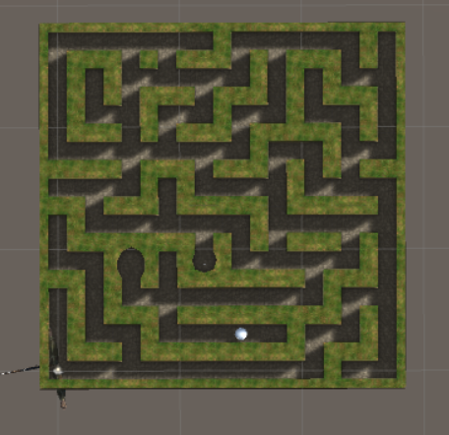

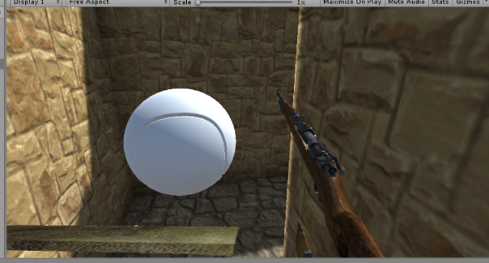
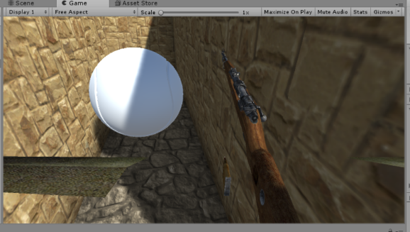
This shows that the map changes when you get the ball but as you can see the ball stays.
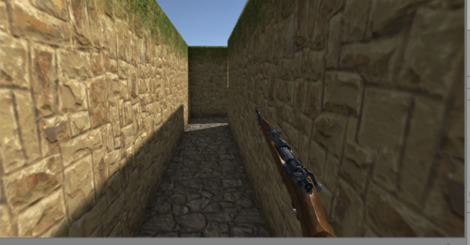
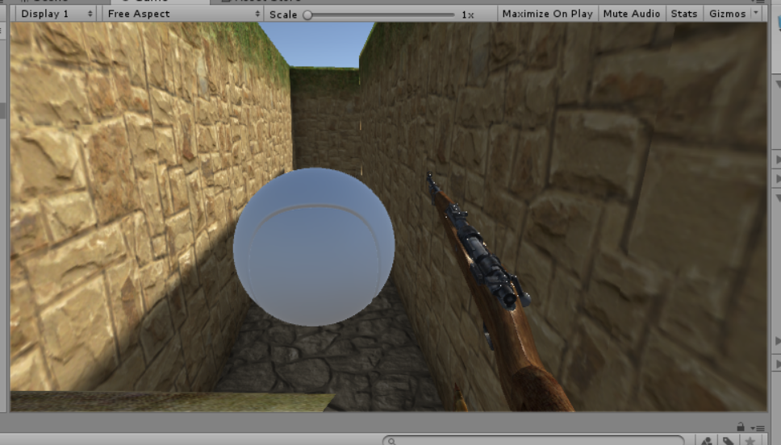
This shows the ball de spawning but the map not changing.
Evaluation.
One of the challenges I faced were to detect that the player is on the sphere so that it would then de spawn and then generate the new maze. In the end I resolved this by creating a separate script that would handle the collision by a by name bases, if the FPSController stood on it then it would execute. The issue I had then with that was that I could get the ball to trigger and de spawn but not generate the new map, or I could keep the ball there and generate a new random map with a new random ball.
The final result is a standard find the object to get out the maze game, all the features work just not together yet. The maze is easy to navigate and see clearly. You know when the ball is in front of you as it is big enough to see. The controls are easy to us also, you can walk, run and jump if needs be.
For games that are never “truly finished” there are always things that you can add, things that you can change or fin, new ideas to be worked on and implemented, the ideas are endless. Even with a simple maze game you can make it a thousand different ways with a thousand different things going one. For me and my game I would like a HUD and something that attacks you, whether that is a static object or something that comes towards you and hunts you down. I would also like more visuals, maybe a beacon showing you where the balls are by looking to the stars.

References:
The only reference I have is the unity help page itself, it helped my understand how to use and implement a few functions that I have used.

marking criteria and Student FEEDBACK

This section details the assessment criteria. The extent to which these are demonstrated by you determines your mark. The marks available for each criterion are shown. Lecturers will use the space provided to comment on the achievement of the task(s), including those areas in which you have performed well and areas that would benefit from development/improvement.

Common Assessment Criteria Applied (Assignment 1) | Marks available | Marks  awarded
1. Research-informed Literature
Extent of research and/or own reading, selection of credible sources, application of appropriate referencing conventions.
A very limited list of references has been provided and the list has not been provided in the correct format. Expand the scope of references consulted to help you improve the quality of your work. (Grade mark: 10.00%) | 5 | 0.5
2. Knowledge and Understanding of Subject
Extent of knowledge and understanding of concepts and underlying principles associated with the discipline.
Demonstrates a very basic understanding of implementing a game from a dynamically generated game world. There is very little contribution to the original code given in the class to start the assignment and even the amount of code used from tutorials is quite basic too. The main areas for improvement are getting the basics right and understanding game object interactions, improving your understanding of events and how they can be used to link object interactions, triggers and events. (Grade mark: 35.00%) | 20 | 7
3. Analysis
Analysis, evaluation and synthesis; logic, argument and judgement; analytical reflection; organisation of ideas and evidence
A fair discussion of one of the challenges faced and how it was resolved. The evaluation is weak and this section could do with some more details. (Grade mark: 40.00%) | 15 | 6
4. Practical Application and Deployment
Deployment of methods, materials, tools and techniques; application of concepts; formulation of innovative and creative solutions to solve problems.
This is a basic attempt with very little functionality implemented. The main area for improvement is getting the basic mechanics right and adding goals and completion/termination conditions to the game. At the moment, the player character appears to be aimlessly wandering around the maze with no real, specific goal. Although some code has been implemented to progress the player character to a new maze level, unfortunately this does not work. You are using the wrong finish prefab and you may want to look into this. You may also want to restrict the player character's rotation on the y-axis. (Grade mark: 38.18%) | 55 | 21
5. Skills for Professional Practice
Attributes in professional practice: individual and collaborative working; deployment of appropriate media; presentation and organisation.
The report is satisfactory. Some sections are a bit sparse and consider using the formatting features of your word processor software to improve the presentation of your reports. See additional comments in your report. (Grade mark: 40.00%) | 5 | 2

Assignment Mark (Assessment marks are subject to ratification at the Exam Board. These comments and marks are to give feedback on module work and are for guidance only until they are confirmed. ) | Late Submission Penalties (tick if appropriate) |  | 36.5%
 | Up to one week late |  | 36.5%
 | 1st/2nd/3rd attempt? |  | 36.5%

